CIS 341 Project Report Outline and Examples

­­­(Reminder the entire project should fit in less than 15 pages)

**Overview (1/2 page)**

* Describe the project as defined in the project proposal discussion
  + Minimum 1-2 paragraphs describing the problem you are trying to solve.
  + Keep in mind the audience is primarily the programming team

**Systems Planning (3 pages)**

* Briefly describe the analysis done to understand the current system 1-2 sentences max.
* Create the documented Business Processes
  + Minimum 1 page in a table format - Example below is for the Housing Project

|  |  |  |  |  |  |
| --- | --- | --- | --- | --- | --- |
| **Process** | **Objective** | **Input** | **Output** | **Tasks** | **Outcomes** |
| **Residents Management** | Maintain a database of all the people living in the apartment building. | Convert from previous spreadsheet (Excel) | Resident information can be shared electronically within the system | 1) Register a Resident 2) Search for people 3) Maintain details for each registered resident | Complete and accurate information about residents. |
| **Payment Process** |  |  | Payment card accepted or declined. |  |  |
| **Etc…** |  |  |  |  |  |

* Document the use cases needed for the project
  + Describe each Use cases in 1-2 sentences max.
  + Maximum 1 page in a table format with Use Case Name, short Description
* Example - Use Cases for the Housing Project – “Credit Card Validation Process”

|  |  |
| --- | --- |
| **Name of Use Case** | **Credit Card Validation Process** |
| Actor | Housing Resident |
| Successful Completion | Customer enters the credit card number information then  System verifies card  System sends authorization message |
| Alternative | Customer enters the credit card number information then  System rejects card  System sends rejection message |
| Precondition | Housing Resident has chosen to pay bill and has proceeded to the payment page |
| Post condition | Credit card has been validated and customer gets receipt |
| Assumptions | None |

* Create a project plan for the new system
  + Minimum 1 page – will likely take 2 pages in MS Project or Excel is acceptable – Project Plan
  + Must contain tasks, timeline, resources and major milestones.

**System Analysis (3 pages)**

* Create a chart for the Systems Requirements features
* Specify all of the software requirements to a level of detail sufficient to enable implementers to satisfy the requirements.
  + Example requirements:
    - The Human Resource system must automatically on board new employees
    - Employees must swipe their ID cards into the online system and the system records labor costs
    - The equipment rental trucks cannot be rented by customers who are overdue on their accounts
    - The inventory system must alert the inventory manager’s dash board when stock is below margins
  + Maximum 1 page – describe at least 6 features of the new system.
  + Describe the system requirement priority as “must have” or “nice to have”.

|  |  |  |  |
| --- | --- | --- | --- |
| **System Features** | **Priority** | **Current Custom Solution** | **Requirements** |
| **<Describe Feature 1>** | Must have | ##% automated | * Replace the current system with the automated <Enter feature 1 here> * Must be able to provide_____________... |
| **<Describe Feature 2>** | Must have | mostly automated  However Aged | * Require <Enter feature 2 here> |
| **<Describe Feature 3>** | Nice to have |  | * Etc… |

* Document new processes, data, and logical data flows for the new system
  + Include network protocols for the major system components at a high level
  + Example protocols are HTTP, HTTPS, SQLNet
* ½ to a full page here – Example below is the basic system diagram of the system HW/SW

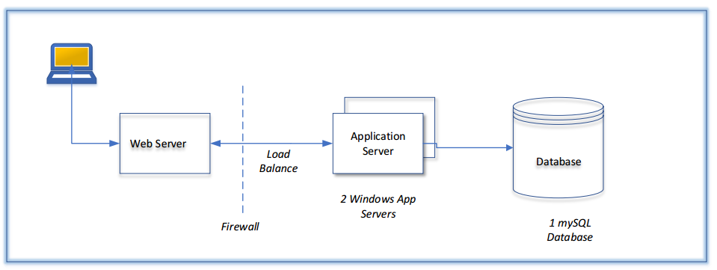

* Describe any security constraints for the new design
* ½ to a full page here - Describe the security
* Constraints on each system – such as PCI compliance for example
* Diagram at least 1 data flow for critical business processes of the new system
  + For example, diagram the usage of an eCommerce gateway processing vendor for the Parking project.
* Maximum 1 page

**System Design (8 pages)**

* Describe the development process
  + How to transform the logical model into a detailed design. (Agile/Waterfall)?
  + How to manage the team of developers?
  + Describe the team base approach and methods planned for development.
  + The method planned should match the project plan in detail.
  + Maximum 1 page
* Database design
  + You need to show an ER Diagram and appropriate description for all the tables with their attributes.
    - Include 1-many relationship with each data tables
    - Include the primary keys for each table
  + There is no need to implement the database.
  + Maximum 2 pages
* Object and methods design
  + You should design the attributes and methods.
  + Document at least 5 methods.
  + Specify the algorithms for these 5 methods using pseudocode

|  |
| --- |
| If a customer account is in good standing and  If the customer orders more than $1,000 then  Subtract 10% from the order  Else  Apply a $25 discount |

* + Maximum 3 pages
* Controls:
  + You should identify and describe at least five control mechanisms to prevent/detect possible errors that can occur in the system.
  + This could be in the form of log files, system alerts, input validation for online forms, etc.
  + Maximum 1 page
* Test Plan
  + Describe how the system will be tested, refer to use cases
  + Show an example of at least one test plan to be given to a testing team
  + Maximum 1 page

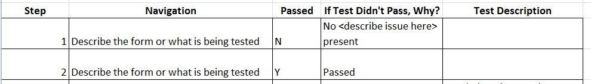

**System Report Summary (1/2 Page)**

* + Summarize the project
  + Identify next steps for Implementation
  + ½ to a full page here