Chris Banci

CS436

10/11/17

Introduction to Networking

Homework - Data Link Layer

1. The following data fragment occurs in the middle of a data stream for which the byte stuffing algorithm described in the text is used: A B ESC C ESC FLAG FLAG D. What is the output after stuffing? (5 pts)

The output after stuffing is: A B ESC ESC C ESC ESC ESC FLAG ESC FLAG D

1. A 12-bit Hamming code whose hexadecimal value is 0xE4F arrives at a receiver. What was the original value in hexadecimal? Assume that not more than 1 bit is in error. (4 pts)

The original value in hexadecimal sent by the sender was 0xA4F.

1. What is the maximum overhead in byte-stuffing algorithm? (3 pts)

The maximum overhead is 100% when the payload only consists of FLAG and ESC bytes.

1. To provide more reliability than a single parity bit can give, an error-detecting coding scheme uses one parity bit for checking all the odd-numbered bits and a second parity bit for all the even numbered bits. What is the Hamming distance of this code? (4 pts)

Since making one change to the bits does not generate an error, but two changes does generate an error, the hamming distance of this code is a minimum of 2.

1. A channel has a bit rate of 4 kbps and a propagation delay of 20 msec. For what range of frame sizes does stop-and-wait give an efficiency of at least 50%? (3 pts)

Since propagation delay is 20 msec, 50% efficiency would be a propagation delay of 40 msec. Given that info, we could say that:

* 160 bits / 4kbps = 40 msec.

The range of frame sizes that give at least 50% is greater than or equal to 160 bits.

1. Suppose that a message 1001 1100 1010 0011 is transmitted using Internet Checksum (4-bit word). What is the value of the checksum? (3 pts)

The checksum can be calculated by adding the bits and finding the one's complement:

* addition: 1001 + 1100 + 1010 + 0011 = 0100
* one's complement: 0100 = 1011

The value of the checksum = 1011

1. In the discussion of ARQ protocol in Section 3.3.3, a scenario was outlined that resulted in the receiver accepting two copies of the same frame due to a loss of acknowledgement frame. Is it possible that a receiver may accept multiple copies of the same frame when none of the frames (message or acknowledgement) are lost? (3 pts)

Yes, it is possible that a receiver may accept multiple copies of the same frame when none of the frames are lost in a sense that the acknowledged frames arrives after the sender's timer ends.

1. Consider the delay of pure ALOHA versus slotted ALOHA at low load. Which one is less? Explain your answer. (3 pts)

Pure Aloha at low load is just as efficient as slotted aloha at low load. However, pure aloha has less of a delay as it sends the packets immediately, while slotted aloha must wait for a slot.

1. In the Aloha protocol, what happens if two stations attempt simultaneous transmission on the inbound frequency, and how is the problem handled? (4 pts)

The signals will collide with one another and in return the two transmission are garbled. The problem is handled by requiring the sender to retransmit each lost packet.

1. What is binary exponential backoff? (3 pts)

Binary exponential backoff refers to an algorithm used to space out repeated retransmission by doubling the delay after each collision occurrence.

1. Give two reasons why networks might use an error-correcting code instead of error detection and retransmission. (4 pts)
2. The time taken to do error-correcting will be considerably less than error detection and retransmission.
3. If a network used error detection and retransmission, more bandwidth would be used.
4. Ethernet frames must be at least 64 bytes long to ensure that the transmitter is still going in the event of a collision at the far end of the cable. Fast Ethernet has the same 64-byte minimum frame size but can get the bits out ten times faster. How is it possible to maintain the same minimum frame size? (4 pts)

It is possible to maintain the same minimum frame size in Ethernet by only allowing the max cable length of faster ethernet to be 1/10 as long as ethernet cable.

1. What is the baud rate of classic 10-Mbps Ethernet? (3 pts)

The baud rate is double the rate of manchester's encoding which is used in ethernet transmission.

* Thus, the baud rate is 20-Mbps.

1. Sketch the Manchester encoding on a classic Ethernet for the bit stream 0001110101. (3 pts)

Since manchester encoding uses the transitions between low to high (0) and high to low (1) to encode bits, it will look like this:

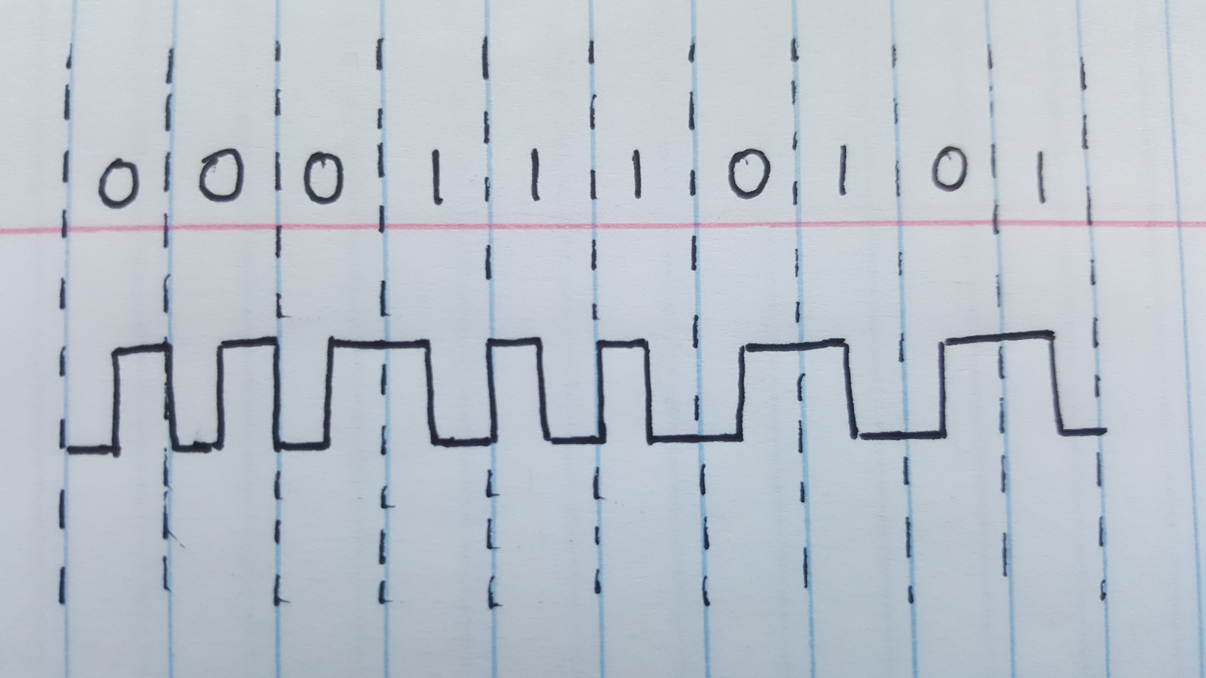

1. Consider five wireless stations, A, B, C, D, and E. Station A can communicate with all other stations. B can communicate with A, C and E. C can communicate with A, B and D. D can communicate with A, C and E. E can communicate A, D and B. (6 pts)
2. When A is sending to B, what other communications are possible?

Because every station will hear station A, no other communication is possible as there will be interference.

1. When B is sending to A, what other communications are possible?

Because every station will hear station A, no other communication is possible as there will be interference.

1. When B is sending to C, what other communications are possible?

It is possible for Station E to communicate with station D, because D cannot hear B and C cannot hear E.