Chris Banci

CS436

11/6/17

Homework - Network Layer (Control Plane)

1. Consider the network shown below. Show the operation of Dijkstra’s (link-state) algorithm for computing the least cost path from D to all destinations. What is the shortest path from D to B, and what is the cost of this path? (8 pts)

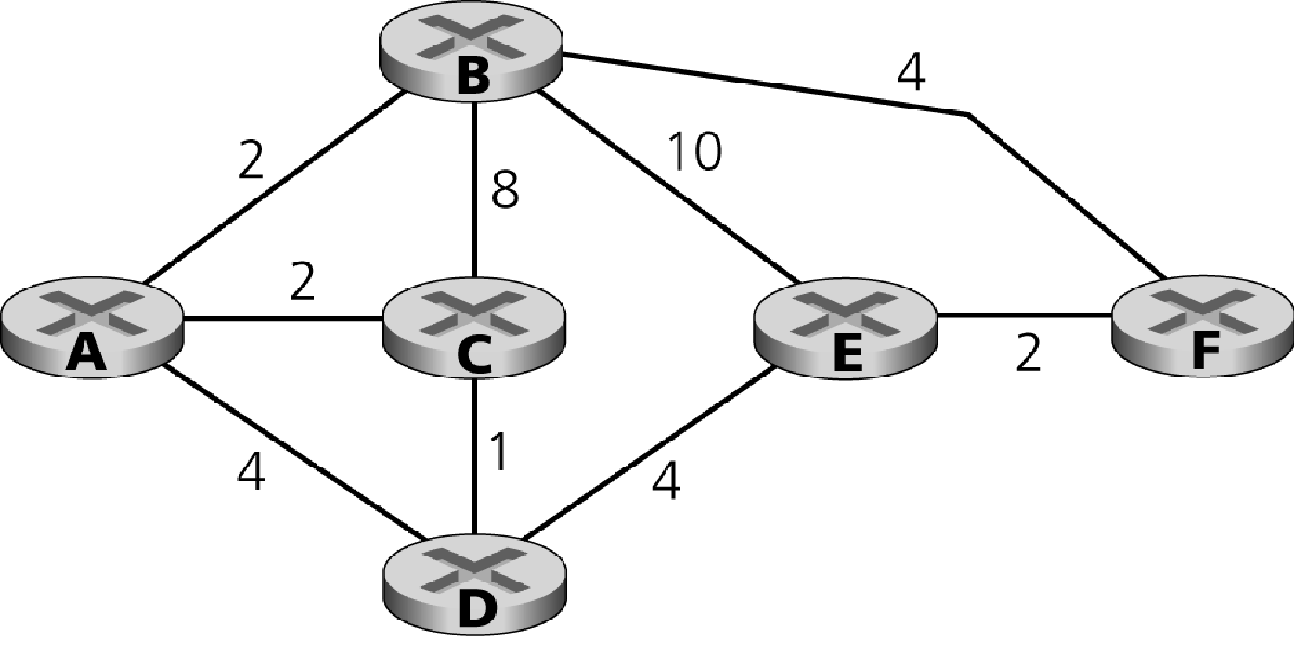

The shortest path is the path that has the least cost.

D->A: shortest path = D->C->A cost = 1 + 2 = 3

D->C: shortest path = D->C cost = 1

D->B: shortest path = D->C->A->B cost = 1 + 2 + 2 = 5

D->E: shortest path = D->E cost = 4

D->F: shortest path = D->E->F cost = 4 + 2 = 6

In this example, the the shortest path from D to B is D->C->A->B, where the cost is 5.

1. **Distance vector algorithm (even more).** Consider the network below. (14 pts)

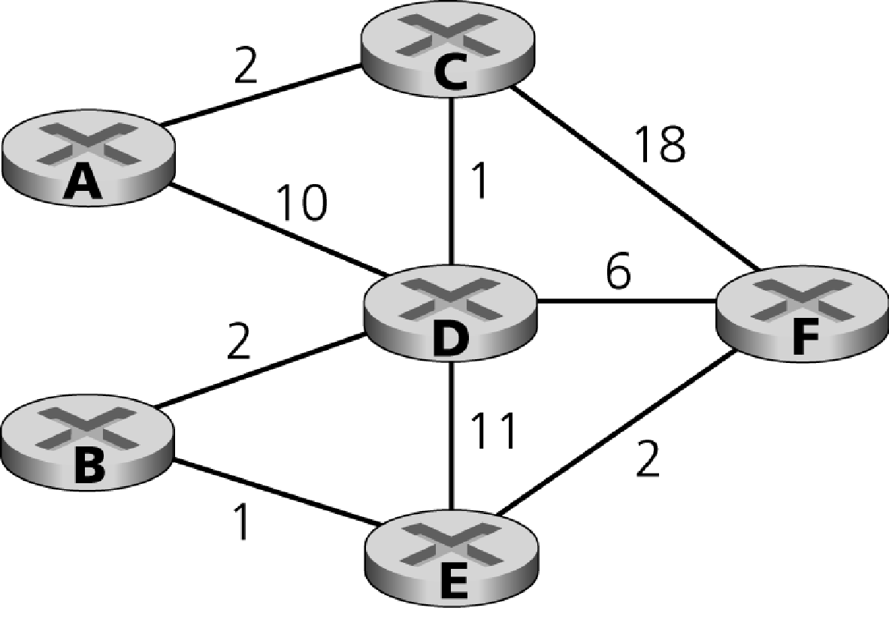

1. What are the initial distance vectors in A, C, D and F, before the distance

vector algorithm begins executing?

A Node

|  |  |  |  |  |  |  |
| --- | --- | --- | --- | --- | --- | --- |
|  | A | B | C | D | E | F |
| A | ∞ | ∞ | ∞ | ∞ | ∞ | ∞ |
| B | ∞ | ∞ | ∞ | ∞ | ∞ | ∞ |
| C | ∞ | ∞ | 2 | ∞ | ∞ | ∞ |
| D | ∞ | ∞ | ∞ | 10 | ∞ | ∞ |
| E | ∞ | ∞ | ∞ | ∞ | ∞ | ∞ |
| F | ∞ | ∞ | ∞ | ∞ | ∞ | ∞ |

C Node

|  |  |  |  |  |  |  |
| --- | --- | --- | --- | --- | --- | --- |
|  | A | B | C | D | E | F |
| A | 2 | ∞ | ∞ | ∞ | ∞ | ∞ |
| B | ∞ | ∞ | ∞ | ∞ | ∞ | ∞ |
| C | ∞ | ∞ | ∞ | ∞ | ∞ | ∞ |
| D | ∞ | ∞ | ∞ | 1 | ∞ | ∞ |
| E | ∞ | ∞ | ∞ | ∞ | ∞ | ∞ |
| F | ∞ | ∞ | ∞ | ∞ | ∞ | 18 |

D Node

|  |  |  |  |  |  |  |
| --- | --- | --- | --- | --- | --- | --- |
|  | A | B | C | D | E | F |
| A | 10 | ∞ | ∞ | ∞ | ∞ | ∞ |
| B | ∞ | 2 | ∞ | ∞ | ∞ | ∞ |
| C | ∞ | ∞ | 1 | ∞ | ∞ | ∞ |
| D | ∞ | ∞ | ∞ | ∞ | ∞ | ∞ |
| E | ∞ | ∞ | ∞ | ∞ | 11 | ∞ |
| F | ∞ | ∞ | ∞ | ∞ | ∞ | 6 |

F Node

|  |  |  |  |  |  |  |
| --- | --- | --- | --- | --- | --- | --- |
|  | A | B | C | D | E | F |
| A | ∞ | ∞ | ∞ | ∞ | ∞ | ∞ |
| B | ∞ | ∞ | ∞ | ∞ | ∞ | ∞ |
| C | ∞ | ∞ | 18 | ∞ | ∞ | ∞ |
| D | ∞ | ∞ | ∞ | 6 | ∞ | ∞ |
| E | ∞ | ∞ | ∞ | ∞ | 2 | ∞ |
| F | ∞ | ∞ | ∞ | ∞ | ∞ | ∞ |

1. Suppose that node A sends its distance vector to C (and that no other distance

vectors are exchanged). What are the distance vectors in A, C, D, and F?

A Node

|  |  |  |  |  |  |  |
| --- | --- | --- | --- | --- | --- | --- |
|  | A | B | C | D | E | F |
| A | ∞ | ∞ | ∞ | ∞ | ∞ | ∞ |
| B | ∞ | ∞ | ∞ | ∞ | ∞ | ∞ |
| C | ∞ | ∞ | 2 | ∞ | ∞ | ∞ |
| D | ∞ | ∞ | ∞ | 10 | ∞ | ∞ |
| E | ∞ | ∞ | ∞ | ∞ | ∞ | ∞ |
| F | ∞ | ∞ | ∞ | ∞ | ∞ | ∞ |

C Node

|  |  |  |  |  |  |  |
| --- | --- | --- | --- | --- | --- | --- |
|  | A | B | C | D | E | F |
| A | 2 | ∞ | ∞ | ∞ | ∞ | ∞ |
| B | ∞ | ∞ | ∞ | ∞ | ∞ | ∞ |
| C | ∞ | ∞ | ∞ | ∞ | ∞ | ∞ |
| D | ∞ | ∞ | ∞ | 1 | ∞ | ∞ |
| E | ∞ | ∞ | ∞ | ∞ | ∞ | ∞ |
| F | ∞ | ∞ | ∞ | ∞ | ∞ | 18 |

D Node

|  |  |  |  |  |  |  |
| --- | --- | --- | --- | --- | --- | --- |
|  | A | B | C | D | E | F |
| A | 10 | ∞ | ∞ | ∞ | ∞ | ∞ |
| B | ∞ | 2 | ∞ | ∞ | ∞ | ∞ |
| C | ∞ | ∞ | 1 | ∞ | ∞ | ∞ |
| D | ∞ | ∞ | ∞ | ∞ | ∞ | ∞ |
| E | ∞ | ∞ | ∞ | ∞ | 11 | ∞ |
| F | ∞ | ∞ | ∞ | ∞ | ∞ | 6 |

F Node

|  |  |  |  |  |  |  |
| --- | --- | --- | --- | --- | --- | --- |
|  | A | B | C | D | E | F |
| A | ∞ | ∞ | ∞ | ∞ | ∞ | ∞ |
| B | ∞ | ∞ | ∞ | ∞ | ∞ | ∞ |
| C | ∞ | ∞ | 18 | ∞ | ∞ | ∞ |
| D | ∞ | ∞ | ∞ | 6 | ∞ | ∞ |
| E | ∞ | ∞ | ∞ | ∞ | 2 | ∞ |
| F | ∞ | ∞ | ∞ | ∞ | ∞ | ∞ |

1. Suppose that node D sends its distance vector to C (and that no other distance

vectors are exchanged). What are the distance vectors in A, C, D and F?

A Node

|  |  |  |  |  |  |  |
| --- | --- | --- | --- | --- | --- | --- |
|  | A | B | C | D | E | F |
| A | ∞ | ∞ | ∞ | ∞ | ∞ | ∞ |
| B | ∞ | ∞ | ∞ | ∞ | ∞ | ∞ |
| C | ∞ | ∞ | 2 | ∞ | ∞ | ∞ |
| D | ∞ | ∞ | ∞ | 10 | ∞ | ∞ |
| E | ∞ | ∞ | ∞ | ∞ | ∞ | ∞ |
| F | ∞ | ∞ | ∞ | ∞ | ∞ | ∞ |

C Node

|  |  |  |  |  |  |  |
| --- | --- | --- | --- | --- | --- | --- |
|  | A | B | C | D | E | F |
| A | 2 | ∞ | ∞ | ∞ | ∞ | ∞ |
| B | ∞ | ∞ | ∞ | 3 | ∞ | ∞ |
| C | ∞ | ∞ | ∞ | ∞ | ∞ | ∞ |
| D | ∞ | ∞ | ∞ | 1 | ∞ | ∞ |
| E | ∞ | ∞ | ∞ | 12 | ∞ | ∞ |
| F | ∞ | ∞ | ∞ | 7 | ∞ | 18 |

D Node

|  |  |  |  |  |  |  |
| --- | --- | --- | --- | --- | --- | --- |
|  | A | B | C | D | E | F |
| A | 10 | ∞ | ∞ | ∞ | ∞ | ∞ |
| B | ∞ | 2 | ∞ | ∞ | ∞ | ∞ |
| C | ∞ | ∞ | 1 | ∞ | ∞ | ∞ |
| D | ∞ | ∞ | ∞ | ∞ | ∞ | ∞ |
| E | ∞ | ∞ | ∞ | ∞ | 11 | ∞ |
| F | ∞ | ∞ | ∞ | ∞ | ∞ | 6 |

F Node

|  |  |  |  |  |  |  |
| --- | --- | --- | --- | --- | --- | --- |
|  | A | B | C | D | E | F |
| A | ∞ | ∞ | ∞ | ∞ | ∞ | ∞ |
| B | ∞ | ∞ | ∞ | ∞ | ∞ | ∞ |
| C | ∞ | ∞ | 18 | ∞ | ∞ | ∞ |
| D | ∞ | ∞ | ∞ | 6 | ∞ | ∞ |
| E | ∞ | ∞ | ∞ | ∞ | 2 | ∞ |
| F | ∞ | ∞ | ∞ | ∞ | ∞ | ∞ |

1. **BGP.** Consider the network below in which network W is a customer of ISP

A, network Y is a customer of ISP B, and network X is a customer of both ISPs A and C. (6 pts)

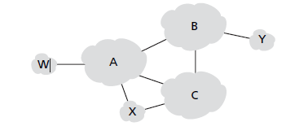

1. What BGP routes will A advertise to X?

A will advertise that it can reach W and Y. It does not have to advertise B and C to X because they are transit networks, not customer networks.

1. What routes will X advertise to A?

.X will not advertise anything to A because it is a customer network.

1. What routes will A advertise to C? For each answer provide a one-sentence explanation.

A will advertise that it can reach W and X because C is a peer network. A will not advertise it can reach Y because that would want C to try to route to it via A.

1. If costs are recorded as 8-bit numbers in a 50-router network, and distance vectors are exchanged twice a second, how much bandwidth per (full-duplex) line is chewed up by the distributed routing algorithm? Assume that each router has three lines to other routers. (4 pts)

To calculate the bandwidth, we must first find the length of the routing table. This can be calculated by multiplying the number of routers in the network by the costs in bits.

50 routers x 8 bits cost = 400 bits.

We can now find the bandwidth for each line by multiplying the number of seconds it takes for the distance vectors to exchange by the length of the routing table.

2 seconds x 400 bits = 800 bits per line

1. In the text it was stated that when a mobile host is not at home, packets sent to its home LAN are intercepted by its home agent on that LAN. For an IP network on an 802.3 LAN, how does the home agent accomplish this interception? (4 pts)

The home agent accomplishes this interception through APR querying. The router broadcasts an APR query when it receives a packet intended for the mobile host. It will asks for the MAC and IP address. If the mobile host is on the home lan, it simply responds to the APR query, else, the home agent responds to it.

1. Assuming that all routers and hosts are working properly and that all software in both is free of all errors, is there any chance, however small, that a packet will be delivered to the wrong destination? (4 pts)

Yes, it is still possible that a packet can be delivered to the wrong destination if it is garbled badly by large noise. The destination address field of a packet could become corrupted noise and checksum could potential not detect the error.

1. Compare and contrast link-state and distance-vector routing algorithms. (4 pts)

In link state routing, the least cost path between the source and destination is computed by having complete knowledge about the entire network. Example of link stating routing is dijkstra's algorithm. The link costs are known to all nodes. In distance vector routing, the least cost path between source and destination is computed out in an iterative distributed way. Example of distance vector routing is bellman-ford algorithm. From time-to-time, each node sends its own distance vector estimates to neighbors.

1. Is it necessary that every autonomous system use the same intra-AS routing algorithm? Why or why not? (4 pts)

No, its not necessary for every autonomy system to use the same routing algorithm, because each autonomous system can have its own autonomy for routing within an AS.

1. When a host joins a multicast group, must it change it's IP address to that of the multicast group it is joining? Justify your answer. (2 pts)

No, it does not need to change it's IP address to that of the multigroup it is joining, because the host can map the ip and port to accept packets from that group.