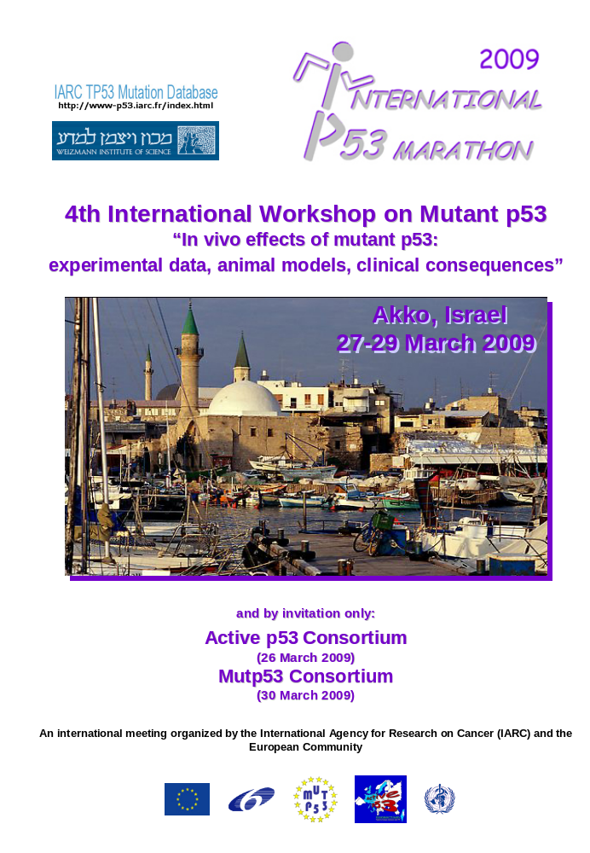

BACKGROUND AND SCOPE

The 4th International Workshop on Mutant p53, to be held in Akko, Israel, will focus on "In vivo effects of mutant p53: experimental data, animal models, clinical consequences". Understanding the biological role of mutant p53 and its clinical impact requires the development of a global approach that integrates the structural biology of mutant proteins, the evaluation of their functional properties, the distribution of mutations in human cancers, and the correlation between mutations and the clinical and pathological parameters of cancer. The objective of this workshop is to review and discuss the state of the art and the experimental methods and models available for such global approaches. The workshop will cover topics ranging from the causes of mutations to the evaluation of their functional and clinical impacts in human cancers.

As for the 2nd and 3rd workshops, the annual meetings of two research consortiums working on p53 (Mutp53 and Activep53) and funded by the European Community (FP6) will be held in conjunction with this international workshop.

The workshop will include lectures from top scientists in the field, short presentations selected from submitted abstracts and a poster session.

ORGANIZERS

Pierre Hainaut, International Agency for Research on Cancer, France
Magali Olivier, International Agency for Research on Cancer, France
Giovanni Blandino, Regina Elena National Cancer Institute, Italy
Klas Wiman, Karolinska Institute, Sweden
Moshe Oren, Weizmann Institute of Science, Israel
Varda Rotter, Weizmann Institute of Science, Israel

Administrative Assistants

Vivienne Laufer, Weizmann Institute of Science
Administrative Assistant to Prof. Varda Rotter
Department of Molecular Cell Biology
Weizmann Institute of Science
Rehovot 76100, ISRAEL
Tel: +972-8-934-4072
Fax: +972-8-934-4125
Email: vivienne.laufer@weizmann.ac.il

Michelle Wrisez, International Agency for Research on Cancer
Group of Molecular Carcinogenesis and Biomarkers
International Agency for Research on Cancer
150 Cours Albert Thomas
F-69372 Lyon CEDEX 08
France
Tel: 33 472 738 462
Fax: 33 472 738 322
Email: wrisez@iarc.fr

FUNDING

This meeting is supported by EU FP6.

LAND ARRANGEMENTS ORGANIZED BY:

Bob Kazmer
Target Conferences Ltd.
PO Box 29041, Tel Aviv 61290, Israel
Tel: +972 3 5175150, Fax: +972 3 5175155, e-mail: p53@targetconf.com



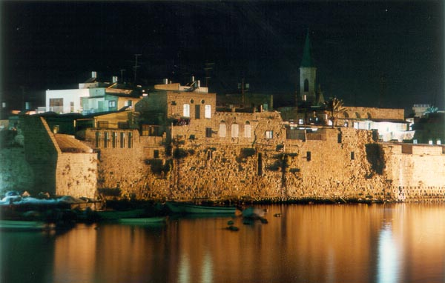

MARATHON PROGRAM

Wednesday, March 25, ‏2009
All day Arrivals of participants of Active p53 Consortium (Module 1)
Late afternoon Registration
Dinner & Overnight: Palm Beach Hotel

Thursday, March 26, ‏2009
All day Sessions Active p53 Consortium (Module 1) – Palm Beach Hotel
Arrivals of participants of Mutant p53 Workshop (Module 2)
Late afternoon Registration – Palm Beach Hotel
Evening Get-together reception (Module 1 and Module 2)
Overnight Palm Beach Hotel

Friday, March 27, 2009
All day: Sessions Mutant p53 Workshop (Module 2) – Prisoners’ Hall – Old City
Module 1 departures
Dinner & Overnight: Palm Beach Hotel

Saturday, March 28, 2009
Morning: Mutant p53 Workshop (Module 2) - Old City
Morning sessions include Poster Session as well as presentation of
Selected Short Papers
Afternoon Tour of Old City of Akko
Evening At leisure/dine around
Overnight Palm Beach Hotel

Sunday, March 29, 2009
All day Mutant p53 Workshop (Module 2) - Old City
Arrivals of participants - Mutp53 Consortium (Module 3)
Evening Crusader Dinner for participants of Module 2 and Module 3 -
Mutant p53 Workshop and Mutp53 Consortium
Overnight Palm Beach Hotel

Monday, March 30, 2009
All day Departures of participants of Mutant p53 Workshop (Module 2)
Mutp53 Consortium (Module 3) – Sessions (Palm Beach Hotel)
Dinner & Overnight: Palm Beach Hotel

Tuesday, March 31, 2009
All day Departures Mutp53 Consortium (Module 3)

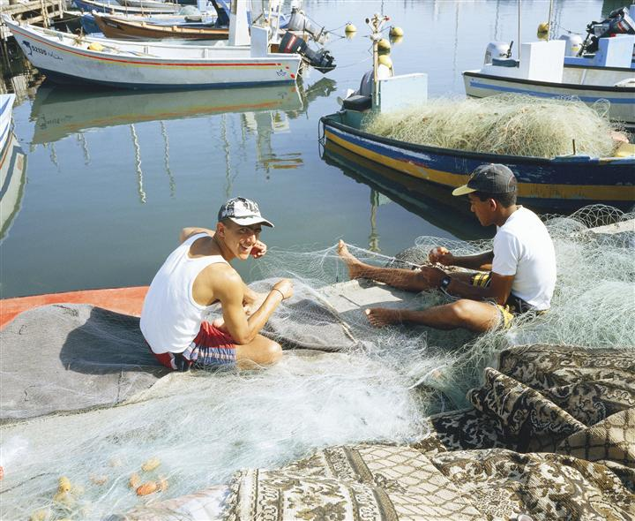

WORKSHOP SCIENTIFIC PROGRAM – Day 1 -

Friday, 27 March 2009

9h00 | Introduction & Welcome

Session 1 – p53 mutants and the p53 pathway
9h15 | Curtis Harris, Bethesda, USA
9h45 | Moshe Oren, Rehovot, Israel
10h15 | Coffee break
10h45 | Wolfgang Deppert, Hamburg, Germany
11h15 | Genrich Tolstonog, Hamburg, Germany
11h45 | Christophe Marine, Ghent, Belgium
12h15 | Lunch
14h00 | Sumitra Deb, Richmond, USA
14h30 | Carol Prives, New York, USA
15h00 | Varda Rotter, Rehovot, Israel
15h30 | Coffee break
16h00 | Mike Resnick, Research Triangle Park, USA
16h30 | Giannino Del Sal, Rome, Italy
17h00 | Ygal Haupt, Jerusalem, Israel
17h30 | Giovanni Blandino, Rome, Italy
18h00 | - end of day -
WORKSHOP SCIENTIFIC PROGRAM – Day 2-

Saturday, 28 March 2009

Session 2 – Short communications selected from abstracts
9h00 | Kanaga Sabapathy, Singapore
9h15 | Gianluca Bossi, Rome, Italy
9h30 | Job de Lange, Leiden, The Netherlands
9h45 | Virginie Marcel, Lyon, France
10h00 | Andrea Bisso, Trieste, Italy
10h15 | Maria Brazdova, Brno, Czech republic
10h30 | Michelangelo Cordenonsi, Padua, Italy

Session 3 – Posters
10h45 | Poster exhibition + Coffee break
13h00 | Lunch + Poster exhibition

Leisure time
Afternoon | Tour in Akko

WORKSHOP SCIENTIFIC PROGRAM – Day 3-

Sunday, 29 March 2009

Session 4 – From structures to drugs
9h00 | Sir Alan Fersht, Cambridge, UK
9h30 | Zipi Shakked, Rehovot, Israel
10h00 | Coffee break
10h30 | Assaf Friedler, Jerusalem, Israel
11h00 | Silvia Soddu, Rome, Italy
11h30 | Galina Selivanova, Stockholm, Sweden
12h00 | Klas Wiman, Stockholm, Sweden
12h30 | Lunch

Session 5 – Phenotypes and clinical impacts of mutations
14h15 | Monica Hollstein, Leeds, UK
14h45 | Gigi Lozano, Houston, USA
15h15 | Hein Te Riele, Amsterdam, The Netherlands
15h45 | Coffee break
16h15 | Jeffrey Myers, Houston, USA
16h45 | Magali Olivier, Lyon, France
17h15 | Pierre Hainaut, Lyon, France
17h45 | -end of scientific sessions-

Evening – Crusader Dinner

- End of workshop -

GENERAL INFORMATION

VENUE
The Palm Beach Hotel, overlooking the Mediterranean Sea in Akko, Israel, is the p53 Marathon venue.

LANGUAGE
The p53 Marathon will be conducted in English.

REGISTRATION, ACCOMMODATION AND TOURS
Target Conferences Ltd.
PO Box 29041, Tel Aviv 61290, Israel
Tel: +972 3 5175150, Fax: +972 3 5175155, email: p53@targetconf.com
Target Conferences is the official travel agent for the Marathon events. In addition to the Workshop Package, a pre- and post-tour is offered, specifically designed for participants.

MARATHON REGISTRATION PACKAGES

Before Student After Supplement
Feb. 28 rate** Feb. 28 single room
Attendance at one event:
1. Active p53 Consortium, 25-27/3 US$260 US$300 US$100

2. Mutant p53 Workshop, 26-30/3* US$665 US$500 US$705 US$200

3. Mutp53 Consortium, 29-31/3 US$260 US$300 US$100

Special package rates for attendance
at more than one event:

4. Active p53 Consortium and
Mutant p53 Workshop 25-30/3* US$810 US$610 US$850 US$250

5. Active p53 Consortium, Mutant p53
Workshop, Mutp53 Consortium, 25-31/3* US$925 US$695 US$965 US$300

6. Mutant p53 Workshop &
Mutp53 Consortium, 26-31/3* US$810 US$610 US$850 US$250

Rates include:
Package 1 or 3: Two nights’ accommodation with dinners and breakfasts, coffee at breaks, lunch on session days

Package 2: Workshop registration, 4 overnights’ accommodation with dinners and breakfasts, coffee at breaks, lunch on session days, participation in social events

Package 4 or 6: Workshop registration, 5 overnights’ accommodation with dinners and breakfasts, coffee at breaks, lunch on session days, participation in social events

Package 5: Workshop registration, 6 overnights’ accommodation with dinners and breakfasts, coffee at breaks, lunch on session days, participation in social events

Sharing accommodation (if requested) will be arranged subject to availability.

*Accompanying person in room sharing with paying participant:
Reduction of US$150 on advertised rate. Should there be a small group interested in optional touring during session times, this will be arranged on-spot.

**Upon presentation of official student identification card or official certification of student status which will need to be sent along with registration/accommodation form.

Israeli participants are eligible for the same rates converted to Shekels according to rate of exchange on day of payment, and subject to VAT.

HOW TO BOOK

Kindly complete the enclosed Registration/Accommodation Form and return with required payment at your earliest convenience.
ALL PARTICIPANTS MUST SUBMIT A REGISTRATION FORM

Check-in time at the Palm Beach Hotel is 15:00 hours and check-out after breakfast. A special room is supplied to leave luggage until departure.

PAYMENT
Payment must be submitted in full together with the Registration Form. Target Conferences accepts direct bank transfers*, cheques and major credit cards. Payment in Israeli currency is subject to VAT (currently 15.5%).

*Please ensure that the name/s of the participants and workshop name are clearly stated on the bank transfer. Bank charges are the responsibility of the payee and should be paid at source in addition to the registration package fees.

CLIMATE
In March the climate is pleasant during the day (about 15-20°) and relatively cold at night. Don’t forget to bring your umbrella, sun hat, sunglasses, bathing suit and comfortable walking shoes. Bring a jacket for the evenings.

ADDITIONAL ACCOMMODATION AND TOURS
Participants requiring pre- or post-accommodation anywhere in Israel are welcome to contact Target Conferences. In addition, regular day tours around the country are available. Should you wish to continue to Jordan, we will gladly arrange tours to Petra too.

VISAS
Some participants may require a visa to enter Israel. We therefore suggest that you contact the Israeli Embassy/Consulate in your country or ask your travel agent for assistance. If you have difficulty obtaining a visa, kindly contact Target Conferences who will make every effort to assist.

Upon request, the Secretariat is willing to send a personal letter of invitation to the applicant to participate in the Workshop. It should be understood that such an invitation is only meant to help participants raise travel funds or obtain a visa, and does not represent a commitment on the part of the organizers to provide any financial support.

FLIGHTS AND TRANSPORTATION
Direct flights into Ben Gurion International Airport exist from most major airports in northern America, Europe, India, China, Thailand and Africa by El Al Israel Airlines as well as by other International carriers.

TRANSFERS FROM BEN GURION INTERNATIONAL AIRPORT TO AKKO
http://www.rail.co.il/EN/Pages/HomePage.aspx

It is advisable to take a train from the airport to Akko and return. Rate is approximately US$12
per direction. Please see website for schedule. Look up Ben Gurion Airport to Akko and vice versa. The Palm Beach Hotel is situated a short taxi ride from the Akko train station (cost about US$5-10).

Note that there are no trains on a Friday afternoon or Saturday. The on-site staff will try to assist in arranging shared taxi transfers for those needing return transfers on the Friday or Saturday.

Journey duration is about 2 hours by train or taxi from the airport to Akko.

IMPORTANT NOTES
Personal travel, luggage and health insurance are recommended. Please purchase this from your local travel agent.
All tours are booked on the express condition that Target Conferences shall not be held responsible for and shall be exempt from all liability in respect of any loss, damage, injury or accident, to any person or his or her luggage or any other property, for any reason whatsoever.

TRAVEL AND ACCOMMODATION
Bob Kazmer
Target Conferences Ltd.
PO Box 29041, Tel Aviv 61290 Israel
Tel: + 972 3 5175150, Fax: + 972 3 5175155
e-mail: p53@targetconf.com

CANCELLATION POLICY
Our refund policy is based upon receiving notification prior to February 28, full refund less US$50 to cover bank charges. Thereafter no refund.

REGISTRATION/ACCOMMODATION FORM

p53 MARATHON
Akko, Israel, March 25-31, 2009

PLEASE COMPLETE AND E-MAIL or PRINT AND FAX TO THE SECRETARIAT
FAX: +972 3 5175155, E-MAIL: p53@targetconf.com
p53 2009, PO Box 29041, Tel Aviv 61290, Israel
Tel: +972 3 5175150, Fax: +972 3 5175155

I. PERSONAL INFORMATION

Family Name

First Name

Title: Prof Dr Mr Ms

Full Mailing Address

______________________________________ State __________________________

Zip Code Country

Tel Fax

E-mail

II. MARATHON REGISTRATION PACKAGES

Before Student After Supplement
Feb. 28 rate** Feb. 28 single room
Attendance at one event:
1. Active p53 Consortium, 25-27/3 US$260 US$300 US$100

2. Mutant p53 Workshop, 26-30/3* US$665 US$500 US$705 US$200

3. Mutp53 Consortium, 29-31/3 US$260 US$300 US$100

Special package rates for attendance
at more than one event:

4. Active p53 Consortium and
Mutant p53 Workshop 25-30/3* US$810 US$610 US$850 US$250

5. Active p53 Consortium, Mutant p53
Workshop, Mutp53 Consortium, 25-31/3* US$925 US$695 US$965 US$300

6. Mutant p53 Workshop &
Mutp53 Consortium, 26-31/3* US$810 US$610 US$850 US$250

*Accompanying person in room sharing with paying participant: Reduction of US$150 on advertised rate.

**Upon presentation of official student identification card or official certification of student status which will need to be sent along with registration/accommodation form.

Registration Packages are based on a shared double room (unless you have marked off the supplement for single room).
I will be sharing a room with _________________________________ another participant, or
Non-participant accompanying person* (US$150 less for Workshop), or I wish to share with another participant (male/female)

Family Name

First Name

III. FLIGHT INFORMATION (Please complete)

Arrival date ________________Airline ____________Flight # ______ at __________ hours

Departure date _____________ Airline ___________Flight # ______ at ___________ hours

IV. OPTIONAL ACCOMMODATION PRIOR TO/FOLLOWING MARATHON

City ______________________

Single room Double room, Check-in date _____________ Check-out date __________

V. TOURING REQUIREMENTS

________________________________________________________________________

________________________________________________________________________

VI. METHOD OF PAYMENT*

Bank Transfer of US$ made as follows: Swift code Lumiilit
Account name: Target Conferences, Bank Leumi, Gordon Branch, 87 Ben Yehuda Street, Tel Aviv, Israel
To: account number: 804-(950) 341500/08 (copy enclosed)

Cheque, payable to Target Conferences Ltd., herewith enclosed

Charge US$ to credit card as below:

American Express Diners Club MasterCard Visa

Credit Card No. Expiry Date

Numbers on back of card

*Israeli participants to pay above rates subject to VAT (currently 15.5%) in Shekels according to rate of exchange on day of payment.

Signature: Date: ______________________

INSTRUCTIONS FOR THE PREPARATION OF POSTERS
- Abstracts should be no longer than one A4 page and include a title, all authors names with affiliations and a brief abstract.
- Title should be typed in CAPITAL LETTERS, bold and aligned to the left.
- Presenting author’s name should be underlined and in bold.
- Poster size should be no more than 90x90 cm.

