**NSSA-220 Project 1: Application Performance Monitoring**

**Isbah Sohaib, Jamin Chen, Mikail Alam**

**Introduction**

Write a 3-4 sentence introduction that describes what this project was about. Use the project slides as your guide. I want to see you describe the project in your own words.

**We are developing an Application Performance Monitoring Tool using Bash to oversee various executable programs. It is used to start these processes but also to gather performance metrics when it is executed. The APM tool will collect both process and system-level performance data. When the monitoring period ends, the script will perform a clean-up operation and will terminate any processes it started along with any subsidiary processes it may have spawned during its execution.**

**Process Level Metrics**

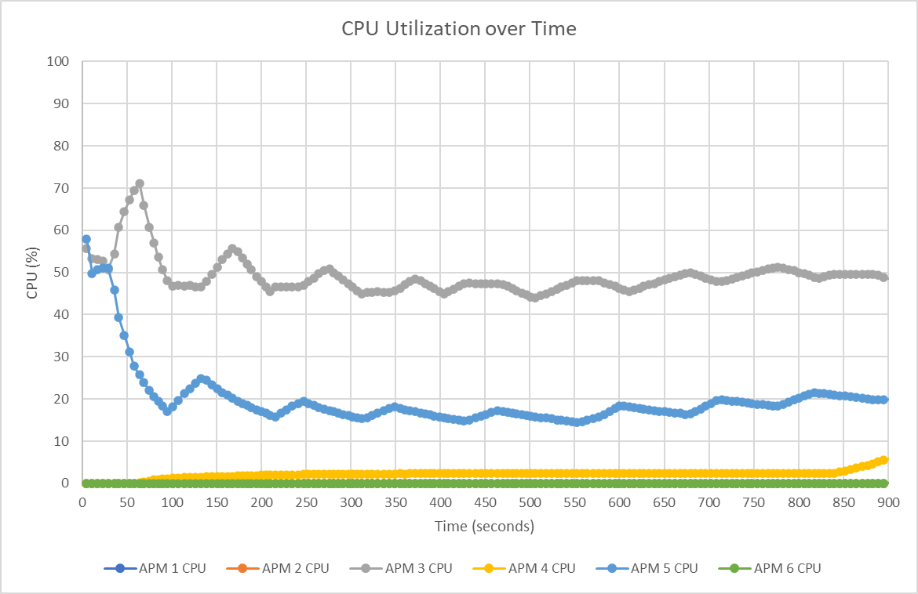

Describe what the CPU utilization plot shows in 2-3 sentences.

**The plot illustrates the CPU usage time of APMs 1-5. APM1 starts with a high CPU usage, and then gradually declines. APM3 hovers around the mid-range values. APMs 2, 4, 5, and 6 maintain relatively consistent low CPU usage throughout the whole process. AMP 1 exhibits an initial spike in utilization before it stabilizes, while other processes remain relatively consistent. AMP 3 seems to have the highest CPU usage, with AMPs 5 and 6 with the lowest.**

Describe what the memory utilization plot shows in 2-3 sentences.

**. APMs 1 - 4 show the least amount of memory usage, as they maintain a near-zero memory usage, effectively “flat-lined”. An interesting pattern is that APM 5 shows repetitive spikes, which leads to increased memory consumption as the APMs maintain consistent memory usage. APM 6 shows a steady increase in memory usage over time. Since APM 5 shows repetitive memory spikes in the graph, it would be safe to assume that this would be a cause of a memory leak.**

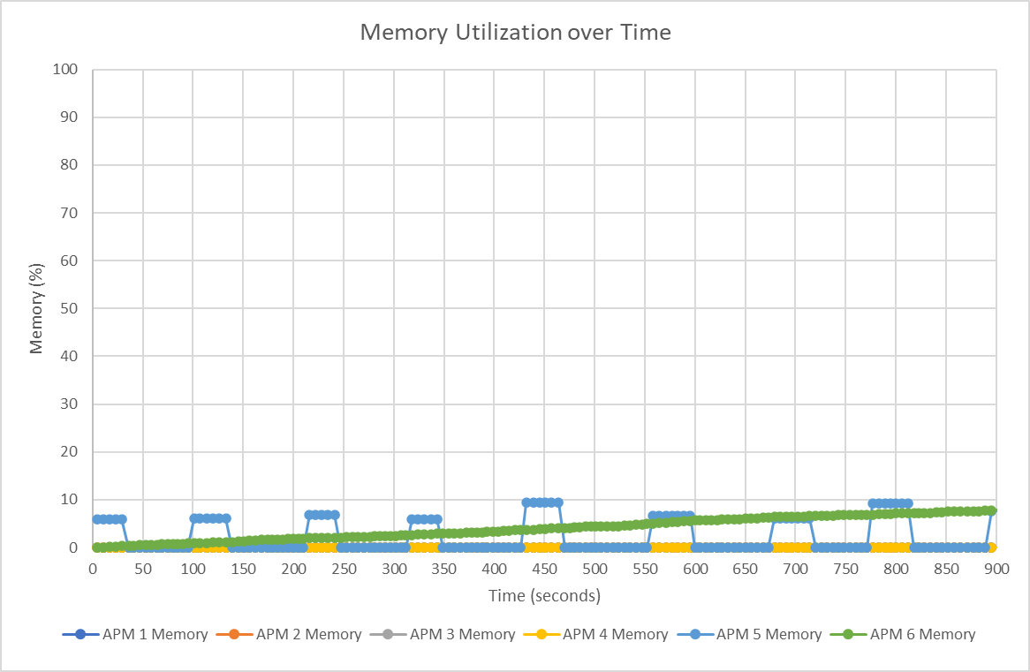

**Potential things to write about**: Which processes used the most CPU/memory? Which processes used the least CPU/memory? Did any processes have any interesting patterns in their CPU and/or memory utilization? Could you see a memory leak (memory use that only increased over time) in any of the processes?

**System Level Metrics**

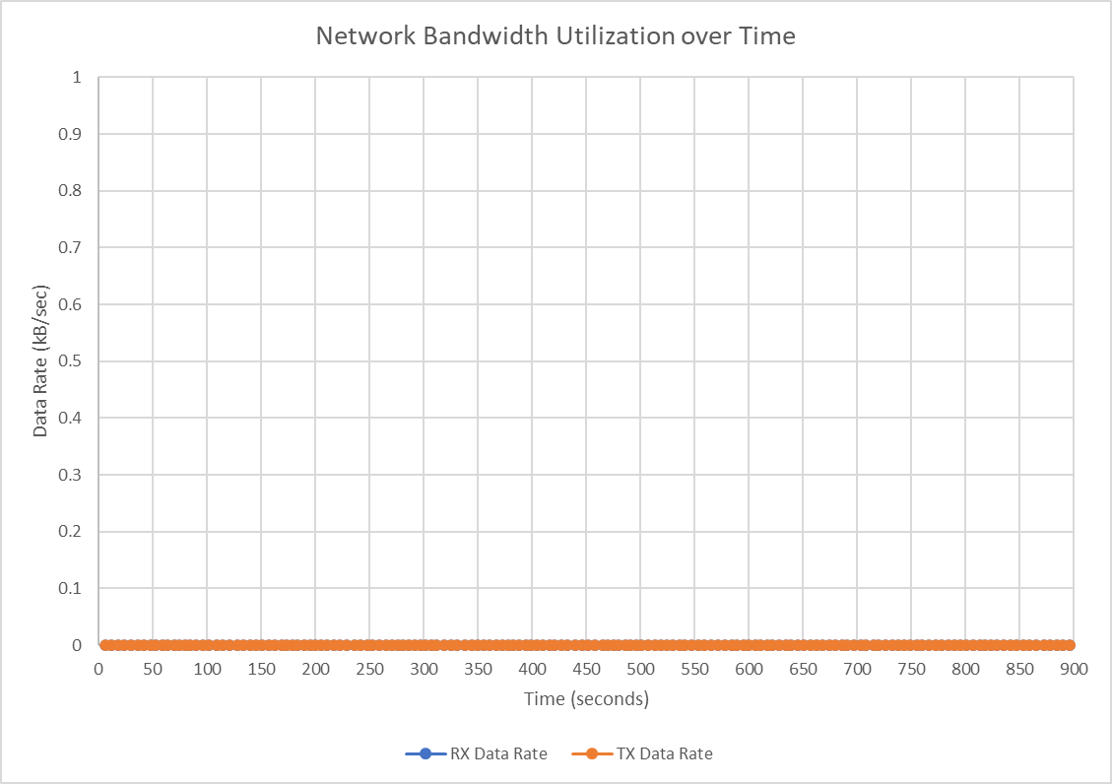

Describe what the network bandwidth utilization plot shows in 2-3 sentences.

**The network bandwidth utilization plot shows that both the network receive and transfer rate are both the same at 0KB/s. This indicates that there is no network activity from the APMs.**

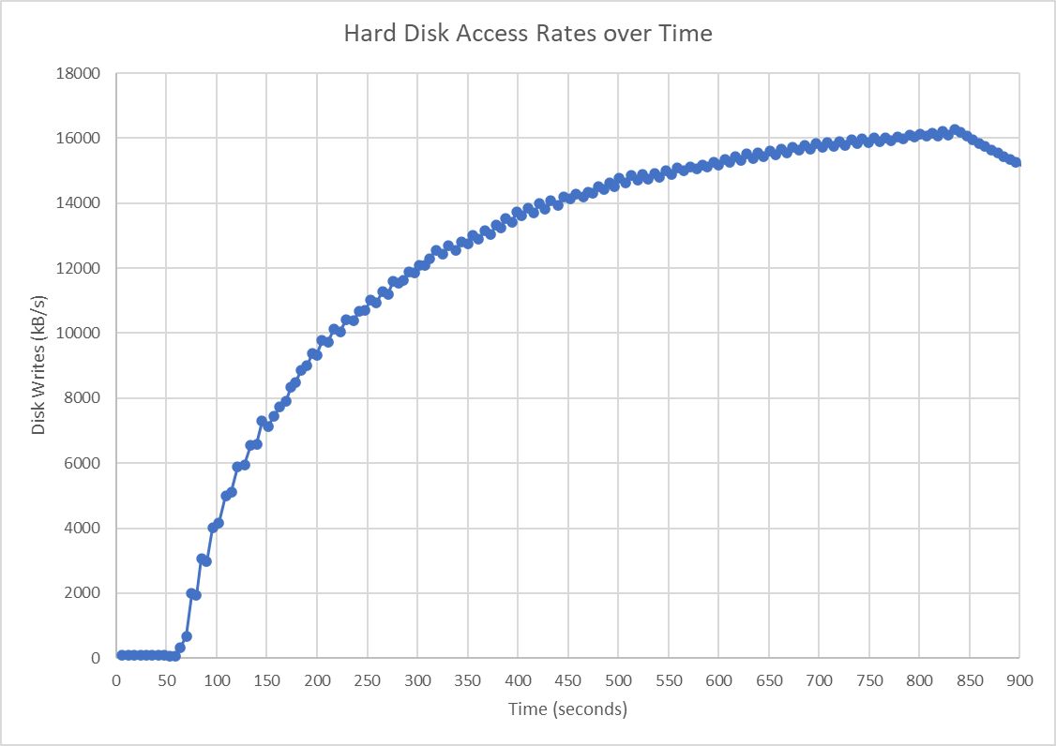

Describe what the hard disk access rates plot shows in 1-2 sentences.

**The hard disk data access rate plot increases logarithmically, staying near 0 KB/s until around 50 seconds in, in which it increases dramatically. Every time the disk usage increases, it also decreases slightly, but still gradually increasing until 850 seconds, when it reaches a peak of around 16000 KB/s and then steadily decreases from there.**

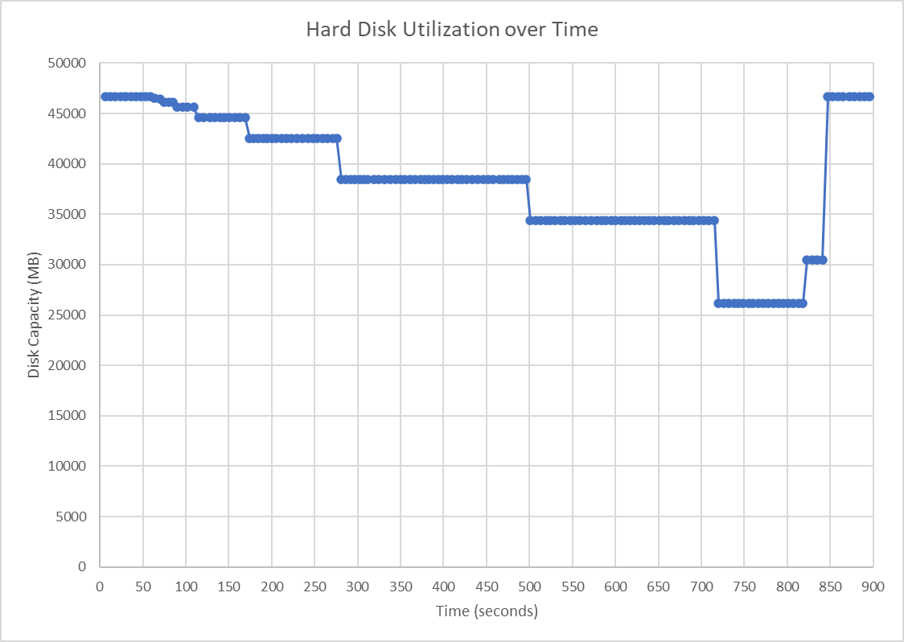

Describe what the hard disk utilization plot shows in 1-2 sentences.

**The hard disk utilization plot shows at the beginning that there is little to no storage being used until around the 50 second mark, when the APMs begin filling the hard disk’s storage. They continue to fill the hard disk, with the lowest disk capacity remaining being at the 700-800 second period at ~26000 MB remaining, after which the APMs begin deleting the data, freeing up the disk capacity until it is at what it was at the beginning, ~46000 MB.**

**Potential things to write about**: How similar (or not) were the transmit and receive data rates? Could you see any patterns in how the data rates changed over time? Were there any interesting patterns in the hard disk access rates or hard disk utilization?

**Summary and Lessons Learned**

Write 3-4 sentences that describes whether or not the VM you used had enough computing resources (CPU, memory, network capacity, and disk) to handle the mix of application processes that were running and what lessons you learned while working as a team on this project.

**Based on the provided data, the VM used had fluctuating CPU utilization for certain processes and varying memory usage for others. However, there was no indication of resource saturation or continuous upward trends for CPU usage that would signify insufficient resources. The memory for APM1-6 remained consistent indicating they were not straining the system. Network capacity and disk also seem adequate for the computer. We believe we did have enough computing resources. Working as a team on this project, we learned the importance of closely monitoring and analyzing system metrics to ensure optimal performance and the value of clear communication and collaboration when interpreting results.**