System Architecture Blueprint, Module Design, and Version Control Overview
A Capstone Project Report of MSIT 5910
MSIT 5910 Capstone Project, Assignment Activity Unit 3
Student: Aya Isbaih
Repository URL: https://github.com/isbaihaya-beep/logistics-workflow-portal/

1. System Architecture Blueprint
The proposed capstone system is a prototype role-based logistics workflow portal designed for three user groups: customers, employees, and managers. The architecture follows a layered design because the project needs a clear separation between the user interface, application logic, and database. This choice supports maintainability and testing because interface changes can be handled separately from workflow rules and stored records. Letaw (2024) explains that requirements guide both what a system must do and how well it should perform, while Walker (2022) notes that architectural patterns help organize software around maintainability, scalability, and flexibility. For this project, a layered architecture is the best fit because the system is small enough for a capstone prototype but still needs clear module boundaries and role-based access control.
The presentation layer includes login screens, order status pages, employee update forms, customer request forms, and manager dashboard views. The application layer will be developed with Python Flask and will handle authentication, role authorization, input validation, workflow status changes, and dashboard calculations. The database layer will use SQLite during the prototype stage. The database will store sample users, role assignments, order records, document readiness status, task assignments, customer requests, delay reasons, and audit fields such as updated date and updated by. No real customer records will be used. This structure keeps the design practical while showing how ethical and security principles can be embedded early in development.
Figure 1. Role-Based Logistics Workflow Portal Architecture
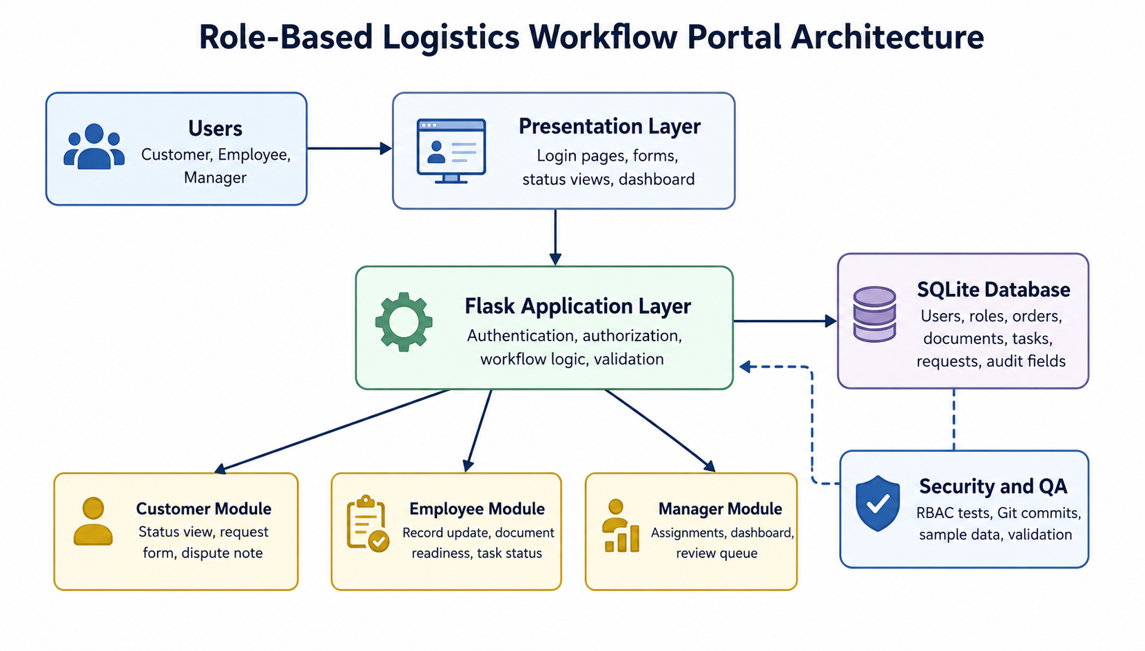

2. Module-Wise Breakdown and Functional Specifications
The authentication and authorization module accepts username and password input, verifies the hashed password, starts a valid session, and checks the user role before allowing access to protected pages. Its output is either a successful role-based redirect or an error message. The method used in this module is session-based authentication with role checks before sensitive actions. This module is important because broken access control is one of the main web application risks identified by OWASP Foundation (2021).
The employee module accepts shipment or order details, document status updates, delay reasons, and task completion entries. Its output is an updated workflow record that can be viewed by authorized users. The method is form-based data entry with validation rules for required fields. The customer module accepts a customer login and customer request or dispute note. Its output is a limited status view showing only that customer’s assigned sample order, document readiness, request history, and clarification status. The customer module will not display employee workload, internal notes, or other customer records.
The manager module accepts task assignments, review decisions, and dashboard filter choices. Its output is a dashboard showing missing documents, delayed records, pending customer requests, open tasks, and records waiting for clarification. This module also supports fairness by showing delay categories instead of only a delayed label. The audit and reporting module records important updates and generates simple dashboard counts from the sample data. The methodology across modules is a basic create, read, update, and review workflow supported by role-based permissions, sample records, and repeatable test cases.

Table 1. Module Functional Specifications
Module | Input | Output | Methodology
Authentication and authorization | Username, password, role | Login result and role-based redirect | Password hashing, sessions, role checks
Customer | Assigned order ID, request note, dispute note | Limited order status and request record | Filtered views, data minimization
Employee | Order update, document status, delay reason | Updated workflow record | Validated forms and required fields
Manager | Assignment action, review decision, dashboard filter | Dashboard indicators and reviewed status | Summary logic, review queue, status categories

3. Functional and Non-Functional Requirements
The main functional requirements are that the system shall allow users to log in by role, employees to create and update sample order records, customers to view only their own sample order status, customers to submit basic requests or dispute notes, managers to assign tasks, managers to review delayed or disputed records, and the dashboard to calculate indicators from sample records. The system shall also block unauthorized access to role-restricted pages and record the last update date for workflow records.
The non-functional requirements shape the design decisions. For security, passwords must not be stored as plain text, protected pages must require login, and role-based access tests must pass before the prototype is considered complete. For usability, each role should complete its main workflow in no more than three basic steps. For reliability, required fields should prevent incomplete records from being saved. For performance, dashboard pages should load within three seconds when using the sample dataset. For scalability, the system should use clear modules and database tables so that future features, such as notifications or document uploads, can be added later. For privacy, the prototype will use only sample or anonymized data and will collect only fields needed for the workflow. These requirements reflect the GDPR principle of data minimization and the NIST Cybersecurity Framework focus on managing cybersecurity risk through planned controls (European Union, 2016; National Institute of Standards and Technology, 2024).

4. Version Control and Collaboration Overview
The project will use a GitHub repository to track code, documentation, diagrams, and progress. The repository will be organized into folders for source code, documentation, design files, test cases, and sample data. The planned folders are src for Flask code, docs for proposal and report materials, design for diagrams and database design, tests for role-based testing notes, data for sample records, and screenshots for implementation evidence. The repository URL will be added after the GitHub repository is created and shared with appropriate viewing permissions.
The branching approach will use main and development branches. The main branch will hold stable files that are ready to submit or demonstrate. The development branch will be used for active coding, documentation updates, database changes, and design revisions. Small feature branches may be added if needed, such as feature-login, feature-dashboard, or docs-report-update, but the required demonstration will show at least main and development. Clear commit messages will describe each update, such as add login route and password hashing, create initial database schema, add customer status page, update architecture diagram, or add role permission test cases.
Version control supports traceability because each meaningful change has a date, message, and file history. Davies (2024) explains that Git allows developers to review status, compare versions, examine logs, and return to earlier versions when needed. In this capstone project, that matters because security-related changes, such as role checks and login logic, should not be hidden or undocumented. Git also improves documentation consistency because design diagrams, reports, test notes, and code can be updated together. Even though this is an individual project, using Git demonstrates professional development practice, supports quality assurance, and creates evidence of steady progress.

References
Al Tera, A., Sari, K., & Khudair, H. Y. (2024). Supply chain digitalization and performance: A moderated mediation model. Heliyon, 10(3), Article e25570. https://doi.org/10.1016/j.heliyon.2024.e25570
Davies, S. (2024). Blueprints: Creating, describing, and implementing designs for larger-scale software projects (Version 2.5). University of Mary Washington. https://open.umn.edu/opentextbooks/textbooks/blueprints-creating-describing-and-implementing-designs-for-larger-scale-software-projects-davis
Delgado, F., Garrido, S., & Bezerra, B. S. (2025). Barriers to visibility in supply chains: Challenges and opportunities of artificial intelligence driven by Industry 4.0 technologies. Sustainability, 17(7), Article 2998. https://doi.org/10.3390/su17072998
European Union. (2016). General Data Protection Regulation, Article 5: Principles relating to processing of personal data. https://gdpr-info.eu/art-5-gdpr/
Joint Task Force. (2020). Security and privacy controls for information systems and organizations (NIST Special Publication No. 800-53 Rev. 5). National Institute of Standards and Technology. https://doi.org/10.6028/NIST.SP.800-53r5
Letaw, L. (2024). Handbook of software engineering methods. Oregon State University. https://open.oregonstate.education/setextbook/
National Institute of Standards and Technology. (2024). The NIST cybersecurity framework 2.0. https://doi.org/10.6028/NIST.CSWP.29
OWASP Foundation. (2021). OWASP Top 10:2021. https://owasp.org/Top10/2021/
OWASP Foundation. (2025). OWASP application security verification standard 5.0.0. https://owasp.org/www-project-application-security-verification-standard/
Summers, B. L. (2020). Effective methods for software engineering. Auerbach Publishers, Incorporated.
Walker, V. (2022, March 16). 14 software architecture design patterns to know. Red Hat. https://www.redhat.com/en/blog/14-software-architecture-patterns

