Insert your name, centre number and candidate number into the header above.
Save this evidence document as evidence_ followed by your centre number_ candidate number. For example: evidence_ zz999_9999.doc
Screenshots or program listings must be copied into appropriate cells in the following tables.
Examiners must be able to read the contents including any screenshots without the use of a magnifying glass. Answers that are not readable or missing will not be awarded any marks.
Save this evidence document at regular intervals, for example every 10 minutes.
Question 1
Part 1(a)(i)
{Copy and paste program code listing for question 1(a)(i) here}

class Bird:
def __init__(self, distanceP, speciesP):
self.__DistancePerHour = distanceP # DistancePerHour as Real
self.__Species = speciesP # Species as String
self.__XPosition = 500.0 # XPosition as Real
self.__YPosition = 500.0 # YPosition as Real

Part 1(a)(ii)
{Copy and paste program code listing for question 1(a)(ii) here}

def GetSpecies(self):
return self.__Species

Part 1(a)(iii)
{Copy and paste program code listing for question 1(a)(iii) here}

def GetPosition(self):
output = "X = " + str(self.__XPosition) + " " + "Y = " + str(self.__YPosition)
return output

Part 1(a)(iv)
{Copy and paste program code listing for question 1(a)(iv) here}

def Move(self, directionP, minutesP):
distanceTravelled = self.__DistancePerHour / 60 * minutesP
if directionP == "N":
self.__YPosition += distanceTravelled
elif directionP == "S":
self.__YPosition -= distanceTravelled
elif directionP == "E":
self.__XPosition += distanceTravelled
else:
self.__XPosition -= distanceTravelled

Part 1(b)
{Copy and paste program code listing for question 1(b) here}

# main program
bird1 = Bird(71.0, "Cockatiel")
bird2 = Bird(56.0, "Macaw")

Part 1(c)(i)
{Copy and paste program code listing for question 1(c)(i) here}

print(f"{bird1.GetSpecies()}: {bird1.GetPosition()}")
print(f"{bird2.GetSpecies()}: {bird2.GetPosition()}")
choice = input("Which one would you choose: Cockatiel or Macaw? ")
while choice != "Cockatiel" and choice != "Macaw":
choice = input("Which one would you choose: Cockatiel or Macaw? ")
direction = input("Which direction would you choose? ")
while direction != "N" and direction != "S" and direction != "E" and direction != "W":
direction = input("Which direction would you choose? ")
time = int(input("Please enter the time, in minutes "))
while time <= 0 or type(time) != int :
time = input("Please enter the time, in minutes ")
if choice == "Cockatiel":
bird1.Move(direction, time)
print(f" Updated: {bird1.GetSpecies()}: {bird1.GetPosition()}")
else:
bird2.Move(direction, time)
print(f" Updated: {bird2.GetSpecies()}: {bird2.GetPosition()}")

Part 1(c)(ii)
{Copy and paste screenshot(s) for question 1(c)(ii) here}

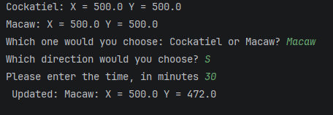

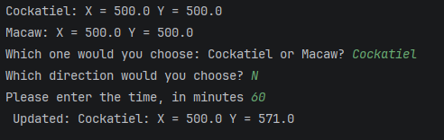

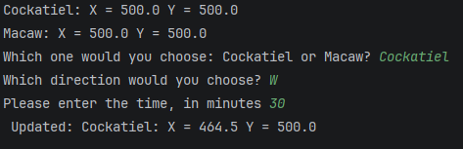

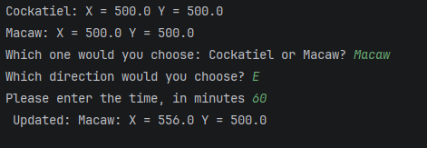

Question 2
Part 2(a)
{Copy and paste program code listing for question 2(a) here}

# main program
arr = []
for i in range(20):
num = random.randint(0,100)
while num in arr:
num = random.randint(0,100)
arr.append(num)

Part 2(b)
{Copy and paste program code listing for question 2(b) here}

def PrintArray(arrP):
output = ""
for num in arrP:
output += str(num) + " "
print(output)

Part 2(c)
{Copy and paste program code listing for question 2(c) here}

def BubbleSort(arrP):
array = arrP
length = len(array)
for i in range(length):
swapped = False
for j in range(length-i-1):
if array[j] > array[j+1]:
temp = array[j]
array[j] = array[j+1]
array[j+1] = temp
swapped = True
if not swapped:
break
return array

Part 2(d)(i)
{Copy and paste program code listing for question 2(d)(i) here}

PrintArray(arr)
print("Sorted")
PrintArray(BubbleSort(arr))

Part 2(d)(ii)
{Copy and paste screenshot(s) for question 2(d)(ii) here}

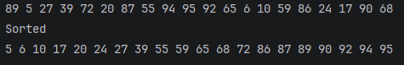

Part 2(e)
{Copy and paste program code listing for question 2(e) here}

def RecursiveBinarySearch(arrP, lowerP, upperP, toFind):
low = lowerP
high = upperP
if low <= high:
arrP[mid] = (low+high)//2
if mid == toFind:
return mid
elif arrP[mid] > toFind:
return RecursiveBinarySearch(arrP, low, mid - 1, toFind)
else:
return RecursiveBinarySearch(arrP, mid + 1, high, toFind)
else:
return -1

Part 2(f)(i)
{Copy and paste program code listing for question 2(f)(i) here}

PrintArray(arr)
print("Sorted")
arr = BubbleSort(arr)
PrintArray(arr)
n = int(input("Enter an integer: "))
returnValue = RecursiveBinarySearch(arr, 0, 19, n)
if returnValue == -1:
print("Not found")
else:
print("Found at position", returnValue)

Part 2(f)(ii)
{Copy and paste screenshot(s) for question 2(f)(ii) here}

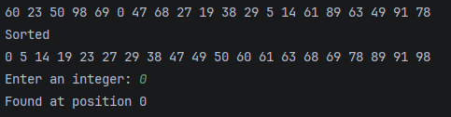

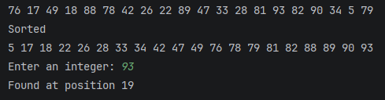

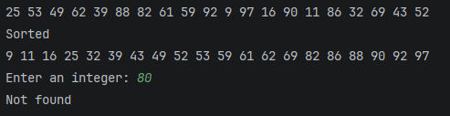

Question 3
Part 3(a)
{Copy and paste program code listing for question 3(a) here}

Part 3(b)
{Copy and paste program code listing for question 3(b) here}

Part 3(c)
{Copy and paste program code listing for question 3(c) here}

Part 3(d)
{Copy and paste program code listing for question 3(d) here}

Part 3(e)(i)
{Copy and paste program code listing for question 3(e)(i) here}

Part 3(e)(ii)
{Copy and paste screenshot(s) for question 3(e)(ii) here}

