Insert your name, centre number and candidate number into the header above.
Save this evidence document as evidence_ followed by your centre number_ candidate number. For example: evidence_ zz999_9999.doc
Screenshots or program listings must be copied into appropriate cells in the following tables.
Examiners must be able to read the contents including any screenshots without the use of a magnifying glass. Answers that are not readable or missing will not be awarded any marks.
Save this evidence document at regular intervals, for example, every 10 minutes.
Question 1
Part 1(a)
{Copy and paste program code listing for question 1(a) here}

def ReadData():
arr = [] # local
try:
f = open("Data.txt", "r")
for line in f:
arr.append(line.strip())
f.close()
return arr
except FileNotFoundError:
print("File not found")

Part 1(b)(i)
{Copy and paste program code listing for question 1(b)(i) here}

def FormatArray(arrP):
returnString = ""
for item in arrP:
returnString += item + " "
return returnString

Part 1(b)(ii)
{Copy and paste program code listing for question 1(b)(ii) here}

# main program
print(FormatArray(ReadData()))

Part 1(b)(iii)
{Copy and paste the screenshot for question 1(b)(iii) here}

Part 1(c)
{Copy and paste program code listing for question 1(c) here}

def CompareStrings(str1, str2):
i = 0
current1 = str1[i]
current2 = str2[i]
while current1 == current2:
i += 1
current1 = str1[i]
current2 = str2[i]
if current1 > current2:
return 2
else:
return 1

Part 1(d)(i)
{Copy and paste program code listing for question 1(d)(i) here}

def Bubble(arrP):
for i in range(0, len(arrP)-1):
for j in range(0, len(arrP)-1):
status = CompareStrings(arrP[j], arrP[j+1])
if status == 2:
temp = arrP[j]
arrP[j] = arrP[j+1]
arrP[j+1] = temp
return arrP

Part 1(d)(ii)
{Copy and paste program code listing for question 1(d)(ii) here}

print(FormatArray(Bubble(ReadData())))

Part 1(d)(iii)
{Copy and paste the screenshot for question 1(d)(iii) here}

Question 2
Part 2(a)(i)
{Copy and paste program code listing for question 2(a)(i) here}

class Horse:
def __init__(self, nameP, heightP, successP):
self.__Name = nameP # Name as String
self.__MaxFenceHeight = heightP # MaxFenceHeight as Integer
self.__PercentageSuccess = successP # PercentageSuccess as Integer

Part 2(a)(ii)
{Copy and paste program code listing for question 2(a)(ii) here}

def GetName(self):
return self.__Name
def GetMaxFenceHeight(self):
return self.__MaxFenceHeight

Part 2(b)(i)
{Copy and paste program code listing for question 2(b)(i) here}

# main program
Horses = []
Horses.append(Horse("Beauty", 150, 72))
Horses.append(Horse("Jet", 160, 65))
print(Horses[0].GetName())
print(Horses[1].GetName())

Part 2(b)(ii)
{Copy and paste the screenshot for question 2(b)(ii) here}

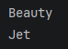

Part 2(c)(i)
{Copy and paste program code listing for question 2(c)(i) here}

class Fence:
def __init__(self, heightP, riskP):
self.__Height = heightP # Height as Integer
self.__Risk = riskP # Risk as Integer
def GetHeight(self):
return self.__Height
def GetRisk(self):
return self.__Risk

Part 2(c)(ii)
{Copy and paste program code listing for question 2(c)(ii) here}

Course = []
for i in range(4):
height = int(input(f"Pleas enter the height of the fence {i+1}: "))
while height <70 or height>180:
height = input(f"Pleas enter the height of the fence {i+1}: ")
risk = int(input(f"Pleas enter the risk of the fence {i+1}: "))
while risk<1 or risk>5:
risk1 = int(input(f"Pleas enter the risk of the fence {i+1}: "))
Course.append(Fence(height, risk))

Part 2(d)
{Copy and paste program code listing for question 2(d) here}

def Success(self, heightF, riskF):
PercentageChance = 0
if heightF > self.__MaxFenceHeight:
PercentageChance = 0.20*self.__PercentageSuccess
else:
if riskF == 1:
PercentageChance = self.__PercentageSuccess
elif riskF == 2:
PercentageChance = 0.9*self.__PercentageSuccess
elif riskF == 3:
PercentageChance = 0.8*self.__PercentageSuccess
elif riskF == 4:
PercentageChance = 0.7*self.__PercentageSuccess
else:
PercentageChance = 0.6*self.__PercentageSuccess
return PercentageChance

Part 2(e)(i)
{Copy and paste program code listing for question 2(e)(i) here}

for j in range(4):
horse1 = f"The horse {Horses[0].GetName()} at fence {j+1} has a {Horses[0].Success(Course[j].GetHeight(), Course[j].GetRisk())} % chance of success"
print(horse1)
for k in range(4):
horse2 = f"The horse {Horses[1].GetName()} at fence {k+1} has a {Horses[1].Success(Course[k].GetHeight(), Course[k].GetRisk())} % chance of success"
print(horse2)

Part 2(e)(ii)
{Copy and paste program code listing for question 2(e)(ii) here}

total1 = 0
for _ in range(4):
total1 += (Horses[0].Success(Course[_].GetHeight(), Course[_].GetRisk()))
average1 = total1/4
print(f"The horse {Horses[0].GetName()} has an average {average1} chance of jumping over all four fences")
total2 = 0
for l in range(4):
total2 += (Horses[1].Success(Course[l].GetHeight(), Course[l].GetRisk()))
average2 = total2/4
print(f"The horse {Horses[1].GetName()} has an average {average2} chance of jumping over all four fences")
if average1>average2:
print(f"The {Horses[0].GetName()} has the highest average chance of success")
else:
print(f"The {Horses[1].GetName()} has the highest average chance of success")

Part 2(e)(iii)
{Copy and paste the screenshot for question 2(e)(iii) here}

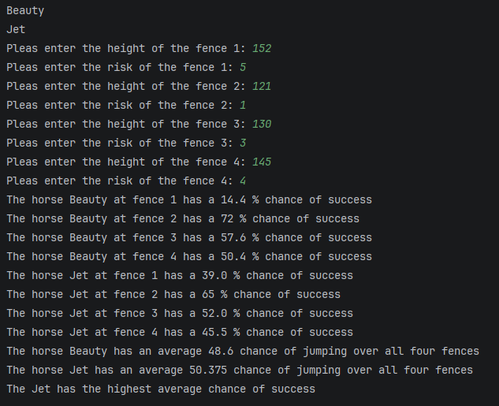

Question 3
Part 3(a)
{Copy and paste program code listing for question 3(a) here}

Part 3(b)
{Copy and paste program code listing for question 3(b) here}

Part 3(c)(i)
{Copy and paste program code listing for question 3(c)(i) here}

Part 3(c)(ii)
{Copy and paste program code listing for question 3(c)(ii) here}

Part 3(c)(iii)
{Copy and paste the screenshot for question 3(c)(iii) here}

Part 3(d)(i)
{Copy and paste program code listing for question 3(d)(i) here}

Part 3(d)(ii)
{Copy and paste program code listing for question 3(d)(ii) here}

Part 3(d)(iii)
{Copy and paste the screenshot(s) for question 3(d)(iii) here}

