Insert your name, centre number and candidate number into the header above.
Save this evidence document as evidence_ followed by your centre number_ candidate number. For example: evidence_ zz999_9999.doc
Screenshots or program listings must be copied into appropriate cells in the following tables.
Examiners must be able to read the contents including any screenshots without the use of a magnifying glass. Answers that are not readable or missing will not be awarded any marks.
Save this evidence document at regular intervals, for example, every 10 minutes.
Question 1
Part 1(a)
{Copy and paste program code listing for question 1(a) here}

WordArray = [] # global array of string
NumberWords = 0 # global
def ReadWords(filenameP):
global WordArray, NumberWords
try:
f = open(filenameP, "r")
for line in f:
WordArray.append(line.strip())
NumberWords += 1
except FileNotFoundError:
print("File not found")
NumberWords -= 1
Play()

Part 1(b)
{Copy and paste program code listing for question 1(b) here}

# main program
level = input("easy, medium or hard? ")
if level == "easy":
ReadWords("Easy.txt")
elif level == "medium":
ReadWords("Medium.txt")
else:
ReadWords("Hard.txt")

Part 1(c)(i)
{Copy and paste program code listing for question 1(c)(i) here}

def Play():
global WordArray, NumberWords
print(WordArray[0], NumberWords)
word = input("Enter a word: ")
counter = 0
while word != "no":
flag = False
for i in range(len(WordArray)):
if word == WordArray[i]:
counter += 1
WordArray[i] = None
flag = True
break
if flag:
print("Answer")
else:
print("Not an answer")
word = input("Enter a word: ")

Part 1(c)(ii)
{Copy and paste program code listing for question 1(c)(ii) here}

print(counter/(len(WordArray)-1)*100)
for i in range(len(WordArray)):
if WordArray[i] != None:
print(WordArray[i])

Part 1(d)(i)
{Copy and paste program code listing for question 1(d)(i) here}

Play()

Part 1(d)(ii)
{Copy and paste screenshot for question 1(d)(ii) here}

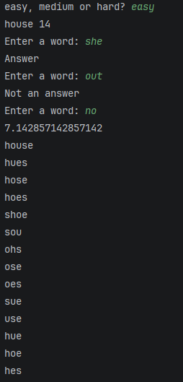

Part 1(d)(iii)
{Copy and paste screenshot for question 1(d)(iii) here}

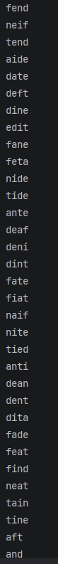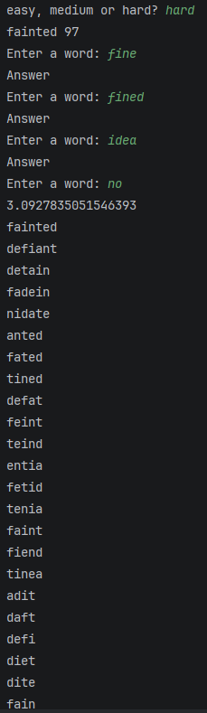

Question 2
Part 2(a)(i)
{Copy and paste program code listing for question 2(a)(i) here}

Part 2(a)(ii)
{Copy and paste program code listing for question 2(a)(ii) here}

Part 2(a)(iii)
{Copy and paste program code listing for question 2(a)(iii) here}

Part 2(b)(i)
{Copy and paste program code listing for question 2(b)(i) here}

Part 2(b)(ii)
{Copy and paste program code listing for question 2(b)(ii) here}

Part 2(b)(iii)
{Copy and paste program code listing for question 2(b)(iii) here}

Part 2(c)(i)
{Copy and paste program code listing for question 2(c)(i) here}

Part 2(c)(ii)
{Copy and paste program code listing for question 2(c)(ii) here}

Part 2(c)(iii)
{Copy and paste screenshot for question 2(c)(iii) here}

Question 3
Part 3(a)
{Copy and paste program code listing for question 3(a) here}

Part 3(b)(i)
{Copy and paste program code listing for question 3(b)(i) here}

Part 3(b)(ii)
{Copy and paste program code listing for question 3(b)(ii) here}

Part 3(b)(iii)
{Copy and paste screenshot for question 3(b)(iii) here}

Part 3(c)(i)
{Copy and paste program code listing for question 3(c)(i) here}

Part 3(c)(ii)
{Copy and paste program code listing for question 3(c)(ii) here}

Part 3(c)(iii)
{Copy and paste screenshot for question 3(c)(iii) here}

Part 3(d)(i)
{Copy and paste program code listing for question 3(d)(i) here}

Part 3(d)(ii)
{Copy and paste program code listing for question 3(d)(ii) here}

Part 3(d)(iii)
{Copy and paste screenshot for question 3(d)(iii) here}

