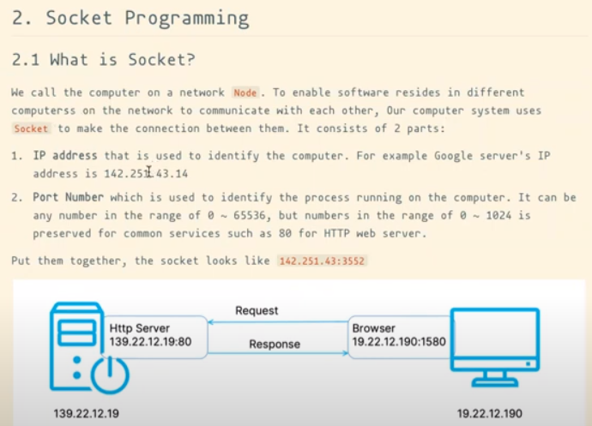

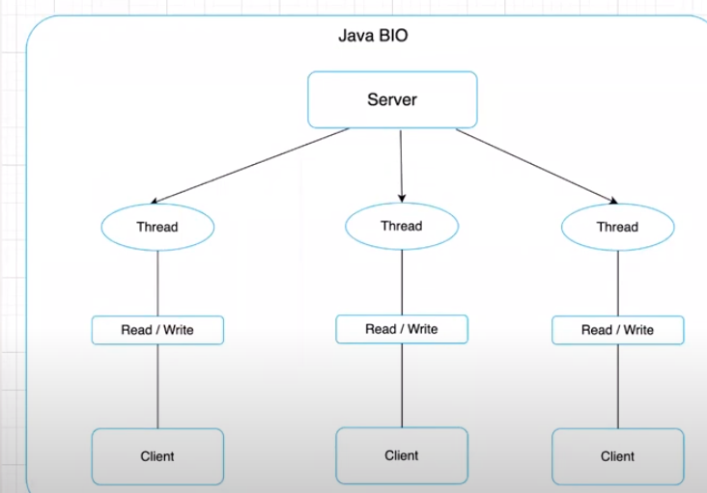

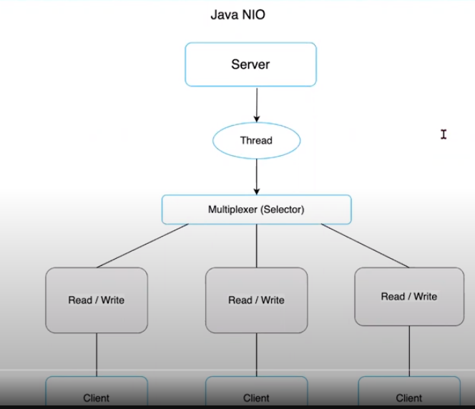

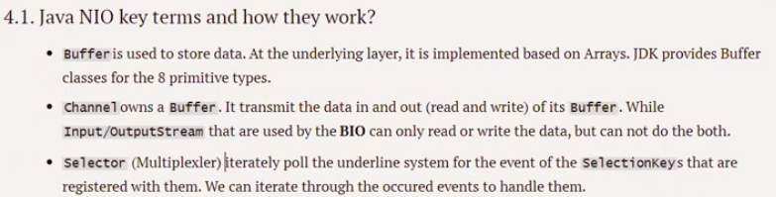

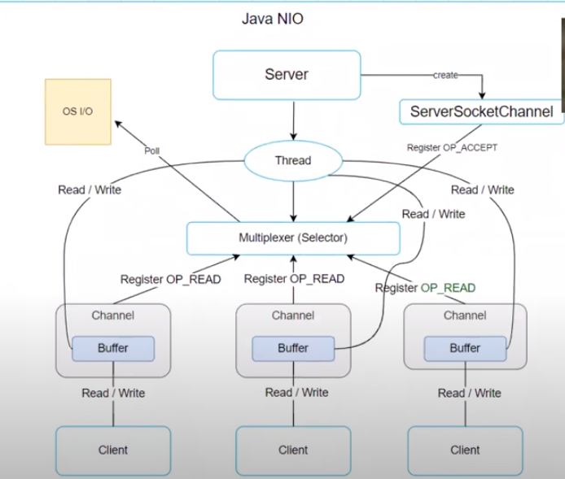

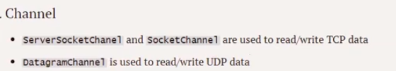

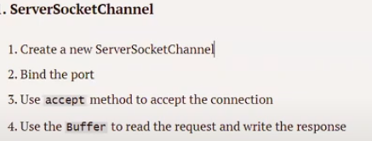

Selector:

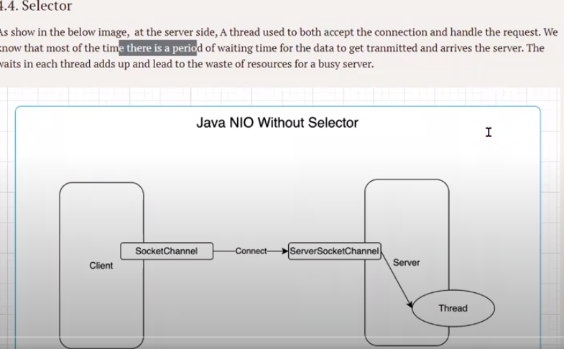

W/O selector once Servers sends response to client , it has to wait for until it receive next request from the client. A thread in the server has to accept and handle the request both.

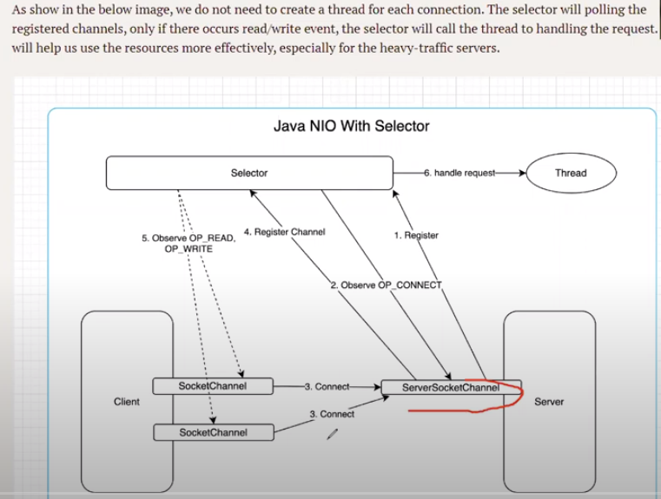

1. The server starts the ServerSocketChannel and register with Selector (Multiplexer)
2. Selector observes the OP_CONNECT
3. After SocketChannel connects with ServerSocketChannel, register the Channel with the Selector
4. After Channels gets registered, operation OP_READ , OP_WRITE are observed by Selector
5. Instead of using ONE thread for each connection , we use ONE thread for ALL the connection.

Selector.select() - Selects a set of keys whose corresponding channels are ready for I/O operations.