Report: Introduction to PyTorch
Computer Vision
Assignment 1

Ian SCHOLL

ischoll@student.ethz.ch

2 Simple 2D classifier (50 pts.)

2.1 Dataset (10 pts.)
My constructor uses the split input to accordingly load the corresponding .npz file in the ‘data’ folder. The ‘samples’ column with 1x2 vectors with the sample coordinates then gets saved into self.samples, and the ‘annotations’ column with the corresponding cluster labeling of each sample gets saved into self.annotations:
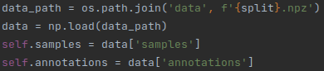

My __getitem__ method then simply goes and takes the sample coordinates and according label at index idx out of the variables created in the constructor:
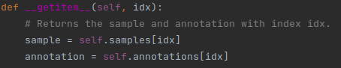

2.2 Linear classifier (10 pts.)
A single line is enough to define the linear layer taking the 1x2 coordinates as input and computing a single value as output:
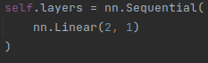

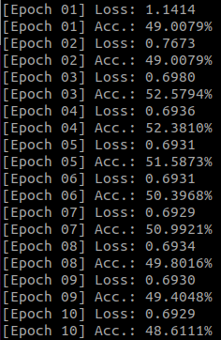
2.3 Training loop (15 pts.)
Once the training loop is implemented as instructed in the run_training_epoch function, the model can be trained and put to the test for the first time, revealing the following results on the figure on the right:

We can observe that the predictions and therefore the accuracy of the model don’t improve over the epochs, and that the accuracy always lies somewhere around 50% (even when using significantly more epochs). This is indeed an expected result, as trying to approximate a radially distributed and divided cluster linearly is nearly impossible. This is illustrated in the following:
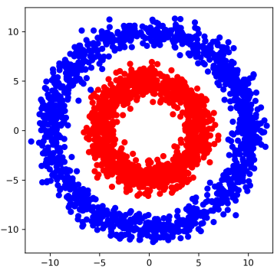

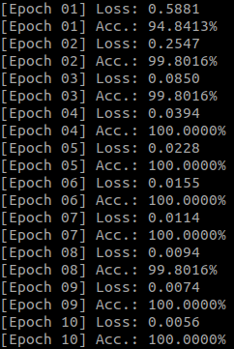
Using solely a linear layer can be visualized with the model trying to fit a straight line as the exemplary ones in green in the depiction above, in order to divide the red cluster from the blue one. However, this will obviously always fail. On average, about half of both the training and validation samples for both clusters will end up on either side of the ‘division line’, which is why we observe an accuracy of around 50% for all epochs.

2.4 Multi-layer perceptron (10 pts.)
The multi-layer classifier shows a lot better results. We can observe accuracies of even 99.8 - 100% over almost all epochs, and losses are divided by a factor of 100 as shown in the figure on the right:

Now, apart from using more linear layers, the main difference is the introduction of ReLU non-linearities into the network. This will immediately allow for the model to tune more parameters to accurately attribute some new point to one of the clusters, as well as find a distinction that might not be a straight line anymore. Much rather, the delimitation found between the two clusters is now more ‘flexible’ and could be ideally visualized as the green line below:

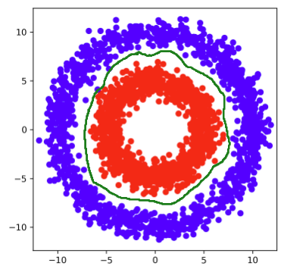

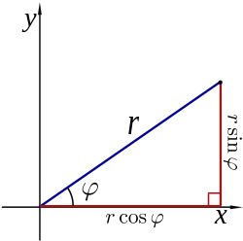source: https://en.wikipedia.org/wiki/Polar_coordinate_system

2.5 Feature transform (5 pts.)
Inspired by the ideal delimitation of subchapter 2.4, one can immediately think of a different coordinate system, which are 2D polar coordinates as shown on the right:

Now, a sample point has coordinates given as a pair:
(r, φ)
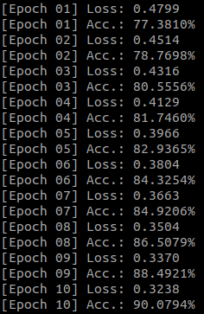
Therefore, drawing a ‘straight’ line through all points with a certain coordinate r (of roughly 7 in our example) – which will translate to a circle of radius r in our original x-y coordinate system - should allow the model to again delimit the clusters as in the figure on the left:

Therefore, using a single linear layer now allows the model to make good predictions and achieve high accuracies of over 90% as can be seen in the results on the right:
r
If we use more epochs than just 10, we can even get the accuracy close to 100%. This is a clear improvement w.r.t. the single linear layer used on the x-y coordinates in 2.3 (cost also divided by 2), and the evolution over the epochs shows how the model actually gets optimized step by step and is not making predictions of pure ‘50-50-chance’ anymore.

3 Digit classifier (50 pts.)

3.1 Data normalization (5 pts.)
A simple mathematical calculation allows to project values in the range {0,255} to values in the range [-1, 1]:
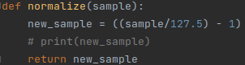

3.2 Training loop (5 pts.)
I followed the same steps as in subchapter 2.3, however this time I used the cross entropy loss as instructed:

3.3 Multi-layer perceptron (10 pts.)
Using just a single linear layer in order to implement a linear classifier, the nn.Sequential looks as follows:
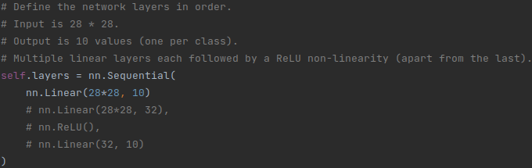
This gives me the following results:
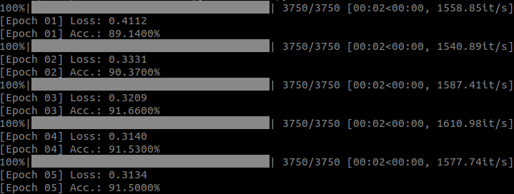
This is not a bad start, but definitely not yet fully satisfying, as we would like an accuracy closer to 100%.

Now I will use a nn.Sequential as instructed with 1 hidden layer of dimension 32 with ReLU and a final linear prediction layer:
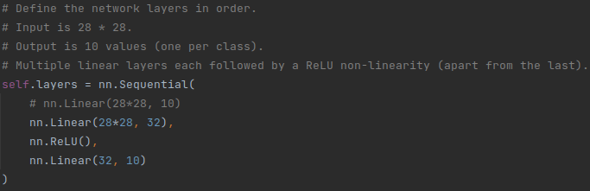
Using several layers and non-linearities again clearly improves the results, the accuracy approaches the 100% more and losses are halved:
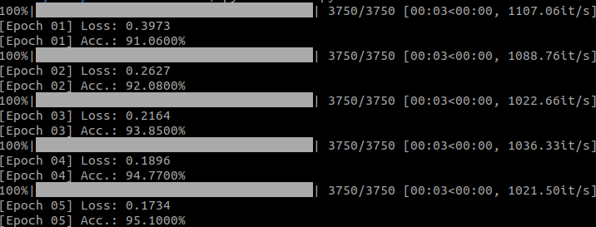
This is both what we hoped for and expected. Introducing more layers on one hand raises the number of parameters that can be tuned in order to improve the model quickly and effectively. Introducing non-linearities through ReLU on the other hand also makes the model less ‘stiff’, as it does not have to completely stick to the limiting idea of full linearity anymore.

3.4 Convolutional network (10 pts.)
The convolutional network takes on a slightly more complicated form and can be seen in my implementation in the nn.Sequential as follows:
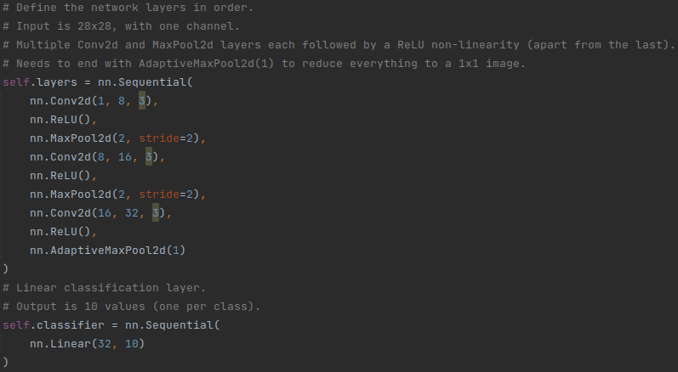
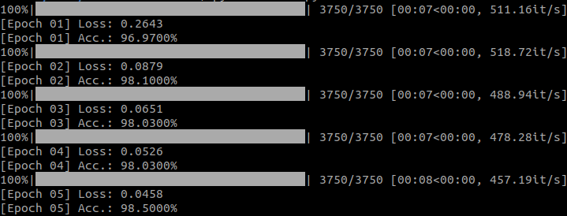
The accuracy that I obtain with this model is even better, which can be seen in the results:
This means, using a full convolutional network instead of a Multi-Layer Perceptron can raise the accuracies and decrease the losses even more, as this should be a more suited technique especially for learning on images than using just linear layers and ReLU.

3.5 Comparison of number of parameters (10 pts.)
(The formulas used in this subchapter have been taken from the following source (20.10.2021): https://learnopencv.com/number-of-parameters-and-tensor-sizes-in-convolutional-neural-network/)
It can first be stated that ReLU(), AdaptiveMaxPool2D() and MaxPool2D() have no parameters associated with them, if anything they only use hyperparameters.
MLP
The number of parameters for the MLP can be computed using the following formulas:
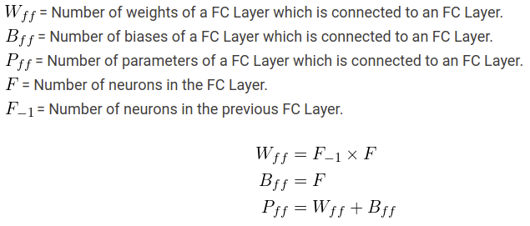
Hidden Layer: W_ff = 784 * 32 = 25088; B_ff = 32; → P_ff = 25088 + 32 = 25120

Final Layer: W_ff = 32 * 10 = 320; B_ff = 10; → P_ff = 320 + 10 = 330

Total number of Parameters: P_tot = 25120 + 330 = 25450

This can be back-checked with some lines of code, which indeed reveals the same number of parameters (multiplying all shown array sizes and adding them up):
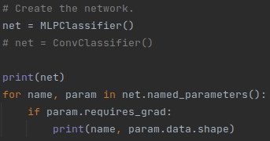
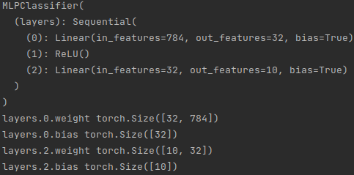

CNN
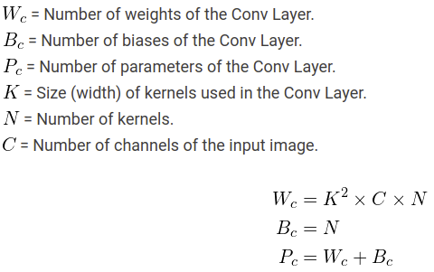

Convolutional Layer 1 (2D Convolution): W_c = 3² * 1 * 8 = 72; B_c = 8; → P_c = 80

Convolutional Layer 2 (2D Convolution): W_c = 3² * 8 * 16 = 1152; B_c = 16; → P_c = 1168

Convolutional Layer 3 (2D Convolution): W_c = 3² * 16 * 32 = 4608; B_c = 32; → P_c = 4640

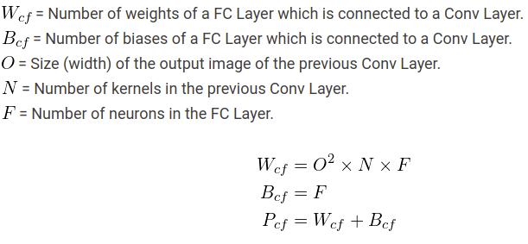

Final Classifier Layer (Linear): W_cf = 1² * 32 * 10 = 320; B_cf = 10; → P_cf = 320 + 10 = 330

Total number of Parameters: P_tot = 80 + 1168 + 4640 + 330 = 6218

Again, this can be back-checked with some small code, which reveals the same number of total parameters (multiplying all shown array sizes and adding them up):
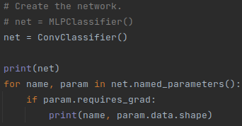

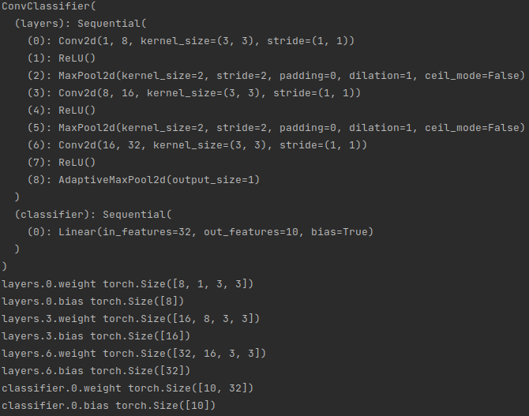
Conclusion: Therefore, we see that using a neural network with convolutions doesn’t only improve our model and predictions, but it at the same time also decreases the number of parameters to be calculated and stored. Therefore we get better performance for less memory use, showing the power of convolutional neural networks!

3.6 Confusion matrix (10 pts.)
Some code of the run_validation_epoch function combined with new lines of code can be used to calculate the confusion matrix’ elements as follows:
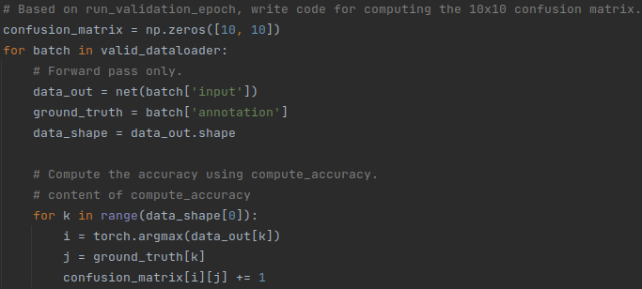
After implementing the suggested code change on Moodle (L61 to plt.text(i, j, '%d' % (confusion_matrix[j, i]), ha='center', va='center', color='w', fontsize=12.5); https://moodle-app2.let.ethz.ch/mod/forum/discuss.php?d=87233#p186459), running this code can be used to compute the final confusion matrix.
In the case of the MLP the confusion matrix looks as follows:
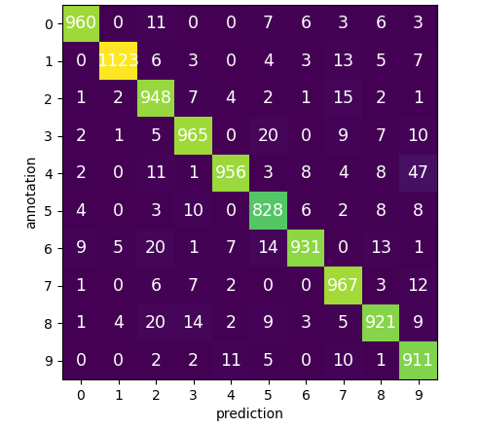

Indeed we can observe an almost diagonal matrix, with a few outliers in the non-diagonal elements, where the highest wrong-prediction number reaches 47 (a number 4 predicted as a number 9, which is understandable as handwritten they look rather similar). This shows that the model’s predictions are very good and also visually tells us, that the accuracy indeed must be rather close to 100%.

In the case of the Convolutional Network the confusion matrix looks as follows:
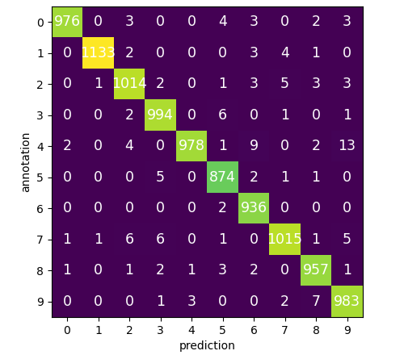

Again we can observe this time an almost perfectly diagonal matrix with many 0-elements and a few outliers in the non-diagonal elements, where the highest wrong-prediction number now reaches only 13 (again the case of a number 4 predicted as a number 9, which is understandable as handwritten they look rather similar). This shows that the model’s predictions are very good and also visually tells us, that the accuracy indeed now must be very close to 100% indeed.

