Report: Image Segmentation
Computer Vision - Assignment 2

Ian SCHOLL (ischoll@student.ethz.ch)

Mean-Shift Algorithm (Total: 40 pts)

Implement the distance Function (12 pts)
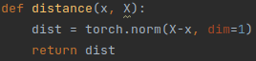
The distance function I implemented first calculates the difference between the sample point x and all other sample points (including itself, radius = +∞) in X in a vectorized manner. Afterwards, I calculate the norm of each of these difference vectors again in a vectorized manner, as looping through each row of X to compute the norms is computationally way too expensive and slow. This results in a vector dist, with the euclidean distances between the sample point and each of the other pixels in the CIELAB space for the scaled image:

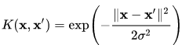

Implement the gaussian Function (12 pts)
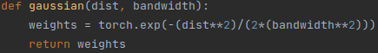
We can now use the obtained dist vector to compute the width using a Gaussian kernel as for example noted in https://en.wikipedia.org/wiki/Mean_shift (01.11.2021).
This results in the following – again vectorized - calculation, giving the vector weights as output:

Implement the update point Function (11 pts)
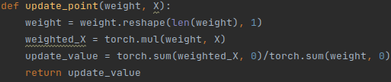
The weight vector first has to be reshaped vertical, to then multiply element-wise with the rows of X, in order to obtain a ‘weighted X’. The value can then be updated with the total-weight-normalized sum of the rows (pixels) of this ‘weighted X’:


Accelerating the Naive Implementation (5 pts)
Running this setup with the given for-loop-based meanshift_step on the CPU of my laptop results in the expected output which looks exactly like the provided ‘sample-result.png’, however the run-time necessary is around 45 seconds:

To make everything more efficient, the data can also be processed as batches. In that case, slightly adapted methods distance_batch, update_point_batch and meanshift_step_batch are used as seen below. Instead of calculating everything point by point, I use torch’s method cdist in distance_batch and matrix multiplication to replace element-wise multiplication in the update_point_batch, in order to process several points at the same time. Finally, I divide the matrix X into batches with batch_size rows in the meanshift_step_batch method. Each batch then runs through the series distance_batch-gaussian-update_point_batch and updates a part of the rows of the original X. After all batches have been looped through, a complete updated X is ready for the next epoch. I have found some of the best results with a batch_size of 55. When now running this new approach on the same CPU of the same laptop, the expected output still looks the exact same, but the run-time has significantly reduced to just below 1sec:

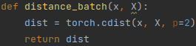
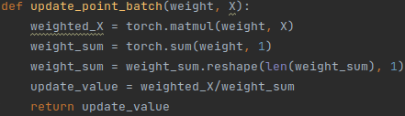
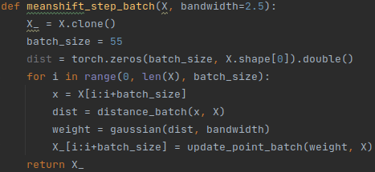

Therefore, we can observe that batchifying the input can help to reduce the run-time by a factor of ~50 in my case. This shows that a fine-tuned approach, where we process a reasonable amount of data simultaneously, very often can be worth it in order to complete a task more efficiently.

