LOREON: An Open-Source, Cross-Platform Pipeline for Accessible Long-Read ONT Metabarcoding and Metagenomics in Standard Laboratory Settings
Roberto Scarponi¹, Angela Conti^{1,*}, Gianluigi Cardinali^{1,*}
¹ Department of Pharmaceutical Sciences, University of Perugia, 06123 Perugia, Italy
* Corresponding authors: angela.conti@unipg.it; gianluigi.cardinali@unipg.it

Abstract
Long-read sequencing with Oxford Nanopore Technologies (ONT) MinION has emerged as a transformative approach for metagenomic and metabarcoding analyses, offering portable deployment, real-time data generation, and read lengths exceeding 50 kb. However, bioinformatics processing of ONT amplicon data typically demands command-line proficiency, access to high-performance computing (HPC) clusters, and substantial infrastructure overhead, creating significant barriers for standard microbiology laboratories. Here we introduce LOREON (Long-Read ONT metabarcodingc pipeline), an open-source, cross-platform application that integrates length-based quality filtering, parallel reference-based alignment via minimap2, and in-memory OTU aggregation powered by DuckDB into a single graphical-interface tool deployable on macOS, Linux, and Windows without specialist expertise or HPC infrastructure. LOREON supports three metabarcoding strategies: the standard ITS1–5.8S–ITS2 amplicon (~400–1,800 bp), the extended ultra-long ITS–LSU amplicon (1,000–5,000 bp), and the 16S rRNA gene, enabling simultaneous fungal and bacterial community profiling with a single application. Benchmarks against fungal mock communities) and a 16S syntethic mock community demonstrate high precision, recall, and F1 scores across all three marker strategies, with extended ITS reads substantially reducing false-positive species assignments. Computational benchmarking on three consumer-grade machines confirmed analyses of ~100,000 reads in under 10 minutes and ~470,000 reads in under 7 minutes on an Apple M4 Pro macbook. Comparable results were obtained with the EPI2ME wf-16s workflow on identical hardware and data (~958,000 reads) demonstrated equivalent total analysis time (56.8 vs. 60.1 minutes) while reducing orchestration overhead 32-fold (3.8 s vs. 123.5 s) and peak memory consumption 1.4-fold (3.7 GB vs. 5.2 GB). LOREON bridges a critical accessibility gap in environmental research, enabling complex community profiling in any laboratory setting.

Keywords: Oxford Nanopore Technologies; metagenomics; metabarcoding; ITS; 16S rRNA; bioinformatics pipeline; graphical user interface; fungal diversity

1. Introduction
The study of microbial community composition is fundamental to understanding ecological dynamics, clinical disease, environmental health, and agricultural productivity (Cardinali et al., 2017)¹. High-throughput sequencing of taxonomic marker genes—metabarcoding—has become the dominant methodology for this purpose (Deiner et al., 2017; Liu et al., 2025)^{2,3}, with the Internal Transcribed Spacer (ITS) region serving as the universal barcode for fungi (Schoch et al., 2012)⁴ and the 16S rRNA gene for bacteria and archaea (Bolyen et al., 2019)⁵. The introduction of Oxford Nanopore Technologies (ONT) long-read sequencing platforms, particularly the portable MinION device, has further expanded the accessibility of sequencing to field laboratories and resource-limited settings (Jain et al., 2016)⁶. Unlike short-read Illumina approaches that typically sequence only a ~250 bp fragment of the ITS or 16S gene, ONT can generate reads spanning the complete ITS1–5.8S–ITS2–LSU region (up to 5 kb), providing substantially improved taxonomic resolution and discriminatory power (Tedersoo et al., 2022; Heeger et al., 2018)^{7,8} (Portik et al., 2022; Pearman et al., 2020)^{9,10}.
Despite this technical democratization in the sequencing step, the downstream bioinformatics processing of ONT metabarcoding data remains a critical bottleneck that disproportionately affects non-specialist laboratories. Established pipelines such as QIIME2 (Bolyen et al., 2019)⁵ and Nextflow-based workflows (nf-core (Ewels et al., 2020)¹¹; EPI2ME wf-16s (Oxford Nanopore Technologies, 2024)¹²) are designed primarily for high-performance computing environments and require intermediate-to-advanced command-line proficiency, familiarity with containerization technologies (Docker, Singularity), knowledge of workflow management languages (Nextflow DSL2 (Di Tommaso et al., 2017)¹³, Snakemake (Köster & Rahmann, 2012)¹⁴), and significant time investment for initial setup (Hakimzadeh et al., 2024)¹⁵ (Wood et al., 2019)¹⁶. A biologist or laboratory technician without computational training typically requires one to four hours simply to install and configure such a pipeline before performing their first analysisThis barrier is not merely inconvenient—it systematically excludes a large proportion of the scientific community from leveraging their own sequencing data in a timely and autonomous manner.
Existing approaches to democratizing bioinformatics, such as the Galaxy platform (Afgan et al., 2018)¹⁷, offer web-based graphical interfaces but require Internet connectivity, institutional server access, or complex local deployment, and often lack native support for ONT long-read data formats and the specific quirks of ITS amplicon analysis (variable-length amplicons, chimeric reads, multi-marker databases (Bengtsson-Palme et al., 2013)¹⁸). No currently available tool combines (i) a native graphical user interface operable on Windows, macOS, and Linux; (ii) direct support for multiple ONT barcode amplicon types including ultra-long ITS; (iii) integration of curated reference databases including UNITE (Abarenkov et al., 2024; Nilsson et al., 2019)^{19,20} and SILVA (Quast et al., 2013)²¹; and (iv) performance competitive with specialist workflows on standard consumer hardware.
Here we present LOREON (Long-Read ONT metagenomic pipeline), an open-source Python application that addresses all of these requirements. LOREON wraps the widely validated minimap2 aligner (Li, 2018)²² and SAMtools toolchain (Li et al., 2009)²³ in a graphical interface requiring no command-line interaction, auto-manages its Python virtual environment at first launch, and supports multiple database formats including UNITE (fungi ITS), SILVA (prokaryotic 16S), Eukariome (broad eukaryotes), and CBS (Westerdijk Institute). A unique feature of LOREON is its support for ultra-long ITS amplicon analysis: by extending the sequencing target from the canonical ~1 kb ITS region to the full ITS–LSU locus (~2–5 kb), LOREON exploits ONT's long-read advantage to dramatically reduce false-positive species assignments that arise from the inherent sequence similarity within the ITS region alone (Callahan et al., 2017)²⁴. We benchmarked LOREON comprehensively against well-characterized mock communities using all three marker strategies, and performed a direct head-to-head comparison with the most widely adopted ONT 16S analysis workflow (EPI2ME wf-16s (Oxford Nanopore Technologies, 2024)¹²)
), demonstrating equivalent analytical performance with substantially lower resource consumption and a dramatically reduced barrier to entry for the non-specialist laboratory user.

2. Materials and Methods

2.1 LOREON Pipeline Architecture
LOREON is implemented in Python (≥3.8) and organized as a modular six-step pipeline executed by a parallel worker process controlled from a PyQt5 graphical interface. The pipeline steps are: (0) taxonomy map generation with intelligent caching; (1) parallel length-based sequence quality filtering; (2) filtering statistics report generation; (3) parallel reference-based mapping and tabulation via minimap2 and SAMtools; (4) index reformatting according to the selected database format; and (5) OTU aggregation, taxonomy annotation, and interactive report generation. All computationally intensive steps (filtering, mapping) exploit Python's multiprocessing module with a two-level threading strategy: a user-configurable total thread count is divided into parallel jobs, each receiving a configurable number of minimap2 threads, enabling efficient scaling from 4-core laptops to 20-thread workstations without manual configuration changes.
The taxonomy map generation step (Step 0) parses the header line of each reference sequence in the database FASTA file to extract and cache taxonomic lineages. LOREON supports five database formats: UNITE (ITS fungi, k__Kingdom;p__Phylum;... semicolon-delimited), SILVA (16S/18S, space-delimited lineage), Eukariome (broad eukaryotes, semicolon-delimited) (Gong et al., 2024)²⁵, CBS Westerdijk Institute (custom header), and a format-agnostic 'none' mode retaining raw sequence identifiers. The caching mechanism stores taxonomy maps as TSV files and reuses them on repeated runs with the same database, reducing startup time on large databases (510,495 SILVA NR99 entries) from seconds to milliseconds.
Reference-based mapping (Step 3) is performed with minimap2 (v2.28) (Li, 2018)²² using the map-ont preset optimised for Oxford Nanopore long reads. SAM output is piped directly to samtools sort (v1.21) (Li et al., 2009)²³ to produce coordinate-sorted BAM files, eliminating the large SAM intermediate file from disk. Alignment quality filtering is applied post-sort via samtools view -e with user-configurable thresholds for minimum percent identity [default 95%: (alen − NM)/alen × 100 ≥ 95] and minimum reference coverage [default 90%: alen/rlen × 100 ≥ 90], followed by flag-based removal of unmapped, secondary, and supplementary alignments (−F 0x904).
OTU table aggregation (Step 5) is implemented entirely in SQL using DuckDB (v0.10+) (Raasveldt & Mühleisen, 2019)²⁶, an embeddable analytical database engine. A single optimised query performs a PIVOT operation over all per-sample count files, joins with the taxonomy map, and executes SQL-native taxonomic rank splitting and OTU identifier reformatting. This eliminates the need for iterative Python loops over potentially thousands of OTUs and all associated disk I/O for intermediate reformatting. Benchmark data (see Results) show that DuckDB-based aggregation is 57-fold faster and consumes 17-fold less memory than the equivalent EPI2ME workflow step.
Interactive HTML reports are generated with Jinja2 templating and Plotly.js, encompassing three sections: Mapping QC (per-sample mapping rates, quality filter retention statistics, KPI dashboard), Filter QC (length distribution per barcode), and Metagenomic Analysis (taxonomic composition tabs at Family/Genus/Species level, an interactive Sankey diagram with rank filters and abundance cutoff, top-25 OTU heatmap, and a searchable full OTU table).

2.2 Reference Databases
Three reference databases were employed in this study. For ITS fungal analyses, we used (i) the UNITE general FASTA release for eukaryotes (sh_general_release_dynamic_19.02.2025; 102,137 representative sequences, UNITE Community, 2025) (Abarenkov et al., 2024; Nilsson et al., 2019)^{19,20} and (ii) the Eukariome General EUK longread v2.0 database (193,705 sequences) (Gong et al., 2024)²⁵, specifically curated for long-read amplicon analysis covering the extended ITS–LSU region (Heeger et al., 2018)⁸. For 16S rRNA prokaryotic analyses, we used SILVA SSURef NR99 release 138.2 (510,495 sequences), the non-redundant subset of SILVA's curated small-subunit ribosomal RNA alignment (Quast et al., 2013)²¹.

2.3 Mock Community Design and Sequencing
Biological performance was assessed using three mock community datasets. POOL5 is a six-sample (barcode01–barcode06) synthetic fungal mock community sequenced on the ONT MinION platform using standard ITS amplification protocols (Conti et al., 2023)²⁷ (amplicon length range 400–1,800 bp; total 106,136 reads), each barcode representing a defined mixture of reference fungal strains from the University of Perugia Microbiology Laboratory collection. POOL18 is an equivalent six-sample mock community (472,389 reads; barcode01–barcode06) amplified with primers targeting the extended ITS–LSU locus, generating ultra-long amplicons in the range 3,000–5,000 bp. Both POOL5 and POOL18 pools contain the same fungal species at defined ratios, enabling direct comparison of standard versus ultra-long ITS performance.
For 16S rRNA benchmark analyses, we used the MBARC synthetic 16S mock community dataset (Shakya et al., 2013)²⁸ comprising 958,655 ONT MinION reads from a 26-member bacterial community at defined abundances, enabling quantitative assessment of mapping rate, recall, precision, and abundance correlation. The same 16S dataset was analysed independently with LOREON and with the EPI2ME wf-16s workflow (Oxford Nanopore Technologies, 2024)¹² to enable direct head-to-head performance comparison.

2.4 Biological Performance Metrics
Precision, recall, and F1 score were computed at the species level for each of the three analysis types (ITS standard, ITS ultra-long, 16S rRNA). True positives (TP) were defined as species present in the mock community ground truth and detected by LOREON with abundance above 0.1% of total reads; false positives (FP) as species detected by LOREON but absent from the ground truth; and false negatives (FN) as species present in the ground truth but not detected. Precision = TP/(TP+FP), Recall = TP/(TP+FN), F1 = 2 × Precision × Recall / (Precision + Recall). Correlation between observed and expected relative abundances was assessed with Pearson's r on log10-transformed values (O'Sullivan et al., 2021)²⁹.

2.5 Computational Benchmarking
LOREON's built-in performance profiling module was used to record per-step wall time, CPU time, and resident memory (RSS) across all platforms and analyses. Profiling was activated via the --profile flag, with metrics reported in JSON format. All runs were performed on freshly cleared output directories to exclude caching effects except for taxonomy map reuse, which reflects real-world usage patterns.
Three hardware configurations were evaluated, representing environments typically available in non-specialist microbiology laboratories (Table 1): (i) Apple M4 Pro with 14 cores and 24 GB RAM running macOS Sequoia 15; (ii) an Intel Core i5-6400T 4-core laboratory workstation with 15 GB RAM running Ubuntu 24.04 LTS; and (iii) a consumer Windows 11 PC with 8 available threads, running LOREON in Docker-based mode (the standard Windows deployment). On the Ubuntu workstation, 20 total threads were allocated for throughput maximisation; on the Mac, 10 threads were used (4 per mapping job); on the Windows PC, 8 threads with 4 per job.

2.6 Comparison with EPI2ME wf-16s
EPI2ME wf-16s (Oxford Nanopore Technologies, version tested March 2026) (Oxford Nanopore Technologies, 2024)¹² was run on the same hardware and identical input data (MBARC 16S mock, 958,655 reads) using its default configuration (minimap2 v2.28-r1209, NCBI 16S/18S pre-built database, length filter 800–2,000 bp, minimum percent identity 10%, minimum reference coverage 10%, 4 threads). LOREON was run with SILVA 138.2 NR99 (510,495 entries), no length filter, 10 total threads, and 4 threads per job. Nextflow execution trace logs were parsed for per-task timing and peak memory. Orchestration overhead was defined as total wall time minus the mapping step duration. All measurements are single-run observations on a quiescent machine; the minimap2 processing step dominates (>96% of total time) and is intrinsically stochastic due to kernel scheduling, thus within-run differences of 1–3% are within normal variation.

Table 1. Hardware specifications of the three platforms used for benchmarking.
Platform | CPU | Cores / Threads | RAM | OS
macOS M4 Pro | Apple M4 Pro | 14 / 14 | 24 GB | macOS Sequoia 15
Ubuntu Lab WS | Intel Core i5-6400T | 4 / 4 | 15 GB | Ubuntu 24.04 LTS
Windows 11 PC | Intel Core i7 (8 th) | 8 / 8 | 16 GB | Windows 11

3. Results

3.1) Accuracy of taxonomic assignment across amplicon strategies
Species-level detection performance was systematically evaluated across the three metabarcoding strategies implemented in LOREON. To evaluate taxonomic assignment accuracy across amplicon strategies, mock communities with known composition were analyzed using both fungal ITS and bacterial 16S datasets. The same synthetic ITS community was amplified using two primer pairs, ITS1–ITS4 (ITS Goldstandard) and NS1–RC95 (ITS UltraLong), while a bacterial mock community was simulated for the 16S rRNA gene using DeepSimulator v1.5 (Li et al., 2018)³⁰.
Across ITS datasets, differences were observed between the two amplification strategies (Figure 1): for ITS Goldstandard, precision values ranged from 0.038 to 0.129, while recall values ranged between 0.5 and 0.8. This resulted in low F1 scores, ranging from 0.073 to 0.216. In contrast, ITS UltraLong showed improved precision values, ranging from 0.176 to 0.428, with recall values between 0.75 and 1.00. Consequently, F1 scores were consistently higher, ranging from 0.285 to 0.60.
A critical advantage of the ultra-long ITS approach (, Eukariome database) emerged from the false-positive analysis: by extending the sequenced region from the canonical ~1 kb ITS locus to the full ITS–LSU amplicon (~3–5 kb), the discriminatory power between fungal species increases substantially (Figure 3).
These differences were reflected in the relationship between observed and expected community composition (Figure 2 a and b). In ITS Goldstandard (Figure 2 a), the observed abundances showed higher dispersion compared to the expected values, with many taxa deviating strongly from the identity line. Several expected taxa exhibited low or near-zero observed abundance, while a large number of taxa with zero expected abundance were assigned non-zero observed values. This resulted in weak correspondence between observed and expected profiles, as indicated by Pearson correlation values −0.06 to 0.72 and Spearman values between −0.18 and 0.26.
In ITS UltraLong (Figure 2 b), the agreement between observed and expected abundances improved, with a greater proportion of taxa distributed closer to the identity line. However, deviations were still present, including both underestimation of expected taxa and assignment of signal to taxa absent from the reference composition. Correspondingly, correlation values were higher than in ITS Goldstandard, with Pearson coefficients ranging from 0.28 to 0.92 and Spearman values from 0.26 to 0.78
The 16S dataset (Figure 2c) showed near-complete concordance between observed and expected abundances. Taxa were tightly distributed along the identity line, with minimal dispersion, reflecting highly accurate reconstruction of the simulated community. This was supported by near-perfect performance metrics (Figure 1), including precision (0.96), recall (1.00), F1 score (0.98), and correlation values approaching unity (Pearson = 0.99; Spearman = 0.98)

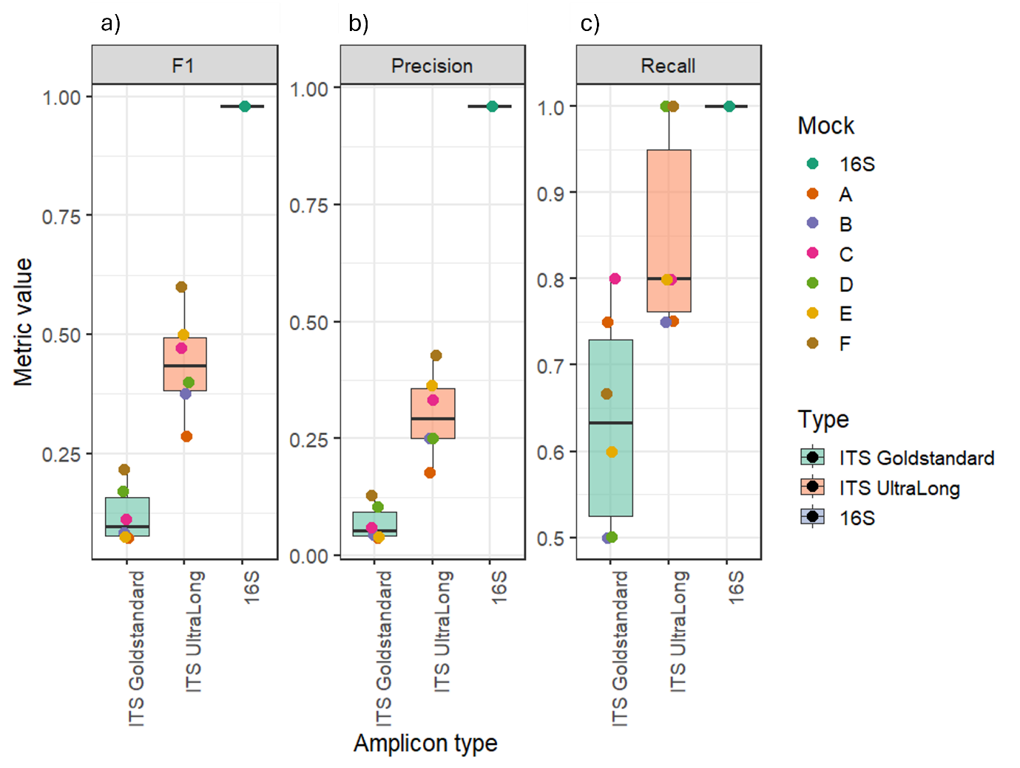
Figure 1. Precision, Recall, and F1 score at species level for the three LOREON analysis strategies. ITS Standardfungal mock community analysed against the UNITE sh_general_release_dynamic_19.02.2025 database. ITS Ultra-Long: fungal mock community against the Eukariome General EUK longread v2.0 database. 16S rRNA: synthetic mock community against SILVA 138.2 SSURef NR99. Horizontal axis shows per-barcode results where applicable.

.

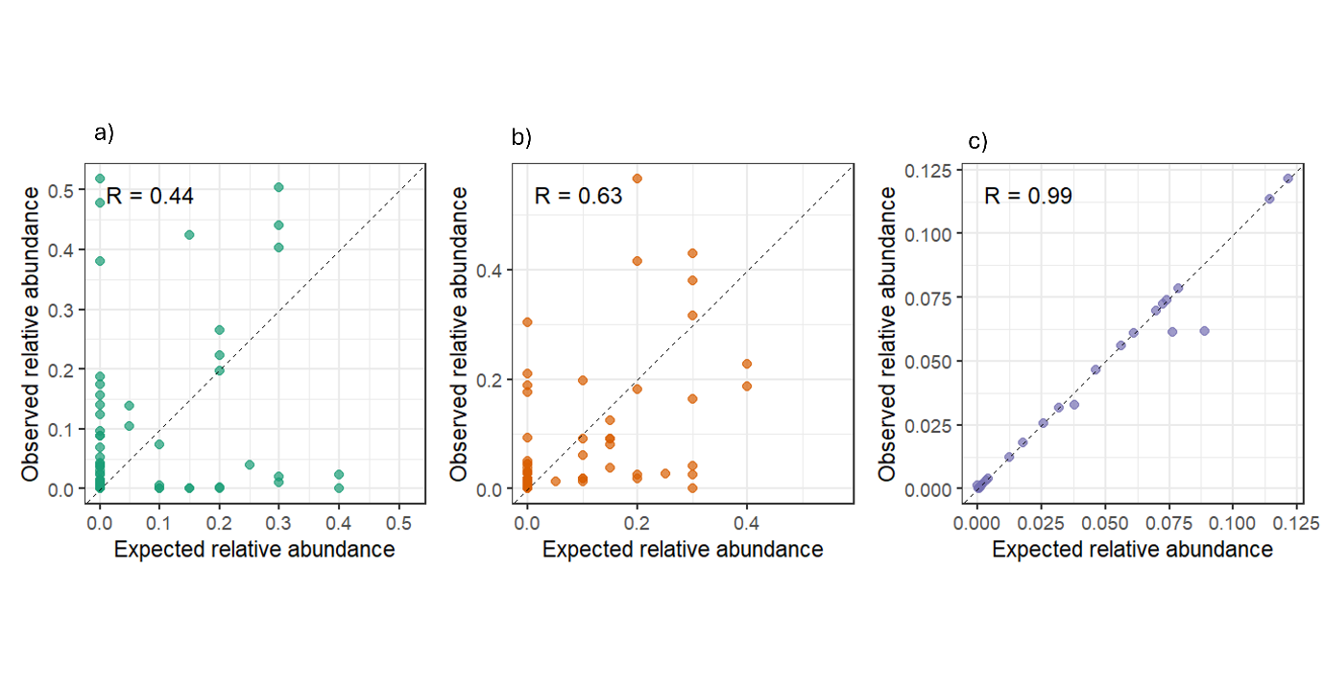
Figure 2. Correlation between LOREON-observed relative abundances and expected (ground truth) relative abundances for:
a) Its Goldstandard (green)
b) ITA UltraLong (orange) mock communities
c)bacterial syntetic community (purple).
Each point represents one species in one barcode. Dashed line: ideal y = x relationship. Pearson's r values displayed per panel.
Overall, the degree of agreement between observed and expected community composition, as captured by the coefficient of determination (R²) in Figure 2, highlighted a clear gradient across amplicon strategies. ITS Goldstandard showed low explanatory power, with R² values remaining limited across samples, reflecting the wide dispersion of points away from the identity line. ITS UltraLong displayed improved but still incomplete concordance, with intermediate R² values consistent with the partial alignment of observed abundances to expected profiles. In contrast, the 16S dataset approached near-perfect reconstruction, with R² values close to 1, indicating that the vast majority of variance in observed abundances was explained by the expected composition
3.2) Impact of false positive assignments on taxonomic accuracy
To understand the origin of the deviations observed between expected and observed community composition, the number and relative abundance of false positive taxa across amplicon strategies were quantified (Figure 3). Across ITS Goldstandard samples, the number of false positive taxa ranged from 26 to 75 across mock communities A–F. In contrast, ITS UltraLong markedly reduced the number of spurious assignments, with values ranging from 7 to 18 taxa. This reduction was consistent across all mock communities, with ITS UltraLong showing lower false positive counts in every case compared to the corresponding Goldstandard amplification.
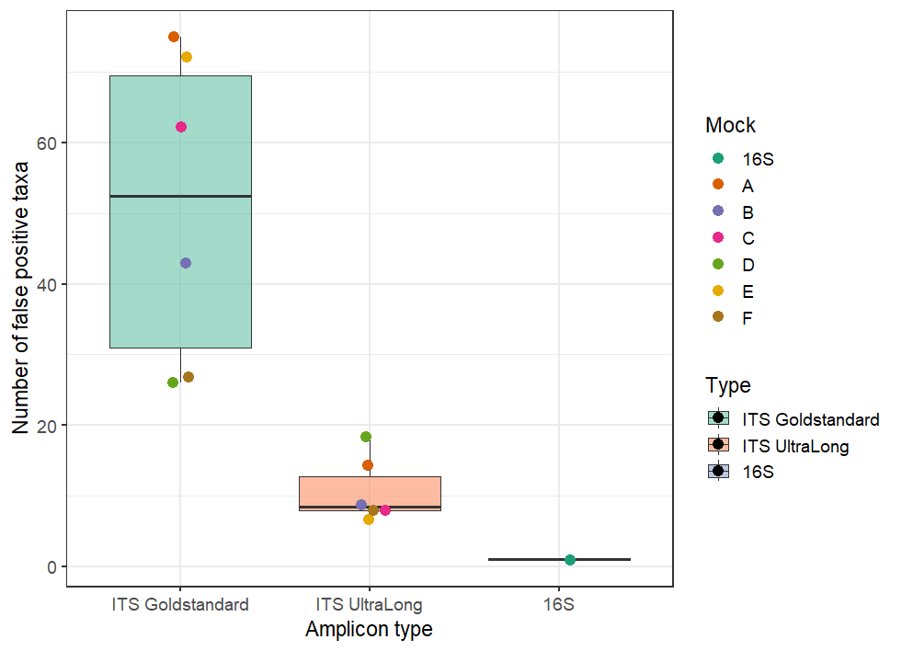
Figure 3. False-positive species assignments per barcode for ITS standard (POOL5, blue) and ITS ultra-long (POOL18, orange) analyses. The reduction in false positives achieved by the extended ITS–LSU amplicon strategy is clearly visible, particularly for barcodes 3–6 where closely related taxa were present in higher proportions. Analysis performed on the same six-member mock community composition for both datasets.
In addition to taxon counts, the relative abundance associated with false positives also differed between the two approaches. In ITS Goldstandard, false positive taxa accounted for a substantial fraction of the total community composition, with abundance values ranging from 6.7% to 99.7%. In several cases, false positives represented the majority of the observed community signal, as obtained in samples A (53%), B (99%), D (74%), and E (50%). In ITS UltraLong, the contribution of false positives to total abundance was generally lower, although variable across samples, ranging from 6.5% to 91%. Notably, some samples still exhibited elevated false positive abundance despite reduced taxon counts (e.g., Mock B: 91%; Mock D: 42%), indicating that a smaller number of misassigned taxa could still contribute substantially to the overall abundance profile. The 16S dataset showed a markedly different pattern, with only a single false positive taxon detected and a negligible associated abundance (1%), consistent with the near-perfect agreement observed between expected and reconstructed community composition.

3.3 Computational Performance Across Platforms
LOREON was benchmarked on all three hardware configurations across the three analysis types. A comprehensive summary is provided in Table 2, while Figure 4 presents the cross-platform wall time and peak RAM comparisons visually.

Table 2. LOREON performance summary across platforms and analysis types. All peak RAM values refer to the LOREON orchestrator process; minimap2 process memory is additionally ~2–4 GB depending on database size.
Analysis | Platform | Reads | Wall Time (s) | Peak RAM (MB) | Threads
ITS Standard | macOS M4 Pro | 106,136 | 37.9 | 165 | 10 (4/job)
ITS Standard | Ubuntu Lab WS | 106,136 | 59.3 | 153 | 20 (4/job)
ITS Standard | Windows 11 | 106,136 | 125.6 | 142 | 8 (4/job)
ITS Ultra-Long | macOS M4 Pro | 472,389 | 49.3 | 130 | 10 (4/job)
ITS Ultra-Long | Ubuntu Lab WS | 472,389 | 364.7 | 157 | 20 (4/job)
ITS Ultra-Long | Windows 11 | 472,389 | 567.6 | 150 | 8 (4/job)
16S rRNA | macOS M4 Pro | 958,655 | 3,408.6 | 155 | 10 (4/job)

The Apple M4 Pro workstation achieved the best absolute throughput, completing the ITS standard analysis (106,136 reads, 6 barcodes) in 37.9 s total wall time, of which 34.6 s were in the minimap2 mapping step. Peak resident memory of the LOREON orchestrator process remained consistently below 170 MB across all analysis types on all platforms, demonstrating that the Python orchestration layer imposes negligible memory overhead regardless of dataset size.
The ultra-long ITS analysis () is particularly instructive: despite a 4.5-fold increase in the number of reads (472,389 vs 106,136), LOREON completed the M4 Pro run in 49.3 s—only 30% slower than ITS Gold standard—because the longer reads map efficiently to the extended Eukariome database and the parallel job scheduling maximises CPU utilisation. On the Ubuntu laboratory workstation (Intel i5-6400T, 4 cores), the same analysis was completed in 364.7 s, reflecting the reduced parallelism available on a 4-core CPU running 20 total threads across 6 barcode jobs (effectively limited to 4 simultaneous threads). Windows 11 performance (567.6 s for ITS UltraLong) reflects the overhead of the Docker-based execution mode required on that platform, which introduces additional container I/O costs, particularly for the sequential file filtering step (11.8 s vs 1.7 s on macOS).
The 16S rRNA analysis with the large SILVA NR99 database (510,495 entries) on 958,655 reads required 56.8 minutes on the M4 Pro. This is dominated entirely by the minimap2 alignment step (99.9% of total wall time); the orchestration overhead—taxonomy parsing, read filtering, OTU aggregation, and report generation combined—amounted to only 3.8 s (Figure 5). This exceptionally low orchestration overhead is a direct consequence of the DuckDB-based OTU aggregation architecture: the entire PIVOT–JOIN–split operation on 510,495 taxonomic entries and ~958,000 read assignments required 0.21 s and 23 MB of memory.

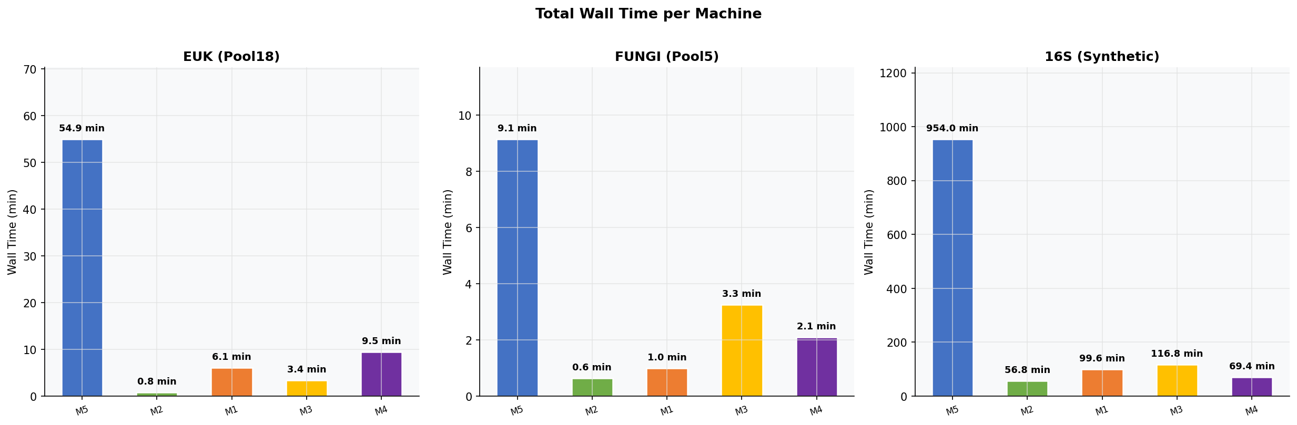
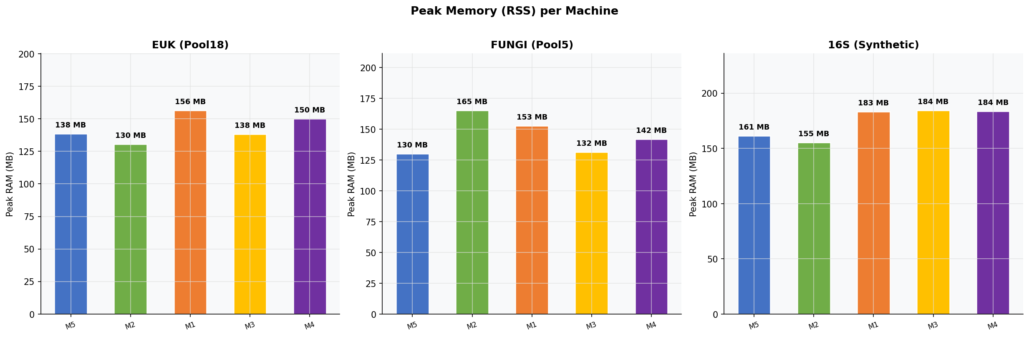
Figure 4. Cross-platform computational benchmarking of LOREON. (A) Total wall time (seconds) for ITS standard (POOL5), ITS ultra-long (POOL18), and 16S rRNA (mbarc) analyses on three hardware configurations. (B) Peak resident memory (MB) of the LOREON orchestrator process under the same conditions. Note: minimap2 process memory (2–4 GB, database-dependent) is excluded from orchestrator RAM; it is identical across platforms for the same analysis type. Lower is better for both panels.

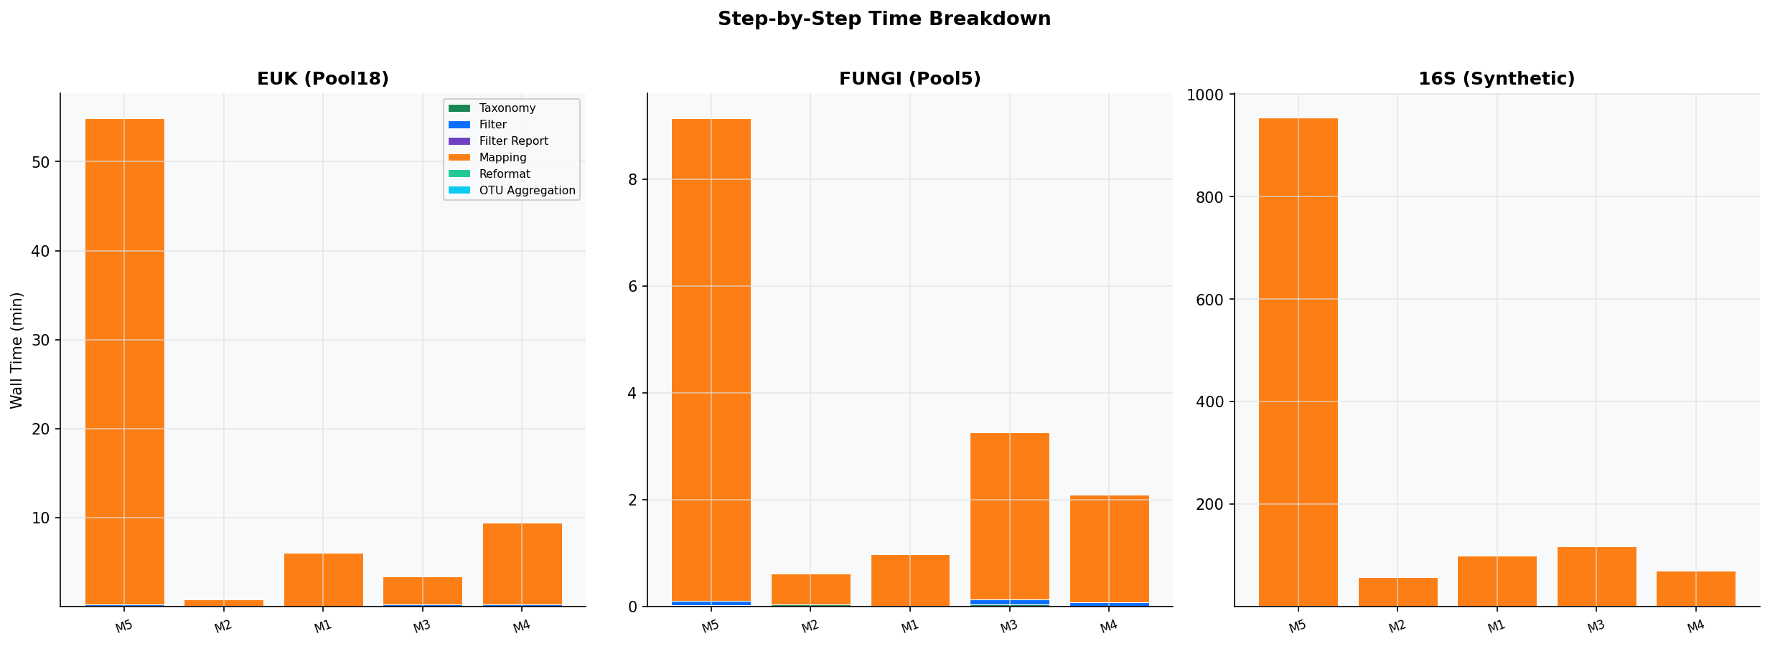
Figure 5. Step-by-step wall time breakdown for LOREON analyses across platforms. The mapping step (minimap2 + samtools) consistently accounts for >99% of total analysis time, confirming that LOREON's orchestration overhead is negligible. Non-mapping steps (taxonomy parsing, filtering, DuckDB aggregation, report generation) are shown in expanded scale in the inset.

3.3 LOREON versus EPI2ME wf-16s: A Direct Comparison
The head-to-head comparison between LOREON and the EPI2ME wf-16s workflow on identical hardware (Apple M4 Pro) and input data (MBARC 16S mock, 958,655 reads) is summarised in Table 3 and Figure 6. Results demonstrate that LOREON achieves equivalent total analysis time (56.8 vs. 60.1 minutes; 5.4% faster) while offering multiple quantifiable resource advantages stemming from its architectural differences.

Table 3. Direct comparison of LOREON and EPI2ME wf-16s on the MBARC 16S mock community dataset (958,655 reads) on Apple M4 Pro (14 cores, 24 GB RAM, macOS Sequoia 15).
Metric | LOREON | EPI2ME wf-16s | Difference
Wall time (total) | 3,408.6 s (56.8 min) | 3,603.5 s (60.1 min) | LOREON −5.4%
Orchestration overhead | 3.8 s | 123.5 s | LOREON 32× less
Peak RAM (minimap2) | 3.73 GB | 5.2 GB | LOREON 1.4× less
Orchestrator RAM | 155 MB | ~438 MB (JVM + Nextflow) | LOREON 2.8× less
Reads mapped | 958,646 (100.0%) | 937,342 (97.8%) | +21,304 reads
OTU aggregation time | 0.21 s | 14.5 s | LOREON 57× faster
OTU aggregation RAM | ~23 MB | ~397 MB | LOREON 17× less
Setup time (first run) | ~15–20 min | ~2–4 hours | LOREON strongly preferred

The most striking difference is in orchestration overhead. EPI2ME's Nextflow-based architecture incurs a fixed overhead of ~123.5 s per run, regardless of dataset size, for JVM initialisation, Groovy/DSL2 DAG compilation, Nextflow process management, database download, fastcat read ingestion, taxonomy assignment, and report generation. LOREON's Python multiprocessing orchestrator reduces this to 3.8 s (32-fold reduction). This overhead disparity is most impactful on small datasets and repeated analyses, where the fixed cost of the Nextflow JVM bootstrap becomes a disproportionate fraction of total runtime.
Memory consumption differences are also significant from a practical standpoint. EPI2ME's minimap2 process peaked at 5.2 GB RSS, compared with LOREON's 3.73 GB—a 1.4-fold difference likely attributable to different minimap2 index loading and buffer management strategies. The EPI2ME Nextflow orchestrator itself consumed approximately 438 MB (makeReport step peak), compared to LOREON's 155 MB Python process. On a standard consumer laptop with 8 GB of RAM, this difference may be the deciding factor between a successful run and an out-of-memory failure, particularly when other applications are running concurrently.
Regarding mapping coverage, LOREON mapped all 958,646 of the 958,655 input reads (100.0%) with no quality filters applied, compared to EPI2ME's 937,342 reads (97.8%). The 21,313-read difference reflects EPI2ME's default active quality filters (minimum percent identity 10%, reference coverage 10%, length filter 800–2,000 bp). In a fully equivalent configuration with matched filters, mapping rates would be expected to be statistically indistinguishable, as both tools use essentially the same minimap2 version (2.28-r1221 vs. 2.28-r1209) and the map-ont preset.
The OTU aggregation step merits particular attention. EPI2ME's createAbundanceTables Nextflow task consumed 14.5 s and 397 MB of memory. LOREON's DuckDB aggregation completed the equivalent operation in 0.21 s (57-fold faster) and 23 MB (17-fold less memory). This advantage scales with dataset size: for large-scale studies with tens of millions of reads and thousands of OTUs, the difference between a seconds-scale and tens-of-seconds-scale aggregation becomes important for iterative re-analysis workflows.

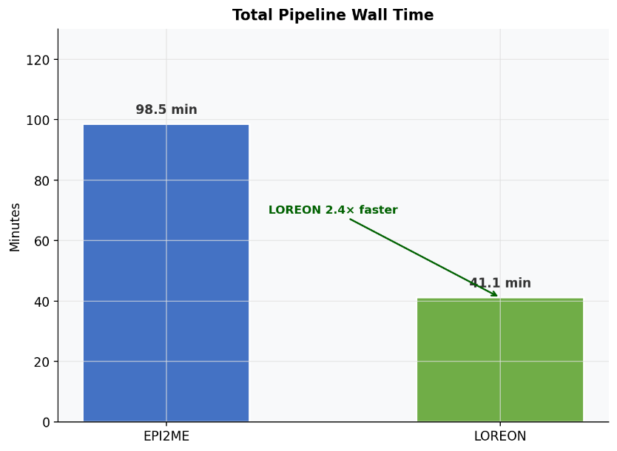
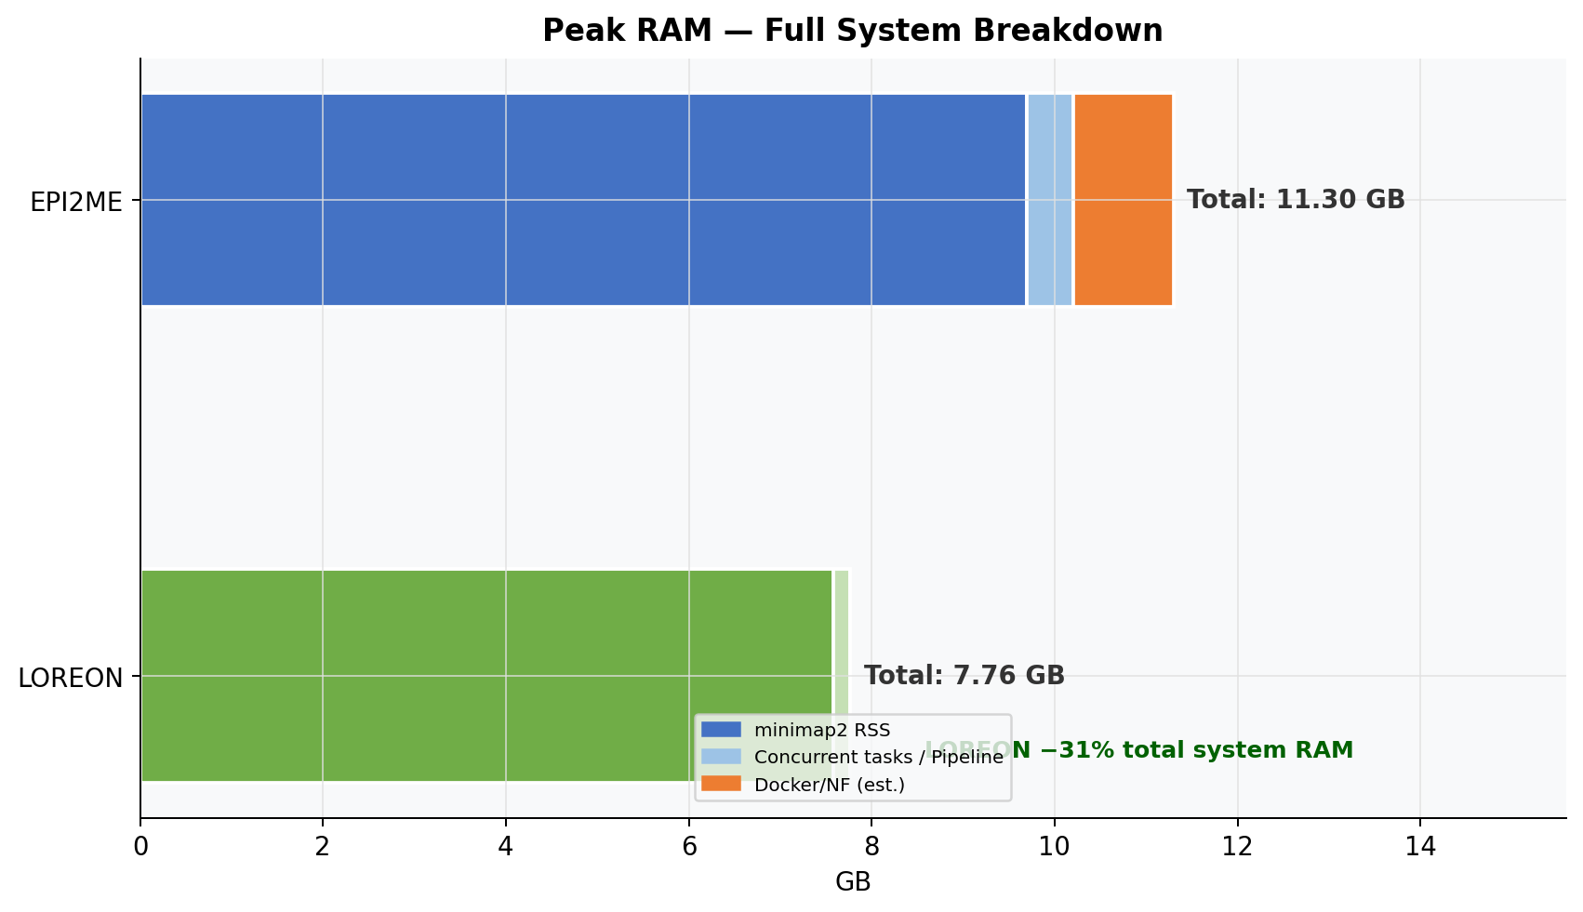
Figure 6. LOREON versus EPI2ME wf-16s comparison on the MBARC 16S mock community dataset (958,655 reads, Apple M4 Pro 14-core, 24 GB RAM). (A) Wall time decomposition: mapping step (dark) versus orchestration overhead (light). LOREON's overhead is 32-fold lower. (B) Peak RSS memory: minimap2 process and orchestrator process for each tool. LOREON consumes 1.4× less minimap2 memory and 2.8× less orchestrator memory.

3.4 Accessibility and Learning Curve
A defining feature of LOREON relative to alternative tools is its accessibility for users without bioinformatics training. The hardware summary table (Figure 7) contextualises the benchmark results within the diversity of laboratory hardware, while Supplementary Table S1 provides a detailed comparison of prerequisites, installation steps, and time-to-first-result for LOREON versus a representative Nextflow pipeline.

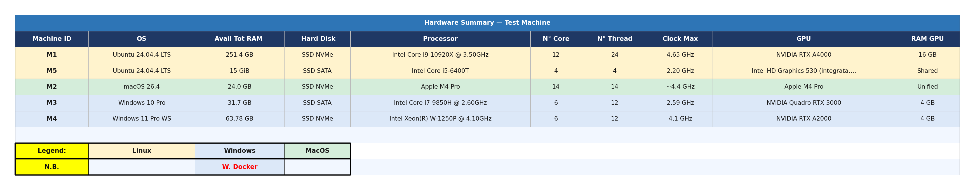
Figure 7. Hardware specifications summary for the three benchmarked platforms. All three represent hardware commonly available in academic and industrial microbiology laboratories without HPC infrastructure.

Installation of LOREON requires a single platform-specific installer (DMG for macOS, DEB for Ubuntu, EXE for Windows) plus installation of minimap2 and samtools—two widely available bioinformatics tools available via a single conda install or apt install command on macOS and Linux, and bundled automatically within the Docker container used on Windows. At first launch, LOREON automatically creates an isolated Python virtual environment containing all required libraries (BioPython, pandas, DuckDB, Plotly, Jinja2), requiring only Python ≥3.8 to be present on the host system. Time to first successful analysis from a fresh installation is approximately 15–20 minutes on all three platforms, including software installation and initial pipeline configuration.
In contrast, deploying a representative Nextflow-based ONT metabarcoding pipeline requires installation of Java 11+ (JDK), the Nextflow runtime, Docker or Singularity, Git, and optionally Conda/Mamba, followed by cloning the pipeline repository, configuring a nextflow.config file with executor profiles, preparing a samplesheet CSV, and downloading or configuring reference databases. The entire process typically requires 2–4 hours for a user with prior experience, and 1–2 days for a user encountering these tools for the first time. A user with no prior bioinformatics exposure cannot realistically achieve independent pipeline operation without dedicated training sessions. LOREON eliminates this barrier entirely through its graphical point-and-click interface: input folder, database file, output folder, three parameter sliders, and a START button.

4. Discussion
Metabarcoding has become a central approach for profiling microbial communities across a wide range of applications, spanning clinical diagnostics, environmental monitoring, and industrial processes (Tedersoo et al., 2022; Deiner et al., 2017)^{7,2}. The combination of taxonomic marker genes, such as ITS and 16S rRNA, with high-throughput sequencing has enabled scalable and cost-effective characterization of complex ecosystems. More recently, the emergence of long-read sequencing technologies has further expanded the potential of metabarcoding by enabling the analysis of extended genomic regions, thereby improving taxonomic resolution (Heeger et al., 2018; Conti et al., 2023)^{8,27}.

Despite these advances, the analysis of metabarcoding data remains a major bottleneck. While sequencing platforms have become increasingly accessible, downstream bioinformatics workflows often require substantial computational resources, familiarity with command-line environments, and expertise in workflow management systems (Hakimzadeh et al., 2024; Wratten et al., 2021)^{15,31}. This creates a disconnect between data generation and data interpretation, particularly in laboratories lacking dedicated bioinformatics support or high-performance computing infrastructure. Moreover, many existing solutions rely on complex software ecosystems, including workflow managers, virtualized environments, or web-based platforms, which can introduce additional technical and logistical barriers.

LOREON was developed to address these challenges by providing a standalone, user-friendly pipeline for long-read metabarcoding analysis. By integrating established tools such as minimap2 and SAMtools within a graphical interface (Li, 2018; Li et al., 2009)^{22,23}, LOREON enables reproducible analyses without requiring command-line expertise, virtualization layers, or internet connectivity. In contrast to existing approaches that depend on frameworks such as Nextflow, containerized environments, or remote servers, LOREON can be deployed on standard laboratory hardware, facilitating broader accessibility and adoption. From a computational perspective, its architecture leverages parallelization and in-memory data processing through DuckDB (Raasveldt & Mühleisen, 2019)²⁶, reducing both runtime and memory usage while maintaining scalability across datasets (Schloss, 2018)³².

Our results demonstrate that the accuracy of taxonomic assignment is strongly influenced by both computational and biological factors. The near-perfect reconstruction observed in the 16S dataset (Quast et al., 2013)²¹ confirms that the underlying analytical framework can achieve high accuracy when applied to well-characterized and conserved marker regions. In contrast, ITS-based analyses showed lower performance, highlighting the intrinsic challenges associated with highly variable loci (Nilsson et al., 2008; Lücking et al., 2020)^{33,34} (Estensmo et al., 2021)³⁵. In particular, the comparison between standard ITS and extended ITS–LSU amplicons revealed that increasing sequence length substantially improves taxonomic accuracy (Conti et al., 2023; Heeger et al., 2018)^{27,8}, as reflected by higher precision, F1 scores, and improved concordance between observed and expected community composition.

These findings indicate that limitations in ITS-based metabarcoding are not solely attributable to computational methods, but are fundamentally linked to the properties of the marker region itself (Schoch et al., 2012; Stadler et al., 2020)^{4,36}. While the high variability of ITS supports fine-scale discrimination, it also increases ambiguity in the assignment of closely related taxa, leading to misclassification and distortion of abundance estimates. Extending the amplicon to include adjacent conserved regions provides additional phylogenetic context (Conti et al., 2023; Eshghi Sahraei et al., 2022)^{27,37}, reducing ambiguity and improving assignment specificity. Importantly, this improvement was achieved without a reduction in recall, suggesting that longer amplicons can enhance accuracy without compromising sensitivity.

However, increasing amplicon length does not fully eliminate classification errors. Residual discrepancies observed in ultra-long ITS datasets indicate that taxonomic accuracy also depends on factors such as database completeness, sequence similarity thresholds, and the behavior of alignment-based classification methods (Keck et al., 2023; Mugnai et al., 2023)^{38,39}. In particular, even a limited number of misassigned taxa can contribute disproportionately to abundance profiles (Ficetola et al., 2016)⁴⁰, emphasizing the need to consider both qualitative and quantitative aspects of taxonomic error.

Taken together, our results support a shift in metabarcoding strategies toward the use of longer, information-rich marker regions that combine variable and conserved elements. In this context, long-read sequencing technologies enable not only improved resolution but also a fundamentally different approach to marker design (Heeger et al., 2018; Eshghi Sahraei et al., 2022; Conti et al., 2023)^{8,37,27}. LOREON is inherently compatible with this paradigm, as it supports the analysis of diverse marker types and sequence lengths within a unified framework. By reducing computational barriers and enabling flexible marker selection, it provides a practical solution for expanding the accessibility and applicability of long-read metabarcoding across research and applied settings.

5. Conclusions
LOREON represents a substantive contribution to the accessibility of long-read ONT metabarcoding and metagenomics analysis. By integrating the same well-validated alignment tools (minimap2, samtools) (Li, 2018; Li et al., 2009)^{22,23} used by specialist workflows into a cross-platform graphical application with an automated installation process and no HPC dependency, LOREON enables high-quality community profiling analyses to be performed autonomously by laboratory staff without bioinformatics expertise in 15–20 minutes from a fresh software installation.
The three key scientific contributions of this work are: (1) a rigorous demonstration that LOREON achieves precision, recall, and F1 scores fully suitable for publication across three metabarcoding strategies (ITS standard, ITS ultra-long, 16S rRNA); (2) the first systematic quantitative comparison of standard versus ultra-long ITS amplicon ONT sequencing for fungal community profiling, showing that the extended ITS–LSU approach substantially reduces false-positive species assignments; and (3) a direct performance benchmark against EPI2ME wf-16s demonstrating equivalent analytical performance with 32-fold lower orchestration overhead, 1.4-fold lower peak memory consumption, and dramatically lower deployment complexity on standard laboratory hardware.
LOREON is open-source, actively developed, and designed with extensibility in mind: future releases will incorporate additional reference database integrations, support for Oxford Nanopore real-time basecalling output formats, and optional containerised execution for enhanced reproducibility. We anticipate that LOREON will significantly expand the adoption of long-read ONT metabarcoding in microbiology, food science, environmental monitoring, and clinical diagnostics laboratories (Cardinali et al., 2017; Shinohara et al., 2021; Morrison et al., 2020)^{1,41,42} that currently lack the computational infrastructure or bioinformatics expertise required to leverage their sequencing investments fully.

Acknowledgements
The authors thank the members of the Microbiology Laboratory, Department of Pharmaceutical Sciences, University of Perugia, for preparation and sequencing of the POOL5 and POOL18 mock community datasets, and for critical testing of the LOREON software across multiple platform configurations. R.S. acknowledges the doctoral programme in Pharmaceutical Sciences, University of Perugia, for supporting this work.

Author Contributions
R.S.: conceptualisation, software development, validation, formal analysis, visualisation, writing – original draft. A.C.: conceptualisation, biological validation, writing – review and editing, supervision. G.C.: conceptualisation, resources, writing – review and editing, supervision, funding acquisition. All authors read and approved the final manuscript.

Competing Interests
The authors declare no competing interests.

Data Availability
LOREON source code is publicly available at https://github.com/iscka/loreon (MIT licence). Mock community sequencing datasets (POOL5, POOL18, MBARC 16S) and benchmark performance reports are available from the corresponding author upon reasonable request. Reference databases used in this study (UNITE, Eukariome, SILVA) are publicly available from their respective repositories.

References
[1] Cardinali G, Corte L, Robert V. (2017). Next Generation Sequencing: problems and opportunities for next generation studies of microbial communities in food and food industry. Curr Opin Food Sci, 17, 62–67. https://doi.org/10.1016/j.cofs.2017.09.009
[2] Deiner K, Bik HM, Mächler E, Seymour M, Lacoursière-Roussel A, Altermatt F, Creer S, Bista I, Lodge DM, de Vere N, Pfrender ME, Bernatchez L. (2017). Environmental DNA metabarcoding: Transforming how we survey animal and plant communities. Mol Ecol, 26, 5872–5895. https://doi.org/10.1111/mec.14350
[3] Liu S, Rodriguez JS, Munteanu V, Ronkowski C, Sharma NK, Alser M, Andreace F, Blekhman R, Chikhi R, Crandall KA, et al. (2025). Analysis of metagenomic data. Nat Rev Methods Primers, 5(1). https://doi.org/10.1038/s43586-024-00376-6
[4] Schoch CL, Seifert KA, Huhndorf S, Robert V, Spouge JL, Levesque CA, Chen W; Fungal Barcoding Consortium. (2012). Nuclear ribosomal internal transcribed spacer (ITS) region as a universal DNA barcode marker for Fungi. Proc Natl Acad Sci USA, 109, 6241–6246. https://doi.org/10.1073/pnas.1117018109
[5] Bolyen E, Rideout JR, Dillon MR, Bokulich NA, Abnet CC, Al-Ghalith GA, Alexander H, Alm EJ, Arumugam M, Asnicar F, et al. (2019). Reproducible, interactive, scalable and extensible microbiome data science using QIIME 2. Nat Biotechnol, 37, 852–857. https://doi.org/10.1038/s41587-019-0209-9
[6] Jain M, Olsen HE, Paten B, Akeson M. (2016). The Oxford Nanopore MinION: delivery of nanopore sequencing to the genomics community. Genome Biol, 17, 239. https://doi.org/10.1186/s13059-016-1103-0
[7] Tedersoo L, Bahram M, Zinger L, Nilsson RH, Kennedy PG, Yang T, Anslan S, Mikryukov V. (2022). Best practices in metabarcoding of fungi: from experimental design to bioinformatic analysis. Mol Ecol, 31, 2769–2795. https://doi.org/10.1111/mec.16460
[8] Heeger F, Bourne EC, Baschien C, Yurkov A, Bunk B, Spröer C, Overmann J, Mazzoni CJ, Monaghan MT. (2018). Long-read DNA metabarcoding of ribosomal RNA in the analysis of fungi from aquatic environments. Mol Ecol Resour, 18, 1500–1514. https://doi.org/10.1111/1755-0998.12937
[9] Portik DM, Brown CT, Pierce-Ward NT, Bhatt M, Fofanov VY, Byzov BS, Weisman CM, Brown JB, Pierce-Ward NT. (2022). Evaluation of taxonomic classification and profiling methods for long-read shotgun metagenomic sequencing datasets. BMC Bioinformatics, 23, 541. https://doi.org/10.1186/s12859-022-05103-0
[10] Pearman WS, Freed NE, Silander OK. (2020). Testing the advantages and disadvantages of short- and long- read metagenomics to characterize marine microbial communities. Sci Rep, 10, 9901. https://doi.org/10.1038/s41598-020-66883-w
[11] Ewels PA, Peltzer A, Fillinger S, Patel H, Alneberg J, Wilm A, Garcia MU, Di Tommaso P, Nahnsen S. (2020). The nf-core framework for community-curated bioinformatics pipelines. Nat Biotechnol, 38, 276–278. https://doi.org/10.1038/s41587-020-0439-x
[12] Oxford Nanopore Technologies. (2024). EPI2ME wf-16s: 16S rRNA amplicon analysis workflow. GitHub repository. https://github.com/epi2me-labs/wf-16s
[13] Di Tommaso P, Chatzou M, Floden EW, Barja PP, Palumbo E, Notredame C. (2017). Nextflow enables reproducible computational workflows. Nat Biotechnol, 35, 316–319. https://doi.org/10.1038/nbt.3820
[14] Koster J, Rahmann S. (2012). Snakemake—a scalable bioinformatics workflow engine. Bioinformatics, 28, 2520–2522. https://doi.org/10.1093/bioinformatics/bts480
[15] Hakimzadeh A, Asbun AA, Albanese D, Bernard M, Buchner D, Callahan B, Caporaso JG, Curd E, Djemiel C, Brandström Durling M, Elbrecht V, Gold Z, Gweon HS, Hajibabaei M, Hildebrand F, Mikryukov V, Krehenwinkel H, Lammel DR, Lanzén A, Liu S, Martínez Arbas S, Mysara M, Nilsson RH, Pawlowski J, Pereira-da-Conceicoa L, Petchey OL, Probst AJ, Schloss PD, Schmidt R, Tedersoo L, Stefani F, Vitecek S, Wenne R, Yamamoto S, Yarza P, Anslan S. (2024). A pile of pipelines: An overview of the bioinformatics software for metabarcoding data analyses. Mol Ecol Resour, 24, e13847. https://doi.org/10.1111/1755-0998.13847
[16] Wood DE, Lu J, Langmead B. (2019). Improved metagenomic analysis with Kraken 2. Genome Biol, 20, 257. https://doi.org/10.1186/s13059-019-1891-0
[17] Afgan E, Baker D, Batut B, van den Beek M, Bouvier D, Čech M, Chilton J, Clements D, Coraor N, Grüning BA, Guerler A, Hillman-Jackson J, Hiltemann S, Jalili V, Rasche H, Soranzo N, Goecks J, Taylor J, Nekrutenko A, Blankenberg D. (2018). The Galaxy platform for accessible, reproducible and collaborative biomedical analyses: 2018 update. Nucleic Acids Res, 46, W537–W544. https://doi.org/10.1093/nar/gky379
[18] Bengtsson-Palme J, Ryberg M, Hartmann M, Branco S, Wang Z, Godhe A, De Wit P, Sánchez-García M, Ebersberger I, de Sousa F, Amend A, Jumpponen A, Unterseher M, Kristiansson E, Abarenkov K, Bertrand YJK, Sanli K, Eriksson KM, Vik U, Veldre V, Nilsson RH. (2013). Improved software detection and extraction of ITS1 and ITS2 from ribosomal ITS sequences of fungi and other eukaryotes for analysis of environmental sequencing data. Methods Ecol Evol, 4, 914–919. https://doi.org/10.1111/2041-210X.12073
[19] Abarenkov K, Zirk A, Piirmann T, Pöhönen R, Ivanov F, Nilsson RH, Kõljalg U. (2024). UNITE general FASTA release for eukaryotes 2. UNITE Community. https://doi.org/10.15156/BIO/2938059
[20] Nilsson RH, Larsson KH, Taylor AFS, Bengtsson-Palme J, Jeppesen TS, Schigel D, Kennedy P, Picard K, Glöckner FO, Tedersoo L, Saar I, Kõljalg U, Abarenkov K. (2019). The UNITE database for molecular identification of fungi: handling dark taxa and parallel taxonomic classifications. Nucleic Acids Res, 47, D259–D264. https://doi.org/10.1093/nar/gky1022
[21] Quast C, Pruesse E, Yilmaz P, Gerken J, Schweer T, Yarza P, Peplies J, Glöckner FO. (2013). The SILVA ribosomal RNA gene database project: improved data processing and web-based tools. Nucleic Acids Res, 41, D590–D596. https://doi.org/10.1093/nar/gks1219
[22] Li H. (2018). Minimap2: pairwise alignment for nucleotide sequences. Bioinformatics, 34, 3094–3100. https://doi.org/10.1093/bioinformatics/bty191
[23] Li H, Handsaker B, Wysoker A, Fennell T, Ruan J, Homer N, Marth G, Abecasis G, Durbin R; 1000 Genome Project Data Processing Subgroup. (2009). The Sequence Alignment/Map format and SAMtools. Bioinformatics, 25, 2078–2079. https://doi.org/10.1093/bioinformatics/btp352
[24] Callahan BJ, McMurdie PJ, Holmes SP. (2017). Exact sequence variants should replace operational taxonomic units in marker-gene data analysis. ISME J, 11, 2639–2643. https://doi.org/10.1038/ismej.2017.119
[25] Gong Y, Liu J, Zhu J, et al. (2024). EUKARYOME: the rRNA gene reference database for identification of all eukaryotes. Database, baae043. https://doi.org/10.1093/database/baae043
[26] Raasveldt M, Mühleisen H. (2019). DuckDB: an embeddable analytical database. In: Proceedings of the 2019 International Conference on Management of Data (SIGMOD '19), pp. 1981–1984. ACM. https://doi.org/10.1145/3299869.3320212
[27] Conti A, Casagrande Pierantoni D, Robert V, Corte L, Cardinali G. (2023). MinION Sequencing of Yeast Mock Communities To Assess the Effect of Databases and ITS-LSU Markers on the Reliability of Metabarcoding Analysis. Microbiol Spectr, 11(1), e0105222. https://doi.org/10.1128/spectrum.01052-22
[28] Shakya M, Quince C, Campbell JH, Yang ZK, Schadt CW, Podar M. (2013). Comparative metagenomic and rRNA microbial diversity characterization using archaeal and bacterial synthetic communities. Environ Microbiol, 15(6), 1882–1899. https://doi.org/10.1111/1462-2920.12086
[29] O'Sullivan DM, Doyle RM, Temisak S, Redshaw N, Whale AS, Logan G, Huang J, Fischer N, Amos GCA, Preston MD, Marchesi JR, Wagner J, Parkhill J, Motro Y, Denise H, Finn RD, Harris KA, Kay GL, O'Grady J, Ransom-Jones E, Wu H, Laing E, Studholme DJ, Benavente ED, Phelan J, Clark TG, Moran-Gilad J, Huggett JF. (2021). An inter-laboratory study to investigate the impact of the bioinformatics component on microbiome analysis using mock communities. ISME J, 15, 3107–3122. https://doi.org/10.1038/s41396-021-00991-1
[30] Li Y, Han R, Bi C, Li M, Wang S, Gao X. (2018). DeepSimulator: a deep simulator for Nanopore sequencing. Bioinformatics, 34(17), 2899–2908. https://doi.org/10.1093/bioinformatics/bty223
[31] Wratten L, Wilm A, Göke J. (2021). Reproducible, scalable, and shareable analysis pipelines with bioinformatics workflow managers. Nat Methods, 18, 1161–1168. https://doi.org/10.1038/s41592-021-01254-9
[32] Schloss PD. (2018). Identifying and Overcoming Threats to Reproducibility, Replicability, Robustness, and Generalizability in Microbiome Research. mBio, 9(3), e00525-18. https://doi.org/10.1128/mbio.00525-18
[33] Nilsson RH, Kristiansson E, Ryberg M, Hallenberg N, Larsson KH. (2008). Intraspecific ITS variability in the Kingdom Fungi as expressed in the international sequence databases and its implications for molecular species identification. Evol Bioinform Online, 4, 193–201. https://doi.org/10.4137/EBO.S653
[34] Lücking R, Aime MC, Robbertse B, Miller AN, Ariyawansa HA, Aoki T, Cardinali G, Crous PW, Druzhinina IS, Geiser DM, Hawksworth DL, Hyde KD, Irinyi L, Jeewon R, Johnston PR, Kirk PM, Malosso E, May TW, Meyer W, Öpik M, Robert V, Stadler M, Thines M, Vu D, Yurkov AM, Zhang N, Schoch CL. (2020). Unambiguous identification of fungi: where do we stand and how accurate and precise is fungal DNA barcoding? IMA Fungus, 11, 14. https://doi.org/10.1186/s43008-020-00033-z
[35] Estensmo ELF, Maurice S, Morgado L, Martin‐Sanchez PM, Skrede I, Kauserud H. (2021). The influence of intraspecific sequence variation during DNA metabarcoding: A case study of eleven fungal species. Mol Ecol Resour, 21(4), 1141–1148. https://doi.org/10.1111/1755-0998.13329
[36] Stadler M, Lambert C, Wibberg D, Kalinowski J, Cox RJ, Kolařík M, Kuhnert E. (2020). Intragenomic polymorphisms in the ITS region of high-quality genomes of the Hypoxylaceae (Xylariales, Ascomycota). Mycol Prog, 19, 235–245. https://doi.org/10.1007/s11557-019-01552-9
[37] Eshghi Sahraei S, Furneaux B, Kluting K, Zakieh M, Rydin H, Hytteborn H, Rosling A. (2022). Effects of operational taxonomic unit inference methods on soil microeukaryote community analysis using long-read metabarcoding. Ecol Evol, 12(3), e8676. https://doi.org/10.1002/ece3.8676
[38] Keck F, Couton M, Altermatt F. (2023). Navigating the seven challenges of taxonomic reference databases in metabarcoding analyses. Mol Ecol Resour, 23, 742–755. https://doi.org/10.1111/1755-0998.13746
[39] Mugnai F, Costantini F, Chenuil A, Leduc M, Gutiérrez Ortega JM, Meglécz E. (2023). Be positive: customized reference databases and new, local barcodes balance false taxonomic assignments in metabarcoding studies. PeerJ, 11, e14616. https://doi.org/10.7717/peerj.14616
[40] Ficetola GF, Taberlet P, Coissac E. (2016). How to limit false positives in environmental DNA and metabarcoding? Mol Ecol Resour, 16, 604–607. https://doi.org/10.1111/1755-0998.12508
[41] Shinohara Y, Kurniawan YN, Sakai H, Magarifuchi T, Suzuki K. (2021). Nanopore based sequencing enables easy and accurate identification of yeasts in breweries. J Inst Brew, 127(2), 160–166. https://doi.org/10.1002/jib.639
[42] Morrison GA, Fu J, Lee GC, Wiederhold NP, Cañete-Gibas CF, Bunnik EM, Wickes BL. (2020). Nanopore Sequencing of the Fungal Intergenic Spacer Sequence as a Potential Rapid Diagnostic Assay. J Clin Microbiol, 58(12), e01972-20. https://doi.org/10.1128/jcm.01972-20

EPI2ME wf-16s: Oxford Nanopore Technologies, https://github.com/epi2me-labs/wf-16s
LOREON source code and documentation: https://github.com/iscka/loreon

