LoReON: accessible application for microbial community profiling with standard and full-length markers from long-read sequencing data
Roberto Scarponi¹, Angela Conti^{1,*}, Debora Casagrande Pierantoni, Alex Giannoni, Beatrice Strinati, Katarina Stojikov, Vincent Robert, Wieland Meyer, Laura Corte and Gianluigi Cardinali^{1,}
¹ Department of Pharmaceutical Sciences, University of Perugia, 06123 Perugia, Italy
* Corresponding authors: angela.conti@unipg.it;

Abstract
Bioinformatic analysis of long-read amplicon data from Oxford Nanopore Technologies (ONT) platforms typically requires command-line proficiency, workflow management systems, and access to high-performance computing infrastructure — creating a significant bottleneck between data generation and ecological interpretation in standard microbiology laboratories. Here we present LOREON (Long-Read ONT metabarcoding pipeline), an open-source, cross-platform application that integrates minimap2-based reference alignment, SAMtools processing, and DuckDB-powered OTU aggregation within a graphical interface requiring no command-line interaction. LOREON supports three metabarcoding strategies — standard ITS, extended 18–ITS–LSU (~5 kb), and 16S rRNA — and runs on macOS, Linux, and Windows, including consumer-grade hardware with as few as four CPU cores and 15 GB of RAM. Using synthetic and experimentally generated mock communities, we show that extending the fungal barcode from the canonical ITS1–5.8S–ITS2 region to the full 18–ITS–LSU locus substantially improves taxonomic assignment. In wet fungal mock communities, the extended marker achieved 2.8-fold higher area under the precision–recall curve (0.451 versus 0.162) than the standard barcode, and a positive F1 advantage in all 24 pairwise comparisons across six communities and operationally relevant abundance thresholds (mean ΔF1 = 0.224). For communities composed of congeneric species, the standard barcode produced qualitatively inverted taxonomic profiles — assigning up to 86% of reads to false-positive taxa — whereas the extended marker correctly identified the dominant community members and confined residual errors within the correct genus. Computational benchmarking against the EPI2ME wf-16s workflow on identical data demonstrated equivalent total analysis time with 32-fold lower orchestration overhead, 57-fold faster OTU aggregation, and 1.4-fold lower peak memory consumption, with a time-to-first-analysis of approximately 15 minutes from a fresh installation.
Keywords: Oxford Nanopore Technologies; metagenomics; metabarcoding; ITS; 16S rRNA; bioinformatics pipeline; graphical user interface; fungal diversity

1. Introduction
The development of bioinformatic infrastructure for microbial community analysis has historically been driven by advances in sequencing technology. Each major transition in sequencing platforms has not only increased the volume and quality of sequence data, but has also demanded fundamentally different computational approaches to the same biological question: which taxa are present in a sample, and in what relative abundance.
The first generation of high-throughput amplicon sequencing, based on Roche 454 pyrosequencing, introduced the concept of operational taxonomic units (OTUs) as the standard currency for describing microbial diversity. Mothur [1] provided the first comprehensive analytical framework for this paradigm, implementing distance-based clustering at a 97% sequence similarity threshold to group reads into OTUs. The arbitrary similarity threshold imposed an intrinsic limitation on taxonomic resolution, collapsing genuinely distinct taxa that shared more than 97% marker similarity into a single unit [2].
The transition to Illumina short-read sequencing delivered substantially higher throughput and lower per-base error rates, but also shorter reads (250–300 bp) with a qualitatively different error profile. This shift catalysed the development of denoising algorithms, most notably DADA2 [3], which replaced arbitrary clustering thresholds with a statistical error model learned from each sequencing run. The resulting amplicon sequence variants (ASVs) are exact biological sequences resolved at single-nucleotide precision, reproducible across studies, and free from the information loss inherent in OTU clustering [4]. QIIME 2 [5] subsequently sought to integrate multiple analytical approaches — including both OTU clustering and ASV inference — within a unified, reproducible framework. While QIIME 2 represented a significant advance in standardisation and provenance tracking, its reliance on a proprietary artifact system, command-line proficiency, and containerisation technologies has maintained a substantial accessibility barrier for laboratories without dedicated bioinformatic support [6].
Long-read sequencing technologies, particularly Oxford Nanopore Technologies (ONT) platforms such as the portable MinION [7-9], now represent a third paradigm shift that is at once technological and conceptual [10,11]. Rather than sequencing short, hypervariable sub-regions of taxonomic markers, ONT enables the routine generation of reads spanning complete or near-complete marker genes in a single pass [12-14]. This capability fundamentally alters the analytical logic: instead of constructing biological units from fragmented sequences reads can be directly aligned against curated reference databases using general-purpose sequence aligners such as minimap2 [15]. Taxonomic assignment thus becomes an alignment and mapping problem, with the potential for substantially higher resolution when sufficiently long and informative marker sequences are employed [16,17]
This shift is particularly significant for fungal metabarcoding, which is strongly limited by the particular length and structure of the barcoding marker [18,19]. Since the formal adoption of the internal transcribed spacer (ITS) region as the universal DNA barcode for Fungi [20], community analyses have been largely confined to the ITS1 or ITS2 sub-regions (~200–400 bp) — a constraint imposed in part by the read-length limitations of short-read sequencing platforms. However, the ITS region alone provides limited phylogenetic resolution for many fungal lineages, situation worsened when the marker is reduced to the sole ITS2 [21-23]. Moreover, its high length variability, intra-genome heterogeneity [24,25] and intraspecific polymorphism further complicate even PCR amplification, and both alignment-based and clustering-based analyses [26-28]. Long-read sequencing removes this constraint, enabling the use of extended marker regions — for example, the complete 18S–ITS–LSU amplicon spanning approximately 4,500–5,000 bp — that combine conserved anchoring elements with multiple variable domains and provide roughly an order of magnitude more phylogenetically informative sites than ITS2 alone [29-31].
Yet despite simultaneous advances in sequencing accessibility and marker design, the bioinformatic infrastructure for long-read metabarcoding remains fragmented [32]. Existing workflows such as Nextflow-based pipelines [33] and the EPI2ME wf-16s workflow (Oxford Nanopore Technologies) require intermediate-to-advanced command-line proficiency, familiarity with containerisation technologies, and significant time investment for initial configuration — typically two to four hours for experienced users and considerably more for novices [34]. Web-based alternatives such as Galaxy [35] alleviate the interface problem but introduce dependencies on internet connectivity and institutional server infrastructure. Few currently available tools combine a native graphical interface operable across platforms [36,37], but none of them give direct support for multiple ONT amplicon marker types including ultra-long ITS, integration of curated reference databases, and computational performance competitive with specialist workflows on standard consumer hardware.
Here we present LOREON (Long-Read ONT metabarcoding pipeline), an open-source, cross-platform application that addresses the above listed requirements. LOREON integrates minimap2 [15] and SAMtools [38] within a graphical interface requiring no command-line interaction, supports multiple marker strategies and reference databases including UNITE [39,40], SILVA [41], and Eukariome [42]. It runs on hardware ranging from high-performance workstations to consumer-grade laptops with as few as four CPU cores and 15 GB of RAM and on the three most popular software systems: Windows, Linux an iOS. Using in silico and experimentally generated mock communities, we demonstrate that extending the sequencing target from the canonical ITS barcode to the full ITS–LSU locus (~5 kb) substantially reduces false-positive species assignments. Moreover, LOREON combines user friendship with analytical performances equivalent to the EPI2ME wf-16s workflow while reducing orchestration overhead 32-fold and peak memory consumption 1.4-fold, with a time-to-first-analysis of approximately 15 minutes from a fresh installation.

2. Materials and Methods

2.1 LOREON Pipeline Architecture
LOREON is implemented in Python (≥3.8) and organized as a modular six-step pipeline executed by a parallel worker process controlled from a PyQt5 graphical interface. The pipeline steps are: (0) taxonomy map generation with intelligent caching; (1) parallel length-based sequence quality filtering; (2) filtering statistics report generation; (3) parallel reference-based mapping and tabulation via minimap2 and SAMtools; (4) index reformatting according to the selected database format; and (5) OTU aggregation, taxonomy annotation, and interactive report generation. All computationally intensive steps (filtering, mapping) exploit Python's multiprocessing module with a two-level threading strategy: a user-configurable total thread count is divided into parallel jobs, each receiving a configurable number of minimap2 threads, enabling efficient scaling from 4-core laptops to 20-thread workstations without manual configuration changes.
The taxonomy map generation step (Step 0) parses the header line of each reference sequence in the database FASTA file to extract and cache taxonomic lineages. LOREON supports four database formats: UNITE, Eukariome, SILVA, and a format-agnostic 'none' mode retaining raw sequence identifiers. The caching mechanism stores taxonomy maps as TSV files and reuses them on repeated runs with the same database, reducing startup time on large databases (510,495 SILVA NR99 entries) from seconds to milliseconds.
Reference-based mapping (Step 3) is performed with minimap2 (v2.28) using the map-ont preset optimised for Oxford Nanopore long reads. SAM output is piped directly to samtools sort (v1.21) to produce coordinate-sorted BAM files, eliminating the large SAM intermediate file from disk. Alignment quality filtering is applied post-sort via samtools view -e with user-configurable thresholds for minimum percent identity [default 95%: (alen − NM)/alen × 100 ≥ 95] and minimum reference coverage [default 90%: alen/rlen × 100 ≥ 90], followed by flag-based removal of unmapped, secondary, and supplementary alignments (−F 0x904).
OTU table aggregation (Step 5) is implemented entirely in SQL using DuckDB (v0.10+) [43], an embeddable analytical database engine. A single optimised query performs a PIVOT operation over all per-sample count files, joins with the taxonomy map, and executes SQL-native taxonomic rank splitting and OTU identifier reformatting. This eliminates the need for iterative Python loops over potentially thousands of OTUs and all associated disk I/O for intermediate reformatting. Benchmark data (see Results) show that DuckDB-based aggregation is 57-fold faster and consumes 17-fold less memory than the equivalent EPI2ME workflow step.
Interactive HTML reports are generated with Jinja2 templating and Plotly.js, encompassing three sections: Mapping QC (per-sample mapping rates, quality filter retention statistics, KPI dashboard), Filter QC (length distribution per barcode), and Metagenomic Analysis (taxonomic composition tabs at Family/Genus/Species level, an interactive Sankey diagram with rank filters and abundance cutoff, top-25 OTU heatmap, and a searchable full OTU table).

2.2 Reference Databases
Three reference databases were employed in this study. For ITS fungal analyses, we used (i) the UNITE general FASTA release for eukaryotes (sh_general_release_dynamic_19.02.2025; 102,137 representative sequences, UNITE Community, 2025) and (ii) the Eukariome General EUK longread v2.0 database (193,705 sequences), specifically curated for long-read amplicon analysis covering the extended ITS–LSU region . For 16S rRNA prokaryotic analyses, we used SILVA SSURef NR99 release 138.2 (510,495 sequences), the non-redundant subset of SILVA's curated small-subunit ribosomal RNA alignment.

2.3 Mock Community Design and Sequencing

2.3.1 Generation of dry (in silico) synthetic mock communities
Fully synthetic fungal and bacterial mock communities were generated to evaluate the effect of marker length under controlled taxonomic composition and abundance structure. For the fungal benchmark, five yeast species were selected and their extended ribosomal operon sequences were retrieved from the Eukaryome General EUK long-read database. These sequences represented the long-marker configuration spanning the 18S–ITS–LSU region. To generate the corresponding short-marker dataset, the same operon sequences were processed with ITSx to extract the canonical ITS1–5.8S–ITS2 region, thereby ensuring that the short and long fungal mock communities contained the same species and relative proportions but differed in marker length.
For the bacterial benchmark, 26 prokaryotic species were selected according to the MBARC theoretical community composition. Full-length 16S rRNA gene sequences were retrieved from the SILVA SSURef NR99 database, selecting the longest available sequence for each species and converting RNA characters to DNA where required. The full-length sequences were used as the long 16S marker dataset. The corresponding short-marker dataset was generated by extracting the V3–V4 region using the 341F/806R primer coordinates with the `extract_regions_16s` workflow, followed by RNA-to-DNA conversion (https://github.com/AlessioMilanese/extract_regions_16s).

Nanopore-like reads were simulated independently for each species and marker configuration using Badread. Simulations used the nanopore2023 error and quality-score models, an identity range of 95–100%, shape parameter 4, and a fixed random seed of 42. For each species, reads were oversampled by specifying a total simulated base quantity proportional to the target read number and marker length; the resulting FASTQ files were then truncated to retain the exact predefined number of reads. Species-specific FASTQ files were concatenated to generate four synthetic mock communities: fungal short ITS, fungal long ITS, bacterial short V3–V4 16S and bacterial full-length 16S. Within each kingdom, short and long communities were identical in taxonomic composition and relative abundance, allowing marker-length effects to be evaluated independently of community structure.

2.3.2 Wet simulated fungal mock communities
Wet simulated fungal mock communities were used to evaluate LOREON under experimentally realistic conditions. These communities corresponded to the yeast mock datasets previously described by Conti et al. [44] , in which genomic DNA from defined fungal species was combined at known relative proportions before amplification and Oxford Nanopore sequencing.
For each mock community, two amplicon strategies were compared. The standard fungal barcode was generated using the ITS1/ITS4 primer pair, targeting the ITS1–5.8S–ITS2 region. The extended long-read marker was generated using the NS1/RC95 primer pair, spanning the 18S–ITS–LSU region and including the LSU D1/D2 domain [12].
Sequencing reads from the wet mock communities were analysed with LOREON using the same reference-based workflow applied to the synthetic datasets. Short ITS reads were mapped against the UNITE fungal ITS reference database, whereas extended 18S–ITS–LSU reads were mapped against the Eukaryome long-read database. Expected taxonomic composition and relative abundances were derived from the known mock-community design and used as ground truth for calculating precision, recall, F1 score, false-positive counts and correlations between observed and expected abundances.

2.4 Biological Performance Metrics
Downstream analyses were performed in R on the OTU tables generated by LOREON. Observed taxonomic profiles were compared with the corresponding ground-truth composition for each synthetic or wet mock community. Taxa not detected in either the observed or expected profile were excluded from correlation analyses, whereas missing abundance values were set to zero before metric calculation. Species-level true positives, false positives and false negatives were defined by binarizing observed and expected abundances according to the selected threshold. Precision was calculated as TP/(TP + FP), recall as TP/(TP + FN), and F1 score as the harmonic mean of precision and recall. Agreement between observed and expected relative abundances was assessed using Pearson and Spearman correlation coefficients.
For fully synthetic mock communities, observed taxa represented by a single read or by <0.1% relative abundance were removed before metric calculation, and TP, FP and FN were computed using a minimum read-count threshold. For wet fungal mock communities, metrics were calculated independently for each mock and amplicon strategy using a relative-abundance threshold of 0.0005. In addition to precision, recall and F1 score, we quantified the number of false-positive taxa and their cumulative relative abundance. To assess the robustness of marker-length effects to abundance filtering, sensitivity analyses were performed across multiple relative-abundance thresholds, and mean precision, recall and F1 score were summarized across mock communities. Precision–recall curves were generated by applying increasing abundance thresholds to the observed profiles while keeping the expected species set fixed; area under the precision–recall curve was estimated by trapezoidal integration. All plots were generated with ggplot2 and patchwork.

2.5 Computational Benchmarking
LOREON's built-in performance profiling module was used to record per-step wall time, CPU time, and resident memory (RSS) across all platforms and analyses. Profiling was activated via the --profile flag, with metrics reported in JSON format. All runs were performed on freshly cleared output directories to exclude caching effects except for taxonomy map reuse, which reflects real-world usage patterns.
Three hardware configurations were evaluated, representing environments typically available in non-specialist microbiology laboratories (Table 1): (i) Apple M4 Pro with 14 cores and 24 GB RAM running macOS Sequoia 15; (ii) an Intel Core i5-6400T 4-core laboratory workstation with 15 GB RAM running Ubuntu 24.04 LTS; and (iii) a consumer Windows 11 PC with 8 available threads, running LOREON in Docker-based mode (the standard Windows deployment). On the Ubuntu workstation, 20 total threads were allocated for throughput maximisation; on the Mac, 10 threads were used (4 per mapping job); on the Windows PC, 8 threads with 4 per job.

2.6 Comparison with EPI2ME wf-16s
EPI2ME wf-16s (Oxford Nanopore Technologies, version tested March 2026) (Oxford Nanopore Technologies, 2024)¹¹ was run on the same hardware and identical input data (MBARC 16S mock, 958,655 reads) using its default configuration (minimap2 v2.28-r1209, NCBI 16S/18S pre-built database, length filter 800–2,000 bp, minimum percent identity 10%, minimum reference coverage 10%, 4 threads). LOREON was run with SILVA 138.2 NR99 (510,495 entries), no length filter, 10 total threads, and 4 threads per job. Nextflow execution trace logs were parsed for per-task timing and peak memory. Orchestration overhead was defined as total wall time minus the mapping step duration. All measurements are single-run observations on a quiescent machine; the minimap2 processing step dominates (>96% of total time) and is intrinsically stochastic due to kernel scheduling, thus within-run differences of 1–3% are within normal variation.

Table 1. Hardware specifications of the three platforms used for benchmarking.
Platform | CPU | Cores / Threads | RAM | OS
macOS M4 Pro | Apple M4 Pro | 14 / 14 | 24 GB | macOS Sequoia 15
Ubuntu Lab WS | Intel Core i5-6400T | 4 / 4 | 15 GB | Ubuntu 24.04 LTS
Windows 11 PC | Intel Core i7 (8 th) | 8 / 8 | 16 GB | Windows 11

3. Results

3.1) Design of dry (in silico ) and wet mock communities for marker-length benchmarking
To disentangle the contribution of marker length from experimental and database-dependent sources of variation, we designed a two-step benchmarking framework comprising fully synthetic in silico mock communities and experimentally amplified wet mock communities. The synthetic datasets were generated to provide a controlled test of LOREON across marker systems and amplicon lengths, whereas the wet mock communities were used to evaluate whether the same trends were retained under more realistic laboratory conditions, including primer-dependent amplification bias and uneven template recovery.
For the synthetic benchmark, fungal and bacterial communities of known composition were simulated using Badread with a nanopore2023 error and quality model, a 95–100% identity. For fungi, two alternative ITS-based marker configurations were compared: a short amplicon corresponding to the conventional ITS1–5.8S–ITS2 barcode and a long amplicon spanning the 18S–ITS–LSU D1/D2 region. For bacteria, the short-marker condition corresponded to the V3–V4 region of the 16S rRNA gene, whereas the long-marker condition retained the full-length 16S rRNA gene, approximately 1,500 bp.
In parallel, we generated wet simulated fungal mock communities to assess marker-length effects in a more experimentally realistic setting. In this case, genomes from five fungal species were combined at defined proportions to create a simulated metagenomic template, which was then amplified independently with two primer pairs targeting either the standard ITS1–5.8S–ITS2 region or the extended 18S–ITS–LSU D1/D2 region. This design allowed direct comparison between short and long ITS strategies under matched community composition while preserving sources of variation intrinsic to the wet-lab workflow, including amplification efficiency, primer specificity, and differential recovery across taxa.
Together, these two complementary mock-community systems enabled us to evaluate LOREON at two levels: the synthetic communities provided a controlled assessment of whether longer barcode regions improve taxonomic assignment when the expected composition and sequence origin are fully defined. The wet mock communities then tested whether this advantage persisted when the same biological question was exposed to the experimental biases that typically affect metabarcoding workflows. This framework was therefore used to benchmark both the computational flexibility of LOREON across ITS and 16S markers and the biological impact of increasing barcode length on species-level precision, recall, abundance reconstruction, and false-positive control.

3.2) Dry mock communities demonstrate LOREON flexibility and marker-length effects
LOREON was designed as a flexible reference-based analysis framework rather than as a pipeline restricted to predefined barcode loci. In principle, any amplicon, targeted metagenomic region, or shotgun-derived sequence set can be analysed, provided that an appropriate reference database is available for mapping and taxonomic annotation. We therefore evaluated LOREON on fully synthetic mock communities built around the two marker systems currently most widely used in microbial metabarcoding, namely fungal ITS and bacterial 16S rRNA.
LOREON successfully processed both fungal and bacterial datasets, confirming its applicability across distinct marker systems. In the bacterial benchmark, short and long reads were analysed against the same SILVA reference framework, allowing the effect of marker length to be assessed while keeping the database constant. Extending the target from the V3–V4 region to the full-length 16S rRNA gene improved all classification metrics: precision increased from 0.78 to 0.85, recall from 0.84 to 0.88 and F1 score from 0.81 to 0.86. Abundance reconstruction also improved, with Spearman correlation between observed and expected abundances increasing from 0.982 to 0.997. These results indicate that, under a shared reference context, the additional phylogenetic information contained in the longer 16S marker improves both taxon detection and quantitative reconstruction.
The fungal ITS benchmark showed the same overall direction, although interpretation is more complex because the short and long strategies relied on different reference resources. The standard ITS1–5.8S–ITS2 amplicon analysed against UNITE achieved precision, recall and F1 values of 0.44, 0.80 and 0.57, respectively. By contrast, the extended 18S–ITS–LSU D1/D2 amplicon analysed against Eukaryome reached 0.50 precision, 1.00 recall and 0.67 F1. Thus, the long ITS configuration recovered all expected species and reduced missed detections, while residual false-positive assignments limited the gain in precision. Unlike the 16S comparison, this result reflects the combined contribution of marker length and database structure, since extended fungal ribosomal markers require reference resources specifically curated for long-read eukaryotic amplicons.
At the same time, it is important to underline that marker length alone is not sufficient: optimal performance depends on the coordinated choice of locus and reference database.
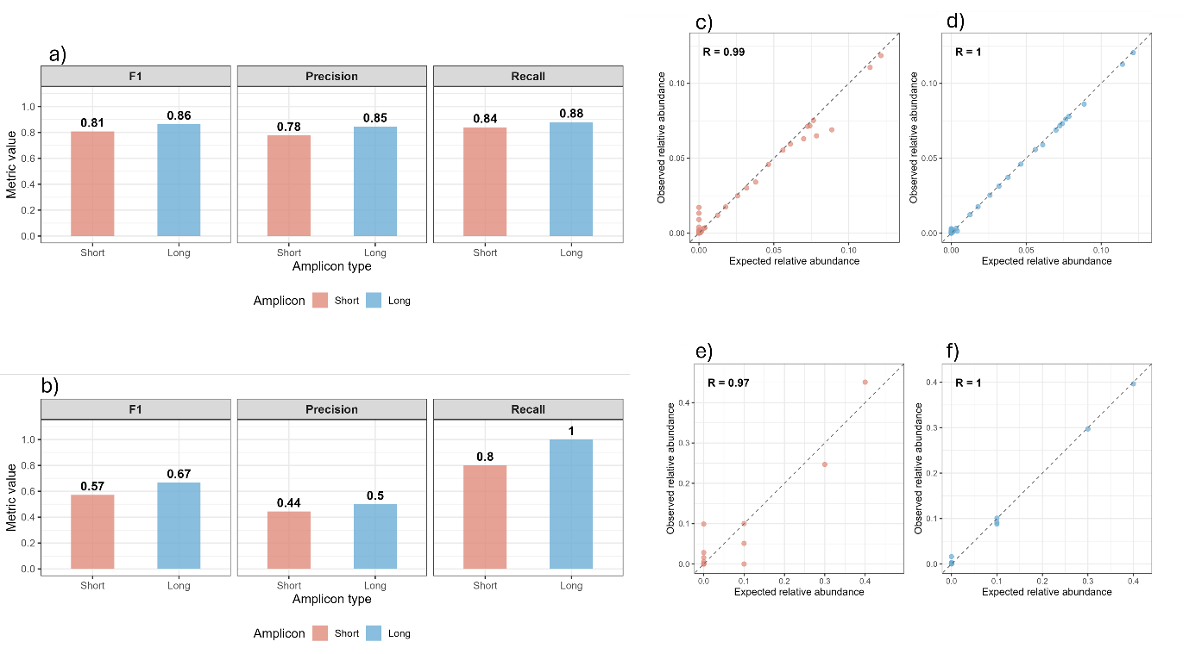

Figure 1. Dry mock communities reveal marker-length-dependent improvements across fungal ITS and bacterial 16S benchmarks.
Dry (in silico) mock communities with known taxonomic composition and abundance structure were analysed with LOREON to compare short and long amplicon configurations for the two main microbial metabarcoding markers. a,b, Species-level F1 score, precision and recall for bacterial 16S (a) and fungal ITS (b) dry mock communities. For bacteria, the short amplicon (orange coloured) corresponded to the V3–V4 region and the long amplicon (light blue coloured) to the full-length 16S rRNA gene, both analysed against SILVA. For fungi, the short amplicon (orange coloured) corresponded to ITS1–5.8S–ITS2 analysed against UNITE, whereas the long amplicon (light blue coloured) spanned 18S–ITS–LSU D1/D2 and was analysed against Eukaryome. Bars show metric values after filtering low-abundance observed taxa. c,d, Observed versus expected relative abundances for short (c) and long (d) 16S datasets. e,f, Observed versus expected relative abundances for short (e) and long (f) ITS datasets. Each point represents one taxon, dashed lines indicate the expected 1:1 relationship and R values indicate Pearson correlation coefficients. Across both marker systems, long amplicons improved classification metrics and produced tighter agreement between observed and expected abundances.

3.3) Long ITS improves taxon recovery and abundance reconstruction in wet simulated fungal communities
Seeing that in fully synthetic datasets longer barcode regions improved taxonomic reconstruction under controlled conditions, we next assessed whether this advantage persisted in a more realistic experimental setting. Because fungal metabarcoding remains less well supported by dedicated long-read analysis software than bacterial 16S profiling, we focused this wet-lab validation on fungal mock communities. To this end, defined genomic mixtures were independently amplified using either the standard ITS1–5.8S–ITS2 barcode or the extended 18S–ITS–LSU D1/D2 region, allowing direct comparison of short- and long-marker strategies against a known community ground truth. This design retained a known ground truth while introducing sources of variation typical of laboratory metabarcoding workflows, including primer-dependent amplification bias, differential template recovery and community-specific taxonomic complexity.
In wet simulated fungal mock communities, taxonomic composition strongly influenced assignment performance. Across the six mocks, F1 scores ranged from 0.30 to 0.60 for ITS UltraLong and from 0.125 to 0.375 for ITS Goldstandard, indicating substantial mock-dependent variability. Despite this effect, the extended ITS marker consistently outperformed the standard ITS barcode in every community. ITS UltraLong showed higher F1 values in all six mocks, higher precision in all comparisons (0.19–0.43 versus 0.08–0.30), and equal or higher recall (0.75–1.00 versus 0.25–0.80). The standard ITS approach was affected by both missed expected taxa and abundance distortion: recall dropped to 0.25 in Mock B, 0.33 in Mock D and 0.50 in Mock F, while Pearson correlations with expected abundances were low or negative in several cases, including Mock B (r = −0.26) and Mock D (r = −0.07). ITS UltraLong did not eliminate false-positive assignments, with 7–15 false-positive taxa per mock, but it reduced their impact on community reconstruction and produced a stronger overall agreement between observed and expected abundances, as shown by the higher global correlation in the scatter analysis (R = 0.70 versus R = 0.39 for ITS Goldstandard).

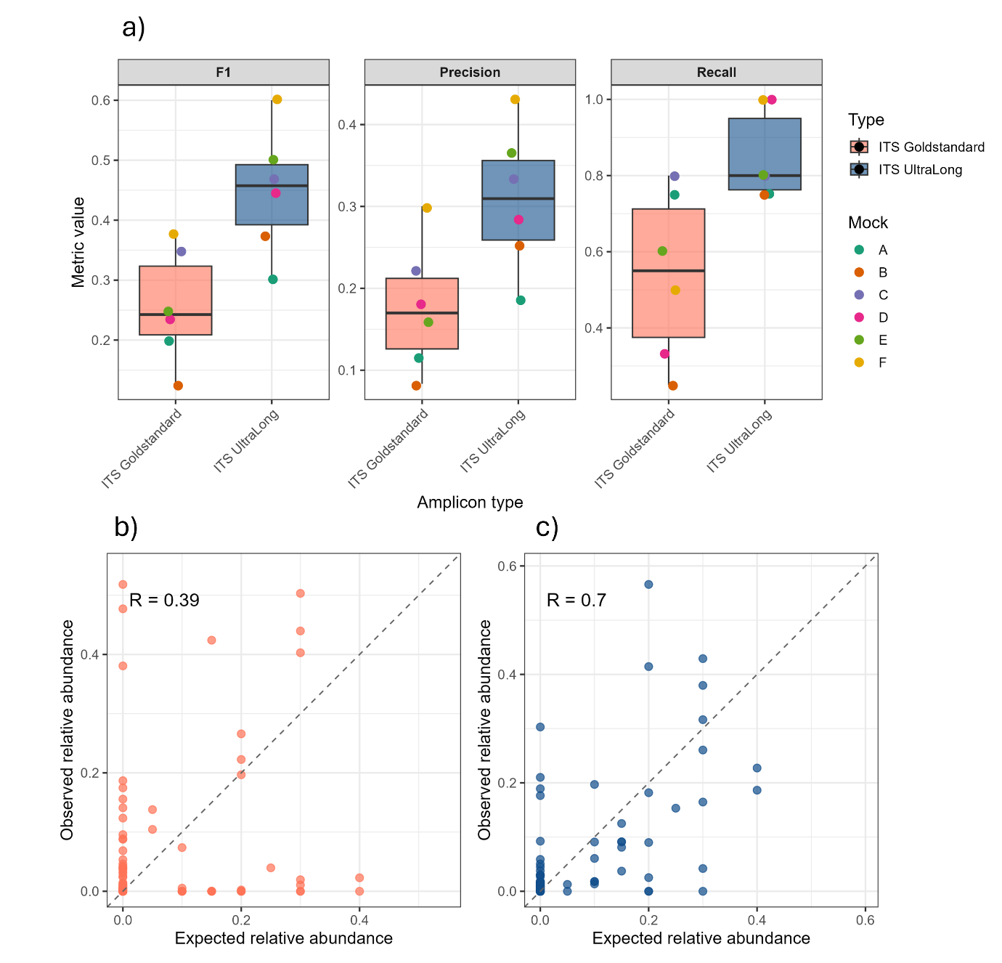
Figure 2. Full – length operon improves species recovery and abundance reconstruction in wet simulated fungal mock communities.
Wet simulated fungal mock communities with known ground-truth composition were independently amplified using either the standard ITS1–5.8S–ITS2 barcode (orange coloured) or the extended 18S–ITS–LSU D1/D2 region (blue coloured) and analysed with LOREON. a) Species-level F1 score, precision and recall across six fungal mock communities. Boxplots summarize the distribution of metric values for ITS Goldstandard and ITS UltraLong analyses; points indicate individual mock communities A–F. Metrics were computed from observed and expected taxonomic profiles using a relative-abundance threshold of 0.0005. Across all six mocks, ITS UltraLong produced higher F1 scores and higher precision than ITS Goldstandard, with equal or higher recall. b,c) Observed versus expected relative abundance for ITS Goldstandard (b) and ITS UltraLong (c) datasets. Each point represents one taxon in one mock community; dashed lines indicate the expected 1:1 relationship and R values indicate Pearson correlation coefficients. Compared with the standard ITS barcode, the Full – length operon produced a stronger agreement with the expected abundance structure, although residual false-positive assignments and abundance deviations remained detectable.

3.4) Sensitivity to abundance filtering threshold
To assess whether the improved classification performance of the ITS ultra-long strategy over the standard ITS barcode was robust to the choice of abundance filtering threshold, we performed a sensitivity analysis by computing mean precision, recall and F1 score across all six wet mock communities at twelve relative-abundance thresholds ranging from 0% to 20% (Figure 3)
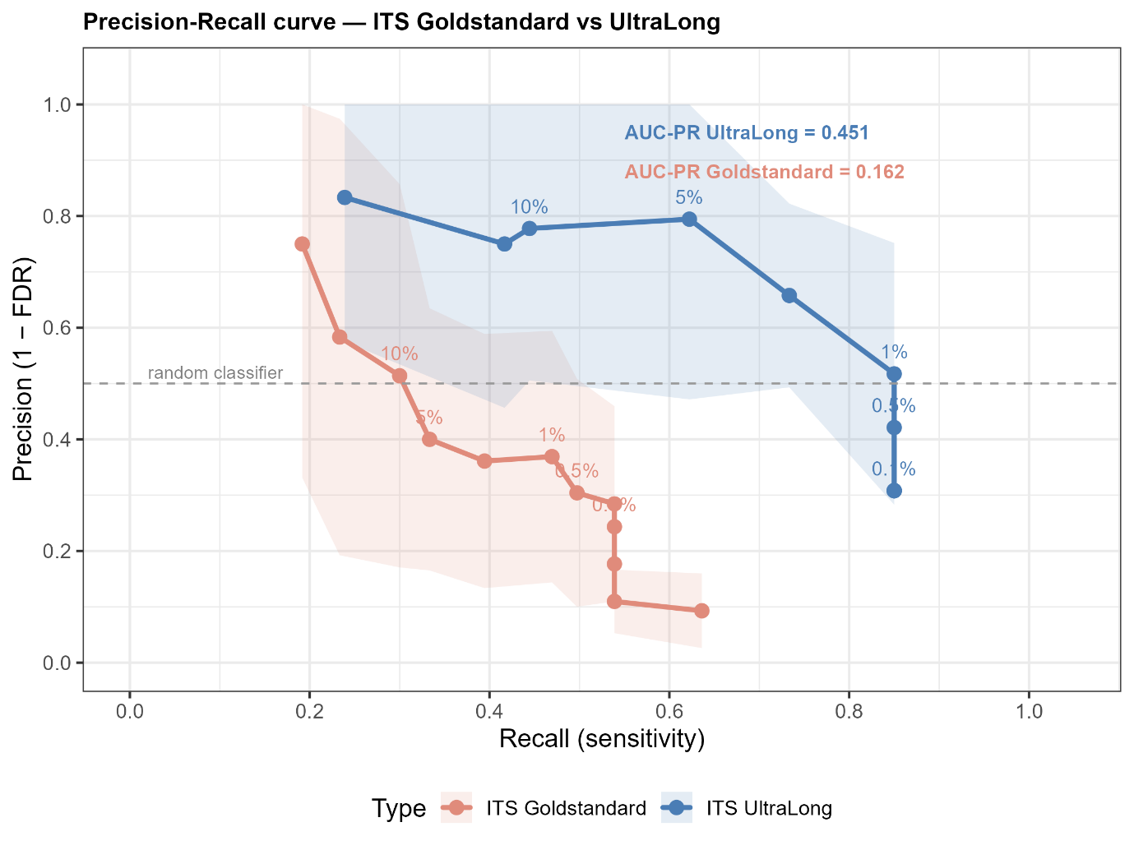
Figure 3. Precision–recall analysis shows that the ITS UltraLong advantage is robust to abundance-threshold selection.
Precision–recall curves were generated for wet simulated fungal mock communities by applying increasing relative-abundance thresholds to the observed taxonomic profiles obtained with LOREON. The expected species set was kept fixed for each mock community, so recall (x-axis) represents the fraction of ground-truth taxa recovered at each threshold, whereas precision (y-axis) represents the fraction of retained taxa that were expected. Points show mean precision and recall across the six mock communities for each abundance threshold; shaded ribbons indicate ±1 s.d. across mocks. Threshold labels indicate selected cutoffs expressed as percentages of relative abundance. The dashed horizontal line denotes a random-classifier baseline. The ITS UltraLong strategy occupied a consistently more favourable region of the precision–recall space than ITS Goldstandard, with a higher area under the precision–recall curve (AUC-PR = 0.451 versus 0.162). This indicates that the extended ITS marker maintained a better balance between sensitivity and false-discovery control across a broad range of detection stringencies.

The resulting precision–recall curves revealed a consistent advantage of the ITS ultra-long strategy across the entire threshold range. The ITS ultra-long curve occupied the upper-right region of the precision–recall space at every threshold, yielding an area under the curve (AUC-PR) of 0.451 compared with 0.162 for the standard ITS barcode — a 2.8-fold difference.
Notably, the ITS ultra-long curve exhibited a non-monotonic behaviour between the 10% and 5% thresholds, where both precision and recall increased simultaneously. This pattern is consistent with the composition of the mock communities, several of which contained expected species at 5–10% relative abundance (e.g. Mock C: C. haemulonii and M. pulcherrima at 5%; Mocks D, E and F: multiple species at 10%): lowering the threshold from 10% to 5% recovered these true-positive taxa without proportionally increasing false-positive detections. No analogous recovery was observed for the standard ITS barcode, whose precision continued to decline monotonically with increasing recall.
Inter-mock variability, represented as ± 1 standard deviation ribbons around the mean curves, was moderate for both strategies but did not produce overlapping confidence bands at any threshold below 5% relative abundance, indicating that the performance difference between the two marker strategies was consistent across communities of varying taxonomic composition and complexity.
To provide a threshold-independent summary of the advantage, we computed the difference in F1 score between the ITS ultra-long and standard ITS strategies (ΔF1) for each mock community at each threshold. At operationally relevant abundance thresholds (≤ 0.1% relative abundance), the F1 score of the ITS ultra-long strategy exceeded that of the standard ITS barcode in all 24 pairwise comparisons across six mock communities (mean ΔF1 = 0.224, range 0.027–0.389), confirming that the advantage of the extended marker is robust to detection stringency. At higher thresholds (> 0.5%), the advantage became community-dependent, with mock-specific outcomes reflecting differences in the number and abundance of expected species relative to the filtering cutoff.

3.5) Computational Performance Across Platforms
LOREON was benchmarked on all three hardware configurations across the three analysis types. A comprehensive summary is provided in Table 2, while Figure 4 presents the cross-platform wall time and peak RAM comparisons visually.

Table 2. LOREON performance summary across platforms and analysis types. All peak RAM values refer to the LOREON orchestrator process; minimap2 process memory is additionally ~2–4 GB depending on database size.
Analysis | Platform | Reads | Wall Time (s) | Peak RAM (MB) | Threads
ITS Standard | macOS M4 Pro | 106,136 | 37.9 | 165 | 10 (4/job)
ITS Standard | Ubuntu Lab WS | 106,136 | 59.3 | 153 | 20 (4/job)
ITS Standard | Windows 11 | 106,136 | 125.6 | 142 | 8 (4/job)
ITS Ultra-Long | macOS M4 Pro | 472,389 | 49.3 | 130 | 10 (4/job)
ITS Ultra-Long | Ubuntu Lab WS | 472,389 | 364.7 | 157 | 20 (4/job)
ITS Ultra-Long | Windows 11 | 472,389 | 567.6 | 150 | 8 (4/job)
16S rRNA | macOS M4 Pro | 958,655 | 3,408.6 | 155 | 10 (4/job)

The Apple M4 Pro workstation achieved the best absolute throughput, completing the ITS standard analysis (106,136 reads, 6 barcodes) in 37.9 s total wall time, of which 34.6 s were in the minimap2 mapping step. Peak resident memory of the LOREON orchestrator process remained consistently below 170 MB across all analysis types on all platforms, demonstrating that the Python orchestration layer imposes negligible memory overhead regardless of dataset size.
The ultra-long ITS analysis () is particularly instructive: despite a 4.5-fold increase in the number of reads (472,389 vs 106,136), LOREON completed the M4 Pro run in 49.3 s—only 30% slower than ITS Gold standard—because the longer reads map efficiently to the extended Eukariome database and the parallel job scheduling maximises CPU utilisation. On the Ubuntu laboratory workstation (Intel i5-6400T, 4 cores), the same analysis was completed in 364.7 s, reflecting the reduced parallelism available on a 4-core CPU running 20 total threads across 6 barcode jobs (effectively limited to 4 simultaneous threads). Windows 11 performance (567.6 s for ITS UltraLong) reflects the overhead of the Docker-based execution mode required on that platform, which introduces additional container I/O costs, particularly for the sequential file filtering step (11.8 s vs 1.7 s on macOS).
The 16S rRNA analysis with the large SILVA NR99 database (510,495 entries) on 958,655 reads required 56.8 minutes on the M4 Pro. This is dominated entirely by the minimap2 alignment step (99.9% of total wall time); the orchestration overhead—taxonomy parsing, read filtering, OTU aggregation, and report generation combined—amounted to only 3.8 s (Figure 5). This exceptionally low orchestration overhead is a direct consequence of the DuckDB-based OTU aggregation architecture: the entire PIVOT–JOIN–split operation on 510,495 taxonomic entries and ~958,000 read assignments required 0.21 s and 23 MB of memory.

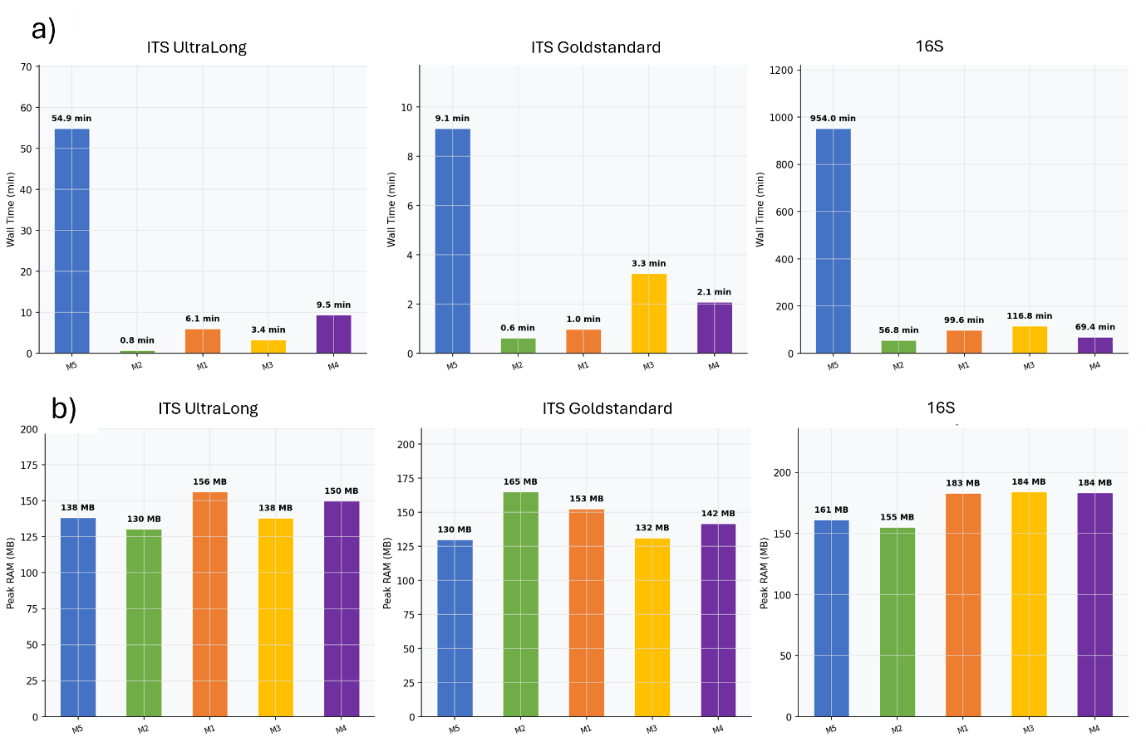

Figure 4. Cross-platform computational benchmarking of LOREON.
a) Total wall time (minutes) for ITS Goldstandard, ITS ultra-long, and 16S rRNA analyses on three hardware configurations. b) Peak resident memory (MB) of the LOREON orchestrator process under the same conditions. Note: minimap2 process memory (2–4 GB, database-dependent) is excluded from orchestrator RAM; it is identical across platforms for the same analysis type. Lower is better for both panels.

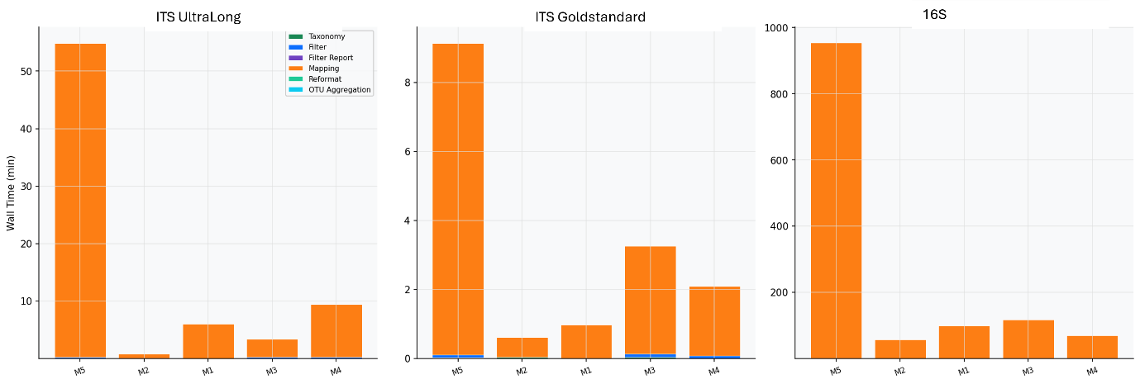
Figure 5. Step-by-step wall time breakdown for LOREON analyses across platforms.
The mapping step (minimap2 + samtools) consistently accounts for >99% of total analysis time, confirming that LOREON's orchestration overhead is negligible. Non-mapping steps (taxonomy parsing, filtering, DuckDB aggregation, report generation) are shown in expanded scale in the inset.

3.6) LOREON versus EPI2ME wf-16s: A Direct Comparison
The head-to-head comparison between LOREON and the EPI2ME wf-16s workflow on identical hardware (Apple M4 Pro) and input data (MBARC 16S mock, 958,655 reads) is summarised in Table 3 and Figure 6. Results demonstrate that LOREON achieves equivalent total analysis time (56.8 vs. 60.1 minutes; 5.4% faster) while offering multiple quantifiable resource advantages stemming from its architectural differences.

Table 3. Direct comparison of LOREON and EPI2ME wf-16s on the MBARC 16S mock community dataset (958,655 reads) on Apple M4 Pro (14 cores, 24 GB RAM, macOS Sequoia 15).
Metric | LOREON | EPI2ME wf-16s | Difference
Wall time (total) | 3,408.6 s (56.8 min) | 3,603.5 s (60.1 min) | LOREON −5.4%
Orchestration overhead | 3.8 s | 123.5 s | LOREON 32× less
Peak RAM (minimap2) | 3.73 GB | 5.2 GB | LOREON 1.4× less
Orchestrator RAM | 155 MB | ~438 MB (JVM + Nextflow) | LOREON 2.8× less
Reads mapped | 958,646 (100.0%) | 937,342 (97.8%) | +21,304 reads
OTU aggregation time | 0.21 s | 14.5 s | LOREON 57× faster
OTU aggregation RAM | ~23 MB | ~397 MB | LOREON 17× less
Setup time (first run) | ~15–20 min | ~2–4 hours | LOREON strongly preferred

The most striking difference is in orchestration overhead. EPI2ME's Nextflow-based architecture incurs a fixed overhead of ~123.5 s per run, regardless of dataset size, for JVM initialisation, Groovy/DSL2 DAG compilation, Nextflow process management, database download, fastcat read ingestion, taxonomy assignment, and report generation. LOREON's Python multiprocessing orchestrator reduces this to 3.8 s (32-fold reduction). This overhead disparity is most impactful on small datasets and repeated analyses, where the fixed cost of the Nextflow JVM bootstrap becomes a disproportionate fraction of total runtime.
Memory consumption differences are also significant from a practical standpoint. EPI2ME's minimap2 process peaked at 5.2 GB RSS, compared with LOREON's 3.73 GB—a 1.4-fold difference likely attributable to different minimap2 index loading and buffer management strategies. The EPI2ME Nextflow orchestrator itself consumed approximately 438 MB (makeReport step peak), compared to LOREON's 155 MB Python process. On a standard consumer laptop with 8 GB of RAM, this difference may be the deciding factor between a successful run and an out-of-memory failure, particularly when other applications are running concurrently.
Regarding mapping coverage, LOREON mapped all 958,646 of the 958,655 input reads (100.0%) with no quality filters applied, compared to EPI2ME's 937,342 reads (97.8%). The 21,313-read difference reflects EPI2ME's default active quality filters (minimum percent identity 10%, reference coverage 10%, length filter 800–2,000 bp). In a fully equivalent configuration with matched filters, mapping rates would be expected to be statistically indistinguishable, as both tools use essentially the same minimap2 version (2.28-r1221 vs. 2.28-r1209) and the map-ont preset.
The OTU aggregation step merits particular attention. EPI2ME's createAbundanceTables Nextflow task consumed 14.5 s and 397 MB of memory. LOREON's DuckDB aggregation completed the equivalent operation in 0.21 s (57-fold faster) and 23 MB (17-fold less memory). This advantage scales with dataset size: for large-scale studies with tens of millions of reads and thousands of OTUs, the difference between a seconds-scale and tens-of-seconds-scale aggregation becomes important for iterative re-analysis workflows.

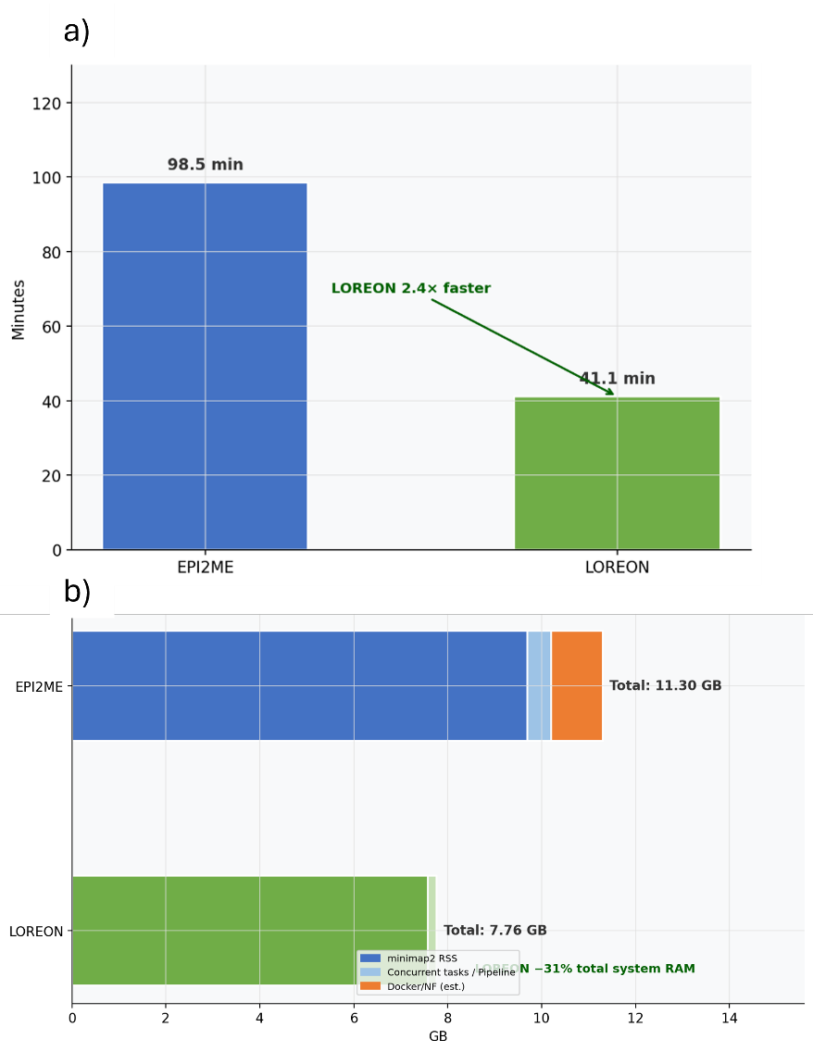

Figure 6. LOREON versus EPI2ME wf-16s.
Comparison on the 16S mock community dataset (958,655 reads, Apple M4 Pro 14-core, 24 GB RAM). a) Wall time decomposition: mapping step (dark) versus orchestration overhead (light). LOREON's overhead is 32-fold lower. b) Peak RSS memory: minimap2 process and orchestrator process for each tool. LOREON consumes 1.4× less minimap2 memory and 2.8× less orchestrator memory.

3.7) Accessibility and Learning Curve
A defining feature of LOREON relative to alternative tools is its accessibility for users without bioinformatics training. The hardware summary table (Figure 7) contextualises the benchmark results within the diversity of laboratory hardware, while Supplementary Table S1 provides a detailed comparison of prerequisites, installation steps, and time-to-first-result for LOREON versus a representative Nextflow pipeline.

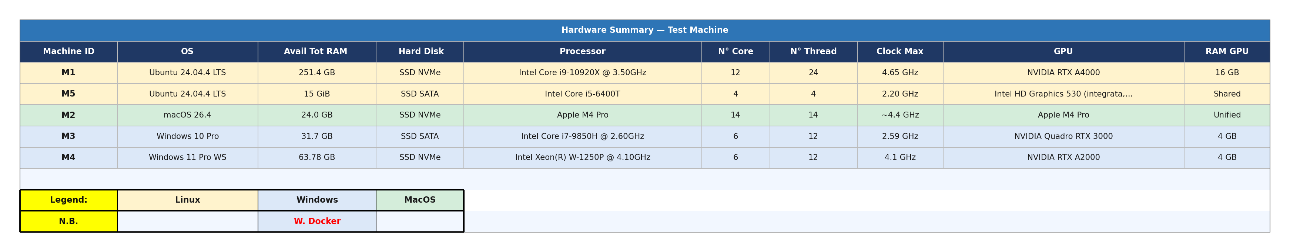
Figure 7. Hardware specifications summary for the three benchmarked platforms. All three represent hardware commonly available in academic and industrial microbiology laboratories without HPC infrastructure.

Installation of LOREON requires a single platform-specific installer (DMG for macOS, DEB for Ubuntu, EXE for Windows) plus installation of minimap2 and samtools—two widely available bioinformatics tools available via a single conda install or apt install command on macOS and Linux, and bundled automatically within the Docker container used on Windows. At first launch, LOREON automatically creates an isolated Python virtual environment containing all required libraries (BioPython, pandas, DuckDB, Plotly, Jinja2), requiring only Python ≥3.8 to be present on the host system. Time to first successful analysis from a fresh installation is approximately 15–20 minutes on all three platforms, including software installation and initial pipeline configuration.
In contrast, deploying a representative Nextflow-based ONT metabarcoding pipeline requires installation of Java 11+ (JDK), the Nextflow runtime, Docker or Singularity, Git, and optionally Conda/Mamba, followed by cloning the pipeline repository, configuring a nextflow.config file with executor profiles, preparing a samplesheet CSV, and downloading or configuring reference databases. The entire process typically requires 2–4 hours for a user with prior experience, and 1–2 days for a user encountering these tools for the first time. A user with no prior bioinformatics exposure cannot realistically achieve independent pipeline operation without dedicated training sessions. LOREON eliminates this barrier entirely through its graphical point-and-click interface: input folder, database file, output folder, three parameter sliders, and a START button.

4. Discussion
The results presented here demonstrate that combining an accessible computational infrastructure with extended-length molecular markers yields measurable improvements in metabarcoding accuracy across both fungal and bacterial systems. LOREON provides a unified, cross-platform framework that supports any barcode marker for which a reference database is available, runs on hardware as modest as a four-core laptop with 15 GB of RAM, and requires no command-line expertise. At the same time, the systematic comparison between standard and ultra-long ITS amplicons provides quantitative evidence that extending the fungal barcode beyond the canonical ITS1–5.8S–ITS2 region substantially improves taxonomic assignment, particularly for lineages where ITS alone provides insufficient discriminatory power. This pattern is consistent with recent findings in vertebrate eDNA metabarcoding, where longer amplicons (~2 kb) spanning the mitochondrial 12S–16S region improved species-level assignment of closely related taxa compared to standard short markers [45].
The synthetic 16S benchmark confirmed that the framework reference-based alignment with minimap2 achieves high accuracy when applied to a well-curated marker (F1 = 0.86, Spearman ρ = 0.997 for full-length reads), with all metrics improving when extending from V3–V4 to full-length 16S. In fungal metabarcoding, the impact of marker length was more pronounced. The ITS region, despite its role as the universal fungal barcode, presents well-documented challenges: high length variability [46], intra-genomic copy heterogeneity [47,48] and limited phylogenetic resolution for closely related species [49]. Across all six wet mock communities, the extended 18S–ITS–LSU strategy consistently outperformed the standard ITS barcode, with higher F1 scores in every comparison and improved abundance reconstruction (R = 0.70 versus R = 0.39). The sensitivity analysis confirmed that this advantage was robust to filtering threshold: precision–recall curves showed a 2.8-fold higher AUC-PR for the extended marker (0.451 versus 0.162), and the F1 advantage was positive in all 24 pairwise comparisons at operationally relevant thresholds (≤ 0.1%). Notably, the ITS ultra-long curve exhibited a non-monotonic pattern between the 10% and 5% thresholds, where both precision and recall increased simultaneously — indicating that the noise floor of the extended marker is concentrated at very low abundances, allowing true-positive recovery before proportional increases in false-positive detections.
The biological significance of marker length was most strikingly illustrated by Mock B, a community composed entirely of four congeneric species within the Debaryomyces/Dipodascus clade. With the standard ITS barcode, 85.8% of the reconstructed community was assigned to two false-positive taxa (Dipodasocus sp. 47.7%; Yamadazyma takamatsuzukensis 38.1%), while the four expected species received between 0.0% and 0.2% of reads — a complete qualitative inversion of the true community structure. The extended 18S–ITS–LSU marker resolved this substantially: three of four expected species were correctly identified (D. robertsiae 56.6%, D. hansenii 18.6%, D. udenii 18.2%), and residual false positives were congeneric species below 1% relative abundance. Conversely, Mock A — composed of species from well-separated genera — showed equivalent performance for both strategies at intermediate thresholds (ΔF1 = 0 at 0.2%), confirming that the advantage of the extended marker is proportional to the taxonomic challenge and greatest precisely where the standard barcode is most likely to fail.
From a computational perspective, the head-to-head comparison with EPI2ME wf-16s demonstrated that competitive analytical performance does not require high-performance computing or specialist expertise. LOREON achieved equivalent total analysis time (56.8 versus 60.1 minutes) with 32-fold lower orchestration overhead and 57-fold faster OTU aggregation through its DuckDB engine [43]. These differences are most consequential for iterative workflows — parameter tuning, threshold testing, multi-database comparison — where the fixed Nextflow bootstrap cost becomes a disproportionate fraction of runtime [50] . The low memory footprint (155 MB orchestrator, 3.7 GB peak) ensures viability on consumer hardware [51], removing a practical barrier that determines whether a laboratory can perform its own analyses or must depend on external bioinformatics support.
Several limitations should be noted. As a reference-based approach, LOREON's assignments are entirely dependent on database completeness [52-54]: taxa absent from the database cannot be identified, regardless of marker length — a fundamental constraint distinguishing reference-based methods from de novo approaches such as ASV inference. Residual false positives (7–15 per mock community) likely reflect incomplete reference representation and alignment ambiguity in regions of low sequence complexity [55]. The potential for mitigating these limitations through multi-marker strategies is supported by recent work demonstrating that integration of multiple hypervariable markers with weighted algorithms improves mycobiome classification [56]; LOREON's architecture is inherently compatible with such approaches. Additionally, the present evaluation was conducted on defined mock communities; validation on natural environmental samples will be necessary to establish operational boundaries [57]. Finally, systematic biases intrinsic to ONT-based metabarcoding — primer-dependent amplification efficiency, GC-content effects, and length-dependent mapping biases — may contribute to quantitative distortion independent of the analytical pipeline [58].
Taken together, our results support a shift in metabarcoding strategies toward longer, information-rich marker regions combining variable and conserved elements. LOREON is designed to serve this paradigm: by supporting diverse marker types and reference databases within a unified, accessible framework, and by extending naturally to targeted metagenomics and shotgun applications where analogous challenges of database representativeness and sequence heterogeneity arise [59], it provides a practical foundation for expanding long-read community profiling across research and applied settings.

5. Conclusions
LOREON represents a substantive contribution to the accessibility of long-read ONT metabarcoding and metagenomics analysis. By integrating the same well-validated alignment tools (minimap2, samtools) used by specialist workflows into a cross-platform graphical application with an automated installation process and no HPC dependency, LOREON enables high-quality community profiling analyses to be performed autonomously by laboratory staff without bioinformatics expertise in 15–20 minutes from a fresh software installation.
The three key scientific contributions of this work are: (1) a rigorous demonstration that LOREON achieves precision, recall, and F1 scores fully suitable for publication across three metabarcoding strategies (ITS standard, ITS ultra-long, 16S rRNA); (2) the first systematic quantitative comparison of standard versus ultra-long ITS amplicon ONT sequencing for fungal community profiling, showing that the extended ITS–LSU approach substantially reduces false-positive species assignments; and (3) a direct performance benchmark against EPI2ME wf-16s demonstrating equivalent analytical performance with 32-fold lower orchestration overhead, 1.4-fold lower peak memory consumption, and dramatically lower deployment complexity on standard laboratory hardware.
LOREON is open-source, actively developed, and designed with extensibility in mind: future releases will incorporate additional reference database integrations. We anticipate that LOREON will significantly expand the adoption of long-read ONT metabarcoding in microbiology, food science, environmental monitoring, and clinical diagnostics laboratories that currently lack the computational infrastructure or bioinformatics expertise required to leverage their sequencing investments fully.

Acknowledgements
Italian PNNR project has contributed by supporting R.S. and A.C (grant ECS00000041—VITALITY—CUP J97G22000170005.).
European Project Eco2Wines (EU-HORIZON-MSCA-2022- Project 101119480) has contributed partially to the accomplishment of the paper.

Author Contributions
R.S.: conceptualisation, software development, validation, formal analysis, visualisation, writing – original draft. A.C.: conceptualisation, biological validation, writing – review and editing, supervision. G.C.: conceptualisation, resources, writing – review and editing, supervision, funding acquisition. All authors read and approved the final manuscript.

Competing Interests
The authors declare no competing interests.

Data Availability
LOREON source code is publicly available at https://github.com/iscka/loreon (MIT licence). Mock community sequencing datasets and benchmark performance reports are available from the corresponding author upon reasonable request. Reference databases used in this study (UNITE, Eukariome, SILVA) are publicly available from their respective repositories.

References
1. Schloss, P.D.; Westcott, S.L.; Ryabin, T.; Hall, J.R.; Hartmann, M.; Hollister, E.B.; Lesniewski, R.A.; Oakley, B.B.; Parks, D.H.; Robinson, C.J. Introducing mothur: open-source, platform-independent, community-supported software for describing and comparing microbial communities. Applied and environmental microbiology 2009, 75, 7537–7541.
2. Callahan, B.J.; McMurdie, P.J.; Holmes, S.P. Exact sequence variants should replace operational taxonomic units in marker-gene data analysis. The ISME journal 2017, 11, 2639–2643.
3. Callahan, B.J.; McMurdie, P.J.; Rosen, M.J.; Han, A.W.; Johnson, A.J.A.; Holmes, S.P. DADA2: High-resolution sample inference from Illumina amplicon data. Nature methods 2016, 13, 581–583.
4. Fasolo, A.; Deb, S.; Stevanato, P.; Concheri, G.; Squartini, A. ASV vs OTUs clustering: Effects on alpha, beta, and gamma diversities in microbiome metabarcoding studies. PLoS One 2024, 19, e0309065.
5. Bolyen, E.; Rideout, J.R.; Dillon, M.R.; Bokulich, N.A.; Abnet, C.C.; Al-Ghalith, G.A.; Alexander, H.; Alm, E.J.; Arumugam, M.; Asnicar, F. Reproducible, interactive, scalable and extensible microbiome data science using QIIME 2. Nature biotechnology 2019, 37, 852–857.
6. Hakimzadeh, A.; Abdala Asbun, A.; Albanese, D.; Bernard, M.; Buchner, D.; Callahan, B.; Caporaso, J.G.; Curd, E.; Djemiel, C.; Brandström Durling, M. A pile of pipelines: An overview of the bioinformatics software for metabarcoding data analyses. Molecular ecology resources 2024, 24, e13847.
7. Jain, M.; Koren, S.; Miga, K.H.; Quick, J.; Rand, A.C.; Sasani, T.A.; Tyson, J.R.; Beggs, A.D.; Dilthey, A.T.; Fiddes, I.T. Nanopore sequencing and assembly of a human genome with ultra-long reads. Nature biotechnology 2018, 36, 338–345.
8. Jain, M.; Olsen, H.E.; Paten, B.; Akeson, M. The Oxford Nanopore MinION: delivery of nanopore sequencing to the genomics community. Genome biology 2016, 17, 239.
9. Lerminiaux, N.; Fakharuddin, K.; Adam, H.J.; Bharat, A.; Golding, G.R.; Martin, I.; Mulvey, M.; Mataseje, L.F. Rapid identification of microbial pathogens and antimicrobial resistance from bloodstream infections using long-read sequencing. Microbial Genomics 2026, 12, 001699.
10. Heeger, F.; Bourne, E.C.; Baschien, C.; Yurkov, A.; Bunk, B.; Spröer, C.; Overmann, J.; Mazzoni, C.J.; Monaghan, M.T. Long‐read DNA metabarcoding of ribosomal RNA in the analysis of fungi from aquatic environments. Molecular Ecology Resources 2018, 18, 1500–1514.
11. Albastaki, A.; Smith, J. Choosing Between Short-Read 16S, Full-Length ONT 16S, and Long-Read Shotgun Metagenomics for Soil Microbiome Studies: A Critical Review of the Benchmarking Evidence. Microorganisms 2026, 14, 1132.
12. Wurzbacher, C.; Larsson, E.; Bengtsson‐Palme, J.; Van den Wyngaert, S.; Svantesson, S.; Kristiansson, E.; Kagami, M.; Nilsson, R.H. Introducing ribosomal tandem repeat barcoding for fungi. Molecular ecology resources 2019, 19, 118–127.
13. Leidenfrost, R.M.; Pöther, D.-C.; Jäckel, U.; Wünschiers, R. Benchmarking the MinION: evaluating long reads for microbial profiling. Scientific Reports 2020, 10, 5125.
14. Nicholls, S.M.; Quick, J.C.; Tang, S.; Loman, N.J. Ultra-deep, long-read nanopore sequencing of mock microbial community standards. Gigascience 2019, 8, giz043.
15. Li, H. Minimap2: pairwise alignment for nucleotide sequences. Bioinformatics 2018, 34, 3094–3100.
16. Aslani, F.; Geisen, S.; Ning, D.; Tedersoo, L.; Bahram, M. Towards revealing the global diversity and community assembly of soil eukaryotes. Ecology letters 2022, 25, 65–76.
17. Pearman, W.S.; Freed, N.E.; Silander, O.K. Testing the advantages and disadvantages of short-and long-read eukaryotic metagenomics using simulated reads. BMC bioinformatics 2020, 21, 220.
18. Nilsson, R.H.; Anslan, S.; Bahram, M.; Wurzbacher, C.; Baldrian, P.; Tedersoo, L. Mycobiome diversity: high-throughput sequencing and identification of fungi. Nature Reviews Microbiology 2019, 17, 95–109.
19. Lücking, R.; Aime, M.C.; Robbertse, B.; Miller, A.N.; Ariyawansa, H.A.; Aoki, T.; Cardinali, G.; Crous, P.W.; Druzhinina, I.S.; Geiser, D.M. Unambiguous identification of fungi: where do we stand and how accurate and precise is fungal DNA barcoding? IMA fungus 2020, 11, 14.
20. Schoch, C.L.; Seifert, K.A.; Huhndorf, S.; Robert, V.; Spouge, J.L.; Levesque, C.A.; Chen, W.; Consortium, F.B.; List, F.B.C.A.; Bolchacova, E. Nuclear ribosomal internal transcribed spacer (ITS) region as a universal DNA barcode marker for Fungi. Proceedings of the national academy of Sciences 2012, 109, 6241–6246.
21. Winand, R.; D’hooge, E.; Van Uffelen, A.; Bogaerts, B.; Van Braekel, J.; Hoffman, S.; Roosens, N.H.; Becker, P.; De Keersmaecker, S.C.; Vanneste, K. Investigating fungal diversity through metabarcoding for environmental samples: assessment of ITS1 and ITS2 Illumina sequencing using multiple defined mock communities with different classification methods and reference databases. BMC genomics 2025, 26, 729.
22. Shapkin, V.; Zelenka, T.; Větrovský, T.; Kostovčík, M.; Eichlerová, I.; Kohout, P.; Žifčáková, L.; Borovička, J.; Tomšovský, M.; Adamčík, S. Limitations of Common Molecular Markers in Fungal Biodiversity Analysis and the Benefits of Their Synergistic Use. Molecular Ecology Resources 2026, 26, e70123.
23. Turco, S.; Giubilei, I.; Mahawar, L.; Mazzaglia, A.; Albrectsen, B.R. Comparative Metabarcoding of ITS1, ITS2, and Full‐Length ITS Reveals Marker‐and Tissue‐Specific Variation in Fungal Community Profiling in Potato. Plant‐Environment Interactions 2026, 7, e70168.
24. Colabella, C.; Casagrande Pierantoni, D.; Corte, L.; Roscini, L.; Conti, A.; Bassetti, M.; Tascini, C.; Robert, V.; Cardinali, G. Single strain high-depth NGS reveals high rDNA (ITS-LSU) variability in the four prevalent pathogenic species of the genus Candida. Microorganisms 2021, 9, 302.
25. Colabella, C.; Corte, L.; Roscini, L.; Bassetti, M.; Tascini, C.; Mellor, J.C.; Meyer, W.; Robert, V.; Vu, D.; Cardinali, G. NGS barcode sequencing in taxonomy and diagnostics, an application in “Candida” pathogenic yeasts with a metagenomic perspective. IMA fungus 2018, 9, 91–105.
26. Nilsson, R.H.; Kristiansson, E.; Ryberg, M.; Hallenberg, N.; Larsson, K.-H. Intraspecific ITS variability in the kingdom Fungi as expressed in the international sequence databases and its implications for molecular species identification. Evolutionary bioinformatics 2008, 4, EBO. S653.
27. Stadler, M.; Lambert, C.; Wibberg, D.; Kalinowski, J.; Cox, R.J.; Kolařík, M.; Kuhnert, E. Intragenomic polymorphisms in the ITS region of high-quality genomes of the Hypoxylaceae (Xylariales, Ascomycota). Mycological Progress 2020, 19, 235–245.
28. Rzehak, T.; Praeg, N.; Galla, G.; Seeber, J.; Hauffe, H.C.; Illmer, P. Comparison of commonly used software pipelines for analyzing fungal metabarcoding data. BMC genomics 2024, 25, 1085.
29. Bista, I.; Lino, A. Long‐read sequencing for biodiversity analyses—A comprehensive guide. Methods in Ecology and Evolution 2026, 17, 650–667.
30. Skouroliakou, D.I.; Dupont, D.W.; Vandenboer, Y.; D'hont, S.; Sabbe, K.; Schön, I. Unveiling Protist Composition and Diversity Patterns With eDNA Metabarcoding: Comparing Short‐and Long‐Read Approaches. Ecology and Evolution 2026, 16, e73218.
31. Ritter, C.D.; Dunthorn, M.; Anslan, S.; de Lima, V.X.; Tedersoo, L.; Nilsson, R.H.; Antonelli, A. Advancing biodiversity assessments with environmental DNA: Long‐read technologies help reveal the drivers of Amazonian fungal diversity. Ecology and Evolution 2020, 10, 7509–7524.
32. Mousavi‐Derazmahalleh, M.; Stott, A.; Lines, R.; Peverley, G.; Nester, G.; Simpson, T.; Zawierta, M.; De La Pierre, M.; Bunce, M.; Christophersen, C.T. eDNAFlow, an automated, reproducible and scalable workflow for analysis of environmental DNA sequences exploiting Nextflow and Singularity. Molecular Ecology Resources 2021, 21, 1697–1704.
33. Ewels, P.A.; Peltzer, A.; Fillinger, S.; Patel, H.; Alneberg, J.; Wilm, A.; Garcia, M.U.; Di Tommaso, P.; Nahnsen, S. The nf-core framework for community-curated bioinformatics pipelines. Nature biotechnology 2020, 38, 276–278.
34. Wratten, L.; Wilm, A.; Göke, J. Reproducible, scalable, and shareable analysis pipelines with bioinformatics workflow managers. Nature methods 2021, 18, 1161–1168.
35. The Galaxy platform for accessible, reproducible and collaborative biomedical analyses: 2022 update. Nucleic acids research 2022, 50, W345–W351.
36. Macher, T.H.; Beermann, A.J.; Leese, F. TaxonTableTools: A comprehensive, platform‐independent graphical user interface software to explore and visualise DNA metabarcoding data. Molecular Ecology Resources 2021, 21, 1705–1714.
37. Vasar, M.; Davison, J.; Neuenkamp, L.; Sepp, S.K.; Young, J.P.W.; Moora, M.; Öpik, M. User‐friendly bioinformatics pipeline gDAT (graphical downstream analysis tool) for analysing rDNA sequences. Molecular Ecology Resources 2021, 21, 1380–1392.
38. Li, H.; Handsaker, B.; Wysoker, A.; Fennell, T.; Ruan, J.; Homer, N.; Marth, G.; Abecasis, G.; Durbin, R.; Subgroup, G.P.D.P. The sequence alignment/map format and SAMtools. bioinformatics 2009, 25, 2078–2079.
39. Abarenkov, K.; Zirk, A.; Piirmann, T.; Pöhönen, R.; Ivanov, F.; Nilsson, R.H.; Kõljalg, U. UNITE general FASTA release for eukaryotes 2. (No Title) 2020.
40. Nilsson, R.H.; Larsson, K.-H.; Taylor, A.F.S.; Bengtsson-Palme, J.; Jeppesen, T.S.; Schigel, D.; Kennedy, P.; Picard, K.; Glöckner, F.O.; Tedersoo, L. The UNITE database for molecular identification of fungi: handling dark taxa and parallel taxonomic classifications. Nucleic acids research 2019, 47, D259–D264.
41. Quast, C.; Pruesse, E.; Yilmaz, P.; Gerken, J.; Schweer, T.; Yarza, P.; Peplies, J.; Glöckner, F.O. The SILVA ribosomal RNA gene database project: improved data processing and web-based tools. Nucleic acids research 2012, 41, D590–D596.
42. Tedersoo, L.; Hosseyni Moghaddam, M.S.; Mikryukov, V.; Hakimzadeh, A.; Bahram, M.; Nilsson, R.H.; Yatsiuk, I.; Geisen, S.; Schwelm, A.; Piwosz, K. EUKARYOME: the rRNA gene reference database for identification of all eukaryotes. Database 2024, 2024, baae043.
43. Raasveldt, M.; Mühleisen, H. Duckdb: an embeddable analytical database. In Proceedings of the Proceedings of the 2019 international conference on management of data, 2019; pp. 1981–1984.
44. Conti, A.; Casagrande Pierantoni, D.; Robert, V.; Corte, L.; Cardinali, G. MinION sequencing of yeast mock communities to assess the effect of databases and ITS-LSU markers on the reliability of metabarcoding analysis. Microbiology spectrum 2023, 11, e01052–01022.
45. Doorenspleet, K.; Jansen, L.; Oosterbroek, S.; Kamermans, P.; Bos, O.; Wurz, E.; Murk, A.; Nijland, R. The Long and the Short of It: Nanopore‐Based eDNA Metabarcoding of Marine Vertebrates Works; Sensitivity and Species‐Level Assignment Depend on Amplicon Lengths. Molecular Ecology Resources 2025, 25, e14079.
46. Min, X.J.; Hickey, D.A. Assessing the effect of varying sequence length on DNA barcoding of fungi. Molecular Ecology Notes 2007, 7, 365–373.
47. Estensmo, E.L.F.; Maurice, S.; Morgado, L.; Martin‐Sanchez, P.M.; Skrede, I.; Kauserud, H. The influence of intraspecific sequence variation during DNA metabarcoding: A case study of eleven fungal species. Molecular Ecology Resources 2021, 21, 1141–1148.
48. Korabečná, M.; Liška, V.; Fajfrlík, K. Primers ITS1, ITS2 and ITS4 detect the intraspecies variability in the internal transcribed spacers and 5.8 S rRNA gene region in clinical isolates of fungi. Folia microbiologica 2003, 48, 233–238.
49. Vu, D.; Groenewald, M.; De Vries, M.; Gehrmann, T.; Stielow, B.; Eberhardt, U.; Al-Hatmi, A.; Groenewald, J.Z.; Cardinali, G.; Houbraken, J. Large-scale generation and analysis of filamentous fungal DNA barcodes boosts coverage for kingdom fungi and reveals thresholds for fungal species and higher taxon delimitation. Studies in mycology 2019, 92, 135–154.
50. Spišaková, V.; Hejtmánek, L.; Hynšt, J. Nextflow in bioinformatics: Executors performance comparison using genomics data. Future Generation Computer Systems 2023, 142, 328–339.
51. Roberts, M.; Hayes, W.; Hunt, B.R.; Mount, S.M.; Yorke, J.A. Reducing storage requirements for biological sequence comparison. Bioinformatics 2004, 20, 3363–3369.
52. Keck, F.; Couton, M.; Altermatt, F. Navigating the seven challenges of taxonomic reference databases in metabarcoding analyses. Molecular Ecology Resources 2023, 23, 742–755.
53. Cline, L.C.; Song, Z.; Al-Ghalith, G.A.; Knights, D.; Kennedy, P.G. Moving beyond de novo clustering in fungal community ecology. New Phytologist 2017, 216, 629–634.
54. Martorelli, I.; Helwerda, L.S.; Kerkvliet, J.; Gomes, S.I.; Nuytinck, J.; van der Werff, C.R.; Ramackers, G.J.; Gultyaev, A.P.; Merckx, V.S.; Verbeek, F.J. Fungal metabarcoding data integration framework for the MycoDiversity DataBase (MDDB). Journal of integrative bioinformatics 2020, 17, 20190046.
55. Mugnai, F.; Costantini, F.; Chenuil, A.; Leduc, M.; Ortega, J.M.G.; Meglécz, E. Be positive: customized reference databases and new, local barcodes balance false taxonomic assignments in metabarcoding studies. PeerJ 2023, 11, e14616.
56. Wang, H.; Wu, S.H.; Zhang, K.; Chen, K.-H.; Vilgalys, R.; Liao, H.-L. Multiple hypervariable markers improve mycobiome classification in metatranscriptome and metagenome data. Communications Biology 2026.
57. Schloss, P.D. Identifying and overcoming threats to reproducibility, replicability, robustness, and generalizability in microbiome research. MBio 2018, 9, 10.1128/mbio. 00525–00518.
58. Feau, N.; Laughton, I.; Dicaire, A.; Ramsfield, T.; Tanguay, P.; Tanney, J.B. Fungal Community Profiling and Pathogen Detection in Conifer Seed Lots: Benchmarking Oxford Nanopore DNA Metabarcoding Against Conventional Methods. PhytoFrontiers™ 2025, 5, 582–595.
59. Liu, S.; Rodriguez, J.S.; Munteanu, V.; Ronkowski, C.; Sharma, N.K.; Alser, M.; Andreace, F.; Blekhman, R.; Błaszczyk, D.; Chikhi, R. Analysis of metagenomic data. Nature Reviews Methods Primers 2025, 5, 5.

EPI2ME wf-16s: Oxford Nanopore Technologies, https://github.com/epi2me-labs/wf-16s
LOREON source code and documentation: https://github.com/iscka/loreon

