**Vocabulary**

Anatomy: internal capsule, cerebral peduncles, pons, medullary pyramids, pyramidal tract, pyramidal decussation, infundibulum, substantia nigra, red nucleus, trigeminal nerve, vagus nerve, optic nerve, inferior olive, neural tube, lateral ventricles, 3rd ventricle, 4th ventricle, cerebral spinal fluid, intraventricular foramen of Monro, cerebral/Sylvian aqueduct, choroid plexus, meninges, temporalization, Broca’s area, Wernicke’s area, hippocampus, amygdala, metabotropic receptors, ionotropic receptors, fornix, calcarine fissure, vestibulospinal tract, spinocerebellar tract, pyramidal tract, dorsal column medial lemniscal pathway, rubrospinal tract, corticospinal tract, Pacinian corpuscle

Circuitry: primary sensory neuron, secondary sensory neuron, interneuron, motor neuron, ipsilateral, contralateral, decussate, afferent, efferent, ascending pathway, descending pathway,

**Learning Goals:**

* Review various brain slices
* Discuss anatomical organizations of pathways covered in class

**Midbrain:**

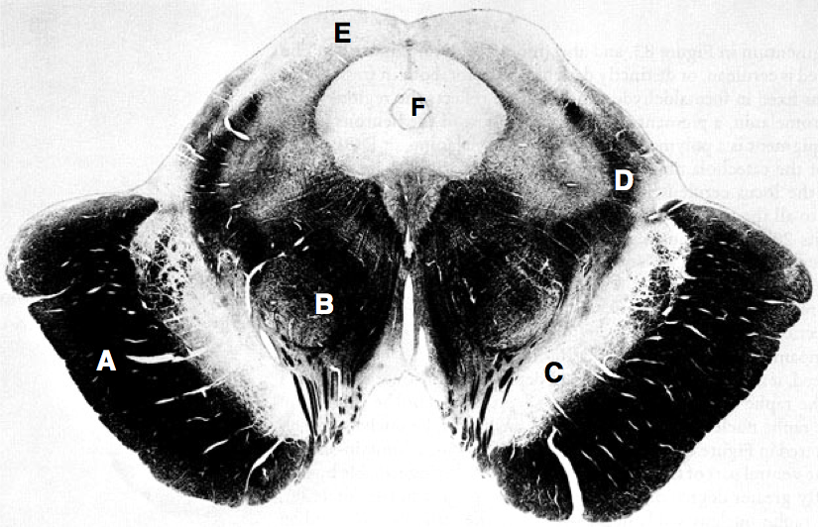

The coronal section above is a **Weigert** stain of the midbrain. You responsible for identifying and describing one region during the review. Work with your group to come up with the answer(s) related to this region. You can fill in information about the other regions on the next page.

|  |  |
| --- | --- |
|  | **Question & Answer** |
| A | Identify this region. Are these axons ascending or descending? What kind of information do they carry? Where do they terminate? Where are their cell bodies located? |
| B | This is the red nucleus. Are these axons ascending or descending? What kind of information do they carry? If the red nucleus is lesioned, what deficits do you expect to observe? |
| C | Identify this region. Name a brain region to which C sends projections. From which embryonic vesicle does C arise? What kind of deficits would you expect to observe if C was lesioned? |
| D | This is the medial lemniscus. Describe the behavior of these fibers before and after they reach the midbrain—where the cell bodies located? Do they cross? Where do they terminate? Are they ascending or descending? What kind of information do they carry? |
| E | Identify this region. Describe two functions of this area. From which embryonic vesicle does this region arise? Is region B ventral or dorsal to this area? Is the inferior colliculus anterior or posterior to this area? |
| F | Identify this region. What is located inside this structure and why is it important in the nervous system? What else does this region connect to? |

**Forebrain:**

**G**

**G**

**F**

**F**

**D**

**C**

**B**

**B**

The coronal section above is a **Weigert** stain of the forebrain. You responsible for identifying and describing one region during the review. Work with your group to come up with the answer(s) related to this region. You can fill in information about the other regions on the next page. Label the starred regions as these areas should be immediately obvious and can help orient you anatomically.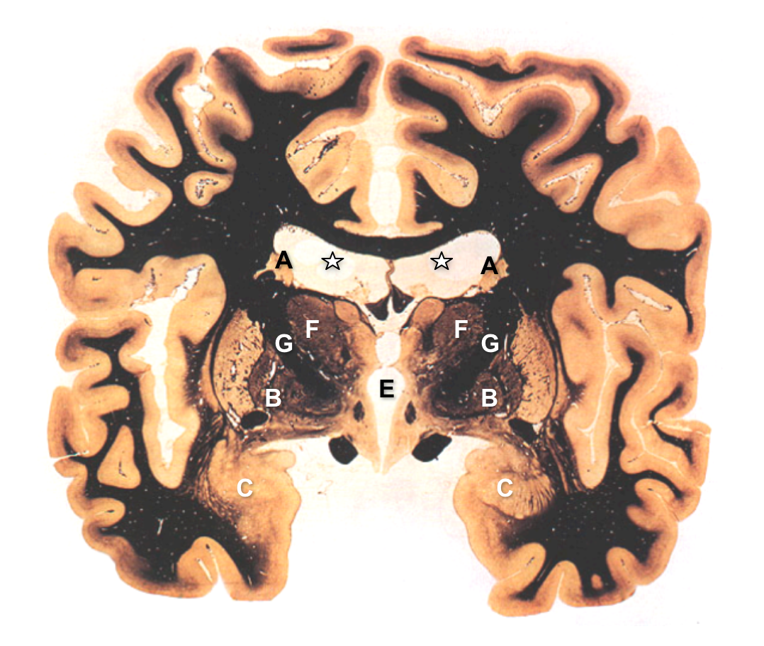

|  |  |
| --- | --- |
|  | **Question & Answer** |
| A | Identify these regions. ~~Are these axons ascending or descending?~~ What part of the motor hierarchy do they participate in? ~~Where do they terminate?~~ Where does their main input come from? Where does their main output go? |
| B | What region of the basal ganglia is this? It has both an inner and an outer segment, label the inner segment. Where does its main output go? What type of connections does it make to its main output? |
| C | Identify this region. Name a brain region to which C sends projections. Which system discussed in lecture does this region belong to? What kind of deficits would you expect to observe if C was lesioned? |
| D | This region is not exactly identifiable from this slice, but if the slice was further rostral it would be obvious due to its horseshoe-like folded shape. What is this region primarily responsible for? Describe the behavioral effects from lesions in this area. Can you label the main output pathway from this region (Hint it is a myelinated area that eventually ends in the mammillary bodies)? |
| E | Identify this region. Describe how this region connects to the starred regions above. What does this structure lack in this diagram that can be identified in the starred regions? Label these structures in the starred regions when you have determined what they are. |
| F | Identify this region. What is located inside this structure and why is it important in the nervous system? What else does this region connect to? |
| G | What is this region? Hint: it is a large tract of myelinated fibers that connects the cortical regions to the medial brain structures. A descending motor pathway dominates its composition, what is this pathway? At this point it should be obvious which labeled structures it separates, list them here. |

**Spinal Cord:**

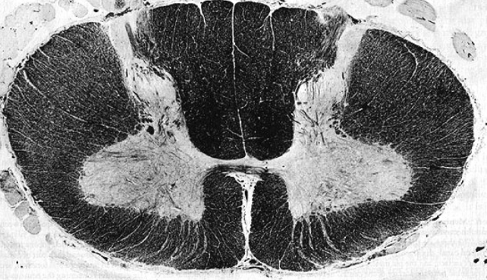

**E**

**D**

**C**

**B**

**B**

**A**

The coronal section above is a Weigert stain of the cervical spinal cord (C7 vertebra). You responsible for identifying and describing one region during the review. Work with your group to come up with the answer(s) related to this region. You can fill in information about the other regions on the next page. Label first the white matter regions and grey matter regions to orient yourself and prepare to label the pathways. Draw arrows to show the flow of information from spinal cord to periphery.

|  |  |
| --- | --- |
|  | **Question & Answer** |
| A | Identify the pathway contained in the inscribed region. Is this tract pyramidal or extrapyramidal? Are these axons ascending or descending? What kind of information do they carry? Where do they terminate? Where are their cell bodies located? What happens when this pathway is lesioned? |
| B | These regions identify the ventral and dorsal parts of which pathway? Label the ventral and dorsal parts respectively. Is this pathway ascending or descending? Where are their cell bodies located? |
| C | Identify the pathway located in this region. Is this pathway ascending or descending? From which midbrain structure does this pathway arise? What kind of deficits would you expect to observe if C was lesioned? |
| D | This is the lateral portion of which tract? Is it ascending or descending? Hint: this pathway ensures that the body remains balanced and postured with relation to the head. Where do the neurons innervating this pathway reside? |
| E | Identify the pathway ascribed in this region. Is this pathway a sensory or a motor pathway? Depending on how you answered the previous question, is it ascending or descending? How many neurons are involved in this pathway (channel)? Does this pathway cross in the spinal cord? Identify an example sensory cell that originates this pathway, the hindbrain region it synapses in, the midbrain region it passes through, and the location of its next synapse. Where is the eventual terminus of this pathway? |