

# **SCHOOL OF SCIENCES**

**ADVANCE PYTHON LAB**

**2024-2026**

# **Lab Exercise-4**

**SUBMITTED TO-**

**Dr. Kavitha R**

**QUESTION:**

**Design a web application to explore the different graphs using layouts**

**a. Identify an interesting StreamlitApp from the given gallery and customise it.**

**Create a word document with the original screen and customised screen.**

**b. Deploy the customised app**

**Streamlit Templates**

**https://streamlit.io/gallery**

**c. Download the CIA-2 submission and Complete it without any**

**support.(Deadline end of Today)**

**CODE:**

**import streamlit as st**

**import requests**

**from datetime import datetime**

**from dotenv import load_dotenv**

**import os**

**import time**

**from streamlit_image_comparison import image_comparison**

**load_dotenv()**

**NASA_API_KEY = os.getenv("NASA_API_KEY")**

**st.set_page_config("Hubble vs Webb & Live Feed", "🔭")**

**st.header("🔭 Hubble vs Webb Telescope & Live Observations")**

**#function to get latest Hubble image from NASA's APOD API**

**def get_nasa_apod():**

**url = f"https://api.nasa.gov/planetary/apod?api_key={NASA_API_KEY}&count=5"**

**try:**

**response = requests.get(url)**

**if response.status_code == 200:**

**return response.json()**

**else:**

**return None**

**except Exception as e:**

**st.error(f"Error fetching NASA APOD data: {e}")**

**return None**

**#Function to get Webb telescope images from NASA's Images API**

**def get_webb_images():**

**url = "https://images-api.nasa.gov/search?q=James%20Webb%20Telescope&media_type=image"**

**try:**

**response = requests.get(url)**

**if response.status_code == 200:**

**data = response.json()**

**return data["collection"]["items"][:5]**

**else:**

**return None**

**except Exception as e:**

**st.error(f"Error fetching Webb telescope images: {e}")**

**return None**

**#Function to get Hubble live feed (if available)**

**def get_hubble_live():**

**hubble_live_url = "https://hubblesite.org/api/v3/live"**

**try:**

**response = requests.get(hubble_live_url)**

**if response.status_code == 200:**

**return response.json()**

**else:**

**return None**

**except Exception as e:**

**st.error(f"Error fetching Hubble live data: {e}")**

**return None**

**#📡 **Hubble Live Feed\*\***

**st.subheader("📡 Hubble Live Feed")**

**hubble_data = get_hubble_live()**

**if hubble_data:**

**target_name = hubble_data.get("target", "Unknown Object")**

**image_url = hubble_data.get("image", "")**

**observation_time = hubble_data.get("timestamp", "")**

**if observation_time:**

**observation_time = datetime.utcfromtimestamp(observation_time).strftime("%Y-%m-%d %H:%M:%S UTC")**

**st.markdown(f"### Currently Observing: {target_name}")**

**if image_url:**

**st.image(image_url, caption=f"Hubble's Live View - {target_name}", use_container_width=True)**

**st.markdown(f"📅 **Observation Time:** {observation_time}")**

**else:**

**st.warning("Hubble live feed is currently unavailable.")**

**#🛰️ **Latest NASA Space Images\*\***

**st.subheader("🛰️ Latest NASA Space Images")**

**nasa_images = get_nasa_apod()**

**if nasa_images:**

**for img_data in nasa_images:**

**title = img_data.get("title", "Unknown Observation")**

**image_url = img_data.get("url", "")**

**explanation = img_data.get("explanation", "No details available.")**

**date = img_data.get("date", "")**

**st.markdown(f"### {title}")**

**if image_url:**

**st.image(image_url, caption=f"{title} ({date})", use_container_width=True)**

**st.markdown(f"📅 **Observation Date:** {date}")**

**st.markdown(f"📝 **Description:** {explanation}")**

**st.write("---")**

**#🔭 **James Webb Space Telescope Images\*\***

**st.subheader("🔭 Latest Images from James Webb Space Telescope")**

**webb_images = get_webb_images()**

**if webb_images:**

**for item in webb_images:**

**title = item["data"][0]["title"]**

**image_url = item["links"][0]["href"]**

**description = item["data"][0].get("description", "No details available.")**

**st.markdown(f"### {title}")**

**st.image(image_url, caption=title, use_container_width=True)**

**st.markdown(f"📝 **Description:** {description}")**

**st.write("---")**

**else:**

**st.warning("No new Webb telescope images available.")**

**#🔭 **Hubble vs Webb Telescope Image Comparison\*\***

**st.subheader("🔭 Hubble vs Webb Telescope Comparison")**

**comparisons = [**

**{**

**"title": "Southern Ring Nebula",**

**"hubble": "https://www.webbcompare.com/img/hubble/southern_nebula_700.jpg",**

**"webb": "https://www.webbcompare.com/img/webb/southern_nebula_700.jpg"**

**},**

**{**

**"title": "Galaxy Cluster SMACS 0723",**

**"hubble": "https://www.webbcompare.com/img/hubble/deep_field_700.jpg",**

**"webb": "https://www.webbcompare.com/img/webb/deep_field_700.jpg"**

**},**

**{**

**"title": "Carina Nebula",**

**"hubble": "https://www.webbcompare.com/img/hubble/carina_2800.png",**

**"webb": "https://www.webbcompare.com/img/webb/carina_2800.jpg"**

**},**

**{**

**"title": "Stephan's Quintet",**

**"hubble": "https://www.webbcompare.com/img/hubble/stephans_quintet_2800.jpg",**

**"webb": "https://www.webbcompare.com/img/webb/stephans_quintet_2800.jpg"**

**}**

**]**

**for comp in comparisons:**

**st.markdown(f"### {comp['title']}")**

**image_comparison(**

**img1=comp["hubble"],**

**img2=comp["webb"],**

**label1="Hubble",**

**label2="Webb"**

**)**

**time.sleep(60)**

**st.experimental_rerun()**

**OUTPUT:**

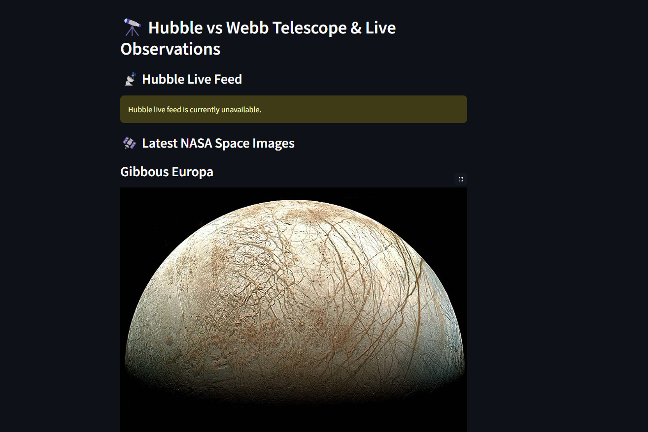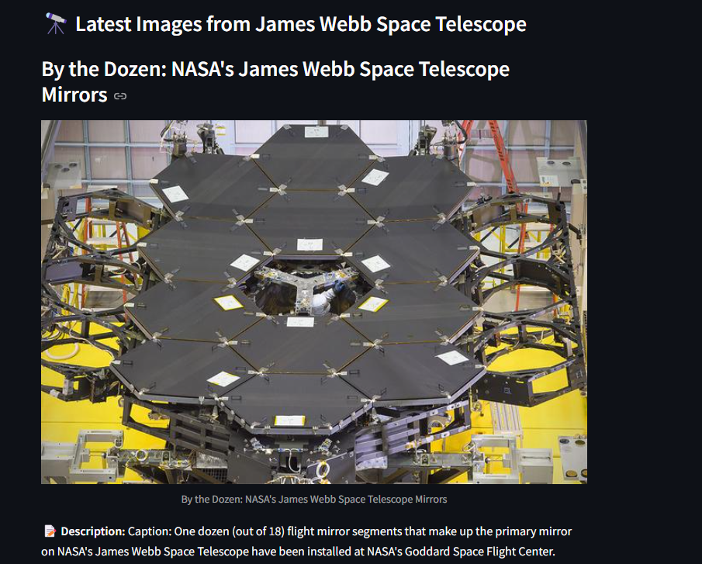

OLDCODE:

import streamlit as st

from streamlit_image_comparison import image_comparison

import cv2

st.set_page_config("Webb Space Telescope vs Hubble Telescope", "🔭")

st.header("🔭 J. Webb Space Telescope vs Hubble Telescope")

st.write("")

"This is a reproduction of the fantastic [WebbCompare](https://www.webbcompare.com/index.html) app by [John Christensen](https://twitter.com/JohnnyC1423). It's built in Streamlit and takes only 10 lines of Python code. If you like this app, please star [John's original repo](https://github.com/JohnEdChristensen/WebbCompare)!"

st.write("")

st.markdown("### Southern Nebula")

image_comparison(

img1="https://www.webbcompare.com/img/hubble/southern_nebula_700.jpg",

img2="https://www.webbcompare.com/img/webb/southern_nebula_700.jpg",

label1="Hubble",

label2="Webb",

)

st.markdown("### Galaxy Cluster SMACS 0723")

image_comparison(

img1="https://www.webbcompare.com/img/hubble/deep_field_700.jpg",

img2="https://www.webbcompare.com/img/webb/deep_field_700.jpg",

label1="Hubble",

label2="Webb",

)

st.markdown("### Carina Nebula")

image_comparison(

img1="https://www.webbcompare.com/img/hubble/carina_2800.png",

img2="https://www.webbcompare.com/img/webb/carina_2800.jpg",

label1="Hubble",

label2="Webb",

)

st.markdown("### Stephan's Quintet")

image_comparison(

img1="https://www.webbcompare.com/img/hubble/stephans_quintet_2800.jpg",

img2="https://www.webbcompare.com/img/webb/stephans_quintet_2800.jpg",

label1="Hubble",

label2="Webb",

)

OUTPUT:

