Real-World Applications 3x3

Three by three systems of linear equations are also used to solve real-life problems. The given problem is expressed as a system of linear equations and then solved to determine the value of the variables. Sometimes, the system will consist of three equations but not every equation will have three variables. Example three is one such problem.

Example 1: Solve the following problem using your knowledge of systems of linear equations.

Jesse, Maria and Charles went to the local craft store to purchase supplies for making decorations for the upcoming dance at the high school. Jesse purchased three sheets of craft paper, four boxes of markers and five glue sticks. His bill, before taxes was $24.40. Maria spent $30.40 when she bought six sheets of craft paper, five boxes of markers and two glue sticks. Charles, purchases totaled $13.40 when he bought three sheets of craft paper, two boxes of markers and one glue stick. Determine the unit cost of each item.

Let p represent the number of sheets of craft paper.
Let m represent the number of boxes of markers.
Let g represent the number of glue sticks.

Express the problem as a system of linear equations:

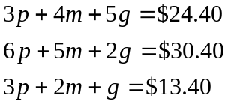
Solve the system of linear equations to determine the unit cost of each item.

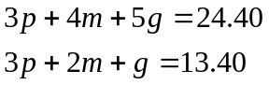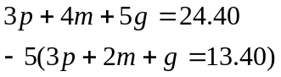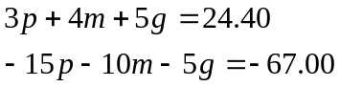
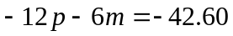

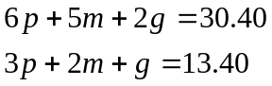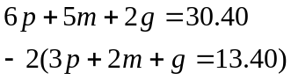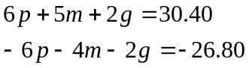
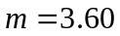

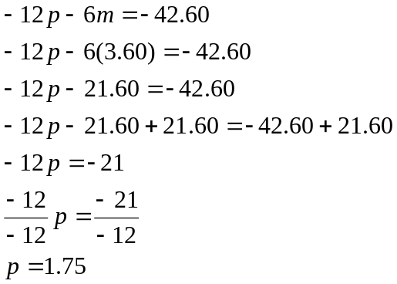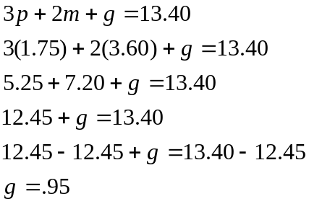

The unit cost of each item is: 1 sheet of craft paper = $1.75
1 box of markers = $3.60
1 glue stick = $0.95

Example 2: Solve the following problem using your knowledge of systems of linear equations.

Rafael, an exchange student from Brazil, made phone calls within Canada, to the United States, and to Brazil. The rates per minute for these calls vary for the different countries. Use the information in the following table to determine the rates.

Month | Time within Canada (min) | Time to the U.S. (min) | Time to Brazil  (min) | Charges  ($)
September | 90 | 120 | 180 | $252.00
October | 70 | 100 | 120 | $184.00
November | 50 | 110 | 150 | $206.00

Let c represent the rate for calls within Canada.
Let u represent the rate for calls to the United States.
Let b represent the rate for calls to Brazil.

Express the problem as a system of linear equations:

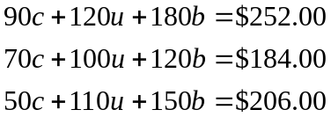

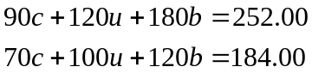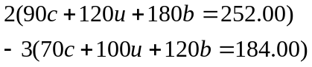

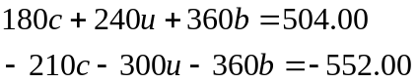
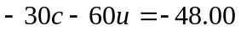

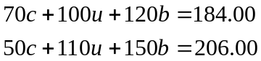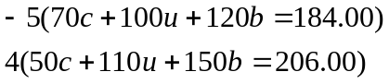

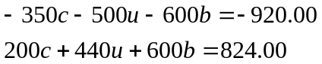
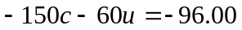

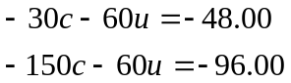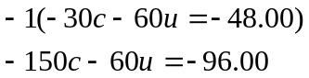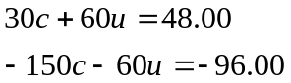
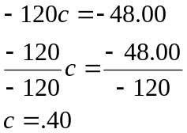

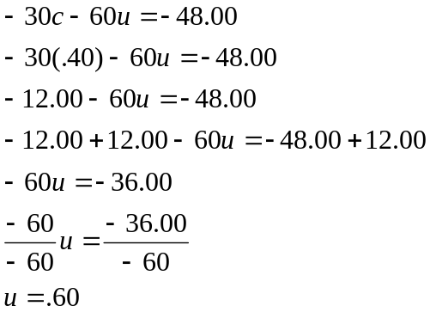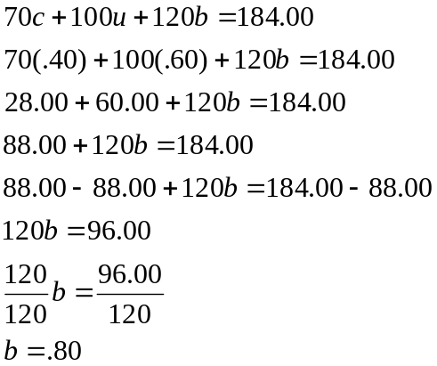

The cost of minutes within Canada is $0.40/min. The cost of minutes to the United States is $0.60/min. The cost of minutes to Brazil is $0.80/min.

Example 3: Solve the following problem using your knowledge of systems of linear equations.

Calculate the number of minutes that Carlos called within Canada, to the United States, and to Mexico during the month of December. The charges are 28¢/min within Canada, 30¢/min to the U.S., and 84¢/min to Mexico if the following conditions applied:
- His total bill for the month was $90.96
- He talked twice as long to Mexico as he did to the U.S.
- The total number of minutes spent talking within Canada and to Mexico was 122.
Let c represent the number of minutes within Canada
Let u represent the number of minutes to the United States
Let m represent the number of minutes to Mexico

Express the problem as a system of linear equations:

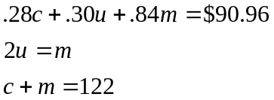

Solve 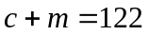 for c 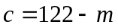
Replace m with 2u in 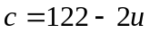

Now replace c and m in the first equation to get an equation in terms of the variable u.

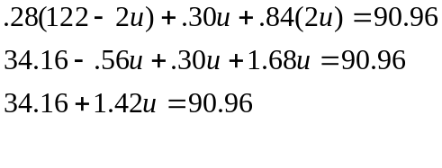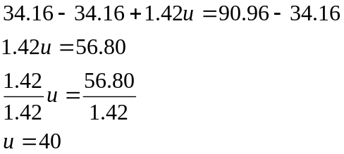

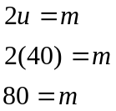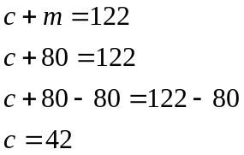

Carlos talked for 42 minutes within Canada, to the U.S. for 40 minutes and to Mexico for 80 minutes.

Example 4: Solve the following problem using your knowledge of systems of linear equations.

Tracy, Danielle and Sherri bought snacks for a girls’ sleepover. They each bought the items shown in the following table at the local convenience store:

Number of bags of potato chips | Number of litres of pop | Number of chocolate bars | Cost  ($)
4 | 4 | 6 | 21.00
3 | 2 | 10 | 20.88
2 | 3 | 4 | 13.17

Calculate the unit price of each snack purchased by the girls.

Let c represent the unit cost of the potato chips.
Let p represent the unit cost of the pop.
Let b represent the unit cost a chocolate bar.

Express the problem as a system of linear equations:

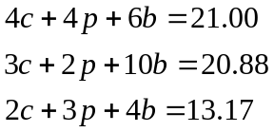

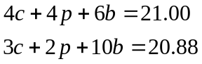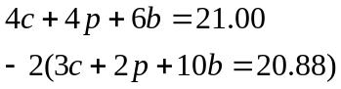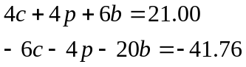
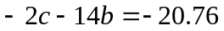

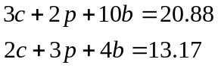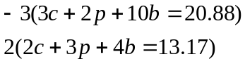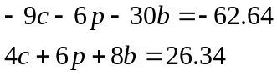
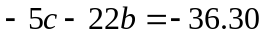

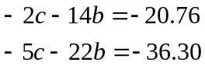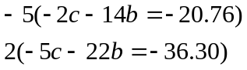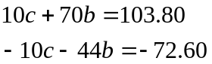
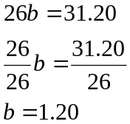

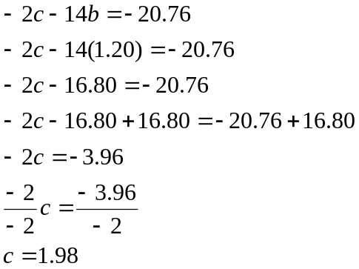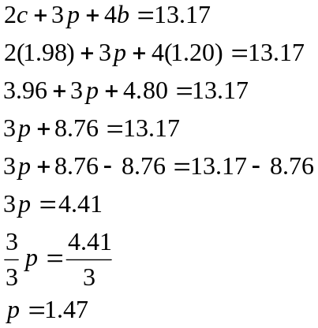

The price of one bag of potato chips is $1.98.
The price of one litre of pop is $1.47
The price of one chocolate bar is $1.20

Exercises:

1. Solve the following systems of linear equations algebraically:

a) 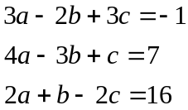 b) 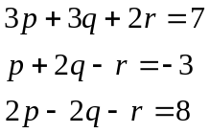 c) 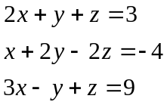 d)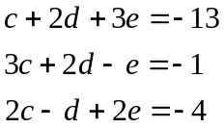

2. A local computer company sells three types of laptop computers to three nearby
stores. The number of laptops ordered by each store and the amount owing to the
company for the order is shown in the following table:

Store | Laptop A | Laptop B | Laptop C | Amount Owing($)
Wal-Mart | 10 | 8 | 6 | 21 200
Sears | 7 | 9 | 5 | 18 700
Target | 8 | 4 | 3 | 13 000

Write a system of equations to represent the above information and determine the unit
price of each type of laptop computer.

3. Cory, Josh and Dan went shopping for Halloween treats. Cory bought 3 chocolate
pumpkins, 4 masks and 8 candy witches. He spent $36.65. Josh bought 5 chocolate pumpkins,
3 masks and 10 candy witches. He spent $37.50. Dan bought 4 chocolate pumpkins, 5 masks
and 6 candy witches. He spent $43.45. Write a system of equations to represent this problem
and algebraically calculate the unit price of each item purchased.

4. Janet, Larry and Sam bought decorations to decorate the clubhouse for a
Christmas party. The number of items bought by each person is given in the table
along with the total cost of each purchase. Write a system of equations to represent
this problem and algebraically calculate the unit price of each item. Each item was
bought at the same store.

Name of the shopper | Number of rolls of garland | Number of wreaths | Number of poinsettias | Cost
Janet | 2 | 4 | 2 | $49.50
Larry | 3 | 2 | 4 | $57.75
Sam | 3 | 3 | 1 | $38.50

Solutions:

1.a)

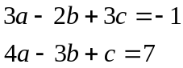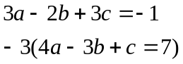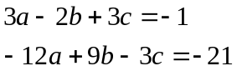
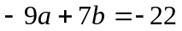

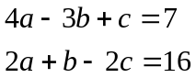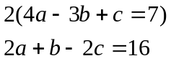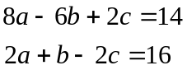
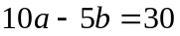

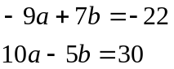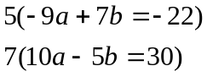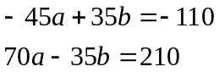
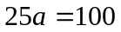
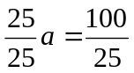
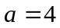

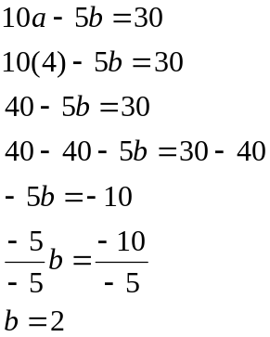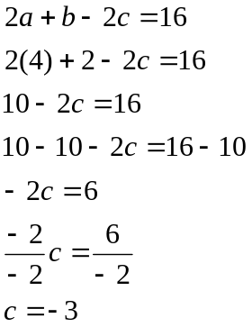

The solution is (a, b, c) = (4, 2, -3)

b)

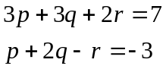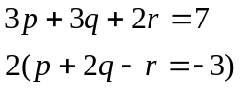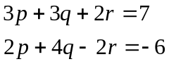
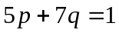

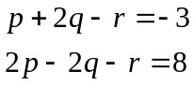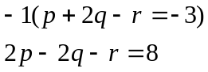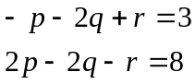
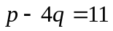

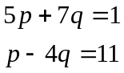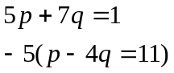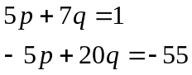
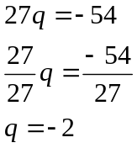

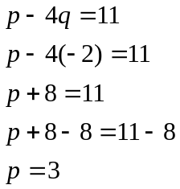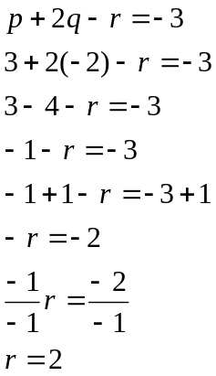

The solution is (p, q, r) = (3, -2, 2)

c)

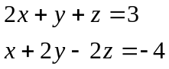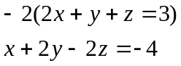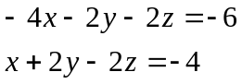
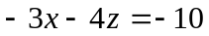

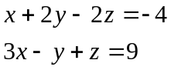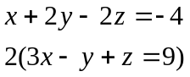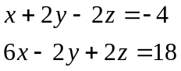
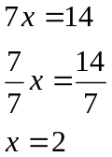
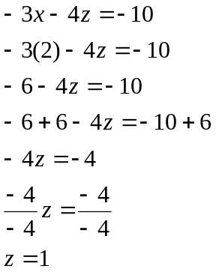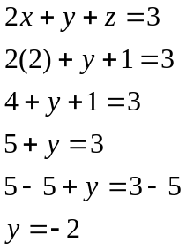

The solution is (x, y, z) = (2, -2, 1)

d)

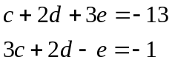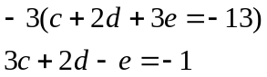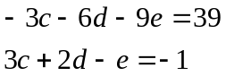
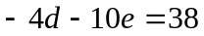

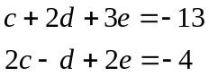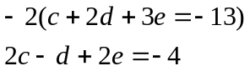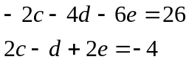
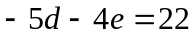

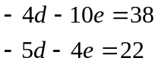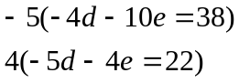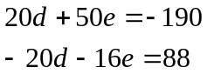
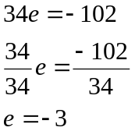

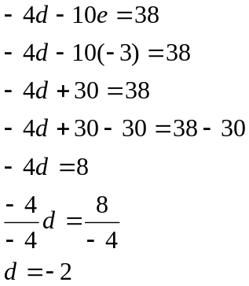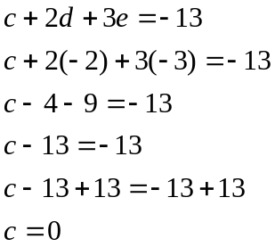

The solution is (c, d, e) = (0, -2, -3)
2. Let a represent the price of Laptop A.
Let b represent the price of Laptop B.
Let c represent the price of Laptop C.

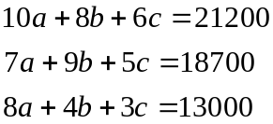

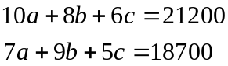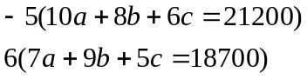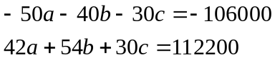
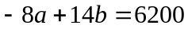

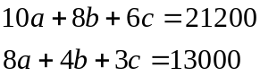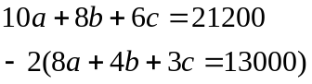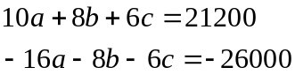
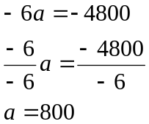

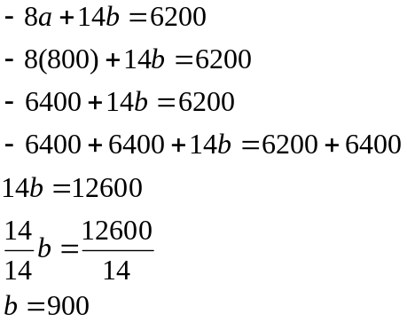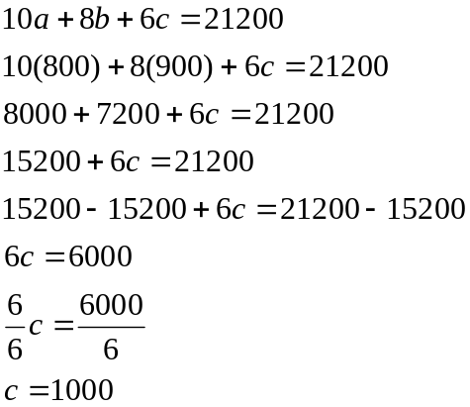

Laptop A costs $800.00. Laptop B costs $900.00. Laptop C costs $1000.00

3. Let p represent the unit price of the chocolate pumpkin.
Let m represent the unit price of the mask.
Let w represent the unit price of the candy witch.

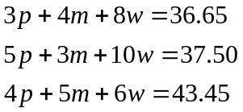

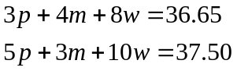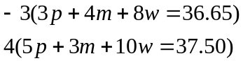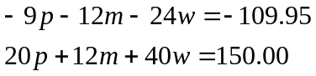
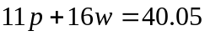

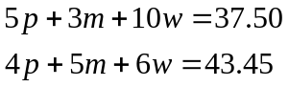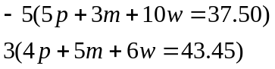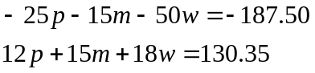
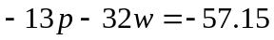

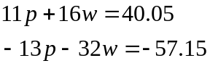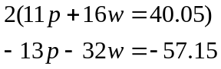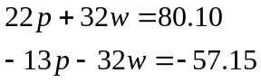
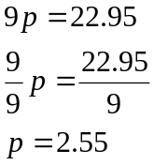

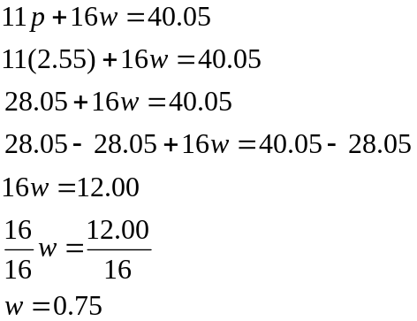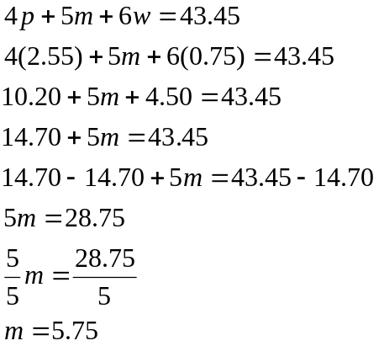

Each chocolate pumpkin costs $2.55.
Each mask costs $5.75.
Each candy witch costs $.75.

4. Let g represent the cost of the garland.
Let w represent the cost of a wreath.
Let p represent the cost of a poinsettia.

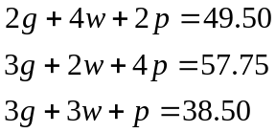

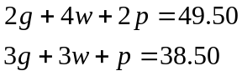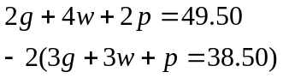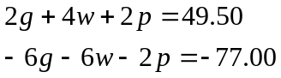
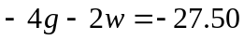

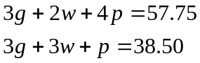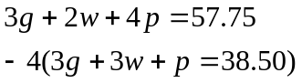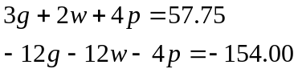
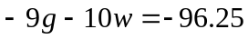

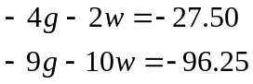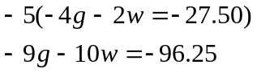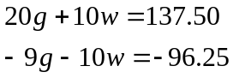
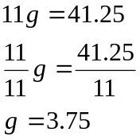

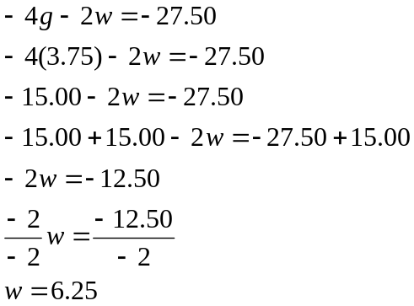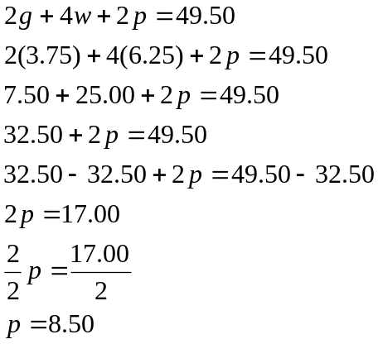

The cost of each roll of garland is $3.75.
The cost of each wreath is $6.25.
The cost of each poinsettia is $8.50.

