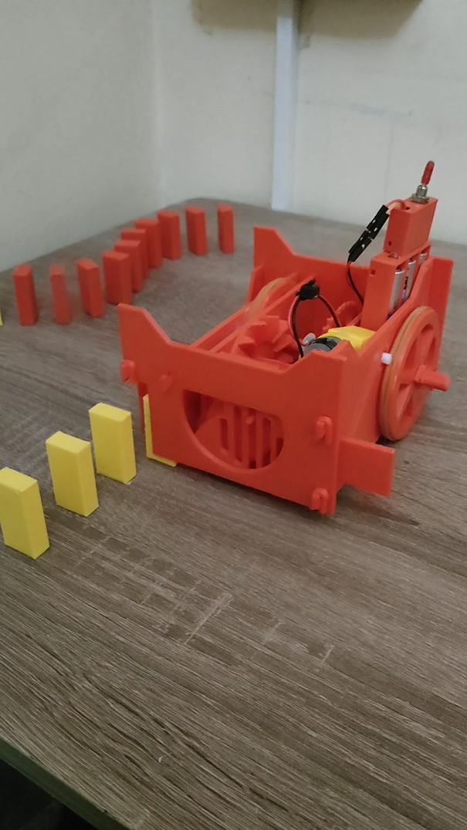

DOMINO
ROBOT
🇩🇿 LEARNING KIT

MOUNTING
GUIDE

DESIGNED BY: AMINE BENBOUALI
( (Alias: KREAM) (CREDITS AT THE END)

INTRODUCTION

Welcome to our educational robot kit designed for young engineers aged 5 to 14! This kit is designed to be both fun and educational, giving children the opportunity to learn about engineering in an interactive and engaging manner.

One of the key features of our robot kit is that it uses just one motor to perform all of its actions. This may sound surprising, but it is made possible through clever design and mechanics. By using a combination of gears, levers, and other mechanisms, the motor can be used to control the movement of the robot's wheels and domino pushing barrier.

Not only does this approach make the robot more affordable and accessible, it also provides an excellent opportunity for children to learn about how different mechanical components work together to create complex movements. By experimenting with different gear ratios and combinations, children can gain a deeper understanding of how mechanical systems work.

Our step-by-step mounting tutorial includes photos to make the process as easy and intuitive as possible. Children can follow along and learn about each component as they assemble the robot, gaining valuable hands-on experience in the process.

Overall, our educational robot kit provides an excellent way for young engineers to learn about engineering in a fun and interactive way. Whether they are building their first robot or experimenting with different gear combinations, we hope that our kit will inspire a lifelong passion for engineering and innovation.

PARTS LIST

The materials included in this robot kit are as follow:
x3 AA batteries.
x1 motor
x30 Domino robot body parts

NOTE: if pins and holes are too tight, it is recommended to widen them with either a knife, scissors or a plastic cutter, such tightness could result from elephant’s foot during 3D printing and non-fine tuned 3D printers and is to be anticipated.

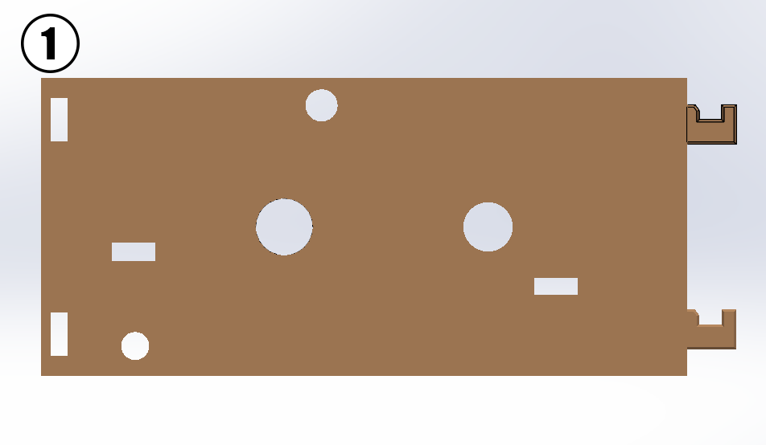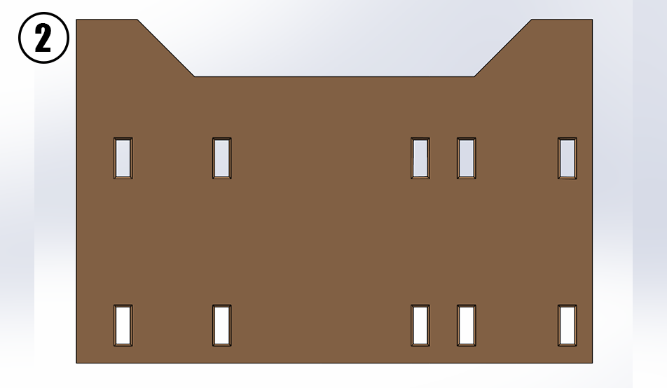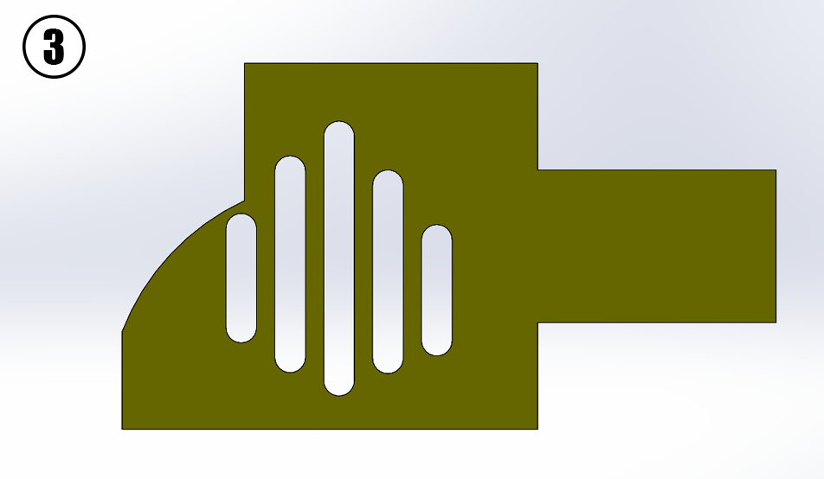
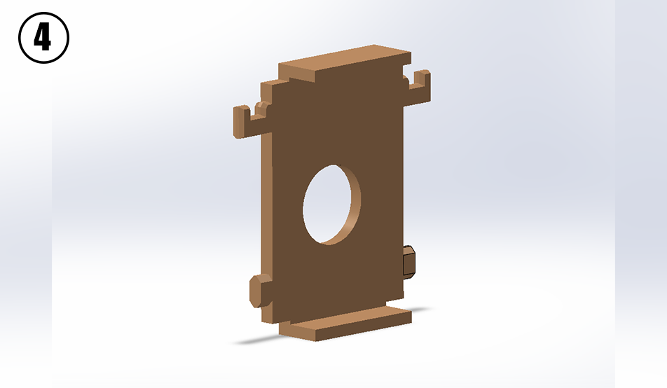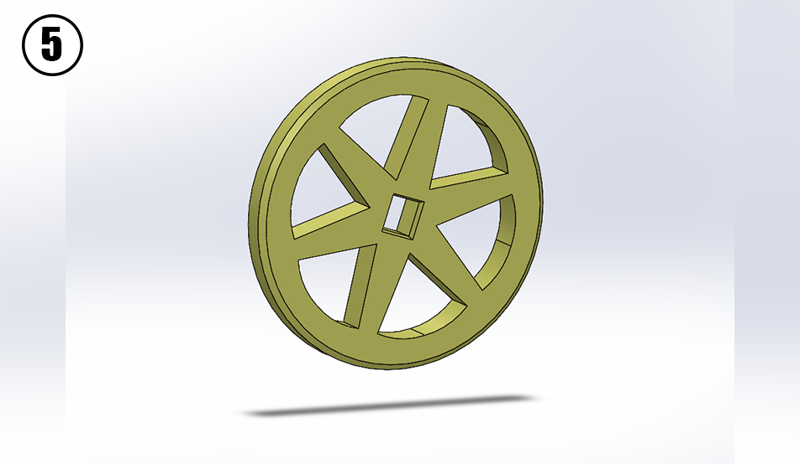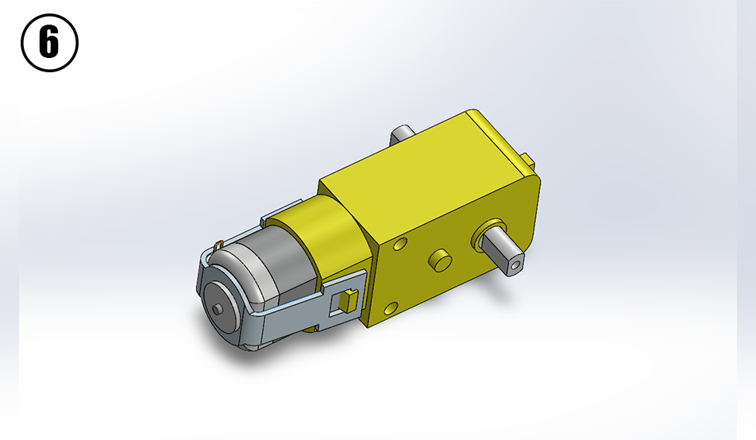
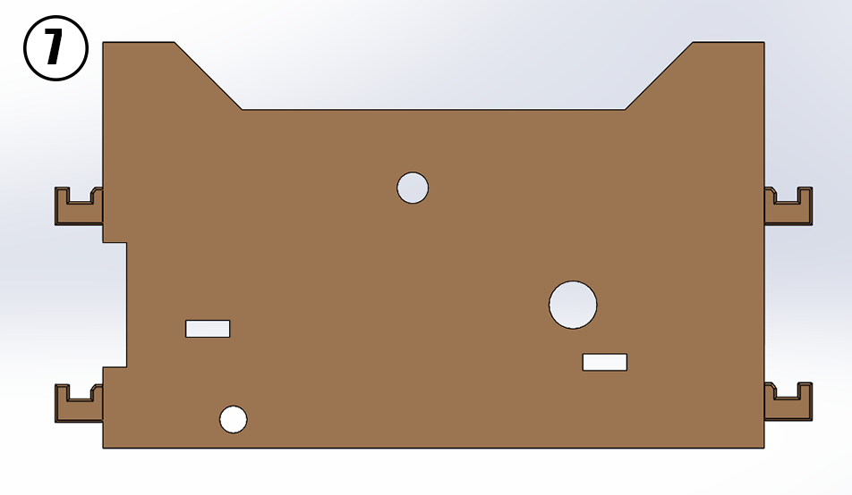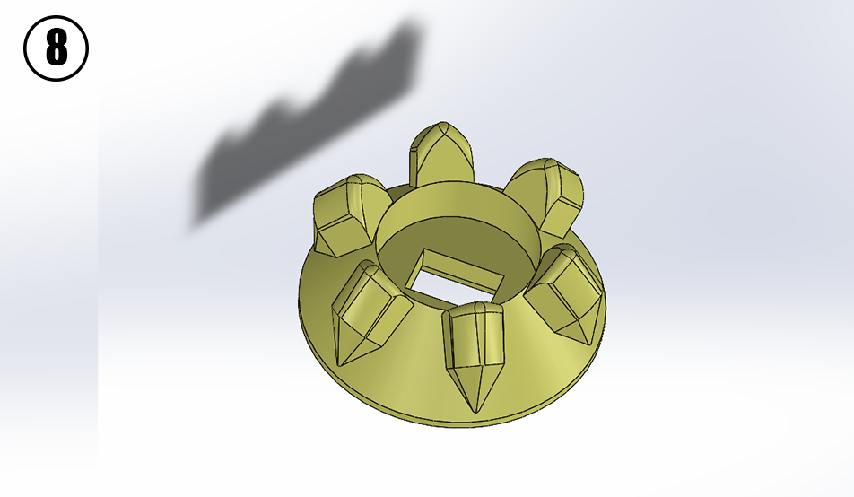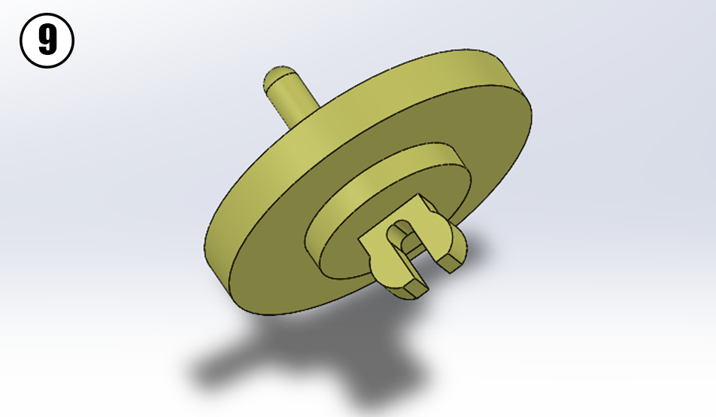

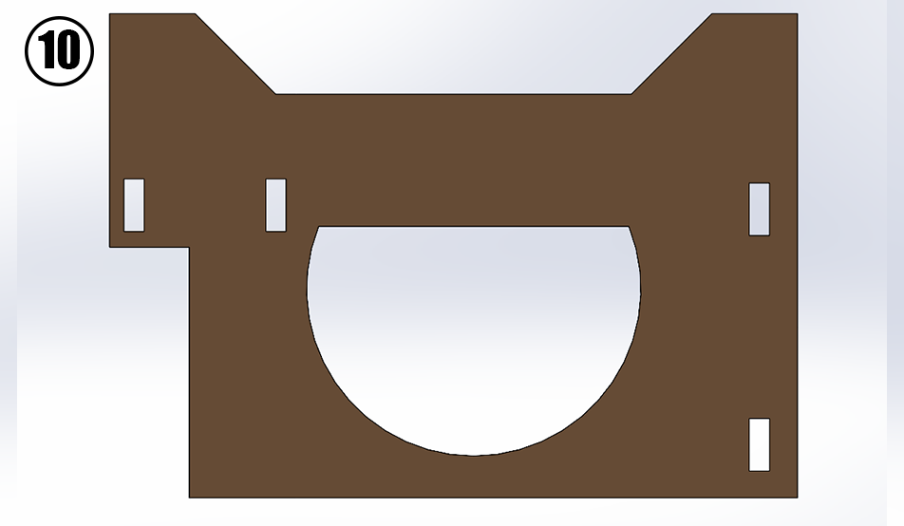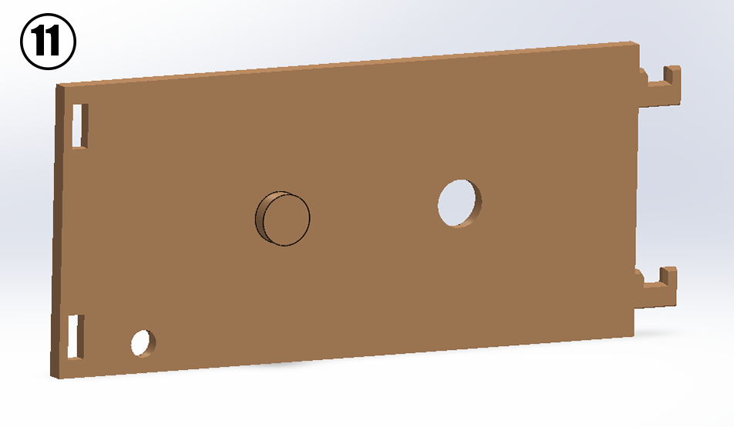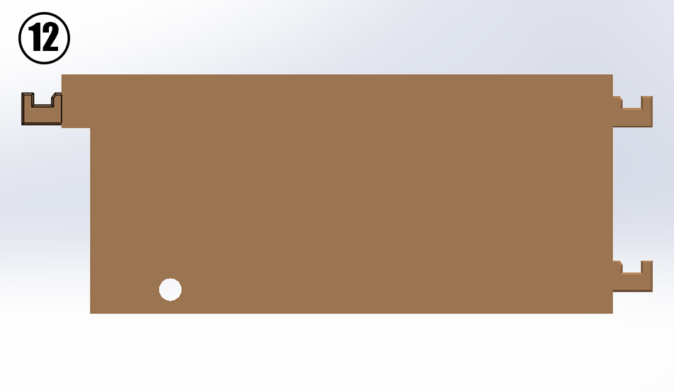
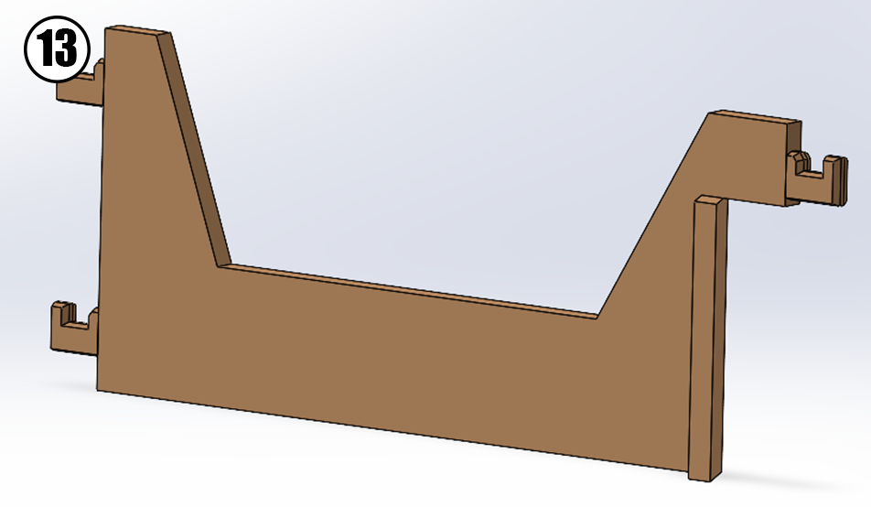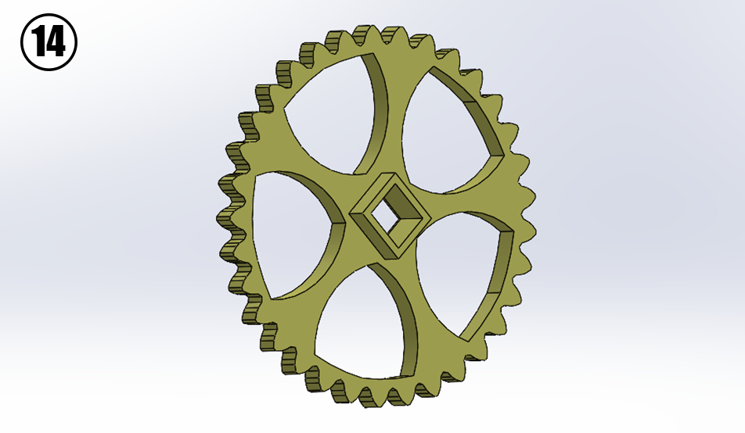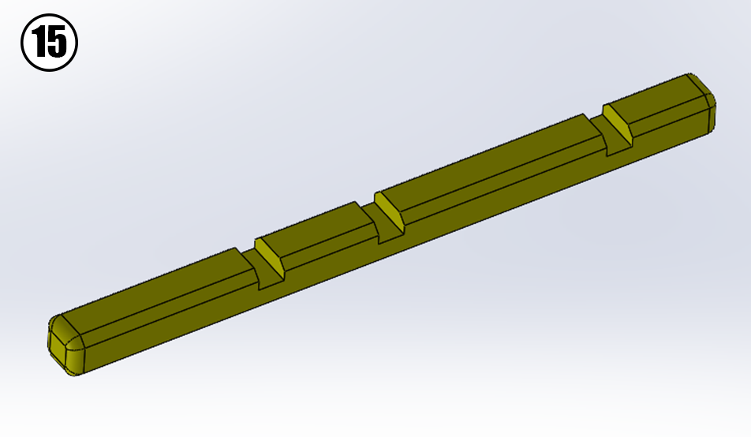
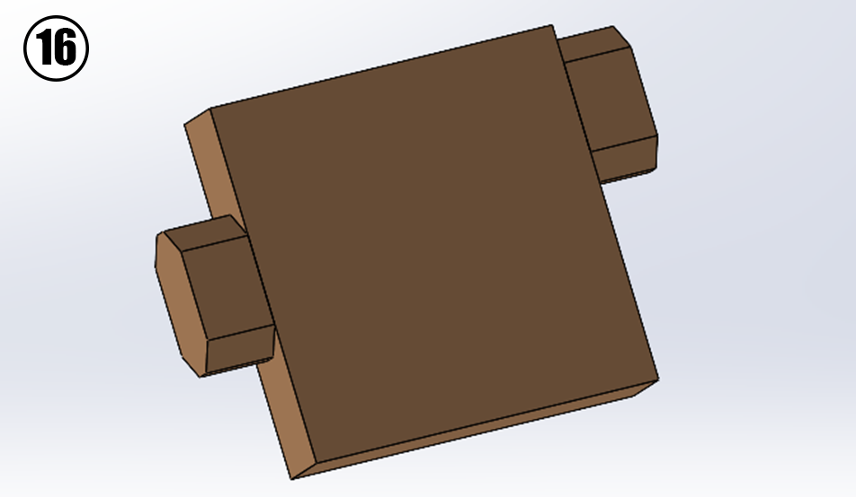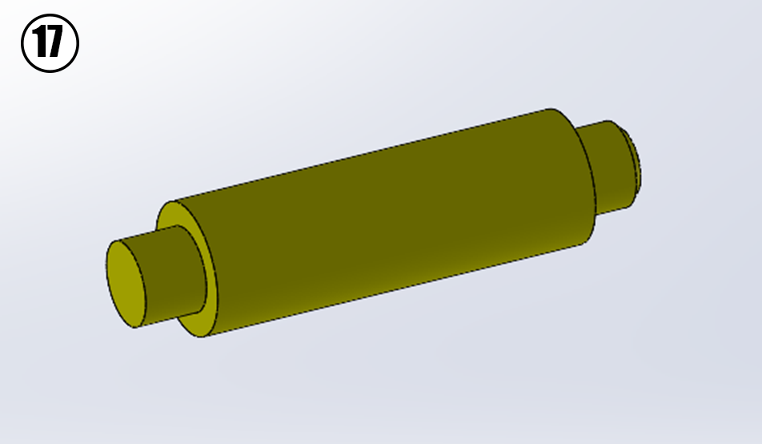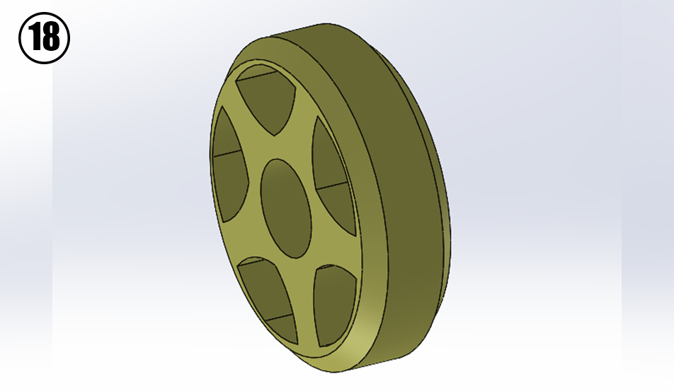

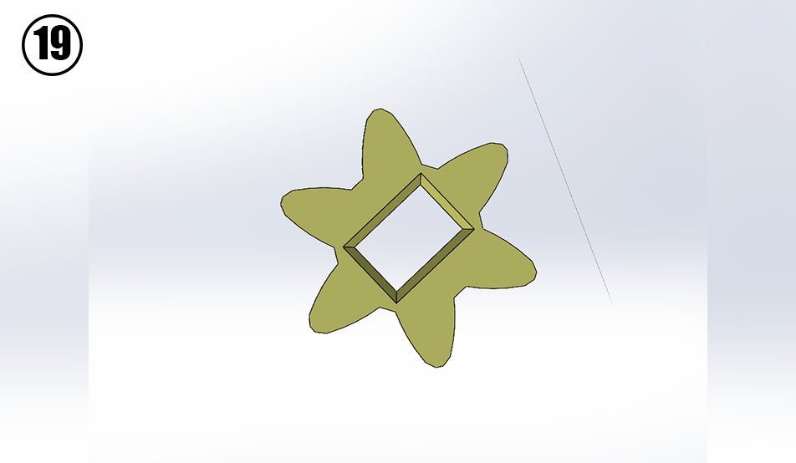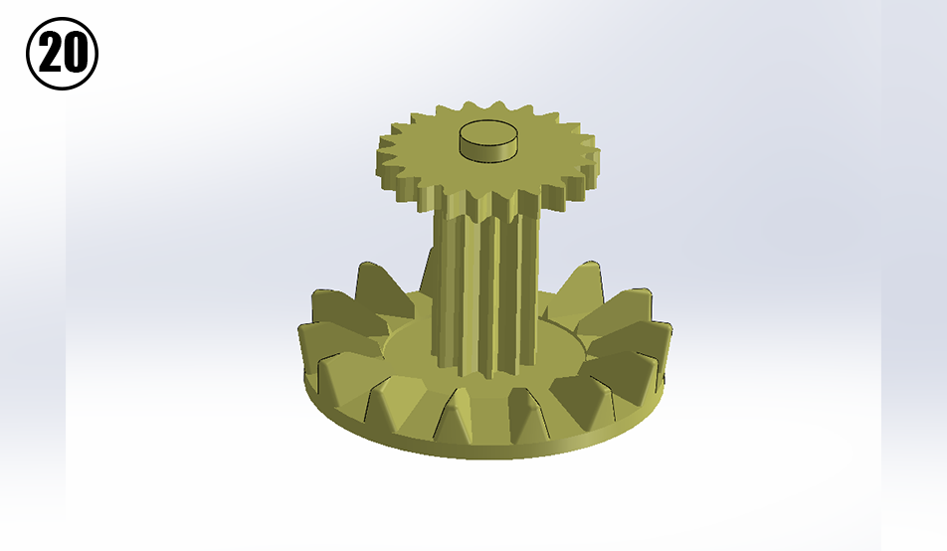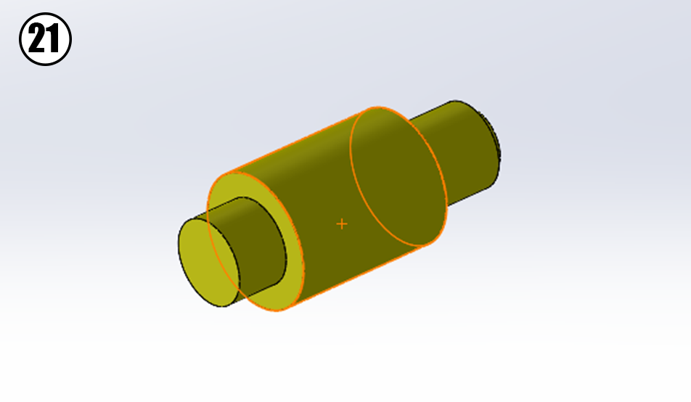
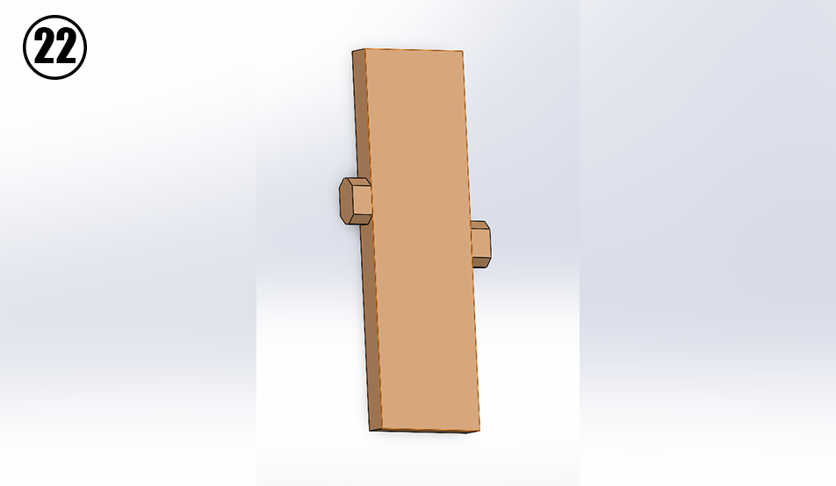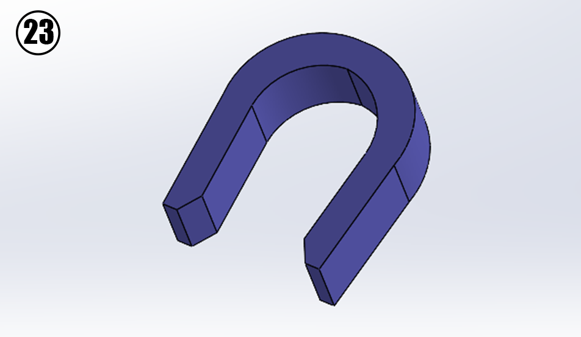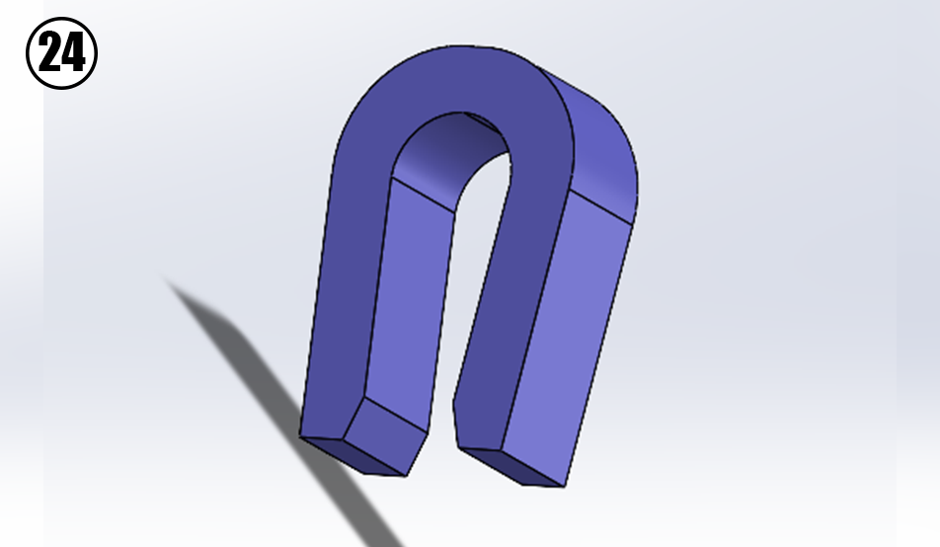
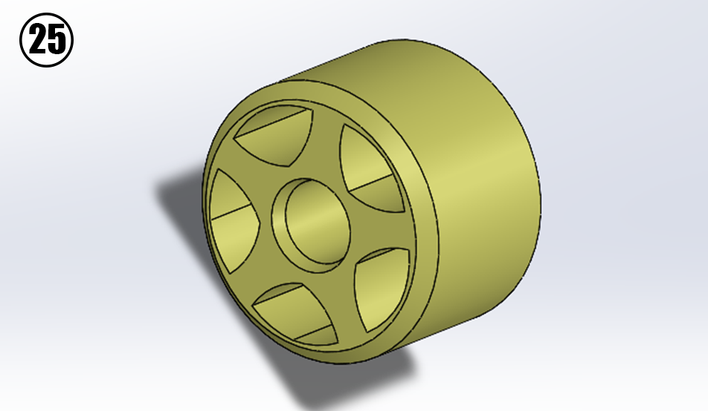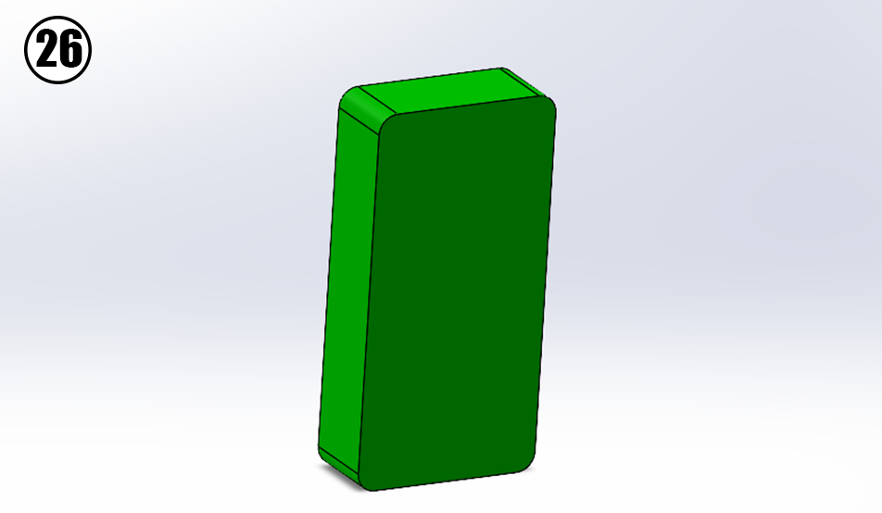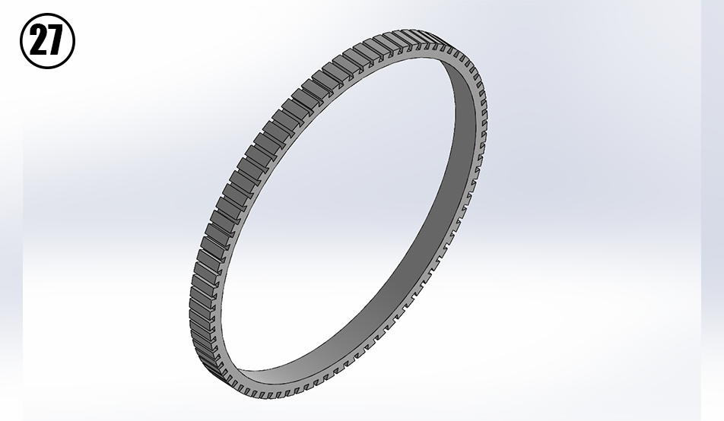
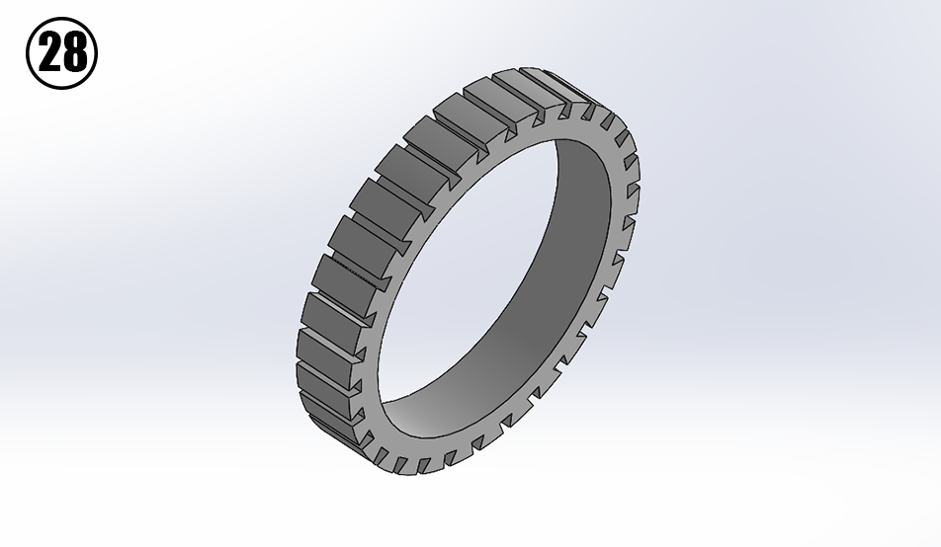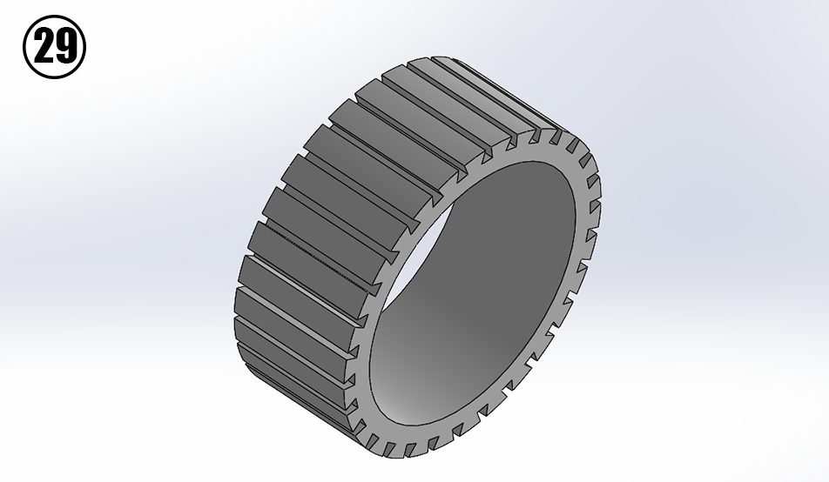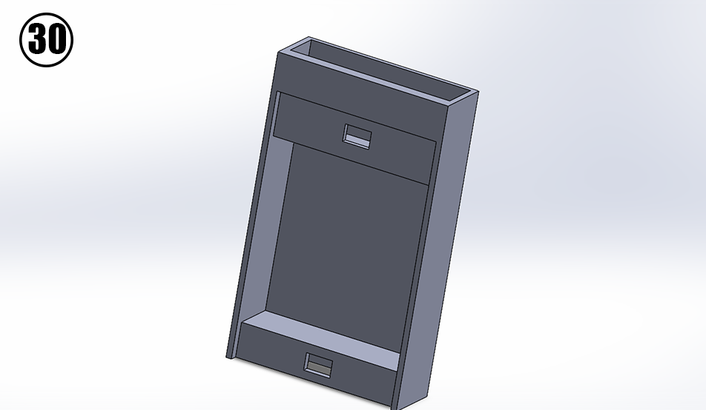

MOUNTING STEPS

STEP 1: In the first step of the mounting of this robot we take the tiny wheel numbered 25 and the flexible grip cover numbered 29 and put them together as in figure 1.
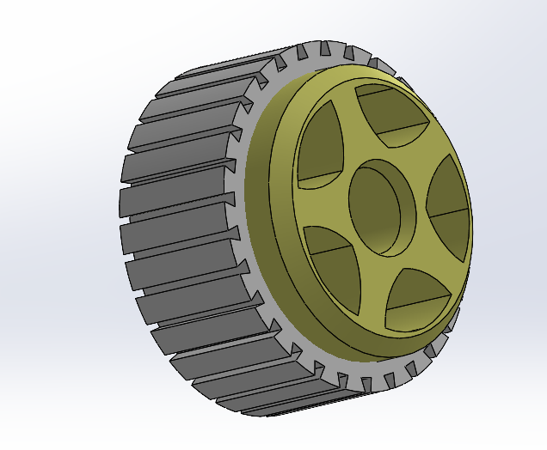
Figure 1: Right small wheel

STEP 2: In this step we take the result part from STEP 1 as well as the axis with the number 17 alongside the wall with the number 1, as well as the two spacers numbered 16 and 22, we also take the motor which is numbered 6, we place all of these pieces on the wall with the number 1 as seen in figure 2, we then close it off using the wall with the number 7.
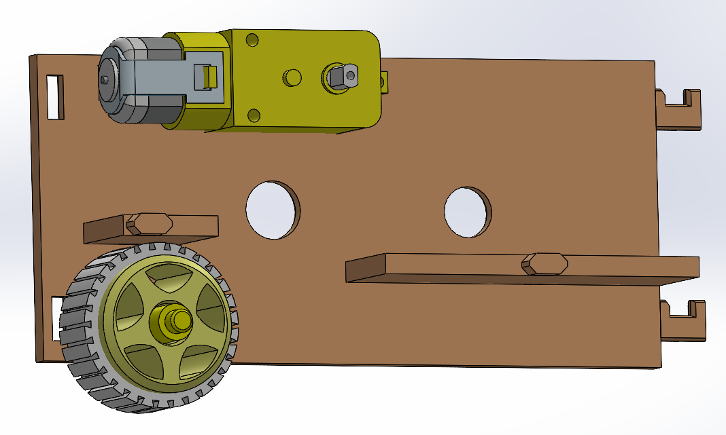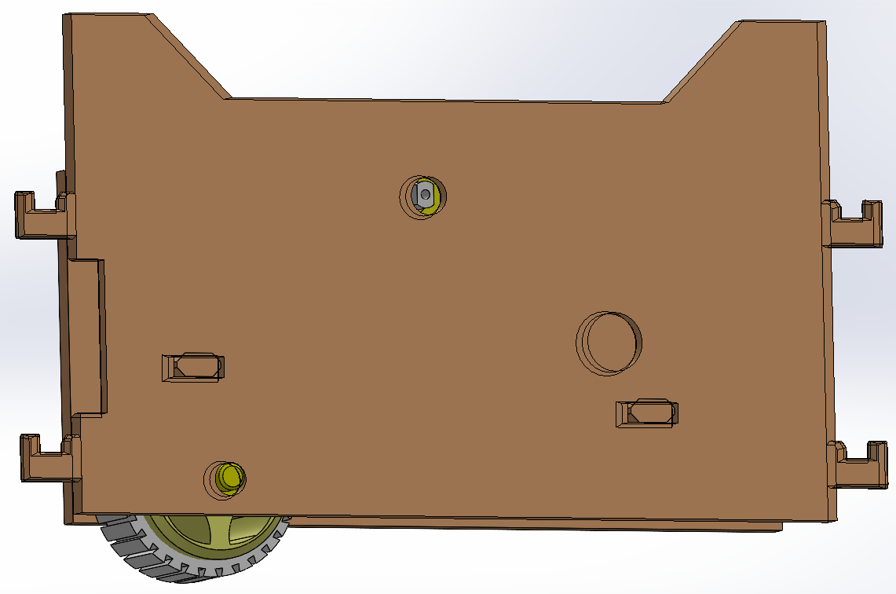
FIGURE 2

STEP 3: In the third step we take the wall numbered 11 and the gear numbered 20 and put them together as seen in figure 3.
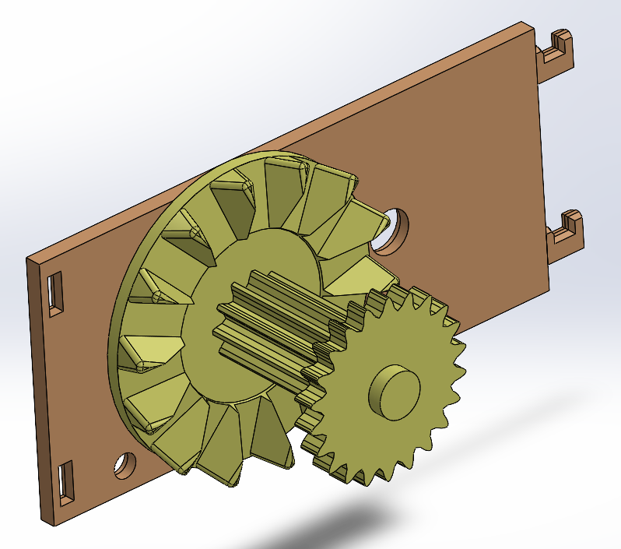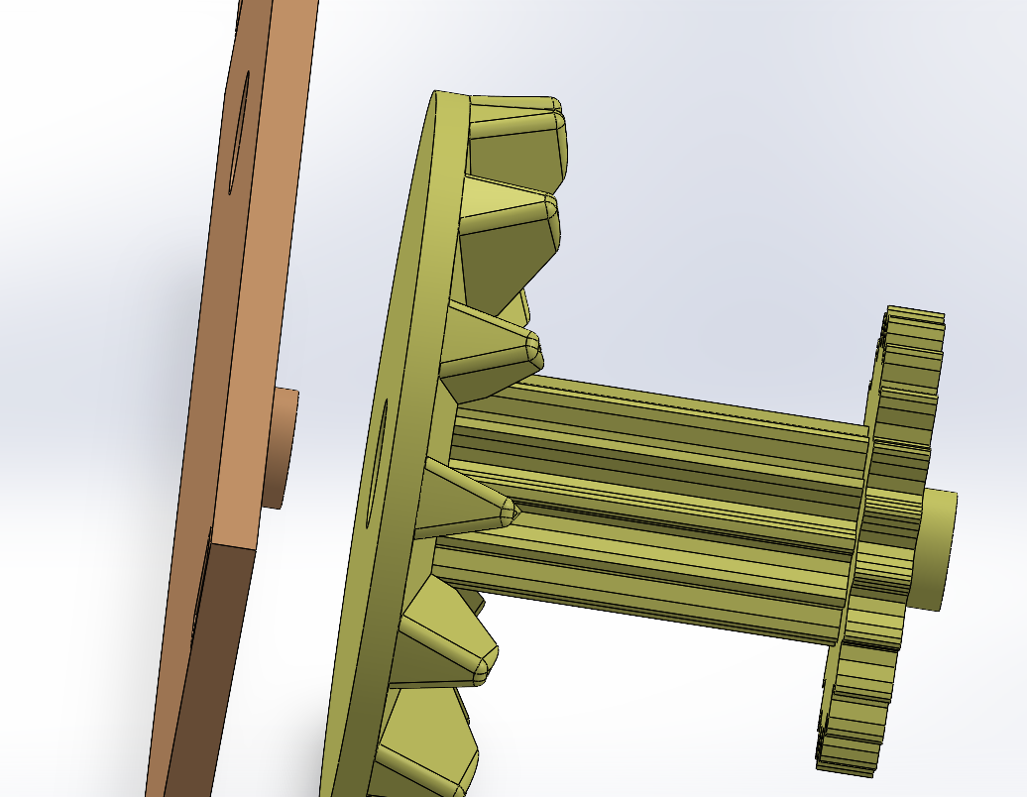
FIGURE 3

STEP 4: In the fourth step we take the result from STEP 2 and STEP 3 as well as the part with the number 4 and put all three together as seen in figure 4.

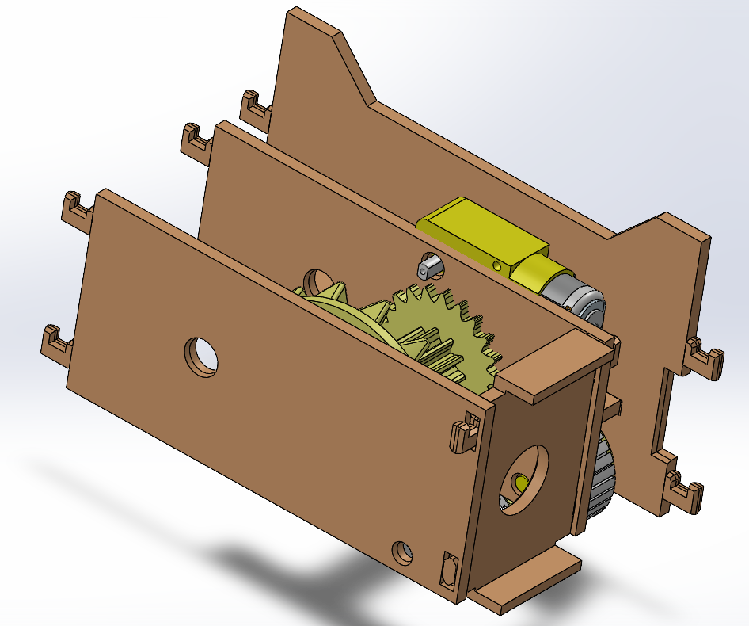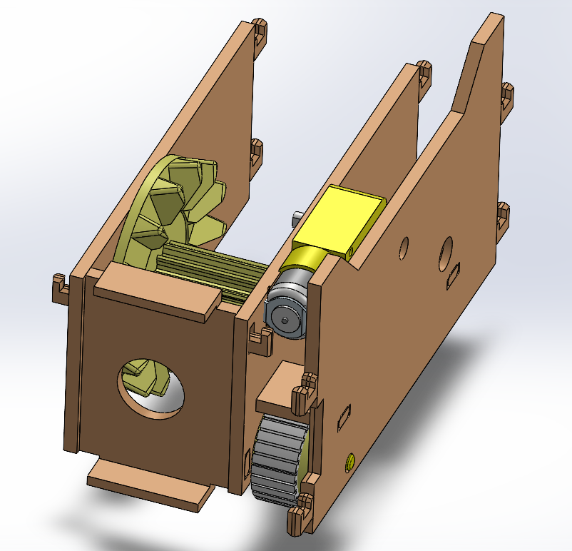
FIGURE 4

STEP 5: In this fifth step we take the result from STEP 4 and use two pinners which are numbered 23, the thinner version of the pinners should be used here as seen in figure 5.
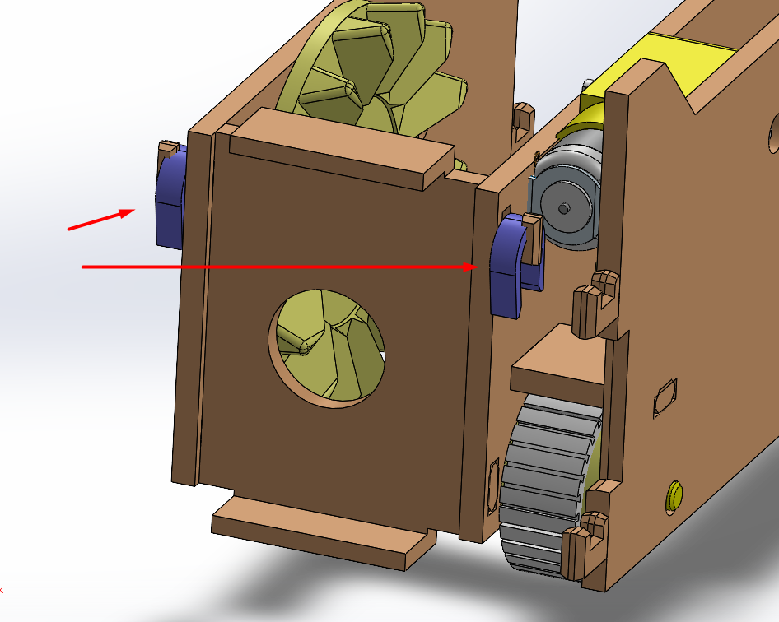
FIGURE 5
STEP 6: In this step we take the result from STEP 5 as well as the wall with the number 2 and put them together as seen in figure 6, after that we pin them together using the thin purple pinners numbered 23.

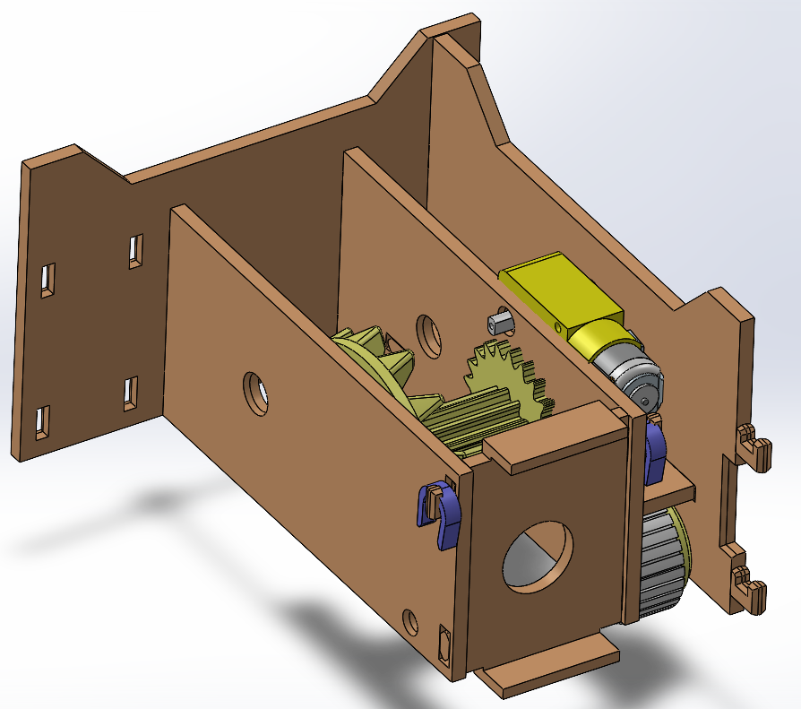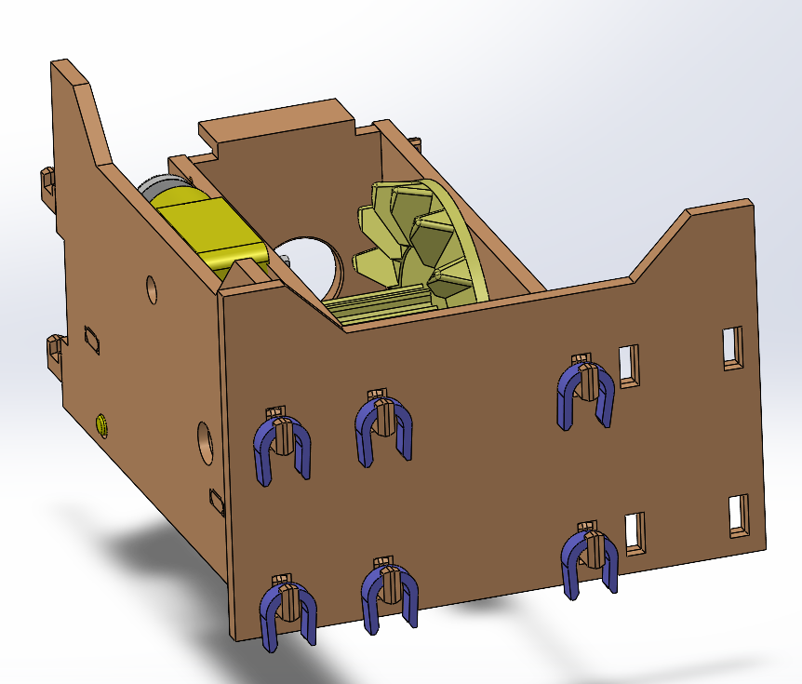
FIGURE 6

STEP 7: In this step we take the walls numbered 12 and 13, we put them through the back wall numbered 2 which is installed in STEP 6 as seen in figure 7, after that we pin them with the same thin purple pinners.
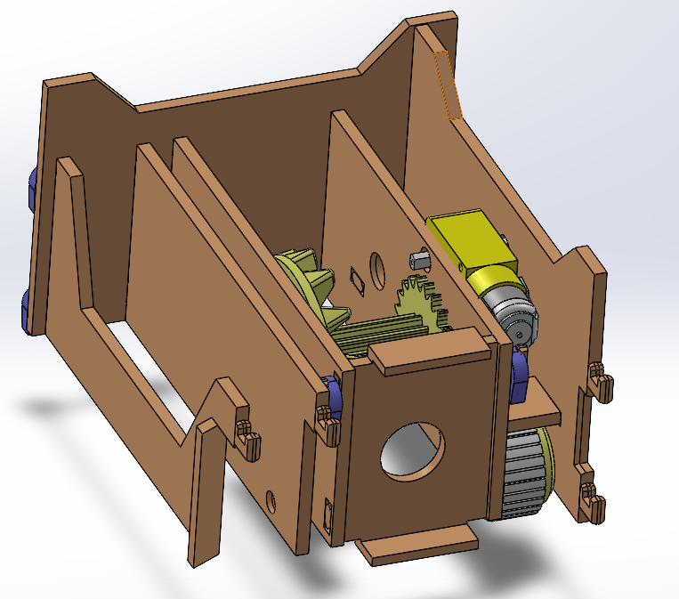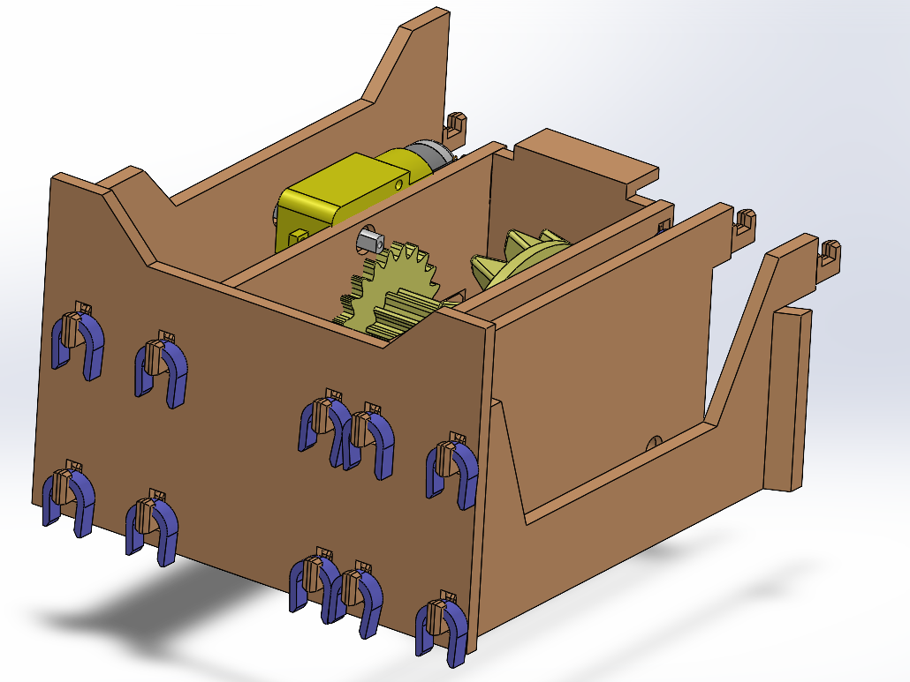
FIGURE 7
So far we are only using the thin purple pinners and not the thiccer ones, that is on purpose as the thiccer purple pinners are used to pin the rotating axis only, as will be seen in next steps.

STEP 8: Before we move on to gear installation, we must install the right small wheel as well, we take the wheel numbered 18 and its cover numbered 28.

As well as their axis numbered 21 and put them together as in figure 8, notice this axis numbered 21 has a wider side than the other as seen in figure 8, this wider side goes into the right as see in figures 9 and 10.
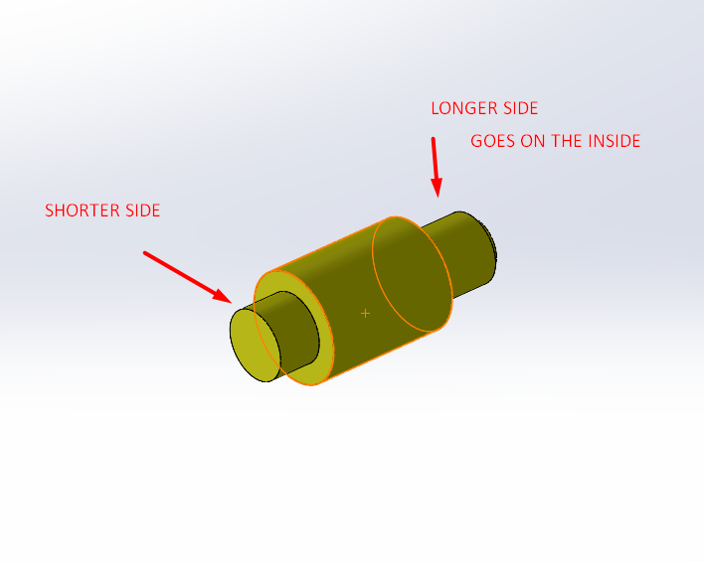
FIGURE 8: small wheel axis

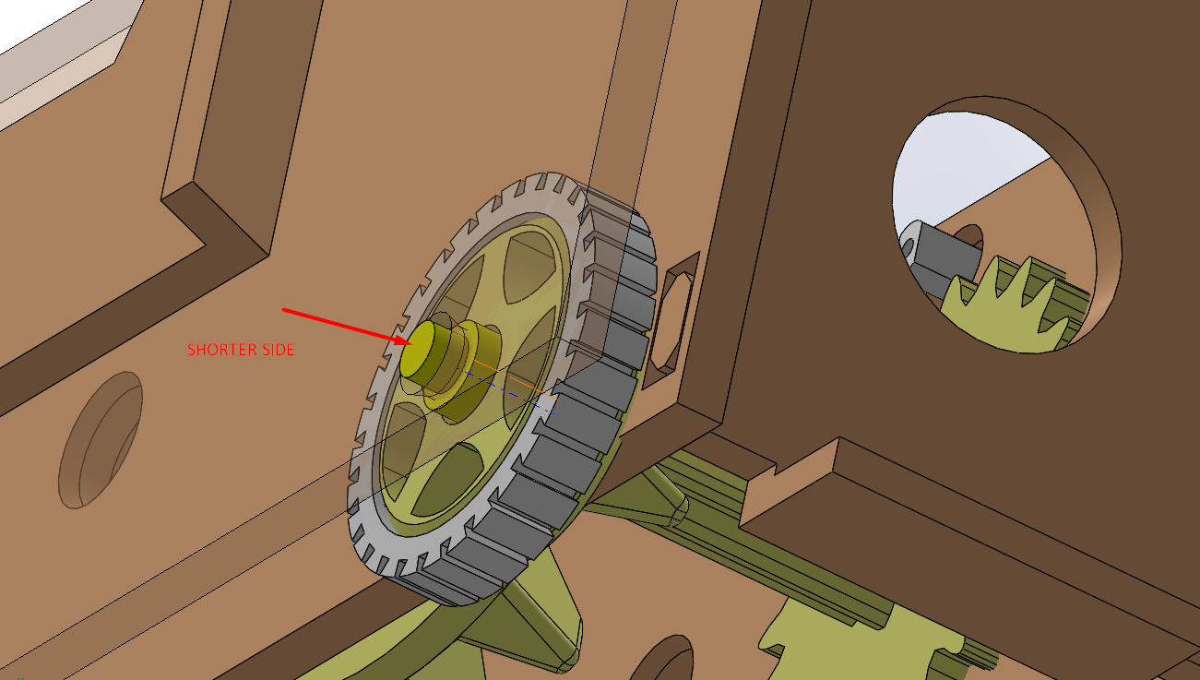
FIGURE 9

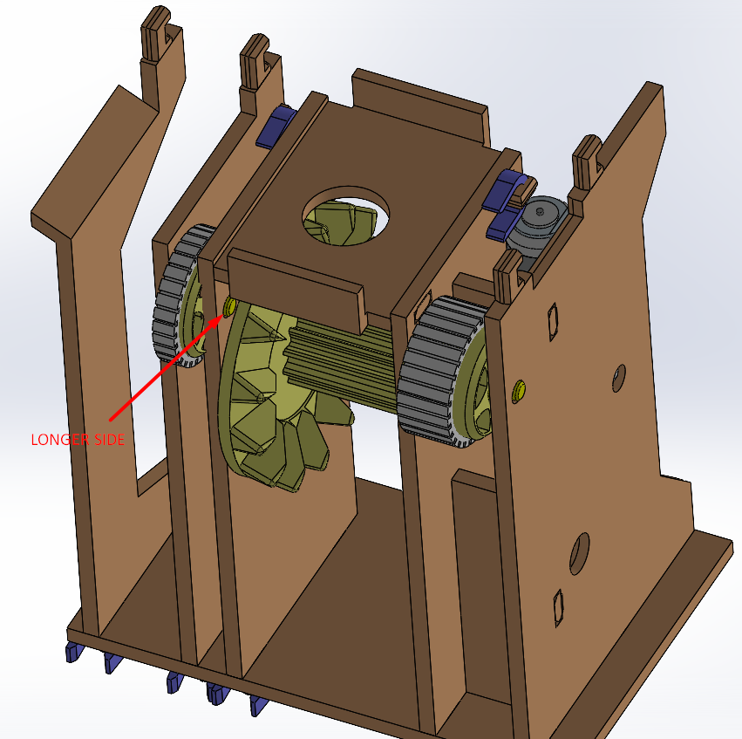
FIGURE 10
STEP 9: In this step we finally take the two parts numbered 8 and 9, we put them through the circle hole in the part numbered 4 which is already part of the robot, as seen in figure 11, we slide the bevel geared part numbered 8 on the inside, and the plate with the thin finger (number 9) on the outside (careful of snapping the thin finger on it) and we attempt to snap them into each other through the circle hole as seen in figure 11, a clearer view of the snapping mechanism is shown in figure 12.
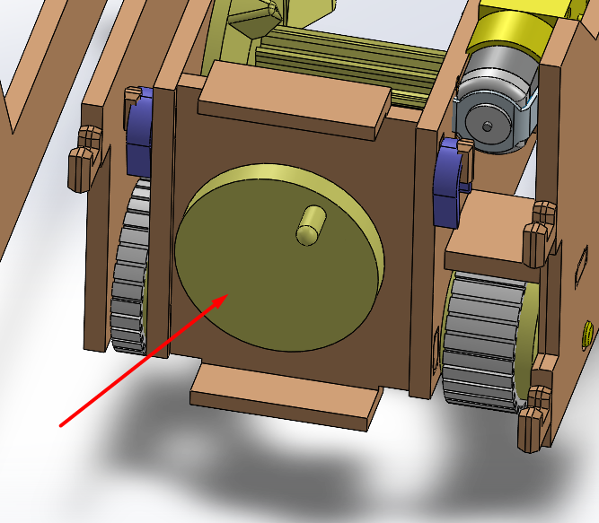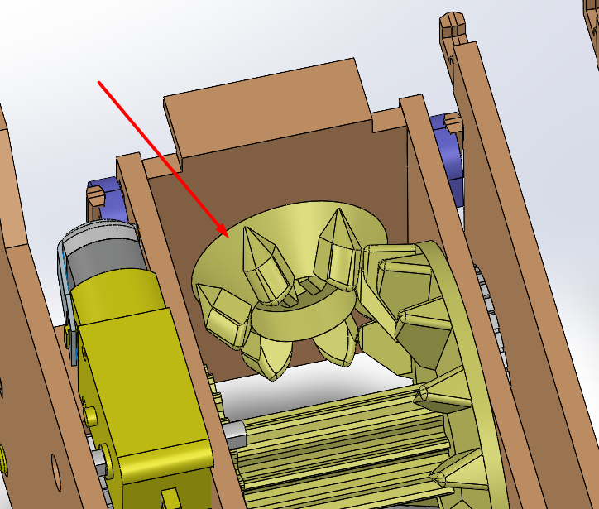
FIGURE 11

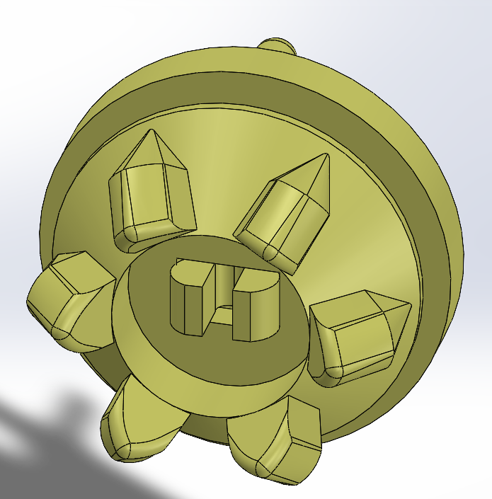
FIGURE 12
STEP 10: In this step we take the part numbered 3, it is the moving door that pushes the dominos out, it has vertical lines in which case, our thin finger goes through, the longest stripe of these, as seen in figure 13.
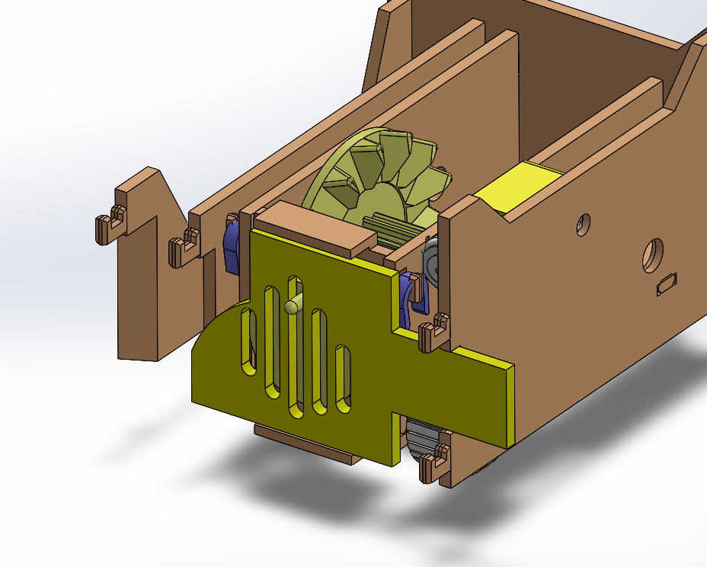
FIGURE 13
STEP 11: The next step is to cover the front with the front wall numbered 10, the pins go through its holes as seen in figure 14, we then take the thin purple pins to pin it in place.

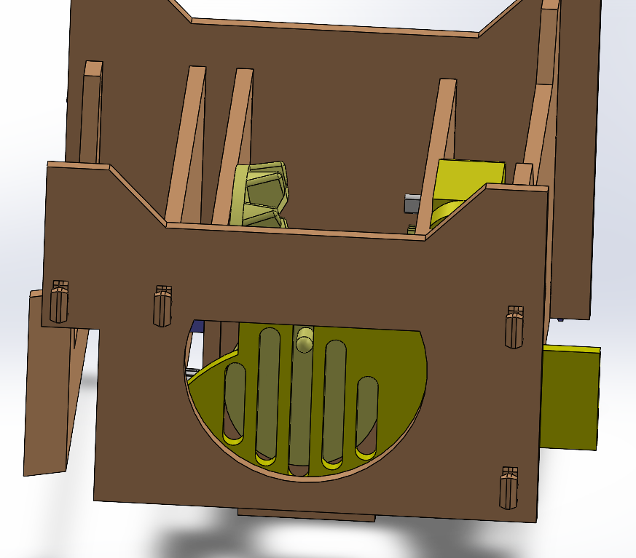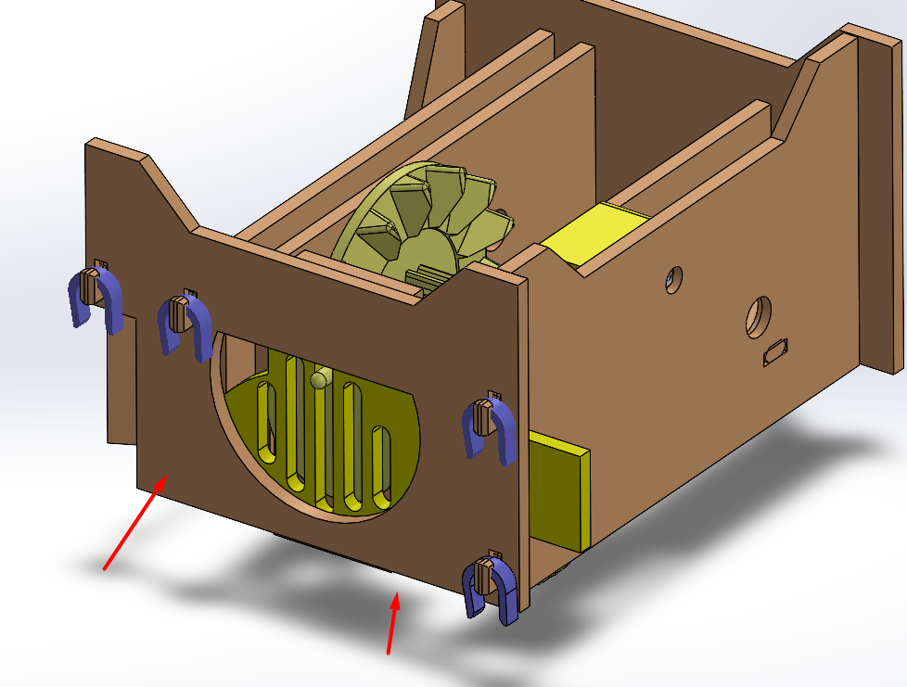
FIGURE 14

STEP 12: Now we move onto the wheels in which we cover with their protective grip rings, the large wheels are numbered 5 and their grip covers are numbered 27 as seen in figure 15.

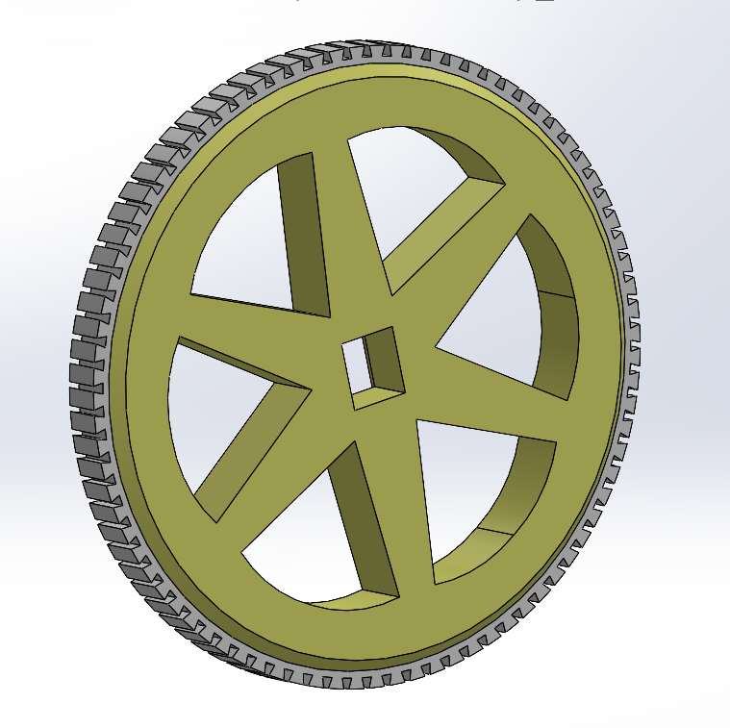
FIGURE 15

STEP 13: Now we move onto finishing the moving mechanisms, we take the axis numbered 15 as well as the thin large gear numbered 14, we pass the axis through the designated holes which are lined up already, but as we pass the axis through the middle room, we slide the thin gear number 14 through it, as seen in figure 16.

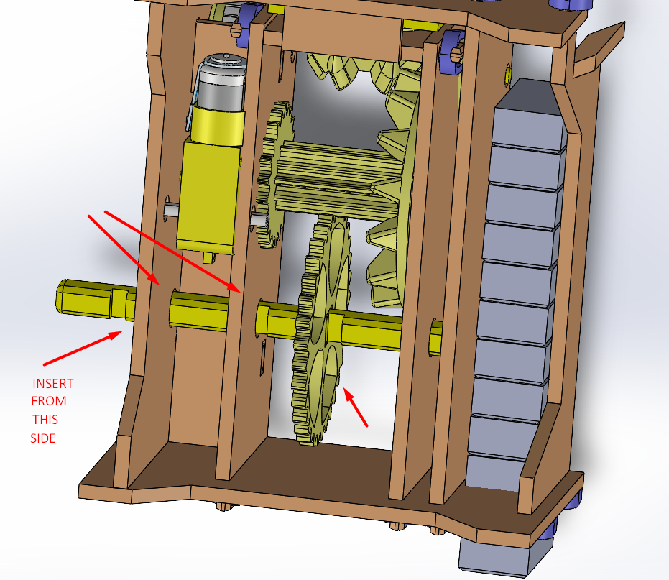

FIGURE 16

Notice the axis has three grooves cut into it, make sure the side with the two grooves closest to each other goes first as seen in figures 16 and 17.
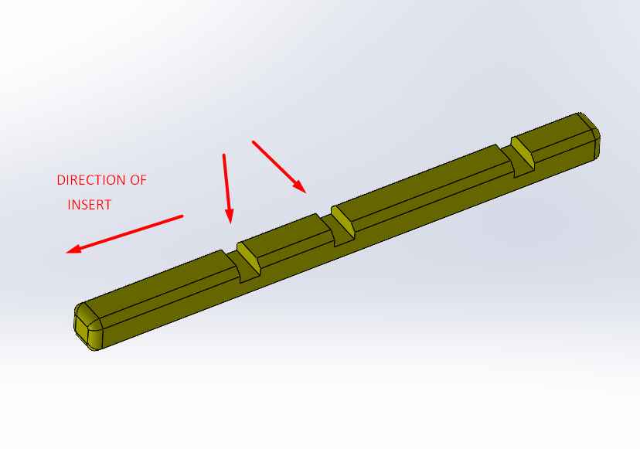
FIGURE 17

STEP 14: before we finish inserting the axis, we will place the first wheel between the two walls close to each other, then we push the axis through as in figure 18.
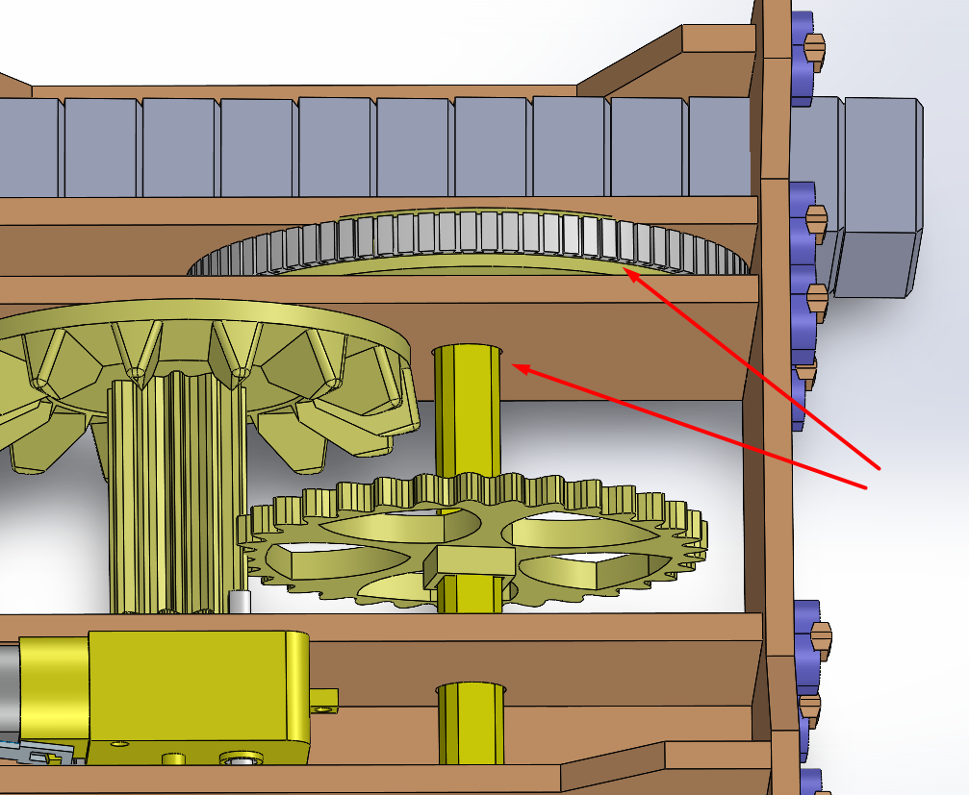
FIGURE 18

STEP 15: Next we insert the second wheel into the axis from the outside as seen in figure 19.
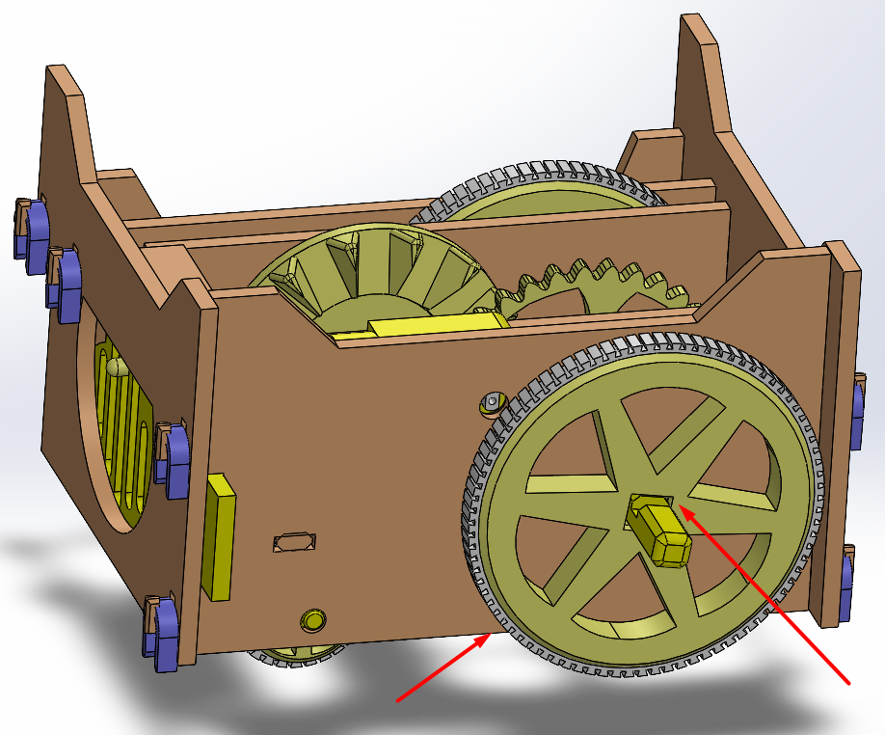
FIGURE 19

STEP 16: We take the tiny gear numbered 19, and push it into the shaft of the motor as seen in figure 20.
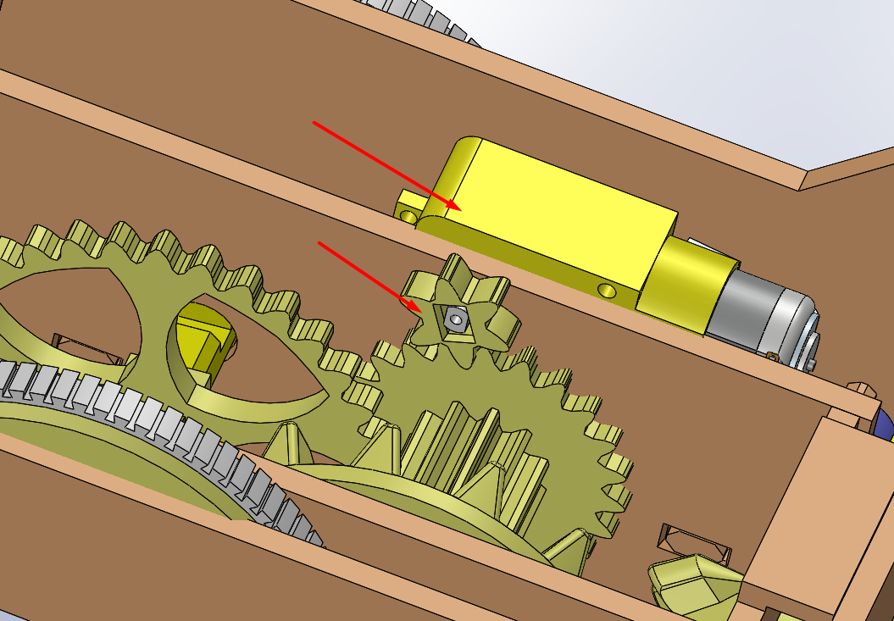
FIGURE 20

STEP 17: Last but not least we take the batteries holder and insert the batteries into it all in the same direction facing up with the positive side facing the switch.

We then take the two wires from the batteries holder and connect them to the two wires of the motor, when the switch is flipped on, the car must be moving backwards, if it is moving forward this means that the wires should be switched.

Now that our robot is finished, we can place the dominos (3D printed dominos which i gave the 26) in their slot in the empty room and we turn the robot on as seen in figure 21.

NOTE: if the robot is turning to the sides too much, this means it is not able to grip properly to the ground, either choose a grippier floor or make sure the tiny wheels are turning freely. If they are not, then it is recommended to spread the walls until the wheels can spin without resistance.

Another solution is to superglue all the wheels to their grippy white covers (3D printed in TPU), it will prevent it from sliding around the wheel, regular elastic can also be used and wrapped around the wheels to improve grippiness to the floor while laying the dominos.

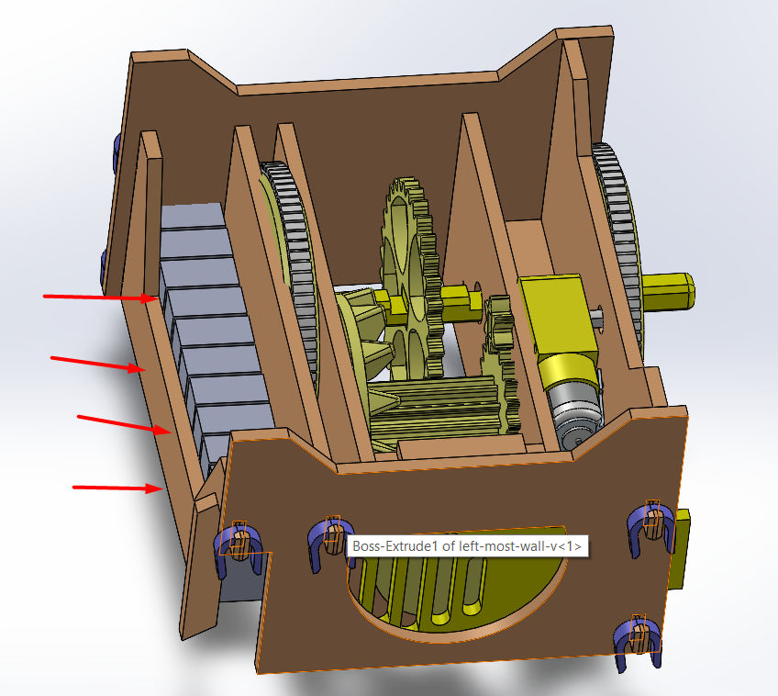
FIGURE 21

ROBOT DESIGNED BY: AMINE BENBOUALI (alias: KREAM)
EMAIL: m.aminebenbouali@gmail.com
INSTAGRAM: @yesthepotatoislookingatyou
FACEBOOK: fb.com/kreamsippycup

