

### Department of Electronical Engineering, Telecommunications and Computers

**Project Report (Phase 1)**

Group 6:

47718: Pedro Diz (a47718@alunos.isel.pt)

48259: Vasco Branco (a48259@alunos.isel.pt)

48264: João Pereira (a48264@alunos.isel.pt)

Professors: Paulo Pereira and Pedro Pereira

2023/2024 Summer Semester

**Index**

Introduction…………………………………………………………………………………………………………………………….3

Conceptual Model…………………………………………………………………………………………………………………...4

Physical Model………………………………………………………………………………………………………………………...5

Open-API Specifications……………………………………………………………………………………………………………5

Details of an API request………………………………………………………………………………………………………….6

Connection Management………………………………………………………………………………………………………..6

Data Access……………………………………………………………………………………………………………………………..6

Error Handling…………………..………………………………………………………………………………………………….…7

Critical Evaluation……………………………………………………………………………………………………………………7

# **Introduction**

The aim of this work is to implement an information system that manages video game sessions.

The application domain consists of these entities:

* **Player**: A **Player** is characterized by having a **unique number**, a **name**, and an **email address**.
* **Game**: A **Game** is characterized by having a **unique number**, a **unique name**, a **developer**, and a **set of associated genres**.
* **Session**: A **Session** is characterized by having a **unique number**, the **number of players involved in the session**, the **session start date**, the **game**, and the **associated players**.

**Conceptual Model**

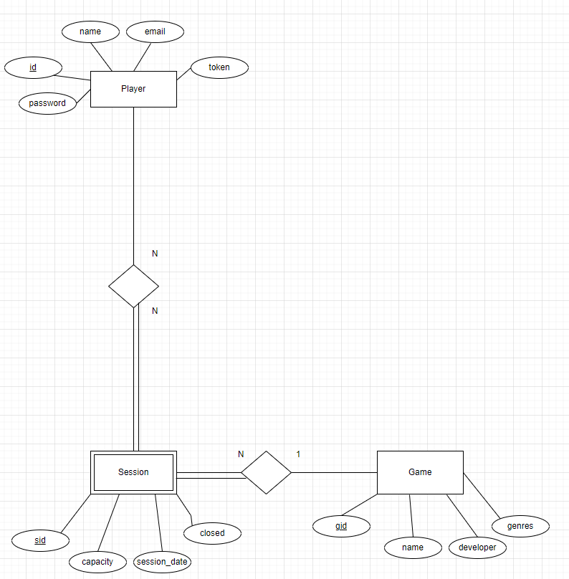

Figure 1 – Conceptual Model

The **model** contains the **three entities** mentioned. Note that **Session** is a weak entity from **Player** and **Game** because, if there are no players or game, there is no session.

Integrity Restrictions:

* ‘Email’ has the following format: abcd@aaa
* ‘Email’ and ‘Name’ are ‘Player’ candidate keys
* ‘Token’ is an unique attribute
* ‘Session_date’ has the following format: YYYY-MM-DD HH:MM:SS
* ‘Name’ is ‘Game’ candidate key

**Physical model**

The physical model can be found [here](https://github.com/isel-leic-ls/2324-2-LEIC42D-G06/blob/main/Backend/sql/createTables.sql).

All the tables are based on the conceptual model.

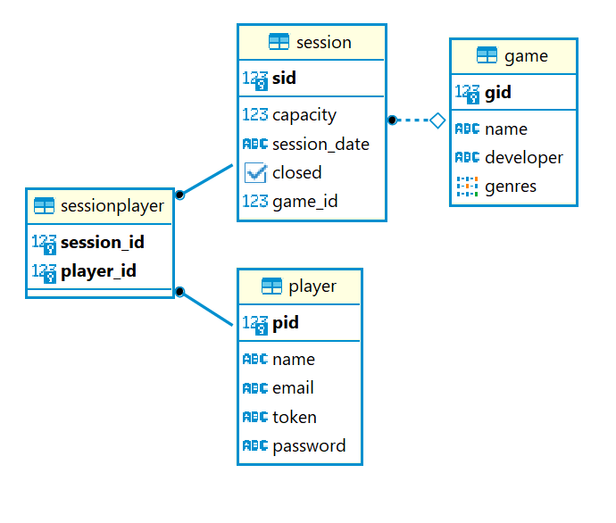

Figure 2 – Physical model

**Open-API specification**

The Open-API specification can be found [here](https://github.com/isel-leic-ls/2324-2-LEIC42D-G06/blob/main/Docs/Open%20API%20Specification.yaml).

All the api’s routes were documented using this specification.

**Details of an API request**

The request reaches the server, and the server then routes the request to the appropriate handler.

After this happens, the following steps are carried out:

* The handler executes a function called errorAwareScope that executes the code needed to fulfill the request. In the event of an error, this function handles the error via the exceptionHandler function.
* Within the function mentioned above, the first thing to do is extract the parameters present in the URI. The token is also extracted if a request requires authentication.
* Next, the JSON is deserialized if the request has a body.
* The associated service is called, which validates the parameters passed in. Within this service, the repository is called to persist, read, and change data.
* The result from the service is then encapsulated in a outputModel class, that class is serialized to JSON and the response is attributed the according status code.

**Connection Management**

Whenever we interact with the DBMS, we fetch a connection via the getConnection() function and utilize the use{} function, which automatically closes the connection after running the code in its scope. As we never set autoCommit to false in the repository functions, all the code runs in a single transaction.

**Data Access**

Our data access has been implemented with three interfaces. There is one interface for managing players, another for managing games, and another for managing sessions. There are two implementations of these interfaces. One of them is for performing CRUD operations in memory, whose names normally act in accordance with the following structure: Mem{entity} Repo, and the other is for performing CRUD operations on a Postgres database, where the names of the repositories follow the structure: Jdbc{Entity}Repo. The JDBC repositories receive as a parameter the PostgreSQL datasource with which they would interact.

**Error Handling**

Backend exceptions are generated in all the main modules. For exemple:

* Repository can’t find a session with id = x.
* The Service fails validation.
* Api can’t extract the route parameter.

All these exceptions are then handled by the exceptionHandler used in the exceptionAwareScope{} function. Within this exceptionHandler function, the exception is converted to a status code using an associative map. A response is then created with a description of the problem. If for any reason an exception can’t be associated with an HTTP status code, that exception is converted to Internal Server Error status code.

**Critical evaluation**

Better analyzation of using big transactions in the JDBC repo classes. Namely if there are issues due to concurrency.