A Comprehensive Survey of Asynchronous API Approaches in
Concurrent I/O Scenarios

Diogo Rodrigues,
DEETC, ISEL, PORTUGAL
a39128@alunos.isel.pt

Abstract— This paper presents a summary of the thesis entitled "A Comprehensive Survey of Asynchronous API Approaches in Concurrent I/O Scenarios.". This work traces the development from traditional asynchronous IO methods to modern reactive stream techniques, detailing key concepts and emphasizing the application of reactive streams and other relevant technologies related to non-blocking data retrieval. It also presents a comparative analysis of several technologies, focusing on their performance across two selected algorithms. Finally, it concludes highlighting the advantages and disadvantages of each technology discussed.
Keywords: Asynchronous IO, Reactive Streams, JAVA, .NET, KOTLIN, JAVASCRIPT, code verbosity, Reactive Extensions (Rx), Project REACTOR,
I. Introduction
This dissertation investigates the overhead and performance implications of reactive stream pipelines within non-blocking I/O programming environments. Employing technologies such as .NET's Async Enumerables, JavaScript's asynchronous generators, and Kotlin's Flow. This study delves into the nuanced trade-offs between the conciseness and readability offered by these modern programming paradigms versus their potential to introduce performance bottlenecks.
The advantage of using reactive streams in handling complex, asynchronous data flows highlights a critical area in software engineering: the efficient management of I/O operations that are foundational to high-performance applications and its code readability and easy to maintain features. Despite their advantages, the integration of non-blocking I/O with reactive streams can sometimes lead to suboptimal resource utilization and efficiency losses, making the understanding of their overheads essential for developers aiming to optimize application performance and enhance user experience.
Research Objectives:
- Investigate state-of-the-art non-blocking I/O technologies: This involves a comprehensive review of the current landscape in asynchronous I/O programming, focusing on reactive stream technologies across major development platforms.
- Analyze baseline approaches without pipelines: By comparing these with traditional non-pipelined approaches, the study aims to benchmark and understand the raw performance capabilities of each.
- Evaluate various non-blocking I/O idioms and technologies: This will assess their operational efficiencies, resource management, and scalability within different programming contexts.
- Study practical implementations of reactive stream pipelines: To document and analyze how these technologies are applied in real-world scenarios and their impact on application architecture.

The introduction sets the stage for a deeper exploration into the intricacies of reactive stream pipelines as laid out in subsequent chapters:

II State-of-the-Art: Reviews from non-blocking IO to reactive stream pipeline background history, show concept and strategies
III Methodology: Details the research design, technology selection, experimental setup, and methods of data analysis.
IV Detailed Analysis and Comparison of Results: Discusses findings and compares the efficacy of various reactive technologies against baseline models.
V Conclusions and Future Directions: Summarizes the insights gained, contributions of the study, and outlines potential avenues for further research.

II. State of the ART

In the late 1980s to early 2000s, advances in hardware and network bandwidth, coupled with the rise of the internet, necessitated high responsiveness and efficient systems. This era saw the development of multicore processors and the need for frameworks that could handle data efficiently in multithreaded and asynchronous environments. Traditional asynchronous models faced limitations in handling large data volumes or continuous data sources, necessitating the development of new projects to address these challenges. Some of these initiatives include Project Reactor, Reactive Extensions, and various API developments, all aimed at addressing these issues with fluent APIs and functional programming. Next we can saw the main points of development that are present in the main document of key developments made between these years:

Gang of Four: Published 23 design patterns for object-oriented problems.

Reactive Synchronous Event Dispatching: Uses a dispatcher and handler model with synchronous I/O, leading to complexity and potential blocking.

Proactor Pattern: The Proactor Pattern introduces an asynchronous approach where a completion dispatcher manages I/O operations, allowing decoupling between application logic and processing mechanisms. This pattern underpins modern platforms like Node.js, Spring WebFlux, and Vert.x.

Before advancing to the state of the art, its important to have in mind several key concepts like:

Synchronous vs. Asynchronous

Synchronous: Blocks the caller until the operation is finished.
Asynchronous: Returns immediately, allowing the caller to continue other tasks.

Push vs. Pull

Pull: The consumer retrieves items from a data source.
Push: The producer sends items to a consumer.

Hot vs. Cold

Cold: Data flow starts when an observer subscribes.
Hot: Data is produced regardless of observer subscription.

Cancelable
Mechanisms to control and cancel asynchronous operations, e.g., C#'s CancellationToken and RxJava's Cancelable.

Error Handling
Isolating errors in asynchronous flows to prevent blocking and ensure proper logging and handling.

Intrinsic Keywords
Simplifying asynchronous code with syntax resembling synchronous code, e.g., async...await in C# and JavaScript.

Back-pressure
Strategies to handle situations where the producer emits items faster than the consumer can process, such as dropping items or buffering.

State of the Art

In the realm of modern software development, the ability to efficiently manage and process data streams is crucial. With the ever-increasing demand for real-time data processing and the need for highly responsive applications, traditional blocking I/O operations have become insufficient. The emergence of non-blocking I/O and reactive streams has revolutionized how developers handle asynchronous data flows, enabling the creation of elegant and efficient pipelines of operations.

Non-blocking I/O allows applications to perform I/O operations without waiting for them to complete, thereby increasing the utilization of system resources and improving overall application performance. Reactive streams build on this concept, providing a robust framework for handling asynchronous data streams in a declarative manner. By leveraging reactive streams, developers can construct pipelines of operations that are not only efficient but also easy to maintain and extend. Next, we will explore several technologies that exemplify these advancements in three different programming environments: Java, C#, and JavaScript.

Java

RxJava: As the Java implementation of the ReactiveX project, RxJava provides a comprehensive set of tools for managing asynchronous data flows. By employing the Observer pattern, RxJava allows developers to create and manipulate streams of data, implementing back-pressure to handle varying rates of data production and consumption. Its fluent API design makes it possible to construct complex data processing pipelines in a clear and concise manner.

Project Reactor: Integrated with the Spring WebFlux framework, Project Reactor offers a powerful toolkit for building non-blocking, reactive applications in Java. Utilizing the Flux and Mono types, Reactor enables developers to define reactive data pipelines that can process sequences of data with fine-grained control over concurrency and back-pressure. Reactor's integration with the broader Spring ecosystem makes it a popular choice for enterprise-grade applications.

Kotlin Flow: Leveraging Kotlin's coroutine capabilities, Kotlin Flow introduces a declarative approach to handling asynchronous data streams. Kotlin Flow allows for the creation of cold and hot streams, providing a flexible and interoperable solution for managing data flows in JVM-based applications. Its use of coroutines simplifies the syntax and readability of asynchronous code, making it an attractive option for developers looking to write maintainable reactive applications.

.NET C#

RxNet: .NET implementation of ReactiveX, providing powerful abstractions for asynchronous data flow.
Asynchronous Enumerables: IAsyncEnumerable<T> and await foreach for asynchronous data handling in .NET.

Asynchronous Enumerables: Introduced in C# 8.0, IAsyncEnumerable<T> and the await foreach construct offer a natural and intuitive way to handle asynchronous data streams. This feature enables developers to iterate over asynchronous sequences with ease, integrating seamlessly with other asynchronous constructs in the .NET framework. Asynchronous enumerables provide a familiar and straightforward approach to building reactive pipelines.

JavaScript

RxJS: JavaScript adaptation of ReactiveX for managing asynchronous data streams.

IxJS: Provides powerful abstractions for managing synchronous and asynchronous sequences in JavaScript.

After presenting some of the technologies, we can connect them to the concepts and characteristics discussed earlier, highlighting which characteristics each technology supports:

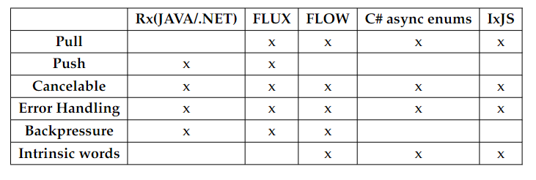
Table 1: Characteristic to tech matrix

III. benchmarking use case algorithms and benchmark setup
In order to have metrics to enable the comparison between some of the different technologies we discussed so far, was decided to make software implementations in three programming languages of two key algorithms.
Each selected to simulate two distinct data processing scenarios. These are the "Count each word occurrence" and "Find the biggest word", both of which offer valuable insights into different aspects of data processing.

As a crucial part of this research, the selection of an appropriate data source was imperative. For the empirical analysis and demonstration of the programming paradigms discussed, the "Gutenberg" library was chosen as the primary data source. This library, renowned for its comprehensive dataset, encompasses several thousands of books spanning a multitude of genres and periods. The richness and diversity of the Gutenberg dataset provided an opportunity to test and evaluate the effectiveness of reactive programming techniques in processing and analyzing large volumes of textual data. The expansive nature of the Gutenberg library not only facilitated a broad assessment across various data-intensive scenarios but also underscored the scalability and adaptability of the programming approaches under study.
On the algorithms, in the case of "Group Word" operation, the idea was to have a memory-intensive task. This operation involves analyzing a dataset to identify and count each word occurrences that fall within a specified size range. Since the algorithm uses data structures, such as dictionaries, for in runtime data storage. These nuances make the "Group Word" operation a curious test case for evaluating the capabilities of asynchronous processing in combination within a memory demanding scenario.
In contrast, the task of finding the largest word, though less memory intensive task, is significant for its simplicity. This operation involves scanning a dataset to find the single longest word, a process that, while straightforward, is critical for understanding the performance of asynchronous processing in more basic computational tasks. It serves as a benchmark for evaluating the efficiency of simpler algorithms and their implementation across different programming languages and environments.

During the implementation of the benchmarking algorithms, a conscious effort was made to keep the operation pipelines as similar as possible across the different technologies for each algorithm and its syntax closest as possible to what is shown in the algorithms' pseudocode. This endeavor aimed to create a fair and representative evaluation of the behaviors of each technology. By maintaining consistency in pipeline operations, we can more accurately attribute performance differences to the underlying technology, rather than variations in the implemented code. This approach brings us closer to a true comparison of how each technology handles the challenges of asynchronous I/O data retrieval and processing.

In certain instances, particularly with Java, there was a need to incorporate external libraries for non-blocking asynchronous file retrieval because this language didn’t have non-blocking IO native tools to retrieve data from files.

IV. benchmarking algorithms and setup
In this chapter are now shown the results on the tests made on the different technologies and strategies applied to two key algorithms, as detailed in previous chapters. Our investigation spans various strategies and implementations across .NET, Java, Kotlin, and JavaScript, culminating in a nuanced understanding of the relative performance and characteristics of different approaches.

.NET Benchmarking

For the "Find the Biggest Word" algorithm in .NET, we used the following strategies:

Baseline: Serves as a basic comparison point.
Asynchronous Baseline: This strategy uses a non-blocking IO to retrieve data from files. Each "fileread" is non-blocking, however, there are several tasks running in parallel reading files, the results are only shown when all tasks are finished.
Parallel: Utilizes parallelization techniques.
AsyncEnumerable: Leverages asynchronous programming with enumerable collections.
RxNet: Uses the Reactive Extensions (Rx) library with asynchronous file reading operations.
Linq: This strategy uses Language Integrated Query (LINQ) for finding the biggest word.

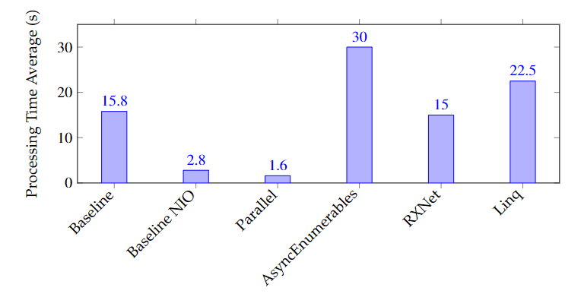
Figure 1 – C# FingBiggest Results

From these results, it is apparent that the baseline approach using non-blocking IO has an advantage over its blocking counterpart. However, it is also evident that the parallel solution holds an advantage over its competitors wich indicates that multithreading has advantages that are not irrelevant.
Taking into account the technologies that provide pipelining, we can see that the overall performance is worse compared to strategies that do not use pipelines. In this context, RxNet demonstrates a performance advantage over both Linq and AsyncEnumerables strategies. It was expected that, since Linq uses a blocking IO source, however, on the other side, Linq solution outperform AsyncEnumerables solution. This may imply that for this particular algorithm, the AsyncEnumerable strategy incurs a higher internal overhead than intended although using non-blocking IO while Linq blocks for each IO operation.

Group Word Algorithm Results:
For "Group Words," the strategies tested in C# we have the following conclutions:

Baseline: Basic approach for word grouping.
Linq: Implements synchronous Language Integrated Query.
AsyncEnumerable: Uses asynchronous enumerable collections.
RxNet: Applies Reactive Extensions for asynchronous, event-based data handling.

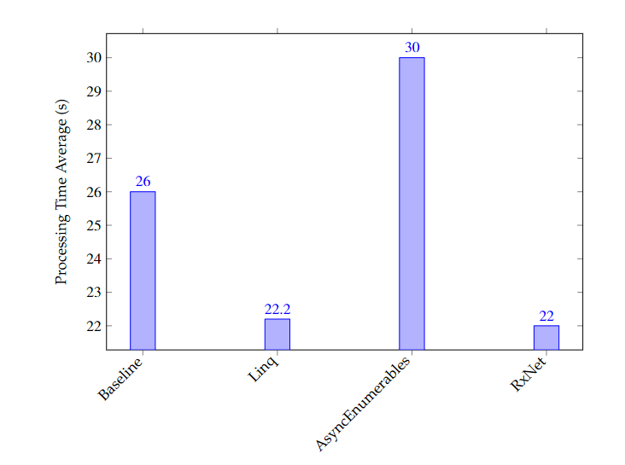
Figure 2 – C# GroupWords Results

First of all, it’s important to make clear once again, that this algorithm is memory-intensive; in this case, it uses maps, to hold information about each word as a value and the number of occurrences for each word repetition in the dataset.

Taking, that in account, and once again as explained, the baseline strategy serves a standard for performance comparison with other solutions. While straightforward, in this case, it does not leverage the advanced features of other approaches, resulting in a moderate processing time. In comparison, the Linq strategy, shows an improvement in performance over the baseline. This suggests that the streamlined querying capabilities of LINQ, despite being synchronous, can efficiently handle the algorithm's requirements better than the baseline approach in this memory-intensive scenario.

On the other hand, the AsyncEnumerable approach, which uses .NET async enumerables to process data asynchronously, exhibits a longer processing time in this context. This indicates that while async enumerables are beneficial for certain applications, their performance in memory-intensive tasks like "Group Words," which heavily relies on dictionaries, might not be optimal.

Furthermore, the RxNet implementation, also demonstrates competitive performance. This underscores the potential of RxNet in efficiently managing asynchronous data flows. In memory intensive algorithms.

Overall, while pipeline libraries tend to outperform the baseline approach in memory-intensive algorithms like "Group Words," the choice between blocking and non-blocking IO operations becomes less significant. This is primarily because the overhead from memory-intensive operations tends to overshadow any potential performance gains from using non-blocking IO operations. The results indicate that the optimal strategy for such algorithms would depend more on how they handle memory-intensive operations rather than the differences in IO operation types.Taking, that in account, and once again as explained, the baseline strategy serves a standard for performance comparison with other solutions. While straightforward, in this case, it does not leverage the advanced features of other approaches, resulting in a moderate processing time. In comparison, the Linq strategy, shows an improvement in performance over the baseline. This suggests that the streamlined querying capabilities of LINQ, despite being synchronous, can efficiently handle the algorithm's requirements better than the baseline approach in this memory-intensive scenario.

On the other hand, the AsyncEnumerable approach, which uses .NET async enumerables to process data asynchronously, exhibits a longer processing time in this context. This indicates that while async enumerables are beneficial for certain applications, their performance in memory-intensive tasks like "Group Words," which heavily relies on dictionaries, might not be optimal.
Furthermore, the RxNet implementation, also demonstrates competitive performance. This underscores the potential of RxNet in efficiently managing asynchronous data flows, especially in scenarios where the processing time is crucial.
Overall, while pipeline libraries tend to outperform the baseline approach in memory-intensive algorithms like "Group Words," the choice between blocking and non-blocking IO operations becomes less significant. This is primarily because the overhead from memory-intensive operations tends to overshadow any potential performance gains from using non-blocking IO operations. The results indicate that the optimal strategy for such algorithms would depend more on how they handle memory-intensive operations rather than the differences in IO operation types.

Java/Kotlin Benchmarking

Biggest Word Algorithm Results:

In Java and Kotlin, the strategies explored include:

Baseline: Basic non-blocking I/O operation.
Reactor Core Flux and Parallelization (Java): Utilizes the Project Reactor for reactive programming.
RXJava (Java): Implements RXJava for reactive and asynchronous programming.
Kotlin Flow (Kotlin): Uses Kotlin's Flow API for handling asynchronous streams.

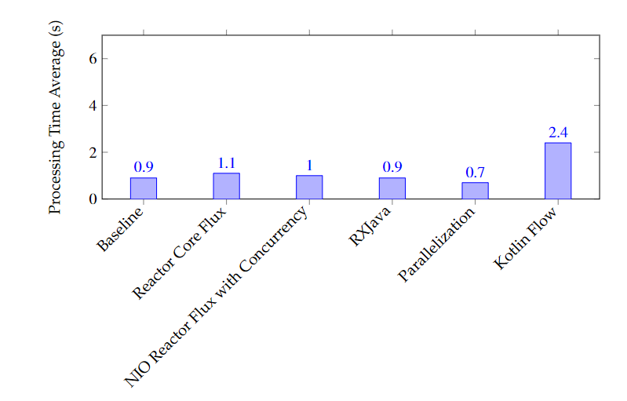
Figure 3 – JAVA FindBiggest Results
The Baseline, representing basic non-blocking I/O operations, provides a competent performance. Reactor Core Flux, utilizing the Project Reactor library for reactive programming, shows a processing time of 1.1 seconds, indicating slight overhead due to managing reactive streams. Enhancing Reactor Core Flux with concurrency reduces the processing time, demonstrating improved efficiency.
RxJava matches the baseline performance, indicating that does not introduce significant overhead. The most notable efficiency is achieved by the Parallelization strategy, which uses Java's Streams API with parallel processing using multithreading mechanisms, resulting in the fastest processing time. This highlights the advantages of parallel processing in optimizing computational tasks by distributing work across multiple threads.
On the other hand, Kotlin Flow, which employs Kotlin's Flow API for managing data asynchronously, shows the highest processing time, the overhead suggests potential areas for optimization.
These results highlight that parallel processing strategies although using blocking IO as a source, achieve the most efficient performance however, using non-blocking IO with reactive stream technologies like RXJava have a very good performance and its code is a loot simpler and easy to maintain than other solutions. This enforces that the chose between solutions are much dependent of the specific needs of the project.
However, we can see a huge difference from what we observed previously in .NET, where the baseline, parallelization, and Rx approaches showed significant differences in performance between each other, while in Java, the differences were minimal and their performances were orders of magnitude better than what we saw in .NET. The only performance that was similar in both JAVA and .NET was the performance related to parallelization using blocking IO, but even then, JAVA outperformed in 2 times the performance time of the .NET Implementation.
This reinforces the idea that choosing the right environment can have a much greater impact on project decisions than initially thought.

Group Word Algorithm Results:

The approaches assessed are:

Baseline: Basic non-blocking strategy.
RXJava (Java): Employs RXJava library.
Reactor Core Flux (Java): Uses Project Reactor's Flux for reactive programming.
Parallel (Java): Utilizes Java's Streams API with parallel processing.
Flow (Kotlin): Implements Kotlin's Coroutines and Flow API.

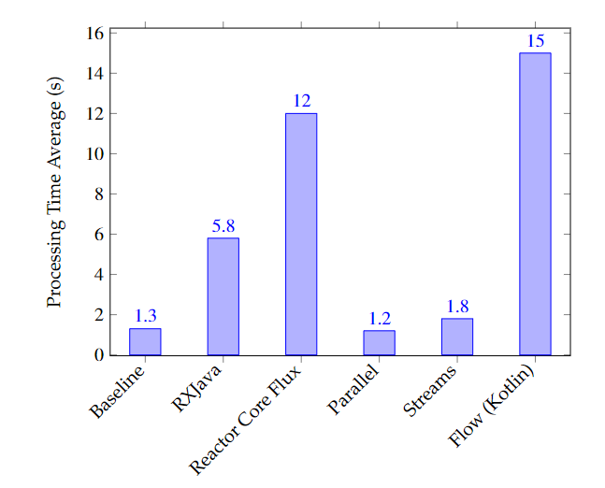
Figure 4 – JAVA GroupWords Results
The Baseline strategy, as before, sets a standard for comparison, showing moderate efficiency. RXJava, known for its asynchronous and event-driven capabilities, demonstrates a longer processing time in this context, indicating potential overheads in handling complex data sequences in this particular environment. Reactor Core Flux, while efficient in handling asynchronous sequences, shows a significant processing time, possibly due to the complexity of the Group Word algorithm. Strategies involving parallel processing, whether through direct use of threadpools or the Streams API, exhibit improved efficiency, highlighting the benefits of parallelism in handling computationally and memory intensive tasks. Notably, Kotlin's Flow API, shows a longer processing time, which could reflect the overheads associated with its internal resource management in complex data processing scenarios.
Overall to JAVA, these results illustrate the trade-offs between different programming paradigms and libraries in Java and Kotlin. While some strategies excel in simple tasks, others are more suited to complex algorithms, indicating the importance of choosing the right approach based on the specific requirements of the algorithm and the nature of the data being processed.

JavaScript Benchmarking

Finding the Biggest Word Algorithm Results:

We examined three strategies in JavaScript:

Baseline: Basic JavaScript implementation.
Stream: Utilizes JavaScript streams for data handling.
RxJS: Leverages the Reactive Extensions for JavaScript.
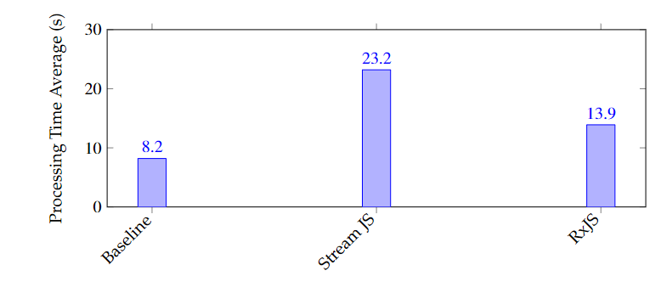
Figure 5 – JS FindBiggest Results
Although RxJS offers better optimization for asynchronous data operations compared to basic JavaScript implementations, it does not outperform the streaming techniques in this particular algorithm. The basic JavaScript implementation remains the fastest for this specific task, while RxJS provides a middle ground with its advantages in handling complex asynchronous operations.

Grouping Words Algorithm Results:

The strategies evaluated include:

Baseline: Standard JavaScript approach.
Stream JS: Uses JavaScript streams.
RxJS: Applies Reactive Extensions for asynchronous operations.

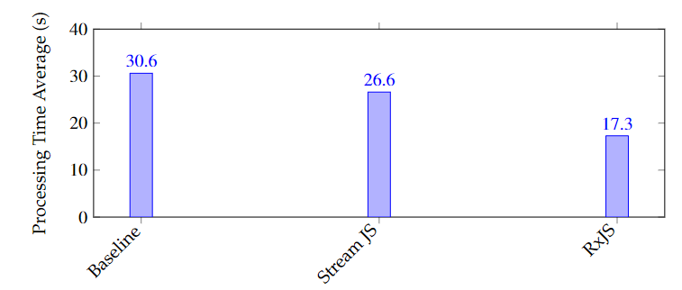
Figure 6 – JS GroupWords Results
This analysis shows that RxJS provides a robust solution for complex data handling challenges, outperforming both traditional and streaming approaches in JavaScript. The use of RxJS enhances scalability and maintainability, making it a superior choice for applications dealing with extensive data manipulation and asynchronous processing.

V. benchmarking algorithms and setup

The analysis of reactive streams programming and pipelining technologies throughout this thesis highlights their substantial benefits in terms of user-friendliness and maintenance simplicity. Nonetheless, these technologies also present certain drawbacks that must be carefully considered in the context of specific application requirements and desired outcomes.
For systems demanding high performance and robustness, a baseline-like approach, which allows for custom optimization, might be ideal. Conversely, for rapid development with satisfactory performance and easier maintenance, tools like RxJava and .NET's AsyncEnumerable provide valuable solutions. The choice largely depends on the project's long-term objectives and operational context. For example, high-frequency trading systems require the raw speed and low latency that finely tuned baseline systems provide. In scenarios where time-to-market is crucial, the productivity benefits of higher-level frameworks may outweigh their performance costs.
While baseline approaches generally performed better in specific algorithms, the practicality of using advanced frameworks like RxJava or .NET's AsyncEnumerable in enterprise environments cannot be overlooked. They facilitate rapid development and easier maintenance, which are often prioritized over minor performance gains in many professional settings.

However, a notable observation from the results is that the programming language, frameworks, and virtual environments running the algorithms have a significant impact on performance. For instance, Java outperformed .NET and JavaScript solutions across baseline, reactive streams frameworks, and parallelization strategies, despite the algorithms and implementations being nearly identical.
Another surprise is that several parallelization implementations using blocking I/O showed very competitive performances, albeit with higher resource usage. This indicates that parallelization can be an effective strategy, even with blocking I/O, under certain conditions.
In conclusion, the choice of technology stack and environment can greatly influence the performance and development efficiency of a project. Therefore, careful consideration of these factors is essential for achieving the desired balance between performance, maintainability, and development speed.
Future Work and Final Thoughts
Looking ahead, there are several promising directions for future research:
Exploration of Emerging Frameworks: Continual investigation into new and emerging frameworks can provide insights into more efficient and scalable solutions for managing asynchronous tasks.
Enhancement of Benchmarking Tools: Developing and utilizing more accurate and comprehensive benchmarking tools to measure the performance, scalability, and reliability of asynchronous technologies across different scenarios will be crucial. This enhancement will allow for deeper insights into both established and emerging technologies and strategies.
Development of Debugging Tools: Asynchronous code debugging can be challenging due to its non-linear execution flow. Improved debugging tools need to effectively manage asynchronous stack traces and provide clear insights into the state of operations at any given moment. Tools that offer visualizations of code execution timelines and interaction patterns can simplify the debugging process and enhance understanding.
This work has clearly demonstrated that different approaches significantly impact the effectiveness of solutions. In today's digital environment, dominated by live data streaming, the method of handling data asynchronously is more crucial than ever. It has been shown that adhering to robust programming practices and selecting the appropriate tools and strategies, based on best practices, are critical.

VI. REFERENCES

[1] AUTHOR’S NAME. “Iterating with Async Enumerables in C# 8”. Accessed: 04-08-2023. (2019), [Online]. Available: https://learn.microsoft.com/en-us/archive/msdn-magazine/2019/november/csharp-iterating-with-async-enumerables-in-csharp-8.
[2] Martin Fowler, Refactoring: Improving the Design of Existing Code. Boston, MA, USA: Addison-Wesley, 1999, ISBN: 0-201-48567-2.
[3] Erich Gamma, Richard Helm, Ralph Johnson, and John Vlissides, Design Patterns: Elements of Reusable Object-Oriented Software. Addison-Wesley, 1994, ISBN: 0-201-63361-2.
[4] Mozilla Developer Network. “AsyncGenerator”. Accessed: 07-08-2023. (2023), [Online]. Available: https://developer.mozilla.org/en-us/docs/web/javascript/reference/global_objects/asyncgenerator.
[5] JetBrains. “Flow”. Accessed: 07-08-2023. (2023), [Online]. Available: https://kotlinlang.org/docs/flow.html.
[6] Oleg Kiselyov, Simon Peyton Jones, and Amr Sabry, “Lazy v. Yield: Incremental, Linear Pretty-Printing”, vol. 7705, Dec. 2012, ISBN: 978-3-642-35181-5. DOI: 10.1007/978-3-642-35182-2_14.
[7] Douglas C. Schmidt, Tim Harrison, Irfan Pyarali, and Thomas D. Jordan, “Proactor - An Object Behavioral Pattern for Demultiplexing and Dispatching Handlers for Asynchronous Events.” 4th Conference of Pattern Languages of Programming, 1997.
[8] Roy Thomas Fielding, Architectural Styles and the Design of Network-Based Software Architectures. University of California, 2000.

