1. If the username or password is used incorrectly, and there is no blocking action, then this loop is allowed?

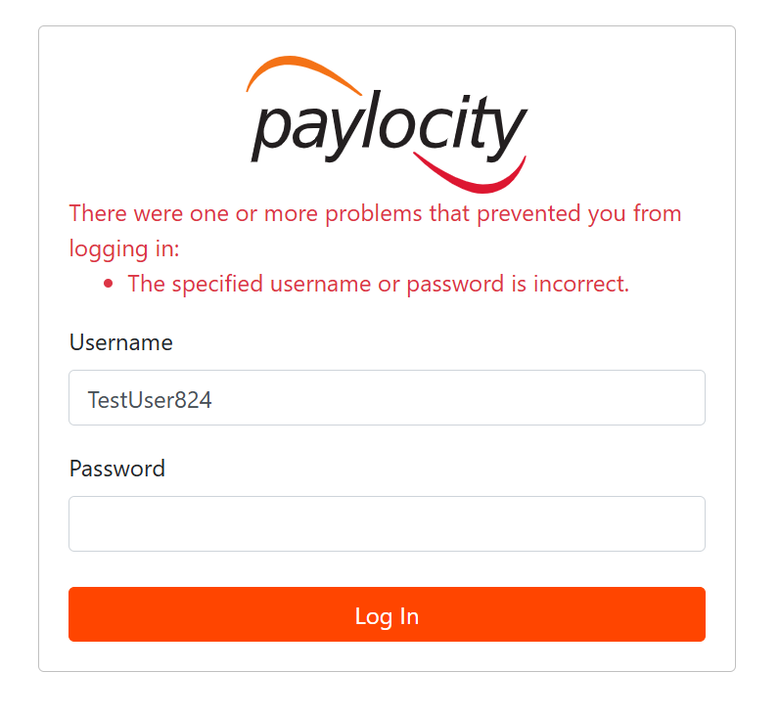

1. The dependents field is not updated, there is no error message or indication of when the dependents limit is reached.

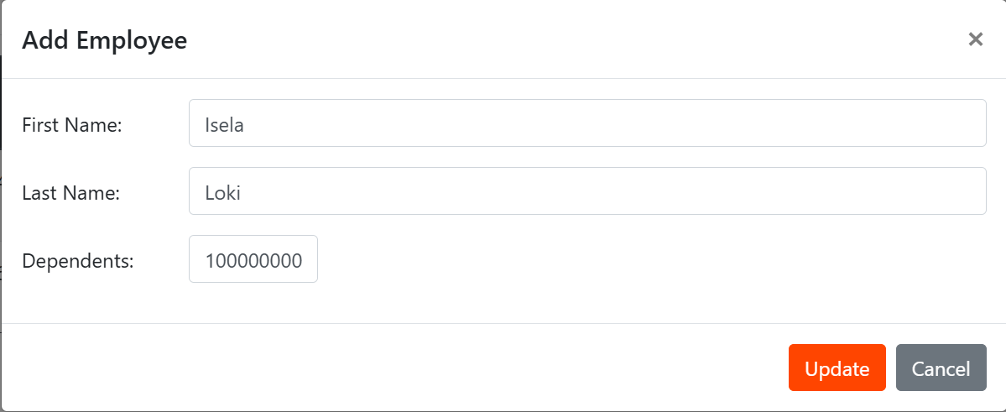

1. There is no indication that the fields are mandatory, so if they are left blank, the registration will not be completed.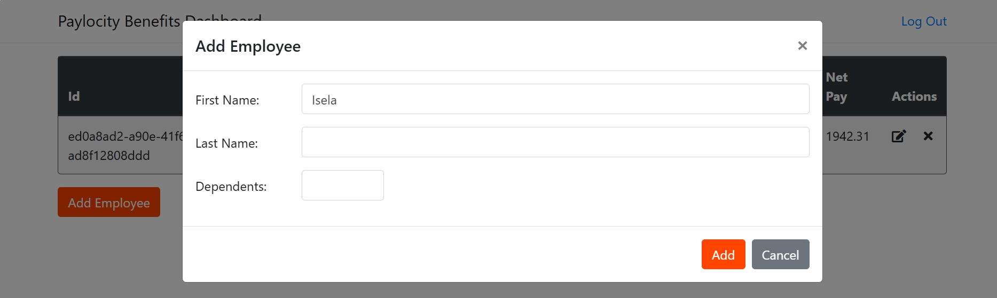
2. Furthermore, the type of information to be entered is not specified, so the registration is generic and ultimately saved (without any indication of the reasons why the registration is not saved).

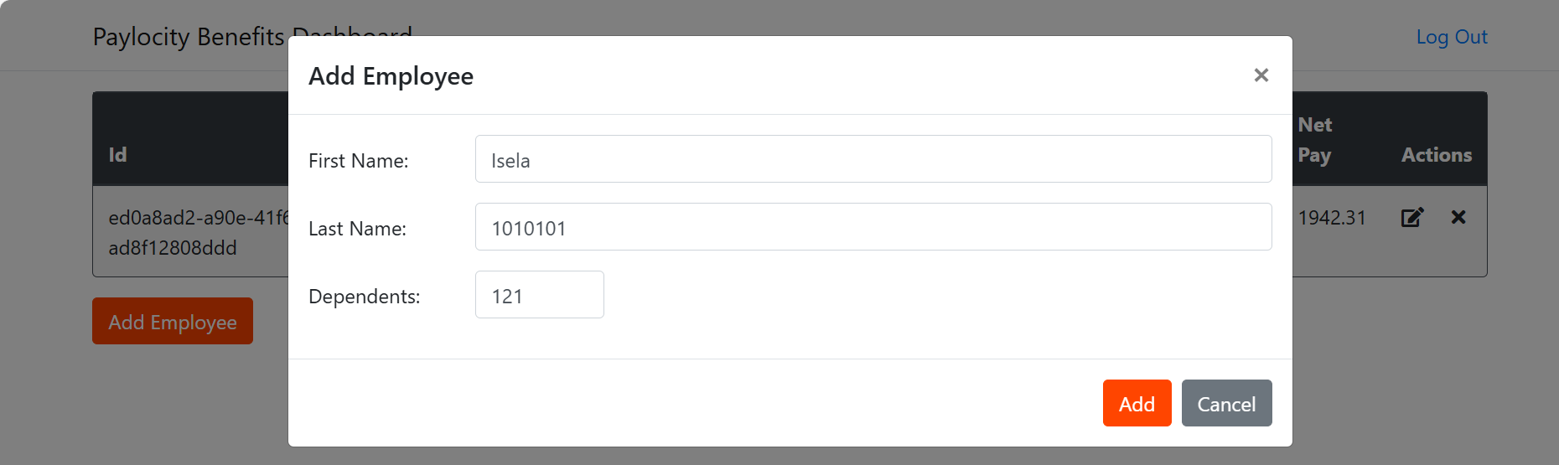

1. You can duplicate records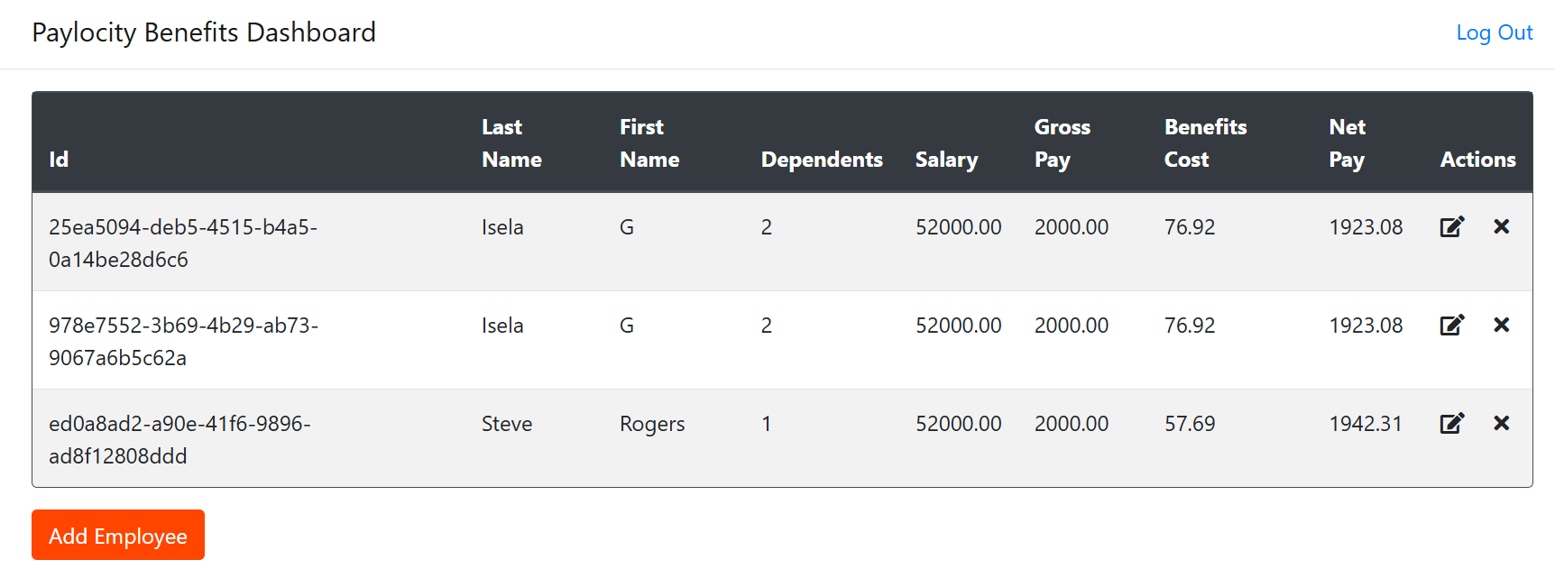
2. Modification option is very basic, and it doesn't display the complete record (nor does it indicate that these are default values).

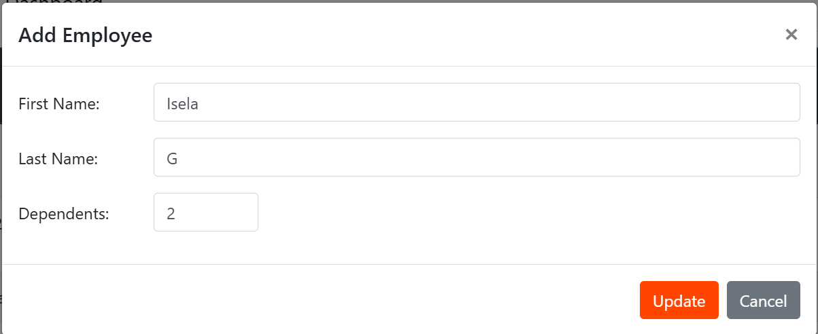

1. Filter option is not visible
2. Currency type used in the record is not displayed.

