Tour Planner
Project Protocol
Semester Project, Software Engineering

Matej Krsteski
Iselin Magnussen

Git repository:
https://github.com/iselinmag/SoftwareEngineering-TourPlanner

05.07.2026

Contents
1. Introduction
2. Application architecture
3. Use cases
4. Sequence diagram: full-text search
5. User interface and UI flow (wireframes)
6. Library and technology decisions
7. Implemented design patterns
8. Unit testing decisions
9. Unique feature: tour image gallery
10. Technical steps, decisions, failures and solutions
11. Lessons learned
12. Time tracking
13. Git repository

1. Introduction
Tour Planner is a web application for planning tours (bike, hike, running or vacation) and for keeping logs of the tours a user has actually done. A tour has a name, a description, a start and end location, a transport type, a distance, an estimated time and a route that is drawn on a map. The distance, the time and the route geometry are retrieved live from the OpenRouteService API, and the map is displayed with Leaflet.
Users register and log in with their own account. Every tour can be seen by everyone and everyone can write logs on any tour, but only the creator of a tour or a log may edit or delete it. This ownership model was confirmed with the course instructor by e-mail before submission. The application also computes two attributes on its own: the popularity of a tour (derived from the number and ratings of its logs) and its child friendliness (derived from the recorded difficulty, times and distances).
The system is a two-tier application. The frontend is written in Angular and follows the MVVM pattern. The backend is written in Java with Spring Boot, is organised in three layers, stores its data in a PostgreSQL database through the JPA/Hibernate O/R mapper and stores uploaded images on the file system. Logging is done with Log4j2. The backend is covered by unit tests written with JUnit 5, Mockito and AssertJ.

2. Application architecture
The application consists of two independent programs that talk to each other over HTTP with JSON bodies: the Angular frontend running in the browser and the Spring Boot backend running on the server. The figure below shows the overall structure.
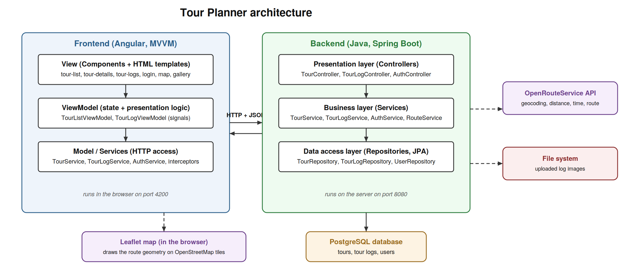
Figure 1: overall architecture with all layers and external systems

2.1 Backend layers
The backend follows the required layer-based architecture. Each layer only calls the layer directly below it, never further down, and each layer has one clear job.
- Presentation layer (controllers): classes TourController, TourLogController and AuthController receive the HTTP requests, read the JSON bodies, validate the input annotations and pass the work on to the business layer. They contain no business logic themselves. The GlobalExceptionHandler also belongs to this layer: it catches the exceptions defined by the layers below and translates them into clean HTTP status codes (404 not found, 403 forbidden, 409 conflict, 401 unauthorized, 400 validation error).
- Business layer (services): classes TourService, TourLogService, AuthService, RouteService, CurrentUser and FileStorageService contain the actual application logic: ownership checks, the computation of popularity and child friendliness, the calls to the OpenRouteService API, password hashing and token creation, and the storing of uploaded images. This layer works with DTO objects towards the controllers and with entities towards the repositories.
- Data access layer (repositories): the interfaces TourRepository, TourLogRepository and UserRepository extend Spring Data JPA. They are the only classes that touch the database. Standard operations (find, save, delete) are generated by Spring, and the full-text search is our own JPQL query. Because JPQL with named parameters is used everywhere, no SQL string is ever concatenated by hand, which rules out SQL injection.
Cross-cutting parts: the security package (JwtService, JwtAuthFilter) checks the login token on every request before it reaches a controller, and the config package (SecurityConfig, WebConfig) wires security and CORS. All settings (database connection, API key, token secret, upload directory) live in application.properties, which is excluded from version control; only a placeholder example file is committed.

2.2 Frontend layers (MVVM)
- View: the Angular components and their HTML templates (tour list, tour details, tour logs, login, register, the map component and the image gallery component). They only display state and forward user actions.
- ViewModel: TourListViewModel and TourLogViewModel hold the UI state in Angular signals (for example the selected tour, the current search text, form state) and expose methods the views call. They contain the presentation logic but no HTTP code.
- Model: the Angular services (TourService, TourLogService, AuthService) do the HTTP communication with the backend and hold the data. Two interceptors attach the login token to every request and translate backend errors into user-friendly messages.

2.3 Class diagram
The following UML class diagram shows the core backend classes, their most important fields and methods, and the dependencies between the layers (arrows point from the caller to the called layer).
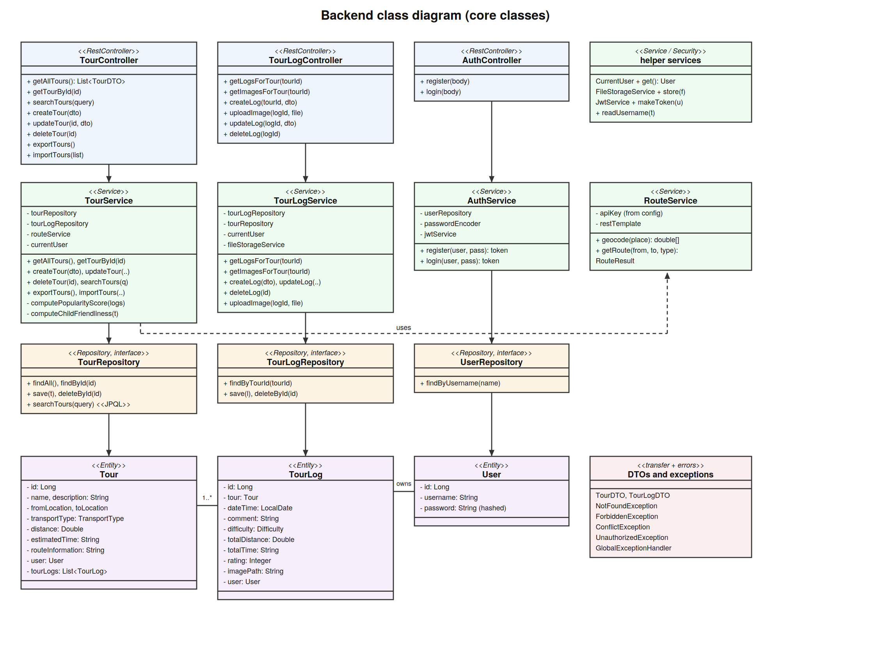
Figure 2: backend class diagram
The entity relationships are: one User owns many Tours and many TourLogs, and one Tour has many TourLogs. The DTO classes (TourDTO, TourLogDTO) are the JSON shapes exchanged with the frontend, so the entities themselves never leave the backend.

3. Use cases
There is one actor, the logged-in user. The diagram below shows everything a user can do. Registration and login are the entry point; every other use case requires a valid login token.
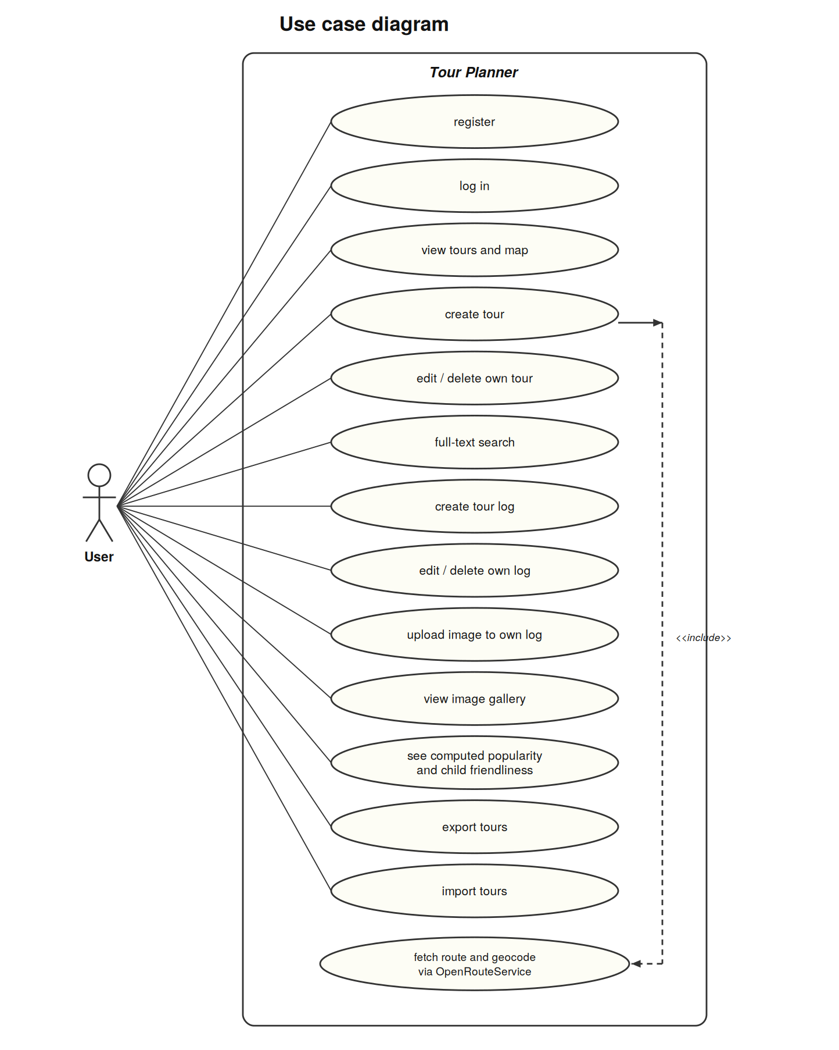
Figure 3: UML use case diagram
Creating a tour includes fetching the route: when the user saves a new tour, the backend first geocodes the two place names (turns them into map coordinates) and then asks the OpenRouteService directions API for the distance, the estimated time and the route geometry. Editing and deleting are restricted to the owner of the tour or log; other users simply do not get these options and the backend additionally rejects such attempts with HTTP 403.

4. Sequence diagram: full-text search
The full-text search runs through every layer of the system, so it is the required sequence diagram. The user types a word, the Angular ViewModel passes it to the Angular service, the backend controller receives the HTTP request, the business layer delegates to the repository, and a single JPQL query searches the tour name, the description, the start and end locations and all tour log comments at once. The service then maps every matching tour to a DTO and computes its popularity and child friendliness on the way out, so the search results already carry the computed values.
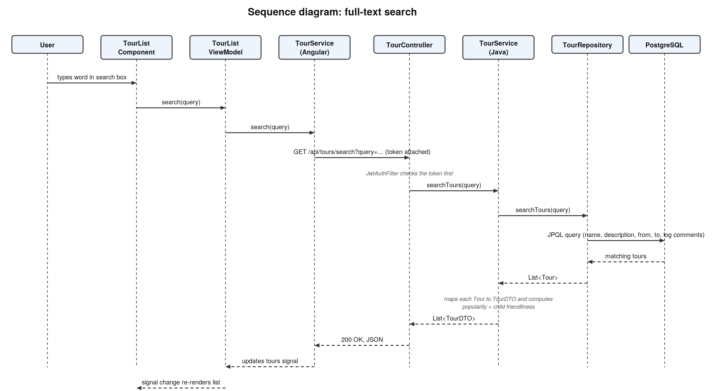
Figure 4: sequence diagram for the full-text search
One requirement clarification: the checklist mentions searching in computed attributes. Because popularity and child friendliness are calculated live in the service layer and are not stored in the database, they are not part of the JPQL query. We asked the course instructor, who confirmed by e-mail that searching inside the computed values is not needed.

5. User interface and UI flow (wireframes)
Before implementing the frontend we sketched the screens as wireframes (rough grayscale drafts of a screen that show layout and controls, not colours or final texts). The application has three main screens plus two forms. The flow between them is shown first.
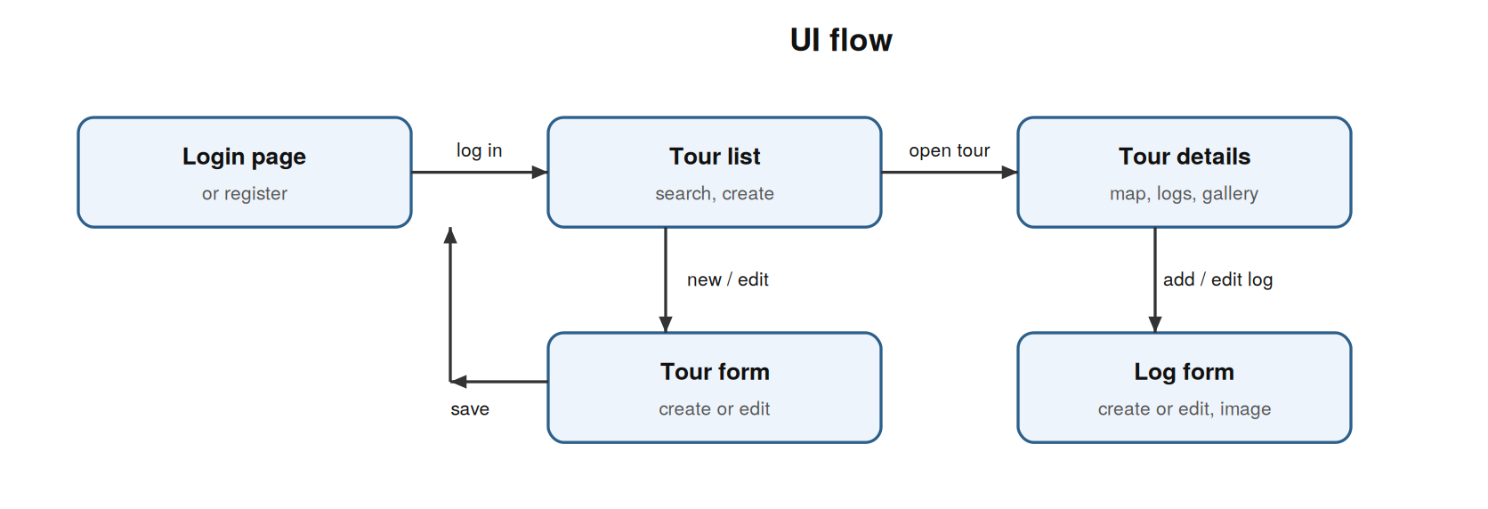
Figure 5: UI flow between the screens
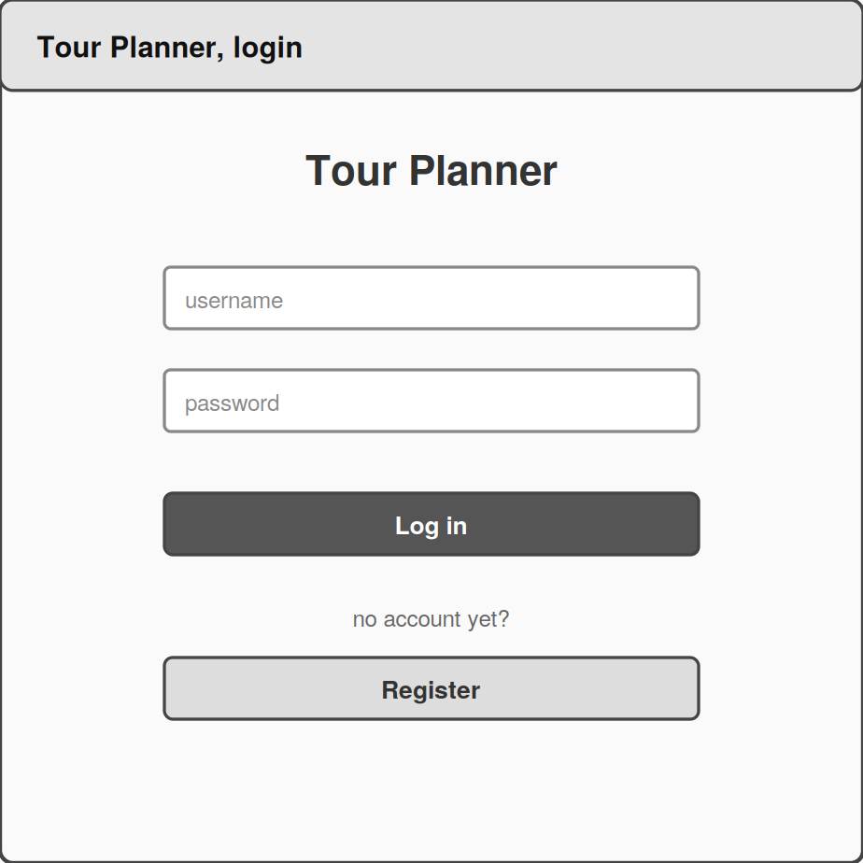
Figure 6: wireframe of the login and register screen
The login screen is deliberately minimal: two fields and two actions. After a successful login the user always lands on the tour list.
Figure 7: wireframe of the tour list screen
The tour list is the home screen. It combines the search bar (which searches tours and logs at once), the list of all tours with their computed badges, and the form for creating a new tour and Edit and delete buttons only appear on tours the logged-in user owns.
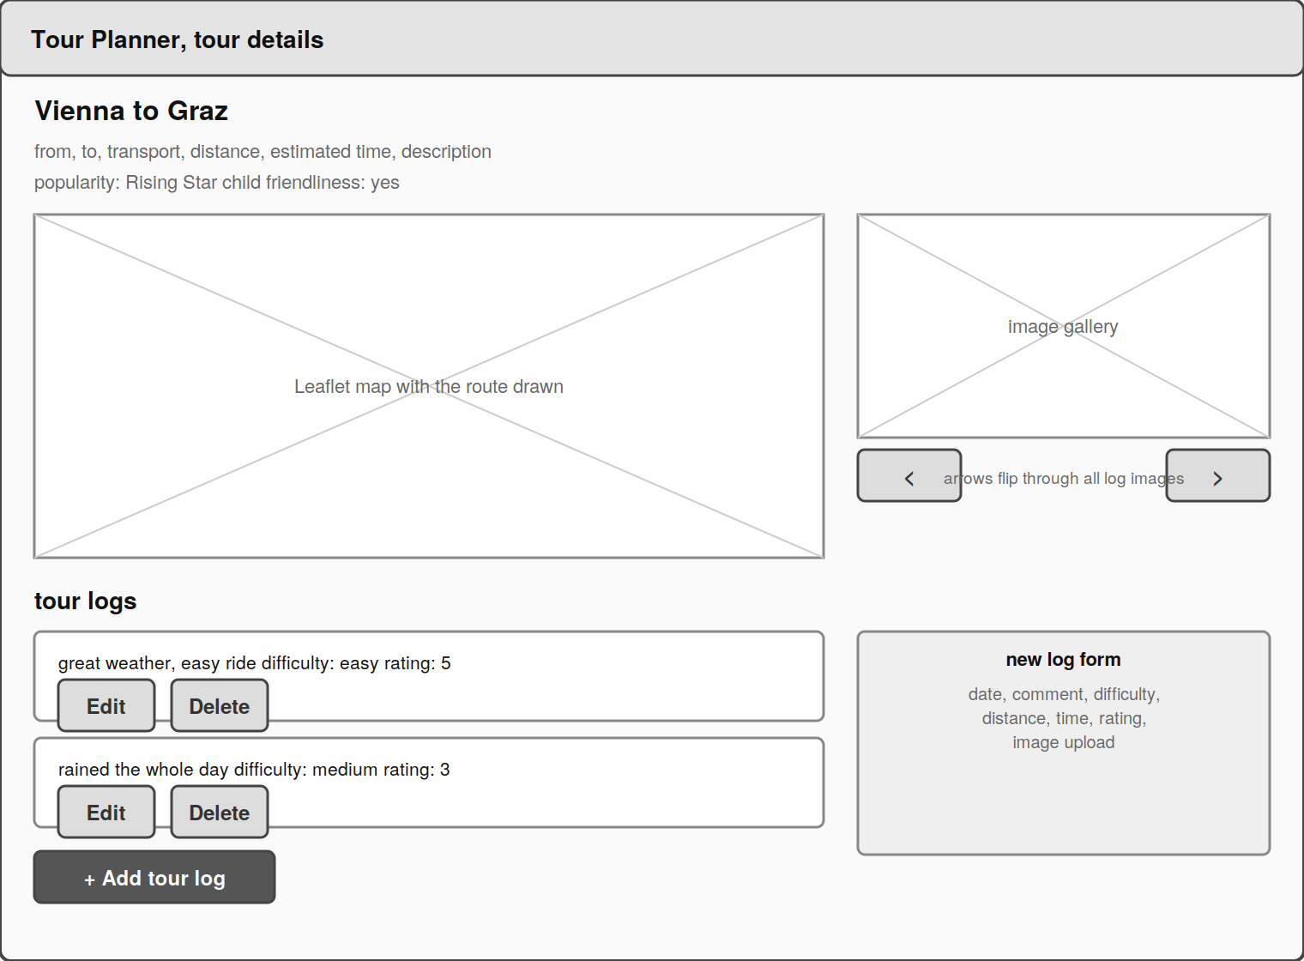
Figure 8: wireframe of the tour details screen
ADD A SIMPLE HAND DRAWN WIREFRAME OF OUR DETAILS PAGE OF THE MAP, THIS IMAGE IS WRONG. The details screen shows all attributes of the selected tour, the Leaflet map with the route drawn on it, the list of tour logs with their attributes, the form for adding a log, and the image gallery that collects the pictures of all logs of this tour.

6. Library and technology decisions
Most technologies were mandated by the assignment (Angular, Spring Boot, PostgreSQL, an O/R mapper, Log4j or Log4net, JUnit or NUnit, OpenRouteService and Leaflet). Within that frame we made the following concrete choices:
- Java + Spring Boot instead of C# + ASP.Net: we chose the Java stack because both team members were more comfortable in Java than in C#, and Spring Boot brings the web server, dependency injection and JPA integration out of one box.
- Spring Data JPA with Hibernate as the O/R mapper: comes bundled with Spring Boot and generates the everyday database operations from interface definitions, so we only had to write the one special search query ourselves.
- Log4j2: we use log4j2 as the logging framework as required. It logs to the console and, through a rolling file appender configured in log4j2-spring.xml, into logs/tourplanner.log, so exceptions and technical information survive a restart.
- JWT for authentication: login works with a JWT (a signed token the backend hands out at login and checks on every later request). This keeps the backend stateless, which is simpler than managing server-side sessions for a two-tier setup.
- JUnit 5 + Mockito + AssertJ for testing: JUnit 5 runs the tests, Mockito replaces the database and external services with controllable stand-ins, and AssertJ makes the assertions readable.
- Angular signals: Angular signals hold the UI state in the ViewModels. Signals are the current Angular mechanism for reactive state and need less boilerplate than older approaches.
- JSON as the import/export format: tours are exported and imported as JSON, because the application already speaks JSON everywhere and the format is human-readable, so an exported file can be checked by eye.

7. Implemented design patterns
The project uses three design patterns. Their use was confirmed as sufficient by the course instructor.

7.1 Repository pattern
All database access goes through repository interfaces (TourRepository, TourLogRepository, UserRepository). The rest of the application asks the repository for objects and never knows how they are stored. A repository behaves like a warehouse counter: the service hands in an order slip and receives goods, without ever walking into the warehouse itself. This is also what makes the services unit-testable, because in the tests the real repository is simply replaced by a mock.

7.2 Dependency injection
No class creates its own collaborators with new; every dependency is declared in the constructor and delivered by the Spring container (in Angular, by its injector). This inverts the responsibility for wiring: the class states what it needs and the framework supplies it. Because dependencies arrive from outside, the unit tests can hand in mocks instead.

7.3 MVVM in the frontend
The Angular frontend separates the View (component templates), the ViewModel (TourListViewModel, TourLogViewModel holding state in signals) and the Model (the HTTP services). The ViewModel acts like a waiter between the dining room and the kitchen: the view only talks to the waiter, the kitchen only sees orders, and neither needs to know the other. This keeps the templates dumb and the state logic in one testable place.

8. Unit testing decisions
The backend is covered by 32 unit tests in TourServiceTest and TourLogServiceTest, plus the frontend ViewModel tests. All tests run without a database and without internet access, because every collaborator of the tested class is replaced by a Mockito mock.

8.1 Why the service layer is tested
We deliberately test the business layer and not the controllers or repositories. The controllers contain no logic (they only forward calls), and the repositories are generated by Spring Data, so testing either would mostly test the framework. The services are where our own decisions live, and a bug there corrupts data or shows wrong values to the user. That makes this code the most critical to verify.

8.2 What the tests cover
- Happy paths: creating, reading, updating, deleting and searching tours and logs return the correctly mapped DTOs, and the right entities are handed to the repository (checked with an ArgumentCaptor, a device that records exactly what a mock received).
- Error paths: asking for a tour or log that does not exist throws NotFoundException with a clear message instead of crashing with a null value.
- Fallback behaviour: if the OpenRouteService returns nothing or throws, the tour is still saved with the values the user typed. Three tests prove the application survives the external API being down.
- Computed attributes: popularity and child friendliness are the only real branching logic in the backend, so every branch has its own test: few or bad logs, medium cases, and the top level with many five-star logs. The tests look similar but each one exercises a different branch, so none of them is a duplicate.
- Ownership checks: editing or deleting a tour or log that belongs to another user throws ForbiddenException, and the save or delete on the repository is verified to never happen. This guards the ownership rule at the backend, where it actually matters, since hiding buttons in the frontend alone would not stop a direct HTTP request.
The tests were chosen so that every path a grader or user can trigger (success, missing data, foreign data, external failure) has at least one test, while framework-generated code is left untested on purpose.

9. Unique feature: tour image gallery
Our unique feature is the per-tour image gallery. Every tour log can carry one uploaded photo. The image file itself is stored on the file system by the FileStorageService, and only the file name is stored in the database, exactly as the assignment demands. The backend offers an endpoint that collects the images of all logs of one tour, and the frontend shows them in a reusable gallery component with arrows to flip through the pictures.
The gallery therefore ties several requirements together in one visible feature: file upload with validation, external image storage, a dedicated reusable UI component, and an aggregation endpoint of its own. During the presentation it also demonstrates nicely that images survive a backend restart, because they live on disk and not in memory.

10. Technical steps, decisions, failures and solutions
This section is the protocol in the narrow sense: what we did in which order, what went wrong, and how we solved it.

10.1 Development steps
- project setup: Spring Boot skeleton, Angular skeleton, PostgreSQL database, git repository with a shared branch workflow.
- intermediate submission: entities, repositories and controllers for tours, first Angular screens, HTTP connection between the two tiers.
- route integration: geocoding and directions calls to OpenRouteService, storing the returned geometry, drawing it with Leaflet.
- users and security: registration, login, JWT filter, ownership checks in the services.
- logs, computed attributes, full-text search, import and export, image upload and the gallery.
- hardening for the final submission: unit tests, input validation, clean error responses, file logging, documentation.

10.2 Failures and selected solutions
- Auth errors returned 500: at first, registering a taken username or logging in with a wrong password produced a generic HTTP 500 error, because the service threw a plain RuntimeException that nothing caught. We introduced our own ConflictException and UnauthorizedException and handlers in the GlobalExceptionHandler, so the frontend now receives a clean 409 or 401 with a readable message. This also keeps the rule that each layer defines its own exceptions.
- Coordinate order of the route API: OpenRouteService expects coordinates in longitude-first order, while one intuitively writes latitude first. The first route requests failed or produced routes in the wrong place until we noticed the order. The solution is the two-step flow in RouteService: geocode each place name first, then hand the coordinates to the directions API in the order it expects.
- External API as a single point of failure: if the route API is unreachable, creating a tour used to be impossible. We decided the tour should still be saveable with the user-typed distance and time as a fallback, and wrote unit tests that pin this behaviour down.
- CORS between ports 4200 and 8080: the browser blocked the frontend requests to the backend until CORS (the browser rule that scripts may only call their own origin unless the server allows it) was configured. Initially every controller carried its own annotation for it; we later centralised the allowed origin in one configuration place.
- Secrets in the configuration: the database password and the API key must never appear in the repository. We keep the real application.properties out of git and commit only an application.properties.example with placeholders; every team member copies and fills it locally. We verified in the git history that the real file and the key were never committed.
- Logs vanished on restart: logging initially went only to the console and disappeared with every restart. We added log4j2-spring.xml with a rolling file appender, so exceptions and technical information are also written to logs/tourplanner.log (a fresh file per day, at most ten kept).
- Re-fetching the route on every view: we store the route geometry JSON in the database together with the tour, so the map can be drawn again at any time without asking OpenRouteService on every page view. This trades a larger text column for fewer external calls and a faster details page.

11. Lessons learned
- security belongs in the backend. Hiding buttons in the UI is comfort, not protection; only the ownership checks in the service layer actually stop foreign edits.
- mock the outside world. Because the tests replace the database and the route API with mocks, they run in seconds, offline, and they forced us to design services whose dependencies are injectable.
- external APIs fail, plan for it. Deciding early what should happen when OpenRouteService is down (save anyway with typed values) removed a whole class of surprises.
- keep secrets out of git from the first commit. Removing a leaked key from a git history afterwards is far harder than never committing it.
- clear layer boundaries pay off. Features like the computed attributes and the search could be added without touching the controllers, because each layer has one job.

12. Time tracking
The table below tracks the time spent per phase and per team member.
Activity | Matej (h) | Iselin (h) | Total (h)
Project setup and planning | [1] | [4] | [5]
Backend: entities, repositories, controllers | [8] | [1] | [9]
Backend: services and business logic | [10] | [1] | [11]
OpenRouteService and Leaflet integration | [8] | [1] | [9]
Authentication and ownership | [7] | [1] | [8]
Frontend: screens and ViewModels | [8] | [8] | [16]
Unit tests | [1] | [7] | [8]
Import/export, search, computed attributes | [0] | [6] | [6]
Unique feature (image gallery) | [5] | [0] | [5]
Debugging and polishing | [6] | [1] | [7]
Documentation and protocol | [1] | [1] | [2]
Sum | [54] | [32] | [86]

13. Git repository
The full source code and the complete development history are available at https://github.com/iselinmag/SoftwareEngineering-TourPlanner. The git history is part of this documentation: the commits show the development steps described in section 10 in their real order, including the intermediate submission state and the hardening for the final submission.

