**// GAURAV JAIN**

**/* Program to print a straight line for a given equation y=x/2+100 */**

#include<graphics.h>

#include<conio.h>

#include<stdio.h>

#include<dos.h>

main()

{

int x;

float y;

int graphdriver=DETECT,graphmode;

initgraph(&graphdriver,&graphmode,"C:\\bgi");

for(x=0;x<=100;x++)

{

y=.5*x+1;

putpixel(x,getmaxy()-int(y),BLUE);

}

getch();

return 0;

}



**/*Midpoint Line Algorithm*/**

#include<stdio.h>

#include<graphics.h>

#include<conio,h>

#include<dos.h>

void main(){

int a,b,p,q,x,y,x1,x2,y1,y2,dx,dy;

a=DETECT;

initgraph(&a,&b,”C:\\TC\\BGI”);

printf(“Enter x1 and y1\n”);

scanf(“%d %d”,&x1,&y1);

printf(“Enter x2 and y2\n”);

scanf(“%d %d”,&x2,&y2);

dy=y2-y1;

dx=x2-x1;

p=dy-dx/2;

q=getmaxy();

y=y1;

for(x-x1;x<=x2;x++){

putpixel(x,q-y,RED);

if(p>0){

y++;

p+=dy-dx;

}

else

p+=dy;

}

getch();

closegraph();

}

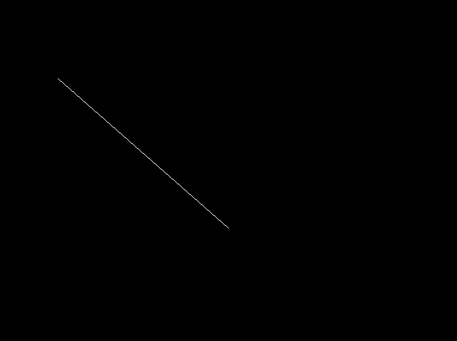

**/*Program to print Circles using Midpoint Algorithm and Polynomial Algorithm*/**

#include<graphics.h>

#include<conio.h>

#include<stdlib.h>

#include<stdio.h>

#include<dos.h>

#include<math.h>

void circ(void)

{

float a,b,r,x,y,i,j,d;

printf("enter the centre\n");

scanf("%f%f",&a,&b);

printf("enter the radius\n");

scanf("%f",&r);

x=0;

y=r;

d=(5/4-r);

putpixel(int(a),getmaxy()-int((b+r)),25);

putpixel(int(a-r),getmaxy()-int((b)),25);

putpixel(int(a+r),getmaxy()-int((b)),25);

putpixel(int(a),getmaxy()-int((b-r)),25);

while(y>x)

{

if(d<0)

{

d+=(2*x)+3;

}

else

{

d+=(2*(x-y))+5;

y--;

}

x++;

putpixel(int(a+x),getmaxy()-int((b+y)),25);

putpixel(int(a-x),getmaxy()-int((b+y)),25);

putpixel(int(a+x),getmaxy()-int((b-y)),25);

putpixel(int(a-x),getmaxy()-int((b-y)),25);

putpixel(int(a+y),getmaxy()-int((b+x)),25);

putpixel(int(a-y),getmaxy()-int((b+x)),25);

putpixel(int(a+y),getmaxy()-int((b-x)),25);

putpixel(int(a-y),getmaxy()-int((b-x)),25);

delay(50);

}

a+=150;

for(x=-r;x<=r;x++)

{

y=abs(int(sqrt(r*r-x*x)));

putpixel(a+x,getmaxy()-(b+y),15);

putpixel(a+x,getmaxy()-(b-y),15);

}

outtextxy(175,300,"Midpoint Algorithm");

outtextxy(350,300,"Bresanhams Algorithm");

}

main()

{

int graphdriver=DETECT,graphmode;

initgraph(&graphdriver,&graphmode,"..\\bgi");

circ();

getch();

return 0;

}

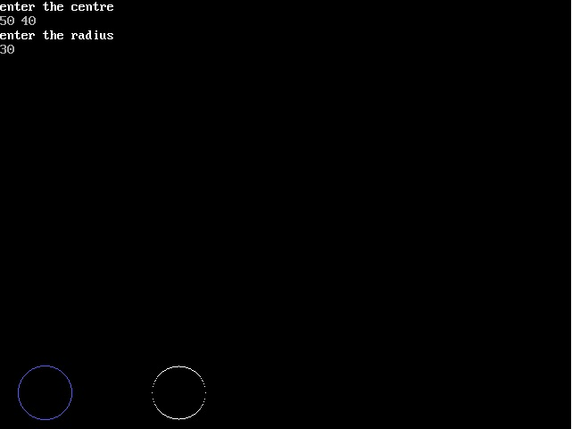

**/* Drawing an ellipse using midpoint algorithm */**

#include <conio.h>

#include <math.h>

#include <graphics.h>

#include<stdio.h>

using namespace std;

void plotline(int x,int y,int z,int o)

{

int a,b;

a=getmaxx()/2;

b=getmaxy()/2;

line(a+x,b-y,a+z,b-o);

}

void drawlips(int a,int b,int x,int y){

putpixel(a+x,getmaxy()-(b+y),RED);

putpixel(a+x,getmaxy()-(b-y),RED);

putpixel(a-x,getmaxy()-(b-y),RED);

putpixel(a-x,getmaxy()-(b+y),RED);

}

int main(){

initwindow(1234,480,"WINDOWS BGI");{

int a,b,x1,y1,c1,c2;

float d,d1;

printf("Enter radiuses of ellipse");

scanf("%d%d",&a,&b);

x1=0;

y1=b;

c1=getmaxx()/2;

c2=getmaxy()/2;

d=(b*b)+((a*a)*0.25)-(a*a*b);

drawlips(c1,c2,x1,y1);

while((b*b*(x1+1))<(a*a*(y1-0.5)))

{

if(d<0)

{

d+=(((2*x1)+3)*(b*b));

x1++;

}

else

{

d+=(((((2*x1)+3))*(b*b))+((2-(2*y1)))*(a*a));

x1++,y1--;

}

drawlips(c1,c2,x1,y1);

}

d1=((b*b)*(x1+0.5)*(x1+0.5))+(a*a*(y1-1)*(y1-1))-(a*a*b*b);

while(y1>0)

{

if(d1<0)

{

d1+=(((b*b)*((2*x1)+2))+((a*a)*((-2*y1)+3)));

x1++;y1--;

}

else

{

d1+=((a*a)*(-2*y1+3));

y1--;

}

drawlips(c1,c2,x1,y1);

}

getch();

closegraph();

}

return 0;

}

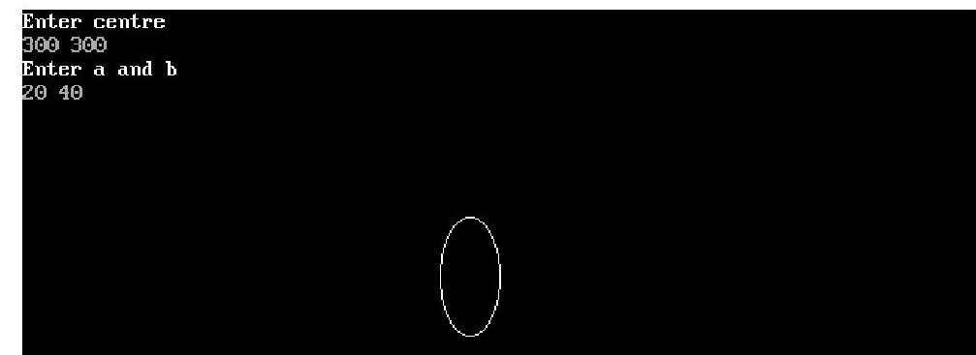**/* To take input from mouse and drawing a line using midpoint algorithm */**

#include<graphics.h>

#include<stdio.h>

#include<conio.h>

#include<dos.h>

union REGS in,out;

int callmouse()

{

in.x.ax=1;

int86(51,&in,&out);

return 1;

}

void mouseposi (int &xpos,int &ypos,int &click )

{

in.x.ax=3;

int86(51,&in,&out);

click=out.x.bx;

xpos=out.x.cx;

ypos=out.x.dx;

}

int mousehide()

{

in.x.ax=2;

int86(51,&in,&out);

return 1;

}

void setposi(int &xpos,int &ypos)

{

in.x.ax=4;

in.x.cx=xpos;

in.x.dx=ypos;

int86(51,&in,&out);

}

int main()

{

int x,y,cl,a,b,cl1;

clrscr();

int g=DETECT,m;

initgraph(&g,&m,"C:\\TC\\BGI");

callmouse();

do

{

mouseposi(x,y,cl);

if(cl==1)

{

a=x;b=y;

break;

}

}while(1);

mousehide();

delay(500);

callmouse();

do

{

mouseposi(x,y,cl);

if(cl==1)

break;

}while(1);

mousehide();

line(a,b,x,y);

getch();

closegraph();

return 0;

}

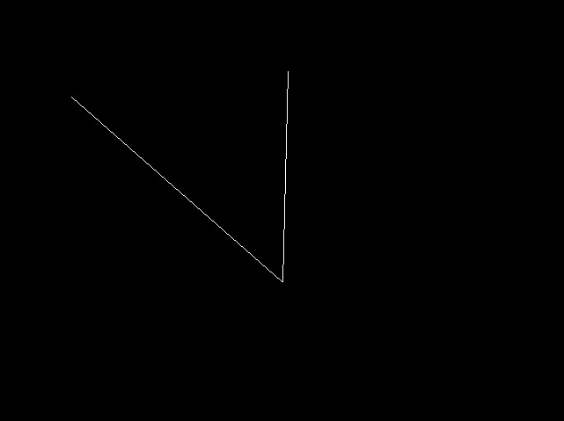

**/* Scan Line Polygon Filling algorithm */**

#include<stdio.h>

#include<conio.h>

#include<dos.h>

#include<graphics.h>

union REGS in,out;

int hidemouse()

{

in.x.ax=2;

int86(51,&in,&out);

return 1;

}

int callmouse()

{

in.x.ax=1;

int86(51,&in,&out);

return 1;

}

void mouse(int &x,int &y,int &c)

{

in.x.ax=3;

int86(51,&in,&out);

c=out.x.bx;

x=out.x.cx;

y=out.x.dx;

}

void set_min_max()

{

in.x.ax=8;

in.x.cx=0;

in.x.dx=getmaxy();

int86(51,&in,&out);

}

main()

{

int temp,j,a[100][100],x,y,d,c,x1,y1,gd=DETECT,gm,i=0,k,xi[100],n;

float dy,dx,slope[100];

initgraph(&gd,&gm,"C://TC//BGI");

set_min_max();

do

{

callmouse();

mouse(x1,y1,c);

if(c==1)

{

if(a[i-1][0]!=x1&&a[i-1][1]!=y1)

{

a[i][0]=x1;

a[i][1]=y1;

i++;

printf("%d %d\n",x1,y1);

}

hidemouse();

delay(100);

}

}while(!kbhit());

a[i][0]=a[0][0];

a[i][1]=a[0][1];

n=i;

for(i=0;i<n;i++)

{

setcolor(36);

line(a[i][0],a[i][1],a[i+1][0],a[i+1][1]);

}

for(i=0;i<n;i++)

{

dy=a[i+1][1]-a[i][1];

dx=a[i+1][0]-a[i][0];

if(dy==0) slope[i]=1.0;

if(dx==0) slope[i]=0.0;

if((dy!=0)&&(dx!=0))

{

slope[i]=(float) dx/dy;

}

}

for(y=0;y< 480;y++)

{

k=0;

for(i=0;i<n;i++)

{

if( ((a[i][1]<=y)&&(a[i+1][1]>y))||

((a[i][1]>y)&&(a[i+1][1]<=y)))

{

xi[k]=(int)(a[i][0]+slope[i]*(y-a[i][1]));

k++;

}}

for(j=0;j<k-1;j++)

for(i=0;i<k-1;i++)

{

if(xi[i]>xi[i+1])

{

temp=xi[i];

xi[i]=xi[i+1];

xi[i+1]=temp;

}

}

setcolor(y%255);

for(i=0;i<k;i+=2)

{

line(xi[i],y,xi[i+1]+1,y);

getch();

}}

delay(1000);

closegraph();

getch();

return 0;

}



**/* Filling circle using Bresenham’s Algorithm */**

#include<stdio.h>

#include<graphics.h>

#include<conio.h>

void cmp(int xc,int yc,int r)

{int x=0;

int yr;

int y=r;

float d;

void pp(int,int,int,int);

d=5/4-r;

while(x<y)

{

if(d<0)

d=d+(2*x+3);

else

{d=d+(2*(x-y)+5);

y--;

}

pp(xc,yc,x,y);

x++;

}}

void pp(int xc,int yc,int x,int y)

{

setcolor(WHITE);

line(xc+x,yc-y,xc-x,yc-y);

line(xc+x,yc+y,xc-x,yc+y);

line(xc+y,yc+x,xc-y,yc+x);

line(xc+y,yc-x,xc-y,yc-x);

}

main()

{

int xc,yc,r,a,b;

int gd=DETECT,gm;

initgraph(&gd,&gm,"C:\\TC\\BGI");

a=getmaxx();

b=getmaxy();

setcolor(RED);

line(a/2,0,a/2,b);

line(0,b/2,a,b/2);

printf("Enter the Center and radius");

scanf("%d%d%d",&xc,&yc,&r);

xc=xc+a/2;

yc=b/2-yc;

cmp(xc,yc,r);

getch();

closegraph();

return 0;

}

