# Book Part (if book contains both parts and chapters): Heading 1, Size 20, Bold

## Book Chapter: Heading 2, Size 18, Bold

### Chapter Section: Heading 3, Size 16, Bold

#### Chapter Subsection: Heading 4, Size 14, Bold

Body text: size 12, not bold (style “normal”). Your first footnote should appear no earlier than the end of the first sentence within your body text, as this one does.[1] Body text should be consistently formatted, e.g. double spaced and left justified, but does not need to be formatted in a particular way. Body text will be formatted during the later stages of the publication process, and varies according to the end format (i.e. HTML, PDF, ePub, PoD, or all of the above). Avoid setting extra paragraph markers to enlarge the distance between two paragraphs (or the distance between headers and body text).

Indented body text: Font size 12, not bold. As with body text, indented body text does not need to be formatted in a particular way, but should be formatted consistently. To create a list, follow this format, or use bullet points:

* This is the first item
* This is the second item
* This is the third item

#### Embedding Images and Figures

Images should be embedded in the text and, additionally, need to be transferred as separate files in a graphic format such as TIFF or PNG with a resolution of 300 dpi or higher. Please include the filename of the image directly into your manuscript, introduced with “#IMAGE<Image number>” e.g. #IMAGE1: authorname_guinea_pig.png. In edited volumes, the numbering re-starts in each chapter with number 1, in monographs the figures should be numbered continuously. Each figure must also have an in-text caption that elaborates on it. Please apply the “caption” style to format the image tag and the caption. Please do not forget to insert an image anchor in your text paragraphs (e.g. “see fig. 1”).

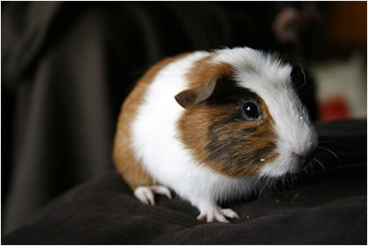

#IMAGE1: authorname_guinea_pig.png

#CAPTION: Figure 1: A Guinea Pig Called Jane (Reed 2009/CC-BY-SA 2.0)

Please note: Filenames must include only Latin characters and numbers and may not include spaces. Each filename should start with the name of the author.

#### Inserting Tables:

Tables may be inserted directly into the text, using the table function, as shown here:

Table 1: This is a table name and caption. The table name goes here. Place the table caption immediately after the name. To create a caption, highlight your intended caption text and click on the “Caption” style. Table captions do not need to be tagged.

Note that this table does not include a header outside of the table cells. Place all your data within the cells themselves and the table name on the first line of the caption, e.g. “Table 1.1: Name. Caption.” Place a hyphen in those cells that do not contain any data values.

Please do not forget to insert a table anchor in your text paragraphs (e.g. “see table 1”).

Body text should resume as shown here. See the end of this template for an example of an endnote.[2]

To create block quotes (for quotes more than four lines in length), highlight your quote and click on the “quote” style, which will provide the formatting shown here. Quote goes here. Quote goes here. Quote goes here. Quote goes here. Quote goes here. Quote goes here. Quote goes here. Quote goes here. Quote goes here. Quote goes here. Quote goes here. Quote goes here.

Resume body text here. Body text goes here. Body text goes here. Body text goes here. Body text goes here. Body text goes here. Body text goes here. Body text goes here. Body text goes here. Body text goes here. Body text goes here. Body text goes here. Body text goes here. Body text goes here. Body text goes here. Body text goes here. Body text goes here. Body text goes here. Body text goes here. Body text goes here.

## References: Heading 2, size 18, bold

Format your references by highlighting your text and selecting the “Bibliography” style. For the header, please use the Book chapter header (font size 18, bold).

Michael Pollan, *The Omnivore’s Dilemma: A Natural History of Four Meals* (New York: Penguin, 2006).

Gabriel García Márquez, *Love in the Time of Cholera,* trans. Edith Grossman (London: Cape, 1988).

1. See Pollan, page 100. This is an example footnote. To insert footnotes, use your word processor’s footnote feature.
2. See García Márquez, page 100. Here is an example of an endnote. To insert endnotes, use your word processing program’s endnote feature. You may use either foot- or endnotes, but not both.