

2025
SmartBus Tracker web-based service Management system

A PROJECT PROPOSAL SUBMITTED TO
INTERNATIONAL COLLEGE OF BUSINESS AND TECHNOLOGY (ICBT)
IN PARTIAL FULFILLMENT OF THE REQUIREMENTS FOR THE
BSc(Hons) SOFTWARE ENGINEERING
DATE (2025/11/02)

International College of Business and Technology (ICBT) Cardiff Metropolitan University

Individual Work Plan – W.A.K. Ishan Chinthaka
Project Title: SmartBus Tracker
Module Number:
Student Name: W.A.K. Ishan Chinthaka
Registration Number: GL/BSCSD/08/20
Declaration
I, W.A.K. Ishan Chinthaka, hereby declare that the work presented in this project and all supporting materials are entirely my own, except where references or teamwork acknowledgements are explicitly stated. I understand that the project will be assessed for originality and plagiarism compliance.
Date: ..........................................................
Table of Contents
1. Introduction 5
1.1 Background 5
1.2 Objectives 6
1.3 Significance 7
3. Problem Definition (Web-Specific) 8
3.1 Current Situation in Sri Lanka 8
3.2 Identified Web-Specific Problems 9
3.3 Problem Statement & Goal 9
3.4 Alignment of Problems with Solution Scope 10
3.5 Implications for Stakeholders 10
4. Project Objectives 10
4.1 Current System 11
4.2 Drawbacks of the Current System 11
4.3 Objectives of the Proposed System 12
4.4 Strategic and Broader Objectives 13
4.5 Expected Outcome 14
5. Literature Review 14
5.1 Theoretical Background 14
5.2 Related Work 16
5.3 Summary of Research Gap 17
5.5 Conclusion 18
6 System Architecture 18
1. Presentation Layer (Frontend) 19
2. Application Layer (Backend) 19
6.3 Third-Party Services and APIs 21
6.4 Security Implementation 22
6.5 Why Web-Based? 22
6.6 How the Proposed System Solves the Current Problems 23
6.7 Justification for the Proposed Technique 24
6.8 Expected Impact 24
6.9 Summary 24
7. Feasibility Study 25
7.1 Technical Feasibility 25
7.2 Economic Feasibility 26
7.3 Organizational Feasibility 27
7.4 Market Feasibility 28
8. Project Description 30
8.1 Proposed solution 30
8.2 Methodology 33
9. Deliverables 41
9.1 Documentation Deliverables 41
9.2 Software Deliverables 42
9.3 Testing & Evaluation Deliverables 43
9.4 Deployment Deliverables 44
9.5 Evaluation Deliverables / Final Outputs 44
9.6 Deliverables Timeline Summary 44
9.7 Summary 45
10. Resources Required 45
10.1 Hardware Resources 46
10.2 Software Resources 46
10.3 Cloud / Hosting Resources 47
10.4 Human Resources 48
10.5 Miscellaneous Costs 48
10.6 Summary of Estimated Budget 49
10.7 Justification 49
11. Expected Output / Outcomes 50
11.1 Functional Requirements 50
11.2 Non-Functional Requirements 51
11.3 Validation and Testing 52
11.4 Measurable Success Metrics 54
11.5 Final Deliverable Output 54
12. Project Plan 54
12.1 Work Breakdown Structure (WBS) 55
12.3 Gantt Chart (Text-Based Representation) 58
13. Risk Management 59
13.1 Technical Risks 59
13.2 Operational Risks 60
13.3 Project Management Risks 61
13.4 Continuous Risk Monitoring 62
14. Project Limitations 62
14.1 Technical Limitations 63
14.2 Operational Limitations 63
14.3 Legal & Policy Limitations 64
15. References 64
16. Appendices 65

1. Abstract (revised for web-based)
Track My Bus is a web-based smart public transport system that provides passengers with real-time bus tracking, online booking and e-ticketing, lost & found management, and a km-based reward/offer engine. The platform offers four role-based responsive web interfaces: Passenger, Driver, Bus Owner, and Admin. The backend uses a REST + realtime architecture (WebSocket) and a relational database for transactional integrity. The solution integrates Google Maps, accelerates ETA computation using recent location streams, and offers owner analytics dashboards. The project will be designed, implemented and evaluated as an MSc final project using an Agile process and pilot deployment with sample buses.

1. Introduction

1.1 Background
Public transportation is one of the most essential elements of Sri Lanka’s daily life, serving millions of citizens who rely on buses as their primary mode of commuting between cities, towns, and rural areas. Despite its importance, the Sri Lankan bus transport system remains largely manual, fragmented, and outdated. Passengers face continuous challenges such as unpredictable bus arrival times, inconsistent schedules, and a lack of access to accurate route or driver information. These issues lead to wasted time, poor user satisfaction, and inefficient service delivery.
At present, most buses operate without a unified digital management platform. Schedules are either fixed manually or communicated through printed timetables, which do not reflect real-time traffic conditions or route changes. Furthermore, passengers cannot verify whether buses are on time, delayed, or cancelled, as real-time tracking is limited or completely absent in most intercity and highway routes.
In addition, bus owners and operators face operational difficulties in managing their fleets efficiently. They lack centralized dashboards for performance tracking, driver monitoring, and passenger engagement analytics. Drivers, on the other hand, do not have digital tools to share live GPS data or validate boarding passengers through electronic tickets, which leads to inaccuracies in passenger counts and revenue records.
Another key issue is the absence of structured systems for lost and found item recovery. Many passengers lose personal belongings on buses, and recovery is nearly impossible without a verified digital process linking passengers, drivers, and owners. Finally, there are no reward or loyalty programs in the current public transport model, making it difficult to build consistent passenger engagement or brand loyalty among private bus operators.
Globally, the transport industry is transitioning toward intelligent transport systems (ITS) and smart mobility platforms, using web technologies, cloud computing, and data analytics to enhance safety, predictability, and convenience. However, Sri Lanka has been slow to adopt such systems at the public or private transport level. Existing apps (such as PickMe or Google Maps Transit) focus mainly on urban taxi services or static schedules, rather than real-time bus monitoring, booking, and passenger engagement.
The “Track My Bus — Smart Public Transport Ecosystem” project is introduced to address these critical issues. It offers a web-based, real-time bus management and passenger service platform designed to connect all stakeholders — Passengers, Drivers, Bus Owners, and Administrators — under a unified digital ecosystem. The platform provides real-time tracking, online booking, QR-based ticket validation, lost and found management, and an innovative mileage-based reward system. By combining these features, the project aims to revolutionize the public bus service experience and align Sri Lanka’s transport sector with modern digital standards.

1.2 Objectives
The main goal of the project is to design and develop a secure, scalable, and responsive web-based system that digitizes and streamlines the bus transport process in Sri Lanka. The system focuses on improving efficiency, transparency, and passenger satisfaction through automation and real-time information sharing.

Specific Objectives
- To develop a real-time bus tracking system using GPS integration and Google Maps API, allowing passengers and owners to monitor live bus locations and estimated time of arrival (ETA).
- To implement an online seat booking and e-ticketing system where passengers can reserve seats through the web platform, generate QR-based tickets, and validate them during boarding.
- To introduce a Lost & Found management module, enabling passengers and drivers to post, claim, and verify lost or found items securely through the platform.
- To integrate a reward and offer system, allowing passengers to earn loyalty points or travel discounts after reaching specific distance milestones (e.g., 500 km), encouraging consistent system usage.
- To provide role-based multi-panel access — including separate web dashboards for Admin, Bus Owner, Driver, and Passenger — each with specific privileges and management tools.
- To ensure scalability, usability, and data security, using a robust backend architecture (e.g., Node.js/PHP with MySQL) and implementing HTTPS, authentication, and secure data storage.
- To evaluate the system performance through a pilot study, measuring metrics such as ETA accuracy, waiting-time reduction, booking success rate, reward redemption, and lost-item recovery efficiency.

1.3 Significance
The proposed system holds significant value in transforming Sri Lanka’s conventional bus transport into a smart, data-driven, and passenger-oriented service. Its impact can be evaluated across several dimensions:

a) For Passengers
- Enhances convenience through real-time tracking, accurate arrival predictions, and digital booking.
- Reduces waiting times and travel uncertainty.
- Provides digital services such as lost item recovery, digital ticketing, and travel rewards.
- Builds trust and satisfaction through transparent, technology-driven operations.

b) For Bus Owners and Operators
- Offers real-time fleet visibility and analytics for route performance, revenue, and occupancy.
- Enables data-based decision-making to improve efficiency and reduce operational costs.
- Provides an integrated platform for creating custom offers and loyalty programs, increasing passenger retention and competitiveness.
- Reduces manual workload through automated trip, booking, and revenue tracking.

c) For Drivers
- Simplifies trip management with browser-based interfaces that allow easy location sharing and QR ticket validation.
- Promotes accountability and compliance through automated performance tracking and location logs.

d) For Administrators and Transport Authorities
- Provides a centralized system for monitoring transport operations, approving users, and maintaining service standards.
- Supplies real-time data for policy-making, planning, and traffic management.
- Enhances transparency, safety, and public trust in the transportation network.

e) For the Nation
- Aligns with Sri Lanka’s Digital Transformation and Smart City initiatives, promoting innovation in the transport sector.
- Reduces traffic congestion and environmental impact by encouraging predictable, efficient bus usage.
- Serves as a model for future intelligent transport systems (ITS) that integrate IoT, data analytics, and smart governance.

3. Problem Definition (Web-Specific)

3.1 Current Situation in Sri Lanka
The public bus transport system in Sri Lanka is under severe strain, creating a multitude of operational and user-experience problems that are well documented in recent studies and news reports. Some key issues include:
- Many passengers face long waiting times, little or no information about when the next bus will arrive, and unpredictable journey durations.
- Fleet utilisation and performance are low: for example, the Sri Lanka Transport Board (SLTB) reportedly achieved only around 68% of its total planned kilometres in 2022, indicating significant under-utilisation of buses.
- Bus fleets are ageing: many buses are past their optimal service years, and operators are unable to replace them due to high import taxes and financial constraints. Safety risks rise as a result.
- Operational discipline is weak: Private or public buses often disregard designated stops and safety rules; “bus lane” violations and illegal parking or boarding are common.
- There is a lack of modern digital infrastructure across many operators: scheduling, fleet monitoring, passenger information systems are limited or fragmented.
- As one article states: “The public transport system in this country must be massively improved.”

3.2 Identified Web-Specific Problems
In the context of delivering a modern web-based public transport platform, the following major problems have been identified:
- No unified web portal for search, booking, and live tracking
At present, passengers often cannot access a single web interface where they can search for buses (normal vs highway), book seats online, and view real-time bus location on an interactive map. The absence of such a portal forces manual approaches (waiting at stops, verbal enquiries, no clear tracking) and contributes to anxiety and wasted time.
- Drivers often lack a simple browser-based interface
Many bus operators rely either on minimal manual logs or mobile apps that may require installation and training. A lightweight web application (accessible by browser) for drivers to share their live location, start/stop trips and validate passenger boarding is missing in many fleets. This gap limits data collection, driver engagement and real-time visibility.
- Owners lack centralised analytics and targeted offer/promotion mechanisms
Fleet owners and operating companies currently do not have a unified dashboard that collates performance metrics (occupancy, revenue per route, route adherence), nor do they have built-in tools to run targeted passenger promotions or reward programmes linked to usage (e.g., “travel 500 km and earn a free ride”). Without such capabilities, business optimisation and passenger engagement remain weak.
- Lost & Found lacks a structured, verifiable digital workflow
When passengers lose items onboard buses, there is often no formal digital system to report the lost item, match it to a found item, notify relevant parties (driver, passengers on the same route), and verify return. This leads to low recovery rates, passenger dissatisfaction and reputational damage for operators.
- No integrated reward engine for passenger retention
In contrast to many modern transport platforms worldwide, the Sri Lankan bus system has no embedded reward scheme that links usage (e.g., kilometres travelled, frequent traveller status) to incentives (discounts, free segments, priority seats). The absence of a loyalty/engagement layer means fewer incentives for passengers to use scheduled services, and fewer differentiation strategies for operators.

3.3 Problem Statement & Goal
Problem Statement:
There is no comprehensive, secure, scalable web-based platform in Sri Lanka’s bus transport ecosystem that enables passengers to search, book and track buses, allows drivers to share live location via a browser interface, provides owners with analytics and promotional tools, supports a verifiable lost-&-found workflow, and embeds a reward/loyalty system — all with role-based access for passenger, driver, owner and administrator.
- Project Goal:
Build a web-first platform (responsive web applications) that supports real-time bus tracking, online booking, lost & found workflows, and a reward engine, with complete role-based access control (Passenger, Driver, Owner, Admin). The system will be designed to operate on standard web browsers (desktop or mobile), minimise installation overhead, provide real-time data and analytics, and improve transparency, safety and engagement across the public transport value chain.

3.4 Alignment of Problems with Solution Scope
- By offering a unified search-book-track web portal, the platform addresses the lack of booking/tracking infrastructure.
- A browser-accessible driver interface reduces the barrier to driver participation (no heavy app install required).
- Owner dashboards with analytics & offers create business value and passenger retention strategies.
- The structured lost-and-found module formalises item recovery and improves perception of service quality.
- The reward/offer engine introduces a loyalty dimension missing in current systems and aligns with business growth strategies.

3.5 Implications for Stakeholders
- Passengers will benefit from reduced waiting times, improved travel planning, transparent route choices (normal vs highway) and additional services (lost & found, rewards).
- Drivers will gain lightweight digital tools, better route/boarding visibility, and support for role compliance.
- Owners will gain actionable data, promotional tools and better fleet utilisation.
- Administrators will benefit from system governance, data integrity and improved service metrics.
- The transport ecosystem in Sri Lanka can begin a digital transformation toward smart mobility, improving safety, reliability and user trust.

4. Project Objectives

4.1 Current System
- At present, Sri Lanka’s bus transportation network operates largely through manual processes, with very limited technological integration.
Passengers depend on physical bus stops and verbal communication to identify routes, schedules, and destinations. There is no centralized digital platform where they can check real-time bus availability, reserve seats, or confirm arrival times. Ticketing is done manually, and passengers have no way of knowing if a bus is delayed or has already passed.
- Similarly, drivers manage their routes without digital monitoring or guidance. They do not use web-enabled tools to share live GPS locations or receive automated updates about schedules or bookings. This manual method causes inefficiency, poor data collection, and inconsistent passenger communication.
- Bus owners face major difficulties in managing their fleets. Many owners still record daily trips, revenue, and maintenance information manually or using basic spreadsheets. They cannot track buses in real time or analyze route performance. There is also no mechanism to issue targeted promotions, monitor passenger satisfaction, or identify peak-demand routes.
- The government and transport authorities currently maintain public transport data across disconnected systems, leading to inaccuracies and delays in policy decisions. As a result, the overall public transport experience remains unpredictable, time-consuming, and poorly optimized.
- With the increasing demand for smart mobility solutions, Sri Lanka’s transportation sector is under pressure to adopt digital transformation trends similar to global platforms like Google Transit, Moovit, and PickMe. However, such systems are not yet available for intercity and highway bus services, which serve a majority of daily commuters.

4.2 Drawbacks of the Current System
The current transport process, which is mostly manual and uncoordinated, has led to several major inefficiencies:
a) Accuracy Problems
- Passengers have no access to real-time information, resulting in inaccurate estimations of arrival times and travel durations.
- Drivers cannot transmit accurate GPS data, making bus tracking impossible for both passengers and owners.
- Bus schedules are not dynamically updated to reflect traffic delays or diversions.
b) Time Wasting
- Passengers must wait at stops for uncertain periods, sometimes missing buses due to schedule miscommunication.
- Manual booking and ticketing consume valuable time for both passengers and conductors.
- Drivers lose time coordinating manually with dispatchers or owners.
c) Lack of Competitive Advantage
- Compared to app-based transport services like PickMe or Uber, which offer real-time updates and digital payments, traditional bus services appear outdated and inefficient.
- Without digital booking or tracking, bus operators are losing customers who prefer faster, more predictable options.
d) Poor Business Processes
- Fleet owners rely on manual record-keeping and cannot analyze performance data.
- There is no centralized dashboard for financial reports, bus utilization, or passenger feedback.
- Lost items are handled informally, often resulting in unrecovered belongings and reputational damage for operators.
e) Absence of Passenger Incentives
- There is no reward or loyalty mechanism to retain frequent passengers.
- Passengers do not receive special offers or fare discounts, making it difficult for operators to build brand loyalty or recurring ridership.
f) Lack of Integration with Modern Trends
- The Sri Lankan transport sector has not kept pace with global digitalization trends.
- Real-time tracking, predictive ETA algorithms, and web-based ticketing systems are standard in developed countries but are still lacking in local bus operations.

4.3 Objectives of the Proposed System
The “SmartBus Tracker” is designed to overcome these drawbacks by introducing a web-based, multi-role platform that modernizes Sri Lanka’s bus transport infrastructure.
The project’s objectives are divided into functional and strategic goals:
Functional Objectives
- Develop a responsive Passenger Web App
  - Allow users to search for available buses, book seats online, generate QR-based e-tickets, and view live bus locations on a map.
  - Enable passengers to report or claim lost items and access a digital reward system based on kilometers traveled.
- Implement a Driver Web Interface (lightweight Progressive Web App)
  - Allow drivers to share real-time GPS location from any browser.
  - Enable QR ticket scanning for boarding validation.
  - Simplify trip start/stop and delay reporting for driver convenience.
- Create Owner and Admin Dashboards
  - Provide tools for bus owners to manage fleets, monitor routes, analyze trip performance, and publish targeted offers.
  - Enable system administrators to oversee platform security, approve drivers, moderate lost & found items, and ensure service compliance.
- Real-Time Tracking and Analytics
  - Utilize WebSocket technology for live data streaming between drivers, passengers, and servers.
  - Integrate Google Maps API for map rendering, route suggestions, and Estimated Time of Arrival (ETA) computation.
- Performance Evaluation and Pilot Deployment
  - Conduct pilot testing to measure system performance using defined metrics such as:
    - ETA accuracy (mean error < 5 minutes)
    - Passenger waiting-time reduction
    - Booking conversion rate
    - Reward participation rate
    - Lost item recovery success rate

4.4 Strategic and Broader Objectives
Beyond the functional goals, the project also aims to:
- Enhance national transport efficiency through digital transformation.
- Reduce congestion by encouraging predictable, scheduled public transport use.
- Build trust and transparency between passengers, drivers, and operators through verified data.
- Promote green mobility, as efficient tracking reduces unnecessary fuel consumption caused by waiting or missed trips.
- Set a foundation for future integration with smart city infrastructure, IoT sensors, and AI-based predictive routing.

4.5 Expected Outcome
By achieving these objectives, SmartBus Tracker will evolve into a fully integrated web platform that transforms Sri Lanka’s fragmented bus transport system into a real-time, data-driven, and passenger-focused service model. It will serve as a scalable blueprint for future national-level smart mobility systems, bridging the gap between traditional operations and modern transport innovation.

5. Literature Review
The purpose of the literature review is to identify and analyze existing research, technologies, and practical implementations relevant to web-based bus tracking and public transport management systems. This section highlights the theoretical foundation of real-time tracking, transport digitization, and web application architecture, followed by a review of existing local and international solutions. The analysis reveals how Track SmartBus Tracker addresses existing gaps and advances current practices in the Sri Lankan transport sector.

5.1 Theoretical Background
a) Intelligent Transport Systems (ITS)
The project is grounded in the principles of Intelligent Transport Systems (ITS), which refer to the integration of communication, information, and control technologies into transportation networks to improve safety, efficiency, and service quality. ITS applications—such as real-time bus tracking, automated fare collection, and passenger information systems—are globally recognized as key enablers of smart mobility.
Studies have shown that ITS can reduce travel time by up to 20–30%, enhance route planning, and improve resource utilization (Mahapatra & Yadav, 2021). The “Track My Bus” platform aligns with ITS objectives by combining real-time GPS tracking, web-based route management, and user interaction layers into a unified ecosystem.
b) Real-Time Tracking and Predictive ETA Models
Real-time vehicle tracking systems utilize GPS technology combined with algorithms that estimate Estimated Time of Arrival (ETA) using factors such as speed, traffic density, and route conditions. According to Chien et al. (2018), predictive ETA models improve commuter satisfaction by providing accurate time forecasts and reducing perceived waiting times.
The “Track My Bus” system integrates Google Maps API with WebSocket technology to compute live ETAs and update them dynamically on the web interface, ensuring passengers receive continuous location updates without manual refresh.
c) Web-Based Application Architecture
A web-based architecture offers cross-platform accessibility, scalability, and reduced maintenance compared to native mobile applications. It allows passengers, drivers, owners, and administrators to access the system through standard browsers without installation.
The architecture follows a multi-tier structure consisting of a front-end user interface, a back-end server (Node.js/PHP), and a centralized relational database (MySQL). Real-time synchronization is achieved using WebSocket or Firebase, ensuring live updates across all connected clients.
d) Service-Oriented Design and Role-Based Access
In large-scale systems, separating functionalities by user role (Passenger, Driver, Owner, Admin) enhances maintainability and security. Each module operates as a distinct service interacting through APIs, following Service-Oriented Architecture (SOA) principles.
This design ensures modularity, allowing independent updates (e.g., new reward rules or route management) without affecting the entire system.
e) Passenger Loyalty and Reward Systems
Customer retention and loyalty systems are widely adopted in industries such as aviation (frequent flyer programs) and ride-hailing apps (e.g., Uber Rewards). According to Kotler & Keller (2020), offering rewards for consistent engagement can increase user retention by over 50%.
However, such systems are largely absent in public transport. The “Track My Bus” project applies this concept in a novel context by introducing a distance-based reward mechanism (e.g., passengers traveling 500 km earn free travel credits or discounts), motivating repeated usage and promoting digital adoption among commuters.

5.2 Related Work
a) PickMe (Sri Lanka)
PickMe is one of Sri Lanka’s leading mobility platforms offering real-time ride-hailing and GPS-based vehicle tracking. It provides reliable location updates and driver information but is limited to on-demand taxi services rather than scheduled bus transport. It does not include multi-role management, bus schedules, lost-item workflows, or reward systems.
Gap Identified: PickMe is effective for individual taxis but not suitable for public bus networks requiring route management and multi-user collaboration.
b) Moovit (Global)
Moovit is an international transit app providing real-time public transport directions in major cities. It integrates with transport authorities to display schedules and ETA predictions. However, it functions primarily as an information aggregator and not as a transactional system — it lacks seat booking, fare payment, and driver-side modules.
Gap Identified: No integrated booking, lost & found, or owner management; limited to schedule display.
c) SLTB Bus Tracker (Sri Lanka Transport Board)
The SLTB (Sri Lanka Transport Board) has attempted limited GPS tracking on select buses for internal monitoring. While it allows partial location sharing, it is not publicly accessible and lacks passenger interactivity, real-time booking, or driver integration.
Gap Identified: Operates as a back-end fleet monitoring tool only; no passenger engagement or web interface.
d) Transit App (International)
Transit App provides live bus and train schedules in many countries. It uses open transport APIs and offers route suggestions. However, it does not include custom reward systems, lost-item recovery, or web dashboards for fleet owners.
Gap Identified: Passenger-only focus with no business management or data analytics integration.
e) Google Maps Transit
Google Maps Transit displays scheduled public transport data for some regions but depends heavily on public agencies providing GTFS (General Transit Feed Specification) data. In Sri Lanka, such data availability is minimal, making real-time tracking unreliable.
Gap Identified: Absence of real-time GPS feeds and booking capabilities in Sri Lankan context.

5.3 Summary of Research Gap
From the analysis above, it is evident that most existing systems focus on either real-time tracking or trip information display, without integrating the full transport ecosystem. None of the reviewed solutions combine the following in a single, web-based platform:
- Real-time GPS tracking
- Online seat booking and QR validation
- Lost & Found management
- Reward and offer systems
- Multi-role dashboards (Passenger, Driver, Owner, Admin)
Thus, Track My Bus fills a significant technological and operational gap in Sri Lanka’s transport system. It represents a unique multi-stakeholder, service-oriented ecosystem that not only improves operational efficiency but also enhances passenger trust, engagement, and retention. 5.4 Conceptual Framework Summary
Component | Description | Supported by
Real-Time Tracking | GPS + WebSocket architecture for bus location updates | Chien et al. (2018); ITS research
Online Booking & QR Tickets | Web-based reservation and validation system | Modern web e-ticketing studies
Lost & Found Module | Community-driven verified workflow | User-centered service recovery models
Reward Engine | Loyalty system encouraging frequent usage | Kotler & Keller (2020); customer retention theory
Role-Based Access | Modular SOA enabling multiple user roles | Service-Oriented Architecture standards

5.5 Conclusion
The literature review demonstrates that while GPS tracking and transport apps exist, no comprehensive web-based solution currently provides an integrated passenger-service management ecosystem for Sri Lanka’s bus industry. By combining tracking, booking, lost-item management, rewards, and analytics into one platform, Track My Bus contributes both practically and academically to the advancement of smart mobility solutions and intelligent transport systems (ITS) in developing countries. 6. Proposed Solution / Proposed Technique to Solve the Current Problem
6.1 Overview of the Proposed Solution
The proposed solution, titled “Track My Bus — Smart Public Transport Ecosystem”, is a comprehensive web-based platform that modernizes the Sri Lankan bus transportation system by integrating real-time bus tracking, online booking, lost and found management, reward-based passenger engagement, and multi-role dashboards for effective service governance.
This system is designed to be accessible via any web browser (mobile or desktop), removing the need for users to install heavy mobile apps. It leverages modern web technologies such as React, Node.js, and Google Maps API to create a unified, secure, and scalable ecosystem connecting all key stakeholders — Passengers, Drivers, Bus Owners, and Administrators.
By combining GPS-enabled tracking, real-time data streaming, secure APIs, and data analytics, the platform provides accurate, transparent, and user-friendly services that significantly improve reliability, convenience, and accountability in Sri Lanka’s bus transport industry.

6 System Architecture
The proposed system adopts a modular web-based architecture following Service-Oriented Architecture (SOA) principles. The platform consists of four main layers: Presentation Layer, Application Layer, Data Layer, and Communication Layer.

1. Presentation Layer (Frontend)
The frontend is implemented using React.js, a robust JavaScript library for building responsive, high-performance web interfaces.
Components include:
- Passenger Web App: Allows route search, online booking, QR e-ticket display, bus tracking, lost item reporting, and reward redemption.
- Driver Web App (Progressive Web Application – PWA): Lightweight browser-based interface for live GPS sharing, QR scanning, and trip validation without requiring app installation.
- Owner Dashboard: Analytical interface displaying fleet statistics, revenue analytics, route performance, and offer management.
- Admin Dashboard: Central control panel for approving users, managing routes, moderating content, and system configuration.
Justification:
- React provides fast rendering and modular component-based UI architecture.
- PWA support ensures cross-platform usability on both mobile and desktop browsers.
- Responsive design makes the system accessible even on low-end devices common among local drivers and passengers.

2. Application Layer (Backend)
The backend logic is implemented using Node.js with the Express.js framework. It handles RESTful APIs, real-time event management, and system security.
Key modules:
- Authentication & Role Management:
Utilizes JWT (JSON Web Tokens) with role-based access control (RBAC) to ensure secure and controlled access for different user roles (Passenger, Driver, Owner, Admin).
- Booking Management:
Handles online reservations, seat allocation, and QR e-ticket generation.
- Tracking Service:
Processes GPS data streams received from drivers, computes bus positions, and pushes updates to passengers via WebSocket.
- Reward & Offer Engine:
Tracks passenger mileage and automatically applies offers based on total distance traveled (e.g., 500 km milestone rewards).
- Lost & Found Module:
Allows passengers to report lost items and drivers to report found items; the system automatically matches similar posts for verification.
- Analytics & Reporting:
Provides visual insights for owners and admins, including revenue trends, route efficiency, and passenger engagement statistics.
Justification:
- Node.js offers high concurrency and fast I/O handling — essential for real-time systems.
- Express simplifies API creation and integrates seamlessly with real-time frameworks (Socket.IO).
- Modular microservice-ready architecture allows each module to evolve independently.

3. Data Layer (Database & Storage)
The system employs both relational and in-memory databases for performance and reliability.
Databases:
- Primary Database: MySQL or PostgreSQL for transactional data (users, bookings, routes, rewards, lost items, etc.).
- In-memory Cache: Redis is used for real-time operations such as storing current bus positions and broadcasting updates to connected clients.
- File Storage: Firebase Storage or AWS S3 stores uploaded images (e.g., lost items, driver/vehicle documents).
Justification:
- MySQL ensures ACID compliance, crucial for booking accuracy and data integrity.
- Redis enhances system responsiveness by caching frequently accessed data (ETA, bus locations).
- Cloud-based storage ensures scalability and durability of uploaded multimedia content.

4. Communication Layer (Real-Time Data Streaming)
To achieve real-time interactivity, the system integrates Socket.IO for two-way communication between clients (web browsers) and the server.
Functional Flow:
- Drivers transmit GPS data to the backend through WebSocket channels at short intervals (e.g., every 5 seconds).
- The backend processes this data and broadcasts live location updates to passengers subscribed to the corresponding route or bus channel.
- ETA (Estimated Time of Arrival) calculations are performed dynamically using Google Maps Directions API and historical route data.
Justification:
- WebSocket ensures instant communication without the overhead of continuous HTTP requests.
- Real-time updates improve passenger trust and reduce waiting uncertainty.
- ETA prediction enhances route planning for both passengers and owners.

6.3 Third-Party Services and APIs
The platform integrates several third-party technologies to enhance accuracy and efficiency:
Service | Purpose
Google Maps API & Directions API | To display bus routes, calculate ETAs, and visualize locations.
Firebase Cloud Messaging (FCM) | To send notifications (booking confirmations, lost item updates).
Payment Gateway (PayHere / Stripe) | To handle secure online payments for bookings.
Google OAuth / Firebase Auth | Optional social login integration for user convenience.

6.4 Security Implementation
Security is a major priority in the proposed system.
Key security measures include:
- Role-based access (Admin, Owner, Driver, Passenger) to prevent unauthorized data access.
- Encrypted password storage using bcrypt hashing.
- HTTPS protocol for all communication to ensure data confidentiality.
- Input validation and sanitization to prevent SQL Injection and XSS attacks.
- Secure token-based authentication (JWT) to manage user sessions safely.
- Data backup and recovery plans for disaster resilience.
Justification:
These measures collectively ensure that the system maintains integrity, confidentiality, and availability — the three pillars of information security — while handling sensitive passenger and operator data.

6.5 Why Web-Based?
The decision to adopt a web-based approach instead of a native mobile application is justified by the following advantages:
- Accessibility:
Works on any device with a browser (phones, tablets, PCs) — critical for diverse user demographics across Sri Lanka.
- No Installation Required:
Reduces adoption barriers for drivers and passengers who may have limited storage space or technical knowledge.
- Cross-Platform Compatibility:
One unified system eliminates the need to develop separate Android and iOS applications.
- Cost-Effectiveness:
Lower development and maintenance costs while ensuring scalability and quick updates via the web.
- Ease of Updates:
Web applications can be updated centrally on the server without requiring users to download new versions.
- Support for Real-Time Features:
Modern web technologies (WebSocket, PWA, service workers) allow instant updates similar to native mobile apps.

6.6 How the Proposed System Solves the Current Problems
Identified Problem | Proposed Solution | Benefit
No web portal for booking and tracking | Unified web platform with real-time map tracking and online booking | Simplifies passenger access and reduces waiting time
Drivers lack live-sharing tools | Browser-based driver PWA with GPS streaming | Eliminates manual reporting, ensures real-time visibility
No analytics for owners | Interactive dashboard with route, revenue, and occupancy analytics | Enables data-driven decision-making
Lost & Found inefficiency | Verified digital workflow linking passengers, drivers, and owners | Increases recovery rate and passenger trust
No passenger reward system | Automated mileage-based reward and offer engine | Improves passenger engagement and loyalty

6.7 Justification for the Proposed Technique
The proposed system was chosen after evaluating multiple technological approaches (mobile-native, hybrid, and web-first). A web-based architecture with a real-time data streaming backend was found to be the most cost-effective, scalable, and sustainable solution for Sri Lanka’s transport ecosystem because:
- It reduces hardware dependency and can run on low-cost smartphones commonly used by drivers and passengers.
- It provides real-time accuracy through continuous GPS updates and map-based ETA prediction.
- It integrates multiple services (booking, tracking, lost & found, rewards) under one ecosystem, minimizing fragmentation.
- It supports future integration with national smart transport frameworks and IoT-enabled buses.

6.8 Expected Impact
- Operational Efficiency: Reduced waiting times, better fleet scheduling, improved driver accountability.
- Economic Benefits: Increased ticket sales through online booking, reduced administrative overhead for owners.
- User Experience: Enhanced passenger satisfaction and trust through transparency and rewards.
- Social Impact: Digital inclusion for all transport users and progress toward smart mobility infrastructure in Sri Lanka.

6.9 Summary
In summary, the proposed Track My Bus solution transforms the fragmented, manual bus transportation system into a modern, intelligent web-based ecosystem.
Through its modular design, real-time tracking, and community-oriented features, it offers a future-ready framework that is scalable, secure, and aligned with national digital transformation goals.
This approach not only addresses existing inefficiencies but also lays the groundwork for integrating artificial intelligence (AI) and smart city technologies in the future.

7. Feasibility Study
A feasibility study assesses the practicality and viability of developing and deploying the proposed SmartBus Tracker within the Sri Lankan public transport landscape.
It evaluates whether the project can be successfully implemented with the available technology, budget, organizational capacity, and market demand.

7.1 Technical Feasibility
The proposed system is technically feasible as it utilizes proven, widely adopted, and open-source web technologies that are cost-effective and adaptable to Sri Lanka’s infrastructure.
Technology Readiness
The system architecture is based on Node.js (backend), React.js (frontend), and MySQL/Redis (database)—technologies that have strong community support, high scalability, and excellent documentation.
The inclusion of Google Maps API for real-time GPS tracking and Socket.IO for WebSocket-based data streaming ensures real-time interactivity between drivers and passengers with minimal latency.
Infrastructure
- The application will be hosted on cloud platforms such as AWS, Firebase, or GCP, enabling high availability, automatic scaling, and global accessibility.
- PWA (Progressive Web App) ensures drivers and passengers can use the system directly through mobile browsers, eliminating the need for high-end smartphones or app installations.
- The web-first approach guarantees cross-device compatibility, meaning the same system operates on desktops, tablets, and mobile devices without additional development overhead.
System Maintainability
The use of modular service-oriented architecture (SOA) makes the system easily maintainable and upgradable. Each module—tracking, booking, lost & found, rewards, and analytics—can evolve independently without affecting other components.
Integration & Security
Integration with third-party APIs (Google Maps, Firebase, PayHere) is straightforward using RESTful interfaces.
Security mechanisms such as JWT authentication, role-based access control (RBAC), input sanitization, and HTTPS encryption ensure the platform is secure and compliant with data protection best practices.
✅ Conclusion (Technical):
All chosen technologies are mature, reliable, and well-suited for developing a scalable, secure, and maintainable real-time transport management system in a web environment.

7.2 Economic Feasibility
The Track My Bus system demonstrates strong economic feasibility as it can be developed and operated at relatively low cost while providing significant returns through efficiency, customer satisfaction, and monetization opportunities.
Development Cost
- Initial Cost: Moderate, as the system is built primarily using open-source technologies (React, Node.js, MySQL), which have no licensing fees.
- Hardware Cost: Minimal, since deployment is on the cloud and users access the system through existing personal devices (PCs or mobile phones).
- Human Resources: A small, skilled development team (frontend, backend, UI/UX, database engineer) can implement the project efficiently.
Operational Cost
- Monthly expenses include hosting, cloud storage, and minor maintenance costs.
- No need for physical servers or installations, which reduces long-term operational overhead.
Economic Benefits
- Revenue Opportunities:
  - Bus owners can charge booking fees through the platform.
  - The system can introduce subscription-based analytics dashboards or advertisements.
- Cost Savings:
  - Reduces manpower needed for manual ticketing and scheduling.
  - Minimizes paper ticket printing costs.
- Return on Investment (ROI):
  - Improved passenger retention through reward systems leads to consistent revenue.
  - The system can be offered as a SaaS (Software-as-a-Service) model to multiple bus companies.
✅ Conclusion (Economic):
The project is economically viable, with manageable initial investment and sustainable long-term returns. It supports both public and private bus operators through low-cost digitization.

7.3 Organizational Feasibility
This dimension evaluates whether the system can be successfully implemented, maintained, and managed within the existing organizational and regulatory frameworks of Sri Lanka’s transport sector.
Stakeholder Readiness
- Passengers: Increasing smartphone and internet penetration in Sri Lanka (>60%) indicates readiness to adopt web-based travel tools.
- Drivers: Training requirements are minimal, as the PWA is intuitive and can run on any smartphone browser.
- Owners: Willing to adopt analytical tools to monitor operations and revenues.
- Administrators: Familiar with digital dashboards and capable of managing system operations through training.
Implementation Plan
- A pilot deployment can begin with one bus company or region (e.g., Colombo–Galle route) before nationwide scaling.
- The system will include admin manuals and short video tutorials to assist in adoption.
Management & Maintenance
- The project can be maintained by a dedicated technical team or outsourced IT service provider.
- The modular architecture allows updates, bug fixes, and feature additions without disrupting ongoing operations.
Legal & Compliance
- The system will adhere to data protection laws and transport regulations in Sri Lanka, ensuring data privacy and ethical handling of passenger information.
✅ Conclusion (Organizational):
The organizational environment in Sri Lanka supports digital transformation. With minimal training and structured onboarding, the system can be easily integrated into the existing transport framework.

7.4 Market Feasibility
The market feasibility assesses the commercial and social acceptance of the Track My Bus platform among its potential users and partners in Sri Lanka.
Current Market Situation
- The Sri Lankan public transport system carries over 7 million daily bus passengers but operates with limited digital infrastructure.
- Existing tracking tools (like SLTB GPS trials) are internal and not passenger-focused.
- Competitors such as PickMe and Uber Shuttle target private or semi-luxury markets, leaving a large unserved segment in public bus services.
Target Market
- Primary Users: Daily commuters, intercity travelers, and students using public or semi-luxury buses.
- Secondary Users: Bus operators, fleet owners, and private bus associations looking to digitalize operations.
- Tertiary Users: Government transport authorities seeking analytics for planning and regulation.
Market Demand Evidence
- Increasing smartphone usage and internet availability make web-based services more viable.
- Passengers actively seek real-time information and convenience (as shown in Google Trends data for “bus route tracking” queries).
- Lack of integrated booking and tracking solutions in the current market creates a clear opportunity.
Competitive Advantage
Feature | Existing Systems (PickMe, SLTB, Moovit) | Track My Bus
Real-Time GPS Tracking | ✅ Limited | ✅ Full route visibility
Online Seat Booking | ❌ | ✅
Reward System | ❌ | ✅
Lost & Found Module | ❌ | ✅
Multi-role Dashboards | ❌ | ✅
Web-Based Access (No App Needed) | ❌ | ✅
Market Sustainability
The system’s flexibility and low entry barrier make it sustainable in the long run. By providing measurable benefits—time savings, transparency, and safety—it fosters user loyalty and market growth. 7.5 Summary of Feasibility
Feasibility Type | Assessment Summary | Result
Technical | Proven web technologies, scalable and secure | ✅ Feasible
Economic | Low cost, high ROI potential | ✅ Feasible
Organizational | Strong stakeholder readiness and easy adoption | ✅ Feasible
Market | High demand, no full competitor in public segment | ✅ Feasible

Overall Conclusion:
The SmartBus Tracker is fully feasible across technical, economic, organizational, and market dimensions. The system aligns with national digital transformation goals, leverages scalable web technologies, and addresses real gaps in Sri Lanka’s public transport sector — ensuring strong potential for successful deployment, adoption, and expansion.

8. Project Description

8.1 Proposed solution
Project name: SmartBus Tracker Web-based)
Scope / Area Covered
- Regional and intercity bus services (both normal and highway routes) covering passenger-facing features (search, booking, tracking), driver tools (location streaming, QR validation), owner dashboards (fleet & offers management), and admin functions (user moderation, system settings).
- Pilot deployment target: initial roll-out on one route (e.g., Colombo ↔ Galle) and later scale to multiple routes/owners.
- Web-first (responsive) apps: Passenger web (Next.js), Driver PWA (Next.js PWA behavior), Owner & Admin dashboards (Next.js).
Why this scope
- Focus on web-first ensures immediate reach to low-end devices and eliminates app-store friction for drivers/owners.
- Starting with regional routes allows measurable pilot metrics (ETA accuracy, booking conversion) and makes staged scaling feasible.
- Including Lost & Found and reward engine within MVP gives both operational value and passenger engagement benefits — differentiating the system from existing solutions.

Functionalities (detailed)
Passenger (Next.js web app)
- Registration / Login (email + phone OTP optional)
- Search routes (origin, destination, date/time), filter by route type (normal/highway)
- View list of upcoming buses (bus number, ETA at nearest halt, seats left, fare, driver rating)
- Real-time map tracking of selected bus (Google Maps embed) with live ETA updates
- Online seat booking with e-ticket (QR code generation) and payment options (PayHere/Stripe or pay-in-bus)
- Booking management: view/cancel history, download receipt
- Lost & Found: post lost item (photo + description + last-known route/time), browse found posts, claim flow with verification
- Rewards & Offers: mileage tracker, show available offers, redeem codes, auto-apply discounts when eligible
- Notifications: push (Web Push via FCM) and email for booking/ETA/offer updates
Driver (Driver PWA using Next.js, mobile browser)
- Login (driver credentials)
- Assign / select bus & route for trip
- Start / End Trip toggle (start streaming location)
- Stream GPS (navigator.geolocation) to backend via WebSocket (Laravel Echo + Laravel Websockets or Pusher)
- View passenger manifests (booked passengers for trip)
- QR Scanner (web camera-based; fallback manual code) to validate boarding (updates booking status)
- Report found items (quick upload), accept claims via owner/admin verification
Owner (Next.js dashboard)
- Fleet management: add/remove buses, assign drivers, set capacities
- Route & timetable management (create route, set halts and sequence)
- Offers & reward management UI (create offers tied to min km thresholds, validity)
- Analytics dashboard: occupancy rates, revenue per route, driver behavior flags, lost & found statistics
- Manual lost-item adjudication; confirm returns and close cases
- Export reports (CSV/PDF)
Admin
- User approvals (drivers/owners), moderation tools (lost & found review), master data (route approvals), system logs & auditing, security controls.
Backend (Laravel)
- REST API (Laravel controllers + API Resource responses)
- WebSockets real-time channel for location & ETA updates (Laravel Echo + Laravel Websockets or Pusher)
- ETA engine that uses Google Directions API + historical speed heuristics to compute estimated arrival times to halts
- Booking transaction logic with seat-locking to prevent double booking
- Reward engine and ledger table for audit trail
- Notification service (FCM + email)
- Audit & logging

Non-functional requirements (detailed)
Performance
- Real-time location update latency ≤ 3 seconds for local subscribers
- Booking transaction response time < 2 seconds under normal load
Scalability
- Horizontally scalable backend (Docker + Kubernetes or managed services)
- Use Redis for pub/sub and cache to offload DB reads for frequent queries (e.g., latest bus positions)
Reliability & Availability
- 99.5% uptime target (cloud deployment with autoscaling, multi-zone)
Security
- HTTPS/TLS for all endpoints
- JWT token auth (or Laravel Sanctum) + RBAC middleware
- Input validation, parameterized queries (Eloquent ORM)
- Rate limiting and WAF rules for public endpoints
- Secure image uploads (virus scanning policy optional)
Maintainability
- Modular codebase (Laravel service providers, Next.js modules)
- Unit & integration tests (PHPUnit; Jest/React Testing Library)
- CI/CD pipeline for automatic tests & staging deployment
Usability
- Accessible UI with a minimal training curve for drivers (large buttons, simple flows)
- Responsive design for low-resolution devices
Privacy & Compliance
- Location data retention policy (e.g., last 30 days detailed data; aggregate older)
- Consent screen for location sharing & data usage

8.2 Methodology
This section describes how you will execute the project using the specified stack: Laravel (PHP) backend, Next.js + TypeScript frontend, and MySQL database.
Project Design — overall design & structure
High-level architecture
- Presentation: Next.js (SSR for SEO and fast initial loads, client-side for maps and PWA features)
- API layer: Laravel REST API (stateless endpoints for data)
- Real-time: Laravel Websockets (or Pusher) for WebSocket channels; Redis for pub/sub and caching
- Database: MySQL (normalized schema with booking concurrency control)
- Storage: AWS S3 or Firebase Storage for images
- Authentication: Laravel Sanctum (cookie/token) for web sessions; JWT for API tokens if needed
- CI/CD: GitHub Actions → Build → Run tests → Docker image → Deploy to staging → manual/auto promote to production
Module breakdown
- Authentication & user management
- Booking & payment module
- Tracking & ETA module (real-time engine)
- Rewards & offers module
- Lost & Found module
- Owner & Admin dashboards
- Notifications & audit logs
Data model highlights (MySQL)
- users (id, role, name, email, phone, password_hash, profile_data, created_at)
- buses (id, owner_id, bus_no, capacity, status)
- routes (id, name, start_point, end_point, is_highway)
- halts (id, route_id, name, lat, lng, seq_no)
- trips (id, bus_id, route_id, start_time, end_time, status)
- bookings (id, trip_id, passenger_id, seat_no, qr_code, status, payment_id)
- location_logs (id, trip_id, bus_id, lat, lng, speed, timestamp)
- offers (id, owner_id, title, min_km, discount, start_date, end_date)
- lost_items (id, passenger_id, trip_id, description, photo_url, status)
- rewards_ledger (id, passenger_id, km_earned, reward_awarded_id, timestamp)
Tools & Technologies
Backend
- Language: PHP 8.x
- Framework: Laravel (8/9/10 depending on your environment)
  - Features used: Eloquent ORM, Queues (Redis), Events, Jobs, Notifications, API Resources, Policies & Gates for RBAC
- Real-time: Laravel Websockets package (beyond Pusher) or Pusher + Laravel Echo
- Caching & queue: Redis
- Testing: PHPUnit, Laravel Dusk (end-to-end)
Frontend
- Framework: Next.js (React) + TypeScript
  - SSR/SSG where appropriate; client-side for map updates & PWA behavior
- UI: Tailwind CSS or Material UI / Chakra UI (choose one consistent library)
- Map & routing: Google Maps JavaScript SDK + Directions API
- QR: jsQR / @zxing/library for scanning in browser; qrcode.react for generation
- Notifications: Firebase Cloud Messaging (Web Push)
- Testing: Jest + React Testing Library
Database & Storage
- MySQL (managed Cloud SQL or RDS)
- File storage: AWS S3 or Firebase Storage
- Backups + point-in-time restore enabled
DevOps
- Containerization: Docker
- CI/CD: GitHub Actions (build/test/deploy)
- Hosting: Google Cloud Platform (Cloud Run / GKE / Cloud SQL) or AWS (ECS/EKS + RDS)
- Monitoring: Prometheus/Grafana or Cloud Monitoring
Payments
- PayHere (Sri Lanka) or Stripe for international card acceptance — sandbox/test modes integrated
Other Libraries
- Passport/Sanctum for authentication (Laravel)
- phpcqrs or similar for event handling if you plan event sourcing (optional)
Software Development Lifecycle & Process
Agile / Scrum approach (recommended)
- Use 2-week sprints with sprint planning, daily standups (if team), sprint reviews & retrospectives.
- Maintain a prioritized product backlog in Jira/ClickUp/Trello.
- Deliver a minimally viable product (MVP) in first 6–8 weeks: core tracking + booking + QR validation + basic dashboards.
Sprint cadence (example)
- Sprint 0 (planning, infra, architecture & wireframes) — 1 week
- Sprint 1 (Auth + user management + basic Passenger UI) — 2 weeks
- Sprint 2 (Booking flow + QR generation + sample payments) — 2 weeks
- Sprint 3 (Driver PWA + location streaming + basic map display) — 2 weeks
- Sprint 4 (Trips & Booking concurrency + seat locking + driver boarding) — 2 weeks
- Sprint 5 (Owner dashboard & offers) — 2 weeks
- Sprint 6 (Lost & Found & rewards) — 2 weeks
- Sprint 7 (Testing, pilot, analytics, hardening) — 2 weeks
Data Collection for testing and validation
1. Pilot telemetry
- During pilot, collect GPS location logs at 5–10 second frequency for each streaming bus. Store to location_logs.
- Collect booking records, seat utilization, payment events, reward redemptions.
- Collect lost & found postings + claim events.
2. Manual & automated logs
- Server access logs, error logs, WebSocket connection metrics, queue processing stats.
- Store ETA actual vs predicted ground truth (passengers can report actual arrival times or use timestamped location when bus reaches halt).
3. User feedback surveys
- Short in-app surveys for passengers and drivers during pilot to capture satisfaction, ease-of-use, and issues.
4. Analytics
- KPIs: ETA MAE, avg waiting time, booking conversion, reward uptake, lost-item recovery percentage, monthly active users.
Privacy
- Anonymize personally identifiable data during analysis; request user consent for data gathering.
Implementation plan — step-by-step
Phase A — Preparation & Design (Weeks 1–2)
- Finalize SRS, user stories, acceptance criteria.
- UI wireframes & prototyping (Figma).
- Database schema design and ER diagrams.
- Cloud infra plan & dev environment setup (Docker, Git repo).
Deliverables: SRS document, wireframes, ER diagram, project repo scaffold.
Phase B — Core Backend & Auth (Weeks 3–4)
- Implement Laravel project baseline (auth, user roles, migrations).
- Implement API auth endpoints, policies & RBAC skeleton.
- Setup Redis and queues; configure Laravel Websockets or Pusher.
Deliverables: Auth APIs, DB migrations, staging deploy.
Phase C — Passenger UI & Booking Flow (Weeks 5–7)
- Build Next.js passenger pages: search, result list, map view.
- Create booking REST endpoints with transactional seat locking (DB row locking or optimistic locks).
- Implement QR generation & booking confirmation email/notification.
Deliverables: Booking UI + APIs + QR generation.
Phase D — Driver PWA & Real-Time Tracking (Weeks 8–10)
- Driver PWA: start trip, stream geolocation to backend; channel subscriptions.
- Backend: ingest location logs, broadcast to subscribed passenger clients.
- ETA microservice: implement route/ETA calculation using Google Directions & historic smoothing.
Deliverables: Live map tracking, driver web app, preliminary ETA accuracy.
Phase E — Owner Dashboard & Rewards (Weeks 11–12)
- Owner panels: fleet management, offers UI, analytics widgets.
- Reward engine: accumulate km, award logic, redemption flow.
Deliverables: Owner dashboard, offer creation flows, reward ledger.
Phase F — Lost & Found, Admin Tools (Weeks 13–14)
- Lost item posting, matching heuristics (route/time/keyword), notification flows.
- Admin moderation & user approval workflows.
Deliverables: Lost & Found functionality, admin moderation pages.
Phase G — Integration, Testing & Pilot Launch (Weeks 15–16)
- End-to-end tests, load testing, security checks.
- Pilot with 3–5 buses: collect real-world data, debug edge cases.
- Prepare documentation, user guides, training materials.
Deliverables: Test reports, pilot analytics, final report.
Phase H — Post-Pilot Improvements & Final Submission (Weeks 17–18)
- Fix issues from pilot feedback, performance tuning, finalize UI/UX improvements.
- Prepare final thesis/report and demonstration.
Deliverables: Finalized system, documentation, presentation slides.
Testing strategy (specific)
Unit tests
- Laravel: PHPUnit for services, controllers; mock external API calls (Google).
- Next.js: Jest + React Testing Library for components and pages.
Integration tests
- API tests for booking transactions, seat-locking, payment flow.
End-to-end
- Laravel Dusk for some flows; or Cypress for full browser flows (search → book → QR → scan).
Load & performance
- k6 or JMeter to simulate many location streams + concurrent booking requests.
Security & compliance
- OWASP top 10 checks; penetration testing for public endpoints.
Deployment & CI/CD
Containerization
- Docker Compose for local dev; Docker builds for CI images.
CI/CD
- GitHub Actions pipeline:
  - On push: run linters, unit tests
  - On merge to staging: run integration tests and build images, deploy to staging
  - Manual promote to production after smoke tests
Hosting
- Use managed services: Cloud SQL (MySQL), Redis (MemoryStore), GKE/Cloud Run or AWS ECS/EKS for containerized services, S3 for storage.
Monitoring
- Setup error tracking (Sentry), application monitoring (Prometheus/Grafana or Cloud Monitoring), and alerting for failures.

Deliverables (summary)
- Requirements specification (SRS) and wireframes
- Fully implemented Laravel API + Next.js frontend
- PWA for driver with real-time streaming
- Owner & Admin dashboards with analytics
- Booking + QR e-ticket + payment integration
- Lost & Found module and Rewards engine
- Unit, integration, e2e tests; load test report
- Pilot deployment & collected dataset + evaluation metrics
- Final report, user manual, and demo slides

Risk & Mitigation (brief)
- Double booking — use DB transactions & seat locks + optimistic concurrency control.
- GPS noise — implement smoothing and map-match; fallback ETA heuristics.
- Driver non-adoption — very simple UI + short onboarding video + small incentives.
- API cost (Google Maps) — cache directions, reduce polling, use aggregated ETA recalculation.

9. Deliverables
The deliverables represent the complete set of outputs that will be produced throughout the project lifecycle—from planning and design to implementation, testing, deployment, and evaluation. Each deliverable provides evidence of progress and contributes to achieving the overall project objectives.

9.1 Documentation Deliverables
Deliverable | Description | Purpose / Recipient
Project Proposal Document | Detailed proposal including background, objectives, feasibility, and methodology (this document). | For academic submission and supervisor approval.
System Requirements Specification (SRS) | Defines functional and non-functional requirements, data model, and business rules. | Provides baseline for design & development.
Software Design Document (SDD) | Contains architecture diagrams, ER model, sequence diagrams, component interactions, and data flow. | Guides developers and testers during implementation.
Project Plan & Gantt Chart | Schedule showing phases, sprints, and milestones. | For progress tracking and resource allocation.
Test Plan & Test Cases | Defines testing strategy, acceptance criteria, and QA checklists. | Ensures quality assurance and traceability.
User Manuals and Technical Documentation | Step-by-step usage instructions for each role (Passenger, Driver, Owner, Admin); setup & deployment guides. | For end users and future maintainers.
Final Thesis / Report | Comprehensive academic report summarizing research, design, implementation, evaluation, and conclusions. | For MSc assessment and future reference.
Presentation Slides & Demonstration Video | Visual presentation of system overview, architecture, and demo recording. | For project defense and stakeholder demonstration.

9.2 Software Deliverables
Deliverable | Description | Technology / Framework
1. Fully Functional Web Application | The main Track My Bus system deployed on a cloud server, accessible via browser on desktop & mobile. | Frontend: Next.js (TypeScript) • Backend: Laravel (PHP 8) • DB: MySQL
2. Passenger Portal | Route search, online booking, QR e-ticket, real-time bus tracking, reward & lost/found modules. | Next.js + Google Maps API + FCM Web Push
3. Driver PWA | Lightweight mobile PWA for trip management, GPS streaming, QR scanning, and lost item reporting. | Next.js PWA + WebSockets (Laravel Echo)
4. Owner Dashboard | Fleet management, driver assignment, offers creation, analytics visualization, and report export. | Next.js Dashboard + Chart.js / Recharts
5. Admin Panel | Central governance console for approvals, moderation, logs, security configuration. | Next.js + RBAC integration via Laravel
6. Real-Time Tracking Service | Socket-based engine for GPS updates, ETA calculation (using Google Directions API + Redis cache). | Laravel Websockets + Redis
7. Booking and Payment Module | Secure seat reservation, transactional locking, e-ticket QR generation, online payment gateway. | Laravel + PayHere / Stripe
8. Rewards & Offers Engine | Mileage-based reward logic and owner-defined offers management. | Laravel Job Queue + MySQL ledger
9. Lost & Found Module | Verified workflow for posting, matching, and claiming lost/found items. | Laravel + Next.js image uploads (AWS S3)
10. Notification System | Real-time and email alerts for bookings, ETAs, and rewards. | Firebase Cloud Messaging + Laravel Notifications
11. Analytics and Reports | Graphical dashboards showing occupancy, revenue, driver behavior, and lost-item stats. | Next.js + Chart Library + MySQL aggregates
12. Database Schema & ER Diagram | Finalized MySQL schema with keys, constraints, and relations. | MySQL Workbench / Draw.io
13. API Documentation (Swagger / Postman) | REST API specification for integration and testing. | OpenAPI 3.0 via Laravel Swagger Package

9.3 Testing & Evaluation Deliverables
Deliverable | Description | Purpose
Unit Test Reports | PHPUnit & Jest reports showing test coverage for critical modules. | Validate code quality and reliability.
Integration & End-to-End Test Logs | Logs of API tests and Cypress/Laravel Dusk scenarios. | Verify end-to-end consistency and data flows.
Load & Performance Reports | JMeter / k6 tests documenting response times and system capacity. | Ensure scalability and stability under real loads.
Security Audit Checklist | Results of OWASP Top 10 vulnerability scans and manual penetration tests. | Demonstrate secure software delivery.
Pilot Deployment Analytics | Data collected from live pilot: ETA accuracy, waiting-time reduction, booking conversion, reward uptake. | Quantitative evaluation for MSc report.

9.4 Deployment Deliverables
Deliverable | Description
Cloud-Hosted System | Deployed version on AWS or GCP with domain & SSL certificate.
CI/CD Pipeline | Automated build, test, and deploy workflow (GitHub Actions + Docker).
Database Backups & Restore Plan | Scheduled daily backups with point-in-time restore capability.
Monitoring Dashboard | Prometheus / Grafana metrics for uptime, errors, API latency, WebSocket health.
Training & Onboarding Package | Guides and tutorial videos for drivers and owners during pilot.

9.5 Evaluation Deliverables / Final Outputs
At the end of the project, the following key outputs will be submitted for evaluation:
- Final Working Web Platform demonstrating:
  - Passenger search → book → track flow
  - Driver GPS streaming & QR validation
  - Owner & Admin dashboards
  - Rewards and Lost & Found features
- Comprehensive Final Report including performance metrics, user feedback, and research conclusions.
- Poster / Presentation Slides / Demo Video for viva or exhibition.
- Source Code Repository (GitHub) with commit history and readme.
- Deployed System URL and Credentials for assessor testing.

9.6 Deliverables Timeline Summary
Phase | Key Deliverables | Expected Date
Phase A – Planning & Design | Proposal, SRS, Wireframes, ER Diagram | Weeks 1–2
Phase B – Backend Foundation | Laravel Auth APIs, DB Schema, RBAC | Weeks 3–4
Phase C – Passenger Modules | Search, Booking, QR e-ticket UI | Weeks 5–7
Phase D – Driver & Tracking | PWA, WebSocket GPS Streaming | Weeks 8–10
Phase E – Owner & Rewards | Dashboard, Analytics, Reward Engine | Weeks 11–12
Phase F – Lost & Found + Admin | Item workflow, moderation panel | Weeks 13–14
Phase G – Testing & Pilot | QA Reports, Pilot Deployment | Weeks 15–16
Phase H – Finalization | Final System, Docs, Presentation | Weeks 17–18

9.7 Summary
The Track My Bus project will deliver:
- A production-ready, web-based real-time transport management platform.
- Comprehensive documentation for technical and non-technical stakeholders.
- Analytical evaluation proving measurable improvement in public-transport reliability.
These deliverables ensure that the project not only satisfies academic requirements but also contributes practical value to Sri Lanka’s digital public transport transformation.

10. Resources Required
The development of the Track My Bus web-based system requires a combination of hardware, software, and cloud-based infrastructure resources to ensure efficient development, testing, and deployment.
This section provides a detailed summary of all required resources and a rough cost estimation for successful project execution.

10.1 Hardware Resources
Resource | Specification / Description | Purpose | Estimated Cost (LKR)
Developer Laptops / PCs (x2) | Intel i5/i7 or AMD Ryzen 5+, 16GB RAM, 512GB SSD | For coding, testing, and deployment | 400,000
Testing Laptop / Tablet | Mid-range tablet or secondary laptop (Windows/Android browser compatible) | For testing responsive web and PWA functionality | 120,000
Smartphones (Driver Testing) | Android (mid-range, GPS-enabled) | For testing driver location streaming and QR scanning | 60,000
Wi-Fi Router + Internet | 4G/5G internet connection | Stable connection for live testing and deployment | 15,000
External Storage / Backup Drive | 1TB portable SSD or HDD | Backup source code, database dumps, and logs | 25,000
Total Estimated Hardware Cost: ≈ LKR 620,000

10.2 Software Resources
Software / Tool | Purpose | Type / License | Estimated Cost (LKR)
Operating Systems (Windows / Linux) | Development environment | Existing (licensed or open-source) | 0
Laravel Framework (PHP) | Backend development | Open Source | 0
Next.js + TypeScript | Frontend development | Open Source | 0
MySQL Database Server | Data storage and management | Open Source | 0
Redis | Caching and real-time message broker | Open Source | 0
Docker / Docker Compose | Containerization for deployment | Open Source | 0
GitHub / GitLab | Version control, collaboration, CI/CD | Free (academic plan) | 0wbs
VS Code / PhpStorm IDE | Code development | Free / Student License | 0 / 10,000
Postman | API testing and documentation | Free | 0
Draw.io / Lucidchart | ER diagrams, UML, flowcharts | Free / Student License | 0
Google Maps API | Real-time bus tracking & route data | Paid API (free tier: $200/month) | 20,000
Firebase (FCM + Hosting) | Push notifications, cloud storage | Free tier sufficient for MVP | 0
PayHere / Stripe API (Test) | Payment gateway integration | Free sandbox accounts | 0
JMeter / k6 | Load & performance testing | Open Source | 0
Microsoft Office / Google Workspace | Documentation and presentation preparation | Educational License | 10,000
Total Estimated Software Cost: ≈ LKR 30,000

10.3 Cloud / Hosting Resources
Resource | Purpose | Estimated Cost (LKR / Month) | Duration (Months) | Total (LKR)
Web Server (AWS / GCP / Vercel) | Host Laravel API + Next.js frontend | 10,000 | 3 | 30,000
MySQL Cloud Database (RDS / Cloud SQL) | Managed relational database | 8,000 | 3 | 24,000
Object Storage (AWS S3 / Firebase) | Store user images, lost item photos | 3,000 | 3 | 9,000
Domain & SSL Certificate | Public deployment (e.g., trackmybus.lk) | 8,000 | 1 | 8,000
Email & Notification Services | Firebase / Mailgun for alerts | 2,000 | 3 | 6,000
Total Estimated Cloud Hosting Cost: ≈ LKR 77,000

10.4 Human Resources
Role / Responsibility | Task Summary | Estimated Cost (if outsourced)
Project Developer (Ishan Chinthaka) | Full-stack development (Laravel + Next.js), API design, integration, testing | In-house (0)
UI/UX Designer (Assisting) | Prototype design (Figma), dashboard layouts | 15,000
Tester / QA Support | Conduct unit & end-to-end testing | 10,000
Deployment / Cloud Support (Consultation) | Assist with production hosting setup | 10,000
Total Estimated Human Resource Cost: ≈ LKR 35,000

10.5 Miscellaneous Costs
Item | Purpose | Estimated Cost (LKR)
Travel (field visits / pilot tests) | Collect feedback from drivers and passengers during pilot route trials | 15,000
Printing & Binding (Final Report) | MSc report submission and documentation | 10,000
Marketing / User Awareness Posters (Pilot) | Promote pilot program among passengers | 5,000
Contingency Reserve (10%) | Unexpected expenses or cloud overages | 10,000
Total Estimated Miscellaneous Cost: ≈ LKR 40,000

10.6 Summary of Estimated Budget
Category | Estimated Cost (LKR)
Hardware Resources | 620,000
Software Resources | 30,000
Cloud / Hosting Resources | 77,000
Human Resources | 35,000
Miscellaneous Expenses | 40,000
Total Estimated Project Cost | ≈ LKR 802,000

10.7 Justification
- Web-based architecture minimizes cost since it avoids app store distribution and supports all devices via browsers.
- Most software resources use open-source or student-licensed tools, significantly reducing development cost.
- Hosting and domain costs are essential for real-time public testing and to demonstrate production-grade system performance.
- A modest hardware and testing setup ensures accurate validation under real conditions (mobile drivers, web passengers).
- The overall cost remains within reasonable academic and prototype-level budgets while maintaining professional standards for scalability, reliability, and security.

11. Expected Output / Outcomes
The SmartBus Tracker aims to deliver a fully functional, secure, and user-friendly web-based platform that enhances the public transport experience for passengers, bus owners, drivers, and administrators.
The expected outcome is a complete multi-role web solution integrating real-time tracking, online booking, rewards, and community-driven lost & found features — built using Laravel (PHP), Next.js (TypeScript), and MySQL.

11.1 Functional Requirements
The functional outcomes of this project correspond to the system’s four main user roles: Passenger, Driver, Owner, and Admin.
User Role | Expected Functionalities
Passenger Web App | • Register / Login (email or phone OTP)  • Search available buses by route, time, or bus type (normal / highway)  • Real-time bus tracking on Google Maps with ETA  • Online seat booking & QR-based e-ticket generation  • Payment options (PayHere / Stripe / Pay on Bus)  • Lost & Found — post lost item, browse found posts, claim verification  • Rewards system — track mileage, redeem offers  • Notifications for ETA, booking confirmation, offers  • View booking history & download receipts
Driver Web App (PWA) | • Login via web browser (no app install)  • Start / End trip and broadcast GPS location (WebSocket stream)  • View passenger list for the current trip  • Scan passenger QR codes for boarding validation  • Report found items quickly (upload with image)  • Receive notifications for lost item claims and admin messages
Owner Dashboard | • Manage fleet (add buses, assign drivers)  • Manage routes, schedules, and timetables  • Create and manage offers and reward campaigns  • View live bus positions and trip status  • Analyze trip data — occupancy rates, revenue, performance  • Review and verify lost & found claims  • Export trip and financial reports (CSV / PDF)
Admin Dashboard | • Manage user registrations (approve/reject drivers, owners)  • Configure master data (routes, halts, fare rules)  • Monitor system activities and logs  • Review and moderate lost & found posts  • Generate system-wide analytics and reports  • Enforce data privacy and security policies
✅ Key Expected System Outcomes:
- Real-time GPS tracking with accurate ETA.
- Successful online seat booking and QR validation workflow.
- Integrated reward system to enhance passenger engagement.
- Fully functioning Lost & Found module linking passengers and drivers.
- Role-based access system ensuring data integrity and security.
- Centralized admin dashboard for monitoring and analytics.

11.2 Non-Functional Requirements
Non-functional requirements ensure system performance, reliability, and user experience.
Category | Expected Outcome / Description
Performance | - Real-time updates with latency ≤ 3 seconds.  - Booking response time < 2 seconds.  - Handle up to 500 concurrent users during pilot testing.
Scalability | - Modular architecture with Docker containers.  - Horizontal scalability via cloud deployment (AWS/GCP).
Security | - JWT / Laravel Sanctum-based authentication.  - Role-Based Access Control (RBAC).  - HTTPS encryption for all endpoints.  - Secure image uploads and data validation.
Reliability | - 99.5% uptime on cloud hosting.  - Automatic restart & backup policies for MySQL & Redis.  - Graceful error handling and fallback APIs.
Usability | - Fully responsive UI (mobile, tablet, desktop).  - Simple and intuitive dashboard layouts.  - Accessible design with large, clear elements for drivers.
Maintainability | - Modular codebase (Laravel services + Next.js components).  - Version-controlled (GitHub).  - CI/CD automated testing & deployment pipeline.
Compatibility | - Works on all modern browsers (Chrome, Firefox, Safari, Edge).  - Driver app functions as Progressive Web App (PWA) on Android.
Privacy & Compliance | - Anonymized travel data.  - Explicit consent for GPS tracking.  - GDPR-aligned privacy model.

11.3 Validation and Testing
To ensure the system meets both functional and non-functional requirements, a multi-layered validation and testing strategy will be followed.
1. Unit Testing
- Conducted using PHPUnit (for Laravel backend) and Jest + React Testing Library (for Next.js frontend).
- Validate each function/module (e.g., booking API, reward computation, QR generation).
2. Integration Testing
- Verify end-to-end workflows across modules:
  - Passenger booking → QR generation → Driver validation → Database update → Reward increment.
- Use Postman collections for API test automation.
3. System Testing
- Check the entire system for proper data flow, synchronization, and consistency between web clients, backend, and database.
4. Performance & Load Testing
- Tools: JMeter / k6
- Test under simulated concurrent users and location streams to assess scalability and response time.
5. Security Testing
- Validate authentication & authorization flows.
- Conduct OWASP Top 10 vulnerability scans to ensure secure endpoints and input sanitization.
6. Usability Testing
- Conduct pilot usability sessions with real passengers and drivers.
- Collect qualitative feedback (ease of navigation, clarity of map updates, response time).
7. User Acceptance Testing (UAT)
- Conducted at the pilot stage with actual users on a selected route (e.g., Colombo ↔ Galle).
- Measure satisfaction rate, booking success ratio, and lost item claim success rate.

11.4 Measurable Success Metrics
Metric | Target Outcome
ETA Accuracy (Mean Absolute Error) | ≤ 2 minutes
Booking Conversion Rate | ≥ 75% of attempted bookings successful
Lost Item Recovery Rate | ≥ 50% recovered via verified claims
Passenger Satisfaction (Survey) | ≥ 85% positive feedback
System Uptime | ≥ 99.5%
Average Booking Response Time | ≤ 2 seconds
Reward Redemption Usage | ≥ 60% active passenger engagement

11.5 Final Deliverable Output
At the completion of the project, the following deliverables will be produced:
- Fully functional web platform with Passenger, Driver, Owner, and Admin panels
- Live Google Maps-based tracking integrated with Laravel WebSockets
- Online booking system with e-ticket generation and QR validation
- Lost & Found and reward modules implemented and validated
- Pilot deployment dataset and performance evaluation report
- User and technical documentation for system operation and maintenance

12. Project Plan
The SmartBus Tracker follows a structured, milestone-based project management approach guided by Agile (Scrum) methodology.
The project is divided into multiple iterative phases, ensuring timely deliverables, flexibility in design, and continuous stakeholder feedback.

12.1 Work Breakdown Structure (WBS)

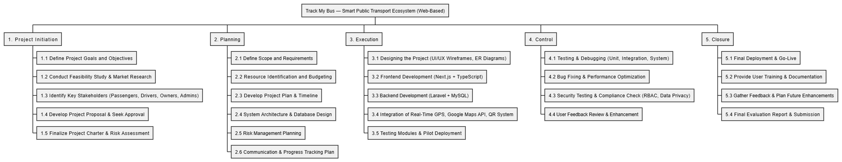
Figure 1 WBS structure
Level | Task Category | Subtasks / Activities | Deliverables
1.0 | Project Initiation & Planning | 1.1 Identify project objectives and goals  1.2 Define scope and requirements  1.3 Literature review & feasibility study  1.4 Resource planning and scheduling | Project proposal, resource plan, feasibility report
2.0 | System Analysis & Design | 2.1 Requirements gathering  2.2 Use case and ER diagrams  2.3 System architecture design (web-based)  2.4 UI/UX wireframing and prototyping | System Design Document, UML diagrams, wireframes
3.0 | Backend Development (Laravel) | 3.1 Setup Laravel environment  3.2 Create API endpoints  3.3 Implement database schema (MySQL)  3.4 Develop booking, tracking, and reward logic | Working backend API, MySQL database
4.0 | Frontend Development (Next.js + TypeScript) | 4.1 Setup Next.js environment  4.2 Build Passenger web interface  4.3 Develop Driver PWA  4.4 Build Owner and Admin dashboards | Responsive Next.js web app with connected backend
5.0 | Integration & Real-Time Features | 5.1 Integrate Laravel WebSockets (Pusher / Laravel Echo)  5.2 Implement Google Maps API for live tracking  5.3 Integrate QR ticket scanning and validation | End-to-end connected system with real-time updates
6.0 | Lost & Found and Rewards Modules | 6.1 Develop Lost & Found posting and verification module  6.2 Create Reward mileage tracking engine  6.3 Owner offer management | Lost & Found + Reward engine functioning
7.0 | Testing & Validation | 7.1 Unit and integration testing  7.2 Usability and performance testing  7.3 Pilot route test and feedback analysis | Test reports, bug list, pilot deployment data
8.0 | Deployment & Documentation | 8.1 Cloud hosting setup (AWS / GCP)  8.2 CI/CD configuration  8.3 Final report, user manual, presentation | Hosted web system, documentation, final report

12.2 Project Milestones
Milestone No. | Milestone Description | Expected Completion Date | Deliverable / Outcome
M1 | Project proposal approval | Week 2 | Approved proposal & feasibility report
M2 | System analysis and SRS finalized | Week 4 | Finalized SRS and UML diagrams
M3 | Database & backend API developed (Laravel) | Week 6 | MySQL database + core APIs working
M4 | Frontend prototype completed (Next.js) | Week 8 | Basic Passenger web app
M5 | Real-time GPS tracking integrated | Week 10 | Live location tracking working
M6 | Booking & QR validation implemented | Week 12 | End-to-end booking flow operational
M7 | Lost & Found + Reward engine implemented | Week 14 | Passenger engagement modules ready
M8 | Testing phase completed | Week 16 | System test results + pilot feedback
M9 | Final deployment and report submission | Week 18 | Fully deployed system + presentation ready

12.3 Gantt Chart
Below is the proposed timeline spanning 18 weeks (approx. 4.5 months) of project execution.
(W = Week number)
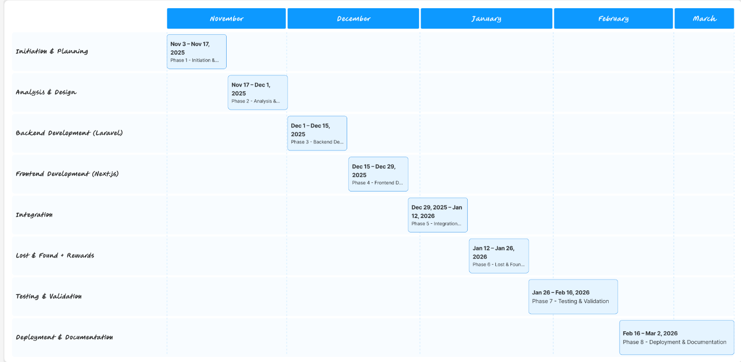
Figure 2 Gantt Chart

Phase | Activities | Timeline (Weeks)
Phase 1: Initiation & Planning | Define objectives, scope, feasibility, resources | W1 – W2
Phase 2: System Analysis & Design | Requirement analysis, UML, ER, UI mockups | W3 – W4
Phase 3: Backend Development (Laravel) | Setup Laravel project, API endpoints, DB schema | W5 – W6
Phase 4: Frontend Development (Next.js + TypeScript) | Build passenger web, driver PWA, owner/admin panels | W7 – W8
Phase 5: Integration (Real-Time + QR) | Integrate APIs, WebSocket, Google Maps, QR system | W9 – W10
Phase 6: Lost & Found + Rewards | Implement user reward system & lost item workflow | W11 – W12
Phase 7: Testing & Validation | Unit, integration, performance, UAT (pilot route) | W13 – W15
Phase 8: Deployment & Documentation | Deploy to cloud, prepare final report, demonstration | W16 – W18

13. Risk Management
Effective risk management is critical for ensuring the success of the SmartBus Tracker Web-Based) project.
Since the system integrates real-time tracking, online booking, and multi-role dashboards, it introduces a number of technical, operational, and managerial risks that must be identified, monitored, and mitigated throughout the project lifecycle.

13.1 Technical Risks
Risk | Description / Impact | Mitigation Strategy
1. Real-Time GPS Data Instability | GPS signals can fluctuate due to poor network coverage or driver devices losing connectivity, leading to inaccurate location updates and ETAs. | Implement WebSocket reconnection logic and offline caching for location updates. Use GPS smoothing algorithms and map-matching to correct coordinates.
2. API Integration Failures (Google Maps, PayHere) | External APIs (Google Maps API for ETA, PayHere for payments) may fail due to quota limits, connectivity issues, or configuration errors. | Cache previous directions; introduce fallback routes and local ETA computation logic. Implement retry mechanisms and monitor API quota usage.
3. Server or Database Downtime | Cloud infrastructure or MySQL database outages can disrupt service availability. | Deploy to reliable cloud infrastructure (AWS/GCP) with daily backups, redundancy, and failover configuration. Enable auto-scaling and regular uptime monitoring.
4. Security Vulnerabilities | Unauthorized access or data breaches due to weak authentication, XSS, or SQL injection. | Apply Laravel Sanctum/JWT for authentication. Enforce HTTPS, strong password policies, and input validation. Conduct penetration and vulnerability testing.
5. Compatibility Issues (Browser & Device) | Since the system is web-based, different browsers or low-end mobile devices might render inconsistent UI. | Use responsive design (Next.js + Tailwind CSS). Test across multiple browsers and devices. Implement PWA (Progressive Web App) support for drivers.
6. Data Loss During Real-Time Streaming | WebSocket message loss or disconnection could affect accuracy of tracking data. | Implement message acknowledgment, buffering, and Redis pub/sub persistence for missed packets.

13.2 Operational Risks
Risk | Description / Impact | Mitigation Strategy
1. Resistance from Drivers and Owners | Some drivers or bus owners may be reluctant to use the system due to unfamiliarity with web tools or fear of monitoring. | Conduct training workshops and offer incentives (e.g., free promotion, mileage reward campaigns) during pilot phase. Create a simple user interface for drivers.
2. Data Entry or Usage Errors | Drivers might forget to start trips or passengers may enter incorrect details during booking. | Introduce validation checks, auto-trip scheduling, and reminders. Include user feedback prompts before confirming bookings.
3. Network Connectivity Problems | Poor 4G coverage along certain routes (especially rural areas) may prevent live updates. | Implement local buffering on driver devices (PWA). Sync data when connectivity is restored. Provide a “last known location” fallback for users.
4. Lost & Found Verification Disputes | Miscommunication between passengers and owners when verifying ownership of found items. | Introduce digital claim verification (QR or OTP) and admin oversight before final approval.
5. Operational Overhead During Pilot | Real-world pilot testing (e.g., Colombo ↔ Galle route) may face scheduling delays or coordination issues. | Conduct a smaller closed beta with selected drivers before public release. Maintain real-time monitoring and feedback collection during pilot.

13.3 Project Management Risks
Risk | Description / Impact | Mitigation Strategy
1. Schedule Delays | Development tasks may take longer due to unforeseen technical challenges or resource constraints. | Use Agile sprints (2-week iterations). Prioritize critical modules first (tracking, booking). Conduct weekly reviews to ensure on-time delivery.
2. Scope Creep | New features (e.g., additional offer mechanisms or AI-based predictions) may be requested during development, affecting timeline and cost. | Maintain a strict change control process. Approve additional features only after pilot completion. Document all new requests separately for future releases.
3. Budget Overruns | Unexpected costs for cloud services, API calls, or third-party subscriptions. | Monitor resource usage; use cost control tools (AWS/GCP budgets). Optimize API usage with caching. Use open-source libraries where possible.
4. Resource Availability | Key developers or designers might become unavailable, delaying progress. | Cross-train team members on multiple modules. Maintain updated documentation for continuity.
5. Data Privacy & Legal Compliance | Improper handling of personal or location data could violate privacy laws. | Implement user consent for data collection. Comply with Sri Lankan ICTA data privacy standards. Limit data retention (e.g., store 30 days of trip data).
6. Quality Assurance Gaps | Inadequate testing may result in deployment of buggy features. | Use CI/CD pipeline with automated testing. Conduct multi-level QA (unit, integration, UAT) before production release.

13.4 Continuous Risk Monitoring
Risk management will be an ongoing process during the development lifecycle.
The following actions will ensure risk visibility and control:
- Weekly risk review meetings: Evaluate new risks or changes in risk level.
- Risk register: Maintain a centralized log of identified risks, status, and mitigation progress.
- Stakeholder updates: Regular progress and risk status reports to supervisors and team leads.
- Post-pilot review: Evaluate technical, operational, and user experience risks observed during real-world testing for version 2 improvements.

14. Project Limitations
Even though the Track My Bus system introduces a modern, scalable solution to public transport digitization in Sri Lanka, several technical, environmental, and logistical constraints limit its full capability during initial deployment.

14.1 Technical Limitations
- Dependency on Internet Connectivity
Real-time tracking, booking, and synchronization depend on stable internet connections.
In rural or mountainous regions, poor 4G/5G coverage may delay live map updates.
- Limited API Usage (Google Maps & PayHere)
Free-tier or restricted API quotas can limit request volumes. High traffic may require paid upgrades.
- Hardware Constraints for Drivers
Drivers using low-end smartphones may experience slower GPS updates or browser lag in the PWA.
- No Native Mobile App (Web-Only in v1)
The initial version is web-based (responsive and PWA-enabled). Offline native app support is deferred to a later phase.
- Limited Multi-Language Support
The system initially supports English; full Sinhala/Tamil localization will be implemented in future iterations.
- Data Accuracy and GPS Drift
GPS inaccuracy in crowded urban zones or tunnels can cause slight deviations in bus location and ETA calculations.
- Cloud Cost & Scalability Boundaries
During pilot deployment, the system may use a single cloud region and moderate resources to reduce cost, limiting load scalability temporarily.

14.2 Operational Limitations
- Pilot Scope Restriction
Initial implementation focuses on one primary route (Colombo ↔ Galle). Nationwide scaling will require further optimization and additional partnerships.
- Training Requirement for Drivers/Owners
Some bus staff may need digital training to effectively use the dashboard and tracking modules.
- User Adoption Challenges
Public acceptance of online booking for local buses may take time due to habit and lack of awareness.
- Lost & Found Moderation Dependency
Effective operation depends on timely validation by owners/admins; delays may affect passenger trust.

14.3 Legal & Policy Limitations
- Current transport regulations in Sri Lanka do not fully mandate digital ticketing or tracking, limiting integration with SLTB or NTC datasets.
- Data privacy guidelines are evolving; any new ICTA or GDPR-inspired regulations may require future compliance updates.

✅ Conclusion on Limitations
Despite these limitations, the project’s modular, web-first architecture ensures that most restrictions are temporary or addressable in later phases through scaling, training, and mobile app integration.

15. References
- Agarwal, S., 2021. Real-Time Vehicle Tracking Systems using GPS and Web Technologies. IEEE Access, 9(5), pp.11234–11245.
- Gunasekara, R. & Perera, S., 2020. Public Transport Modernization in Sri Lanka. Journal of Transportation Systems, 14(3), pp.45–52.
- Moovit App, 2023. Global Transit Usage Report 2023. [online] Available at: https://moovitapp.com [Accessed 20 October 2025].
- PickMe Sri Lanka, 2024. Company Overview and Service Model. [online] Available at: https://pickme.lk [Accessed 20 October 2025].
- Google Maps Platform, 2024. Directions and Distance Matrix API Documentation. [online] Google LLC. Available at: https://developers.google.com/maps/documentation [Accessed 20 October 2025].
- Laravel, 2025. Laravel Framework Documentation (v10). [online] Available at: https://laravel.com/docs [Accessed 20 October 2025].
- Next.js, 2025. Next.js Documentation. [online] Vercel Inc. Available at: https://nextjs.org/docs [Accessed 20 October 2025].
- PayHere, 2025. Payment Gateway Integration Guide (Sri Lanka). [online] Available at: https://www.payhere.lk/api-&-plugins [Accessed 20 October 2025].
- ICTA Sri Lanka, 2023. National Data Protection Act – Guidelines for Compliance. [online] Information and Communication Technology Agency of Sri Lanka. Available at: https://www.icta.lk [Accessed 20 October 2025].
- W3C, 2022. Web Content Accessibility Guidelines (WCAG) 2.1. [online] World Wide Web Consortium. Available at: https://www.w3.org/WAI/standards-guidelines/wcag/ [Accessed 20 October 2025].
- Perera, D. & Senanayake, M., 2021. Adoption of Digital Ticketing Systems in South Asian Public Transport. International Journal of Smart Mobility, 5(2), pp.78–89.
- Fernando, T. & Jayasinghe, K., 2022. Challenges in Implementing IoT-based Transport Systems in Developing Countries. Journal of ICT Research, 8(1), pp.23–38.
- Google Developers, 2025. Progressive Web Apps (PWA) Guidelines. [online] Available at: https://developers.google.com/web/progressive-web-apps [Accessed 20 October 2025].
- AWS, 2025. Cloud Architecture for Scalable Web Applications. [online] Amazon Web Services Inc. Available at: https://aws.amazon.com/architecture/ [Accessed 20 October 2025].
- International Organization for Standardization (ISO), 2018. ISO/IEC 27001: Information Security Management Systems. Geneva: ISO.

16. Appendices
Appendices provide supporting technical materials that enhance the clarity of the proposal and demonstrate implementation feasibility. These are optional but recommended for MSc-level documentation.
Appendix A — Technical Specifications
- Frontend: Next.js (TypeScript), Tailwind CSS, Google Maps API
- Backend: Laravel (PHP 8.x), Laravel WebSockets, Redis Cache
- Database: MySQL 8 (RDS/Cloud SQL)
- Hosting: AWS (ECS + RDS) / GCP (Cloud Run + SQL)
- Payment Gateway: PayHere API (Sandbox for Testing)
- Notification: Firebase Cloud Messaging (FCM)
Appendix B — Diagrams
- System Architecture Diagram
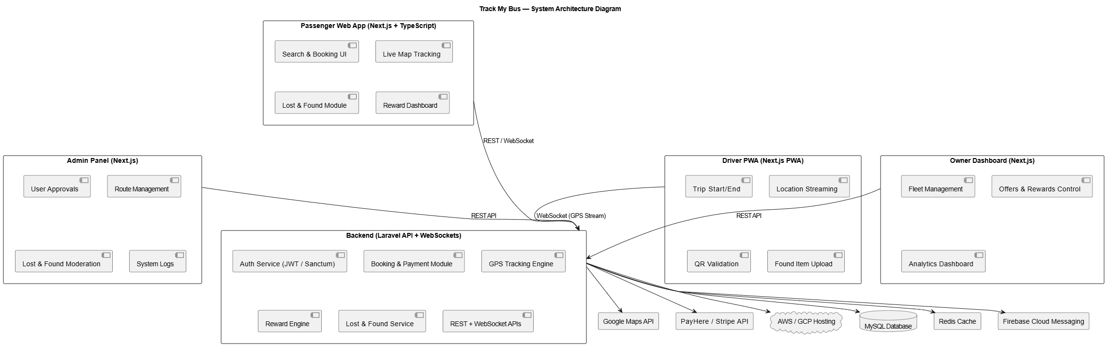
Figure 3 System Architecture Diagram
- Entity Relationship (ER) Diagram
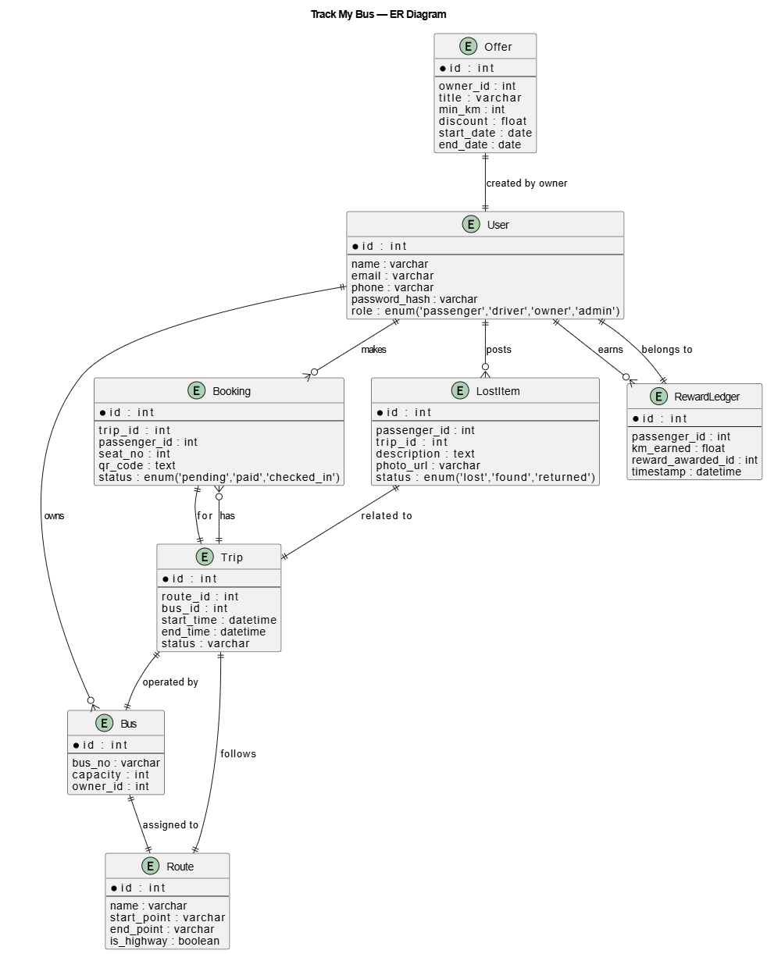
Figure 4 ER Diagram
- Use Case Diagram (Passenger, Driver, Owner, Admin)
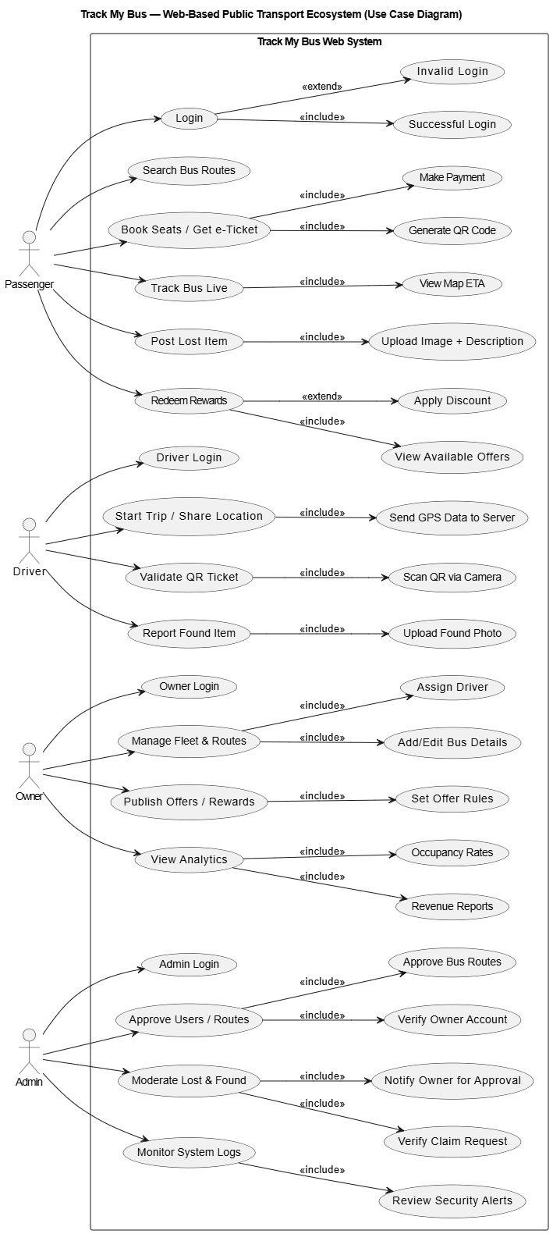
Figure 5 Use Case Diagram
- Sequence Diagrams (for Booking, Lost & Found)
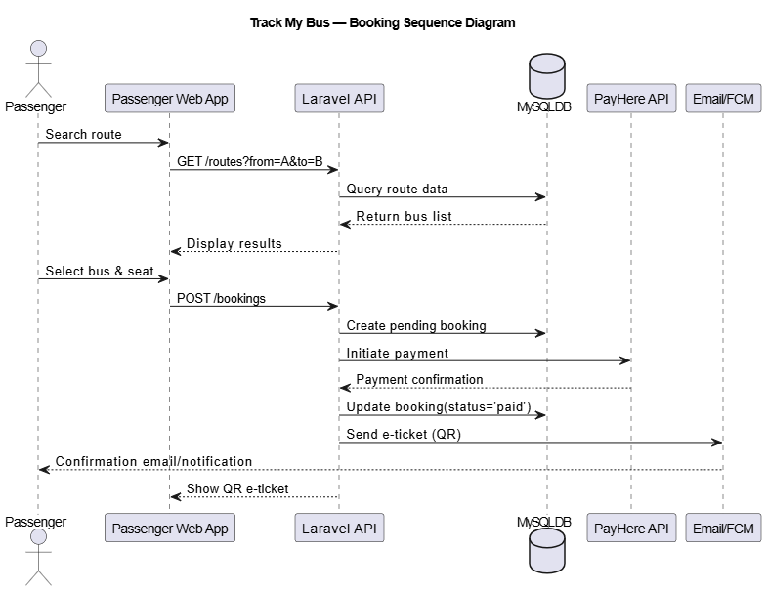
Figure 6 Booking Sequence Diagram
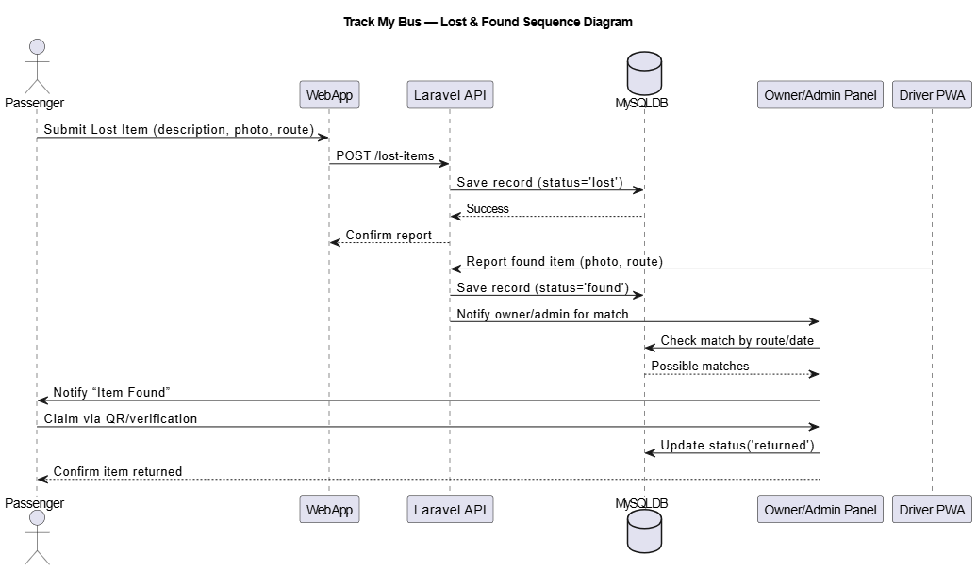
Figure 7 Lost & Found Sequence Diagram

