Create a React App named “bloggerapp” in with 3 components.

1. Book Details
2. Blog Details
3. Course Details

Implement this with as many ways possible of Conditional Rendering.

Blogs.js

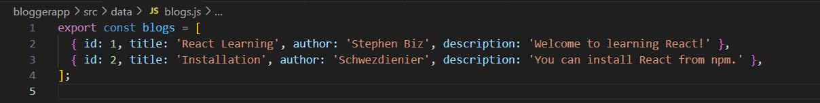

Books.js

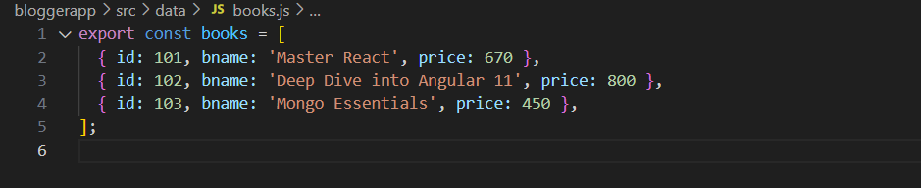

Courses.js

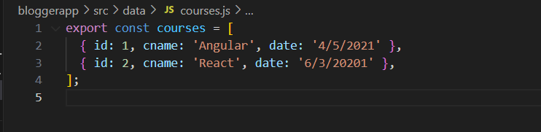

App.css

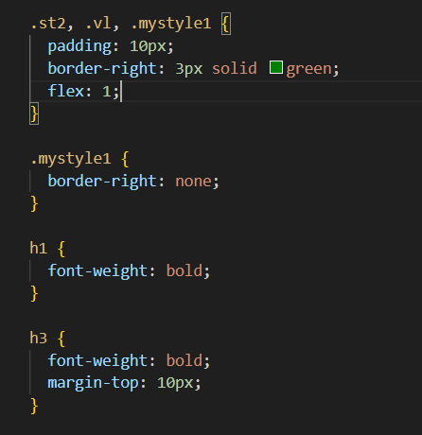

App.js

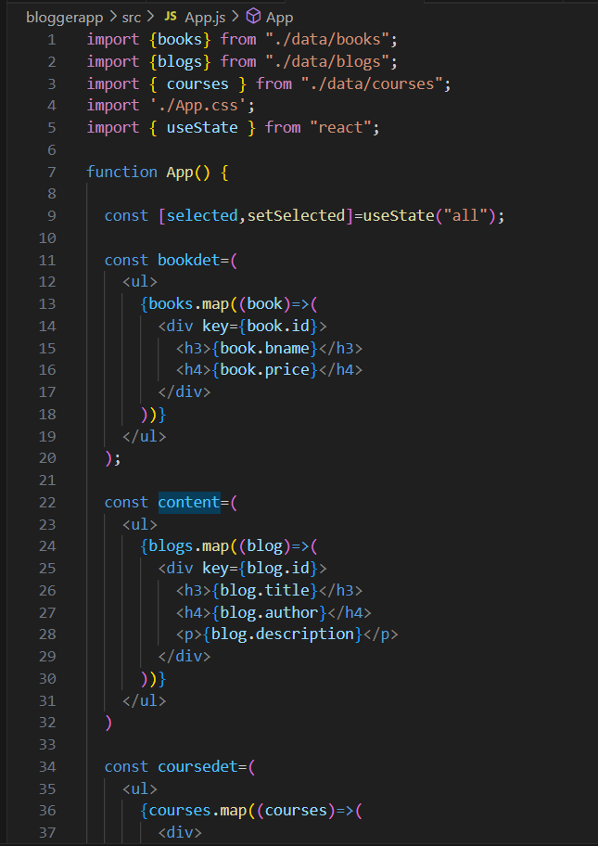

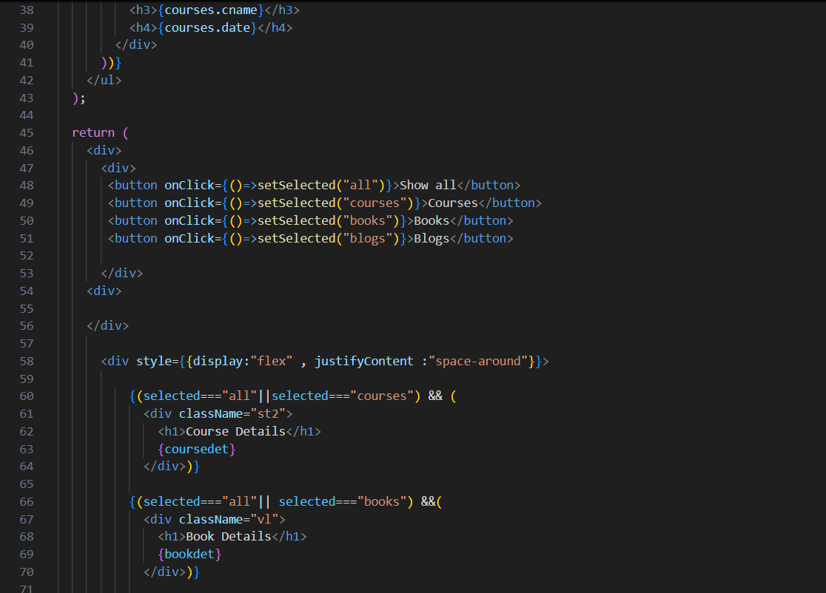

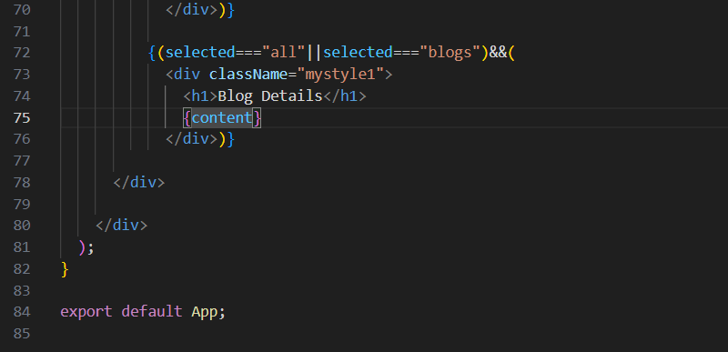

Output

1. Selected all

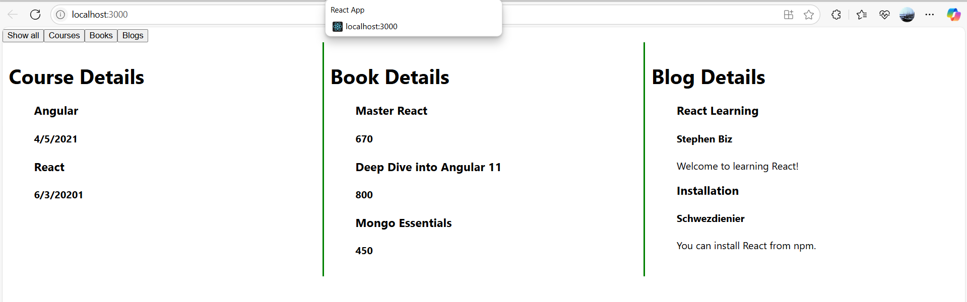

2. Books is selected

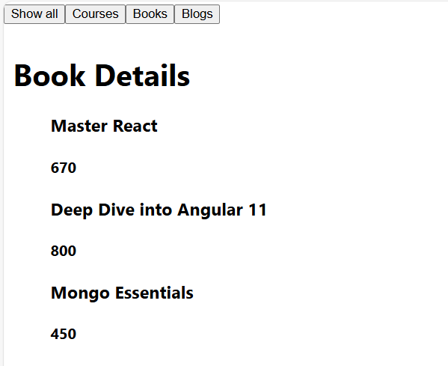

3. Courses is selected

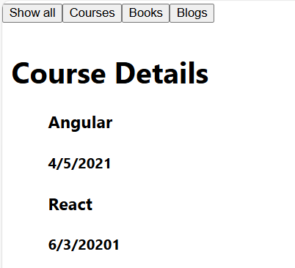

4. Blog is selected

