Create a **“.log”** file and a **log folder** in the working directory of Git. Update the **.gitignore** file in such a way that on committing, these files (.log extensions and log folders) are ignored.

Verify if the git status reflects the same about working dir ectory, local repository and git repository.

Make .log file



Make log folder

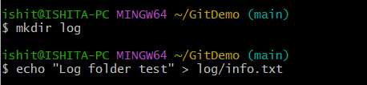

Update the **.gitignore** file in such a way that on committing, these files (.log extensions and log folders) are ignored.

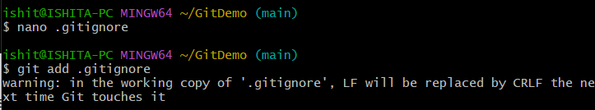

In .gitignore we have added

*.log

log/

Verify the status

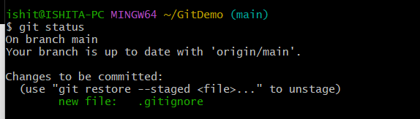

So the .log file and log folders are not untracked now and successfully ignored.

Commit the changes



Push it to remote repository

