Please follow the instructions to complete the hands-on. Each instruction expect a command for the Git Bash.

1. Verify if master is in clean state.

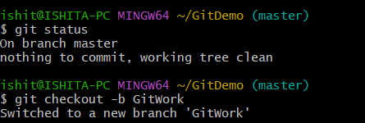

1. Create a branch **“GitWork”.** Add a file “hello.xml”.

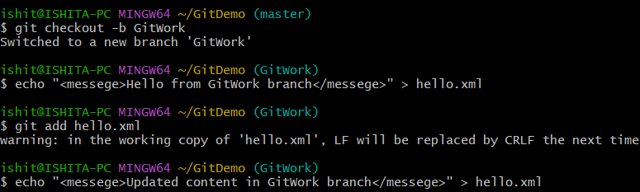

1. Update the content of “hello.xml” and observe the status

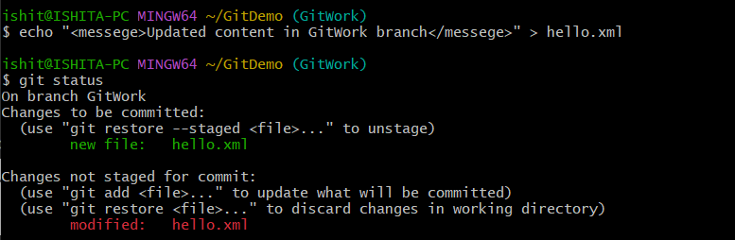

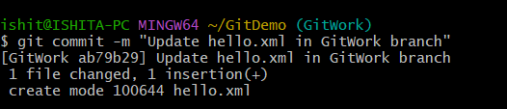

1. Commit the changes to reflect in the branch

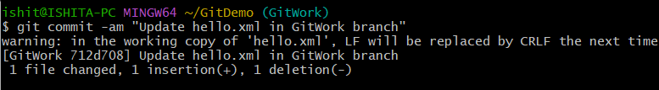

1. Switch to master.

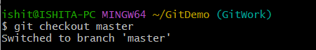

1. Add a file **“hello.xml”** to the master and add some different content than previous.



1. Commit the changes to the master

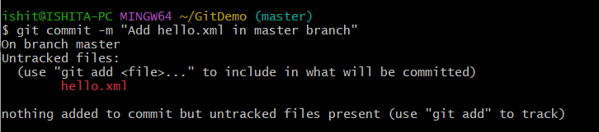

1. Observe the log by executing **“git log –oneline –graph –decorate –all”**

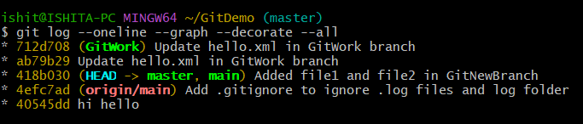

1. Check the differences with Git diff tool

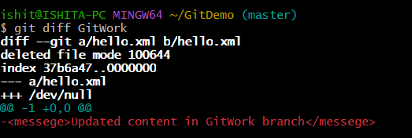

1. For better visualization, use P4Merge tool to list out all the differences between master and branch

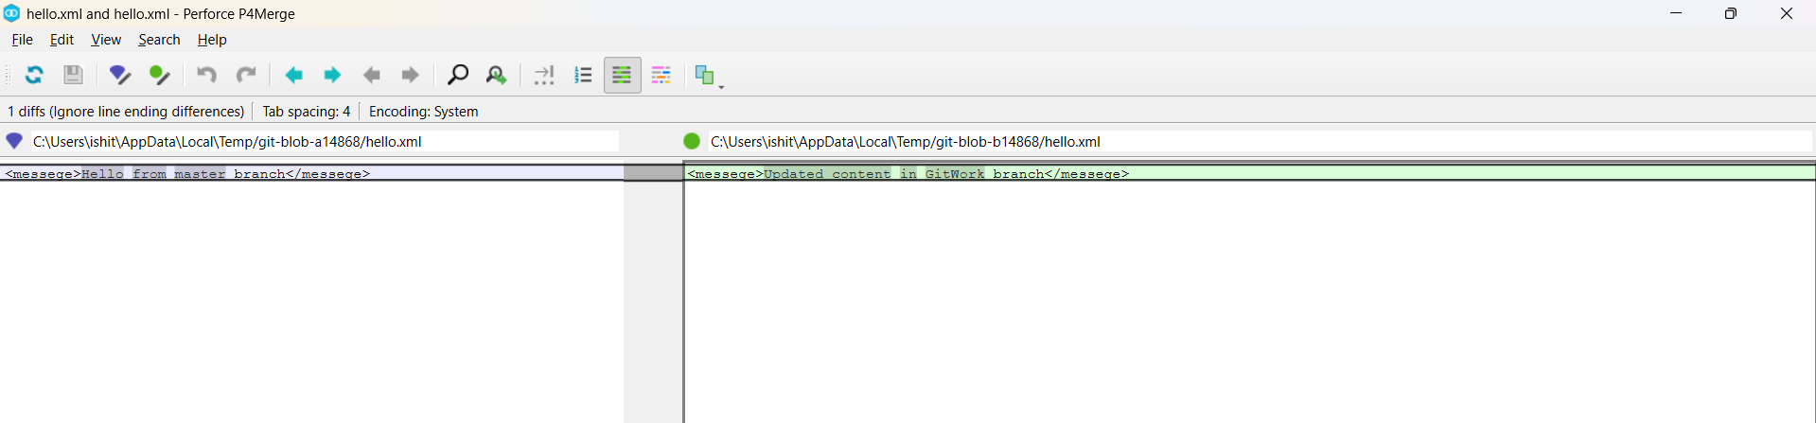

1. Merge the bran to the master

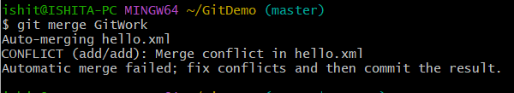

1. Observe the git mark up.

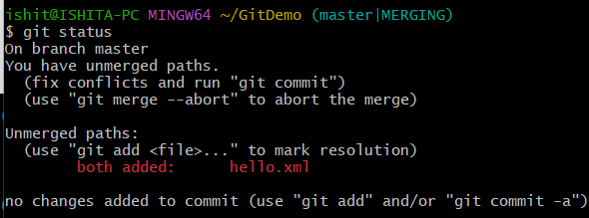

1. Use 3-way merge tool to resolve the conflict

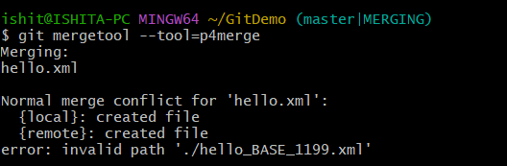

1. Commit the changes to the master, once done with conflict

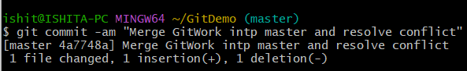

1. Observe the git status and add backup file to the .gitignore file.

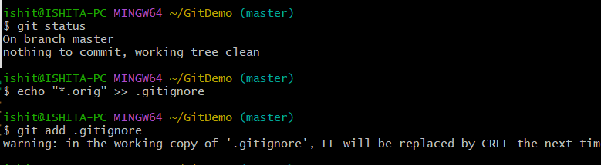

1. Commit the changes to the .gitignore

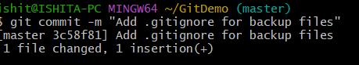

1. List out all the available branches

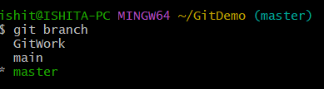

1. Delete the branch, which merge to master.

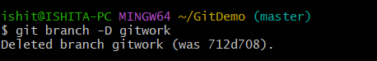

1. Observe the log by executing **“git log –oneline –graph –decorate”**

