Batch T4
Assignment No. 12
Student Name: Ishwar Raut
Student PRN: 22510065

- Create 10,000 Random Location Points
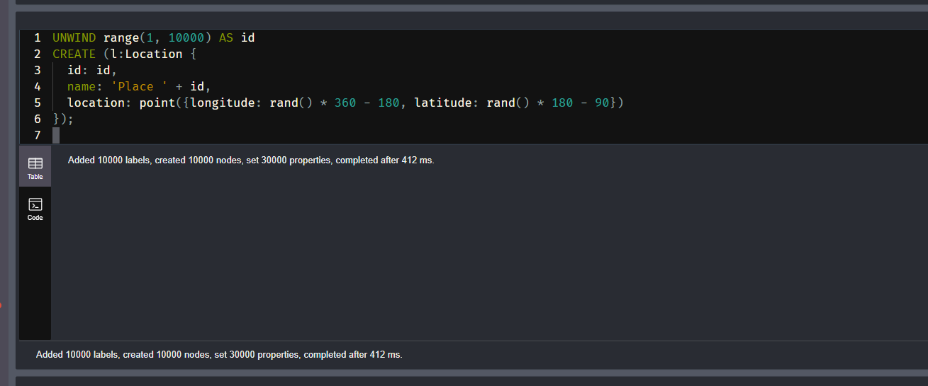

- Find Nearby Locations Using point() and distance()
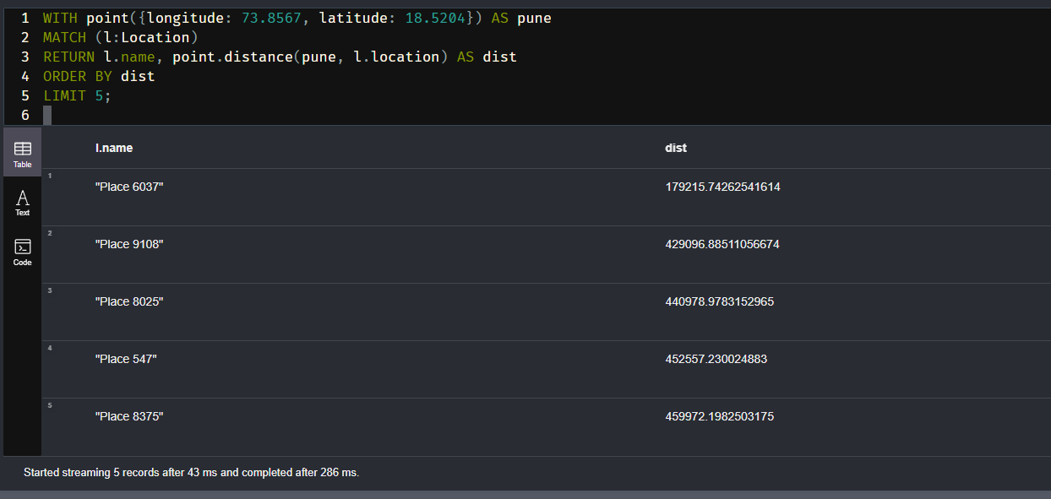

Demonstration Cypher Queries

1. Add 10,000 Random Locations
UNWIND range(1, 10000) AS id
CREATE (l:Location {
id: id,
name: 'Place ' + id,
location: point({longitude: rand() * 360 - 180, latitude: rand() * 180 - 90})
});

2. Find 5 Nearest Locations to a Fixed Point (e.g., Pune)
WITH point({longitude: 73.8567, latitude: 18.5204}) AS pune
MATCH (l:Location)
RETURN l.name, point.distance(pune, l.location) AS dist
ORDER BY dist
LIMIT 5;
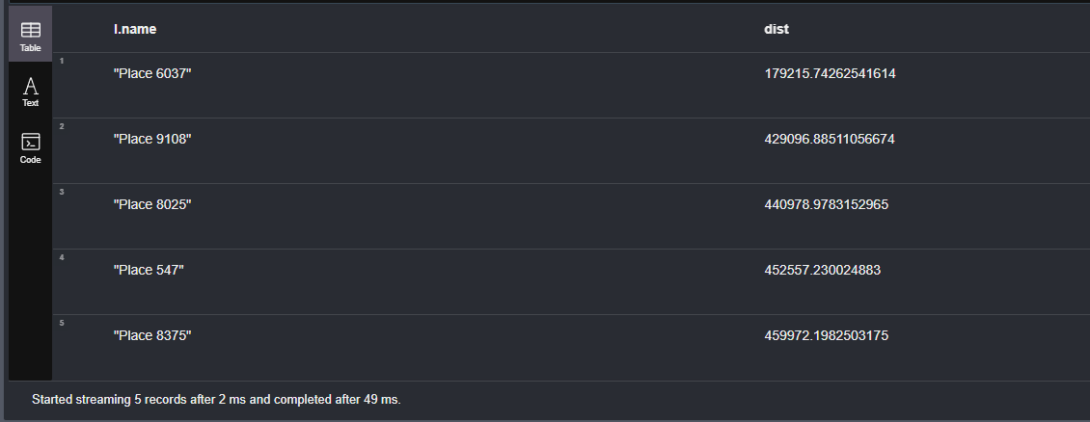

3. Find All Locations Within 100 Kilometers of Mumbai
WITH point({longitude: 72.8777, latitude: 19.0760}) AS mumbai
MATCH (l:Location)
WHERE point.distance(mumbai, l.location) < 100000
RETURN l.name, point.distance(mumbai, l.location) AS dist
ORDER BY dist;

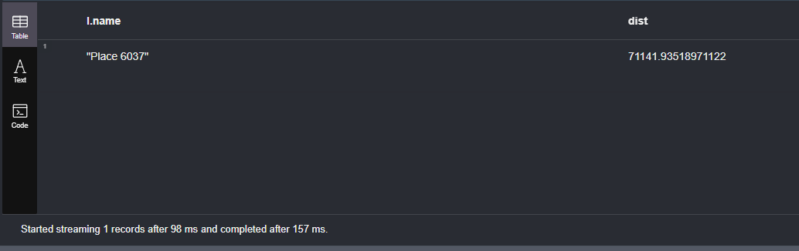

4. Find All Pairs of Locations Less Than 5km Apart
MATCH (a:Location), (b:Location)
WHERE id(a) < id(b) AND point.distance(a.location, b.location) < 5000
RETURN a.name AS Place1, b.name AS Place2, point.distance(a.location, b.location) AS dist
LIMIT 10;
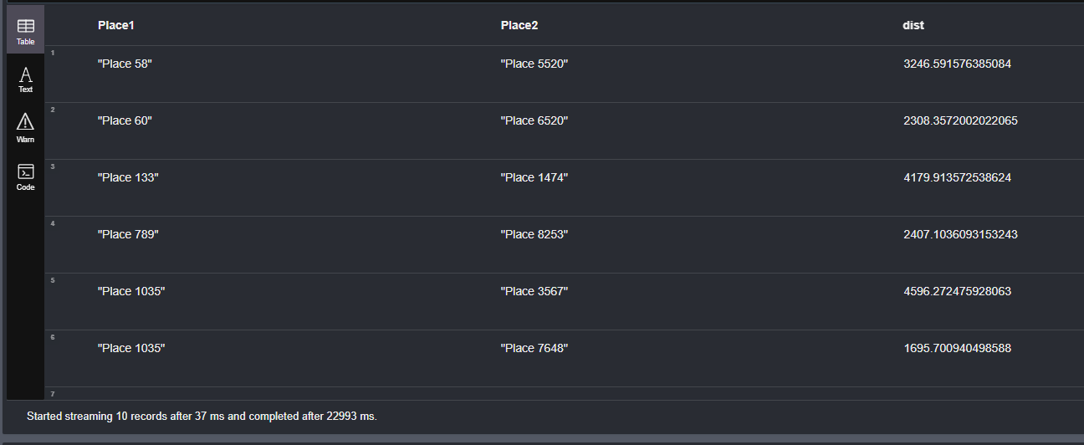

5. Find the Farthest Location from a Fixed Point
WITH point({longitude: 77.5946, latitude: 12.9716}) AS bangalore
MATCH (l:Location)
RETURN l.name, point.distance(bangalore, l.location) AS dist
ORDER BY dist DESC
LIMIT 1;

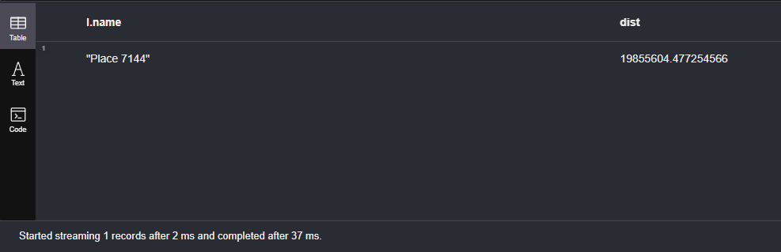

6. Average Distance of All Locations from Delhi
WITH point({longitude: 77.1025, latitude: 28.7041}) AS delhi
MATCH (l:Location)
RETURN avg(point.distance(delhi, l.location)) AS avgDistanceInMeters;

