BITS Pilani – WILP
Course: Full Stack Application Development (S2-25_SEZG503)
Assignment-1
TaskFlow
Smart Task & Productivity Management System

Project Type | Full Stack Web Application
Course | S2-25_SEZG503 — Full Stack Application Development
Tech Stack | Spring Boot 3.3.5 • React 18 • PostgreSQL 15+
Version | 1.0.0

Submitted By:
Isha Girish Naik
BITS ID: 2025TM93222
Academic Year: 2025–26

GitHub Repository: https://github.com/isha-naik/smart-task-productivity-system
Demo Video:
https://drive.google.com/file/d/1G6-3NsRwxYpXGW-8Im63yLNgREIeq1N_/view?usp=sharing

Table of Contents
1. Project Overview
1.1 Purpose & Goals
1.2 Key Features at a Glance
2. Problem Statement
3. System Architecture
3.1 Architecture Overview
3.2 Request Lifecycle
3.3 Security Architecture
4. Technology Stack
4.1 Backend
4.2 Frontend — Production Dependencies
4.3 Frontend — Development Dependencies
4.4 Development Tools
5. Project Structure
5.1 Backend Directory Tree
5.2 Frontend Directory Tree
6. Database Schema
6.1 users
6.2 categories
6.3 tasks
6.4 Seeded Demo Data
7. Backend Components
7.1 Security Layer
7.2 Service Layer
7.3 Repository Layer
8. Frontend Components
8.1 Routing & Auth (App.jsx)
8.2 useAuth Hook
8.3 api.js — Axios Configuration
8.4 Dashboard Charts (AnalyticsChart.jsx)
9. Application Screenshots
9.1 Frontend Screenshots
10. API Endpoints Reference
10.1 Authentication (No Token Required)
10.2 Tasks
10.3 Categories, Users, Analytics & Insights
10.4 Request / Response Samples
11. Design Decisions & Trade-offs
12. Setup & Installation Guide
12.1 Prerequisites
12.2 Database Setup
12.3 Backend Startup
12.4 Frontend Startup
12.5 Demo Credentials
13. Common Errors & Fixes
14. AI Usage Log & Reflection
14.1 AI Tools Used
14.2 AI Usage Log
14.3 AI Generated vs. Manually Written
14.4 Reflection
15. Conclusion

1. Project Overview
TaskFlow is a production-grade, full-stack task and productivity management web application built as an academic project for a Full Stack Application Development course. It simulates the core features of real-world SaaS tools like Asana, Linear, and Jira — scaled to a clean, well-scoped academic deliverable.

1.1 Purpose & Goals
- Role-Based Workflow: Separate experiences for Managers and Employees within the same system.
- Full CRUD Operations: Create, read, update and delete tasks with validation at every layer.
- Real JWT Security: Stateless authentication using industry-standard JSON Web Tokens.
- Analytics Dashboard: Live charts and metrics for productivity tracking.
- AI Productivity Insights: Rule-based analysis engine that generates contextual recommendations.
- Professional UI: Dark mode, glassmorphism cards, animated counters, responsive design.

1.2 Key Features at a Glance
Feature | Manager | Employee
View Tasks | All tasks in system | Only own assigned tasks
Create Task | Yes — assign to any employee | Yes — auto-assigned to self
Update Task | Any task + reassign | Own tasks only
Delete Task | Yes | No (403 Forbidden)
Analytics Dashboard | Team-wide metrics | Personal metrics
AI Insights | Based on full team data | Based on own tasks
Category Management | Yes | Yes
Team Overview Panel | Yes (Admin Panel) | No
Notification Bell | Yes | Yes
Dark Mode | Yes | Yes

2. Problem Statement
Modern teams struggle to manage tasks, monitor productivity, track deadlines, and collaborate efficiently in a centralised system. Existing solutions are either too complex for small teams or too simplistic to capture meaningful analytics.

This project aims to build a secure, full-stack task and productivity management platform with:

- Role-based access control — distinct workflows for Managers and Employees
- Analytics dashboards — real-time charts showing completion rates, priority breakdown, and productivity scores
- AI-generated productivity insights — rule-based engine producing contextual, actionable recommendations
- Responsive UI features — dark mode, notification bells, animated metric cards

The goal is to improve workflow efficiency and team visibility through a cohesive, production-pattern application built from scratch using Spring Boot (backend) and React + Vite (frontend).

3. System Architecture
TaskFlow follows a classic three-tier architecture with clear separation between the presentation, business logic, and data layers.

3.1 Architecture Overview
┌──────────────────────────────────────────────────────────────────┐
│ PRESENTATION LAYER │
│ React 18 + Vite + Tailwind CSS + Chart.js │
│ Port 5173 — Vite Dev Server with /api proxy │
└──────────────────────────┬───────────────────────────────────────┘
│ HTTP / REST (JSON)
│ Authorization: Bearer <JWT>
┌──────────────────────────▼───────────────────────────────────────┐
│ BUSINESS LOGIC LAYER │
│ Spring Boot 3.3.5 + Spring Security + JWT │
│ Port 8081 — Embedded Tomcat │
│ Controllers → Services → Repositories │
└──────────────────────────┬───────────────────────────────────────┘
│ JPA / Hibernate
┌──────────────────────────▼───────────────────────────────────────┐
│ DATA LAYER │
│ PostgreSQL 15 — localhost:5432/task_management_db │
│ Tables: users, tasks, categories │
└──────────────────────────────────────────────────────────────────┘

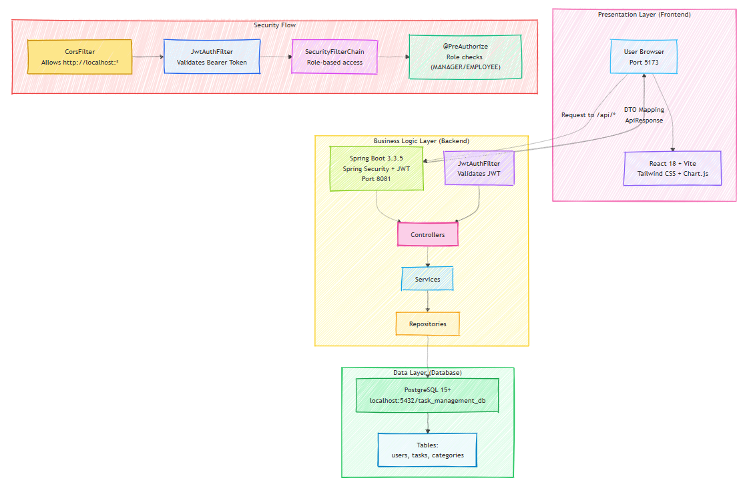
Fig: TaskFlow Architechture Diagram

3.2 Request Lifecycle
- 1. Browser → React sends request to /api/* (Vite proxy, same-origin)
- 2. Vite Proxy → Forwards to http://localhost:8081 (no CORS needed in dev)
- 3. JwtAuthFilter → Extracts Bearer token, validates HMAC-SHA256 signature, sets SecurityContext
- 4. Controller → @AuthenticationPrincipal User injected, delegates to service
- 5. Service → Applies role-based business logic, calls repository
- 6. Repository → JPA executes SQL on PostgreSQL, returns entity
- 7. DTO Mapping → Entity converted to DTO, wrapped in ApiResponse<T>
- 8. Response → JSON returned, React updates state and re-renders UI

3.3 Security Architecture
JWT Flow: Login → Server validates credentials → Signs JWT (HMAC-SHA256, 24h expiry) → Client stores in localStorage → Attached to every request as Bearer token → JwtAuthFilter validates on each request

HTTP Request → CorsFilter (allows http://localhost:*)
→ JwtAuthFilter (validates Bearer, sets SecurityContext)
→ SecurityFilterChain (/api/auth/** = public, else authenticated)
→ @PreAuthorize (hasRole(MANAGER) on specific endpoints)
→ Controller / Service

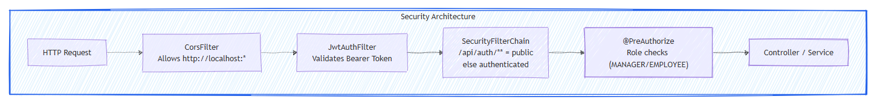

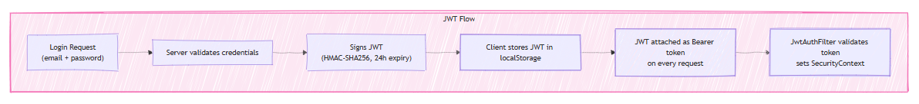

4. Technology Stack

4.1 Backend
Exact versions as declared in pom.xml:

Dependency / Tool | Version | How Declared | Purpose
Java (JDK) | 23 | java.version=23 in pom.xml | Core programming language & runtime
Spring Boot | 3.3.5 | spring-boot-starter-parent 3.3.5 | Application framework, auto-configuration, embedded Tomcat 10
Spring Web (MVC) | 6.1.x (managed) | spring-boot-starter-web | REST controllers, DispatcherServlet, JSON serialization
Spring Security | 6.3.x (managed) | spring-boot-starter-security | Filter chain, stateless JWT auth, @PreAuthorize RBAC
Spring Data JPA | 3.3.x (managed) | spring-boot-starter-data-jpa | Repository abstraction, query generation, transactions
Hibernate ORM | 6.5.x (managed) | Pulled by spring-boot-starter-data-jpa | JPA implementation, DDL auto-generation (ddl-auto=update)
Spring Validation | 6.1.x (managed) | spring-boot-starter-validation | @NotBlank, @NotNull on DTOs, global error handler
PostgreSQL JDBC Driver | 42.7.x (managed) | postgresql (runtime scope) | JDBC connection to PostgreSQL 15+
JJWT API | 0.11.5 | jjwt-api 0.11.5 (explicit) | JWT creation and parsing interfaces (HMAC-SHA256)
JJWT Impl | 0.11.5 | jjwt-impl 0.11.5 (runtime) | JWT implementation classes
JJWT Jackson | 0.11.5 | jjwt-jackson 0.11.5 (runtime) | JSON serialization support for JWT
Lombok | 1.18.34 | lombok.version=1.18.34 (explicit) | @Data, @Builder, @RequiredArgsConstructor, @Slf4j
SpringDoc OpenAPI (Swagger) | 2.3.0 | springdoc-openapi-starter-webmvc-ui 2.3.0 | Swagger UI at /swagger-ui/index.html, bearerAuth scheme
Maven | 3.9+ | pom.xml build tool | Dependency management, build lifecycle

4.2 Frontend — Production Dependencies
Exact versions as declared in package.json ("dependencies" section):

Package | Version | Purpose
react | ^18.2.0 | Core UI library — component model, hooks, virtual DOM
react-dom | ^18.2.0 | DOM renderer — ReactDOM.createRoot, portals
react-router-dom | ^6.21.0 | Client-side routing — BrowserRouter, Routes, NavLink, protected routes
axios | ^1.6.2 | HTTP client — request/response interceptors, JWT header injection, 401 auto-redirect
chart.js | ^4.4.1 | Chart rendering engine — Doughnut, Line, Bar chart types
react-chartjs-2 | ^5.2.0 | React wrapper for Chart.js — <Doughnut>, <Line>, <Bar> components
lucide-react | ^0.303.0 | Icon library — Bell, CheckSquare, AlertTriangle, TrendingUp, etc.
react-hot-toast | ^2.4.1 | Toast notifications — success/error toasts with custom dark styling
@radix-ui/react-dialog | ^1.0.5 | Accessible modal dialog primitive
@radix-ui/react-dropdown-menu | ^2.0.6 | Accessible dropdown menu primitive
@radix-ui/react-select | ^2.0.0 | Accessible select/combobox primitive
@radix-ui/react-label | ^2.0.2 | Accessible label primitive
@radix-ui/react-slot | ^1.0.2 | Slot pattern for component composition (asChild)
@radix-ui/react-separator | ^1.0.3 | Accessible separator/divider primitive
@radix-ui/react-avatar | ^1.0.4 | Accessible avatar with fallback primitive
@radix-ui/react-progress | ^1.0.3 | Accessible progress bar primitive
@radix-ui/react-alert-dialog | ^1.0.5 | Accessible confirmation dialog primitive (ConfirmDialog)
class-variance-authority | ^0.7.0 | Type-safe component variant management (CVA pattern)
clsx | ^2.0.0 | Conditional className string builder
tailwind-merge | ^2.2.0 | Merges Tailwind classes without conflicts (twMerge)
date-fns | ^3.0.6 | Date formatting — formatDate helper in utils/helpers.js

4.3 Frontend — Development Dependencies
Package | Version | Purpose
vite | ^5.0.8 | Build tool and dev server — /api proxy to :8081, HMR, ES module bundling
@vitejs/plugin-react | ^4.2.1 | React Fast Refresh, JSX transform via Babel for Vite
tailwindcss | ^3.4.0 | Utility-first CSS framework — dark mode via class strategy, custom animations
postcss | ^8.4.32 | CSS transformation pipeline (required by Tailwind)
autoprefixer | ^10.4.16 | Auto-adds vendor prefixes to CSS output
eslint | ^8.55.0 | JavaScript/JSX linting
eslint-plugin-react | ^7.33.2 | React-specific ESLint rules
eslint-plugin-react-hooks | ^4.6.0 | Enforces Rules of Hooks
eslint-plugin-react-refresh | ^0.4.5 | Validates components are compatible with Fast Refresh
@types/react | ^18.2.43 | TypeScript type definitions for React (IDE intellisense)
@types/react-dom | ^18.2.17 | TypeScript type definitions for React DOM

4.4 Development Tools
- IntelliJ IDEA / VS Code — IDE (VS Code with ESLint + Tailwind IntelliSense extensions recommended)
- Postman — API testing with Bearer token collections
- Swagger UI — http://localhost:8081/swagger-ui/index.html (built-in, no extra tool needed)
- pgAdmin 4 / DBeaver — PostgreSQL GUI administration
- Git — Version control (GitHub repository)
- Node.js 18+ — Required to run Vite and npm scripts
- PostgreSQL 15+ — Relational database server

5. Project Structure

5.1 Backend Directory Tree
task-management-backend/
├── pom.xml ← Maven build, Java 23, dependencies
└── src/main/java/com/taskmanager/
├── TaskManagementApplication.java ← @SpringBootApplication entry point
├── config/
│ ├── SecurityConfig.java ← Filter chain, BCrypt, AuthManager
│ ├── CorsConfig.java ← Allows http://localhost:* (any Vite port)
│ ├── SwaggerConfig.java ← OpenAPI + bearerAuth scheme
│ └── DataLoader.java ← CommandLineRunner seeds demo data
├── entity/
│ ├── User.java ← Implements UserDetails
│ ├── Task.java ← Core domain, @ManyToOne to User & Category
│ ├── Category.java ← Task category
│ ├── Role.java ← Enum: MANAGER | EMPLOYEE
│ ├── TaskStatus.java ← Enum: PENDING | IN_PROGRESS | COMPLETED | OVERDUE
│ └── TaskPriority.java ← Enum: LOW | MEDIUM | HIGH
├── dto/ ← Request/Response DTOs
├── repository/ ← JPA repositories
├── service/ ← Business logic layer
├── controller/ ← REST endpoint controllers
├── security/ ← JwtUtil, JwtAuthFilter, UserDetailsServiceImpl
└── exception/ ← GlobalExceptionHandler + custom exceptions

5.2 Frontend Directory Tree
task-management-frontend/
├── package.json ← npm scripts use node node_modules/vite/bin/vite.js
├── vite.config.js ← /api proxy → http://localhost:8081
├── tailwind.config.js ← darkMode: class, custom colors
└── src/
├── main.jsx ← ReactDOM.createRoot entry point
├── App.jsx ← BrowserRouter, ProtectedRoute, AppLayout
├── pages/
│ ├── Login.jsx ← JWT login, demo credential fill buttons
│ ├── Register.jsx ← Registration (Employee only)
│ ├── Dashboard.jsx ← Cards + Charts + Insights + Recent Tasks
│ ├── Tasks.jsx ← Card/Table view toggle, full CRUD
│ └── AdminPanel.jsx ← Manager: Tasks | Team | Categories tabs
├── components/ ← Navbar, Sidebar, TaskCard, TaskForm, etc.
├── hooks/ ← useAuth, useTasks
├── services/ ← api.js (Axios instance)
└── utils/ ← auth.js, helpers.js

6. Database Schema
Hibernate auto-generates the schema from JPA entities (ddl-auto=update). Three tables are created automatically on first startup.

6.1 users
Column | Type | Constraints | Description
id | BIGINT | PK, AUTO_INCREMENT | Unique user identifier
name | VARCHAR(255) | NOT NULL | Full display name
email | VARCHAR(255) | NOT NULL, UNIQUE | Login identifier
password | VARCHAR(255) | NOT NULL | BCrypt hashed password
role | VARCHAR(50) | NOT NULL | MANAGER or EMPLOYEE

6.2 categories
Column | Type | Constraints | Description
id | BIGINT | PK, AUTO_INCREMENT | Unique category identifier
category_name | VARCHAR(255) | NOT NULL | e.g. Development, Design, DevOps

6.3 tasks
Column | Type | Constraints | Description
id | BIGINT | PK, AUTO_INCREMENT | Unique task identifier
title | VARCHAR(255) | NOT NULL | Task title
description | TEXT | NULLABLE | Detailed task description
status | VARCHAR(50) | NOT NULL | PENDING | IN_PROGRESS | COMPLETED | OVERDUE
priority | VARCHAR(50) | NOT NULL | LOW | MEDIUM | HIGH
due_date | DATE | NULLABLE | Target completion date
created_at | TIMESTAMP | NOT NULL, auto | Record creation timestamp (@CreationTimestamp)
assigned_to_id | BIGINT | FK → users.id, NULLABLE | Employee responsible for task
created_by_id | BIGINT | FK → users.id, NULLABLE | Manager who created the task
category_id | BIGINT | FK → categories.id, NULLABLE | Task category

6.4 Seeded Demo Data
Type | Name | Email | Password | Landing
MANAGER | Arjun Sharma | manager@taskmanager.com | manager123 | /admin
EMPLOYEE | Priya Patel | priya@employee.com | employee123 | /dashboard
EMPLOYEE | Rahul Verma | rahul@employee.com | employee123 | /dashboard
EMPLOYEE | Sneha Gupta | sneha@employee.com | employee123 | /dashboard
Additionally, 5 categories (Development, Design, Marketing, QA Testing, DevOps) and 10 realistic sample tasks are seeded covering all statuses and priorities.

7. Backend Components

7.1 Security Layer

JwtUtil.java
- generateToken(User): Creates signed JWT with email as subject, 24-hour expiry, HMAC-SHA256 signing key derived from application.properties secret.
- extractUsername(token): Parses the JWT and returns the email claim (subject).
- isTokenValid(token, UserDetails): Checks signature integrity and expiry, matches email to loaded user.

JwtAuthFilter.java
Extends OncePerRequestFilter. Runs before every HTTP request:
- Reads Authorization header, checks for "Bearer " prefix.
- Extracts JWT, calls JwtUtil.extractUsername().
- Loads UserDetails via UserDetailsServiceImpl (DB lookup by email).
- On valid token: creates UsernamePasswordAuthenticationToken, sets SecurityContextHolder.
- On failure: logs warning, continues filter chain without auth (request rejected downstream by SecurityFilterChain).

SecurityConfig.java
- CSRF: Disabled (stateless JWT API, no session cookies).
- Public endpoints: /api/auth/**, /swagger-ui/**, /api-docs/**
- All other requests: require authentication.
- Fine-grained: @PreAuthorize("hasRole('MANAGER')") on UserController endpoints.
- Session policy: STATELESS — no server-side sessions.

7.2 Service Layer

TaskService.java
- getAllTasks: MANAGER → findAll(); EMPLOYEE → findByAssignedTo(currentUser). Both paths auto-mark overdue tasks before returning.
- createTask: MANAGER sets assignedToId from DTO; EMPLOYEE tasks auto-assigned to self.
- updateTask: EMPLOYEE enforced to only update their own tasks (403 otherwise). MANAGER can reassign.
- deleteTask: EMPLOYEE receives UnauthorizedException. MANAGER deletes any task.
- checkAndMarkOverdue: Private helper called on every task returned. If dueDate < today and status != COMPLETED, sets OVERDUE and persists.

AnalyticsService.java
Metric | Manager Source | Employee Source
totalTasks | taskRepository.count() | userTasks.size() (assigned to them)
completedTasks | countByStatus(COMPLETED) | stream filter on user tasks
overdueTasks | findOverdueTasks(today).size() | findOverdueTasks(today).size()
productivityScore | completion% × 0.7 - overdue% × 0.3 + 30 | Same formula

7.3 Repository Layer
// Find all tasks past due date that are not completed
@Query("SELECT t FROM Task t WHERE t.dueDate < :today AND t.status != 'COMPLETED'")
List<Task> findOverdueTasks(LocalDate today);

// Count overdue tasks for a specific user
@Query("SELECT COUNT(t) FROM Task t WHERE t.assignedTo = :user AND t.dueDate < :today AND t.status != 'COMPLETED'")
long countOverdueTasksForUser(User user, LocalDate today);

// Standard Spring Data methods:
List<Task> findByAssignedTo(User user);
long countByStatus(TaskStatus status);
long countByPriority(TaskPriority priority);

8. Frontend Components

8.1 Routing & Auth (App.jsx)
ProtectedRoute component wraps all authenticated pages using React Router's <Outlet> pattern. On load, useAuth checks token expiry in localStorage. If expired, user is cleared and redirected to login. On login, role determines landing page: MANAGER → /admin, EMPLOYEE → /dashboard.

8.2 useAuth Hook
- login(email, password) — calls POST /api/auth/login, stores token + user in localStorage, returns { success, user }
- register(name, email, password, role) — calls POST /api/auth/register, same storage pattern
- logout() — calls clearAuth() which removes both localStorage keys, shows toast
- isManager() — returns user?.role === "MANAGER"
- isAuthenticated — boolean derived from !!user state
- isInitialized — false until token-expiry check on mount completes (prevents flash of login page)

8.3 api.js — Axios Configuration
- Base URL: '' (empty string) — all /api/* calls go through Vite proxy. No CORS errors in dev.
- Request Interceptor: Reads token from localStorage, attaches Authorization: Bearer <token> header to every request.
- Response Interceptor: Catches 401 responses, calls clearAuth(), redirects to /login.
- Timeout: 10 seconds on all requests.

8.4 Dashboard Charts (AnalyticsChart.jsx)
Chart | Library | What it Shows
StatusDoughnut | Chart.js Doughnut | 72% cutout, 4 status segments, centre % overlay showing completion rate
WeeklyLine | Chart.js Line | Simulated 7-day activity trend. Canvas gradients created in useEffect via chartRef.current.ctx after mount
PriorityBar | Chart.js Horizontal Bar | LOW / MEDIUM / HIGH task counts with canvas gradient fills. Percentage breakdown bars below
ScoreGauge | Pure SVG (no Chart.js) | Animated semicircle gauge. Arc path M 16 72 A 58 58. Needle dot tracks center (74,72) radius 58 exactly

9. Application Screenshots
The following screenshots illustrate the key user-facing features of TaskFlow.

9.1 Frontend Screenshots
📷 Login Page — http://localhost:5173/login
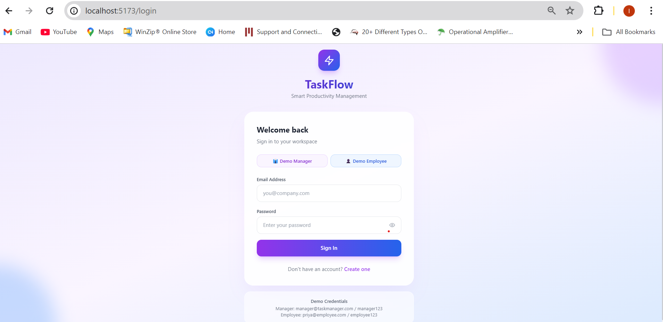

📷 Manager Dashboard — Analytics Cards, Charts & AI Insights
Administrative Productivity Overview
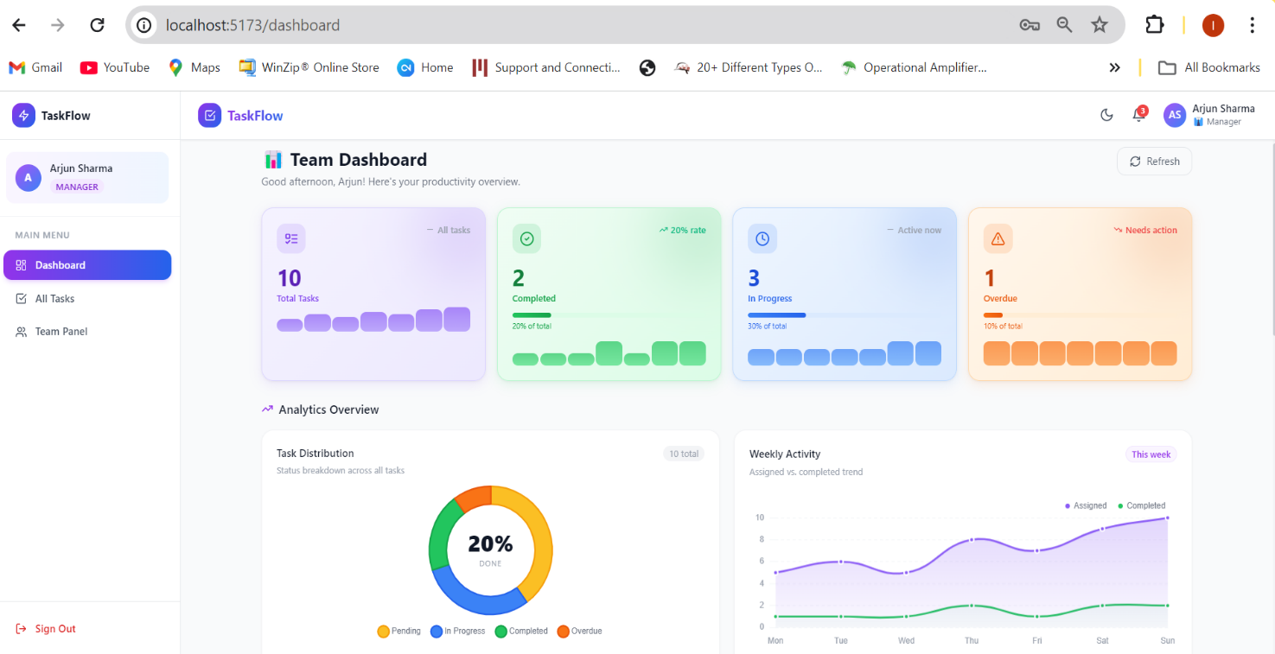
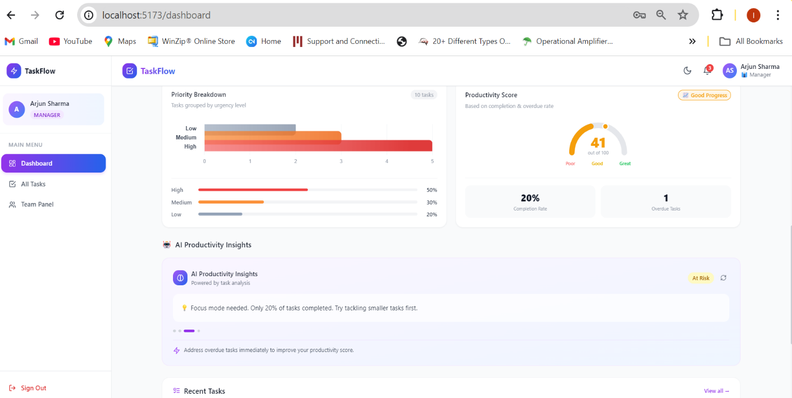

📷 Task Management Page Overview — Card / Table View Toggle (Manager)
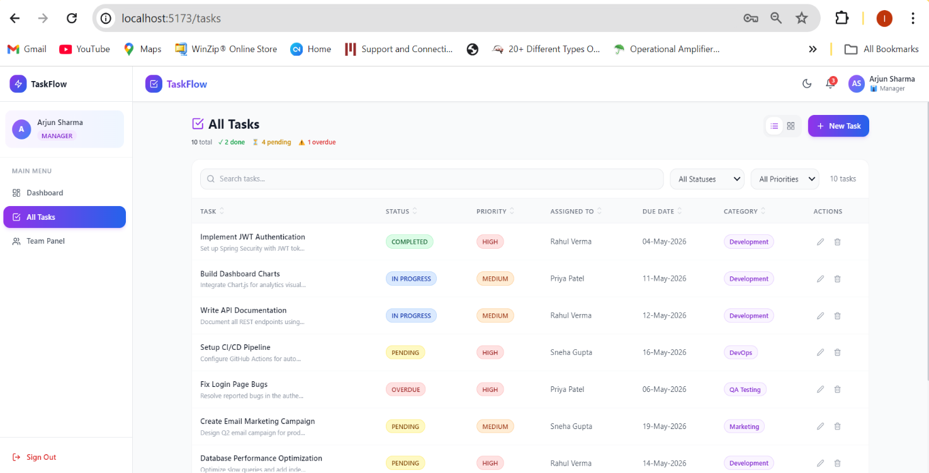

📷 Admin Panel — Manager View (Tasks | Team | Categories tabs)
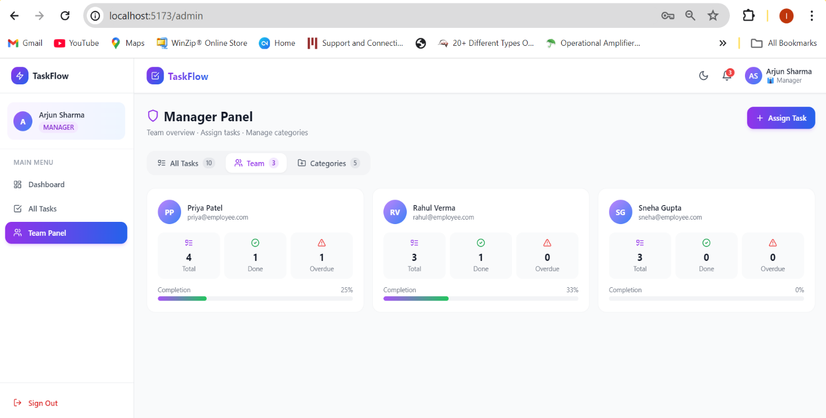

📷 Dark Mode UI

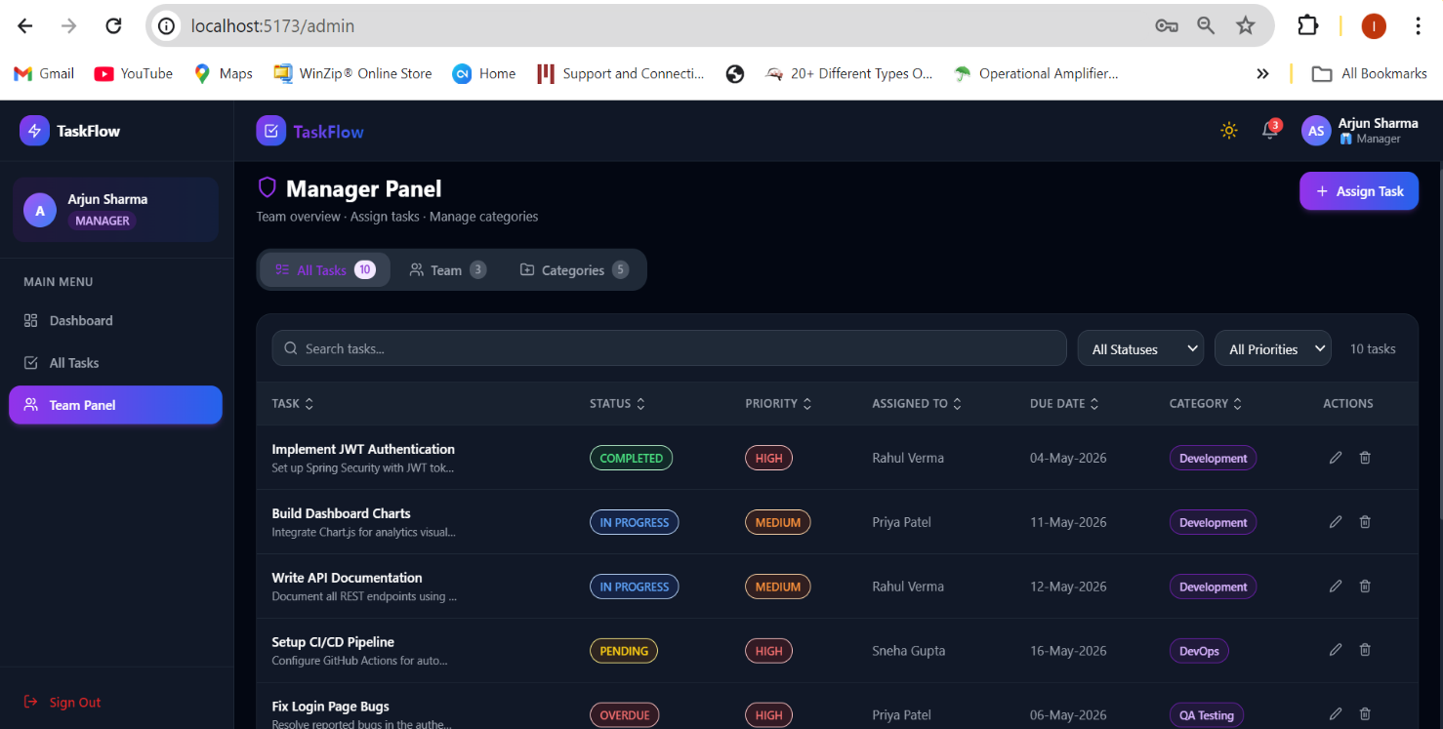

📷 Employee Dashboard — Personal Productivity Workspace and AI Productivity Insights
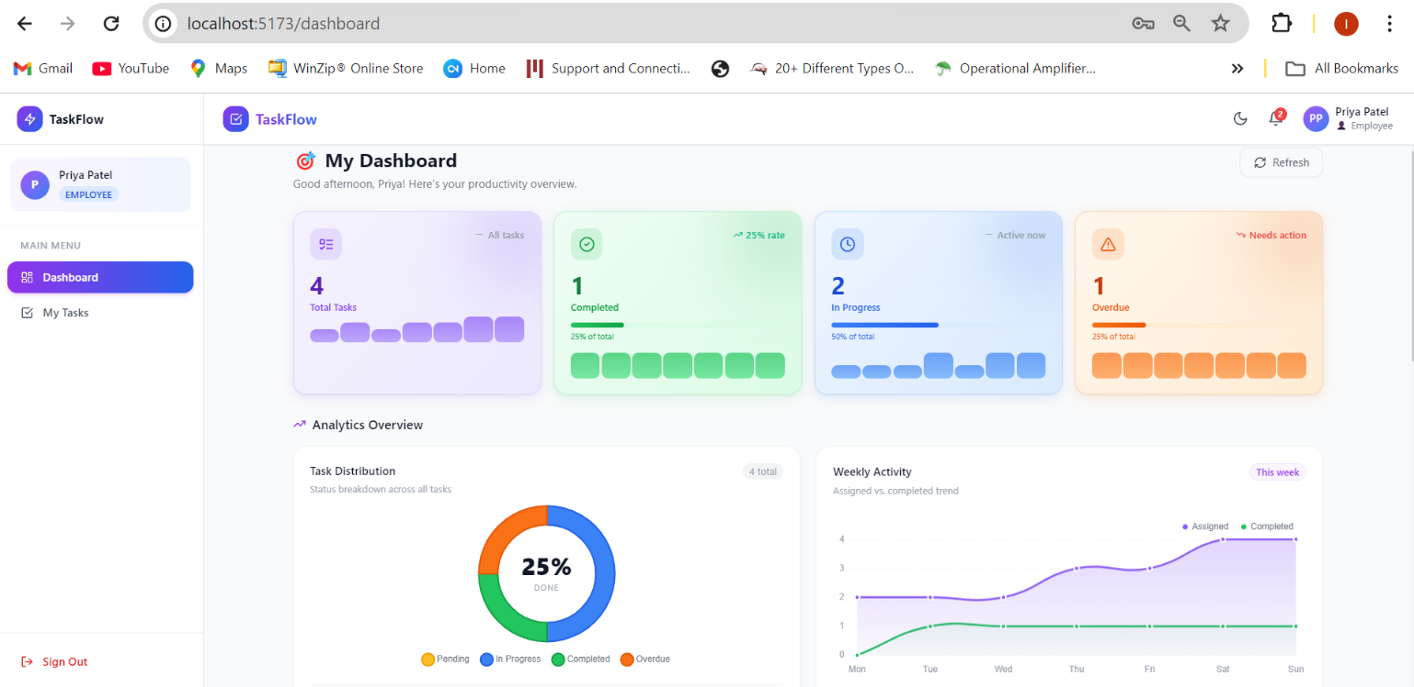

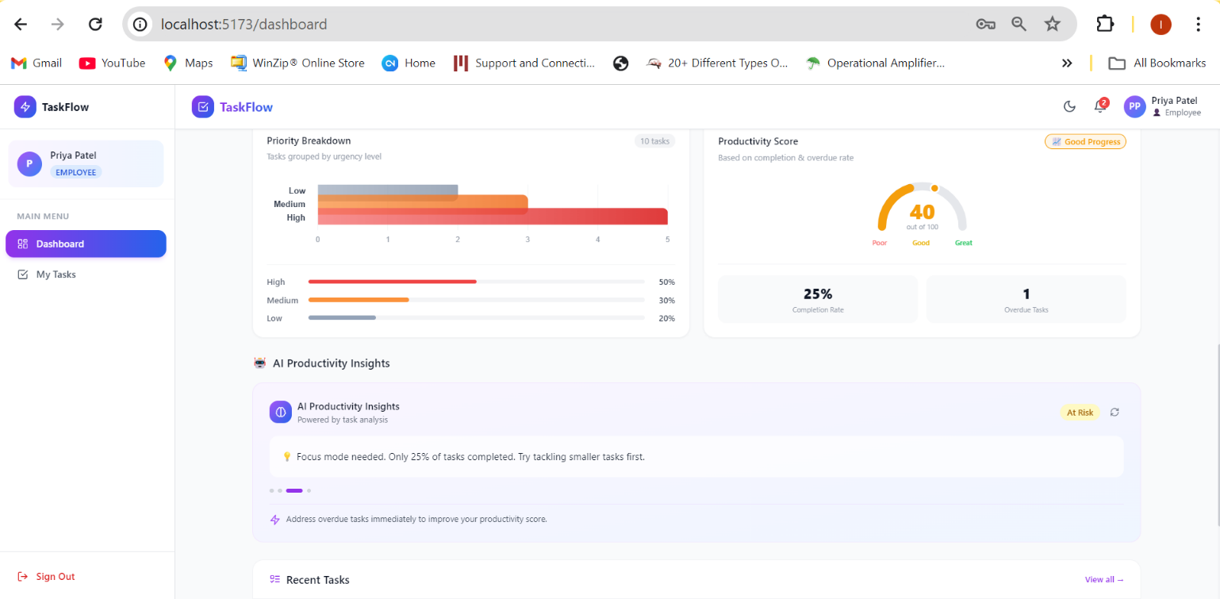
📷 Employee Task Workspace — Personal Task Management
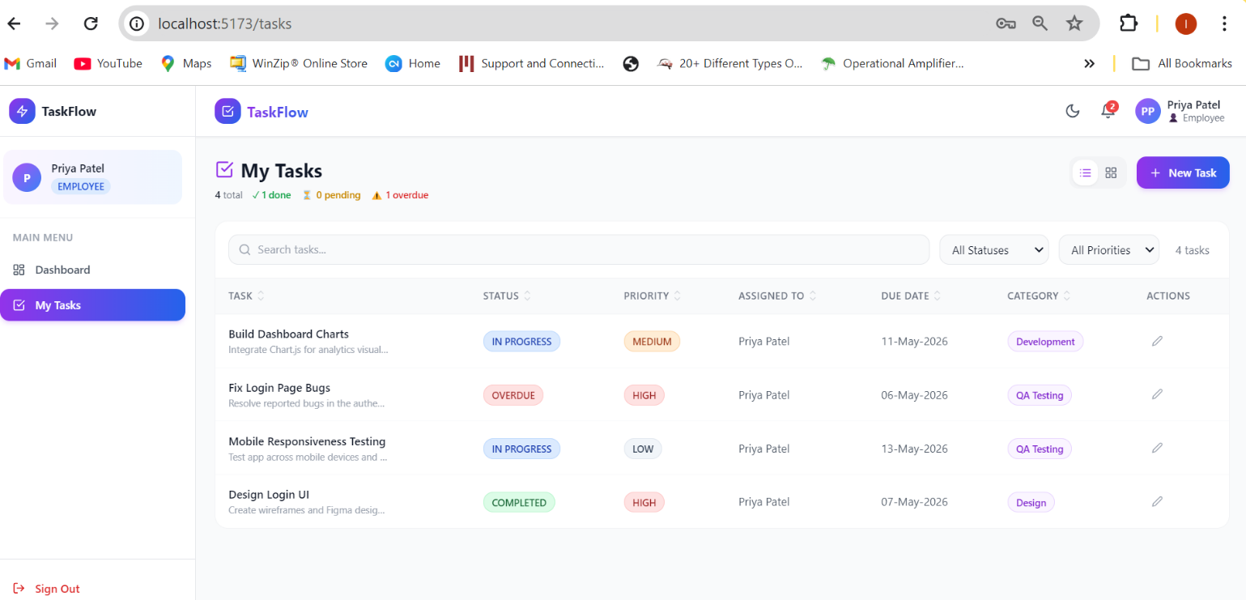

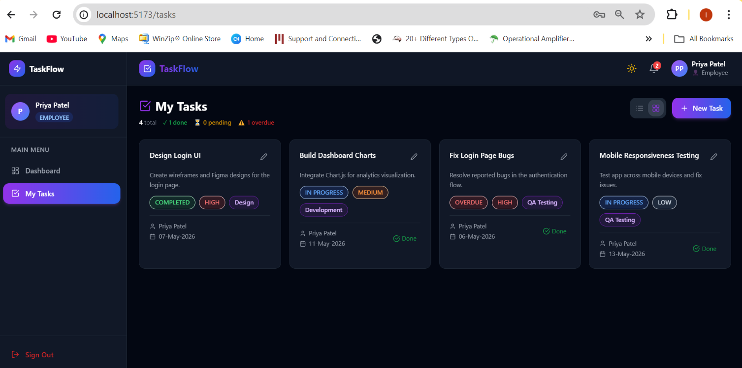
📷 Responsive Dark Mode Interface

9.2 Swagger UI Screenshots
Swagger UI available at: http://localhost:8081/swagger-ui/index.html

📷 Swagger UI — Full Endpoint List (all 16 endpoints) with Schemas
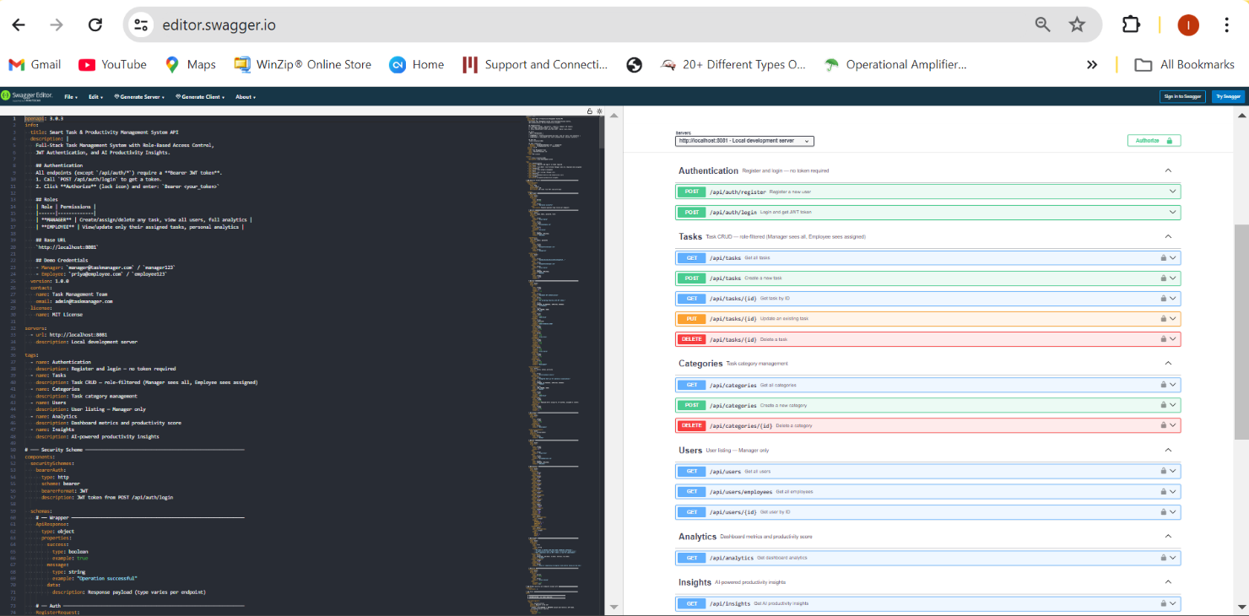
📷 Swagger UI — POST /api/auth/login with Request Body & Response
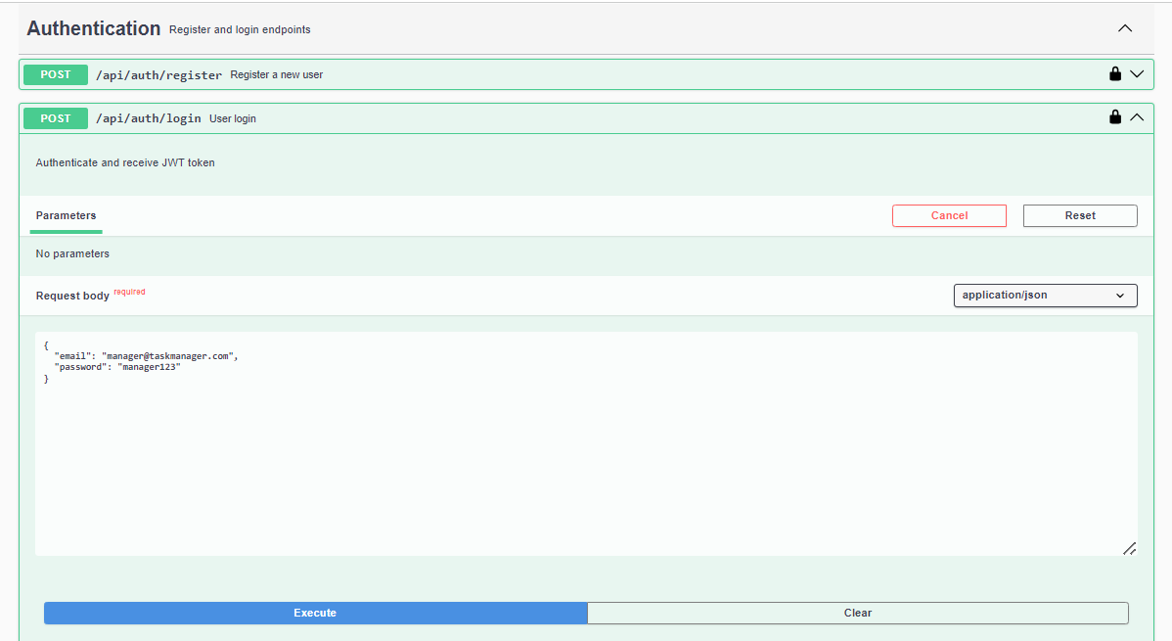
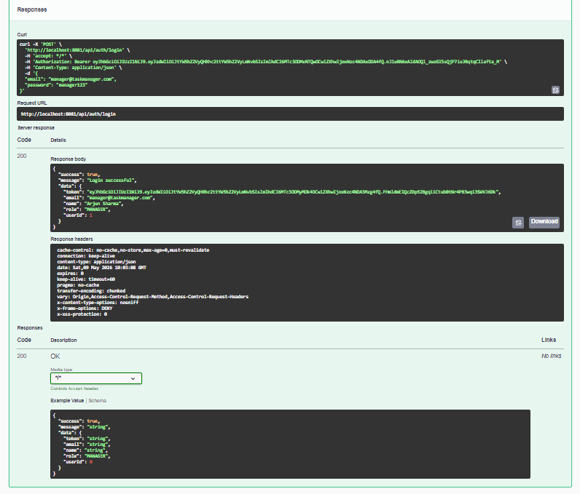

📷 Swagger UI — GET /api/tasks with Bearer Auth & Response
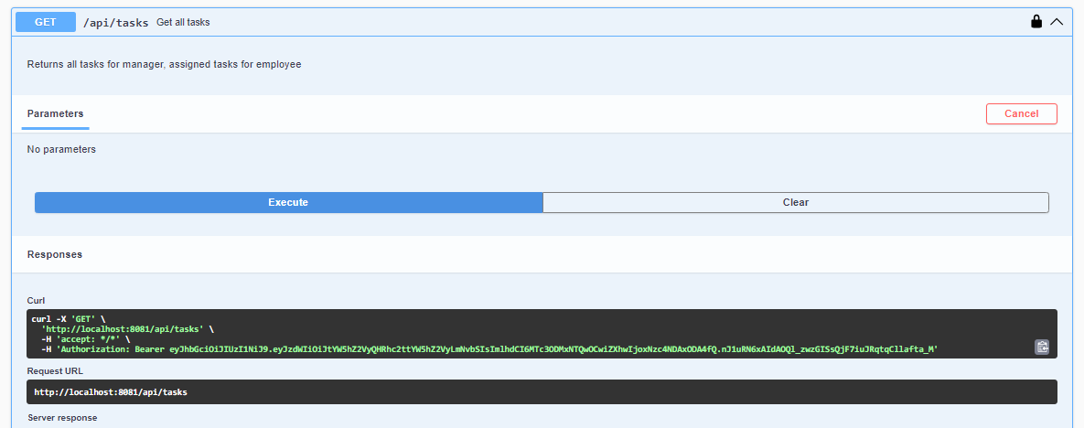
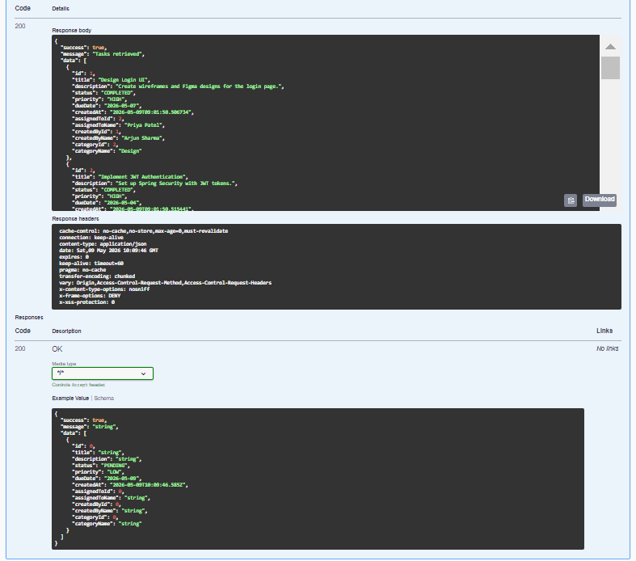

📷 Swagger UI — GET /api/analytics Response
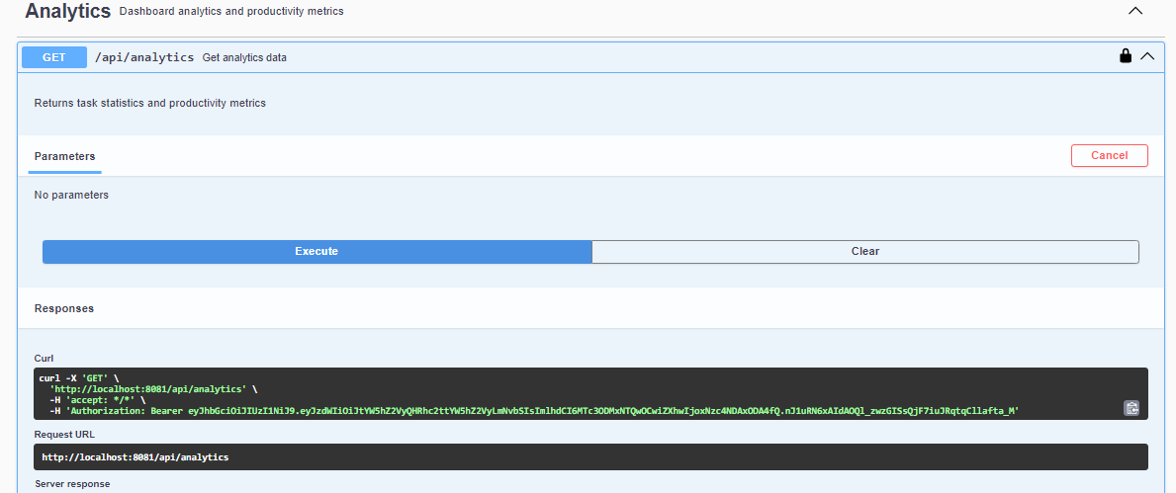
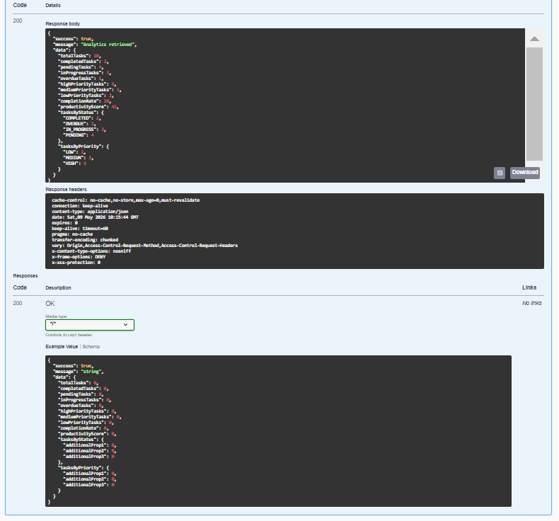

10. API Endpoints Reference
Base URL: http://localhost:8081 | All protected endpoints require: Authorization: Bearer <JWT>

10.1 Authentication (No Token Required)
Method | URL | Auth | Description
POST | /api/auth/register | None | Register new user — self-registration defaults to EMPLOYEE role, returns JWT
POST | /api/auth/login | None | Authenticate, returns JWT token valid 24 hours

10.2 Tasks
Method | URL | Auth | Description
GET | /api/tasks | Both roles | Manager: all tasks. Employee: own tasks only
GET | /api/tasks/{id} | Both roles | Single task. Employee gets 403 on others' tasks
POST | /api/tasks | Both roles | Create task. Manager sets assignedToId, Employee auto-assigned
PUT | /api/tasks/{id} | Both roles | Update task. Employee limited to own tasks
DELETE | /api/tasks/{id} | Manager only | Permanently delete task. Employee gets 403

10.3 Categories, Users, Analytics & Insights
Method | URL | Auth | Description
GET | /api/categories | Both roles | All categories
POST | /api/categories | Both roles | Create category { categoryName: "..." }
DELETE | /api/categories/{id} | Both roles | Delete category by ID
GET | /api/users | Manager only | All users (managers + employees)
GET | /api/users/employees | Manager only | Only EMPLOYEE role users (Assign To dropdown)
GET | /api/users/{id} | Both roles | Single user by ID
GET | /api/analytics | Both roles | Role-filtered dashboard metrics
GET | /api/insights | Both roles | AI insight messages + status + recommendation

10.4 Request / Response Samples — All 16 Endpoints

1. POST /api/auth/register
Access: Public — No token required
Request Body:
{
"name": "Sneha Gupta",
"email": "sneha@employee.com",
"password": "employee123",
"role": "EMPLOYEE"
}
Response 201:
{
"success": true,
"message": "User registered successfully",
"data": {
"token": "eyJhbGciOiJIUzI1NiJ9.eyJzdWIiOiJzbmVoYUBlbXBsb3llZS5jb20...",
"email": "sneha@employee.com",
"name": "Sneha Gupta",
"role": "EMPLOYEE",
"userId": 5
}
}
Response 400 (duplicate email):
{
"success": false,
"message": "Email already registered",
"data": null
}

2. POST /api/auth/login
Access: Public — No token required
Request Body:
{
"email": "manager@taskmanager.com",
"password": "manager123"
}
Response 200:
{
"success": true,
"message": "Login successful",
"data": {
"token": "eyJhbGciOiJIUzI1NiJ9.eyJzdWIiOiJtYW5hZ2VyQHRhc2ttYW5hZ2VyLmNvbSIsImlhdCI6...",
"email": "manager@taskmanager.com",
"name": "Arjun Sharma",
"role": "MANAGER",
"userId": 1
}
}
Response 401 (wrong credentials):
{
"success": false,
"message": "Invalid email or password",
"data": null
}

3. GET /api/tasks
Access: Bearer token required — Manager gets all tasks, Employee gets own only
Headers: Authorization: Bearer <token>
Response 200 (Manager):
{
"success": true,
"message": "Tasks retrieved successfully",
"data": [
{
"id": 1,
"title": "Design Login UI",
"description": "Create wireframes and Figma designs for the login page.",
"status": "COMPLETED",
"priority": "MEDIUM",
"dueDate": "2026-04-30",
"createdAt": "2026-04-20T09:00:00Z",
"assignedToId": 2,
"assignedToName": "Priya Patel",
"createdById": 1,
"createdByName": "Arjun Sharma",
"categoryId": 2,
"categoryName": "Design"
},
{
"id": 2,
"title": "Integrate Chart.js Analytics",
"status": "IN_PROGRESS",
"priority": "HIGH",
"dueDate": "2026-05-15",
"assignedToId": 3,
"assignedToName": "Rahul Verma",
"categoryName": "Development"
}
]
}

4. POST /api/tasks
Access: Bearer token required — Manager assigns to others, Employee auto-assigned to self
Headers: Authorization: Bearer <token>
Request Body:
{
"title": "Setup CI/CD Pipeline",
"description": "Configure GitHub Actions for automated deployment.",
"status": "PENDING",
"priority": "HIGH",
"dueDate": "2026-05-30",
"assignedToId": 3,
"categoryId": 5
}
Response 201:
{
"success": true,
"message": "Task created successfully",
"data": {
"id": 11,
"title": "Setup CI/CD Pipeline",
"description": "Configure GitHub Actions for automated deployment.",
"status": "PENDING",
"priority": "HIGH",
"dueDate": "2026-05-30",
"createdAt": "2026-05-09T11:00:00Z",
"assignedToId": 3,
"assignedToName": "Rahul Verma",
"createdById": 1,
"createdByName": "Arjun Sharma",
"categoryId": 5,
"categoryName": "DevOps"
}
}
Response 400 (missing required field):
{
"success": false,
"message": "Validation failed: title must not be blank",
"data": null
}

5. GET /api/tasks/{id}
Access: Bearer token required — Employee gets 403 on another user's task
Headers: Authorization: Bearer <token>
Example: GET /api/tasks/1
Response 200:
{
"success": true,
"message": "Task retrieved successfully",
"data": {
"id": 1,
"title": "Design Login UI",
"status": "COMPLETED",
"priority": "MEDIUM",
"dueDate": "2026-04-30",
"assignedToName": "Priya Patel",
"createdByName": "Arjun Sharma",
"categoryName": "Design"
}
}
Response 404:
{
"success": false,
"message": "Task not found with id: 99",
"data": null
}

6. PUT /api/tasks/{id}
Access: Bearer token required — Employee can only update own tasks
Headers: Authorization: Bearer <token>
Example: PUT /api/tasks/2
Request Body:
{
"title": "Integrate Chart.js Analytics",
"status": "COMPLETED",
"priority": "HIGH",
"dueDate": "2026-05-15",
"categoryId": 1
}
Response 200:
{
"success": true,
"message": "Task updated successfully",
"data": {
"id": 2,
"title": "Integrate Chart.js Analytics",
"status": "COMPLETED",
"priority": "HIGH",
"assignedToName": "Rahul Verma",
"categoryName": "Development"
}
}
Response 403 (Employee updating another's task):
{
"success": false,
"message": "Access denied: You can only update your own tasks",
"data": null
}

7. DELETE /api/tasks/{id}
Access: Manager only — Employee receives 403
Headers: Authorization: Bearer <token>
Example: DELETE /api/tasks/11
Response 200:
{
"success": true,
"message": "Task deleted successfully",
"data": null
}
Response 403 (Employee attempts delete):
{
"success": false,
"message": "Access denied: Only managers can delete tasks",
"data": null
}

8. GET /api/categories
Access: Bearer token required — Both roles
Headers: Authorization: Bearer <token>
Response 200:
{
"success": true,
"message": "Categories retrieved successfully",
"data": [
{ "id": 1, "categoryName": "Development" },
{ "id": 2, "categoryName": "Design" },
{ "id": 3, "categoryName": "Marketing" },
{ "id": 4, "categoryName": "QA Testing" },
{ "id": 5, "categoryName": "DevOps" }
]
}

9. POST /api/categories
Access: Bearer token required — Both roles
Headers: Authorization: Bearer <token>
Request Body:
{
"categoryName": "Data Science"
}
Response 201:
{
"success": true,
"message": "Category created successfully",
"data": {
"id": 6,
"categoryName": "Data Science"
}
}

10. DELETE /api/categories/{id}
Access: Bearer token required — Both roles
Headers: Authorization: Bearer <token>
Example: DELETE /api/categories/6
Response 200:
{
"success": true,
"message": "Category deleted successfully",
"data": null
}
Response 404:
{
"success": false,
"message": "Category not found with id: 6",
"data": null
}

11. GET /api/users
Access: Manager only
Headers: Authorization: Bearer <token>
Response 200:
{
"success": true,
"message": "Users retrieved successfully",
"data": [
{ "id": 1, "name": "Arjun Sharma", "email": "manager@taskmanager.com", "role": "MANAGER" },
{ "id": 2, "name": "Priya Patel", "email": "priya@employee.com", "role": "EMPLOYEE" },
{ "id": 3, "name": "Rahul Verma", "email": "rahul@employee.com", "role": "EMPLOYEE" },
{ "id": 4, "name": "Sneha Gupta", "email": "sneha@employee.com", "role": "EMPLOYEE" }
]
}

12. GET /api/users/employees
Access: Manager only — used to populate the "Assign To" dropdown
Headers: Authorization: Bearer <token>
Response 200:
{
"success": true,
"message": "Employees retrieved successfully",
"data": [
{ "id": 2, "name": "Priya Patel", "email": "priya@employee.com", "role": "EMPLOYEE" },
{ "id": 3, "name": "Rahul Verma", "email": "rahul@employee.com", "role": "EMPLOYEE" },
{ "id": 4, "name": "Sneha Gupta", "email": "sneha@employee.com", "role": "EMPLOYEE" }
]
}

13. GET /api/users/{id}
Access: Bearer token required — Both roles
Headers: Authorization: Bearer <token>
Example: GET /api/users/2
Response 200:
{
"success": true,
"message": "User retrieved successfully",
"data": {
"id": 2,
"name": "Priya Patel",
"email": "priya@employee.com",
"role": "EMPLOYEE"
}
}
Response 404:
{
"success": false,
"message": "User not found with id: 99",
"data": null
}

14. GET /api/analytics
Access: Bearer token required — Manager sees team-wide, Employee sees personal
Headers: Authorization: Bearer <token>
Response 200 (Manager):
{
"success": true,
"message": "Analytics retrieved successfully",
"data": {
"totalTasks": 10,
"completedTasks": 2,
"pendingTasks": 4,
"inProgressTasks": 3,
"overdueTasks": 1,
"highPriorityTasks": 4,
"mediumPriorityTasks": 4,
"lowPriorityTasks": 2,
"completionRate": 20.0,
"productivityScore": 44,
"tasksByStatus": { "PENDING": 4, "IN_PROGRESS": 3, "COMPLETED": 2, "OVERDUE": 1 },
"tasksByPriority": { "LOW": 2, "MEDIUM": 4, "HIGH": 4 }
}
}

15. GET /api/insights
Access: Bearer token required — Both roles
Headers: Authorization: Bearer <token>
Response 200:
{
"success": true,
"message": "Insights generated successfully",
"data": {
"insights": [
"You have 1 overdue task that needs immediate attention.",
"4 high-priority tasks require your focus — tackle these first.",
"Your completion rate is 20% — there is significant room for improvement.",
"3 tasks are currently in progress. Stay focused to complete them."
],
"overallStatus": "AT_RISK",
"productivityScore": 44,
"recommendation": "Focus on resolving overdue tasks immediately, then work through high-priority items."
}
}

16. GET /api/tasks/{id} — 401 Universal Example
(applies to all secured endpoints when token is missing or expired)
Response 401:
{
"success": false,
"message": "Invalid or missing JWT token",
"data": null
}

All 16 endpoints covered with request body, headers, success response, and error response. ✅

11. Design Decisions & Trade-offs
Decision | Reason
Empty Axios baseURL (routes via Vite proxy) | Eliminates CORS entirely in development. All /api/* calls are same-origin from the browser's perspective.
useAuth.jsx + useAuth.js dual file pattern | Vite esbuild parses .js as plain JS (no JSX transform). JSX code lives in .jsx; .js is a one-line re-export.
npm scripts use node node_modules/vite/bin/vite.js | The & in folder name is a Windows CMD separator that breaks npm run dev. Calling node directly bypasses the .cmd wrapper.
CorsConfig uses setAllowedOriginPatterns("http://localhost:*") | Vite may allocate ports 5173–5180 depending on availability. Pattern wildcard avoids hardcoding a specific port.
"AI Insights" are rule-based (no LLM) | Real AI would require an API key and incur cost. The InsightService generates contextually accurate messages purely from task statistics.
Sparklines use simulated data | A real sparkline would need time-series DB rows (one per day). Simulated ratios from current value create a believable trend.
ScoreGauge is pure SVG | Chart.js cannot produce a true semicircle gauge. The SVG approach gives pixel-perfect control with CSS transitions.
ddl-auto=update in application.properties | Convenient for dev — schema evolves with entity changes. Production would use ddl-auto=validate with Flyway/Liquibase migrations.

12. Setup & Installation Guide

12.1 Prerequisites
Tool | Version | Notes | Download
Java JDK | 23 | Project compiles with source=23, target=23. | adoptium.net
Apache Maven | 3.9+ | Used with mvn clean install and mvn spring-boot:run | maven.apache.org
Node.js | 18.x or 20.x LTS | Required to run npm install and Vite dev server | nodejs.org
PostgreSQL | 15+ | Create database task_management_db before first run. | postgresql.org
Git | Any recent | For cloning/version control | git-scm.com

12.2 Database Setup
CREATE DATABASE task_management_db;
-- Hibernate auto-creates all tables on first backend startup

Update credentials in application.properties if needed:
spring.datasource.url=jdbc:postgresql://localhost:5432/task_management_db
spring.datasource.username=postgres
spring.datasource.password=admin1234 ← change to your postgres password

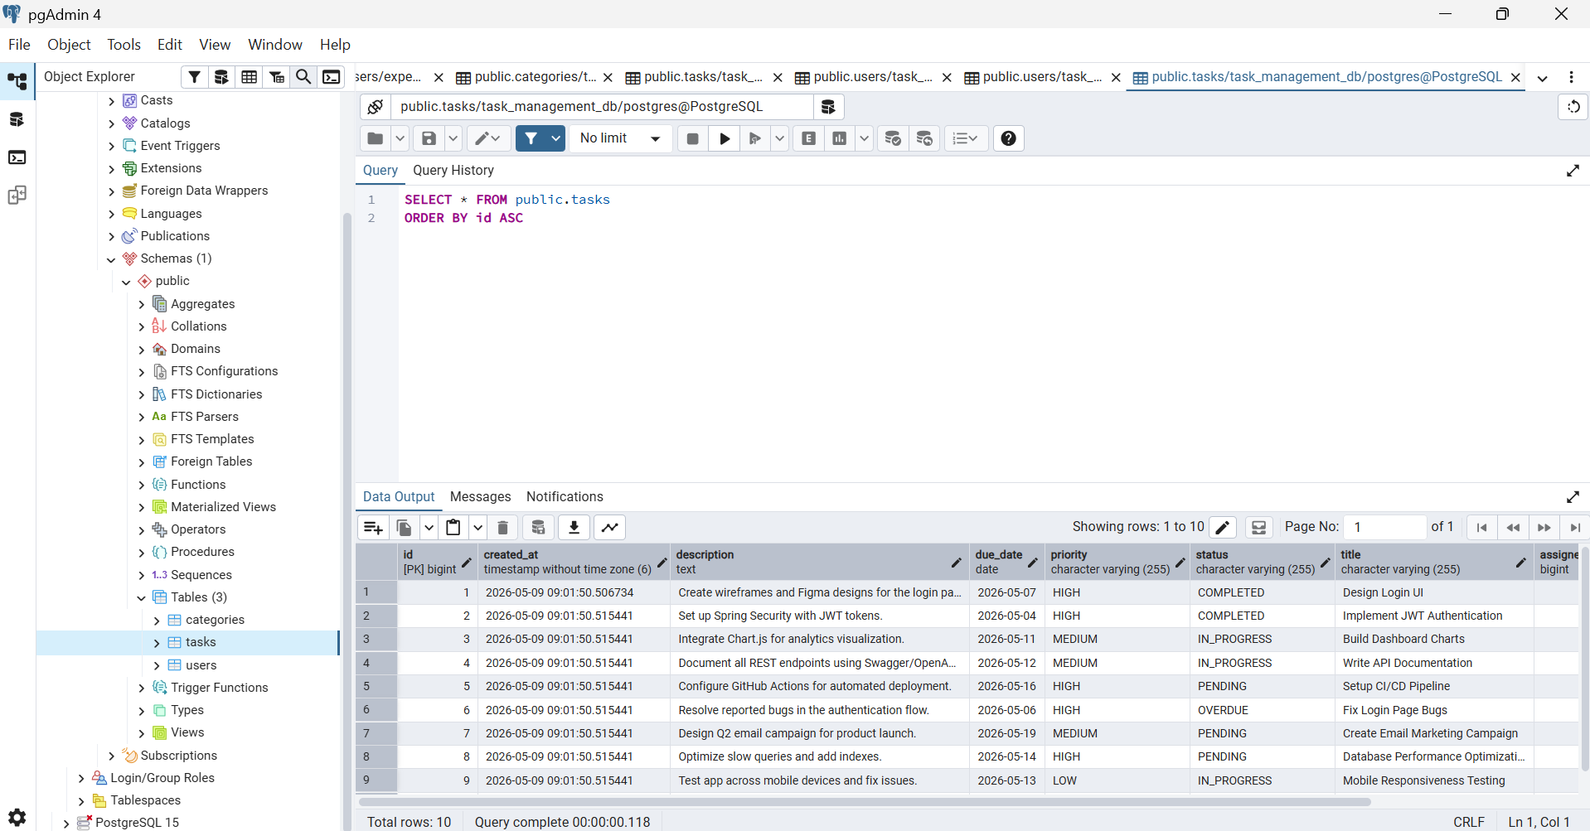

12.3 Backend Startup
cd "Smart Task & Productivity Management System/task-management-backend"
mvn clean install -DskipTests
mvn spring-boot:run

# Backend starts at: http://localhost:8081
# Swagger UI: http://localhost:8081/swagger-ui/index.html
# API Docs JSON: http://localhost:8081/api-docs

12.4 Frontend Startup
cd "Smart Task & Productivity Management System/task-management-frontend"
npm install
npm run dev
# Windows if & in path causes issues:
node node_modules/vite/bin/vite.js

# Frontend starts at: http://localhost:5173

12.5 Demo Credentials
Role | Email | Password | Landing Page
MANAGER | manager@taskmanager.com | manager123 | /admin (Manager Panel)
EMPLOYEE | priya@employee.com | employee123 | /dashboard
EMPLOYEE | rahul@employee.com | employee123 | /dashboard
EMPLOYEE | sneha@employee.com | employee123 | /dashboard

13. Common Errors & Fixes
Error | Cause | Fix
Port 8081 already in use | Another app on 8081 | Kill the process: netstat -ano | findstr :8081 → taskkill /PID <pid> /F
"Productivity" is not recognized / vite not found | & in folder name breaks Windows CMD | Scripts already use node node_modules/vite/bin/vite.js
JSX syntax error in .js hook files | esbuild does not transform .js as JSX | useAuth.jsx and useTasks.jsx hold JSX; .js files are re-exports
CORS policy blocked | Frontend port not in allowed origins | api.js uses empty baseURL (Vite proxy); CorsConfig uses setAllowedOriginPatterns("http://localhost:*")
Pages not loading / white screen | AnalyticsChart passed data as function to Chart.js v5 | Fixed: plain object initial data + canvas gradient in useEffect
Build failed — Java version mismatch | pom.xml had java.version=17 | pom.xml: java.version=23, Spring Boot 3.3.5, Lombok 1.18.34
401 on all API calls after login | Token not sent in headers | Axios request interceptor attaches Authorization: Bearer <token>
Employee login fails after DB reset | DataLoader skips if users table not empty | DROP and recreate task_management_db, then restart backend

14. AI Usage Log & Reflection
This project was developed using Option A — built from scratch with the assistance of AI tools. All AI-generated code and content was reviewed, modified, tested, and integrated manually.

14.1 AI Tools Used
AI Tool | Purpose
Claude (Anthropic) | Architecture planning, Spring Boot boilerplate generation, JWT implementation guidance, React component scaffolding, bug debugging, Swagger YAML generation, documentation writing
GitHub Copilot | Inline code suggestions for repetitive patterns (DTOs, repositories, Tailwind utility classes)
ChatGPT | Initial project structure brainstorming, UI layout ideas for the dashboard

14.2 AI Usage Log
Area | Prompt Summary | AI Output | Student Action
Project Setup | Generate Spring Boot project with JWT, PostgreSQL, Swagger | pom.xml + application.properties template | Adjusted versions to 3.3.5 + Java 23; fixed Lombok version
JWT Security | Implement JwtUtil and JwtAuthFilter for stateless auth | JwtUtil.java + JwtAuthFilter.java boilerplate | Tested token flow; fixed token expiry handling and exception propagation
Task CRUD | Create TaskService with role-based filtering for Manager vs Employee | TaskService.java with getAllTasks switch | Added checkAndMarkOverdue logic manually; verified employee restriction
Analytics | Generate AnalyticsService computing productivity metrics | AnalyticsService with completion rate formula | Refined productivity score formula; added role-filtered employee metrics
React Dashboard | Build Dashboard.jsx with charts and metric cards | Dashboard + AnalyticsChart scaffolding | Fixed canvas gradient bug; rewrote SVG gauge arc path for correct semicircle
Register Flow | Remove role picker so self-registration defaults to Employee | Register.jsx without role selection UI | Added info box explaining Employee-only registration; validated form flow
Swagger Docs | Generate swagger.yaml for all 16 endpoints with bearerAuth | swagger.yaml initial draft | Fixed RFC 3339 date format; added all schema $ref links to eliminate unused schema warnings
AI Insights UI | Create auto-cycling InsightAlert component with dot navigation | InsightAlert.jsx skeleton | Added manual cycling timeout reset; styled for dark mode consistency
Documentation | Write comprehensive project documentation | PROJECT_DOCUMENTATION.md + SETUP_GUIDE.md | Verified all port numbers (8081); updated employee email domains; added troubleshooting entries

14.3 AI Generated vs. Manually Written
AI-Assisted (~55%) | Manually Written / Debugged (~45%)
- Spring Boot boilerplate (pom.xml, application.properties)  - JPA entity skeletons and DTO classes  - Basic JWT token generation/validation structure  - React component initial scaffolding  - Tailwind utility class patterns  - Swagger YAML initial structure | - SVG gauge arc path formula debugging  - Chart.js canvas gradient in useEffect fix  - Windows & path npm workaround discovery  - DataLoader idempotency for employee email change  - Role-based task filtering logic refinement  - Overdue task auto-detection and persistence

14.4 Reflection
AI tools significantly accelerated development by assisting with component generation, boilerplate code, API structuring, and documentation. The estimated 55% AI-assisted ratio reflects tasks where AI provided a useful starting scaffold.

However, approximately 45% of the work involved manual debugging, design decisions, and integration effort that AI could not perform autonomously. Key examples include:

- The SVG arc gauge formula required understanding of SVG path mathematics and manually fixing the center coordinates (74,72) and radius (58) to align the needle correctly.
- The Chart.js canvas gradient bug required understanding that gradients must be created inside a useEffect after the canvas DOM element is mounted — an issue specific to React lifecycle.
- The Windows & path issue with npm required discovering the Vite binary path workaround independently after the standard npm run dev command failed.
- The DataLoader idempotency issue (DB not re-seeding after email domain change) required understanding Spring Boot's CommandLineRunner lifecycle and choosing between SQL UPDATE vs. DB drop-recreate.

AI tools were used as an accelerator and reference, not as a replacement for understanding. Every piece of generated code was read, understood, and modified before being integrated into the project.

AI tools were used responsibly as development accelerators and learning aids. Final implementation decisions, debugging, testing, and integration were performed manually to ensure correctness, maintainability, and academic integrity.

14.5 Git Commit History & Version Control

- Git was used throughout the development lifecycle to maintain incremental project progress, track feature additions, and manage code evolution systematically.

- The repository contains component-wise commits covering backend APIs, frontend UI development, authentication, integration, Swagger documentation, and final project polishing.

- Meaningful commit messages were used to reflect actual development stages and improve traceability.

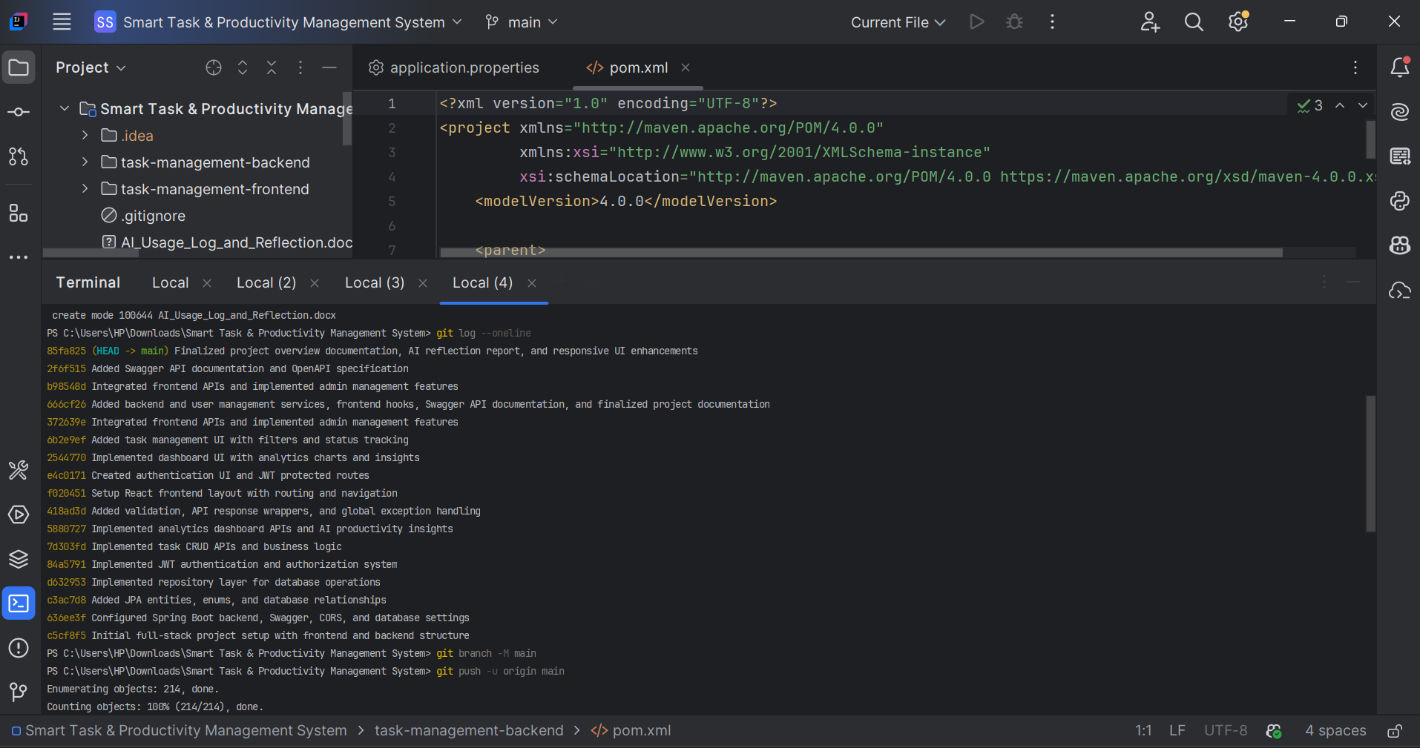

15. Conclusion
TaskFlow successfully demonstrates the implementation of a modern full-stack application using Spring Boot 3, React 18, JWT authentication, PostgreSQL, and responsive UI design. The project integrates backend APIs, frontend interactivity, analytics dashboards, AI-based productivity insights, and role-based access control into a cohesive production-style system.

The key technical achievements of this project include:

- Spring Boot 3 + Java 23 backend with clean layered architecture (Controller → Service → Repository) and stateless JWT security
- React 18 + Vite frontend with Context API, custom hooks, protected routes, and Axios interceptors for automatic token injection
- High-End UI with Chart.js analytics (Doughnut, Line gradient, Bar charts), animated metric cards, SVG productivity gauge, dark mode, and notification bell
- PostgreSQL + Hibernate with automatic schema management and realistic seeded demo data covering all task statuses and priorities
- Swagger / OpenAPI documentation with all 16 endpoints, request/response schemas, and Bearer auth support
- Role-based access control enforced at both the API layer (@PreAuthorize) and the UI layer (route protection and conditional rendering)

The project demonstrates industry-standard practices including stateless authentication, separation of concerns, responsive design, and developer tooling (Swagger, ESLint, Maven). It serves as a complete, end-to-end example of a production-ready task management system.

GitHub Repository
https://github.com/isha-naik/smart-task-productivity-system
Demo Video
https://drive.google.com/file/d/1G6-3NsRwxYpXGW-8Im63yLNgREIeq1N_/view?usp=sharing

