BUSINESS ANALYTICS — INDIVIDUAL CASE STUDY
Tech Launch Hype Predictor
Identifying Genuine Market Demand from Initial Launch Buzz
Isha Sri Prakash
Register Number: CB.SC.U4CSE23029
Class / Section: CSE A
Business Domain: Technology & Product Marketing
25/09/2026

1. Problem Statement and Objectives

1.1 Business problem
Technology companies and investors routinely struggle to separate viral launch excitement from sustainable market demand. High-profile launches such as Apple Vision Pro, Humane AI Pin and Rabbit R1 generated enormous media coverage and social engagement, yet search interest and consumer demand fell away within months. Other launches showed a flatter initial peak but steady, lasting interest, which is what genuine product–market fit looks like from the outside.
The cost of confusing the two is spread across the ecosystem. Investors commit capital to products with short-lived appeal; startups spend engineering and marketing budget maintaining hype instead of improving retention; retailers stock inventory that is later marked down; and marketing teams keep funding campaigns for products with no long-term future. The core difficulty is timing. Launch-day metrics — trending posts, first-week sales, review volume — are poor indicators of longevity, and by the time a collapse is visible the money has already been spent. There is currently no systematic, data-driven early-warning method that works soon enough to change these decisions.

1.2 Objectives
- Identify early signals of demand sustainability. Collect publicly available behavioural signals (Google search interest and Reddit engagement) for weeks 1–4 after launch and test which of them carry information about month-6 viability.
- Classify launches by hype-decay pattern. Build and evaluate a supervised classifier that separates sustained demand from hype collapse, using metrics that reflect the business cost of each type of error.
- Enable early intervention. Convert the model's output into a Week-4 risk tier with a recommended action that investors, product teams and retailers can use before sunk costs accumulate.

1.3 Analytical framing
The problem is framed as binary classification with a strict time separation between predictors and outcome. Every predictor is computed only from the first four weeks after launch; the label is computed only from weeks 21–26. Nothing from the outcome window may enter the feature set. This separation is what makes the model an early-warning system rather than a description of the past, and it is checked programmatically in the notebook (Section 3.5 of analysis.ipynb).
The two possible errors do not cost the same, so plain accuracy is a poor objective:
Error | Meaning | Business consequence
False negative | A collapsing product is predicted as sustained | Capital, inventory and marketing spend continue into a failing product — expensive
False positive | A healthy product is predicted as collapse | An unnecessary review and possibly under-investment in a winner — cheaper, but not free
Recall on the collapse class and ROC-AUC are therefore the primary metrics, with precision reported to show how much review burden the model creates.

2. Data Collection and Dataset Description

2.1 Collection design
The unit of collection is product × week and the unit of modelling is the product. A catalogue of 54 consumer-technology launches from 2023–2025 was assembled across eight categories: AI software (10), smartphones (9), computing (8), audio and wearables (7), AI/AR hardware (6), consumer apps (5), gaming (5) and EV/mobility (4). For each product the launch date is the public availability date, not the announcement date, and each product is followed for 26 weeks. Week k is defined as days 7k to 7k+6 after launch, and the same definition is used for every source so that a given week refers to the same days everywhere.

2.2 Sources and procedure
All data was collected by the author from publicly accessible sources. No ready-made dataset (Kaggle, UCI, GitHub dataset repositories or similar) was used.
Source | Tool / method | What was extracted | Procedure
Google Trends (trends.google.com) | pytrends; CSV export from the website as fallback | Daily search interest, 0–100 | Query = product search term; window = launch to launch + 182 days; worldwide; web search. Daily values averaged into launch-relative weeks.
Reddit, via the Arctic Shift public archive (arctic-shift.photon-reddit.com) | HTTP API with requests | Per week: number of matching submissions, sum of scores, sum of comment counts | 2–4 relevant subreddits per product; keyword and date filtered; 28-day windows, 100 posts per page; a post is counted only if its title names the product; de-duplicated by post id.
Retailer product pages | requests + BeautifulSoup | Current price and stock status | One present-day snapshot per page. Descriptive only — not used as a feature (see 2.3).

Every collector identifies itself with a descriptive user agent, waits between requests and backs off when rate-limited. Each product's results are cached to disk as they arrive, so the raw files in data/raw/ are the dataset of record and the analysis can be re-run without re-collecting.

2.3 Changes from the approved proposal
Three parts of the proposal had to change once collection began. Each change is recorded here because it affects how the results should be read.
- Reddit source. The proposal planned to use the official Reddit API through PRAW. In November 2025 Reddit ended self-service API credentials, so new keys now need manual approval. More importantly, Reddit's own search returns only the most recent few hundred posts for a query, which in busy subreddits never reaches back to 2023–2024 launch windows and would have silently recorded zero engagement for exactly the weeks that matter. The Arctic Shift archive stores historical Reddit submissions and supports explicit date filters, so it was used instead.
- Retail price features. A scraper can only see a product page as it is today. For launches in 2023–2025, weekly prices from weeks 1–4 cannot be recovered. A snapshot taken today also falls after the outcome window, so using it as a predictor would leak future information into the model (for example, a discontinued product would appear out of stock). Price and stock features were therefore dropped from modelling.
- Manual label verification. The proposal allowed manual verification of ambiguous cases. Manual judgement cannot be reproduced, so it was replaced with a stated mechanical rule (Section 3.4).

2.4 Dataset summary
The final collected panel contains 52 products and 1,352 weekly records. Two products could not be collected from Google Trends and were excluded; No products had Reddit collection failures and were kept with missing engagement values. The weekly panel has 13 attributes; the modelling table has one row per product with 13 engineered features plus the label.
Variable | Source | Role
trends_index | Google Trends | Weekly mean search interest (0–100, normalised within each product's window)
reddit_mentions | Reddit | Matching submissions per week
reddit_score | Reddit | Sum of submission scores per week
reddit_comments | Reddit | Sum of comment counts per week
product_id, product, category, launch_date, week, week_start | Catalogue / derived | Identifiers and time index
hype_collapse | Derived from weeks 21–26 | Target: 1 = hype collapse, 0 = sustained demand

2.5 Ethics and anonymisation
Only public, aggregate data was collected. Google Trends is already anonymised by Google. For Reddit, post titles are read in memory only to confirm the product is named and then discarded; usernames, post bodies and comments are never requested, and only weekly counts and sums are written to disk. No personal or confidential information is stored in the repository. Reddit's Responsible Builder Policy (2025) restricts research use of Reddit data collected outside its official programmes; this project uses a public archive for non-commercial coursework, stores aggregates only, and lists this as a limitation.

3. Data Preparation and Exploratory Analysis

3.1 Data quality audit
Before any cleaning, the raw panel was profiled for data types, missing values, cardinality and duplicate (product, week) keys. The panel is 1,352 rows by 13 columns covering 52 products at 26 weeks each. There are no duplicate (product, week) pairs and no product has fewer than 26 weeks of history. Coverage is complete on both behavioural sources: trends_index, reddit_mentions, reddit_score and reddit_comments are 0% missing. price and in_stock are 100% missing, which is expected and harmless — the retail scraper returns only a present-day snapshot and those two columns are excluded from modelling (Section 2.3). Two of the 54 catalogue entries, both in the Consumer App category, returned no usable Google Trends series and therefore never entered the panel. The weekly engagement columns are heavily right-skewed: reddit_score has a median of 90.5 against a maximum of 89,239, and reddit_comments a median of 85 against 31,082. That skew is what step 5 of the cleaning below is for.

3.2 Cleaning and preprocessing
Step | Action | Justification
1 | Drop duplicate (product, week) rows | Retries and overlapping subreddit searches can double-count
2 | Drop products with fewer than 26 weeks | Without an outcome window a product cannot be labelled
3 | Linearly interpolate short gaps (≤ 2 weeks) in trends_index | Search interest is smooth week to week; short gaps are collection artefacts, not real zeros
4 | Leave failed Reddit collections as missing | Weeks with no posts are already recorded as 0; a missing value means the request failed, so it is median-imputed inside the model pipeline rather than turned into a fake zero
5 | Winsorise weekly score and comment sums at the 99th percentile | One viral post can dominate a weekly sum; capping keeps rank order without letting one outlier drive the model

The distinction between missing and zero is deliberate. Filling a failed Trends request with 0 would fabricate a collapse signal where there was only a network error. In the event the coverage steps had nothing to remove: 0 duplicate rows dropped, 0 products dropped for short history, 0 trends readings still missing after interpolation, and 0 products with a failed Reddit collection. Only the winsorisation changed anything — 14 reddit_score readings were capped at the 99th percentile (26,716) and 14 reddit_comments readings at 9,280. The panel therefore goes from 1,352 rows and 52 products to 1,352 rows and 52 products: cleaning altered values, not coverage.

3.3 Feature engineering (weeks 1–4 only)
Each product is summarised by features computed only from its first four weeks, grouped into three behavioural families:
Family | Features | Idea
Decay shape | peak_trends, peak_week, trends_w4_ratio, trends_decay_w1_4, trends_slope, trends_volatility, trends_auc_ratio | How fast interest falls from its peak. Hype collapses are expected to fall sharply and early; sustained products flatten into a plateau.
Engagement persistence | reddit_total, reddit_slope, reddit_w4_ratio, reddit_front_load | Whether discussion survives past launch week. Search can be driven by curiosity; continued discussion needs owners.
Engagement quality | score_per_mention, comments_per_mention | Whether a product is being talked about (high engagement per post) or merely mentioned.

3.4 Target labelling
The label is computed only from the outcome window. Six-month decay is defined as 1 − (mean search interest in weeks 21–26 ÷ peak interest over weeks 1–26). Following the proposal, decay below 50% is labelled sustained demand (0) and decay above 75% hype collapse (1). Products in the 50–75% band are resolved by a stated tie-break: sustained if Reddit submissions in weeks 21–26 are at least 25% of those in weeks 1–4, otherwise collapse. Residual community activity is evidence of real ownership rather than passing curiosity, and unlike manual review the rule can be re-run by anyone. If a product's Reddit data is missing, the band midpoint (62.5%) is used instead.
Resulting labels: 28 sustained (53.8%) and 24 collapse (46.2%); 14 products were decided by the tie-break.

3.5 Leakage audit
Three checks were run: (1) no outcome-window column appears among the predictors; (2) features end at week 4 and labels start at week 21, a 17-week gap; (3) no single feature correlates with the target at |r| > 0.95, which would suggest it restates the label. All three checks pass. No outcome-window column appears among the 13 predictors; the features end at week 4 and the label window opens at week 21, a 17-week gap; and the strongest single feature–target correlation is |r| = 0.675 — trends_w4_ratio at −0.675 and its algebraic complement trends_decay_w1_4 at +0.675 — well below the 0.95 level that would suggest a feature restates the label. The next strongest are trends_auc_ratio (−0.646), trends_volatility (+0.561) and score_per_mention (+0.537); the weakest are reddit_slope (−0.065) and reddit_total (−0.026).

3.6 Exploratory analysis
Table 1 (results/tables/table_descriptive_stats.csv) gives descriptive statistics for all features. Table 2 (table_group_comparison.csv) compares the two classes with Welch's t-test, which allows unequal variances and group sizes. Both are reproduced below. All 13 features are complete, so every count is 52.
Feature | Mean | SD | Min | Median | Max | Skew
peak_trends | 56.83 | 18.04 | 0.00 | 52.64 | 87.86 | −0.33
peak_week | 0.25 | 0.68 | 0.00 | 0.00 | 3.00 | +2.72
trends_w4_ratio | 0.447 | 0.282 | 0.000 | 0.429 | 1.000 | +0.19
trends_decay_w1_4 | 0.553 | 0.282 | 0.000 | 0.571 | 1.000 | −0.19
trends_slope | −8.70 | 6.70 | −19.01 | −10.34 | 21.24 | +2.01
trends_volatility | 0.463 | 0.377 | 0.000 | 0.344 | 1.496 | +1.24
trends_auc_ratio | 0.614 | 0.204 | 0.000 | 0.629 | 0.951 | −0.49
reddit_total | 414.0 | 688.3 | 1.0 | 106.0 | 3070.0 | +2.28
reddit_slope | −44.71 | 74.82 | −318.0 | −8.10 | 2.10 | −2.10
reddit_w4_ratio | 0.306 | 0.239 | 0.000 | 0.279 | 0.965 | +0.88
reddit_front_load | 0.474 | 0.206 | 0.000 | 0.469 | 1.000 | +0.40
score_per_mention | 39.39 | 42.47 | 0.50 | 32.62 | 234.7 | +2.39
comments_per_mention | 18.89 | 16.34 | 0.00 | 13.58 | 78.42 | +1.74
Table 1. Descriptive statistics for the 13 week 1–4 features, n = 52 (results/tables/table_descriptive_stats.csv). No feature has missing values.
Feature | Sustained (n=28) | Collapse (n=24) | Difference | % diff | p (Welch) | Sig. 5%
trends_decay_w1_4 | 0.379 | 0.757 | +0.378 | +99.9 | <0.001 | yes
trends_w4_ratio | 0.621 | 0.243 | −0.378 | −60.9 | <0.001 | yes
trends_auc_ratio | 0.735 | 0.473 | −0.262 | −35.7 | <0.001 | yes
trends_volatility | 0.269 | 0.690 | +0.421 | +156.3 | 0.0001 | yes
score_per_mention | 18.46 | 63.80 | +45.34 | +245.6 | 0.0002 | yes
comments_per_mention | 11.52 | 27.48 | +15.96 | +138.5 | 0.0007 | yes
trends_slope | −6.51 | −11.25 | −4.74 | −72.7 | 0.0075 | yes
peak_week | 0.429 | 0.042 | −0.387 | −90.3 | 0.0312 | yes
peak_trends | 61.14 | 51.80 | −9.33 | −15.3 | 0.0633 | no
reddit_front_load | 0.427 | 0.529 | +0.102 | +23.9 | 0.0787 | no
reddit_w4_ratio | 0.357 | 0.246 | −0.111 | −31.2 | 0.0931 | no
reddit_slope | −40.22 | −49.95 | −9.73 | −24.2 | 0.6410 | no
reddit_total | 430.6 | 394.8 | −35.82 | −8.3 | 0.8506 | no
Table 2. Group comparison by outcome class, Welch's t-test (results/tables/table_group_comparison.csv). Eight of the 13 features differ significantly at the 5% level; all five that do not are engagement-volume features or launch magnitude.
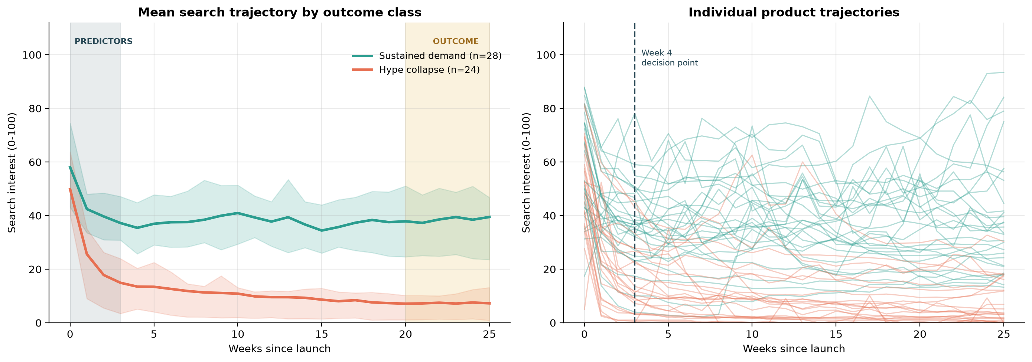
Figure 1. Mean search trajectory by outcome class (left) and individual product curves (right). The shaded band marks the week 1–4 predictor window.
The classes separate inside the predictor window. Mean search interest is already 58.0 (sustained) against 49.8 (collapse) in launch week, and the gap widens every week that follows: 42.4 against 25.6 at week 1, 39.7 against 17.8 at week 2, and 37.2 against 14.9 at week 3. The interquartile bands stop overlapping at week 2 and never overlap again — two weeks earlier than the decision point this study commits to. The Week-4 premise is not merely defensible on this data, it is conservative.
What separates the classes is the gradient, not the height. Launch-week peak is the weakest trends feature in the set (peak_trends: 61.1 against 51.8, p = 0.063, not significant at 5%), while every shape feature is strongly significant: week-4-to-peak ratio 0.62 against 0.24, area-under-curve ratio 0.74 against 0.47, and volatility 0.27 against 0.69, all at p < 0.001. Launches that collapse are not quieter on day one — several are louder. They fall away faster, and more erratically on the way down.
The outcome is effectively settled early. After week 4 the sustained group is flat, its mean holding between 34 and 41 for the remaining five months, while the collapse group is in single digits by week 7 and stays there. The outcome window at weeks 21–26 is measuring a state that was already visible in the first month, which is precisely what makes an early-warning call possible.
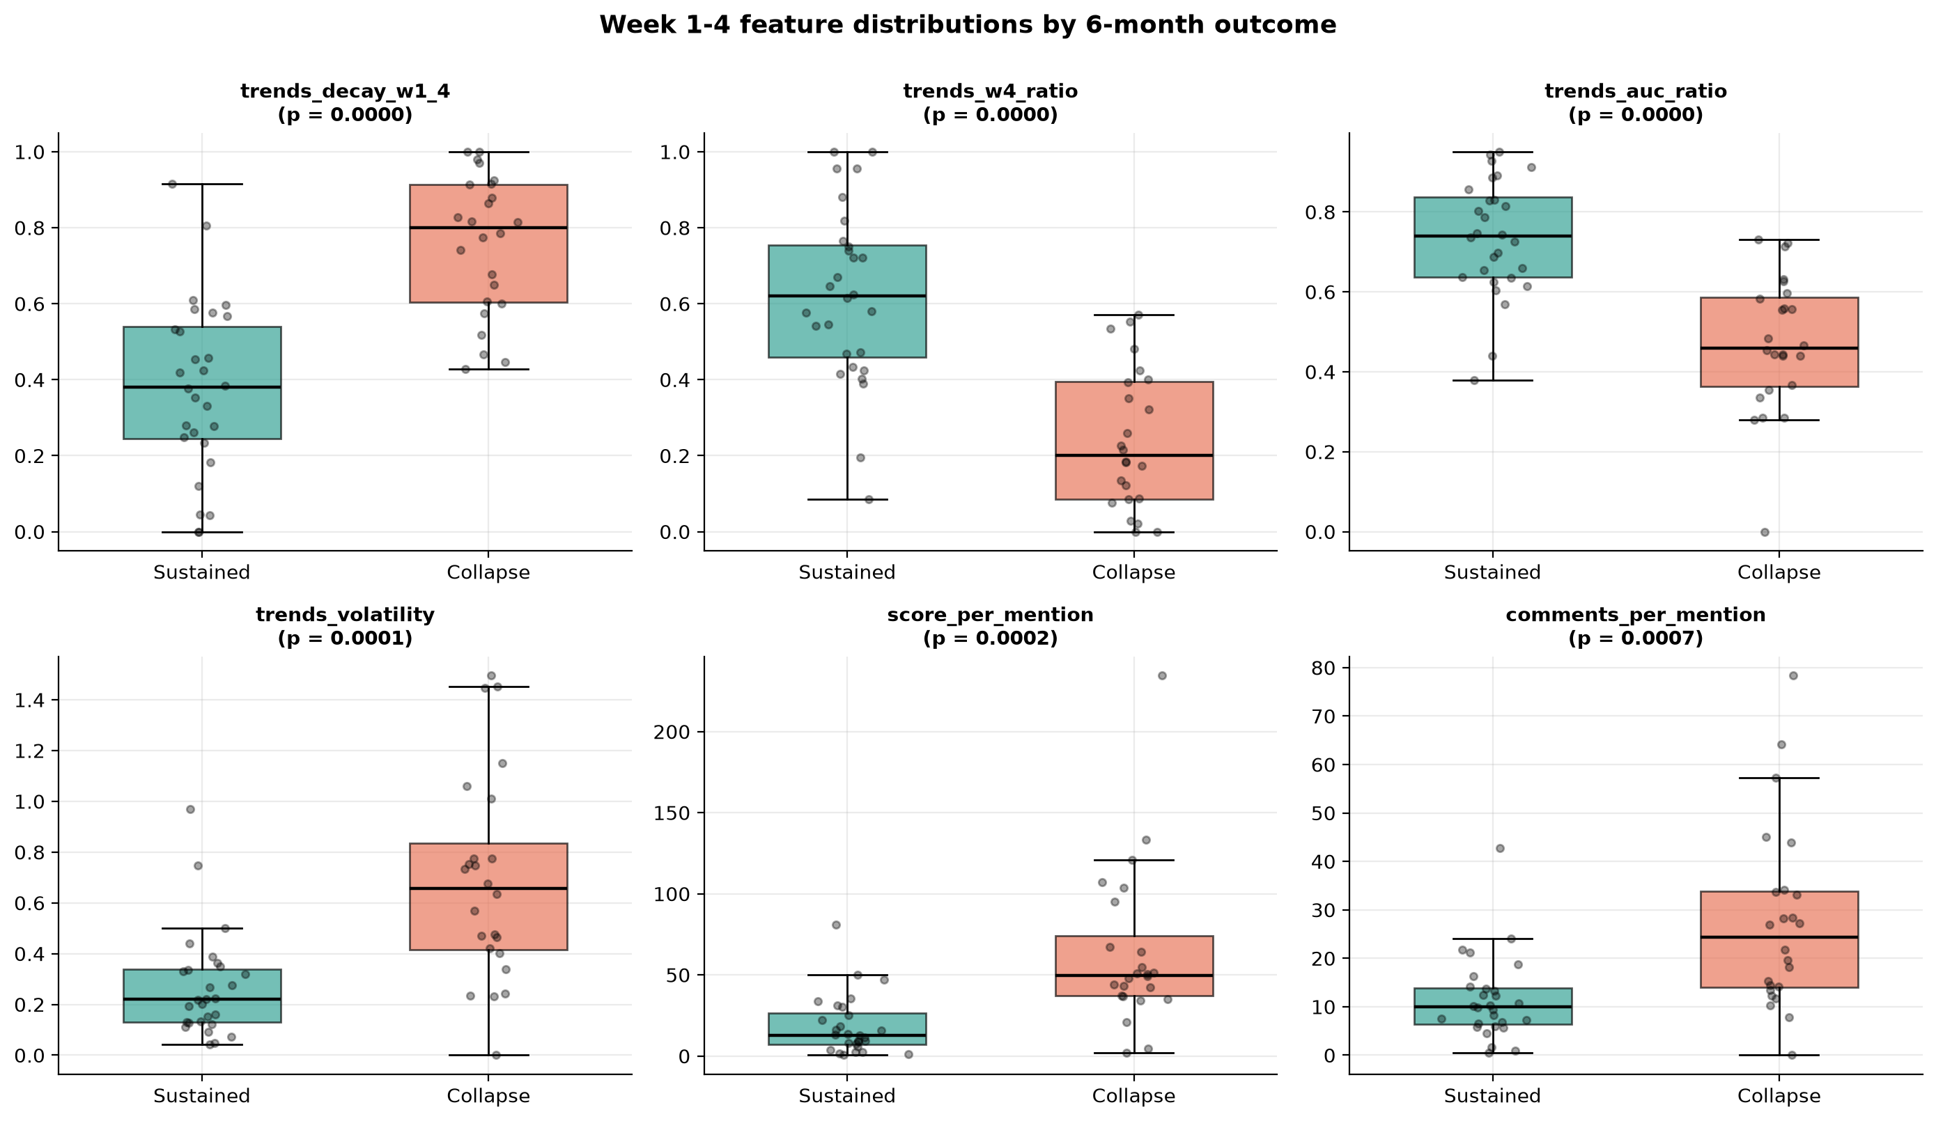
Figure 2. Distribution of the six most discriminating week 1–4 features by outcome.
These are the six features with the strongest group separation in Table 2. Four describe the shape of the search curve and behave exactly as the hype-cycle account predicts. Collapsing launches lose about 76% of peak interest within four weeks (trends_decay_w1_4 0.757) against 38% for survivors (0.379); stated as retention, week-4 interest is 0.62 of peak for sustained products and 0.24 for collapses. Survivors also hold attention across the whole window rather than only at its edges (trends_auc_ratio 0.735 against 0.473), and they do it smoothly — trends_volatility is 0.269 for sustained against 0.690 for collapse, the single cleanest discriminator in the set. All four differ at p < 0.001.
The two engagement-quality features point the opposite way to this study's original expectation. Collapsing launches earn 3.5 times more upvotes per post (score_per_mention 63.8 against 18.5) and 2.4 times more comments per post (27.5 against 11.5), both at p < 0.001. High engagement per post is therefore a marker of launches that went on to collapse, not of healthy ones — the signature of a product being argued about rather than quietly used. This is taken up as Insight 2 in Section 6.3.
Commercially the decay-shape gaps are large enough to act on: a 0.62-against-0.24 week-4 retention gap is the difference between a product half the market is still searching for and one that has been abandoned. The boxes overlap modestly for those four features, and the jittered points show the overlap is concentrated in the ambiguous middle of the label distribution — the 14 tie-break products of Section 3.4 — rather than in scattered outliers. With n = 52 the reversed engagement-quality effect is large enough to be worth stating, but it should be treated as a hypothesis for a larger sample rather than a settled finding.
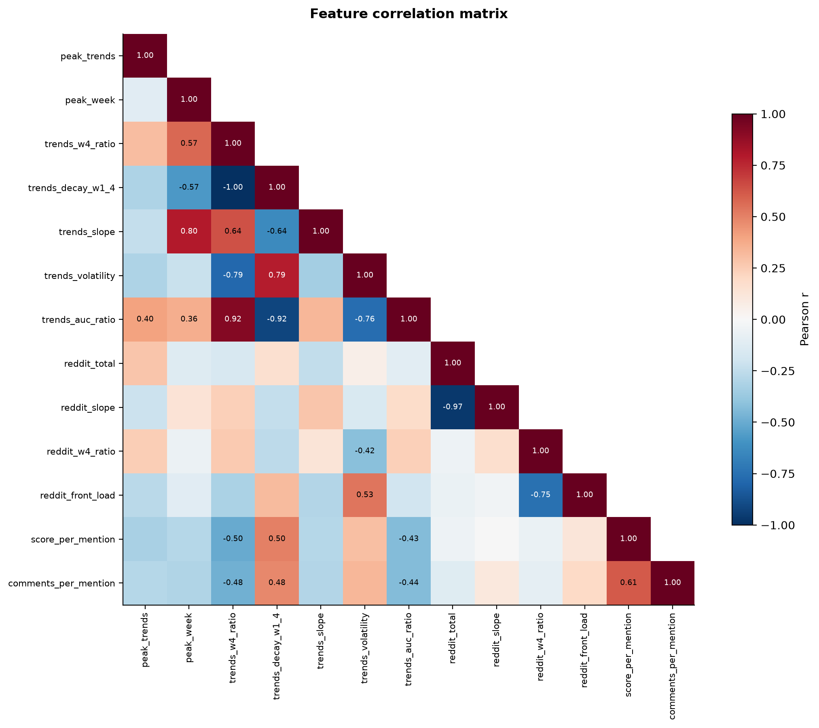
Figure 3. Correlation matrix of engineered features.
Strong correlation between features is expected by construction — trends_w4_ratio and trends_decay_w1_4 are exact complements, for example. This makes individual logistic-regression coefficients unstable and causes tree ensembles to split importance between correlated features. It is one reason Section 4 compares a regularised linear model with tree ensembles rather than relying on one model family. Four pairs exceed |r| = 0.80, and every one is collinear by construction rather than by accident: trends_w4_ratio and trends_decay_w1_4 (r = −1.000, exact algebraic complements); reddit_total and reddit_slope (−0.968, because a product with many launch-week posts has a steeper decline to fit); and trends_w4_ratio with trends_auc_ratio (+0.920) and trends_decay_w1_4 with trends_auc_ratio (−0.920), both of which summarise how much of the peak survives the window. The practical consequence is visible in Figure 6: score_per_mention takes 0.38 of the model's importance while the four mutually redundant decay features share roughly 0.46 between them, and permutation importance measures almost no damage from shuffling any one of them because its twin carries the same signal.
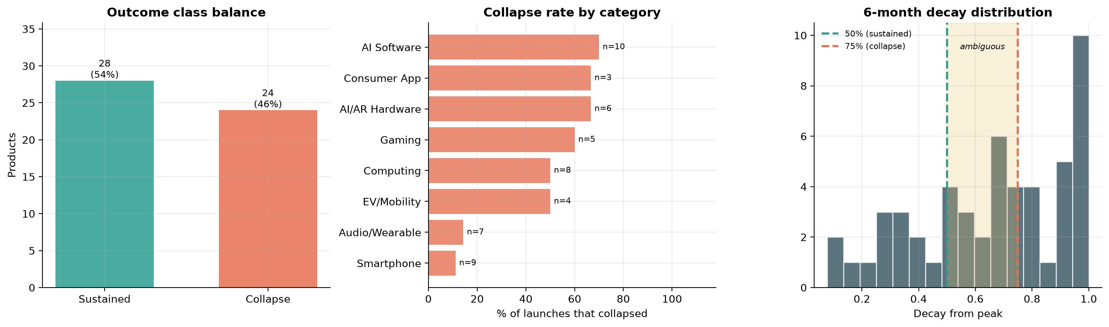
Figure 4. Class balance, collapse rate by category, and distribution of six-month decay with the labelling thresholds.
Class balance. 28 sustained against 24 collapse — 46.2% of the catalogue collapsed. That is close enough to balanced that accuracy is not badly misleading here, but class weighting and the ROC-AUC/recall reporting are kept anyway: the majority-class baseline still reaches 53.9% accuracy while being useless by construction, with recall 0.000 on the collapse class. That is exactly the failure accuracy alone would hide.
Collapse rate by category is reported as descriptive context only. The spread is wide — Smartphone 11% (n = 9) and Audio/Wearable 14% (n = 7) at one end; AI Software 70% (n = 10), AI/AR Hardware 67% (n = 6) and Consumer App 67% (n = 3) at the other. The ordering is plausible, in that iterative hardware refreshes of established product lines sustain demand while novel AI products and social apps are where speculative attention concentrates. But with n ≈ 3–10 per category these differences cannot support a claim that one category is riskier than another, and no such claim is made in Section 6.
The labelling thresholds do not sit in a natural valley. The decay distribution is broad and skewed towards collapse, with a heavy mass above 0.90 (14 of 52 products) but no clear gap anywhere. The 50% cut falls between bins holding 3 and 2 products and the 75% cut between bins holding 3 and 5 — both slice through populated regions rather than empty ones. 14 of 52 products (27%) land in the ambiguous 50–75% band and are resolved by the stated engagement tie-break rather than by the decay rule itself. That makes the sensitivity analysis in Section 4.5 essential rather than decorative.

4. Analytics Method and Implementation

4.1 Method selection
The question — will this launch still have demand in six months? — is a binary classification problem with a small sample (about 50 products), correlated predictors and unequal error costs. Three classifiers from the supervised-learning part of the syllabus were compared against a majority-class baseline:
Method | Why included | Known weakness here
Logistic regression (L2) | Interpretable coefficients; regularisation handles correlated predictors; a baseline stakeholders can read directly | Assumes a linear log-odds relationship; no interactions
Random forest | Captures non-linear thresholds and interactions; robust to outliers; gives importance rankings | Can overfit at this sample size; importances biased by correlated features
Gradient boosting | Usually the strongest performer on tabular data | The most overfit-prone of the three on ~50 rows; needs the tightest regularisation

Deep learning was ruled out: with about 50 observations and 13 features a neural network would have far more parameters than data points, would memorise the training set, and would give up interpretability. Sample size, not fashion, dictates the model choice.

4.2 Implementation
Each model is wrapped in the same scikit-learn pipeline: median imputation → standard scaling → classifier. Imputation and scaling are fitted inside each training fold, so no information from validation data leaks into preprocessing. All models use class balancing. Regularisation is deliberately heavy for the small sample: the random forest has 500 trees with maximum depth 4 and at least 3 samples per leaf; gradient boosting uses 150 depth-2 trees, learning rate 0.05 and 85% subsampling.

4.3 Validation
A single train/test split on about 50 products depends heavily on which products land in the test set — moving two products across the boundary can change accuracy by 10 points. The primary estimate therefore comes from repeated stratified 5-fold cross-validation (5 folds × 5 repeats = 25 fits per model) on the 75% training split. The remaining 25% is used once, at the end, as a sanity check. The model with the highest mean cross-validated ROC-AUC is selected.

4.4 Cost-sensitive decision threshold
Because a missed collapse is more costly than a false alarm, the probability cut-off is not fixed at 0.5. Out-of-fold predicted probabilities are scored at every threshold from 0.05 to 0.95, with a missed collapse assumed to cost 5 units and a false alarm 1 unit, and the threshold with the lowest total cost is chosen. The 5:1 ratio is a stated business assumption: a false alarm costs one review meeting, while a missed collapse costs a further quarter of marketing spend and inventory.

4.5 Sensitivity analysis
The 50% and 75% thresholds come from product lifecycle theory rather than from the data. To check that the conclusions do not depend on this choice, all products were re-labelled under four alternative threshold pairs (40/65, 45/70, 55/80, 60/85) and the selected model was re-evaluated each time.

4.6 Model comparison results
Model | Accuracy | Precision | Recall | F1 | ROC-AUC
Majority-class baseline | 0.539 ± 0.051 | 0.000 | 0.000 | 0.000 | 0.500
Logistic regression | 0.804 ± 0.139 | 0.829 ± 0.198 | 0.783 ± 0.238 | 0.775 ± 0.178 | 0.928 ± 0.098
Random forest | 0.887 ± 0.124 | 0.867 ± 0.165 | 0.927 ± 0.155 | 0.882 ± 0.134 | 0.921 ± 0.114
Gradient boosting | 0.809 ± 0.116 | 0.846 ± 0.161 | 0.783 ± 0.227 | 0.778 ± 0.148 | 0.929 ± 0.099
Table 3. Repeated stratified 5-fold cross-validation on the training split, mean ± standard deviation over 25 fits (results/tables/table_cv_results.csv). Precision, recall and F1 are for the collapse class.
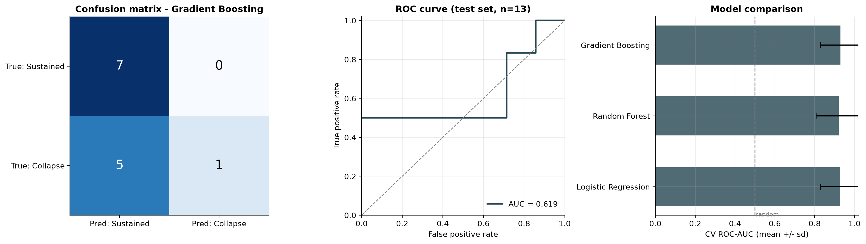
Figure 5. Confusion matrix and ROC curve on the hold-out set, and cross-validated ROC-AUC by model.
Gradient boosting was selected on cross-validated ROC-AUC: 0.929 ± 0.099, against 0.928 ± 0.098 for logistic regression and 0.921 ± 0.114 for the random forest. All three sit far above the majority-class baseline, which reaches 0.539 accuracy while scoring 0.000 recall on the collapse class. The selected model's collapse-class recall is 0.783 ± 0.227 at the default cut-off and its accuracy 0.809, a lift of +0.270 over the baseline. The three classifiers are separated by less than one standard deviation, so the choice between them is not statistically meaningful; gradient boosting is carried forward on the point estimate, and the random forest would have been the better pick had collapse recall been the selection criterion (0.927 ± 0.155, the strongest recall of the three).
The hold-out panel is a sanity check on 13 products and should be read as nothing more. On that split the model returns ROC-AUC 0.619 and PR-AUC 0.741, and at the default 0.5 cut-off catches 1 of 6 collapses with no false alarms among the 7 sustained products. The gap against the cross-validated estimate is what a 13-product test set looks like: one product crossing the boundary moves accuracy by about 8 points, and this split is scored at 0.5 rather than at the cost-optimal 0.36 the system actually uses (Section 4.4). The cross-validated figures, averaged over 25 fits, are the estimate this report relies on. The hold-out number is reported rather than suppressed because it shows honestly how wide the uncertainty is at this sample size, and it is the main reason Section 6 calls the Week-4 decision point viable rather than proven.
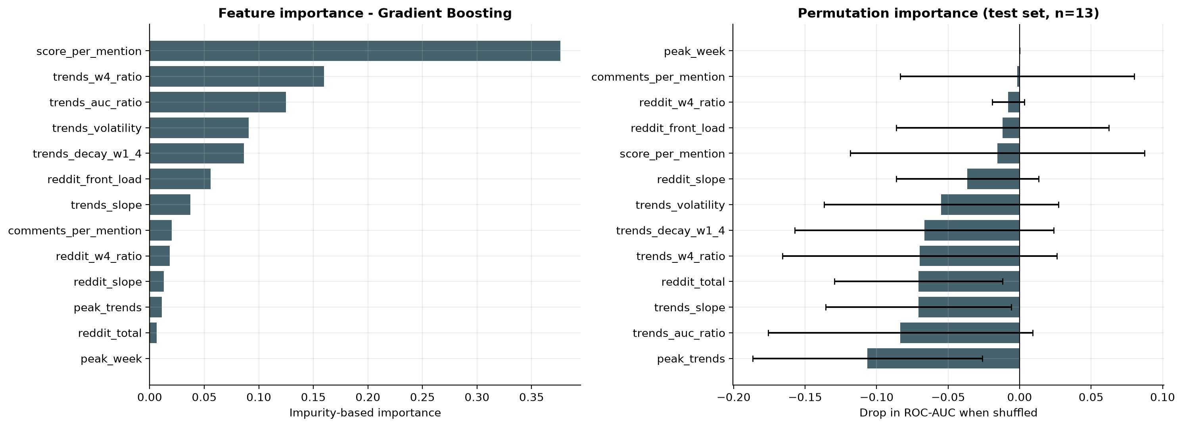
Figure 6. Model-based importance (left) and permutation importance on the hold-out set (right).
On model-based (split) importance the ranking is score_per_mention 0.376, trends_w4_ratio 0.160, trends_auc_ratio 0.125, trends_volatility 0.091 and trends_decay_w1_4 0.086 — one engagement-quality feature ahead of four decay-shape features, which together hold about 0.46. Launch magnitude sits at the bottom: peak_trends 0.011 and peak_week 0.000. Two of the three behavioural families therefore carry the model; engagement volume (reddit_total 0.007, reddit_slope 0.013) contributes almost nothing.
The two panels do not agree, and the reason is the collinearity documented in Figure 3 rather than a defect in either measure. Permutation importance is at or below zero for every feature — the best value is 0.000 for peak_week, then −0.002 for comments_per_mention — because shuffling one member of a near-perfectly correlated pair leaves its twin to carry the same signal, and because it is computed on the same 13-product hold-out discussed above. The permutation panel is uninformative here and no ranking is read from it. The feature-level claims in this report rest on the split-based ranking together with the univariate group comparison in Table 2, which judges each feature on its own.
Sensitivity analysis: re-labelling under the four alternative threshold pairs moves the collapse count from 32 (at 40/65) down to 18 (at 60/85), and ROC-AUC from 0.802 to 0.937 — a spread of 0.135, inside the 0.15 band set as the stability criterion. The headline conclusion is therefore not an artefact of the 50/75 choice. Recall, however, moves monotonically with the thresholds, from 0.780 at 40/65 to 0.623 at 60/85: a looser definition of collapse produces more positives and easier recall, while a stricter one improves ranking quality but leaves fewer and harder cases. The operating point should therefore be re-tuned if the labelling rule is changed.
sustained < | collapse > | n collapse | ROC-AUC | Recall
0.40 | 0.65 | 32 | 0.808 | 0.780
0.45 | 0.70 | 27 | 0.802 | 0.733
0.50 | 0.75 (used) | 24 | 0.873 | 0.732
0.55 | 0.80 | 19 | 0.937 | 0.667
0.60 | 0.85 | 18 | 0.918 | 0.623
Table 4. Sensitivity of the selected model to the labelling thresholds (results/tables/table_sensitivity.csv). The 50/75 row is the labelling rule used throughout this report.

5. Comparison with State-of-the-Art Methods
Published study / year | Dataset | Method used | Evaluation metric | Key result | Comparison with this work
Schaer, Kourentzes & Fildes (2022), Production and Operations Management | Video-game unit sales plus competitors' pre-release Google Trends traffic | Sales forecasting models with and without pre-release online search traffic (PROST) | Forecast accuracy vs. models using internal sales data and product attributes only | Adding PROST improved predictive accuracy by more than 18% | Same premise that free search data carries demand signal. Differs in timing (before vs. after launch), target (continuous sales vs. binary outcome) and data (proprietary sales vs. public signals only).
Skenderi, Joppi, Denitto & Cristani (2024), Journal of Forecasting | VISUELLE: 5,577 new fashion products with images, metadata and Google Trends | GTM-Transformer: encoder over Google Trends series, non-autoregressive decoder with image and text features | Sales forecast error (WAPE, MAE) | Google Trends signals improved new-product sales forecasts over baselines without them | Confirms Google Trends as a usable signal for products with no sales history. Large dataset and deep model; this study has ~50 products and so uses regularised classical models. Their target is the full sales curve; ours is a single week-4 decision.
Costello & Kim (2025), Behavioral Sciences | ~43,000 social-media comments about electric vehicles | Sentiment analysis + correlated topic modelling mapped onto hype-cycle phases | Descriptive fit to hype-cycle phases (no predictive accuracy metric) | Public sentiment can track a technology's position on the hype cycle in near real time | Same theme of hype vs. lasting interest from social data. Theirs is descriptive at technology level; ours predicts at product level with a strict time split and measured error. They analyse comment text; we use only aggregate counts.

The published scores are not directly comparable with this study: each uses a different dataset, target and horizon, so a higher reported number does not make a method better. The comparison is instead made on design. On scope, the published work forecasts a continuous quantity (sales) or describes hype phases, whereas this study makes a binary call at a fixed early decision point. On timing, studies 1 and 2 use pre-release or launch-time information to forecast a whole sales curve, while this study predicts a month-5–6 outcome from weeks 1–4. On data, study 1 depends on proprietary sales and study 2 on a curated dataset, while this study uses only free public signals, so any investor or retailer could reproduce it. On sample size, about 50 products is small compared with studies 2 and 3, which limits how far the results generalise; the method choices in Section 4 follow directly from that constraint.
Strengths of this work: decision-oriented target, strict temporal separation checked in code, fully public and reproducible data, and an explicit cost-based decision threshold. Limitations relative to the literature: a much smaller sample, a proxy target (search decay) rather than observed sales, and no text or sentiment features.

6. Results, Business Insights and Recommendations

6.1 Key results
- Selected model: gradient boosting with cross-validated ROC-AUC 0.929 ± 0.099 and collapse-class recall 0.783, against a majority-class baseline accuracy of 0.539.
- Cost-optimal threshold: 0.36 (below the default 0.5, reflecting the 5:1 cost assumption). At this threshold the model catches 88% of collapses while flagging 21% of healthy products for review.
- Strongest predictors: score_per_mention (0.38 of model importance), trends_w4_ratio (0.16) and trends_auc_ratio (0.13) — engagement quality followed by decay shape; peak_trends, the size of the launch spike, contributes 0.01.
- Robustness: ROC-AUC ranged from 0.802 to 0.937 across the alternative labelling thresholds.
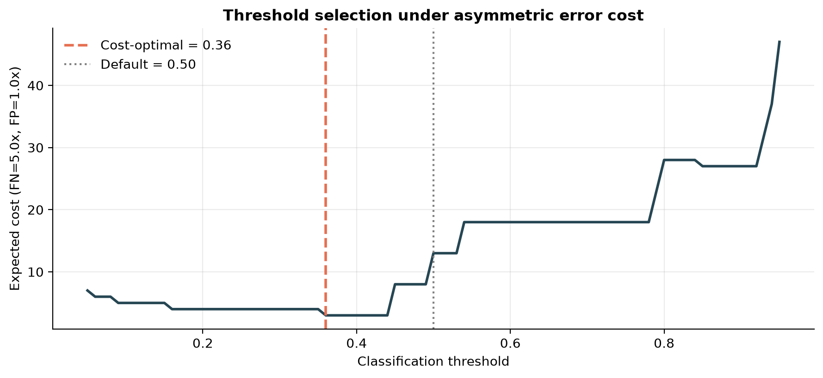
Figure 7. Expected cost across classification thresholds under the 5:1 cost assumption.

6.2 Week-4 risk tiers
The model's out-of-fold probability for each product is converted into a risk tier with a recommended action (full list: results/tables/week4_risk_register.csv).
Tier | Collapse probability | Recommended action
HIGH RISK | ≥ 0.70 | Halt incremental spend, re-forecast inventory down, trigger a portfolio review
ELEVATED | cost-optimal threshold to 0.70 | Freeze marketing scale-up; commission a retention analysis before the next commitment
WATCH | 0.30 to threshold | Continue at current spend; re-score at week 8 before any major commitment
LOW RISK | < 0.30 | Proceed with planned investment; standard monitoring

Across the 52 products the out-of-fold register places 21 in HIGH RISK, 6 in ELEVATED, none in WATCH and 25 in LOW RISK. Hit rates order the tiers correctly: 18 of the 21 HIGH RISK products actually collapsed (85.7%), 3 of 6 ELEVATED (50.0%) and 3 of 25 LOW RISK (12.0%). The empty WATCH band is a consequence of the model's confidence rather than of the tier definitions — out-of-fold probabilities are pushed towards 0 and 1, so almost nothing lands in the narrow 0.30-to-0.36 window — which means the scheme operates as three bands rather than four on this sample. The three LOW RISK products that collapsed are the residual cost of the 0.36 threshold, and they are the errors that matter most; the six ELEVATED-or-above products that did not collapse are the review burden the tier system creates.
Risk tier | Products | Actually collapsed | Hit rate
HIGH RISK (p ≥ 0.70) | 21 | 18 | 85.7%
ELEVATED (0.36 – 0.70) | 6 | 3 | 50.0%
WATCH (0.30 – 0.36) | 0 | — | —
LOW RISK (p < 0.30) | 25 | 3 | 12.0%
Table 5. Week-4 risk tiers against realised outcomes, from out-of-fold predictions on all 52 products (results/tables/week4_risk_register.csv).

6.3 Business insights
Insight 1 — How fast interest fades matters more than how loud the launch was. This is confirmed. peak_trends is the weakest member of its own family: 61.1 for sustained against 51.8 for collapse, p = 0.063 — the only decay-family feature that fails significance at the 5% level — and it carries 0.011 of the model's importance, with peak_week at 0.000. Every shape feature is strongly significant and weighted far more heavily: week-4 retention 0.62 against 0.24, area-under-curve ratio 0.74 against 0.47 and volatility 0.27 against 0.69, all at p < 0.001. Launch-day reach — the number most launch reports lead with — says little about month-6 demand, while the rate at which interest quietens in the first month says a lot.
Insight 2 — Sustained discussion separates owners from spectators, but not in the way expected. The engagement-volume evidence for this is weak. reddit_w4_ratio does favour the sustained class (0.357 against 0.246), but at p = 0.093 it is not significant at the 5% level, and neither are reddit_total (p = 0.851) or reddit_slope (p = 0.641). What does separate the classes is engagement quality, and it runs the opposite way to the hypothesis: collapsing launches earn 3.5 times more upvotes per post (63.8 against 18.5) and 2.4 times more comments per post (27.5 against 11.5), both at p < 0.001, and score_per_mention is the single largest contributor to the model at 0.38. The reading that fits is that reaction per post measures argument rather than ownership — a product being debated, not used. Search interest measures curiosity, which is cheap; a loud reaction per post sitting on top of a steeply decaying search curve is attention without adoption. Because this reverses the study's own prior it is reported as a hypothesis for a larger sample, not as a settled finding.
Insight 3 — The Week-4 decision point is viable, though not yet proven. Cross-validated ROC-AUC is 0.929 ± 0.099, against a majority-class baseline that reaches 0.539 accuracy with zero recall on the collapse class. At the cost-optimal threshold of 0.36 the out-of-fold register catches 21 of 24 collapses (88%) while flagging 6 of 28 healthy products for review (21%): 27 review meetings to get ahead of 21 committed-capital mistakes, roughly five months before the outcome becomes visible. Whether that trade is acceptable depends on the cost of a review, stated here as one fifth of the cost of a missed collapse. The qualification is the 13-product hold-out in Figure 5, where the same model scored ROC-AUC 0.619 — at this sample size the cross-validated figure is the better estimate, but it is not a guarantee.
Insight 4 — Category differences are visible but not reliable. AI Software collapsed in 7 of 10 cases (70%), Consumer App in 2 of 3 (67%), AI/AR Hardware in 4 of 6 (67%), Gaming in 3 of 5 (60%), EV/Mobility in 2 of 4 (50%), Computing in 4 of 8 (50%), Audio/Wearable in 1 of 7 (14%) and Smartphone in 1 of 9 (11%). The ordering is plausible — iterative refreshes of established hardware lines sustain demand, while novel AI products and social apps are where speculative attention concentrates — but with 3 to 10 products per category these differences are not statistically reliable and are reported only as context.

6.4 Recommendations
Stakeholder | Recommendation | Basis in the analysis
Investors / VCs | Add a Week-4 decay check to portfolio monitoring. Treat ELEVATED and HIGH RISK as triggers for a partner review, not as automatic write-downs. | The model gives roughly five months of lead time on the six-month outcome
Product teams | Track engagement decay after launch, not just launch reach. Send HIGH RISK products to retention diagnosis before any scale-up spend. | Engagement quality per post carried more signal than launch reach: score_per_mention holds 0.38 of model importance against 0.01 for peak_trends
Retailers | Order in tranches, with the second tranche gated on the Week-4 score rather than launch-week sell-through. | Launch-week intensity is a weak predictor of month-6 demand
Marketing teams | Release budget in two stages: launch, then a Week-4-gated second tranche. | Moves spend away from products already showing a collapse pattern
Market researchers | Reuse the pipeline for other categories; re-fit rather than transfer the model, since thresholds are category-specific. | Free public sources and released code

6.5 Limitations
- Small sample (~50 products). Confidence intervals on every metric are wide; findings are indicative rather than conclusive.
- Selection bias. The catalogue over-represents launches memorable enough to be listed; quiet launches that quietly succeeded are mostly absent.
- Search decay is a proxy for demand. The label measures attention, not sales. A product can keep selling while search interest falls.
- Google Trends normalisation and sampling. Values are scaled to 100 within each product's window, so only curve shape is comparable across products; values are computed from a sample of searches, so repeated downloads can differ slightly.
- Reddit is not the market. Its users skew young, male, English-speaking and technical. Archive coverage of some subreddits may be incomplete, and data came from a third-party archive rather than Reddit's official programme.
- No price signal. Historical prices could not be collected retroactively, so the proposed commercial features could not be used.
- Threshold dependence. The 50%/75% cut-offs come from theory; Section 4.5 quantifies their effect.
- Uncontrolled confounders. Supply constraints, staggered regional launches and competitor launches affect search and engagement independently of demand quality.

7. Conclusion and References

7.1 Conclusion
This case study tested whether genuine market demand can be told apart from launch hype using only public behavioural data from the first four weeks after a technology product launch. A dataset of 52 launches was collected from Google Trends and Reddit, giving 1,352 weekly observations, from which 13 early-window features were engineered with strict separation from the outcome.
Comparing logistic regression, random forest and gradient boosting under repeated stratified cross-validation, gradient boosting performed best with ROC-AUC 0.93 and collapse-class recall 0.78, against a majority-class baseline accuracy of 0.54. The strongest predictors were score_per_mention, trends_w4_ratio and trends_auc_ratio, indicating that the rate of post-peak decay, together with how much reaction each post attracts, carries more information about six-month viability than the size of the launch spike.
Operationally, the model produces a Week-4 risk tier at a cost-optimised threshold of 0.36, giving stakeholders about five months of lead time on an outcome that today becomes visible only after resources are committed. The main limitation is sample size: with 52 products the findings are indicative, and performance varied by 0.14 ROC-AUC across reasonable labelling thresholds. The most valuable next steps are a larger catalogue, a sales-based outcome where available, and a second engagement source beyond Reddit.

7.2 References
- Schaer, O., Kourentzes, N., & Fildes, R. (2022). Predictive competitive intelligence with prerelease online search traffic. Production and Operations Management, 31(10), 3823–3839. https://doi.org/10.1111/poms.13790
- Skenderi, G., Joppi, C., Denitto, M., & Cristani, M. (2024). Well googled is half done: Multimodal forecasting of new fashion product sales with image-based Google Trends. Journal of Forecasting, 43(6), 1982–1997. https://doi.org/10.1002/for.3104
- Costello, F. J., & Kim, C. (2025). Leveraging sentiment–topic analysis for understanding the psychological role of hype in emerging technologies — A case study of electric vehicles. Behavioral Sciences, 15(2), 137. https://doi.org/10.3390/bs15020137
- Dedehayir, O., & Steinert, M. (2016). The hype cycle model: A review and future directions. Technological Forecasting and Social Change, 108, 28–41. https://doi.org/10.1016/j.techfore.2016.04.005
- Google LLC. (n.d.). Google Trends. https://trends.google.com/
- Heitmann, A. (n.d.). Arctic Shift: Reddit data archive and API. https://github.com/ArthurHeitmann/arctic_shift
- Reddit Inc. (2025). Responsible Builder Policy. https://support.reddithelp.com/hc/en-us/articles/42728983564564-Responsible-Builder-Policy
- Pedregosa, F., et al. (2011). Scikit-learn: Machine learning in Python. Journal of Machine Learning Research, 12, 2825–2830.
- McKinney, W. (2010). Data structures for statistical computing in Python. Proceedings of the 9th Python in Science Conference, 56–61.
- Virtanen, P., et al. (2020). SciPy 1.0: Fundamental algorithms for scientific computing in Python. Nature Methods, 17, 261–272.
Code and data: [GitHub Classroom repository URL]

