# Fuel Price vs Vehicle Usage in India

## 📁 Project Overview

This project analyzes how fuel prices impact vehicle registration trends in India. It utilizes datasets of crude oil prices, retail fuel prices, petroleum consumption, and vehicle registration records. An interactive dashboard was built using Python, Pandas, Plotly, and Streamlit to visualize trends, correlations, and forecasts.

## 📌 Objectives

- Analyze year-wise trends of crude oil, petrol, and diesel prices.

- Track total vehicle registrations in India by fuel type.

- Study the relationship between fuel prices and vehicle usage.

- Forecast future vehicle registrations based on historical trends.

## 📊 Data Sources

1. Crude Oil & Fuel Prices (PPAC India)

2. Vehicle Registration Data (VAHAN portal)

3. Petroleum Consumption (State-wise, Petroleum Ministry)

| Dataset | Description |
| --- | --- |
| fuel_prices_indian_basket.csv | Monthly fuel prices including Indian Basket of Crude Oil, Petrol and Diesel prices from 2018 to 2022. |
| VAHAN Vehicle Registrations by Fuel Type.csv | Year-wise registration data of vehicles categorized by fuel type. |
| petroleum_consumption_statewise.csv | Annual petroleum consumption by states and union territories of India. |

## 🧹 Data Preprocessing

- Standardized and cleaned date formats (`Month`, `Year`) across all datasets.  
- Converted fuel price monthly data to annual averages.  
- Aggregated vehicle registrations across all fuel types.  
- Cleaned and aligned years across all datasets for accurate merging.

## 🔗 Key Relationships Analyzed

- Fuel Prices vs Vehicle Registrations

- Vehicle Registrations vs Petroleum Consumption

- Petrol vs Diesel Trends

- Correlation Matrix (Petrol, Diesel, and Total Registrations)

## 📈 Dashboard Features

- Highest Petrol Price: ₹95.41 (2022)

- Highest Diesel Price: ₹86.67 (2022)

- Max Vehicle Registrations: 3.67M+

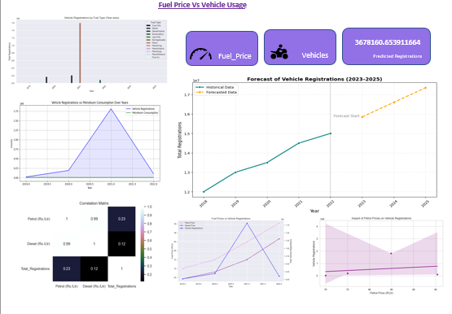

📉 Visualizations

1. Vehicle Registrations Over Years

2. Average Fuel Prices (Petrol & Diesel) Over Years

3. Petroleum Consumption vs Vehicle Registrations

4. Correlation Matrix

5. Forecast of Vehicle Registrations (2023–2025)

## 📍 Insights

- A sharp increase in fuel prices was observed post-2020.

- Despite rising fuel prices, vehicle registrations continued growing, especially electric and petrol variants.

- A moderate correlation (≈0.23) was found between petrol price and total registrations.

- Vehicle registrations are expected to rise by ~5% annually (forecasted through 2025).

## 🔮 Forecast Summary

|  |  |
| --- | --- |
| Year | Predicted Registrations |
| 2023 | 3.48 million |
| 2024 | 3.67 million |
| 2025 | 3.86 million |

## 🛠️ Tech Stack

- Python – Data analysis

- Pandas – Data wrangling

- Plotly – Interactive plots

- Streamlit – Web dashboard

- GitHub – Project version control