**Isha Tomar**

**B.Tech, ECE A, 3rd Year**

**19/BEC/041**

**Project:** Radar System using Arduino

**Problem Statement:**

Detection of objects in aircrafts, ships, spacecrafts, guided missiles, motor vehicles, weather formations, terrain and most importantly blind people to detect obstacles.

In this project, I am making Radar System. RADAR is an object detection system which uses radio waves to determine the range, altitude, direction, or speed of objects.

**The Idea**

Army, Navy and the Air Force make use of this technology. The use of such technology has been seen recently in the self-parking car systems launched by AUDI, FORD etc. And even the upcoming driverless cars by Google like Prius and Lexus. The project made by me can be used in any systems the customer may want to use like in a car, a bicycle or anything else. The use of Arduino in the project provides even more flexibility of usage of the above-said module according to the requirements.

**Requirements**

**Hardware Requirement:**

Arduino UNO

Breadboard

Jumper Wires

HC SR04 ultrasonic sensor

Servo Motor

**Software Requirement**

Arduino IDE

Processing Software

**Technologies Used**

**Language:** Arduino Programming Language

**Project Description**

**What is Arduino?**

Arduino designs, manufactures, and supports electronic devices and software, allowing people around the world to easily access advanced technologies that interact with the physical world. Our products are straightforward, simple, and powerful, ready to satisfy users’ needs from students to makers and all the way to professional developers.

**How does Radar works?**

RADAR stands for RAdio Detecting and Ranging and as indicated by the name, it is based on the use of radio waves. Radars send out electromagnetic waves similar to wireless computer networks and mobile phones. The signals are sent out as short pulses which may be reflected by objects in their path, in part reflecting back to the radar.

**Ultrasonic Sensor**

An ultrasonic sensor is a proximity sensor that is used to measure the distance of a target or object. It detects the object by transmitting ultrasonic waves and converts the reflected waves into an electrical signal. These sound waves travel faster than the speed of the sound that humans can hear.

[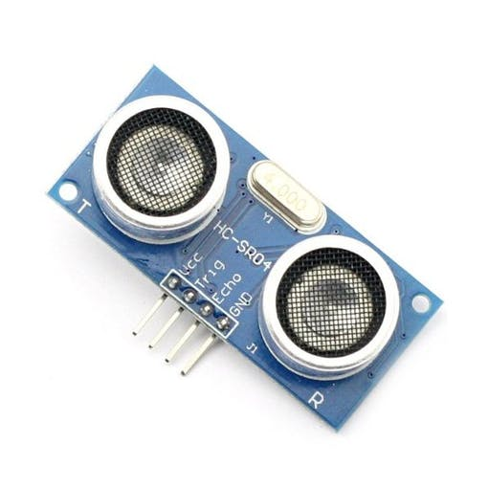](javascript:openLightBox('aa909e1c9c',%200);)

It has two main components: the transmitter & receiver. The transmitter emits the sound using a piezoelectric crystal, and the receiver encounters the sound after it has travelled to and from the target.

For the calculation of the object distance, the sensor measures the time taken by the signal to travel between the transmission of the sound by the transmitter to the reflecting back towards the receiver.

The formula for this calculation is,

D = ½ T x C

D = distance

T = time

C = speed of sound which is 340 meters/second.

These sensors are mostly found in automobile self-parking technology and anti-collision safety systems. Also, used in robotic obstacle detection systems, manufacturing technology, and many more. To know more about the ultrasonic sensor.

**Servo Motor**

A servomotor is a linear actuator or rotary actuator that allows for precise control of linear or angular position, acceleration, and velocity. It consists of a motor coupled to a sensor for position feedback. It also requires a relatively sophisticated controller, often a dedicated module designed specifically for use with servomotors.

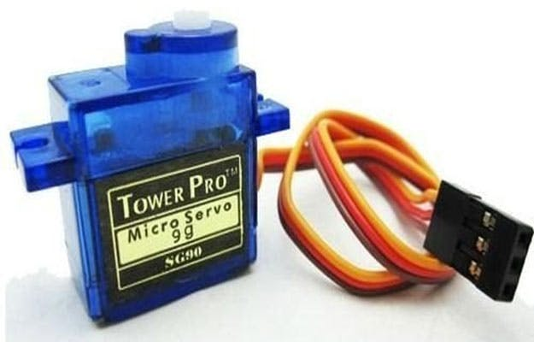

**Hardware Connection**

|  |  |  |
| --- | --- | --- |
| Arduino UNO | Ultrasonic Sensor | Servo Motor |
| Vcc | Vcc | Vcc |
| Gnd | Gnd | Gnd |
| D10 | Trig | - |
| D11 | Echo | - |
| D13 | - | Signal |

**Arduino Source Code**

#include <Servo.h>

const int trigPin = 10;

const int echoPin = 11;

long duration;

int distance;

Servo myServo;

void setup() {

pinMode(trigPin, OUTPUT);

pinMode(echoPin, INPUT);

Serial.begin(9600);

myServo.attach(13);

}

void loop() {

for(int i=15;i<=165;i++){

myServo.write(i);

delay(30);

distance = calculateDistance();

Serial.print(i);

Serial.print(",");

Serial.print(distance);

Serial.print(".");

}

for(int j=165;j>15;j--){

myServo.write(j);

delay(30);

distance = calculateDistance();

Serial.print(i);

Serial.print(",");

Serial.print(distance);

Serial.print(".");

}

}

int calculateDistance(){

digitalWrite(trigPin, LOW);

digitalWrite(trigPin, HIGH);

delayMicroseconds(10);

digitalWrite(trigPin, LOW);

duration = pulseIn(echoPin, HIGH);

distance= duration*0.034/2;

return distance;

}

**Processing Software Source code**

**import processing.serial**

**import java.awt.event.KeyEvent;**

**import java.io.IOException;**

**Serial myPort;**

**String angle="";**

**String distance="";**

**String data="";**

**String noObject;**

**float pixsDistance;**

**int iAngle, iDistance;**

**int index1=0;**

**int index2=0;**

**PFont orcFont;**

**void setup() {**

**size (1200, 700);**

**smooth();**

**myPort = new Serial(this,"COM3", 9600);**

**myPort.bufferUntil('.');**

**}**

**void draw() {**

**fill(98,245,31);**

**noStroke();**

**fill(0,4);**

**rect(0, 0, width, height-height*0.065);**

**fill(98,245,31);**

**drawRadar();**

**drawLine();**

**drawObject();**

**drawText();**

**}**

**void serialEvent (Serial myPort) {**

**data = myPort.readStringUntil('.');**

**data = data.substring(0,data.length()-1);**

**index1 = data.indexOf(",");**

**angle= data.substring(0, index1);**

**distance= data.substring(index1+1, data.length());**

**iAngle = int(angle);**

**iDistance = int(distance);**

**}**

**void drawRadar() {**

**pushMatrix();**

**translate(width/2,height-height*0.074);**

**noFill();**

**strokeWeight(2);**

**stroke(98,245,31);**

**// draws the arc lines**

**arc(0,0,(width-width*0.0625),(width-width*0.0625),PI,TWO_PI);**

**arc(0,0,(width-width*0.27),(width-width*0.27),PI,TWO_PI);**

**arc(0,0,(width-width*0.479),(width-width*0.479),PI,TWO_PI);**

**arc(0,0,(width-width*0.687),(width-width*0.687),PI,TWO_PI);**

**// draws the angle lines**

**line(-width/2,0,width/2,0);**

**line(0,0,(-width/2)*cos(radians(30)),(-width/2)*sin(radians(30)));**

**line(0,0,(-width/2)*cos(radians(60)),(-width/2)*sin(radians(60)));**

**line(0,0,(-width/2)*cos(radians(90)),(-width/2)*sin(radians(90)));**

**line(0,0,(-width/2)*cos(radians(120)),(-width/2)*sin(radians(120)));**

**line(0,0,(-width/2)*cos(radians(150)),(-width/2)*sin(radians(150)));**

**line((-width/2)*cos(radians(30)),0,width/2,0);**

**popMatrix();**

**}**

**void drawObject() {**

**pushMatrix();**

**translate(width/2,height-height*0.074);**

**strokeWeight(9);**

**stroke(255,10,10);**

**pixsDistance = iDistance*((height-height*0.1666)*0.025);**

**if(iDistance<40){**

**// draws the object according to the angle and the distance**

**line(pixsDistance*cos(radians(iAngle)),-pixsDistance*sin(radians(iAngle)),(width-width*0.505)*cos(radians(iAngle)),-(width-width*0.505)*sin(radians(iAngle)));**

**}**

**popMatrix();**

**}**

**void drawLine() {**

**pushMatrix();**

**strokeWeight(9);**

**stroke(30,250,60);**

**translate(width/2,height-height*0.074);**

**line(0,0,(height-height*0.12)*cos(radians(iAngle)),-(height-height*0.12)*sin(radians(iAngle)));**

**popMatrix();**

**}**

**void drawText() {**

**pushMatrix();**

**if(iDistance>40) {**

**noObject = "Out of Range";**

**}**

**else {**

**noObject = "In Range";**

**}**

**fill(0,0,0);**

**noStroke();**

**rect(0, height-height*0.0648, width, height);**

**fill(98,245,31);**

**textSize(25);**

**text("10cm",width-width*0.3854,height-height*0.0833);**

**text("20cm",width-width*0.281,height-height*0.0833);**

**text("30cm",width-width*0.177,height-height*0.0833);**

**text("40cm",width-width*0.0729,height-height*0.0833);**

**textSize(40);**

**text( width-width*0.875, height-height*0.0277);**

**text("Angle: " + iAngle +" °", width-width*0.48, height-height*0.0277);**

**text("Distance: ", width-width*0.26, height-height*0.0277);**

**if(iDistance<40) {**

**text(" " + iDistance +" cm", width-width*0.225, height-height*0.0277);**

**}**

**textSize(25);**

**fill(98,245,60);**

**translate((width-width*0.4994)+width/2*cos(radians(30)),(height-height*0.0907)-width/2*sin(radians(30)));**

**rotate(-radians(-60));**

**text("30°",0,0);**

**resetMatrix();**

**translate((width-width*0.503)+width/2*cos(radians(60)),(height-height*0.0888)-width/2*sin(radians(60)));**

**rotate(-radians(-30));**

**text("60°",0,0);**

**resetMatrix();**

**translate((width-width*0.507)+width/2*cos(radians(90)),(height-height*0.0833)-width/2*sin(radians(90)));**

**rotate(radians(0));**

**text("90°",0,0);**

**resetMatrix();**

**translate(width-width*0.513+width/2*cos(radians(120)),(height-height*0.07129)-width/2*sin(radians(120)));**

**rotate(radians(-30));**

**text("120°",0,0);**

**resetMatrix();**

**translate((width-width*0.5104)+width/2*cos(radians(150)),(height-height*0.0574)-width/2*sin(radians(150)));**

**rotate(radians(-60));**

**text("150°",0,0);**

**popMatrix();**

**}**

**Scope**

Radar System is widely use and having a lot of applications. It is based on the use of radio waves. Radars send out electromagnetic waves similar to wireless computer networks and mobile phones. The signals are sent out as short pulses which may be reflected by objects in their path, in part reflecting back to the radar.

Radar can work in adverse conditions like rain, fog and dust and is able to cover long range as well as close distance. It preserves anonymity due to the fact, that it is not able to deliver high-resolution pictures from faces or license plates, which ensures its acceptance.

Motion sensors for anti-burglary protection systems – indoor or outdoor – are very inexpensive components, which take advantage of the doppler effect. In this application, radar replaces more and more the Passive Infrared Sensors, which have established in the past because of their low price.

Link of the project

<https://drive.google.com/file/d/14TPoOWEg2B0oEZrei0vX7cGFZ3mq-P2B/view?usp=sharing>

**Conclusion**

Numerous advanced control methods gave designers to have more command over different advanced applications. The field that I have chosen, “Radar System” is a very vast field and future scope of this technology is very high. We have tremendous applications in which radar system have been implemented or used. There is a lot of future scope of this design because of its security capacity. It can be used in many applications. This framework can also be developed or modified according to the rising needs and demand.