VELLORE INSTITUTE OF TECHNOLOGY
School of Computer Science and Engineering
BCSE302L – Database Systems
Digital Assignment II – Project Report
SYNAPSE
An AI-Powered Digital Twin for Student Well-being and Academic Planning
Submitted by
Ishan Kumar
Register Number: 24BCE1563
Technology Stack: MongoDB Atlas · Express.js · React · Node.js · Google Gemini
October 2026

1. Abstract
University students record their health, meals, academic deadlines and personal documents in separate applications, so no single system can relate a week of poor sleep to an approaching examination. This project presents Synapse, a full-stack MERN application that stores all four kinds of personal data in a single MongoDB database and treats them as one digital twin of the student. Aggregation pipelines convert raw logs into trends, alerts and a combined wellness score. Cross-collection queries relate one module to another, and an AI assistant built on Google Gemini can read the same data and propose changes that are written to the database only after the user confirms them.
The database comprises eight collections that combine embedded and referenced documents, compound, unique and text indexes, and multi-stage aggregation pipelines. The implementation was evaluated on a seeded dataset in MongoDB Atlas. The results show that indexed lookups examine a single document where an unindexed lookup scans the whole collection, that embedded arrays remain fully queryable through $unwind, and that the combined data exposes patterns, such as reduced activity during periods of poor sleep, that separate applications cannot reveal.

2. Problem Statement
Student well-being and academic performance are closely linked, yet the data that describes them is fragmented. Sleep and activity are recorded by fitness applications, meals by diet trackers, deadlines in calendars or learning portals, and important documents such as identity cards, certificates and insurance policies are scattered across phone galleries and email. Because each source stores its data in isolation, the following problems arise:
- No combined view. A student cannot see that sleep has fallen below six hours during the same week in which three deadlines fall due.
- Late warnings. Overdue assignments and expiring documents are noticed only after the deadline has passed.
- Heterogeneous data. Health logs are time series, meals contain a variable number of food items, and documents carry different metadata depending on their type. A single rigid relational schema handles this variety poorly.
- Unsafe automation. Assistants that write directly to user data can make unintended changes without the user’s knowledge.
The problem addressed by this project is therefore to design and implement a database-backed system that stores heterogeneous personal data in one place, queries it efficiently, relates the modules to one another, and allows intelligent assistance without giving up user control over every change.

3. Objectives
- Design a document-oriented schema that suits each module: time-series health logs, meals with embedded food items, goals with embedded milestones, and documents with flexible metadata.
- Serve every screen through indexed queries and server-side aggregation pipelines rather than computation in the browser.
- Relate modules to one another through cross-collection queries ($lookup) so that the digital twin can connect health, nutrition and academic data.
- Provide an AI assistant that reads the same database and proposes changes, which are applied only after explicit user confirmation.
- Deliver a complete, secure web application with a React front end, an Express REST API and a MongoDB Atlas back end, and demonstrate its behaviour on a realistic dataset.

4. Novel Aspects of the Work
Synapse differs from conventional single-purpose tracking applications in four respects, summarised in Table 1.
Aspect | Conventional applications | Synapse
Unified digital twin | Each application stores one kind of data in isolation. | Health, nutrition, academic and document data share one database and one user key, combined into a 0–100 wellness score.
Cross-module analytics | Insights are limited to a single domain. | Aggregation pipelines with $lookup relate sleep to academic goals and nutrition, producing alerts that span modules.
Confirmed AI actions | Assistants either cannot change data or change it directly. | Every AI write is stored as a pending agentactions document and executed atomically only after the user presses Confirm, with a 24-hour expiry.
Hybrid document model | A fixed relational schema or unstructured storage. | Embedded arrays for bounded data (meal items, milestones), separate time-series collections for unbounded data, and schema-less metadata for documents.
Table 1. Novel aspects compared with conventional applications

5. Methodology

5.1 System Architecture
The system follows a three-tier architecture: a React single-page application, an Express REST API on Node.js, and a MongoDB Atlas cluster. The browser never communicates with the database directly. Every request carries a JSON Web Token (JWT), and the API restricts every query to the authenticated user’s identifier. Figure 1 shows the path of a typical request, using the Health page as an example.
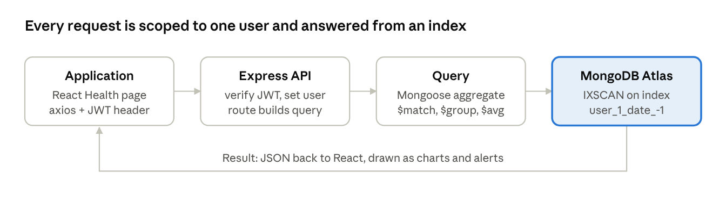
Figure 1. Request flow from the application through the API and query to the database and back
- Application. The Health page calls GET /api/health/trends, and the HTTP client attaches the user’s token.
- API. The authentication middleware verifies the token, and the route handler builds the query for that user.
- Query. Mongoose sends an aggregation pipeline ($match → $group → $avg) to MongoDB Atlas.
- Database. MongoDB resolves the $match stage through the compound index {user: 1, date: -1} and reads only that user’s recent logs.
- Result. The JSON response is rendered as trend cards, charts and alert banners in the browser.

5.2 Database Design
The synapse database contains eight collections. Every document belongs to exactly one user through the reference user: ObjectId → users._id. Table 2 summarises the collections.
Collection | Purpose | Embedded or flexible part | Indexes
users | Account and nutrition goals | nutritionGoals object | unique email
healthmetrics | One health log (sleep, steps, heart rate, water, weight) | source enumeration | {user, date}
nutritionlogs | One meal with its macros | items[] food items | {user, date}
academicgoals | Exam, project, assignment or course goal | milestones[] | _id
documents | Uploaded file in the personal vault | metadata (schema-less) | text {title, ocrText, tags}
chatmessages | Conversation with the AI twin | actions[] references | {user, timestamp}
agentactions | Change proposed by the AI, awaiting confirmation | args (schema-less) | {user, status, createdAt}
digitaltwinprofiles | Cached summary of the twin | recommendations[] | unique user
Table 2. Collections of the synapse database
The choice between embedding and referencing was made per relationship, according to how the data is read and how large it can grow:
- Embedded food items in a meal. A meal is always displayed with its items, and the number of items is small. A single read returns the complete meal, while $unwind still allows item-level analysis.
- Embedded milestones in a goal. Progress is derived from the milestones, so keeping them in the same document makes a milestone update atomic.
- Separate time-series collections. Health and nutrition logs grow without limit. Storing them inside the user document would eventually exceed the 16 MB document limit, so they are kept in their own collections and indexed by user and date.
- Schema-less metadata. Fields extracted from an identity card differ from those of an insurance policy. A flexible field stores both without schema migration, which a fixed relational table cannot do.

5.3 Indexing Strategy
Indexes were chosen from the access patterns of the application. The compound index {user: 1, date: -1} follows the equality–sort–range rule: the equality condition on user comes first, followed by the field used for sorting and range filtering. The unique index on email supports login and prevents duplicate accounts, and the text index on documents enables keyword search ranked by relevance. The effect of indexing is verified with the Explain Plan in Section 7.

5.4 Query and Aggregation Design
Seven representative queries were designed to cover the database features used by the application. Each corresponds to a screen of the application and is demonstrated in Section 7.
No. | Question answered | Collection | Technique
Q1 | Which logs show less than six hours of sleep? | healthmetrics | $match with $lt, $project, $sort
Q2 | How do steps and heart rate vary with sleep quality? | healthmetrics | $group with $avg
Q3 | Which foods are eaten most often? | nutritionlogs | $unwind on embedded array
Q4 | Who owns each goal and how far has it progressed? | academicgoals, users | $lookup join
Q5 | Which documents mention “insurance”? | documents | $text with textScore
Q6 | How many milestones of a goal are complete? | academicgoals | $filter and $size on array
Q7 | How many goals are in each status? | academicgoals | $group with $sum and $avg
Table 3. Representative queries

5.5 AI Agent with Confirmed Actions
The assistant uses the Gemini generateContent interface with function calling over twelve tools. Five tools only read data (overview, health logs, meals, goals and document search) and seven propose changes (logging a meal or health entry, creating or updating a goal, adding milestones, completing a milestone and setting nutrition goals). A write tool never modifies data directly. Instead, it stores a document with status pending in the agentactions collection, and the chat interface displays a Confirm or Cancel card.
When the user confirms, the server claims the action with an atomic findOneAndUpdate that changes the status from pending to executing, so a double click cannot run the action twice. Actions older than 24 hours expire. When no Gemini key is configured, the assistant falls back to rule-based answers, so the application remains usable.

5.6 Security
- Passwords are hashed with bcrypt, and sessions use signed JWTs whose secret is kept in an environment file that is excluded from version control.
- Uploaded files are not served publicly. They are streamed through an endpoint that verifies that the requester owns the document.
- Cross-origin requests are limited to the configured client address, and request bodies are limited to 1 MB.

6. Implementation

6.1 Back End
The back end is an Express 4 application on Node.js that uses Mongoose 8 for schema definition and validation. It exposes eleven route modules under /api: authentication, dashboard, health, nutrition, goals, academic, documents, chat, digital twin, profile and agent. Schema validation enforces required fields, enumerations such as meal type and goal status, numeric ranges on progress, and unique e-mail addresses. An insights module averages sleep, steps, water and macronutrients against the user’s goals, detects overdue and at-risk goals and expiring documents, and combines these signals into the wellness score. A central error handler converts upload-size errors, invalid identifiers and unknown routes into clear HTTP responses.

6.2 Front End
The front end is a React 19 single-page application with nine pages: Dashboard, Health, Nutrition, Academic, Documents, AI Twin, Profile, Login and Register. Charts are drawn as hand-written SVG without an external charting library. The interface supports light and dark themes and a responsive layout down to a 375-pixel screen width, and it uses skeleton loaders while data is fetched.

6.3 Sample Dataset
A seeding script (backend/scripts/seed.js) creates a demonstration student with thirty days of realistic data, including an examination week in which sleep falls below six hours. The script replaces only the demonstration user’s data, so it can be run repeatedly. Table 4 lists the document counts in MongoDB Atlas after seeding (Figure 2).
Collection | Documents | Collection | Documents
nutritionlogs | 116 | documents | 8
healthmetrics | 47 | users | 6
chatmessages | 33 | agentactions | 2
academicgoals | 11 | digitaltwinprofiles | 2
Table 4. Document counts after seeding

7. Results and Demonstration
All results below were obtained in the MongoDB Atlas web Data Explorer on Cluster0, database synapse. Find queries were entered in the Filter bar, and aggregation pipelines were entered in the Aggregations tab in text mode.

7.1 Database and Indexes
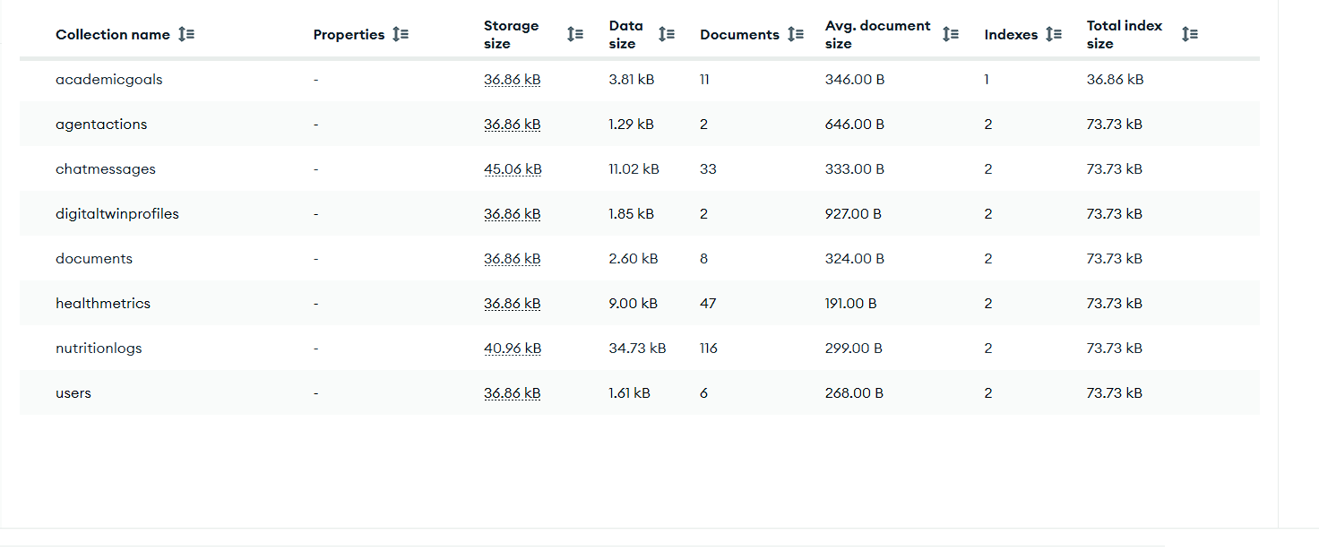
Figure 2. The eight collections of the synapse database with document counts
The demonstration user (Figure 3) was retrieved with the filter below. The record shows the embedded nutritionGoals object and a bcrypt hash in place of the plain-text password.
{ email: "demo@synapse.dev" }
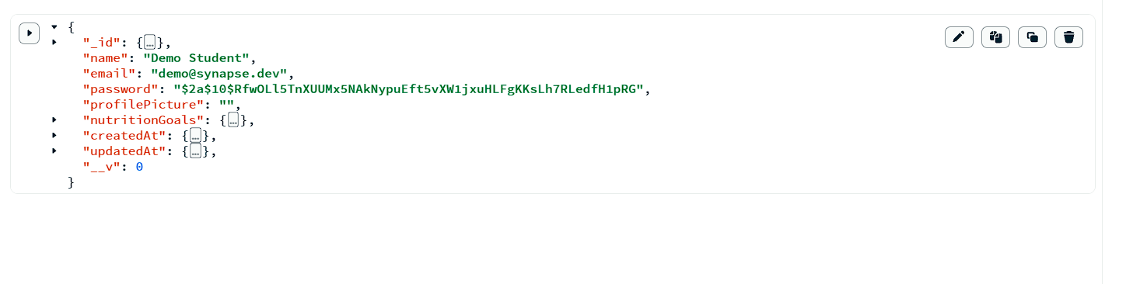
Figure 3. Demonstration user document
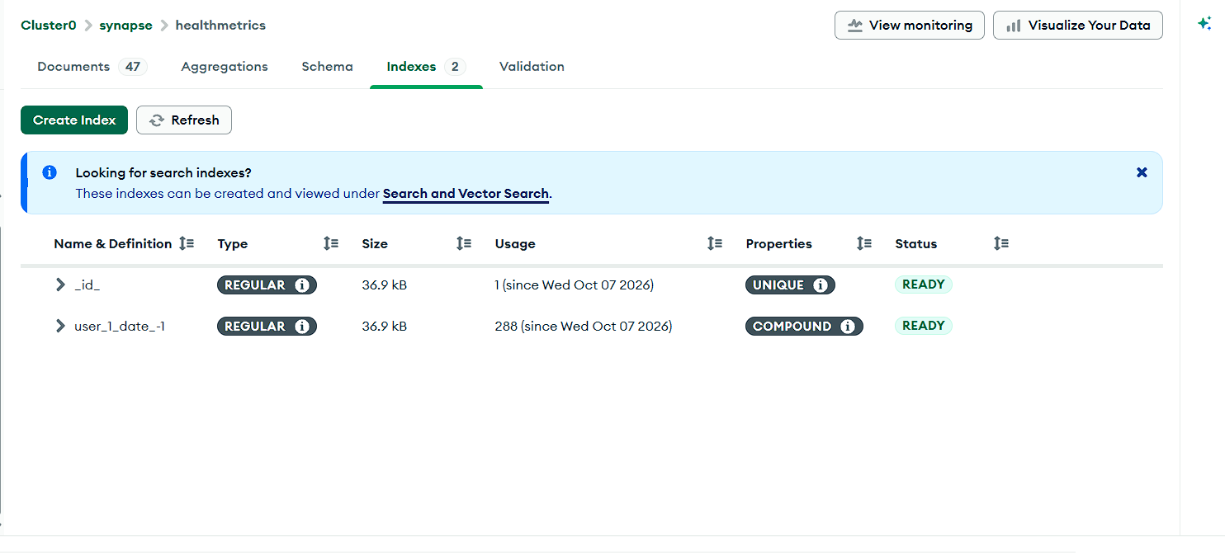
Figure 4. Indexes on healthmetrics, including the compound index user_1_date_-1
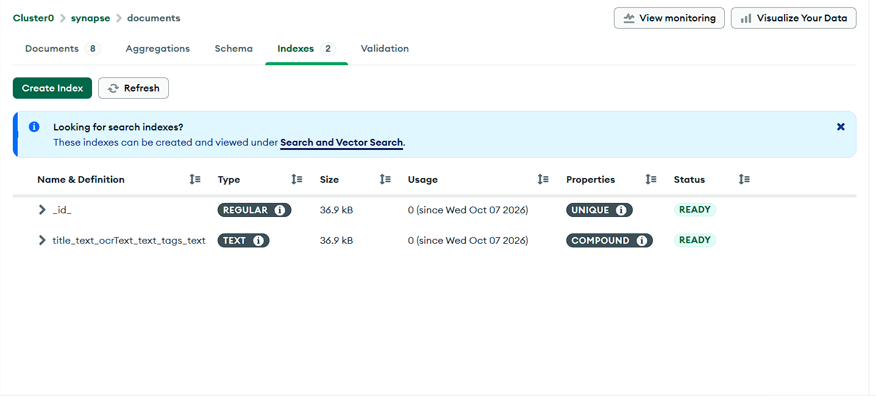
Figure 5. Text index on the documents collection over title, ocrText and tags

7.2 Q1: Logs with Less Than Six Hours of Sleep
[
{ $match: { sleepHours: { $lt: 6 } } },
{ $project: { _id: 0, date: 1, sleepHours: 1,
sleepQuality: 1, steps: 1, heartRate: 1 } },
{ $sort: { sleepHours: 1 } }
]
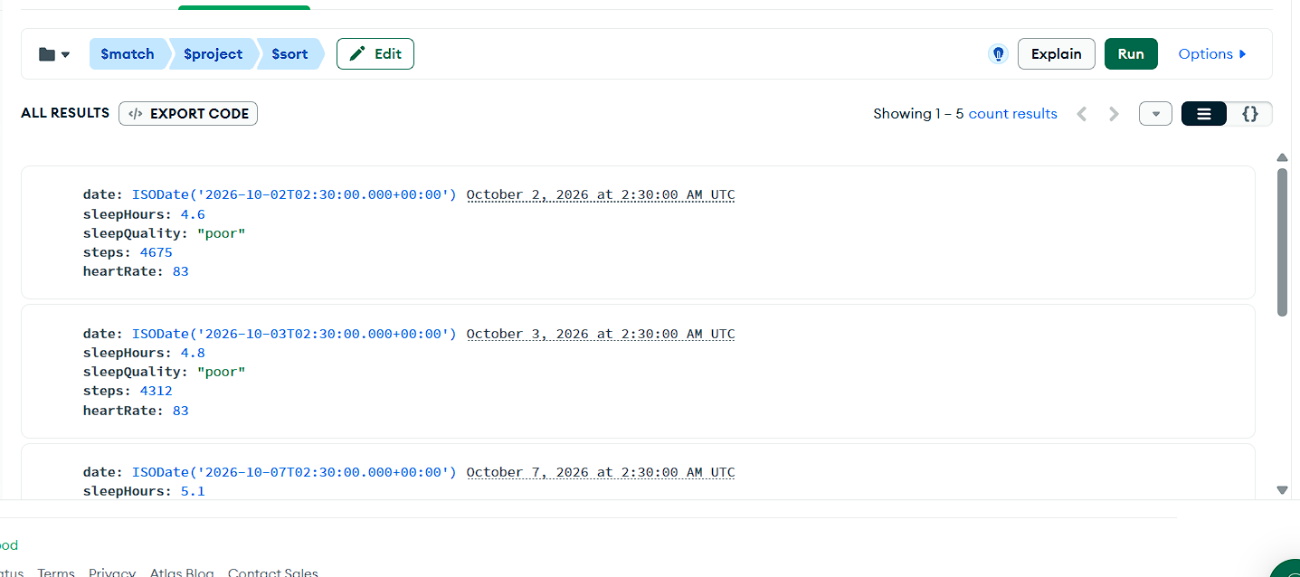
Figure 6. Q1 output: five logs from the examination week
The query returned five logs. The entries shown fall in the examination week in early October and combine sleep quality “poor”, a resting heart rate of 83 beats per minute and only about 4,300 to 4,700 steps, which is markedly lower activity than on normal days.

7.3 Effect of Indexing (Explain Plan)
Two lookups on the users collection were compared with the Explain Plan. The first filters on the indexed email field and the second on the unindexed name field.
[ { $match: { email: "demo@synapse.dev" } } ]
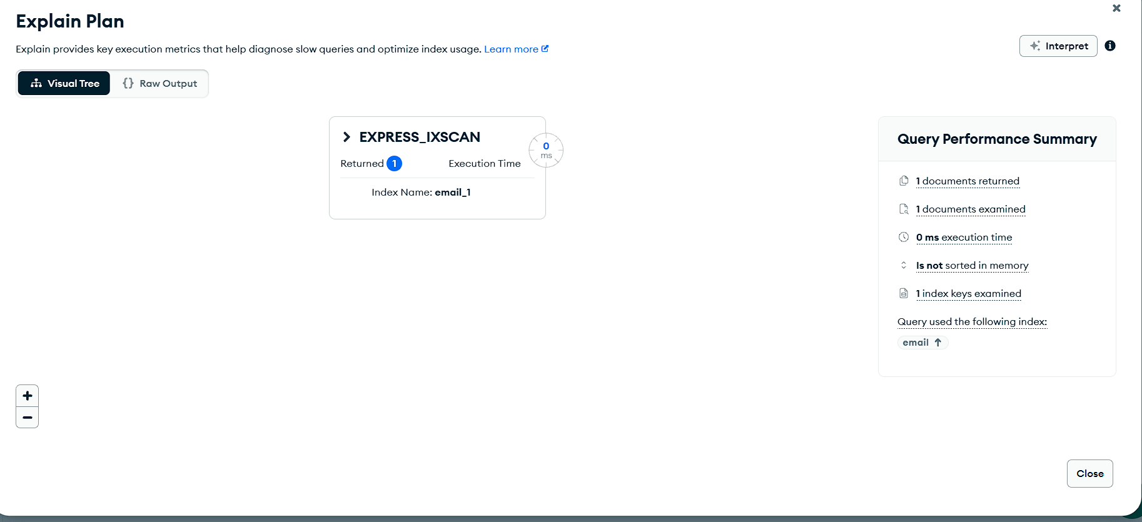
Figure 7. Explain Plan for the indexed lookup: EXPRESS_IXSCAN on email_1
[ { $match: { name: "Demo Student" } } ]
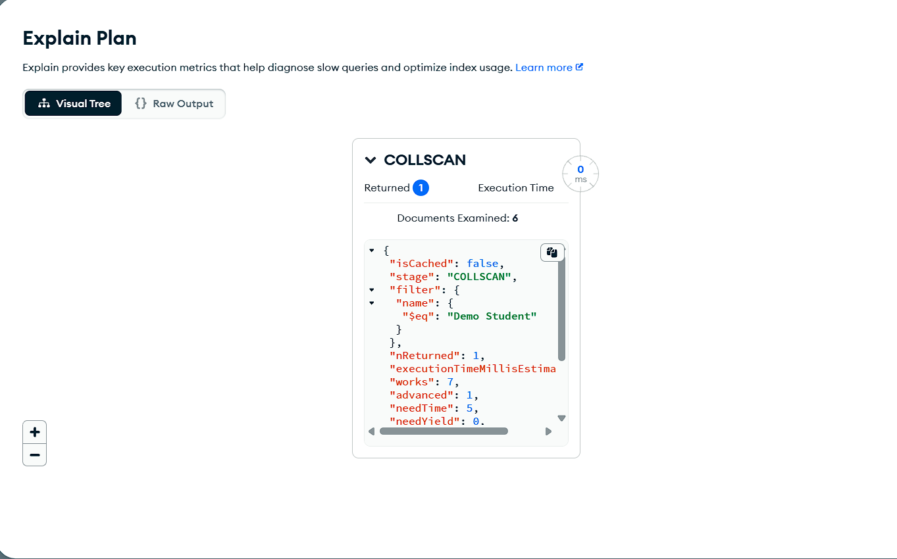
Figure 8. Explain Plan for the unindexed lookup: COLLSCAN
Query | Winning plan | Index used | Keys examined | Documents examined
{ email: ... } | EXPRESS_IXSCAN | email_1 | 1 | 1
{ name: ... } | COLLSCAN | none | 0 | 6 (all)
Table 5. Explain Plan comparison
With the index, MongoDB examined one key and one document. Without it, every document in the collection was examined. The cost of the indexed lookup depends only on the number of matching documents, whereas the cost of the collection scan grows with the size of the collection, so the difference widens as more users register.

7.4 Q2: Health Averages by Sleep Quality
[
{ $match: { sleepQuality: { $exists: true } } },
{ $group: {
_id: "$sleepQuality",
days: { $sum: 1 },
avgSleep: { $avg: "$sleepHours" },
avgSteps: { $avg: "$steps" },
avgHeartRate: { $avg: "$heartRate" } } },
{ $sort: { avgSleep: 1 } }
]
Insert screenshot here: output of Q2 from the Aggregations tab of healthmetrics
Figure 9. Q2 output: averages grouped by sleep quality
The pipeline groups the health logs by sleep quality and computes the number of days and the average sleep, steps and heart rate for each group, which summarises how activity and heart rate change with the quality of sleep.

7.5 Q3: Most Frequently Eaten Foods
[
{ $unwind: "$items" },
{ $group: { _id: "$items.name", timesEaten: { $sum: 1 },
totalCalories: { $sum: "$items.calories" } } },
{ $sort: { timesEaten: -1 } },
{ $limit: 5 }
]
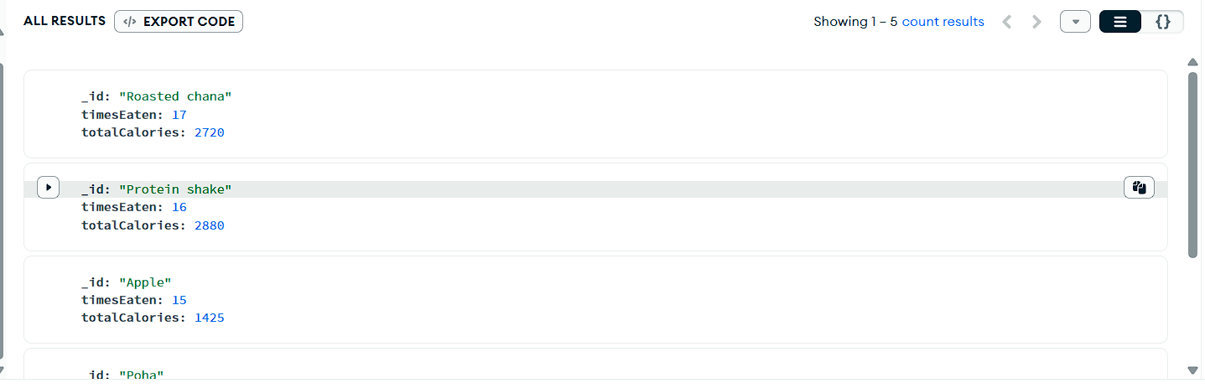
Figure 10. Q3 output: most frequently eaten foods
$unwind turned each embedded food item into a separate row before grouping. Roasted chana was the most frequent item (17 times, 2,720 kcal), followed by protein shake (16 times, 2,880 kcal) and apple (15 times, 1,425 kcal). This shows that embedding items inside a meal does not prevent item-level analysis.

7.6 Q4: Goals with Their Owners
[
{ $lookup: { from: "users", localField: "user",
foreignField: "_id", as: "owner" } },
{ $unwind: "$owner" },
{ $project: { _id: 0, goal: "$title", status: 1,
progress: 1, owner: "$owner.name" } },
{ $sort: { progress: -1 } }
]
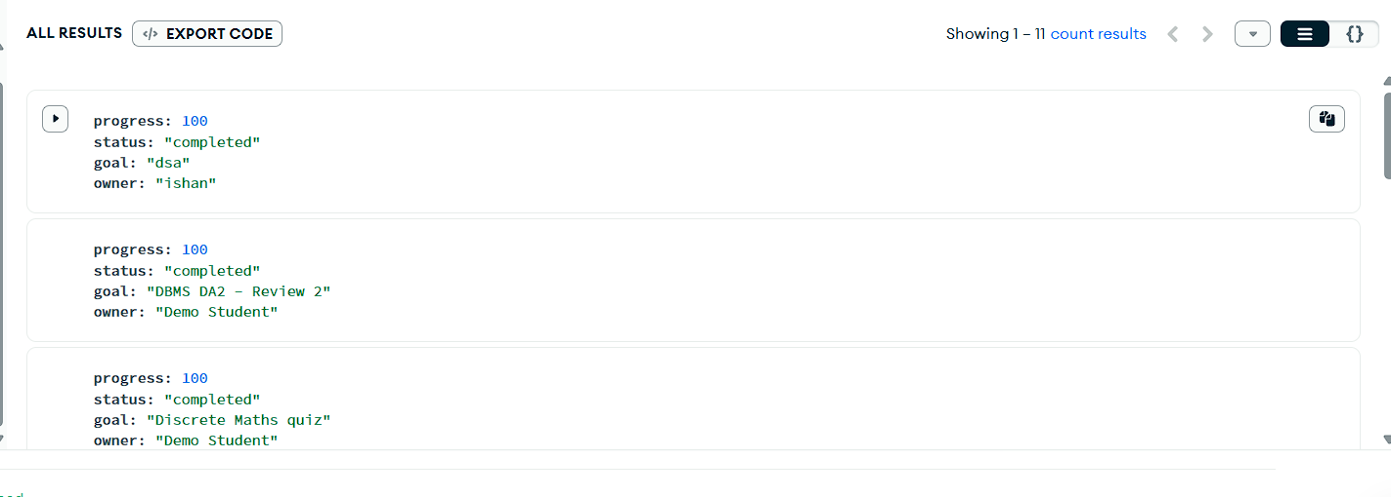
Figure 11. Q4 output: goals joined with their owners
The $lookup stage joined all eleven goals with the matching user document, in the same way as a relational join, and returned each goal with its owner’s name, status and progress.

7.7 Q5: Full-Text Search and Document Expiry
[
{ $match: { $text: { $search: "insurance" } } },
{ $project: { title: 1, category: 1,
score: { $meta: "textScore" } } },
{ $sort: { score: { $meta: "textScore" } } }
]
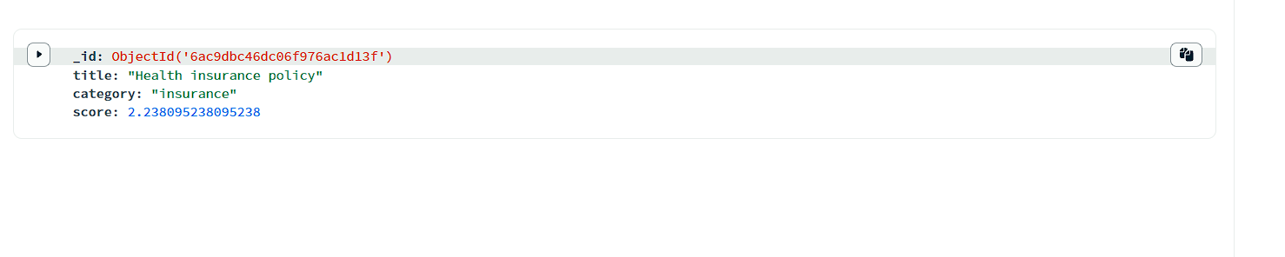
Figure 12. Q5 output: text search ranked by relevance
The text index matched “Health insurance policy” with a relevance score of 2.24. A second pipeline lists documents by expiry date, which the application uses for expiry alerts:
[
{ $match: { expiryDate: { $exists: true } } },
{ $project: { _id: 0, title: 1, category: 1, expiryDate: 1 } },
{ $sort: { expiryDate: 1 } }
]
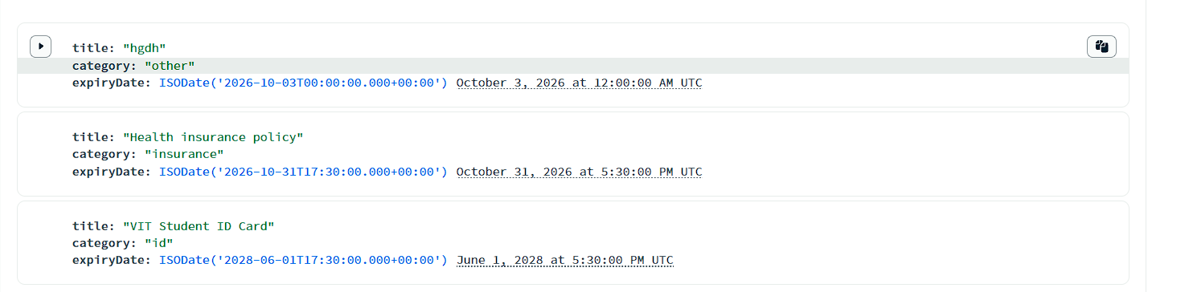
Figure 13. Documents sorted by expiry date

7.8 Q6: Embedded Milestones
The goal “Operating Systems CAT-2” stores its milestones inside the goal document (Figure 14). The pipeline below counts the completed milestones directly inside the array without unwinding it.
{ title: "Operating Systems CAT-2" }
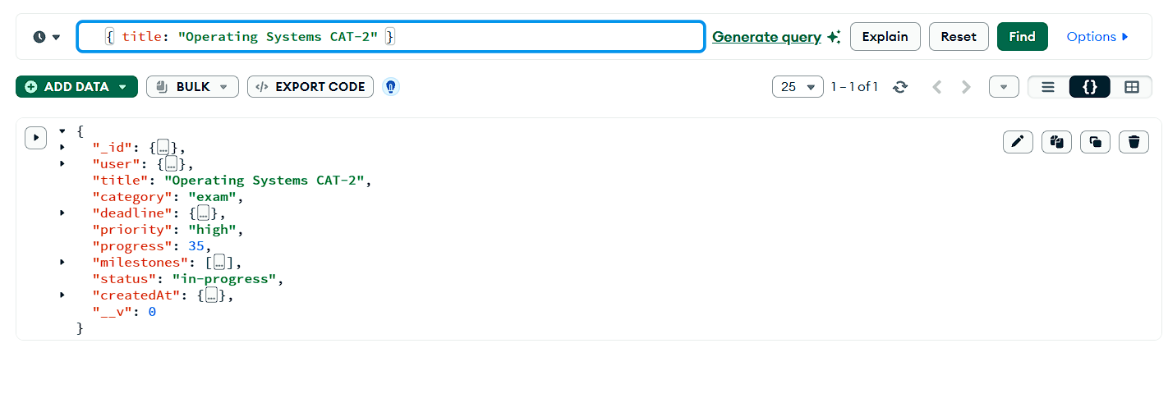
Figure 14. Goal document with embedded milestones (progress 35)
[
{ $match: { title: "Operating Systems CAT-2" } },
{ $project: {
_id: 0, title: 1,
done: { $size: { $filter: { input: "$milestones",
cond: "$$this.completed" } } },
total: { $size: "$milestones" } } }
]
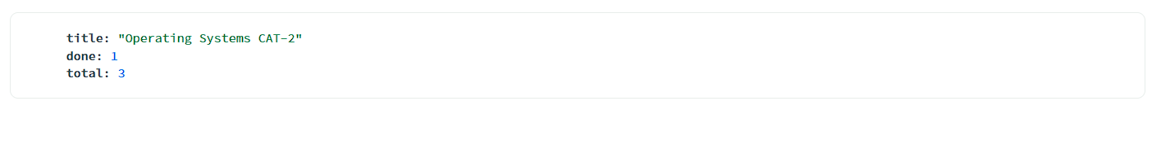
Figure 15. Q6 output: one of three milestones completed
The result shows one of three milestones completed. Because the milestones are embedded, marking one as complete is a single atomic positional update ($set: { "milestones.$.completed": true }), which is also how the AI agent’s milestone tool updates progress.

7.9 Q7: Goals per Status
[
{ $group: { _id: "$status", goals: { $sum: 1 },
avgProgress: { $avg: "$progress" } } },
{ $sort: { goals: -1 } }
]
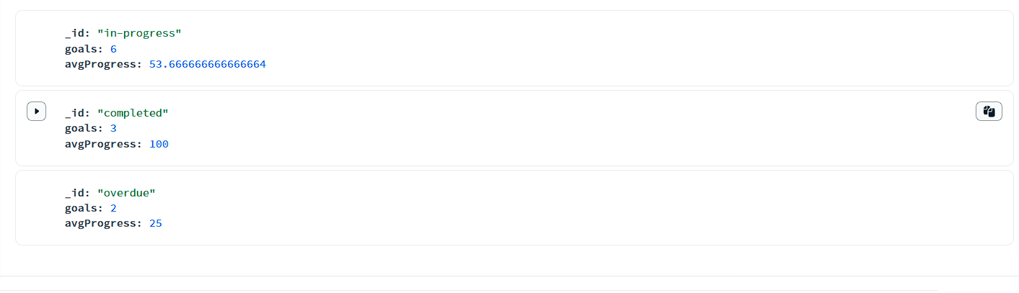
Figure 16. Q7 output: goal count and average progress per status
Six goals were in progress with an average progress of 53.7%, three were completed, and two were overdue with an average progress of 25%. These figures feed the dashboard summary and the overdue alerts.

7.10 Summary of Results
Feature | Evidence | Observation
Indexing | Figures 7–8 | Indexed lookup examined 1 document; unindexed lookup examined all 6.
Aggregation | Figures 6, 9, 16 | Logs and goals were summarised on the server into groups and averages.
Embedded documents | Figures 10, 14, 15 | Meal items and milestones remained fully queryable inside their parent documents.
Joins | Figure 11 | $lookup related goals to users across collections.
Text search | Figure 12 | Documents were ranked by relevance through the text index.
Cross-module pattern | Figure 6 | Examination-week logs combined poor sleep, low steps and a raised heart rate.
Table 6. Summary of results

8. Conclusion
Synapse demonstrates that a document database can unify heterogeneous personal data that is normally scattered across separate applications. Embedding was used for bounded, always-together data such as meal items and milestones, and separate collections were used for unbounded time series, giving both fast single-document reads and full analytical access. Compound, unique and text indexes keep the main access paths efficient, as the Explain Plan comparison confirms, and aggregation pipelines move summarisation from the browser to the database.
The novel contribution of the project is the combination of a cross-module digital twin with an AI assistant whose changes are stored as pending actions and executed atomically only after user confirmation. This design keeps the benefits of intelligent assistance while leaving the user in control of their data. The complete system, comprising a React front end, an Express API and MongoDB Atlas, has been implemented and demonstrated on a realistic dataset.

Future Scope
- Store a calendar-day field on each log so that cross-module joins can use plain indexed localField and foreignField matching.
- Use MongoDB time-series collections for health logs, and a TTL index to remove expired AI actions automatically.
- Move uploads to GridFS or cloud object storage and fill the ocrText field automatically with OCR.
- Add real Fitbit and Google Fit synchronisation, Atlas Search for fuzzy matching, and automated API tests with continuous integration.

