Synapse – AI Digital Twin for Students
DBMS DA3 Final Report · 10 October 2026
Synapse is a MERN web app on MongoDB Atlas. It keeps a student's health, nutrition, academic goals and documents in 8 collections, and turns them into one "digital twin" view.
Course | Database Management Systems, DA3 (final review)
Project | Synapse: AI Digital Twin for Students
Database | MongoDB Atlas, Cluster0, database synapse
Repository | github.com/ishaaan0310/Synapse

Member | Reg. No. | Role
Ishan Kumar | 24BCE1563 | Backend & Database Developer
Harsh Choudhary | 24BCE1623 | Frontend Developer: Academic & Dashboard
Mudit Jayesh | 24BCE1510 | Frontend Developer: Health & Nutrition

1. Project overview
Students track sleep in one app, meals in another, deadlines in a third and documents in a phone gallery, so no one connects "slept 5 hours" with "exam in 3 days". Synapse stores all four kinds of data per user in one MongoDB database. It uses aggregation pipelines to turn them into trends, alerts and a single wellness score.
Objectives
- Design a document schema that fits each module: time-series logs, embedded sub-items and flexible document metadata.
- Serve every screen with indexed queries and server-side aggregations instead of computing in the browser.
- Link modules with cross-collection queries ($lookup) so the twin can relate health to academics and nutrition.
- Add an AI assistant that reads the same data and can propose changes, applied only after the user confirms.
Features
Module | What the user can do | Main collection(s)
Dashboard | Wellness score, alerts, 7-day charts, activity feed, quick actions | all (aggregated)
Health | Log sleep, steps, heart rate, water, weight; 7/30-day trends; alerts; simulated Fitbit/HealthKit sync | healthmetrics
Nutrition | Log meals with several food items; macros vs goals; weekly history | nutritionlogs, users
Academic | Goals with milestones, progress, filters, overdue detection | academicgoals
Documents | Upload, full-text search, expiry tracking, owner-only download | documents
AI Twin chat | Rule-based answers or Gemini agent with 12 tools; writes need Confirm | chatmessages, agentactions
Profile | Nutrition goals, password, JSON export, delete account | users
Stack: MongoDB Atlas, Mongoose 8, Express 4, Node.js, React 19 (react-router 7, axios), JWT + bcrypt, Multer, Google Gemini API (optional).

2. Data model
The synapse database holds 8 collections. Every document belongs to one user through user: ObjectId → users._id. Data that is always read with its parent is embedded. Data that grows without limit gets its own collection.
Collection | Purpose | Key fields | Embedded / flexible parts | Indexes
users | Account and goals | name, email, password (bcrypt hash), timestamps | nutritionGoals {calories, protein, carbs, fat} | unique email
healthmetrics | One health log per entry | user, date, sleepHours, sleepQuality, steps, heartRate, waterIntake (L), weight, source | source enum: manual / fitbit / healthkit | {user:1, date:-1}
nutritionlogs | One meal | user, mealType, foodName, calories, protein, carbs, fat, date | items[]: name + macros per food | {user:1, date:-1}
academicgoals | Exam, project, assignment, course | user, title, category, deadline, priority, progress 0-100, status | milestones[]: title, completed, dueDate | _id
documents | Vault entry for an uploaded file | user, title, fileUrl, fileType, category, tags[], expiryDate, ocrText | metadata.extractedFields (Mixed, schema-less) | text {title, ocrText, tags}
chatmessages | Twin chat history | user, role, content, module, source (agent / rules), timestamp | actions[]: refs to agentactions | {user:1, timestamp:-1}
agentactions | Change proposed by the AI, waiting for confirmation | user, message, tool, args (Mixed), summary, status, resolvedAt | details[] | {user:1, status:1, createdAt:-1}
digitaltwinprofiles | Cached twin summary | user, healthSummary, nutritionSummary, academicSummary, lastSynced | recommendations[] | unique user
Embed or reference: the design choices
- Embedded items[] in a meal. A meal is always shown with its foods, and there are only a few per meal. One read returns the whole meal, and $unwind can still analyse the items (Q3).
- Embedded milestones[] in a goal. Progress is calculated from milestones, so keeping them together makes the update atomic. arrayFilters changes one milestone in place (Q6).
- Embedded nutritionGoals in a user. It is a fixed 4-field object, read on every nutrition screen.
- Separate healthmetrics and nutritionlogs. One document per day per user would grow without limit inside users and hit the 16 MB document cap. As separate time-series collections with a {user, date} index, they stay fast at any size.
- Separate agentactions. A proposal has its own lifecycle (pending → confirmed / cancelled / expired, with a 24-hour expiry). An atomic findOneAndUpdate on status stops a double-click from running it twice.
- Flexible metadata in documents. Fields extracted from an ID card differ from those on an insurance policy. A Mixed field stores both without schema changes, which is something a fixed relational table cannot do.
Sample dataset
backend/scripts/seed.js loads a demo student (demo@synapse.dev) with 30 days of realistic data, including an exam week where sleep drops below 6 hours. It is safe to re-run, because it only replaces the demo user's own data. After seeding, the database holds the counts below (Fig. 1).
Collection | Documents
nutritionlogs | 116
healthmetrics | 47
chatmessages | 33
academicgoals | 11
documents | 8
users | 6
agentactions | 2
digitaltwinprofiles | 2

3. Implementation
Synapse has three tiers: a React single-page app, an Express REST API, and MongoDB Atlas. The browser never talks to the database directly. Every request carries a JWT, and the API scopes every query to that user's _id.

3.1 Request flow: application → database → query → result
Example: opening the Health page.
- Application. Health.js calls api.get('/health/trends'), and axios adds Authorization: Bearer <token>.
- API. authMiddleware verifies the JWT and sets req.user.id. The route in routes/health.js builds the query.
- Database. Mongoose sends an aggregation to Atlas: $match {user, date ≥ 7 / 30 days ago} → $group → $avg of sleep, steps, heart rate and water.
- Query plan. MongoDB uses the {user:1, date:-1} index (IXSCAN), so it reads only that user's last 7 days.
- Result. JSON goes back to React, which shows the 7- and 30-day averages next to the charts and alert banners.
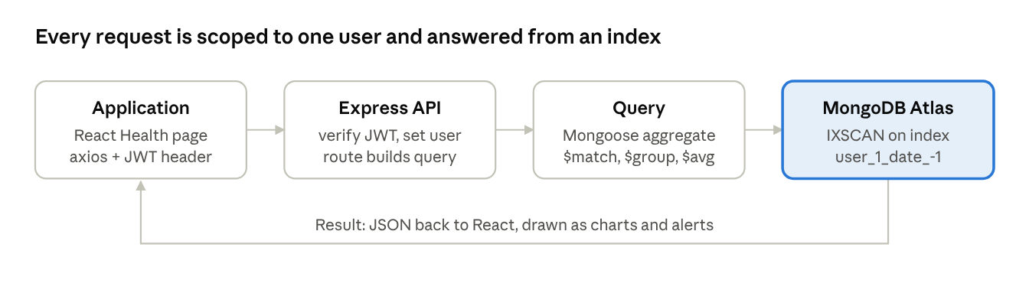
The same path serves every screen: only the route and the pipeline change.

3.2 Backend (Express + Mongoose)
- 11 route modules under /api: auth, dashboard, health, nutrition, goals, academic, documents, chat, digital-twin, profile, agent.
- Validation in the schema: required fields, enums such as mealType and status, min/max on progress, and a unique email.
- Insights engine (utils/insights.js): averages sleep, steps, water and macros against goals. It finds overdue and at-risk goals and expiring documents, and combines them into a 0–100 wellness score.
- Error handling: central handler for Multer limits (10 MB), invalid ObjectIds (CastError → 400) and 404s.

3.3 Frontend (React 19)
- Nine pages (Dashboard, Health, Nutrition, Academic, Documents, AI Twin chat, Profile, Login, Register) and shared components: Navbar, Charts (line, bar, twin core), Toast and Icons.
- Hand-written SVG charts with no chart library. Light and dark themes, a responsive layout down to 375 px, and skeleton loaders.

3.4 Agentic AI (Gemini)
- agent/gemini.js calls generateContent with function calling. It has retries, a fallback model, and keeps the model's thought signatures.
- agent/tools.js has 12 tools. Five read data: overview, health logs, meals, goals, document search. Seven write: log meal, log health, create goal, add milestones, set milestone status, update goal, set nutrition goals.
- A write tool never writes directly. It stores an agentactions document with status pending, and the chat shows a Confirm / Cancel card. Confirming claims the action atomically (findOneAndUpdate {status:'pending'} → 'executing'), checks the 24-hour expiry, then runs it.
- Without a GEMINI_API_KEY, chat falls back to rule-based answers.

3.5 Security
- Passwords are hashed with bcrypt (10 rounds). JWTs are signed with JWT_SECRET, and secrets stay in .env, which git ignores.
- Uploaded files are not public. GET /api/documents/:id/file checks ownership before streaming.
- CORS allows only CLIENT_URL and localhost. The JSON body limit is 1 MB.

4. Important queries
Each of the seven queries below is the database work behind one screen of the app. They were run in the MongoDB Atlas Data Explorer on the sample dataset. Section 6 gives each query's exact text, in the order run, next to its Atlas screenshot. Per-user versions of these queries, with explain output, are kept in backend/scripts/queries.js.
# | Question it answers | Collection | Technique | Used by
Q1 | Which logs show under 6 h of sleep? | healthmetrics | $match with $lt, then $project and $sort | Health log, alerts
Q2 | How do steps and heart rate change with sleep quality? | healthmetrics | $match → $group → $avg | Health trends
Q3 | Which foods are eaten most? | nutritionlogs | $unwind on embedded items[] | Nutrition history
Q4 | Who owns each goal, and how far along is it? | academicgoals → users | $lookup join | Dashboard
Q5 | Find "insurance" in the vault | documents | $text + textScore | Document search
Q6 | Mark one milestone done | academicgoals | positional $ update + $filter / $size | Academic, AI agent
Q7 | How many goals are in each status? | academicgoals | $group + $avg | Dashboard summary

5. Indexing and aggregation features
The two NoSQL features the project relies on most are compound and text indexes and the aggregation pipeline. Embedded documents with arrayFilters come third.

5.1 Indexes
Index | Collection | Why it exists | Queries it serves
{user:1, date:-1} | healthmetrics, nutritionlogs | Every screen asks for one user's recent logs, newest first. Equality on user then range and sort on date follows the ESR rule (Equality, Sort, Range). | dashboard, health and nutrition pages, trends
{user:1, timestamp:-1} | chatmessages | Load the latest chat history without a sort in memory | chat page, agent context
{user:1, status:1, createdAt:-1} | agentactions | Find a user's pending actions quickly, newest first | confirm / cancel, expiry
text {title, ocrText, tags} | documents | Keyword search across title, OCR text and tags with relevance ranking | Q5, /documents/search
unique {email:1} | users | Login lookup, and duplicate accounts are impossible | register, login
unique {user:1} | digitaltwinprofiles | Exactly one twin per user | twin sync
Proof with Explain Plan. Two lookups on users were explained in Atlas. One filters on the indexed email field (Fig. 6). The other filters on name, which has no index (Fig. 7).
Query | Winning plan | Index used | Docs examined
{ email: "demo@synapse.dev" } (Fig. 6) | IXSCAN → FETCH | email_1 | 1
{ name: "Demo Student" } (Fig. 7) | COLLSCAN | none | every document in users
With the index, the work grows with the number of rows returned. Without it, the work grows with the size of the whole collection, so every user's queries slow down as more students sign up.

5.2 Aggregation pipeline
Stage / operator | Where it is used | What it does here
$match | Q2, Q6 (Fig. 14), dashboard | Filters documents before grouping
$group + $sum / $avg | Q2, Q3, Q7 | Turns many logs into one summary row per group
$unwind | Q3 | Turns each embedded food item into its own row
$lookup | Q4, app's health ↔ goals correlation | Joins one collection with another, like a SQL join
$project, $sort, $limit | Q3, Q4, Q6 | Shapes, orders and trims the output
$filter, $size | Q6 (Fig. 14) | Counts the completed milestones inside the array
$dateToString, $facet | App: nutrition history, dashboard | Groups by Indian calendar day; returns several result sets in one call

5.3 Embedded documents
A positional update (milestones.$.completed, or milestones.$[m].completed with arrayFilters) changes exactly one array element in one atomic write. Node never reads, edits and re-saves the whole goal, so two quick clicks cannot overwrite each other. In this project, the "Deadlocks" milestone of the OS goal was updated this way. Fig. 13 shows the goal before the update. Fig. 14 counts the completed milestones afterwards with $filter and $size. The AI agent's set_milestone_status tool relies on the same idea.

6. Query execution in MongoDB Atlas (screenshots)
Every screenshot below comes from the MongoDB Atlas web Data Explorer (Cluster0 → Browse Collections → synapse), after the sample dataset was loaded. Each query is a single box. Find queries go in the Filter bar. Aggregations go in the Aggregations tab in Text mode, pasted whole from [ to ].

Fig. 1. Collections in the synapse database
Cluster0 → Browse Collections. The 8 collections and their document counts after seeding.
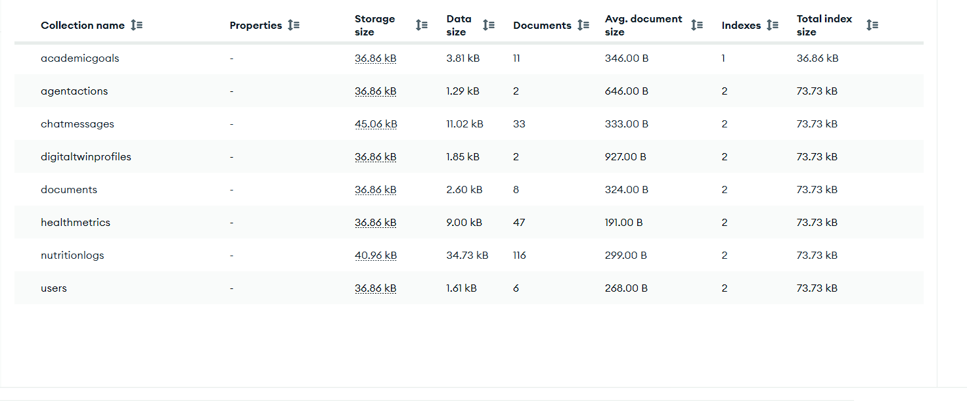

Fig. 2. Demo user document
Collection users → Find. The embedded nutritionGoals object and the bcrypt-hashed password.
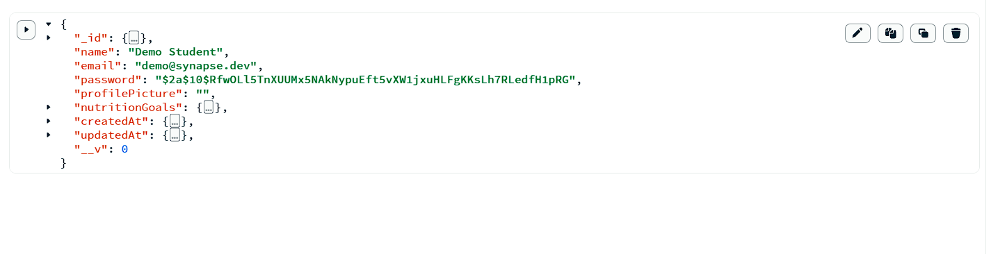
{ email: "demo@synapse.dev" }

Fig. 3. Compound index on healthmetrics
Collection healthmetrics → Indexes tab. The default _id_ index and the compound index user_1_date_-1.
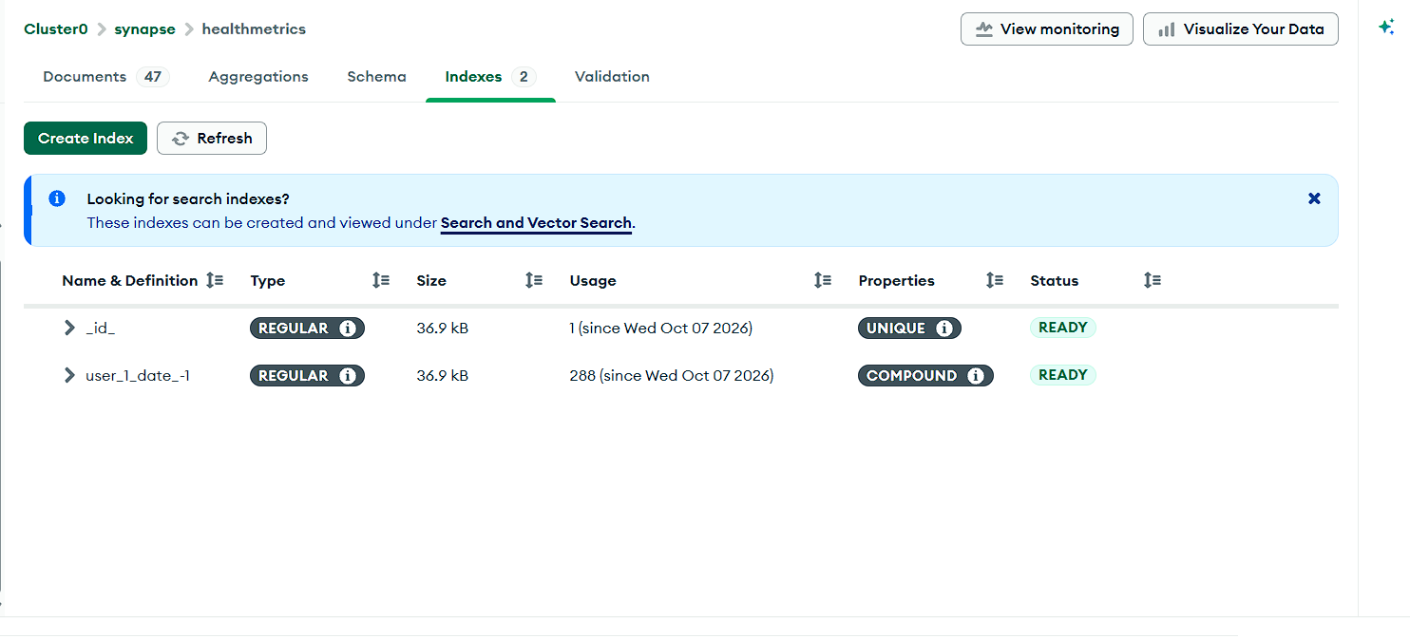

Fig. 4. Text index on documents
Collection documents → Indexes tab. The text index over title, ocrText and tags.
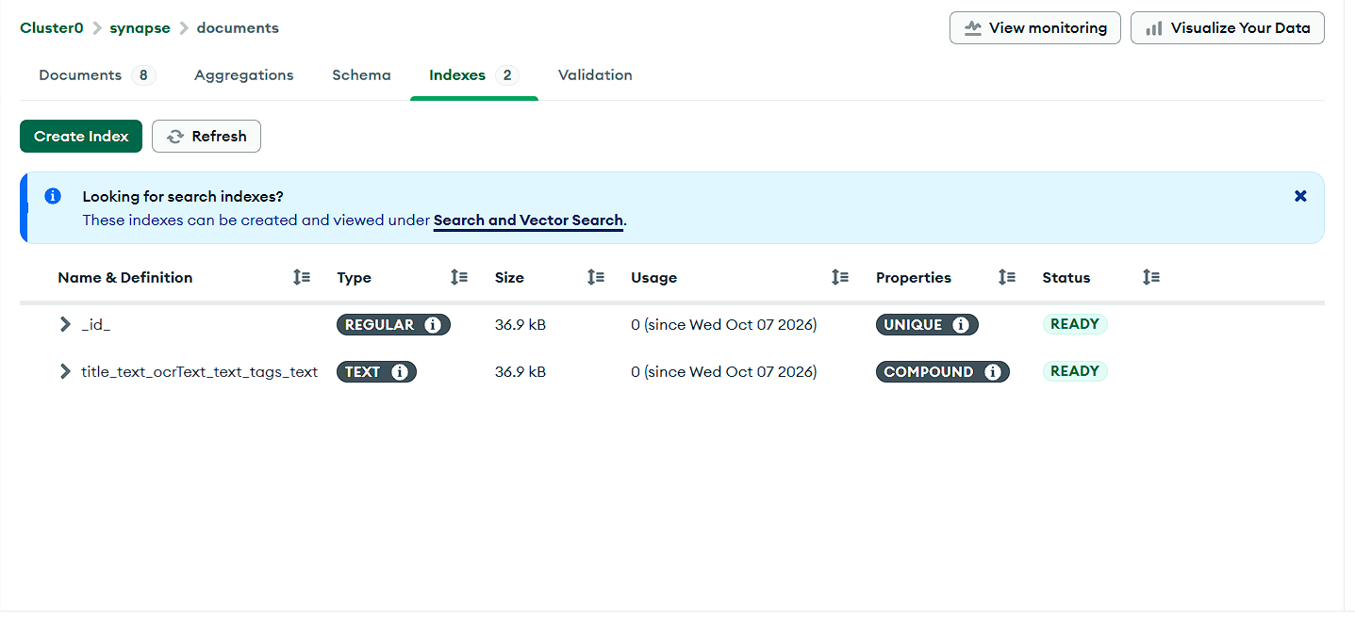

Fig. 5. Q1: health logs with under 6 hours of sleep
Collection healthmetrics → Aggregations. A comparison operator ($lt), then a projection and a sort.
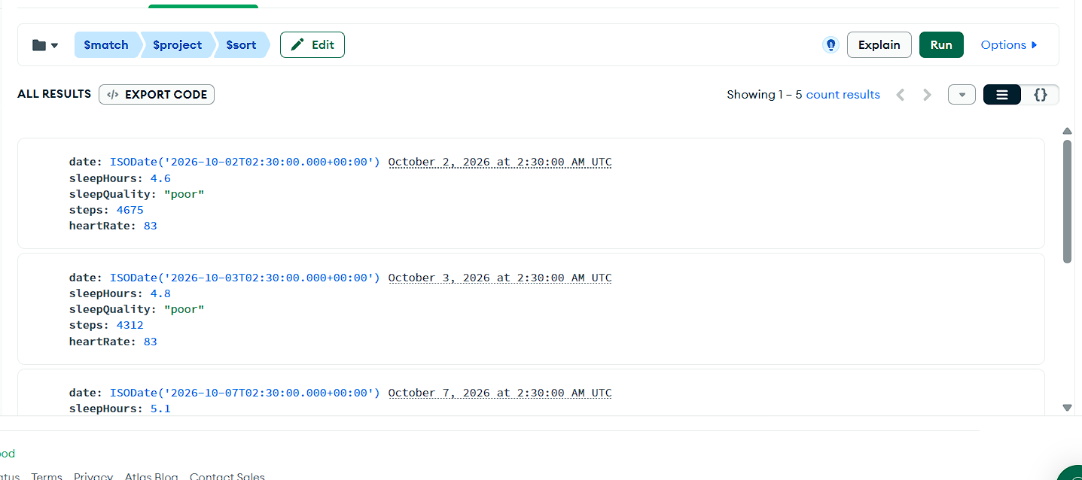
[
{ $match: { sleepHours: { $lt: 6 } } },
{ $project: { _id: 0, date: 1, sleepHours: 1, sleepQuality: 1, steps: 1, heartRate: 1 } },
{ $sort: { sleepHours: 1 } }
]

Fig. 6. Explain plan: index scan on users.email
Collection users → Aggregations → paste → Explain. The query planner uses IXSCAN on the unique index email_1, so only 1 document is examined.
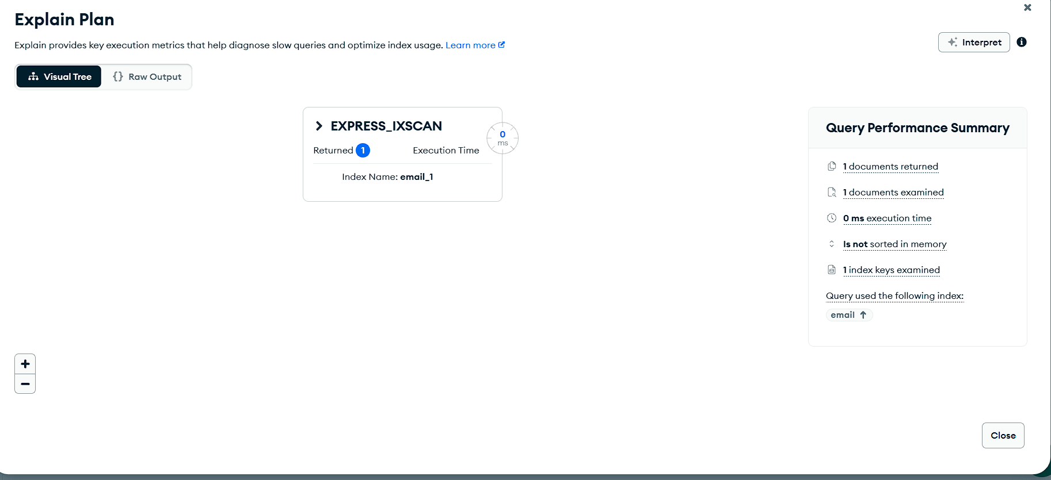
[
{ $match: { email: "demo@synapse.dev" } }
]

Fig. 7. Explain plan: collection scan on an unindexed field
Collection users → Aggregations → paste → Explain. name has no index, so the plan is COLLSCAN and every user document is examined.
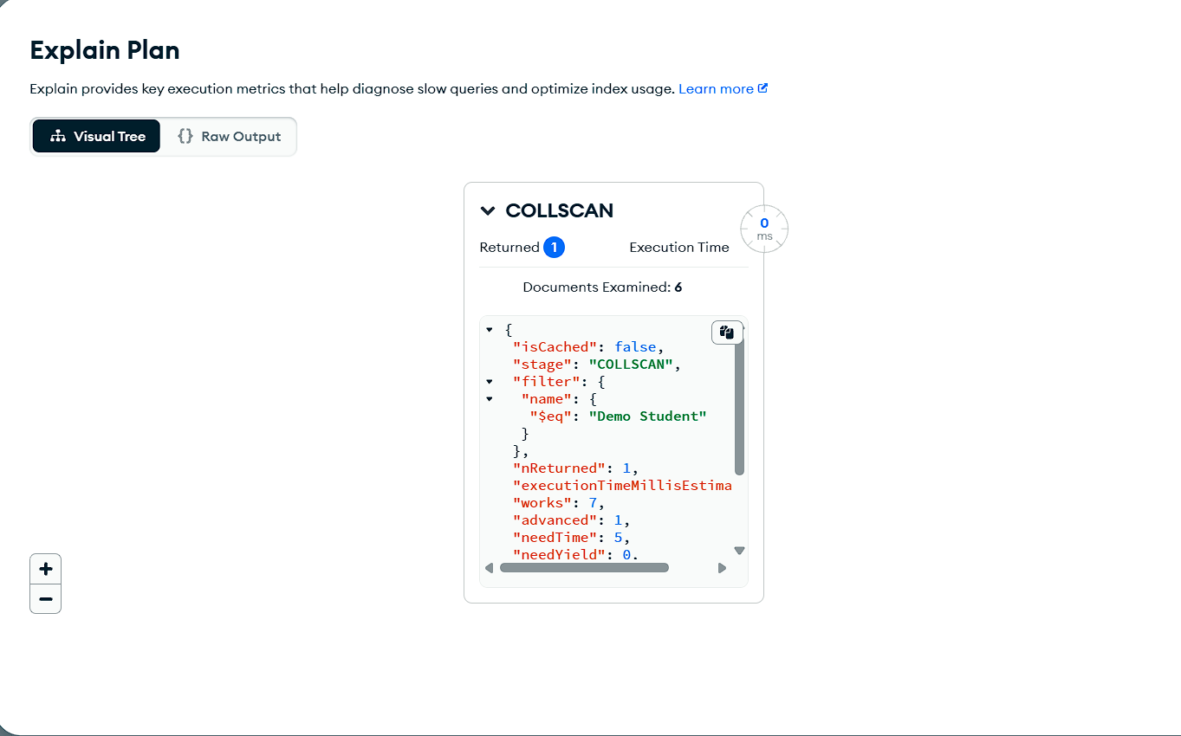
[
{ $match: { name: "Demo Student" } }
]

Fig. 8. Q2: health averages by sleep quality
Collection healthmetrics → Aggregations. Groups the logs by sleep quality. Poor-sleep days show fewer steps and a higher heart rate.

[
{ $match: { sleepQuality: { $exists: true } } },
{ $group: {
_id: "$sleepQuality",
days: { $sum: 1 },
avgSleep: { $avg: "$sleepHours" },
avgSteps: { $avg: "$steps" },
avgHeartRate: { $avg: "$heartRate" } } },
{ $sort: { avgSleep: 1 } }
]
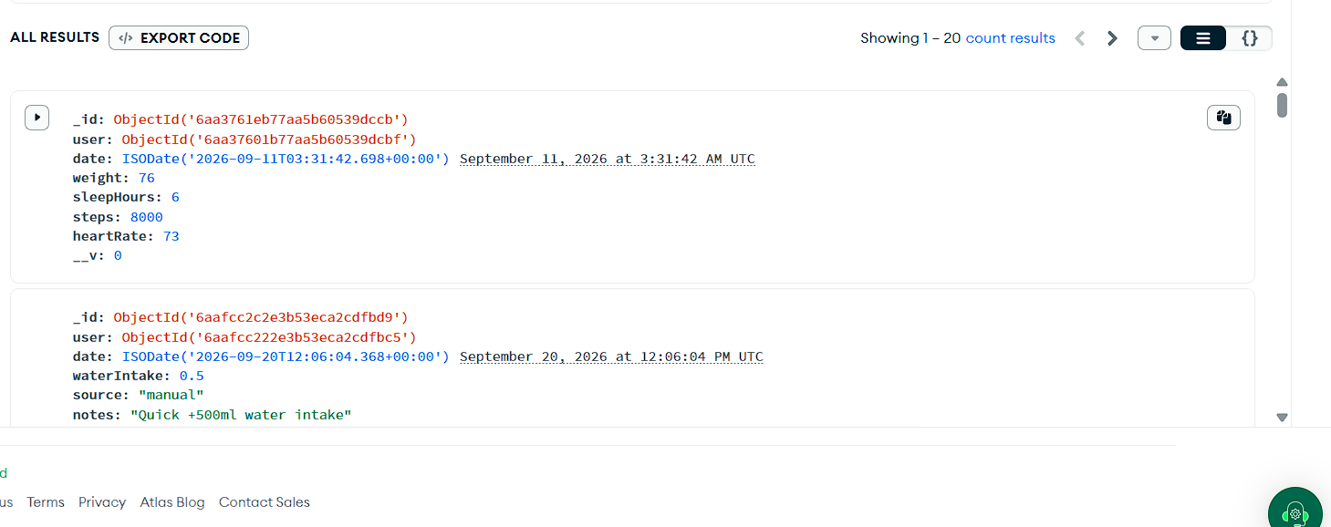

Fig. 9. Q3: most eaten foods ($unwind on embedded items)
Collection nutritionlogs → Aggregations. Each embedded food item becomes its own row, then the rows are grouped by food name.
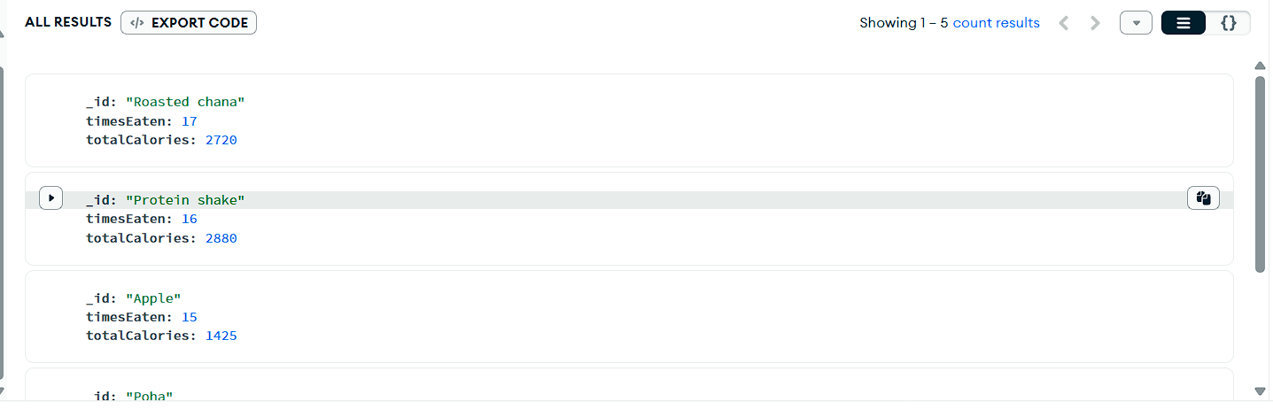
[
{ $unwind: "$items" },
{ $group: { _id: "$items.name", timesEaten: { $sum: 1 }, totalCalories: { $sum: "$items.calories" } } },
{ $sort: { timesEaten: -1 } },
{ $limit: 5 }
]

Fig. 10. Q4: goals with their owner ($lookup join)
Collection academicgoals → Aggregations. Joins each goal with its user from the users collection.
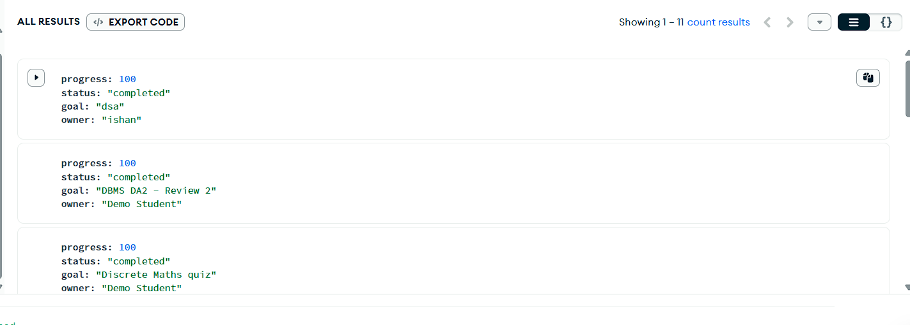
[
{ $lookup: { from: "users", localField: "user", foreignField: "_id", as: "owner" } },
{ $unwind: "$owner" },
{ $project: { _id: 0, goal: "$title", status: 1, progress: 1, owner: "$owner.name" } },
{ $sort: { progress: -1 } }
]

Fig. 11. Q5: full-text search in the document vault
Collection documents → Aggregations. Uses the text index from Fig. 4 and ranks results by relevance score.
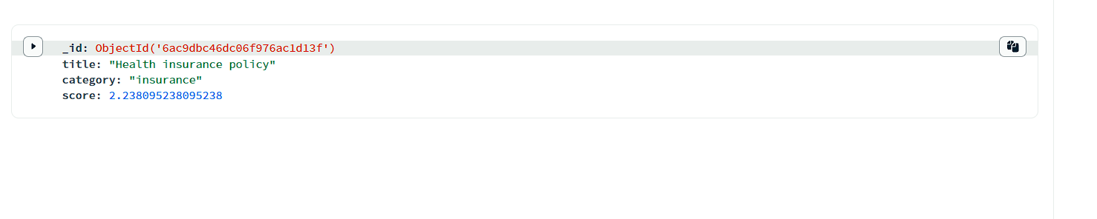
[
{ $match: { $text: { $search: "insurance" } } },
{ $project: { title: 1, category: 1, score: { $meta: "textScore" } } },
{ $sort: { score: { $meta: "textScore" } } }
]

Fig. 12. Documents sorted by expiry date
Collection documents → Aggregations. The query behind the expiry alerts.
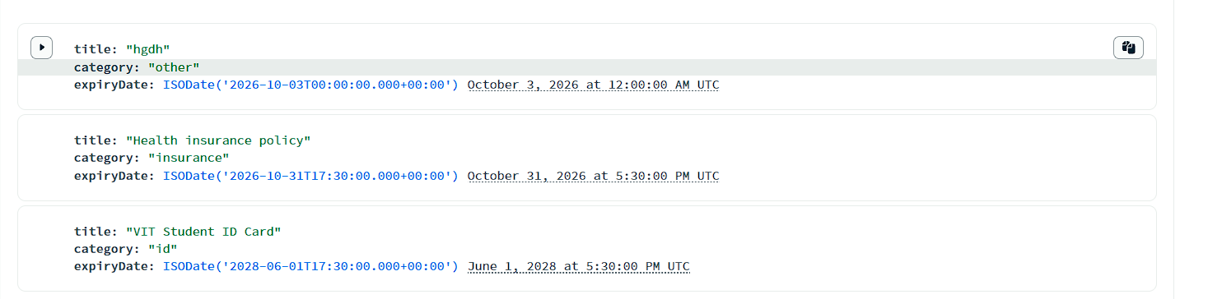
[
{ $match: { expiryDate: { $exists: true } } },
{ $project: { _id: 0, title: 1, category: 1, expiryDate: 1 } },
{ $sort: { expiryDate: 1 } }
]

Fig. 13. Q6 (before): goal with embedded milestones
Collection academicgoals → Find → Filter. The milestone "Deadlocks" is completed: false.
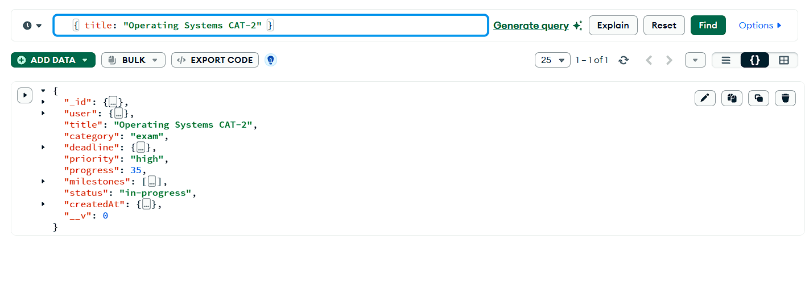
{ title: "Operating Systems CAT-2" }

Fig. 14. Q6 (after): completed milestones counted from the array
Collection academicgoals → Aggregations. After the update, 2 of the 3 milestones are complete.
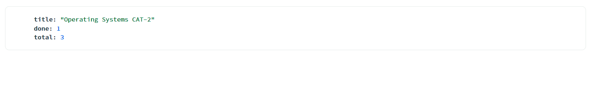
[
{ $match: { title: "Operating Systems CAT-2" } },
{ $project: {
_id: 0, title: 1,
done: { $size: { $filter: { input: "$milestones", cond: "$$this.completed" } } },
total: { $size: "$milestones" } } }
]

Fig. 15. Q7: goals per status
Collection academicgoals → Aggregations. The goal count and average progress for each status.
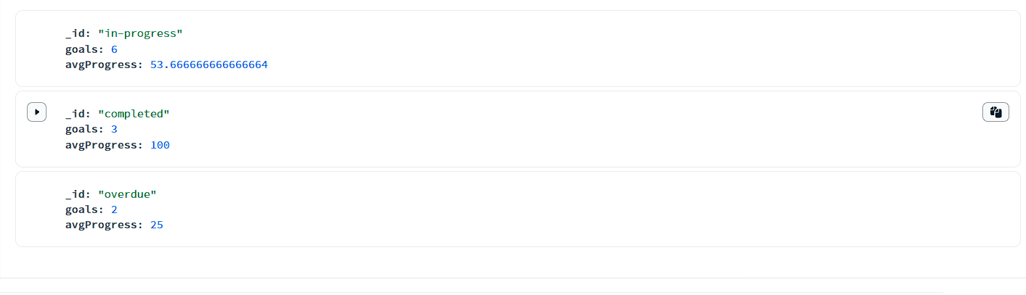
[
{ $group: { _id: "$status", goals: { $sum: 1 }, avgProgress: { $avg: "$progress" } } },
{ $sort: { goals: -1 } }
]

Results
- Sleep and activity move together. The low-sleep logs (Fig. 5) and the sleep-quality groups (Fig. 8) show fewer steps and a higher heart rate when sleep is poor. Linking signals like this is what the digital twin is built for.
- Indexes. The unique email_1 index answers a login lookup by examining 1 document (Fig. 6). A lookup on the unindexed name field scans the whole collection (Fig. 7).
- Embedded documents. Meal items stay fully queryable through $unwind (Fig. 9). One milestone changes in a single atomic write, and the array can be counted in place (Figs. 13, 14).
- Joins and flexible schema. $lookup links goals to their owners (Fig. 10). Text search ranks documents by relevance (Fig. 11).

7. Limitations and future scope
Limitations
Area | Limitation | Impact
Joins | The app's health ↔ nutrition $lookup compares computed day strings, so it cannot use the nutritionlogs index | Fine for one user's 30 days; slow across many users or years
Academic index | academicgoals has no {user, deadline} index yet | Goal queries scan all of a user's goals (small today)
Wearables | Fitbit / HealthKit sync is simulated, not a real OAuth integration | Data must be typed in or simulated
OCR | The ocrText field exists, but nothing fills it automatically | Search covers only title, tags and any text typed in
File storage | Uploads sit on the API server's disk | Lost if the server is redeployed; does not scale across servers
AI agent | Needs a Gemini key and internet; free-tier rate limits apply | Falls back to rule-based answers
Testing | No automated test suite or CI | Regressions are caught by hand
Branches | Harsh's academic-dashboard / frontend-h work is not yet merged into main | Goal-filter UI and DA2 evidence live on a side branch
Future scope
- Store a day field (IST date string) on each log, indexed with user. That lets $lookup use plain localField / foreignField with an index.
- Add {user:1, deadline:1} on academicgoals, and a TTL index that clears expired agentactions automatically.
- Move uploads to MongoDB GridFS or cloud object storage, and run OCR (e.g. Tesseract) on upload to fill ocrText.
- Use MongoDB time-series collections for healthmetrics, and Atlas Charts or $setWindowFields for moving averages.
- Add Atlas Search for fuzzy, typo-tolerant document search, and vector search so the AI twin can find relevant notes.
- Add real Fitbit and Google Fit OAuth sync, push reminders, and a mobile app (React Native) on the same API.
- Add Jest + Supertest API tests against an in-memory MongoDB, a GitHub Actions CI, and a deployment (Render / Vercel + Atlas).

8. Individual contributions
Roles follow the DA2 plan. The counts come from git log --all on the GitHub repository; the full commit table is in docs/PROJECT_EVIDENCE_LOG.md.
Member | Role | Commits | Key commits
Ishan Kumar | Backend & Database | 16 + 2 merges | b9d29ed initial project · 22a29ec JWT security · 5ac989e insights, milestones, secure documents · e796f72 Gemini agent · c79991c redesign · 4653b49 PR #1 merge
Harsh Choudhary | Frontend: Academic & Dashboard | 6 | 3a296b8 Academic page redesign · 96948fb dashboard stats · fb66857 responsive styling · 4a2ce06 goal delete/filter · 29af6a1 DA2 evidence
Mudit Jayesh | Frontend: Health & Nutrition | 8 | 8375644 health trend pipeline · 9bc31c9 alerts + wearable sync · 6142b85 meal items[] · 26b1e37 7-day nutrition aggregation · f18afd1 dashboard command center
Ishan Kumar (24BCE1563)
- Designed the MongoDB schema: 8 collections, embedding decisions, compound, text and unique indexes. Set up Atlas.
- Built the Express API: auth with JWT and bcrypt, ownership checks on every route, central error handling, secure file streaming.
- Wrote the aggregation-based insights engine and wellness score, plus the dashboard, health and nutrition API improvements.
- Built the Gemini agent: 12 tools, the agentactions confirm flow, retries and model fallback.
- Merged the team's branches (resolved 7 conflicting files, PR #1). Did the UI redesign and blurred backdrop.
- DA3: seed.js, queries.js, the evidence log, the README and this report.
Harsh Choudhary
- Redesigned the Academic goals page and improved the goals module.
- Built the dashboard statistics and responsive styling.
- Added the goal deletion endpoint, goal filtering and the quick water-log button.
- Prepared the DA2 evidence report.
Mudit Jayesh
- Health page: expanded schema and form fields, alerts engine, simulated Fitbit / HealthKit sync.
- Wrote the 7- and 30-day health trend aggregation (GET /api/health/trends).
- Nutrition: embedded multi-item meals, calories remaining, macro split, 7-day history aggregation.
- Dashboard command center: alerts banner, quick actions, activity feed.

9. Repository deliverables
The source code is at github.com/ishaaan0310/Synapse. Setup and run steps are in its README.md.
Item | Path
Sample dataset script | backend/scripts/seed.js
Query script (Q0–Q7 + explain) | backend/scripts/queries.js
Project evidence log | docs/PROJECT_EVIDENCE_LOG.md
Setup and run steps | README.md

