Experiment Title:
Multi Client Communication using TCP and UDP in ns-3
Name: Ishan Kumar
Registration number:24bce1563
Slot:F2
Course: Computer Networks Lab

Submitted to:
Dr.Subbulakshmi T

AIM
To simulate multi-client communication using TCP and UDP protocols in ns-3 and analyze network performance using FlowMonitor.

OBJECTIVES
- To implement multi-client communication
- To compare TCP and UDP protocols
- To measure throughput and delay
- To simulate client-server interaction

THEORY
. TCP

Transmission Control Protocol is a reliable, connection-oriented protocol that ensures data delivery with error checking and retransmission.

. UDP

User Datagram Protocol is a connectionless protocol that provides fast communication but does not guarantee delivery.

. ns-3

ns-3 is a discrete-event network simulator used to model and analyze network systems.

. FlowMonitor

FlowMonitor is used to measure network performance metrics such as throughput, delay, and packet loss.

EXPERIMENT 1
Multi-client TCP Communication
🔹 Description
In this experiment, multiple clients send data to a server using TCP protocol. Each client is connected to the server using point-to-point links.
🔹 Algorithm
- Create multiple client nodes and one server node
- Connect each client to server using point-to-point links
- Install internet stack
- Assign IP addresses
- Install PacketSink on server
- Install OnOff applications on clients
- Run simulation

CODE

#include "ns3/core-module.h"
#include "ns3/network-module.h"
#include "ns3/internet-module.h"
#include "ns3/point-to-point-module.h"
#include "ns3/applications-module.h"

using namespace ns3;

int main() {
NodeContainer clients;
clients.Create(3);

NodeContainer server;
server.Create(1);

NodeContainer all;
all.Add(clients);
all.Add(server);

PointToPointHelper p2p;
p2p.SetDeviceAttribute("DataRate", StringValue("5Mbps"));
p2p.SetChannelAttribute("Delay", StringValue("2ms"));

NetDeviceContainer devices = p2p.Install(all);

InternetStackHelper stack;
stack.Install(all);

Ipv4AddressHelper address;
address.SetBase("10.1.1.0", "255.255.255.0");
Ipv4InterfaceContainer interfaces = address.Assign(devices);

uint16_t port = 8080;

// Server
PacketSinkHelper sink("ns3::TcpSocketFactory",
InetSocketAddress(Ipv4Address::GetAny(), port));
ApplicationContainer serverApp = sink.Install(server.Get(0));
serverApp.Start(Seconds(1.0));
serverApp.Stop(Seconds(10.0));

// Clients
for (int i = 0; i < 3; i++) {
OnOffHelper client("ns3::TcpSocketFactory",
InetSocketAddress(interfaces.GetAddress(3), port));

client.SetAttribute("DataRate", StringValue("1Mbps"));
client.SetAttribute("PacketSize", UintegerValue(1024));

ApplicationContainer app = client.Install(clients.Get(i));
app.Start(Seconds(2.0 + i));
app.Stop(Seconds(10.0));
}

Simulator::Run();
Simulator::Destroy();
}

OUTPUT
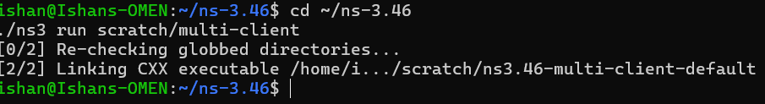

EXPERIMENT 2
Multi-client TCP & UDP with Performance Measurement
🔹 Description

This experiment extends the previous simulation by including both TCP and UDP protocols and measuring performance using FlowMonitor.

🔹 Algorithm
Create nodes (clients + server)
Connect using point-to-point links
Assign IP addresses
Select protocol (TCP/UDP)
Install applications
Install FlowMonitor
Run simulation
Calculate throughput and delay
🔹 Code
#include "ns3/core-module.h"
#include "ns3/network-module.h"
#include "ns3/internet-module.h"
#include "ns3/point-to-point-module.h"
#include "ns3/applications-module.h"
#include "ns3/flow-monitor-module.h"

using namespace ns3;

int main(int argc, char *argv[]) {
bool useUdp = false;

CommandLine cmd;
cmd.AddValue("useUdp", "Use UDP instead of TCP", useUdp);
cmd.Parse(argc, argv);

std::cout << (useUdp ? "Running UDP Simulation\n" : "Running TCP Simulation\n");

// Nodes
NodeContainer clients;
clients.Create(3);
NodeContainer server;
server.Create(1);

InternetStackHelper stack;
stack.Install(clients);
stack.Install(server);

PointToPointHelper p2p;
p2p.SetDeviceAttribute("DataRate", StringValue("5Mbps"));
p2p.SetChannelAttribute("Delay", StringValue("2ms"));

// Links
NetDeviceContainer d1 = p2p.Install(clients.Get(0), server.Get(0));
NetDeviceContainer d2 = p2p.Install(clients.Get(1), server.Get(0));
NetDeviceContainer d3 = p2p.Install(clients.Get(2), server.Get(0));

Ipv4AddressHelper address;

address.SetBase("10.1.1.0", "255.255.255.0");
Ipv4InterfaceContainer i1 = address.Assign(d1);

address.SetBase("10.1.2.0", "255.255.255.0");
Ipv4InterfaceContainer i2 = address.Assign(d2);

address.SetBase("10.1.3.0", "255.255.255.0");
Ipv4InterfaceContainer i3 = address.Assign(d3);

uint16_t port = 8080;
std::string protocol = useUdp ? "ns3::UdpSocketFactory" : "ns3::TcpSocketFactory";

// Server
PacketSinkHelper sink(protocol,
InetSocketAddress(Ipv4Address::GetAny(), port));

ApplicationContainer serverApp = sink.Install(server.Get(0));
serverApp.Start(Seconds(1.0));
serverApp.Stop(Seconds(10.0));

// Clients
OnOffHelper client1(protocol, InetSocketAddress(i1.GetAddress(1), port));
client1.SetAttribute("DataRate", StringValue("1Mbps"));
client1.SetAttribute("PacketSize", UintegerValue(1024));
ApplicationContainer app1 = client1.Install(clients.Get(0));
app1.Start(Seconds(2.0));
app1.Stop(Seconds(10.0));

OnOffHelper client2(protocol, InetSocketAddress(i2.GetAddress(1), port));
client2.SetAttribute("DataRate", StringValue("1Mbps"));
client2.SetAttribute("PacketSize", UintegerValue(1024));
ApplicationContainer app2 = client2.Install(clients.Get(1));
app2.Start(Seconds(3.0));
app2.Stop(Seconds(10.0));

OnOffHelper client3(protocol, InetSocketAddress(i3.GetAddress(1), port));
client3.SetAttribute("DataRate", StringValue("1Mbps"));
client3.SetAttribute("PacketSize", UintegerValue(1024));
ApplicationContainer app3 = client3.Install(clients.Get(2));
app3.Start(Seconds(4.0));
app3.Stop(Seconds(10.0));

// Flow Monitor
FlowMonitorHelper flowmon;
Ptr<FlowMonitor> monitor = flowmon.InstallAll();

std::cout << "Simulation started...\n";

// CRITICAL FIX
Simulator::Stop(Seconds(10.0));

Simulator::Run();

std::cout << "Simulation finished!\n";

// Results
monitor->CheckForLostPackets();

Ptr<Ipv4FlowClassifier> classifier =
DynamicCast<Ipv4FlowClassifier>(flowmon.GetClassifier());

auto stats = monitor->GetFlowStats();

for (auto &flow : stats) {
Ipv4FlowClassifier::FiveTuple t = classifier->FindFlow(flow.first);

std::cout << "\n=============================\n";
std::cout << "Flow ID: " << flow.first << std::endl;
std::cout << "Source: " << t.sourceAddress << std::endl;
std::cout << "Destination: " << t.destinationAddress << std::endl;

std::cout << "Tx Bytes: " << flow.second.txBytes << std::endl;
std::cout << "Rx Bytes: " << flow.second.rxBytes << std::endl;

double time = flow.second.timeLastRxPacket.GetSeconds() -
flow.second.timeFirstTxPacket.GetSeconds();

double throughput = (flow.second.rxBytes * 8.0) / time / 1024;

std::cout << "Throughput: " << throughput << " Kbps" << std::endl;

std::cout << "Delay: "
<< flow.second.delaySum.GetSeconds() << " sec" << std::endl;
}

Simulator::Destroy();
}

OUTPUT

1.TCP OUTPUT

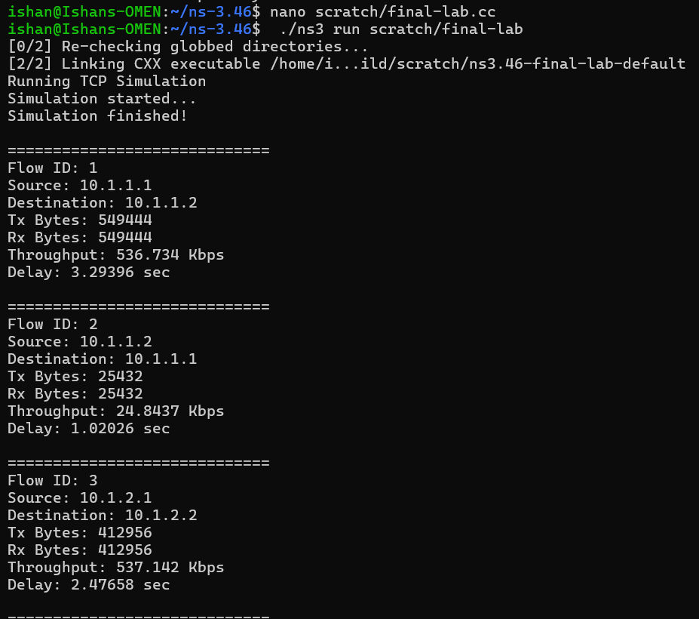
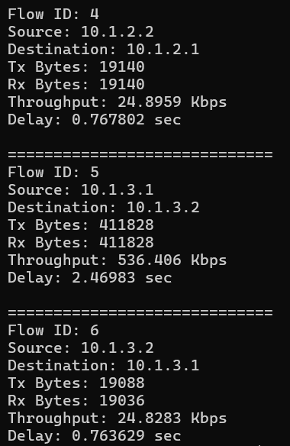

2.UDP OUTPUT
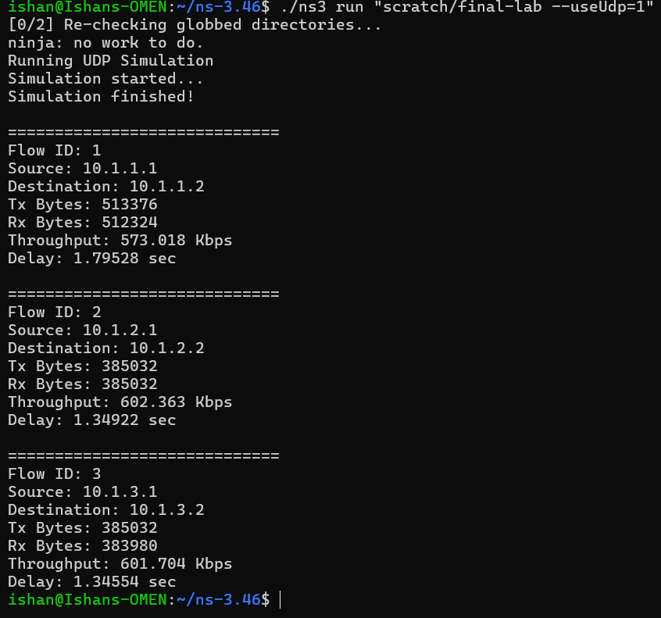

PERFORMANCE ANALYSIS
🔹 Throughput
- Represents data transfer rate
- Higher throughput indicates better performance
🔹 Delay
- Represents time taken for packet delivery
- Lower delay indicates better performance
🔹 Observation
- TCP has higher reliability but slightly more delay
- UDP has lower delay but less reliability

CLIENT-SERVER CALCULATION
In ns-3, client-server interaction is simulated using packet transmission. The client sends data packets, and the server receives and processes them logically.
RESULT
Thus, multi-client communication using TCP and UDP protocols was successfully simulated in ns-3 and network performance was analyzed using FlowMonitor.
CONCLUSION
- TCP provides reliable communication
- UDP provides faster communication
- ns-3 effectively simulates network behavior
- FlowMonitor helps evaluate performance

