A Report

on

LifeLink: Secure API-Driven Multichannel
Organ Pledge Registry

carried out as part of the course Project Based Learning- 2
Submitted by

Isha Negi

2427030834

IV Semester

in partial fulfilment for the award of the degree

of

BACHELOR OF TECHNOLOGY

In

Computer Science & Engineering



Department of Computer Science & Engineering,
School of Computer Science and Engineering,
Manipal University Jaipur,
Jan-May 2026

A Report

on

LifeLink: Secure API-Driven Multichannel
Organ Pledge Registry

carried out as part of the course Project Based Learning-2
Submitted by

Isha Negi

2427030834

IV Semester

in partial fulfilment for the award of the degree

of

BACHELOR OF TECHNOLOGY

In

Computer Science & Engineering

Under the Guidance of :

Guide Name : Dr. Bali Devi

Guide Signature(with date) : ………………………………………

Acknowledgement

This project would not have been completed without the help, support, comments, advice, cooperation and coordination of various people. However, it is impossible to thank everyone individually; I am hereby making a humble effort to thank some of them.

I acknowledge and express my deepest sense of gratitude to my internal supervisor Dr. Bali Devi for her constant support, guidance, and continuous engagement. I highly appreciate his technical comments, suggestions, and criticism during the progress of this project titles “LifeLink : Secure API-driven Multichannel Organ Pledge Registry”.

I owe my profound gratitude to Dr. Neha Chaudhary , Head, Department of CSE, for her valuable guidance and for facilitating me during my work. I am also very grateful to all the faculty members and staff for their precious support and cooperation during the development of this project.

Finally, I extend my heartfelt appreciation to my classmates for their help and encouragement.

Isha Negi

2427030834



Department of Computer Science and Engineering
School of Computer Science and Engineering

Date: _____________

CERTIFICATE

This is to certify that the project entitled “LifeLink : Secure API-driven Multichannel Organ Pledge Registry" is a bonafide work carried out as PBL-2 End Term Assessment in partial fulfillment for the award of the degree of Bachelor of Technology in Computer Science and Engineering, by Isha Negi bearing registration number 2427030834, during the academic semester IV of year 2025-2026.

Place: Manipal University Jaipur, Jaipur

Name of the project guide: Dr. Bali Devi

Signature of the project guide: ______________________

ABSTRACT

Organ donation has the potential to save thousands of lives, yet donor registration and confirmed pledges in India remain critically low compared to the population and the demand for transplants. A key gap exists at the start of the donation chain—pledging—where reliance on a limited set of standalone web portals, low awareness, and lack of convenient registration touchpoints lead to poor conversion of willing donors into registered pledgers. In addition, even when a pledge is recorded, later family refusal can occur when family members are unaware of the donor’s intent.

This report presents LifeLink, a secure API-driven multichannel Organ Pledge Registry prototype designed to increase outreach and convenience by enabling multiple digital channels to submit pledges to a single central registry without local storage. The proposed design includes a two-level integration model (government service integrations via APIs and institution-led redirection without data handling), an audit and traceability framework to improve trust, analytics for monitoring channel impact, and notification workflows that inform family members at the time of pledging to reduce the risk of future refusal. The current phase (Semester IV) focuses on system workflow design, detailed database schema and initial HTML forms design and implementation. The backend coding and database creation and integration are planned as next steps.

Contents
Page No.

Certificate

Abstract

Table of Contents
1. Introduction 1
1.1. Objective of the project 1
1.2. Brief description of the project 2
1.3. Technology used 3
1.3.1. H / W Requirement 3
1.3.2. Software Requirement 3
1.4. Organization Profile 3
2. Design Description 4
2.1 Flow Chart 4
2.2 Data Flow Diagrams(DFDs) 4
2.3 Entity Relatoinship Diagram(E-R Diagram) 5
3. Project Description 5
3.1 Data Base 5
3.2 Table Description 5
3.3 File/Database Design 9
4. Input/Output Form Design 9
5. Testing & Tools used 11
6. Implementation & Maintenance 11
7. Conclusion and Future Work 11
8. Outcome 11
9. Bibliography 11

Introduction

Organ donation saves lives, but in India—the gap between willingness to donate and actual donations remains large. National Organ and Tissue Transplant Organisation (NOTTO) is India’s central donor registry.
The donor registration/pledging is very low, leading to very low actual transplants. [1]
- Population of India - 1.4 billion
- Pledges registered with NOTTO - 487,898 (~0.03% of population) [2]
- Approximate no. of deaths annually – 9.5 million. It includes 150,000 brain deaths (majority 18–35 age group)
- <1% of potential brain deaths convert to actual donation
Figure 1: Pledging
- People waiting for transplant - 500000
- Transplant – 18911 in 2024 NOTTO Report [3]
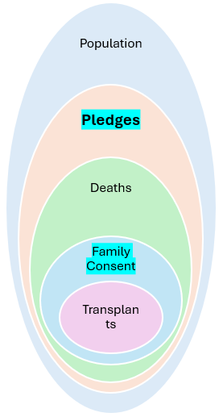
This project focuses on start of the organ donation chain i.e. pledging with a thought that input drives the output. Other parts of the chain are out of scope of this project.

Objective of the project

Current organ donor registration/pledging systems in India suffers from below key structural problems -
- Passive standalone and static (not event driven) Single primary pledge channel through NOTTO/NGO/State websites
- No multi-touch point government/public integration leading to pledging like Driving License integration, ABHA integration (Ayushman Bharat Health Account), Passport Seva integration, ITR filing integration.
- Low awareness and accessibility; unawareness of process and entry points
- Family override problem - Even if pledged, family refusal rate remains high, mainly because families are often unaware of pledge. Indian law mandates family consent, even if the deceased had pledged.
This project proposes to address these reasons to increase number of pledges and hence increase the donor pool, which in turn will increase transplants.

Pledges registered with India’s NOTTO are very low (~0.03%) [2] There are multiple factors affecting [4] it – outreach and convenience of process, belief [5], personal values, legal, ethical etc.
Other Opt-in countries have much higher donor registrations e.g. USA - 51%; Australia - 36%, Israel – 10%, India – 0.03%
Channels for pledging other that state registry websites –
- USA – Driving license registration, Apple Health app, Healthcare portals, Tax filing (in some states)
- Australia - Driving license registration, Medicare enrollment
- Canada - Driving license registration, Health card renewal, Health insurance portals
Multiple integrated pathways for organ donation registration increases overall reach and convenience and lead to higher registered donor numbers than relying on single channel. [6]
Use of online platforms and social media increases engagement & donor registrations. [7] Increasing donor registrations as a means to increase transplants. Annual Data Report also shows More Donors → More Transplants
One of the Causes of family refusal for organ donation is lack of awareness regarding the patient’s wishes about donation. [8]
This project implements notification to the family member at the time of pledging, thus reducing the chances of refusal to organ donation later.
Objective for semester IV is to design workflow, database schema and HTML forms.

Brief description of the project

Absence of multiple digital channels integrated with organ donation registration system is major cause of critically low number of registrations because it reduces participation and conversion of willing individuals into confirmed pledgers. This limits the pool of potential donors despite high transplant demands
Also, Lack of knowledge of patient’s pledge leads to family refusal for organ donation.
This project aims at increasing donation pledges using digital engineering by increasing outreach and convenience of the pledging process as a part of actions they already perform, to attack the problem at the root.
More Donor Registrations → More Transplants
This project is targeted to develop a prototype for API-driven multichannel organ pledging system with following objectives –
- Develop a secure API-driven digital organ pledge central registry to streamline and verify online pledge submissions, addressing the low number of registered donors. Central registry is the only pledge data store.
- Design a two-level multi-channel integration model to spread outreach and overcome limited accessibility caused by single-source registration. Designing data handling as per the law and policy
  - National level - Government services platforms submit pledge data directly to the central registry via APIs without local storage (Government policy-driven)
  - Local level - Institution-led pledge facilitation model through redirection without any data handling (Institutional/corporate authorities driven)
- Design and implement an audit and traceability framework to maintain transparent record-keeping, addressing trust gaps in digital organ pledging systems.
- Incorporate analytics and reporting modules to monitor pledge trends and channels impact, supporting data-driven strategies

Technology used

H / W Requirement

Not Applicable

Software Requirement

- Simulated RTO and local institution portal – HTML, JavaScript
- REST APIs over HTTPs, JWT with JSON payload
- Database - SQLite
- Registry Frontend – HTML + JavaScript
- Registry Backend – Python/Flask

Organization Profile

Not Applicable

Design Description

Flow Chart

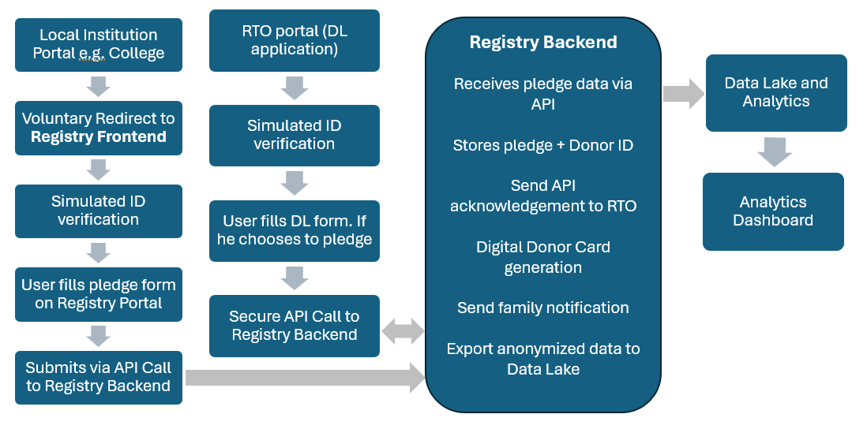
Figure 2: Workflow of organ pledging registry

Data Flow Diagrams(DFDs)

The pledge data will follow the path as depicted in the above workflow. While data enters the data lake, it will be anonymized.

Entity Relatoinship Diagram(E-R Diagram)

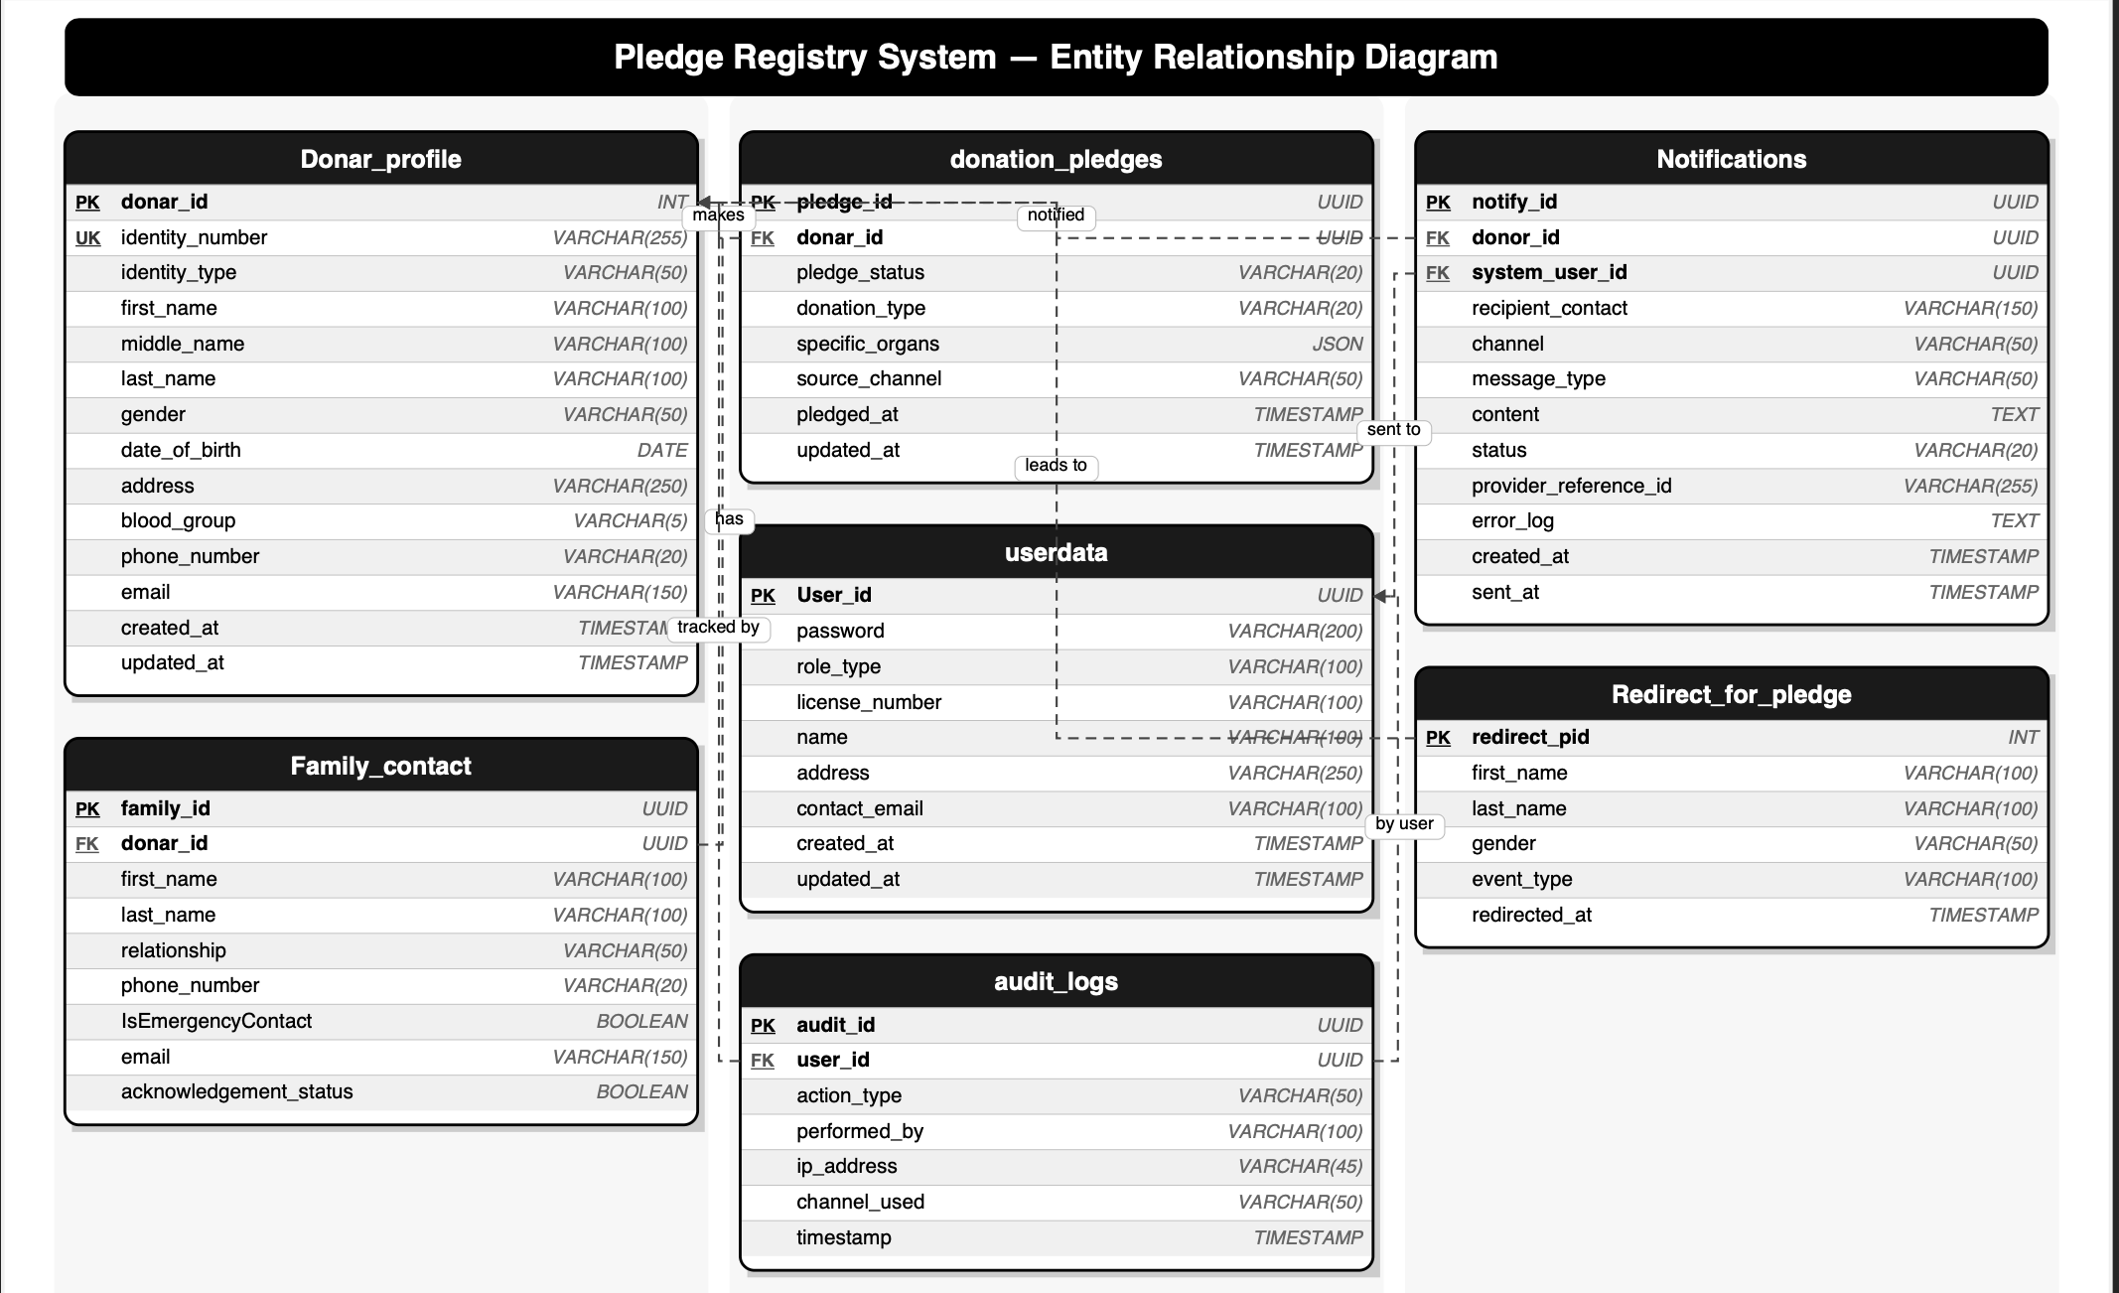

Project Description

Data Base

This prototype will use SQLite.

Table Description

Table 1 : donar_profile table schema
Column Name | Data Type | Constraints | Description
donar_id | INT | PRIMARY KEY | Unique identifier for the user.
identity_number | VARCHAR(255) | UNIQUE, NOT NULL | National ID (e.g., Aadhaar, DL). Must be encrypted/hashing
identity_type | VARCHAR(50) | NOT NULL | Type of ID (e.g., 'PASSPORT', 'DL').
first_name | VARCHAR(100) | NOT NULL | first name.
middle_name | VARCHAR(100) |  | middle name.
last_name | VARCHAR(100) | NOT NULL | last name.
Father's/Husband's name | VARCHAR(100) | NOT NULL | Father's/Husband's name
Mother's name | VARCHAR(100) | NOT NULL | Mother's name
gender | VARCHAR(50) |  | Gender
date_of_birth | DATE | NOT NULL | Used to verify legal age of consent.
address | VARCHAR(250) |  | address
blood_group | VARCHAR(5) |  | e.g., 'O+', 'AB-'.
phone_number | VARCHAR(20) | NOT NULL | Primary contact number.
email | VARCHAR(150) |  | Email for notifications.
created_at | TIMESTAMP | DEFAULT NOW() | Record creation date and time
updated_at | TIMESTAMP | DEFAULT NOW() | Last update timestamp.

Table 2 : family_contact table schema
Column Name | Data Type | Constraints | Description
family_id | UUID | PRIMARY KEY | Unique identifier of family member for notification
donar_id | UUID | FOREIGN KEY, NOT NULL | Links to donar_id in donar table
first_name | VARCHAR(100) | NOT NULL | Relative first name.
last_name | VARCHAR(100) | NOT NULL | last name.
relationship | VARCHAR(50) | NOT NULL | e.g., 'SPOUSE', 'PARENT', 'SIBLING'.
phone_number | VARCHAR(20) | NOT NULL | contact number.
IsEmergencyContact | Boolean | Default false | Emergency contact number.
email | VARCHAR(150) |  | contact email.
acknowledgement_status | Boolean | Default false | family acknowledgement status

Table 3 : donation_pledge table schema
Column Name | Data Type | Constraints | Description
pledge_id | UUID | PRIMARY KEY | Unique identifier for the pledge.
donar_id | UUID | FOREIGN KEY, UNIQUE | Links to donar_id (1-to-1 relationship).
pledge_status | VARCHAR(20) | NOT NULL | e.g., 'ACTIVE', 'REVOKED'.
donation_type | VARCHAR(20) | NOT NULL | ALL_ORGANS' or 'SPECIFIC_ORGANS'.
specific_organs | JSON | NULL | Array of specific organs if applicable (e.g., ["HEART", "EYES"]).
source_channel | VARCHAR(50) | NOT NULL | Where the pledge originated (e.g., 'WEB', 'Institute Portal', 'DMV').
pledged_at | TIMESTAMP | DEFAULT NOW() | When the pledge was made.
updated_at | TIMESTAMP | DEFAULT NOW() | When the pledge was last modified.

Table 4 : userdata table schema
Column Name | Data Type | Constraints | Description
User_id | UUID | PRIMARY KEY | Unique identifier.
password | VARCHAR(200) | NOT NULL | encrypted password
role_type | VARCHAR(100) | NOT NULL | e.g. Admin, donar
created_at | TIMESTAMP | DEFAULT NOW() | Record creation timestamp.
updated_at | TIMESTAMP | DEFAULT NOW() | Last update timestamp. E.g. password change

Table 5 : audit_log table schema
Column Name | Data Type | Constraints | Description
audit_id | UUID | PRIMARY KEY | Unique identifier for the log.
user_id | UUID | FOREIGN KEY, NOT NULL | Links to donar_id or user id
action_type | VARCHAR(50) | NOT NULL | e.g., 'PLEDGE_CREATED', 'PLEDGE_REVOKED', 'STATUS_CHECKED'.
performed_by | VARCHAR(100) | NOT NULL | Who triggered it (e.g., 'USER', 'SYSTEM', 'HOSPITAL_ID').
ip_address | VARCHAR(45) |  | IP address of the requester.
channel_used | VARCHAR(50) | NOT NULL | The channel used for the action (e.g., 'WEB_PORTAL').
timestamp | TIMESTAMP | DEFAULT NOW() | Exact time of the action.

Table 6 : notification table schema
Column Name | Data Type | Constraints | Description
notify_id | UUID | PRIMARY KEY | Unique identifier for the notification record.
donor_id | UUID | FOREIGN KEY, NULL | Links to the users (donor) table. NULL if sent to a hospital.
system_user_id | UUID | FOREIGN KEY, NULL | Links to system_users id
recipient_contact | VARCHAR(150) | NOT NULL | The actual phone number or email address the message was sent to.
channel | VARCHAR(50) | NOT NULL | e.g., 'SMS', 'WHATSAPP', 'EMAIL'.
message_type | VARCHAR(50) | NOT NULL | e.g., 'PLEDGE_CONFIRMATION', 'OTP_LOGIN', 'REVOCATION_ALERT'.
content | TEXT | NOT NULL | The actual body of the message sent.
status | VARCHAR(20) | DEFAULT 'PENDING' | e.g., 'PENDING', 'SENT', 'DELIVERED', 'FAILED'.
provider_reference_id | VARCHAR(255) | NULL | The ID returned by email provider for tracking.
error_log | TEXT | NULL | If the status is 'FAILED', store the reason here (e.g., "Invalid phone number").
created_at | TIMESTAMP | DEFAULT NOW() | When the system requested the message to be sent.
sent_at | TIMESTAMP | NULL | The exact time the provider confirmed it was sent out.

Table 7 : redirect_to_pledge table schema
Column Name | Data Type | Constraints | Description
redirect_pid | INT | PRIMARY KEY | Unique identifier for redirect record.
first_name | VARCHAR(100) |  | first name.
last_name | VARCHAR(100) |  | last name.
gender | VARCHAR(50) |  | Gender
event_type | VARCHAR(100) | NOT NULL | e.g. admission, banner, campaign
redirected_at | TIMESTAMP | DEFAULT NOW() | Date and time when redirected to pledge register

File/Database Design

Integrity Constraints: The aove table description also describes referential integrity through foreign keys and specific constraints that prevent invalid data from entering the system.
Performace improvement: Performance optimization will be done through indexing as mentioned below -
CREATE INDEX idx_donar_identity_number ON donar_profile(identity_number);
CREATE INDEX idx_pledges_donar_id ON donation_pledges(donar_id);
CREATE INDEX idx_audit_logs_donar_id ON audit_logs(donar_id);

Input/Output Form Design

Form for organ pledging on Registry Portal
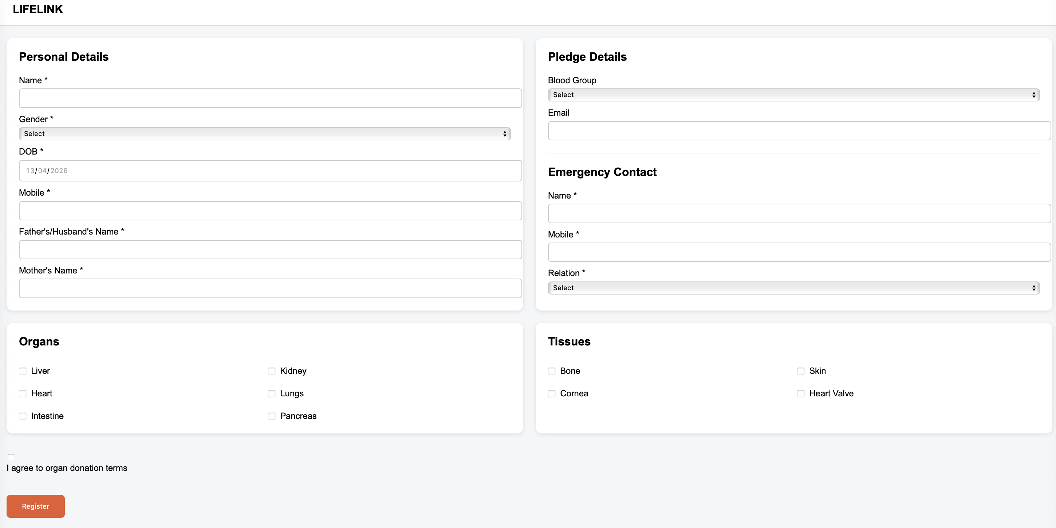

Form for organ pledging on RTP portal
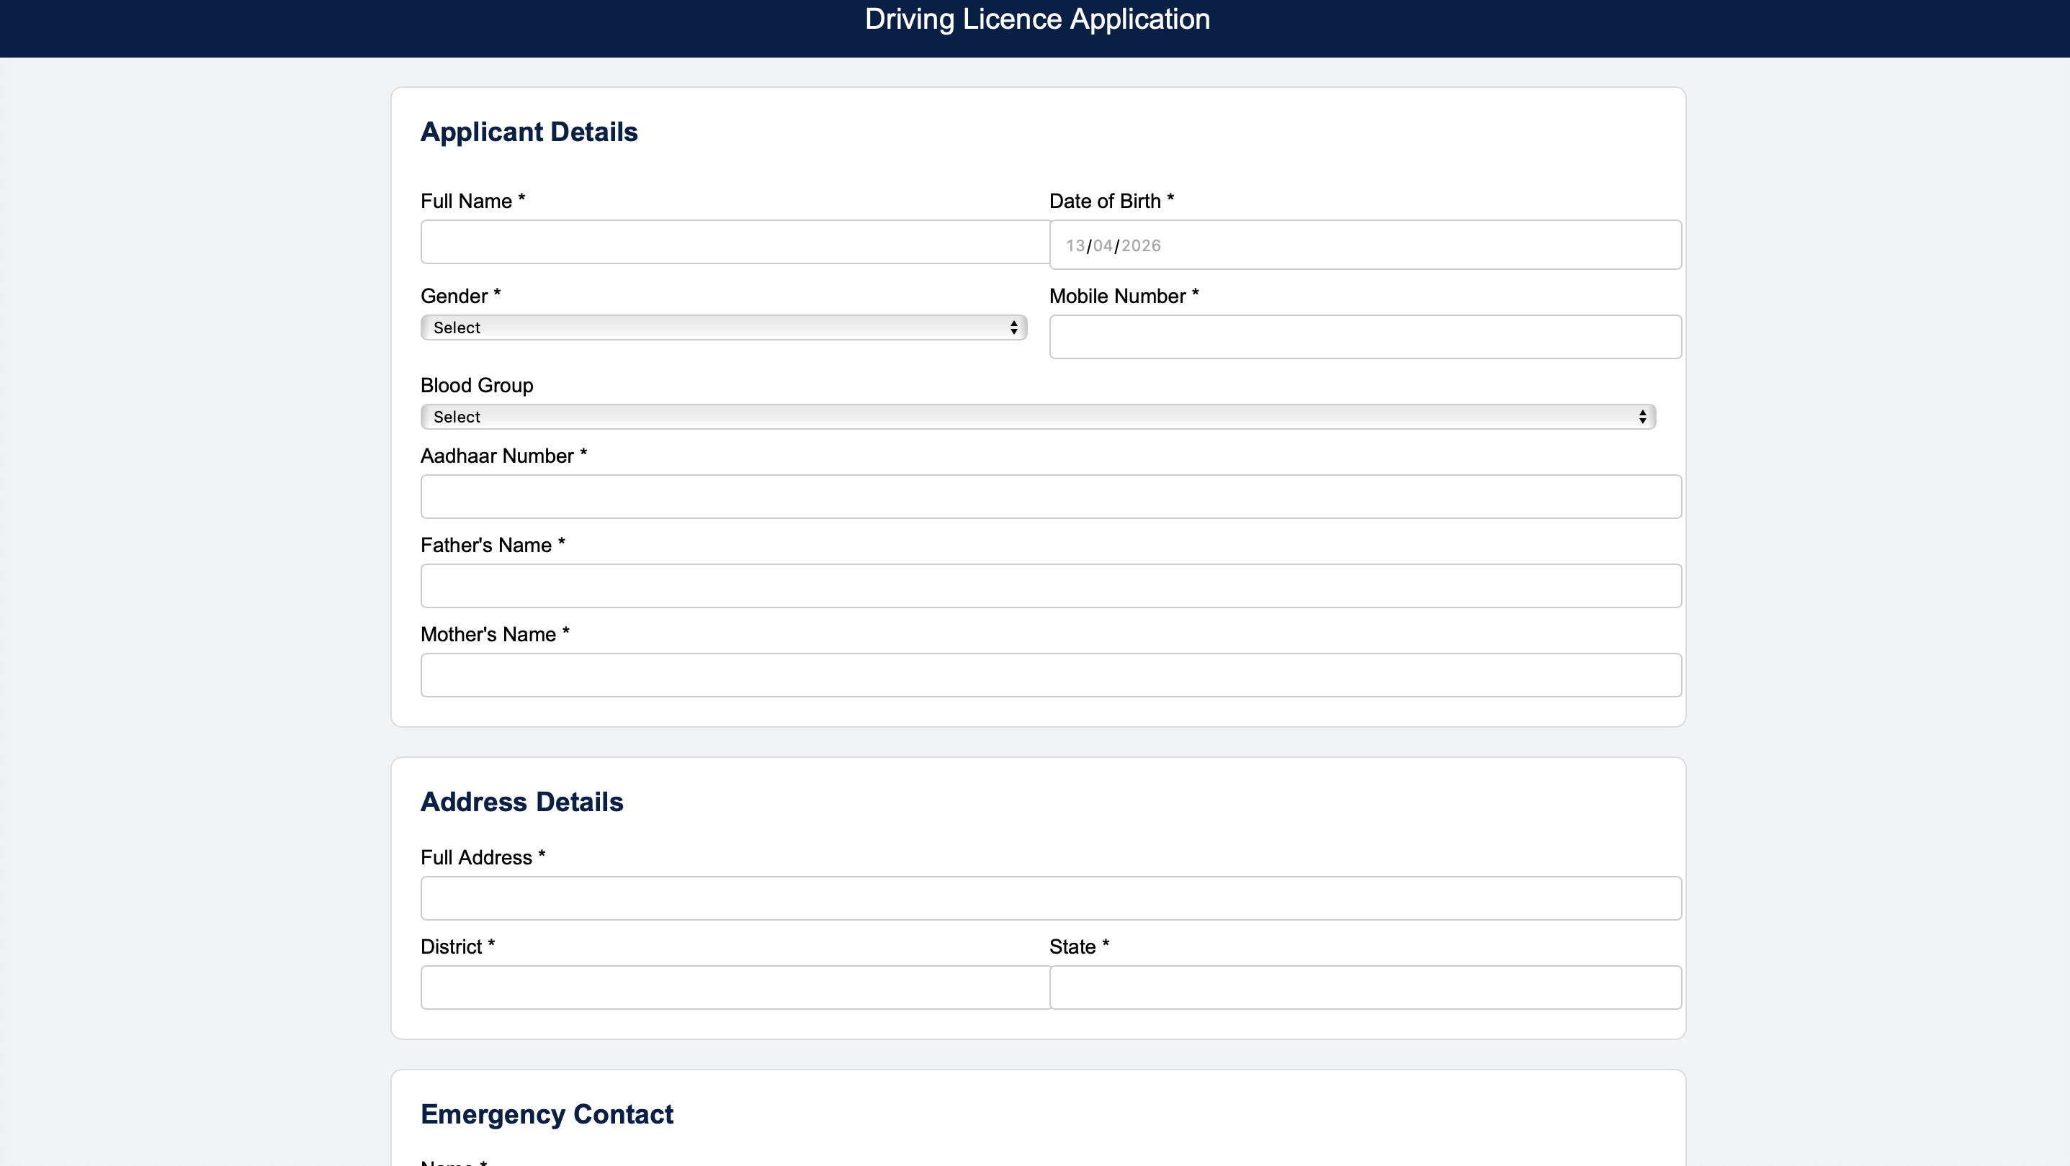
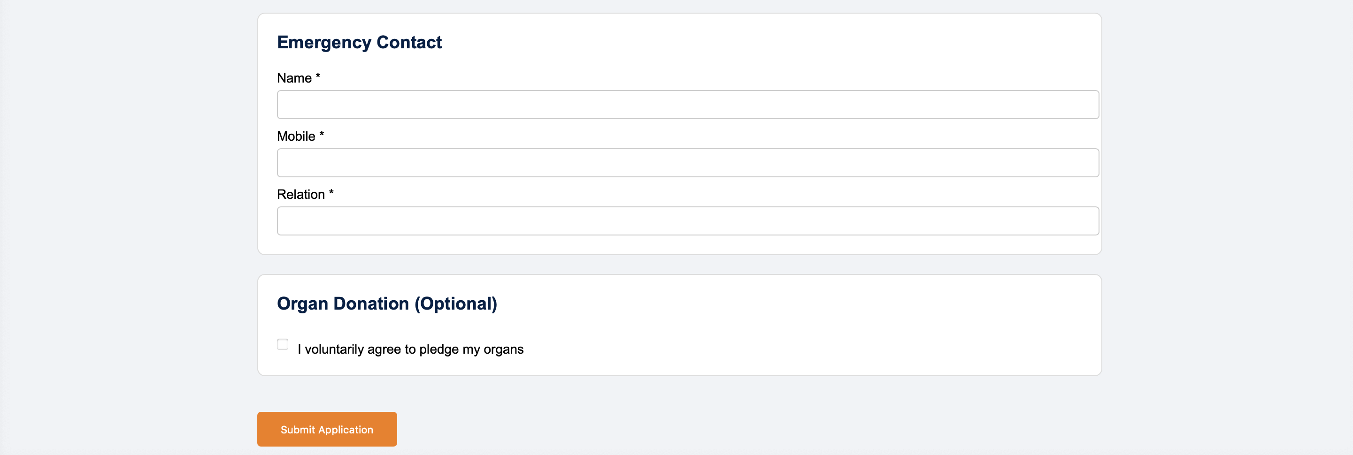

Confrimation of Pledging
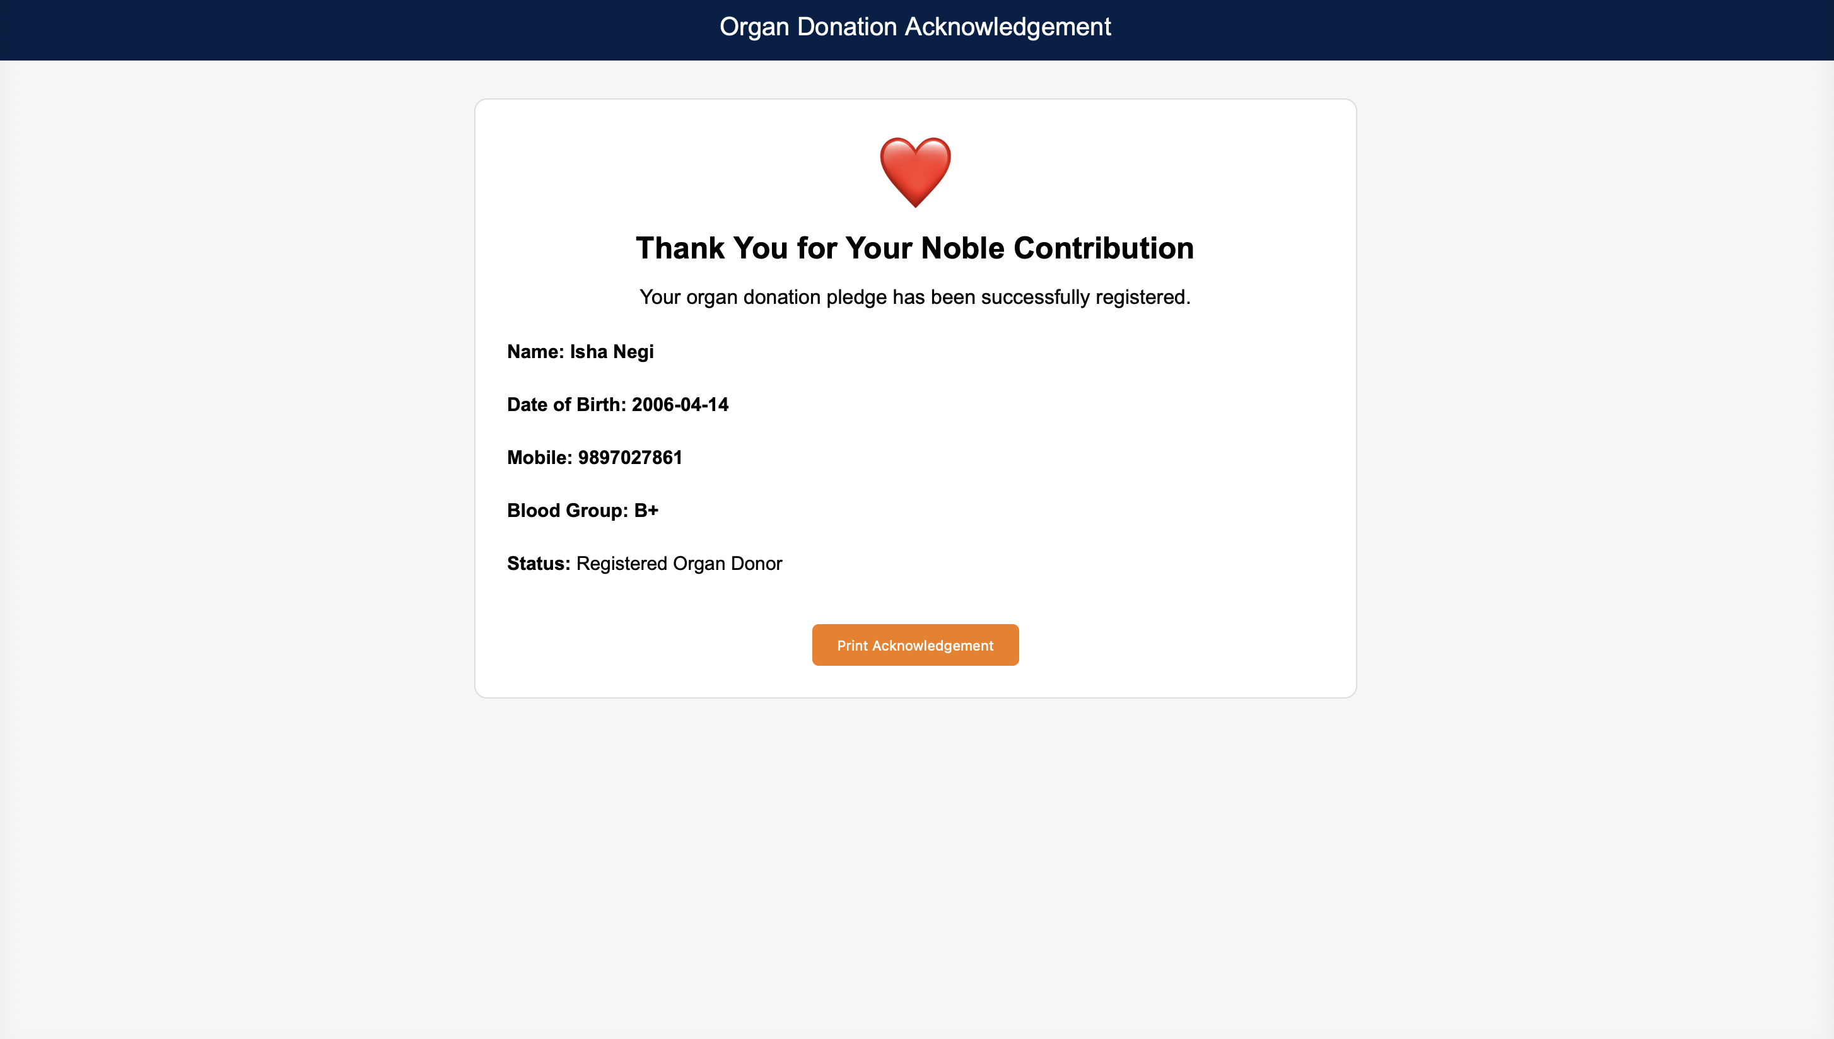

Testing & Tools used

Not applicable at current stage

Implementation & Maintenance

Workflow is designed. Forms are designed and implemented. databased schema design is prepared in detail. Further coding is the next step.

Conclusion and Future Work

A structured prototype, high level system design, workflow and databased schema design is prepared. Forms are designed and implemented. The next phase involves coding and database integration

Outcome

Aiming for -
- Real Time Deployment of prototype – Design completed including database schema. A structured prototype, high level system design, workflow and databased schema design is prepared. Forms are designed and implemented. The next phase involves coding and database integration
- Research Paper – will be done after ptototype is developed

Bibliography

[1] Richharia, Sneha (2025). “ Deceased organ donation alarmingly low in country: NOTTO report” The Tribune, https://www.tribuneindia.com/news/delhi/deceased-organ-donation-alarmingly-low-in-country-notto-report (Aug. 03, 2025).

[2] National Organ and Tissue Transplant Organization (2026), "Organ Pledge Statistics", NOTTO, https://www.notto.mohfw.gov.in/index.htm (Apr. 11, 2026).

[3] National Organ and Tissue Transplant Organization (2025), "Data for Organ Donation and Transplantation (2013-2024) Report", NOTTO, https://www.notto.mohfw.gov.in/WriteReadData/Portal/News/924_1_2013_to_2024.pdf (Apr. 11, 2026)

[4] Mohan, Lalitha and Thanga Panneer Selvam. T. (2020). “Perspective on organ donation in India: A comprehensive review.” Journal of Community Health Management, 7(3):73-76, 2020.

[5] Neha Joe , Shinto Teni Chakala , Farah Fathima and Nachiket Shankar (2024). “Awareness & perceptions about organ donation among patient attendants in a tertiary-care hospital in South India: An observational study.” Indian Journal of Medical Research, 160(6):552-559, Dec 2024.

[6] Walton, Phil; Pérez-Blanco, Alicia; Beed, Stephen; Glazier, Alexandra Esq; Ferreira Salomao Pontes, Daniela; Kingdon, Jennifer; Jordison, Kim ; Weiss, Matthew J (2023), “Organ and Tissue Donation Consent Model and Intent to Donate Registries: Recommendations From an International Consensus Forum”, Transplant Québec, Montréal, QC, Canada, 9(5):p e1416, May 2023.

[7] Michael Stefanone , Ashley E Anker, Melanie Evans, Thomas Hugh Feeley (2012), “Click to "like" organ donation: the use of online media to promote organ donor registration”, Progress in Transplantation, 22(2):168-74, Jun 2012.

[8] Federica De Min, Maria Assunta Donato, Elisa Raimondo, Alessandro Ivan De Martino, Alessia Bresil, Alessandra Agnese Grossi, Martina Baiardo Redaelli, Paolo Severgnini and Luca Cabrini (2025), “Family refusal rates for organ donation after brain death and after circulatory death: a single-center 6-year experience”, Journal of Anesthesia, Analgesia and Critical Care, Volume 5, article number 86, Nov 2025.

[9] UNet Documentation (2026), "Documentation Home Page", UNet Docs, https://docs.unet.com (13 April 2026)

[10] Sanju D. J., Shashank M., Tarun S.V Naik., V. Sai Abhijith., Veeresh C Doddamani (2025), “ Smart Blockchain-Based Organ Donation System for Secure Donor-Recipient Matching”, International Journal for Research in Applied Science & Engineering Technology, 10.51584/IJRIAS.2025.100500092, Jun 2025.

