**Computer Science Project**

Trojan

In python

By

Ishaan Kapoor

**INDEX**

|  |  |  |
| --- | --- | --- |
| Serial  Number | Content | Page no. |
| 1 | *Certificate* | 1 |
| 2 | *Acknowledgement* | 2 |
| 3 | *Software Used* | 3 |
| 4 | *Introduction* | 4 |
| 5 | *Intent* | 5 |
| 6 | *Advantages* | 6 |
| 7 | *Disadvantages* | 7 |
| 8 | *Source Code* | 8 |
| 9 | *Output Screen* | 17 |
| 10 | *Installation Process* | 22 |
| 11 | *Bibliography* | 23 |

**

***CBSE PRACTICAL EXAMINATION, 2020-2021***

***CLASS XII- COMPUTER SCIENCE (083)***

***CERTIFICATE***

*This is to certify that Ishaan Kapoor of Class XII has worked under my supervision and guidance with great interest and has completed the project according to the guidelines provided by the CBSE for 2020-2021. He has taken proper care and shown utmost sincerity in the completion of the project.*

*The work, as well as the conduct of Ishaan Kapoor in completing the project, was praiseworthy.*

*Mr. Prashant Arora Ms. Sangeeta Kain External Examiner*

*Internal Examiner Principal CBSE*

(1)

*Acknowledgement*

*I would like to thank Mr. Prashant Arora for presenting me with the opportunity to make such an interesting project on Trojan with Python, additionally I would also like to thank my friends and family for their constant help and support throughout the process of making this project.*

(2)

*Software Used*

Python is an interpreted, high-level and general-purpose programming language. Python's design philosophy emphasizes code readability with its notable use of significant whitespace. Its language constructs and object-oriented approach aim to help programmers write clear, logical code for small and large-scale projects.

Python is dynamically typed, and it supports multiple programming paradigms, including structured (particularly, procedural), object-oriented and functional programming. Python is often described as a "batteries included" language due to its comprehensive standard library.

Python was created in the late 1980s, and first released in 1991, by Guido van Rossum as a successor to the ABC programming language. Python 2.0, released in 2000, introduced new features, such as list comprehensions, and a garbage collection system with reference counting, and was discontinued with version 2.7 in 2020. Python 3.0, released in 2008, was a major revision of the language that is not completely backward compatible, and much Python 2 code does not run unmodified on Python 3. With Python 2's end-of-life (and pip having dropped support in 2021, only Python 3.6.x and later are supported.

(3)

Introduction

In computing, a Trojan is a malware which misleads users of its true intent. The term is derived from the Ancient Greek story of the deceptive Trojan Horse that led to the fall of the city of Troy.

Trojans are generally spread by some form of social engineering, for example where a user is duped into executing an email attachment disguised to appear not suspicious, (e.g., a routine form to be filled in), or by clicking on some fake advertisement on social media or a Snake game. Although their payload can be anything, many modern forms act as a backdoor, contacting a controller which can then have unauthorized access to the affected computer. Trojans may allow an attacker to access users' personal information such as banking information, passwords, or personal identity. It can also delete a user's files or infect other devices connected to the network. Ransomware attacks are often carried out using a Trojan.

(4)

Intent

My idea to make a trojan sprung from the need of surveillance in our IT labs, a trojan installed in school computers can give teachers a lot more control and oversight over the content that the students are exposed to and intimately lead to a safer digital environment in school. Though the notion of a trojan being used for purposes that aren’t malicious sounds quite foreign, but in the right hands and with the right intent a trojan can be a very useful tool. There is of course the possibility of this trojan being used for unintended malicious purposes but this is where a factor of trust between the administrator and user comes into play.

Besides this another noteworthy motivator was the general interest in the world of viruses and hackers.

(5)

Advantages

This code offers many features and functionalities in its small and compact form factor.

The advantages offered by this code include but are not limited to…

* Full access to the Command Prompt (CMD) of the target's computer.
* Ability to transfer files from the target’s PC to the trojan server.
* Works even when the target is not actively running the Snake game on his machine.
* Target automatically reconnects to the trojan server every minute in case of a disconnection due to any circumstances.

(P.S… even the snake game is great fun in itself. Try pressing ‘p’ preceded by a ‘space bar’)

(6)

Disadvantages

Due the constraints of time and limited knowledge, our code has but of course a few shortcomings and weaknesses, some notable ones are: -

* This trojan is easily detectable by most, if not all anti-virus software.
* This trojan only works over Local Area Network (LAN connection) (both wired and wireless).
* It does not consist of additional features such as keylogger, screenshot revival, etc.

(7)

Output Screen

Snake Game: -

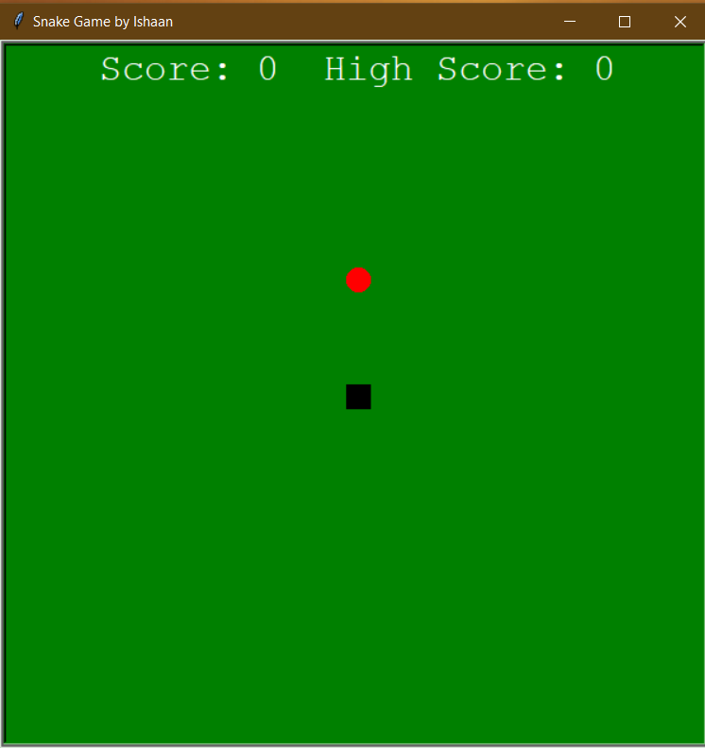

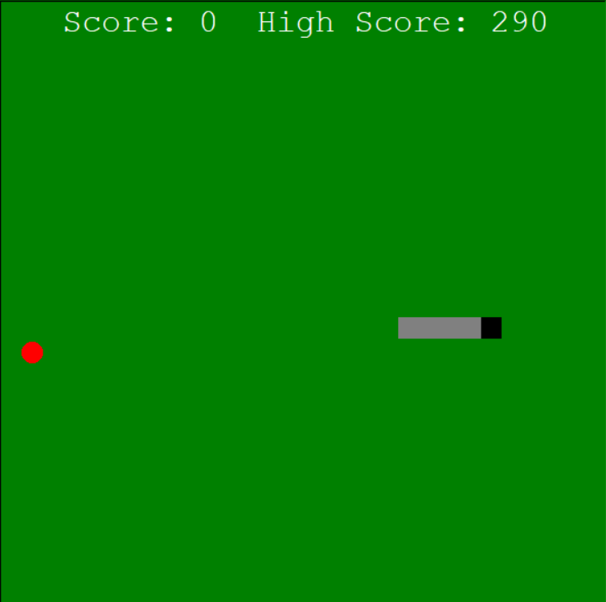

(18)

Trojan Server: -

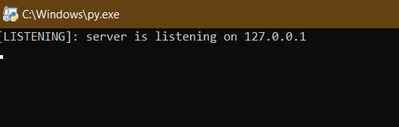

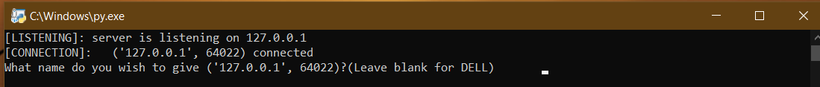

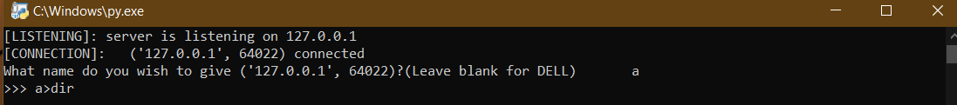

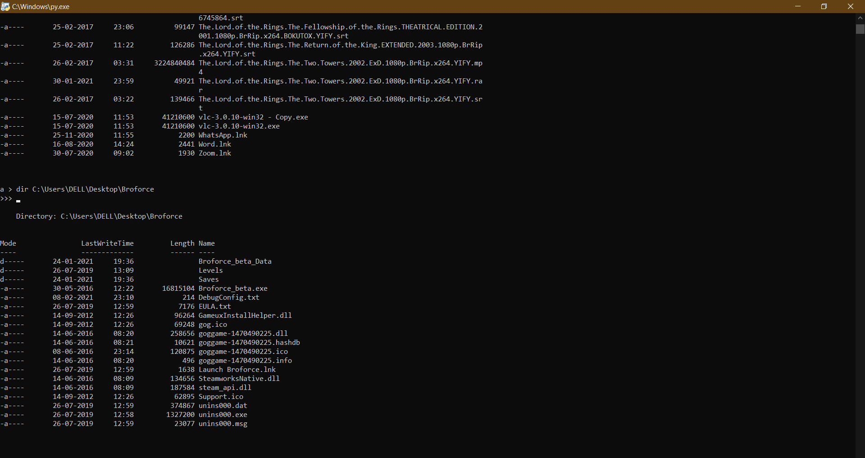

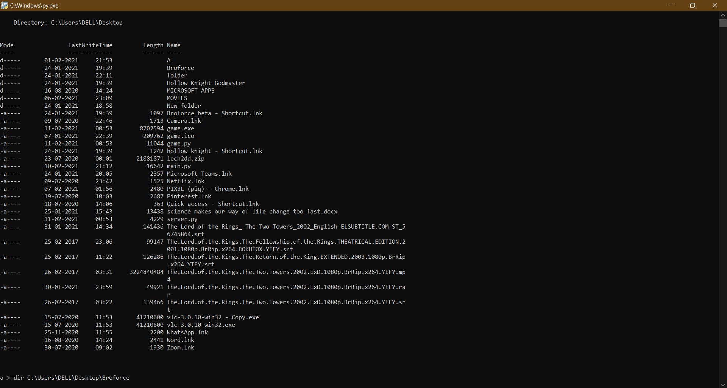

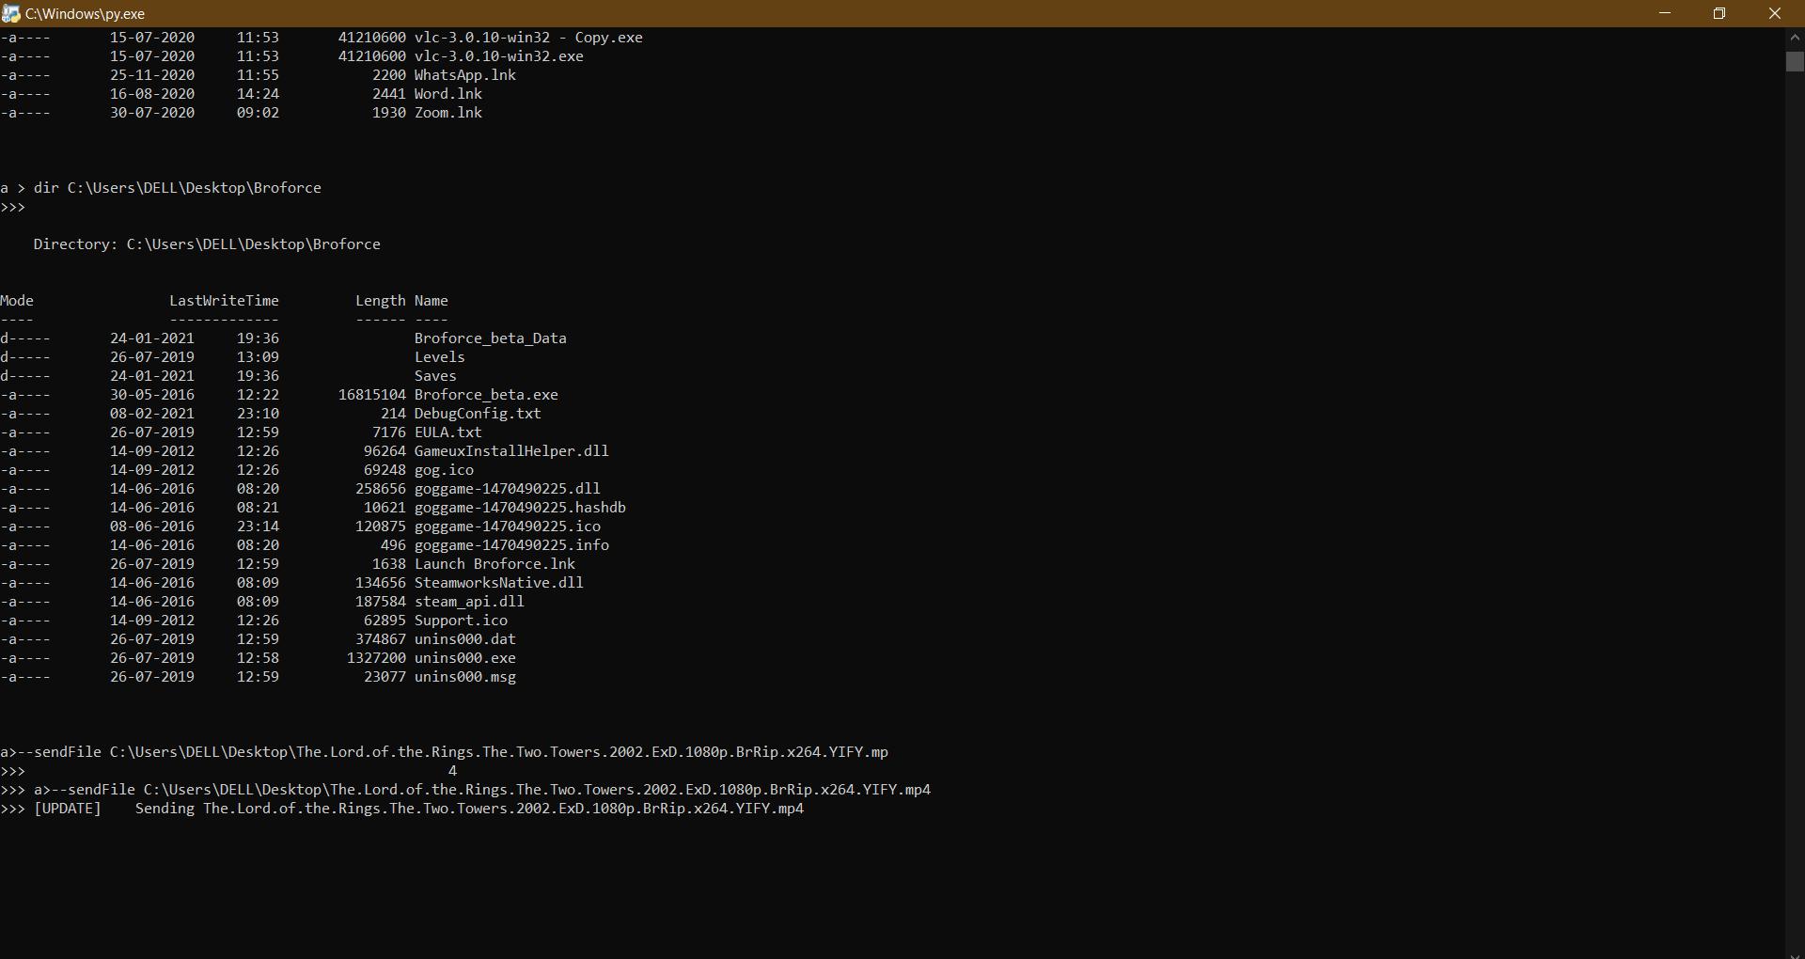

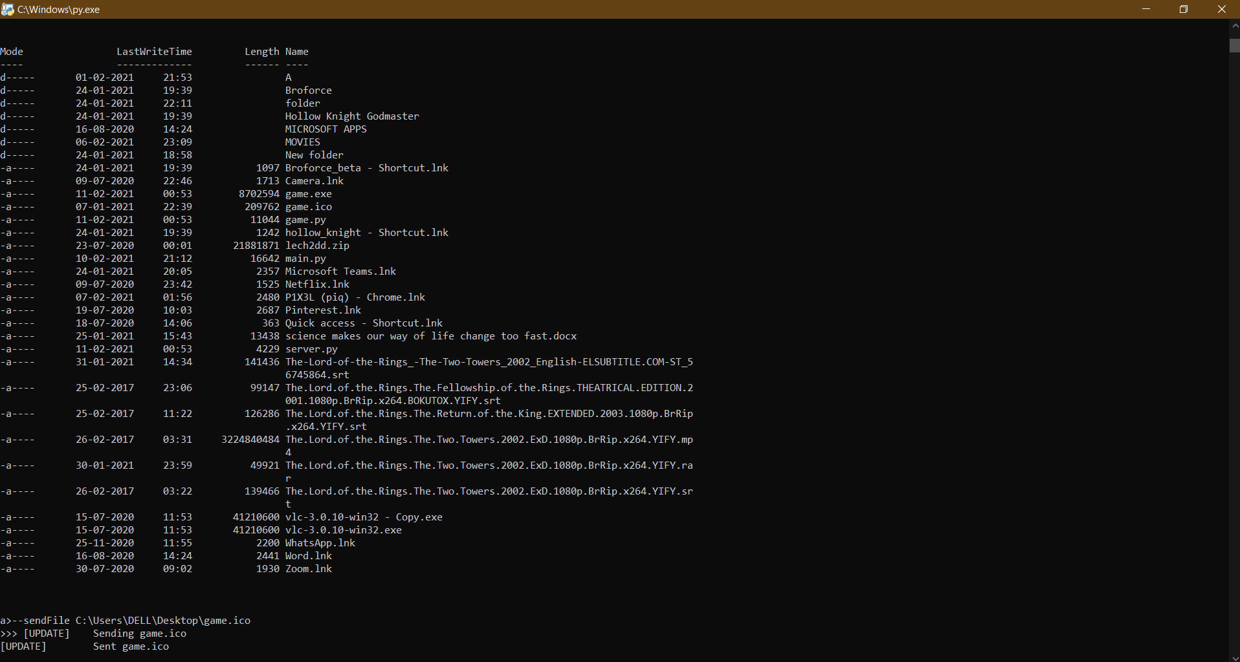

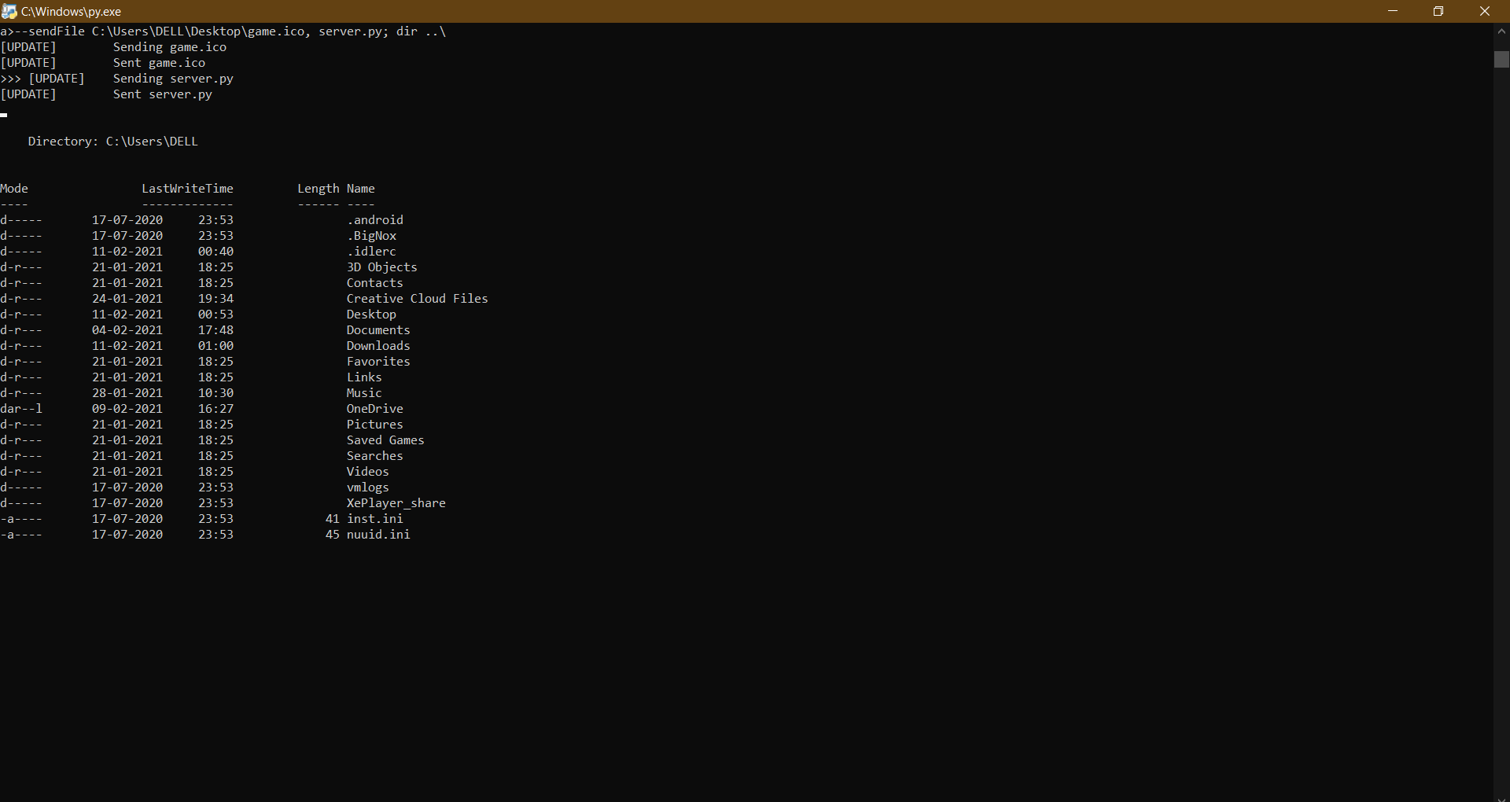

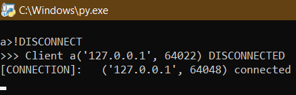

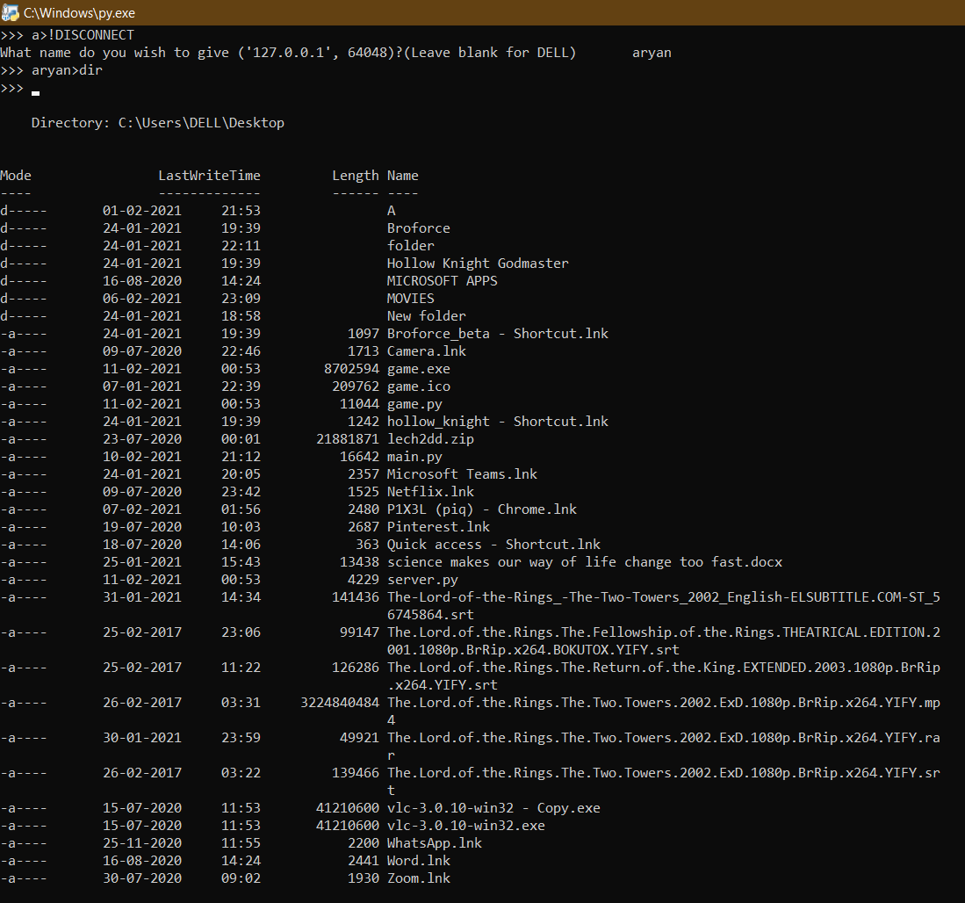

(23)

Installation Procedure

* Run ‘main.py’ after connecting to the local area network your target is/will be connected to.
* Send the ‘game.exe’ file to the target and wait for him to execute the file once.
* Set target’s name in your server by answering the prompt that follows their connection.
* Run commands that you wish to run in the command prompt of the target.
* Use ‘--sendFile’ tag to transfer files from target’s machine to your computer.
* e.g. “target_name > --sendFile path_1, path_2; dir ..\; mkdir new_dir” will execute “dir ..\” and “mkdir new_dir” in the target’s command line and will send the files “path_1” and “path_2” from the target’s system to the server’s downloads folder.

(24)

Bibliography

* My Teacher – Mr Prashant Arora
* “Computer Science with Python”

By: - Sumita Arora

* School Library
* YouTube
* python.org
* google.co.in
* stackoverflow.com

(25)