Confidential
Internet-Based Logistics Exchange
Business Plan
February, 2000
This business plan has been submitted on a confidential basis solely for the benefit of selected highly qualified investors in connection with a private placement of securities and id not for use by any other person nor may it be reproduced, stored, or copied in any form. By accepting delivery of this plan, the recipient agrees to return this copy to the corporation at the address listed above if the recipient does not undertake to subscribe to the offering. Do not copy, fax, reproduce, or distribute without permission.

Table of Contents

Executive Summary 4
Introduction - The Market 6
Market Size 6
Market Structure and Dynamics 6
Our Solution 10
Six Components of the Company’s Solution 11
Value Proposition for Participants 14
Business Strategy 15
Marketing Plan 15
Technology solution 15
System Architecture: 15
Software Components and Architecture 16
Directory Service 17
Auction Technology 17
Transaction Tracking Service 18
Financial Model 22
Making it happen 22
Competitive Landscape 25
On-line Market Places 25
Load Posting Services 26
Logistics Software Companies 26
Summary of Potential Competitors 26
Why will we succeed? 27
Integrated Solution 27
Early Mover Advantage and Barriers to Entry 27
Management Team 28
Appendix 1 – Exchange Rules and Procedures 31
Pre-Qualification Procedure 31
Ongoing-Qualification Requirements 32
Auction Rules 32
Reporting and Notification Procedures 33
Ongoing Performance Monitoring and Rating 33
Performance Enforcement: Penalties and Exceptions 34
Payment Procedures 37
Appendix 2 - Sequence of Events 38
Shippers Posting a Load 38
Carriers Posting Available Capacity 39
Appendix 3 – Marketing Plan 40
Public Relations and Advertising Campaign 40
Direct Sales Force 40
Direct Mailing Campaign 41
Internet Co-Branding Partnerships 41
Appendix 4 – Technology 44
Appendix 5 - List of web site screens 45
Shipper Specific Screens 45
Carrier Specific Screens 45
Shipper and Carrier Screens 46
Appendix 6 – Competitive Analysis 47
On-line Market Places 47
Current Players in the Trucking Industry 48
Trucking ERP Vendors & IT Companies 49
Summary of Competitive Threats 51
Appendix 7 – Financial Projections 52

Executive Summary

The Company proposes to create an internet-based exchange to serve the long-haul trucking industry. The Company has the potential to create enormous value by streamlining the information, financial and physical flows of the industry, which are currently plagued by communication and coordination driven inefficiencies caused by the industry’s highly fragmented structure.
The domestic long-haul trucking industry is a huge and growing industry, with revenues of approximately $235 billion. The industry is extremely fragmented, both horizontally and vertically, with the largest players holding less than 1% of the overall market. This diffuse industry structure generates an extremely fragmented set of information on prices, loads, and counter party performance histories, and allows each player to observe only a fraction of the activity in the industry. This lack of visibility manifests itself in the opaque and inefficient pricing, reflected in the large information rents extracted by market intermediaries, whose commissions average 15-20% of the shipping cost. Incomplete information is also the main cause of poor capacity utilization, whereby an estimated 7-9% of industry capacity is consumed by trucks driven empty or left idle.
The current structure of the trucking industry creates a substantial market opportunity for an internet-based trucking exchange able to generate broad visibility into real-time market prices, supply and demand. To capture this opportunity, the Company will offer the following key components:
- A broad, deep, and liquid auction market enabled by the pre-qualification of exchange participants and by electronic counter party identification, transaction negotiation and execution.
- Performance evaluation and rating of all exchange participants, and enforcement of exchange rules and performance standards.
- Integrated electronic shipment tracking, transaction processing, financial settlement and accounting services.
- Information enabled value-added services.
The proposed exchange leverages the internet to provide broad dissemination of information about shipper loads and carrier availability, and to support efficient auction-based price setting among competing market participants. The exchange enables completion of the transaction on-line by providing electronic tracking of load pick-up, transit, delivery, financial settlement and transaction accounting. By enabling the entire transaction process on-line, the exchange substitutes the current multi-node, pairwise, commonly telephone and fax based communications, which currently characterize the industry, with a hub and spoke structure in which the exchange is the only entity with which shippers and carriers, or their designated service providers (third party logistics companies, brokers, freight forwarders) need to interact. By doing so, the exchange addresses the critical “points of pain” in the current trucking industry structure, namely the labor intensive and error prone processes of identifying and evaluating counter parties and of negotiating, tracking, billing, auditing and paying for transactions. The exchange thus offers an integrated solution that streamlines the information, financial and physical flows of the trucking industry.
To generate initial liquidity on the exchange, its launch will be supported by a network of brokers and few large shippers such as Dial, Hewlett Packard, and Ralston Purina, which have indicated interest. Subsequent growth will be driven by viral marketing by brokers who use the exchange to leverage their resources and competitive position relative to brokers who fail to use it, and through direct marketing to large shippers.
The integrated solution offered by the exchange represents a compelling value proposition to all industry participants. Shippers will achieve cost savings through the introduction of real-time competition for their loads and through automation of their tracking, billing, auditing and payment functions. Carriers will achieve higher capacity utilization through access to a larger number of shippers and also reduced cost, working capital and financial risk through the automation of back-office functions.
As the nexus of a significantly more efficient market hub structure, the exchange will be able to profit by charging transaction fees that represent a fraction of the value it adds, and through the packaging and sale of the information about the trucking market which it generates. Based on transaction fees alone, the revenues of the exchange are conservatively projected to reach $300M in year 3. By entering as the first trucking exchange for the long-haul market, and by offering the right market structure and combination of services, the Company has excellent prospects for rapidly achieving critical scale and market liquidity.

Introduction - The Market

Market Size
Transportation is a huge and growing industry. Total U.S. transportation outlays amounted to $467 billion in 1996, representing approximately 3% of U.S. economic activity. At roughly 80% of this amount, trucking comprises the vast majority of the transportation sector.
The trucking market is segmented into local (less than 100 miles) and long haul. Local trucking consists primarily of the distribution of goods from warehouses and local logistics centers to the point of use or sale. The long haul market, which is the primary target market for the Company, moves goods between major hubs along well-established shipping lanes. In the U.S., the long haul market is approximately $235 billion in size.

Market Structure and Dynamics
The trucking industry is extremely fragmented, both vertically and horizontally. This fragmentation results from the very limited economies of scale available from operating a larger fleet of trucks, which is due primarily to two factors. First, large carriers have only limited capital and fuel cost advantages over small carriers since the markets for trucks, maintenance, and fuel are competitive. Second, small operator owned carriers commonly achieve lower driver costs since the actual driving of trucks is an activity that is both highly independent and extremely difficult to supervise.
In addition to the direct cost of operating and maintaining trucks, the other factor critical to profitability in the trucking industry is capacity utilization. Higher utilization is crucially dependent on the availability of information about the requirements of the largest possible universe of shippers. Large carriers seek to improve capacity utilization through central dispatch of their fleet using large “command and control” optimization programs. In contrast, small carriers rely on personal relationships with shippers and brokers, and on load posting services, which are electronic bulletin boards that list available loads and carrier equipment. As will be detailed below, both solutions have substantial flaws that result in significant amounts of idle capacity and carrier miles driven empty. The Company’s solution is designed to eliminate these coordination and communication driven inefficiencies.

Shortcomings of the Current Coordination and Communication Solutions in the Trucking Industry

Command and Control Solution
Command and control systems in the trucking industry have two primary weaknesses. First, centrally owned and managed trucking companies generally have lower operator efficiencies due to the inherently difficult to monitor nature of the truck driving profession. Second, no single trucking firm has more than an inconsequential share of the overall trucking market. For example, the largest publicly traded carrier, Roadway Express, holds only 0.6% of the market, and the largest ten carriers together comprise only 3.8% of the market. As a result, even the largest carriers are optimizing only a tiny portion of the available universe of carriers and loads. Consequently, they are unable to realize more than a small fraction of the efficiency gains that could be achieved through better communication and coordination among a larger portion of the shipper-carrier universe. The fact that existing carriers have not merged in an attempt to achieve these gains confirms the lack of scalability of the centralized, command and control structure.

Small Scale Network Solution
While smaller carriers do not face the same driver management issues as large carriers, they encounter important challenges in generating credibility and awareness among shippers, in managing capacity when serving all but the smallest shippers, and in providing the necessary infrastructure for critical business functions such as accounting, billing, financing and collections. With over 450,000 trucking companies in the U.S. and an average fleet size of fewer than 10 trucks, the number of firms facing these challenges and the inefficiencies associated with the solutions they have individually developed are enormous. An elaborate infrastructure of service providers has developed to serve the needs of these companies. The following types of firms provide the primary elements of this infrastructure:
- Load Posting Companies disseminate information over the Internet about available shipper loads and available carrier capacity. Actual transactions are negotiated and executed between prospective counter-parties off-line.
- Brokers and Freight Forwarders match loads and shipping capacity that are not contracted under long-term arrangements.
- Freight Payment Companies audit freight bills and perform accounting for shippers.
- Factoring Companies finance and collect receivables held by carriers.
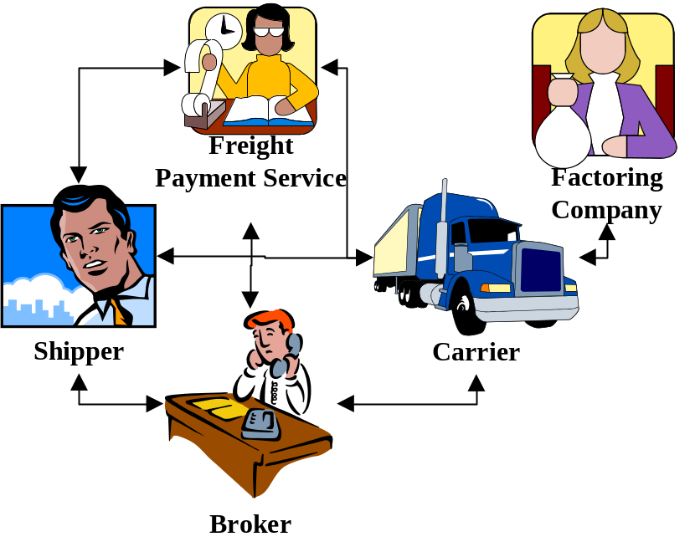
- Integrated Third-party Logistics Providers manage the entire chain of transportation, distribution, customs clearance, warehousing and inventory control on behalf of large shippers.

Figure 1: Current structure of the trucking industry
The steps of a typical transaction under the current industry structure best illustrate the role of each of these players:
- A shipper and carrier are matched after searching load-posting services, contacting brokers and freight-forwarders, or by directly contacting individual carriers or shippers.
- The shipper attempts to verify the quality, insurance level and reliability of the carrier.
- The carrier attempts to verify the shipper’s credit quality and the likelihood that it will honor its committed load pick-up and delivery times and locations.
- The shipper delivers the Bill of Lading and requests load pick-up, transit status, and delivery notification.
- The carrier prepares and the shipper audits and pays the invoice for the transaction, perhaps with the help of a freight payment service.
- The carrier finances and collects the receivable itself, or relies on the services of a factoring and collections company.
Most of the interactions necessary to complete the steps above occur through pair-wise manual exchanges by telephone or fax. Interactions of this kind are time consuming, error prone, and difficult to monitor or audit. The resulting low level of performance and high overhead are frequently unacceptable to many large shippers, who outsource the operational management of their transportation requirements to integrated third-party logistics providers.
It is important to note that in addition to its operational inefficiency, the current communication and coordination infrastructure of the trucking industry generates an extremely fragmented set of information on prices, loads, and the performance of individual shippers, carriers, and intermediaries such as brokers, freight forwarders, and third party logistics companies. In particular, any market participant is only aware of the prices, loads, and counter party performance histories of the network of players with which it interacts on a direct and frequent basis. The size of this network is clearly limited by the time and cost required to maintain it. Given the small size of carriers in the trucking industry, even large shippers or logistics companies, who may be able to support relationships with a hundred or more carriers, are aware of only a fraction of the activity in the industry. This fragmentation manifests itself in poor coordination and opaque and inefficient pricing, all of which are reflected in the large information rents extracted by market intermediaries such as brokers, whose commissions average 15-20% of the shipping cost. The Company’s business model is designed to enable substantial cost reductions and performance improvements through the replacement of this fragmented information set with market-based information transparency that generates broad visibility into real-time market prices, supply and demand.

Our Solution

The inefficiencies of the current industry structure present an opportunity for an organized exchange that provides the following:
- A broad, deep, and liquid auction market enabled by the pre-qualification of exchange participants and by electronic counter party identification, transaction negotiation and execution.
- Performance evaluation and rating of all exchange participants, and enforcement of exchange rules and performance standards.
- Integrated electronic shipment tracking, transaction processing and payment services.
- Information enabled value-added services.
The Company’s solution leverages the internet to provide broad dissemination of information about shipper loads and carrier availability, and to support efficient auction-based price setting among competing market participants. After the price and counterparties for a transaction have been determined, the Company enables completion of the transaction on-line by providing electronic tracking of load pick-up, transit, delivery, and finally payment and transaction accounting. Thus the Company substitutes the current multi-node, pairwise, commonly telephone and fax based communications with a hub and spoke structure in which the Company is the only entity with which shippers and carriers, or their designated service providers (such as third-party logistics providers, brokers, or freight forwarders) need to interact. As the nexus of this dramatically more efficient hub structure, the Company will be able to profit by charging transaction fees of a fraction of the value it adds, and through the packaging and sale of the information about the trucking market which it generates.
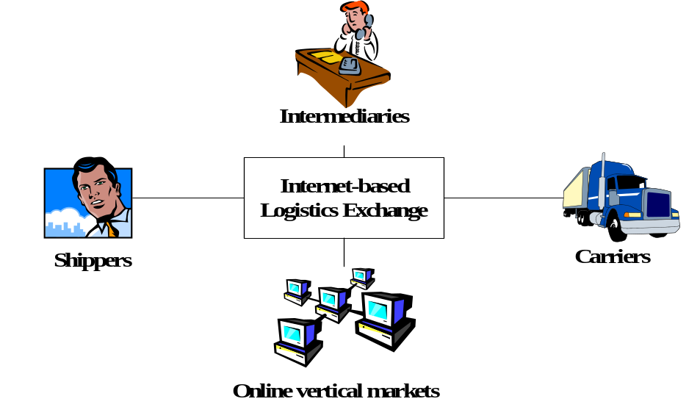
Figure 2 The company’s solution
A more detailed description of the Company’s solution and of how it will charge for and profit from its role in the trucking industry value chain is provided below. The description naturally divides into descriptions of the following six key components of the The Company’s solution:

Six Components of the Company’s Solution
- Qualification of participating shippers and carriers
- Identification of prospective shippers and carriers for individual transactions, and determination of transaction price
- Shipment tracking
- Shipper and carrier performance rating, monitoring, and enforcement
- Financial settlement and accounting
- Information enabled value-added services

Qualification of Participating Shippers and Carriers
In order to allow exchange participants to execute transactions without having to conduct due diligence individually on each of their prospective counterparties, the Company will establish and enforce membership criteria, and will qualify and monitor the physical performance capabilities and also guarantee the financial performance of its participants. Since in any given transaction an exchange member must function as either a shipper or a carrier, members will be qualified to serve in either or both of these functions. For example, a broker or freight-forwarder may seek qualification to act as both shipper and carrier, since for any given transaction they may serve in either role. A detailed description of the specific shipper and carrier qualifications required by the exchange is provided in Appendix 1. The primary requirements for a carrier are that it be suitably licensed and insured, and that it maintain a satisfactory performance history on the loads it carries for the exchange. The primary requirements of a shipper are that it demonstrate its ability to pay, which the exchange will verify on a transaction by transaction basis, and that it maintain a satisfactory performance history at the pick-up and drop-off points of the loads it offers through the exchange. Finally, all members must agree to the operating procedures and requirements of the exchange, which are also detailed in Appendix 1.

Shipper and Carrier Identification and Price Determination
The exchange will enable prospective transaction counterparties to identify each other easily using search capabilities by load type, required equipment, pick-up and delivery time, geographic region, and counter party perfomance rating. In addition, each participant will be able to form customized groups of selected counterparties. The specific shipper-carrier pair for and price of each transaction will be determined through a forward or reverse auction, depending on whether the transaction was originated by a carrier or a shipper.

Shipment Tracking
The exchange will provide shipment tracking based on the reporting requirements of carriers and shippers listed below:
- Carrier notification of pick-up time
- Periodic carrier notification of location and status during transit
- Immediate carrier notification of disruption during transit, such as breakdown or accident
- Carrier notification of drop-off time and status
- Shipper verification of drop-off time and load condition at delivery (optional)
A detailed description of the specific shipper and carrier reporting and notification procedures of the exchange is provided in Appendix 1.

Shipper and Carrier Performance Rating, Monitoring, and Enforcement
Carriers will be rated by the exchange based on the number of times they fail to serve a load they have committed to haul, on their on-time performance at pick-up and delivery, and on the number of damage claims filed against them. Shippers will be rated by the number of times they fail to make a load available, by their readiness at pick-up, and by the number of times their designated recipient is not ready at the designated delivery time and location, or fails to accept some or all of the load.
To compensate a shipper or carrier for the failure of its counter party to perform according to one of the dimensions listed above in a given transaction, the exchange will award penalty fees to the damaged party that must be paid by the negligent party. The magnitude of the fees can be selected from a menu of standard exchange-specified fee structures, or may be customized by individual shippers and carriers for particular transactions. This unique aspect of the exchange allows members to communicate the monetary value they assign to each performance dimension for individual transactions, and in the case of performance failure to be compensated accordingly. For example, a shipper that faces extremely large costs if a particular load is not delivered on time may specify large late delivery fees. By doing so, it encourages only the most reliable carriers to bid for the load and ensures that it will receive appropriate compensation should a problem nevertheless occur. Similarly, a carrier that would like to meet a tightly scheduled series of commitments may specify significant fees for shipper delays at pick-up or delivery. Alternatively, shippers and carriers with few performance constraints may specify lower fees in order to attract bidders willing to offer the most preferential rates in exchange for being allowed greater flexibility.
In summary, the system ensures the most tailored, cost-effective counter party performance possible. A detailed description of the specific shipper and carrier performance rating, monitoring and enforcement procedures of the exchange is provided in Appendix 1.

Financial Settlement and Accounting
The exchange will debit the shipper, using the shipper’s prefered form of payment, at the time an auction closes. Shippers may choose to pay with direct debit from an account established with the Company or from specified account or line of credit at another financial institution, or by credit card. Similar payment alternatives will be available to carriers that generate penalty fees or other liabilities to the exchange. Exchange members may monitor their fiancial activity with the exchange on-line, or through the receipt of periodic statements.

Information-Enabled Value Added Services
As the nexus of dynamic counter party matching and transaction pricing and execution in the long-haul trucking market, the Company will generate extremely valuable information about the following critical aspects of the market:
- Real-time pricing and supply and demand trends: The Company’s access to information about current market conditions, including real-time prices and the real-time supply-demand balance, will allow it to provide previously unavailable information that will be invaluable to guiding decisions about the timing and routing of shipments and fleets.
- Forecasted prices and supply and demand conditions: By tracking and analyzing historical information about pricing, supply and demand by lane and by season over the course of the year, as well as during specific weather and other conditions, the Company will be able to offer services to help its customers to plan shipments, make resource commitments, and manage risk more effectively.
- Active carriers and shippers, and active carrier and shipper types, by lane: By tracking information about the activity of individual carriers and shippers, of particular carrier and shipper types on specific lanes at specific times of year, the Company will be able to design customized products and services to meet the needs of its customers, including customized contracts, and analyses of supply and demand trends and the principal market participants which drive them, in their markets of interest.

Value Proposition for Participants
The Company’s solution enables shippers, carriers and intermediaries (third party logistics companies, freight forwarders, and brokers) to streamline their businesses significantly. The specific benefits, which the Company provides to each of these customer classes, are summarized below and illustrated in Figure 3.
Shippers
- Substantial cost savings for both long-term contracts and short-term overage/underage loads through the expansion of the shipper’s carrier base and the introduction of active price competition for the shipper’s business.
- Carrier performance qualification and enforcement:
- Carrier qualification and performance monitoring is done by the exchange and based on the carrier’s performance across all shippers, rather than only with an individual shipper.
- Shipper compensation for carrier non-performance through user-customizable carrier penalty fees.
- Reduced back-office overhead (invoice accounting, auditing and payment)
- Improved ability to serve customers through on-line tracking of shipment status
Carriers
- Higher capacity utilization through access to larger number of potential shippers
- Shipper performance enforcement:
- Exchange monitors shipper’s readiness for load pick-up and delivery
- Carriers receive user customizable compensation for shipper non-performance
- Guarantee of timely payment eliminates shipper credit risk and reduces carrier’s working capital requirements
- Reduced back-office overhead (billing, collections, accounting)
Intermediaries

Intermediaries derive the benefits for both shippers and carriers since they can participate in both capacities. By automating many of the current activities of intermediaries, the exchange provides them with the opportunity to focus their activities on providing additional value-added services to their clients. Many of these potential services will be enabled by the information services and assets offered by the exchange.
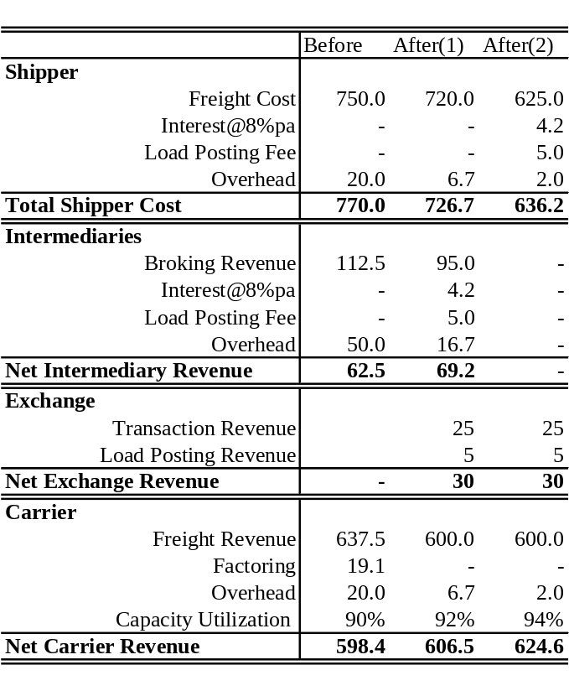
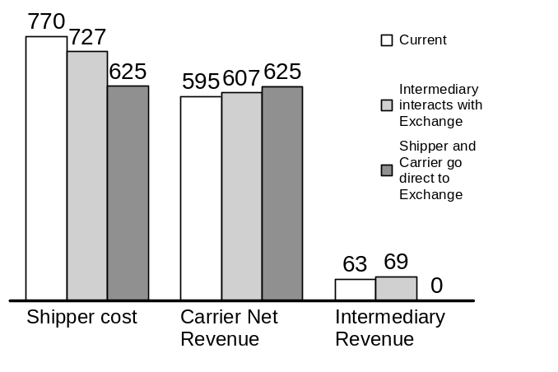
Figure 3. Value proposition to exchange participants. After(1) scenario is when intermediaries interact with the exchange, and After(2) scenario is when shippers and carriers go direct to the exchange.

Business Strategy

Marketing Plan
To acquire clients for the exchange in a timely and cost-effective manner, the Company will launch a public relations campaign, place targeted advertisements, and employ a direct sales force. The goal of the public relations and advertising campaign will be to create wide market awareness about the exchange products and services.
The direct sales force will focus primarily on attracting large shippers and carriers. We project to start with about 40 direct sales people and gradually expand to about 140. The direct sales force will represent the bulk of our marketing spending.
In addition, Internet co-branding partnerships will be used to promote the exchange on complementary e-commerce sites. A more detailed description of the marketing plan appears in Appendix 3.

Technology solution

System Architecture:
The Company’s services will be assessed primarily through the Internet, with the call center handling occasional exception reports. These internet-based services can be categorized into three technology groups, namely Directory Service, Auction Technology and Transaction Tracking Technology. A schematic of the system architecture is illustrated in Fig. 4. A more detailed description of each of the technologies appears below, along with a timeline of service and technology deployment in Table 1.
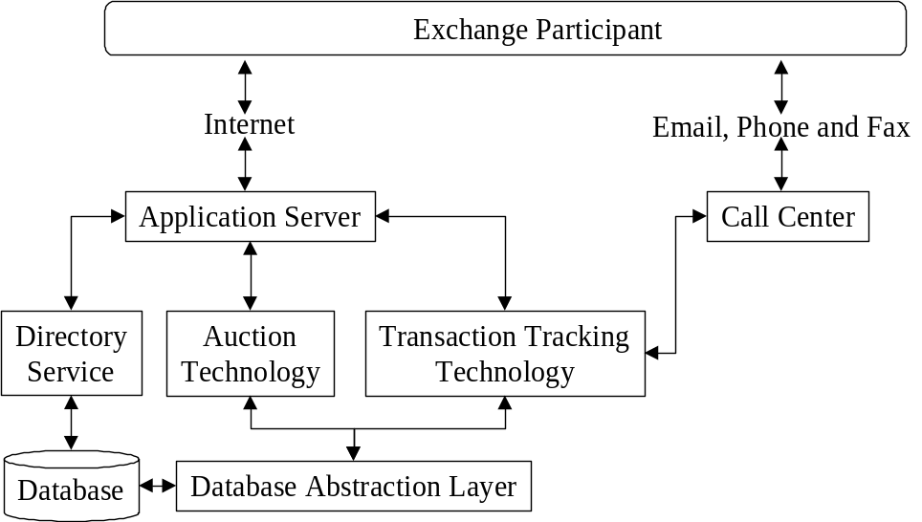
Figure 4. Schematic of system architecture.

The system architecture is better understood by following through the workflow of a transaction object (see Fig. 5). Every transaction object is owned by a member, and is created when a member posts a load or capacity on the exchange. This object stays live until it is closed by an event, such as the successful delivery of goods. The Directory Service module updates and stores information relating to the transaction object. Posted loads and capacities are then made live by the Auction Technology so that multiple parties can bid on them. The live transaction object then collects bids, decides on the winner, if any, at the close of the auction, and then notifies the shipper and carrier of the auction results. Once the shipper and carrier have been notified of the details of the transaction, the Transaction Tracking Technology tracks the object from pickup, through shipping, to drop off. After a successful drop off it –
- Assesses any cash penalties the exchange needs to levy against the carrier.
- Updates any effect the transaction has had on the exchange rankings of the shipper and carrier.
- Credit the carrier’s account with the amount due after all penalties are assessed.

At the end of these steps, the workflow ends and the transaction object is closed.
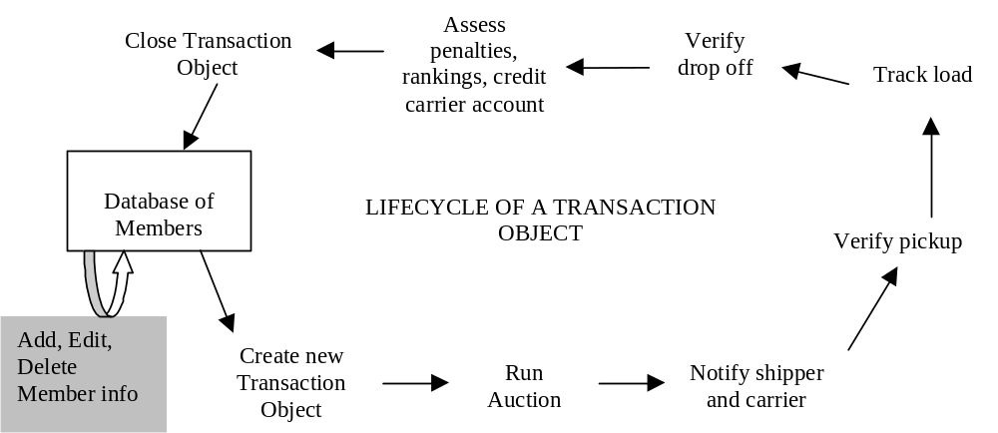
Figure 5. Workflow of a transaction object.

Software Components and Architecture
Based on the workflow explained above, we can outline the different software components that, put together, would give us each of the three services.

Directory Service
The directory service allows members to sign up and list their information, for shippers to post load and carriers to post capacity. This service also verifies insurance levels for carriers and credit worthiness for shippers. All this information is stored in a user-searchable database. The search features of this service would enable shippers and carriers to identify counterparties that satisfy the requirements. At the core of the Directory Service is database management software. Various user-interface modules that facilitate the signing-up of new members, updating of member information, creating new transactions, searching for counterparties are managed by the Directory Service.
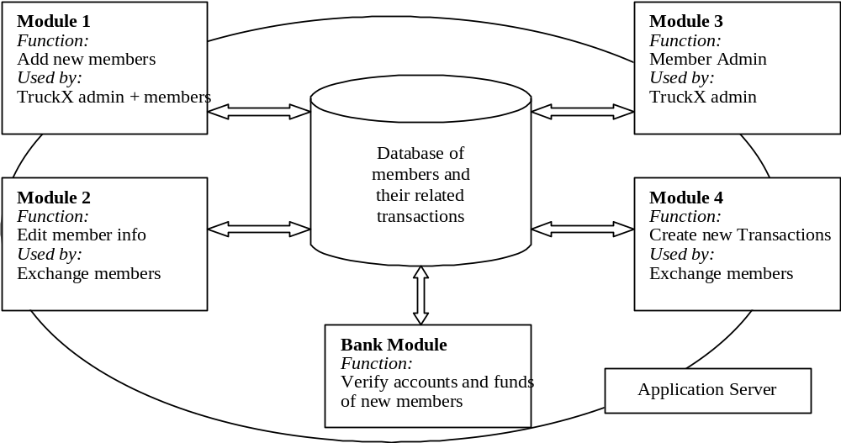
Figure 6. Directory Service Architecture.

The central piece of this service would be an SQL Server database. Modules 1 – 4 are HTML user interfaces built as Java servlets. The entire setup would run on a web server/ application server such as Microsoft’s IIS web server with Allaire’s Jrun product. The Bank Module is a module that allows the service to communicate with the bank using EDI and SSL.

Auction Technology
Adding load posting capabilities to this service opens the door to providing load and capacity auctions to the members, making it possible for transactions to be concluded efficiently.
The Auction Technology runs auctions on the newly opened transaction objects and decides on a winner. The auction technology will be provided through third party software, such as CommerceBid or OpenSite.


Figure 7. Auction technology Architecture
The Database Abstraction Layer is an object that allows the auction software to get access to new transactions it needs to run auctions on, the list of members and their information and the ranking system. When the auction decides on a winner, the transaction object is updated in the database.

Transaction Tracking Service
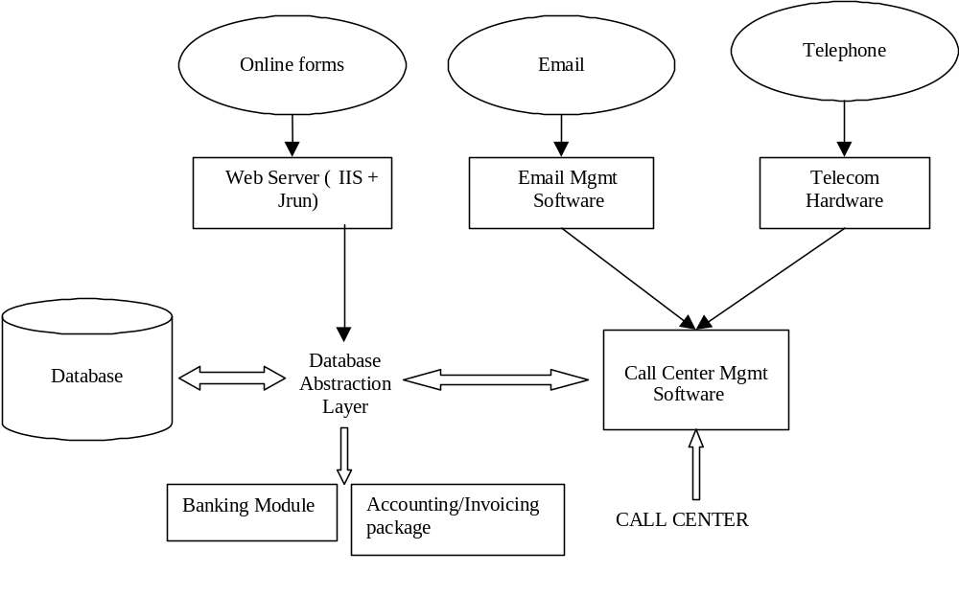
Figure 8. Transaction Tracking Service Architecture
As an Internet based service, the Logistics Exchange differs from other auction sites in that it sees a transaction through from pickup to delivery. This third level of the service adds a lot of complexity to it, but also differentiates this service from others. It also acts to incentivize shippers and carriers to use the service, because it acts as a mediator by holding the carrier’s payment until the shipment is completed and its success assessed. It also ranks shippers and carriers on multiple levels, giving members the ability to assess each other’s abilities in an objective fashion.

The Web Server, as discussed in the Directory Service section is made up of Microsoft’s IIS and Allaire’s Jrun. The email management software is provided by Kana, and the telecommunications system is built by Nortel Networks. The call center management software can be provided either by Siebel Systems or Clarify Inc. The accounting package can be purchased from Great Plains Inc. or SAP.

Integration Features
Creating new transactions manually over the web may become a tedious process for exchange members with a large number of transactions to dispatch at frequent intervals. To overcome this problem, we intend to provide integration tools that tie in the exchange to the ERP systems of shippers and carriers. We plan to offer a consulting service to facilitate these tie-ins.

Table 1: Timeline for Service and Technology Deployment

 | Pilot Roll-out | Ramp-up | Pre-IPO
New Services Offered | Directory  Auction | Transaction Tracking | Wireless hook-up  GPS tracking
Number of shipment transactions (PEAK) | 0.09 transactions/second*  790 transactions/day* | 0.09 transactions/second*  790 transactions/day* | 6 transactions/second*  61830 transactions/day*
Number of call-center calls (PEAK) | NA | 0.02 transactions/second*  198 transactions/day* | 2 transactions/second*  15457 transactions/day*
Number of Web Server hits (PEAK) | 3.6 hits/sec  Web Site = Total* | 3.6 hits/sec + 0.1 hits/sec = 3.7 hits/sec  Web Site + Call Center = Total* | 240 hits/sec + 10 hits/sec = 250 hits/sec  Web Site + Call Center = Total*
Number of Database Hits (PEAK) | 7.2 hits/sec | 7.4 hits/sec | 500 hits/sec
Number of concurrent users on system | Less than 1000 | Less than 1000 | 50,000 to 100,000
Number of concurrent database connections | 10 – 20 connections | 10 – 20 connections | 500 – 1000 connections
Database Used | SQL Server 7.0 | SQL Server 7.0 | Oracle 8 (or latest edition)
Web Server / Application Server Used | Internet Information Server with JRUN Servlet activation engine (round robin cluster) | Internet Information Server with JRUN Servlet activation engine (round robin cluster) | WebLogic Enterprise Server  (load balancing cluster)

Financial Model
Although the exchange will be membership based, it will not charge a membership fee. Instead, the Company will derive its revenue from transaction fees and from the sale of information based services. A detailed description of the financial model is presented in Appendix 7. It includes only transaction-fee based revenues because both the revenue and costs associated with these information based services are difficult to estimate accurately at this time, and in order to present the financial prospects of the exchange conservatively.
Transaction Fees-Based Revenues
The exchange will charge both shippers and carriers for a transaction. Shippers will pay a fee for each load posted, regardless of whether the transaction is completed. This fee will be small (on the order of $5/posting), and is designed to encourage shippers to post only those loads which they intend to complete. Carriers will pay a service fee for each transaction in the range of 4% of the shipment cost. As point of reference, brokerage and factoring commissions currently range from 15-20% and 1-4%, respectively. In addition, there will be a support fee for transactions that utilize the Company’s telephone-based customer support.
Based on this transaction fee structure alone, the revenues of the exchange are conservatively projected to reach $300M in year 3.

Expenses
The principal costs of building and operating the exchange are software development, call center operation, and sales and marketing. Software development will be largely a fixed cost, while call center and sales and marketing will scale with the size of exchange. The largest cost component is sales and marketing. A more detailed analysis of other costs is presented in Appendix 5.

Making it happen
The success of the exchange critically depends on attracting industry players to the exchange. The Company plans to use existing relationships of its founders with industry players to ramp-up liquidity. A detailed timeline of the Company’s activities appears below.
Liquidity during the pilot roll-out phase
The brokers of Sunset Transportation will provide initial liquidity to the exchange during the pilot rollout phase. Sunset Transportation, a St. Louis, Missouri based trucking brokerage company owned by one of the founders, has revenues of over $16 million a year and a network of 20 brokers nationwide. Sunset currently operates a virtual private network, which will be replaced by the Company’s internet-based exchange. Sunset has spoken to a number of additional brokers who have expressed an interest in joining its broker network once the Company’s scalable internet-based exchange comes on-line. This network of brokers will also help in identifying options for improvement in the Company’s technology processes before the exchange is opened to other industry players.
Liquidity during the ramp-up phase
During the ramp-up phase, a few large shippers including as Dial, Hewlett Packard and Ralston Purina will contribute significantly to generating volume on the exchange. All of these companies have indicated interest in participating in a pilot project.

Making it happen

Phase | Pilot Roll-Out | Ramp-up | Pre-IPO
Duration | 3 months | 8 months | 1 year
Customers | - Sunset Transportation’s broker network (~20 brokers) | - Pre-selected shippers: Dial, HP, Ralston Purina  - Other industry players | - All industry players
Exchange Technology | - Auctions  - Forward market  - Spot market  - Develop carrier and shipper performance evaluation system | - Payment Processing  - Automatic Confirmation  - Call Center with human interface  - Test performance evaluation system with pilot participants | - Call Center with automated telephony interface  - Roll-out of performance evaluation system
Marketing | - Interview and hire 10 direct sales people, organize initial training  - Prepare public relations campaign  - Prepare advertising campaign  - Approach potential partners for marketing partnerships | - Continue hiring and training direct sales force  - Launch public relations campaign  - Launch advertising campaign  - Sign marketing partnerships | - Continue hiring and training direct sales force  - Continue public relations campaign  - Continue advertising campaign
Financing | First round of venture financing |  | Second round of venture financing

Competitive Landscape

The Company will face competitors of three general types: 1) on-line market places that currently operate in other segments of the transportation industry or other industries, 2) current players in the trucking industry such as load posting services, larger brokers and freight payment services, and 3) software companies offering logistics/trucking management solutions. A brief summary of the most credible competitors appears below. A more detailed competitive analysis is presented in Appendix 6.

On-line Market Places
- National Transportation Exchange (NTE):
NTE (www.nte.net) is a membership-based trucking exchange focused on the less than truckload (LTL) segment, with full truckloads (FTL) shipments forming only 18% of their total volume. Shippers post load requirements to NTE, which then tries to fulfill them with available capacity of member carriers. NTE offers a fixed price to the shipper but does not guarantee the capacity to service the shipment. As a result, shippers cannot rely on NTE to service a shipment or to provide price discovery. NTE makes money on the spread between the fixed prices it charges shippers and the variable costs it negotiates with carriers. As a result shippers pay more, carriers earn less and fewer transactions are completed than will be the case for the exchange proposed here. Thus, economically, NTE functions more like as an old-fashioned rent-seeking broker rather than an exchange. NTE is backed by AT&T Ventures, Hummer Winblad, Platinum Software Ventures, CrossPoint Ventures, FedEx, and has partnerships with SAP, Manugistics and other software vendors and trucking industry players. NTE serves more than 350 members.
- Celarix.com
Celarix.com currently focuses on ocean and air freight. It operates an auction-based transportation exchange and in addition provides a set of logistics solutions. It has stated plans to offer solutions for the trucking industry, but industry sources suggest that it has no specific plans to actually do so. Celarix.com was founded in August 1998 and has raised $14 million from Charles River Ventures, TL Ventures and Comdisco Ventures.
- GoCargo.com
GoCargo is a direct competitor to Celarix.com backed by Atlas ventures and SOFTBANK launched in November 1999. It offers an auction-based price discovery mechanism for ocean freight, and has no stated plans for the trucking industry.
- FreeMarkets.com
FreeMarkets creates customized business-to-business on-line auctions for industrial parts, raw materials and commodities. FreeMarkets has also, however, conducted auctions for long-term trucking contracts for a few shippers. It recently went public in an extremely successful IPO.
With the exception of NTE, the on-line market places listed above lack the infrastructure or services, such as a quality rating and performance enforcement, shipment tracking, and payment and accounting, necessary to service the trucking industry.

Load Posting Services
The load posting services are membership-based Internet bulletin boards where shippers and carriers post loads and capacities. The objective of the services is to simply help carriers and shippers identify prospective counter-parties. The services do not pre-qualify participants, manage payment or performance risk, or in any other way facilitate the negotiation, execution or settlement of the transaction. Some of these services, especially DAT, which is the largest, have built substantial infrastructure and membership, which could serve as a platform to launch a more complete market-making service.

Logistics Software Companies
IT companies focusing on ERP systems and software for the trucking industry are potential competitors due to their existing relationships and their core competence in IT. Of the various trucking ERP vendors, Sabre Technologies is the largest in size, and the most sophisticated.

Summary of Potential Competitors
Each of these types of potential competitors possesses unique capabilities that would allow them to build an on-line exchange to compete with the proposed venture. The main advantage of current trucking industry players is the customer relationships they have developed over time. However, most of these players have so far lacked the vision and the technological capability to offer a robust solution to the industry’s problems. Software companies, on the other hand, have the technological prowess but have concentrated their efforts on perfecting centralized, optimization-based, command-and-control solutions that do not address the fundamental problems of the industry. The most credible threat comes from NTE and existing on-line market places that currently serve other segments of the transportation market. Such players have components of the vision and are developing technology and acquiring the execution skills that could be applied to build a trucking exchange. At present, however, a clear window of opportunity exists in the market.

Why will we succeed?

Integrated Solution
The Company will be the first to offer an integrated solution that streamlines the information, financial and physical flows of the trucking industry, and makes the marketplace transparent. Although other competitors have conceptualized and to different degrees implemented aspects of our solution, none of them provide all of the dimensions necessary to offer a compelling value proposition to each of the key market participants, which include shippers, carriers, and their third party logistics, freight-forwarder, and broker service providers.
In summary, the Company’s solution addresses the critical “points of pain” in the current trucking industry structure, namely the labor intensive and error prone processes of identifying and evaluating counter parties and of negotiating, tracking, billing, auditing and paying for transactions, and enables the greatest opportunity for value creation through efficient communication, coordination and transaction execution among the hundreds of thousands of participants of the highly fragmented trucking industry.

Early Mover Advantage and Barriers to Entry
In view of the current window of opportunity, it is imperative that the idea be executed quickly. The Company needs to capture the first mover advantage, which will allow it to build assets and relationships that will be difficult to replicate.
The experience of other organized marketplaces suggests that exchanges exhibit network economics, i.e. existing market participants attract more market participants and liquidity generates more liquidity. As an early trucking exchange, the Company will be the first to achieve critical scale and provide market liquidity, which will facilitate customer acquisition and retention. High liquidity on our exchange will deter new market entrants by making it very difficult for them to recruit clients.
Over time our industry leading depth and liquidity, combined with our proprietary shipper and carrier performance measurement and penalty fee systems will allow us to develop unparalleled databases of price and load trends and shipper and carrier performance. This database, combined with our analytical capabilities, will allow us to offer uniquely valuable information based services to our customers.

Management Team

We have assembled a strong management team with complementary skills.

Blake Johnson President
Blake is currently on leave from his position as a professor in the Management Science and Engineering Department at Stanford University, where he is a Terman Fellow. His academic work addresses the creation of markets and market-like mechanisms to enable new business processes and facilitate risk sharing, and the development of real options based methods of structuring, valuing and managing investments, contracts and operating policies.
Blake's recent applied work has focused on high-technology markets and investments, with a particular focus on the role which market creation can play in enhancing the ability of market participants to create value and manage risk. Recently, Blake founded TradingHubs.com, a B2B market for electronic products, components and logistics currently being spun out of HP. Prior to that, he focused on the recently deregulated markets for electric power, where he played a central role in helping leading firms such as Enron and PowerGen extend existing valuation and risk management tools to adequately address the unprecedented volatility which results from electricity's uniquely non-storable nature.
Before joining Stanford, Blake was an associate in CS First Boston's Asset Finance group, where he led the analytical development of a range of the first non-mortgage asset securitization products, including products based on credit card receivables and computer leases. For the first credit card transaction (which with over $200 billion issued through 1998 has since become the most important non-mortgage product), Blake was responsible for providing all analysis necessary to secure the support of investors, bank regulators, rating agencies, letter of credit banks and accountants. He subsequently assumed overall responsibility for the credit card product, including product development and marketing, transaction execution, and sales and trading support, and lead the sales effort for the first transactions in both Europe and Japan.
Blake received his B.S., M.S., and Ph.D. degrees from Stanford University. He is a founder and CEO of Options, Markets & Analytics, a leading provider of high-end analytics for electricity trading and asset valuation, and founder and CTO of IP Valuation, Inc., a supplier of software and consulting services for structuring and valuing complex intellectual licensing transactions for the semiconductor industry.

Jim Williams VP of Sales
Jim is currently the CEO of Sunset Transportation, which he co-founded in 1990. Sunset has doubled its revenue every year for the past four years. Besides shipping brokerage, Sunset Transportation has branched out into freight payment services – auditing and paying freight bills for companies. Under Jim’s stewardship, Sunset has developed a nationwide network of affiliates who have significantly extended the market reach of Sunset. This network has grown from 1 office to 8 offices in the last six months, and hopes to grow to in excess of 20 by the end of next year.
Jim also serves as the Chairman of Enterprise Bank in Sunset Hills, Missouri. In the last three years Enterprise Bank has experienced 30% annual growth by focusing on the highly profitable segment of high net-worth individuals.
Jim started his professional career in 1975 at the Williams Paper Company, a paper converting facility founded by Jim’s great grandfather in 1861. The Company produced cardboard boxes, envelopes and other packaging materials. Jim started the logistics division at Williams Paper with one truck, purchased in 1978, to carry loads from a supplier in Boston. In order to reduce transportation costs, he started brokering third-party loads to fill the backhaul from St. Louis to Boston. This marked the beginning of independent logistics activities, which Jim developed into a stand-alone business unit. Under his guidance the division grew from one truck in 1978 to 50 in 1985 and it was spun out of Williams Paper in 1985 and sold to Key Way Trucking. Jim remained with Key Way until 1990 when he started Sunset Transportation.

Vicki Vondross Director of Sales
Vicki is currently the Program Manager for HP logistics international air freight. At HP Vicki is directing the strategic alignment of HP's enterprise wide air programs and leading HP's investigation into "E-Logistics.” She also implements air, ocean and surface logistics auctions for TradingHubs.com. Previously, she managed sales and marketing efforts for several international logistics companies for over 10 years. Vicki holds a BA with honors from Portland State University.

Bogomil Balkansky Director of Business Development
Bogomil is currently attending the MBA program at Stanford University where he expects to graduate in June 2000. Prior to that Bogomil was a management consultant with McKinsey & Company in Frankfurt, Germany, where he worked with large financial institutions in various European countries. As a consultant he developed expertise in strategy, operations, customer segmentation, marketing, sales stimulation, cost reduction and post-merger management. Most recently, he worked part time at 3Com where he helped the New Product Introduction unit think through the cost implications of product proliferation.
Bogomil received Bachelor’s Degree Cum Laude in Mathematics and Economics from Cornell University.

Mike Weber Director of Marketing

For the past four years Mike has been the New Business Creation Marketing Consultant at HP for internal start-ups and technology transfer projects from labs to divisions. He is a founding member of TradingHubs.com where he conducted over 300 auctions valued at over $13 million in goods and services. He also assessed and coordinated B2B auction efforts of 10+ HP divisions, trained over 100 users and developed a learning products plan. Mike holds an MBA from Santa Clara University.

Jeff Mckibben Director of Technology
Jeff McKibben is currently the Director of Information Technology for TradingHubs.com. In this role he has the overall responsibility for all information technology strategy, architecture, development and operations. Under his management, TradingHubs.com has brought to production two major releases of their core application system in just 8 months.
Prior to joining TradingHubs.com, Jeff was a product team manager with the Supply Chain Information Systems department of HP’s Product Processes Organization (PPO). In this role he managed a product portfolio of supply chain planning and execution systems used by HP divisions worldwide. Jeff joined HP in 1990 as an information systems developer in the corporate controllership organization. He quickly advanced to a management role responsible for support of HP's worldwide financial reporting system.
Jeff holds a master's degree in management information systems from the University of Arizona. He also holds a bachelor’s degree in international relations from Georgetown University.

Bradley Romine
Brad will receive his Ph.D. in Management Science and Engineering from Stanford University in December 1999. His dissertation research focused on the development of a real options based methodology to value assets in the energy industries, and an equilibrium model of price dynamics in the natural gas market. This model was to used to predict price movements in natural gas based on transportation costs, weather, and storage costs.
While working on his Ph.D. Brad interned at both Enron and Cornerstone Research. His work at Enron focused on building models to assess and mitigate credit risk to Enron’s portfolio. He also built models to predict the demand for natural gas and electricity based on weather conditions. While at Cornerstone, Brad worked on valuing Commercial Mortgage Backed Securities as well as performing a market structure analysis of the tobacco industry.
In addition to his Ph.D., Brad has Masters Degree in Engineering Economic Systems also from Stanford University, and Bachelor’s Degree in Mathematics from Cornell University.

Venu Nagali
Venu is currently a Research Engineer with IP Valuation, Inc., where he is involved in the development and marketing of MediciTM, a software tool to structure and value semiconductor intellectual property. At IP Valuation, he has consulted to semiconductor industry on structuring intellectual property licensing transactions.
Working with Blake Johnson, Venu developed and implemented risk management tools for the power industry including models for power prices, and analytics to value structured contracts and exotic options. He has also consulted to several leading utilities in the United States on the development of integrated risk management systems and the application of real-options based methodologies to the valuation of assets and contracts.
Venu received his Ph.D. from Stanford University, M.S. from the University of Maryland at College Park, and a Bachelor of Technology degree from the Indian Institute of Technology at Madras.

Appendix 1 – Exchange Rules and Procedures

Pre-Qualification Procedure
In order to join the exchange, each member must pass a qualification procedure. The exchange’s pre-qualification procedures for shippers and carriers are outlined below.

Shippers
- Choose one of four forms of payment:
- Direct debit from an account or line of credit at shipper’s financial institution
- Direct debit from an account with the Company’s bank
- Credit card (results in additional 1-2% charge to cover credit card transaction fee)
- Provide a bank account and routing number for automatic crediting of payments.
- Agree to the rules and regulations of the exchange concerning auction rules, payment procedures, and performance monitoring and penalty fee structure. Agree to mediation to resolve any other exchange-related disputes.
- Federal tax ID.
Carriers
- Supply Federal Carrier ID number, which the exchange uses to verify the carrier’s status as a licensed carrier with the Federal Highway department.
- Provide proof of insurance, including policy number, expiration date, and level of insurance, and add the exchange to the list of those notified by the insurance company of changes to the policy.
- Provide a bank account and routing number for automatic crediting of payments.
- Agree to the rules and regulations of the exchange concerning auction rules, payment procedures, and performance monitoring and penalty fee structure. Agree to mediation to resolve any other exchange-related disputes.
- Federal tax ID.
Intermediaries
Intermediaries such as brokers, freight forwarders and third party logistics providers can act as shippers by taking principal positions, but can only act as agents of carriers.
- To act as shippers, intermediaries have to satisfy the pre-qualification procedures of shippers listed above.
- As agents of carriers, intermediaries are required to pre-qualify all the carriers they represent on the exchange.
- In addition, brokers must provide their Federal brokerage ID number and bond level.
- Federal tax ID.

Ongoing-Qualification Requirements
Shippers
- Demonstrate ability to pay before posting a load or bidding for posted capacity on the exchange (see payment procedures).
- Maintain satisfactory performance at the pick-up and drop-off points for the loads offered through the exchange.
Carriers
- Be suitably licensed to carry the particular type of load.
- Maintain an adequate insurance level to cover the specified damages before bidding on a load.
- Maintain satisfactory performance at the pick-up and drop-off points for the loads carried through the exchange.

Intermediaries
- Acting as shippers, intermediaries must satisfy all the qualification requirements for shippers listed above.
- Acting as agents of carriers, intermediaries must ensure that the carriers that they represent satisfy all the qualification requirements for carriers listed above.

Auction Rules
The Exchange will offer both forward and reverse auctions. Shippers can use reverse auctions to solicit bids from carriers for their loads, and carriers can use forward auctions to solicit bids from shippers for their available capacity/equipment and desired origination and destination.
When posting a load in a reverse auction, a shipper must enter the characteristics of the load, including size, weight, origin, destination, pick-up time and date, required equipment, the duration of the auction, a reserve price for the auction (the highest price he is willing to pay) and provide an optional automatic accept price (at which the auction automatically closes) which is visible to all bidders. The shipper may also restrict the viewing and bidding of an auction to a particular subset of the exchange’s carriers, as well as select a minimum carrier rating for auction participation and specify the penalty levels for counter party performance failures. When a carrier bids on a load his performance rating and desired penalty fee structure are also shown to the shipper. Shippers close the auction by accepting one of the posted bids, which as a result of the carrier rating and penalty fee structure need not be the lowest bid.
In a forward auction, the carrier lists the type of equipment, along with information on the point of origin, general destination, and the date when the equipment will be available, reserve price and automatic accept price. As above, the originating carrier must specify a minimum shipper rating and penalty fee structure for counter party performance failures, and bidding shippers must specify their bids and penalty fee structures.

Reporting and Notification Procedures
The exchange will provide shipment tracking based on the reporting requirements of carriers and shippers listed below. A few notifications are optional, but are recommended as the notifications will be used to resolve disputes between counterparties.
Carriers or their agents are required to notify the exchange of
- Pick-up time
- Location and status during transit
- Immediate notification of disruption during transit, such as breakdown or accident
- Drop-off time
- Inability to serve a contracted load
Shippers or their intermediaries are required to notify the exchange of the
- Changes in the shipment details
- Pick-up time (optional)
- Drop-off time (optional)
- Load condition at delivery (optional)
- If necessary, file damage claim within 48 hours of delivery

Ongoing Performance Monitoring and Rating
A system of multi-dimensional performance ratings will be established to monitor the ongoing performance of an exchange participant. These multi-dimensional ratings, which will be updated periodically, are set to a scale of 1 to 5, with 5 being the highest rank.
A carrier’s performance will be rated along four dimensions, Timeliness, Accuracy, Exception Claims and Handling, and Financial Responsibility. Timeliness reflects a carrier’s on-time performance, as measured by the percentage of pick-ups and deliveries performed within the specified time frames, and promptness in updating the exchange about pick-up, delivery and transit. Accuracy measures the number times a carrier fails to serve a load whether it failed show up at the right location, assigned the wrong equipment, or was simply unprepared for the load. Exception Claims and Handling measures the percentage of loads that have damage claims filed against the carrier. Financial Responsibility reflects the carrier's promptness in paying late fees and penalties.
A shipper’s performance will be rated along the same four dimensions. Timeliness will measure of how quickly the shipper gets the carrier loaded and unloaded. Accuracy measures the shipper's ability to specify the correct equipment for a load, and notify the proper pick-up and drop-off addresses and times. Exception Claims and Handling measures the number of exceptions reports a shipper files against carriers hauling his loads. A poor Exception Claims and Handling rating implies that a shipper may be requesting a level of service and care that does not properly reflect the nature of his goods, or is not packing them properly. Financial Responsibility reflects both the shipper’s promptness in paying late fees and penalties, and the number of times the shipper posts loads for auction without sufficient funds.
Exceptions are occasions when a load has been delivered and the receiver disputes the Bill of Lading. The receiver can dispute that the load has an overage, underage or damage.
A shipper or a carrier will receive a perfect score for a transaction if no problems are reported. If either one of the counter parties fails to satisfy the pre-determined transaction conditions, points will be deducted from its transaction score. The exchange will then periodically adjust the performance ratings. The impact on rankings due to the reported problems and exceptions is listed in Tables 1 and 2.

Performance Enforcement: Penalties and Exceptions
To compensate a shipper or carrier for the failure of its counter party to perform according to one of the dimensions listed above in a given transaction, the exchange will award penalty fees to the damaged party that must be paid by the negligent party. The magnitude of the fees can be selected from a menu of standard exchange-specified fee structures, or may be customized by individual shippers and carriers and for particular transactions. Penalties for various reported problems and exceptions are listed in Tables 1 and 2.

Table 1: Ranking and Penalty System for Exchange
Problem | When | Responsibility | Penalty | Impact on Ranking
Insufficient Funds | Posting load | Shipper | Transaction Fee | Negative on Financial Responsibility
End Auction with no winner | Before Auction Closes | Shipper | Transaction Fee + Early Withdrawal Penalty | Negative on Accuracy
Insufficient Funds | After Auction Closes | Shipper | Transaction Fee, Withdrawal Fee, Bounced Check Fee, +Carrier Time Fee | Negative on Financial Responsibility
Shipper Changes Data | Notification | Shipper | Possible Applicable Fees (Mediation Fee, Carrier Fee, New Auction Fee, Truck No Use Fee, etc.) | Negative on Accuracy
Carrier Changes Data | Notification | Carrier | Same as Shipper | Negative on Accuracy
Shipper Changes Data | Pick up | Shipper | Same as Notification | Negative on Accuracy  Negative on Timeliness
Carrier Changes Data | Pick up | Carrier | Same as Notification | Negative on Accuracy  Negative on Timeliness
No Response from anyone | Pick up | Shipper and Carrier | Hold Money, Transaction Fee | Negative on Accuracy
State of goods in question and no resolution | Pick up | Shipper and Carrier | Mediation Fee, Hold Money | Negative on Exception for shipper  Negative on Exception for Carrier
Delay | Tracking | Carrier | See Notification | Negative on Timeliness
State of goods | Delivery |  | See Table 2. | See Table 2.
Delay | Delivery | Carrier | See Notification | Negative on Timeliness

Table 2: Exceptions, Ranking and Penalty System for Exchange
Exception Type | Responsibility | When | Penalty | Impact on Ranking
Overage | Receiver | Delivery | None | None
Overage | Shipper | Delivery | Delay Fee, Storage Fee | Negative Accuracy  Negative Timeliness  Negative on Exception
Underage | Shipper | Delivery | None | Negative Accuracy
Underage | Carrier | Delivery | Possible Actions  (Insurance Claim, Withhold Transport Money, None) | Negative Accuracy  Negative on Exception
Damage | Shipper | Delivery | None | None
 | Carrier | Delivery | File Insurance Claim or Carrier Pays Claim with Transport Fee | Negative on Exception

Payment Procedures
The payment procedures of the exchange ensure financial performance to exchange participants and differ according to whether the transaction is for moving the load over the next week (spot market transaction) or later than a week (forward market transaction).
In a spot market transaction, the exchange will verify the shipper’s ability to pay the reserve price before the shipper posts a load or bids for available capacity. After the auction closes the exchange will automatically debit the shipper, using the shipper’s preferred form of payment. The exchange will hold the funds until forty-eight hours after delivery and then release the funds to the carrier provided the shipper makes no damage claims. The section on exceptions and penalties above lists a set of possible claims.
In a forward market transaction, the exchange will require the shipper to post a margin (a fraction of the shipping cost) at the close of the auction. The balance of the amount will be debited from the shipper when the carrier picks up the load.

Appendix 2 - Sequence of Events

Shippers Posting a Load
- Shipper posts a load for auction; gives details about load, pick-up date, time and location, specifies reserve price (maximum price a shipper is willing to pay) and auction close date and time. Corresponds to financial event A.
- Auction ends. Corresponds to financial event B.
- Carrier notified by email of the successful bid, and shipper notified about the assigned carrier.
- Shipper sends pick-up details (time, location place and dock, type of load) to the exchange, the exchange then forwards the details to the carrier. (for Forward market transactions)
- Pick up point staff notifies exchnage of pick-up. (Optional)
- Carrier notifies exchange of pick-up time.
- During transit, the carrier updates the exchange on its current location and status on intervals. These updates are available for download by the shipper. In case of any disruption, such as a mechanical breakdown or an accident, the carrier notifies the exchange immediately. The exchange then relays the information to the shipper and drop-off location.
- Carrier drop-off. Notifies exchange of drop-off time.
- Drop off location reports quality of load and files overage, underage, or breakage report if necessary.
- Carrier gets paid two days after drop-off unless there is a breakage report from the shipper. Financial event C.

Financial Sequence of Events
- The exchange will verify the shipper’s ability to pay the reserve price (for a spot market transaction) or a margin, which is a fraction of the reserve price (for a forward market transaction) before the shipper posts a load.
- In a spot market transaction, shipper pays for the load at the end of the auction. In a forward market transaction, the exchange will require the shipper to post a margin (a fraction of the shipping cost) at the close of the auction.
- Carrier gets paid.
(See also the section on Payment Procedures in Appendix 1)

Carriers Posting Available Capacity
- Carrier posts available capacity for auction; gives details about type of equipment, general destination, date when the load should be moved, specifies reserve price (minimum price the carrier is willing to take) and auction close date and time. Corresponds to financial event D.
- Auction ends. Corresponds to financial event E.
- Shipper notified by email of the successful bid, and carrier notified about the assigned shipper.
- Shipper sends pick-up details (time, location place and dock, type of load) to the exchange; the exchange then forwards the details to the carrier.
- Pick up point staff notifies exchange of pick-up. (Optional)
- Carrier notifies exchange of pick-up time.
- During transit, the carrier updates the exchange on its current location and status on intervals. These updates are available for download by the shipper. In case of any disruption, such as a mechanical breakdown or an accident, the carrier notifies the exchange immediately. The exchange then relays the information to the shipper and drop-off location by email/fax.
- Carrier drop-off. Notifies exchange of drop-off time.
- Drop off location reports quality of load and files breakage report if necessary.
- Carrier gets paid two days after drop-off unless there is a breakage report from the shipper. Financial event F.

Financial Sequence of Events
- The exchange will verify the shipper’s ability to pay the reserve price (for a spot market transaction) or a margin, which is a fraction of the reserve price (for a forward market transaction) before the shipper bids for available capacity.
- In a spot market transaction, shipper pays for the load at the end of the auction. In a forward market transaction, the exchange will require the shipper to post a margin (a fraction of the shipping cost) at the close of the auction.
- Carrier gets paid.
(See also the section on Payment Procedures in Appendix 1)

Appendix 3 – Marketing Plan

To acquire clients for the exchange in a timely and cost-effective manner, the Company will launch a public relations and targeted advertising campaign and employ a direct sales force. The public relations and targeted advertising campaign will be designed to create wide market awareness about the products and services offered by the exchange. The direct sales force will call on large shippers and carriers, and use a combination of direct mail and telephone solicitations to acquire smaller shippers and carriers. In addition, Internet co-branding partnerships will be used to promote the exchange on complementary e-commerce sites. A detailed marketing timeline appears at the end of this appendix.

Public Relations and Advertising Campaign
The public relations and advertising campaign will position the on-line trucking exchange as a revolutionary development that offers a compelling value proposition to shippers and carriers of all sizes. We plan to use public relations and targeted advertising to generate awareness and interest in our solutions for the trucking industry, and to highlight the technical and financial capabilities of the exchange.
Advertisements will be placed in major transportation industry trade publications read by transportation and logistics managers. The preliminary list of such publications includes Transportation Topics, Logistics Management and Distribution Report, Transportation and Distribution, ITE Journal, Inbound Logistics and Purchasing Magazine. A more modest advertising campaign in the general business media is planned to generate interest in the wider business community.
The public relations and advertising budget for the first year is $0.8 million.

Direct Sales Force
The Company will deploy a direct sales force to attract large volume shippers and carriers to the exchange. Because a decision to change how a company meets its transportation needs is likely to be made at the level of Transportation or Logistics Manager or higher, the objective of the direct sales force will be to facilitate this decision by providing personalized and tailored introduction to the benefits which the exchange offers. In addition, the direct sales force will provide initial training on the use of the exchange, and collect customer feedback on how the exchange and its services can be improved an expanded.
We project to start with 40 sales representatives in the first year and add another 100 over five years. The estimated cost of the direct sales force is $2.4 million in the first year, increasing to $10.3 million in the fifth year.

Direct Mailing Campaign
The goal of the direct mailing campaign is to produce sales leads primarily among small and medium sized potential participants in the exchange. The direct mailing campaign will be followed by phone calls by the sales force.
The cost of a mailing campaign with two sequential mailings is estimated at $70,000.

Internet Co-Branding Partnerships
A very cost-effective way to promote the exchange is through the formation of partnerships with other on-line businesses that offer complementary services. The Company will publish banners of these partners in exchange for advertising space on their site.

Phase | Pilot Roll-Out | Ramp-up | Pre-IPO
Duration | 3 months | 8 months | 1 year
Public Relations | - Prepare media kit consisting of  - News release detailing the on-line trucking exchange and its timing  - Company overview  - Bios of key staff  - FAQ with bite-size factual data  - Print out of web site front page  - Initiate contacts with editors and columnists at selected publications  - Prepare letters to editor and guest columnist articles  - Identify trade shows and industry events where the Company should participate and potentially present | - Begin PR push in general business publications, focusing on customer value proposition and the revolutionary role the exchange can play in the industry. Cite examples of early success  - Continue pursuing coverage in trade publications  - Develop and place an ongoing stream of news releases to trade publications to build on initial rollout. Goal is one release per month with possible topics including  - Quarterly stats about number of users, revenues  - Introduction of new services, updates/ improvement to web site  - new personnel  - new business partners or sponsors  - Develop and place a customer case study story in trade publications focusing on how the site has positively affected their business  - Pursue appropriate industry trade show PR | - Continue push in trade, general business and computer/Internet publications  - Ongoing news release placement in trade magazines  - Ongoing pursuit of stories in general business publications
Advertising | - Prepare advertising campaign: message, media, ads | - Place ads in selected publications | Place ads in selected publications
Marketing Partnerships | - Approach potential partners | - Negotiate agreements
Direct Mailing | - Compile necessary information about target audience: owner of firm/ key decision maker, telephone numbers, address  - Develop and produce direct mail package | - Send direct mail packages  - Follow up on responses with phone calls  - Send second mailing to non-respondents
Direct Sales | - Interview and hire 10 account managers  - Organize initial training covering the capabilities of the exchange as well as general sales skills  - Collect information about potential high volume users  - Initiate coverage of high-potential prospects | - Interview, hire and train an additional 30 account managers  - Expand coverage of high-potential prospects | - Interview, hire and train an additional 25 account managers  - Expand coverage of high-potential prospects

Appendix 4 – Technology

Appendix 5 - List of web site screens

Shipper Specific Screens
- Auction management folder.
  - Current auctions portfolio monitoring screen.
  - Auction entry screen.
  - Individual auction tracking screen.
- Shipment management folder
  - Shipment portfolio management screen
  - Individual Bill of Lading entry screen.
  - Load status-monitoring screen.
  - Individual load status update screen.
  - Individual load tracking screen.
  - Individual load quality reporting screen.
- Research folder
  - Carrier information searching screen.
  - History of previous auctions by type of load and lanes.
  - Lane information.

Carrier Specific Screens
- Auction management folder
  - Current auctions portfolio monitoring screen.
  - Search for auction by date and lane screen.
  - Bid entry screen.
  - Automatic notification of future auctions set-up screen.
- Shipment management folder
  - Shipment portfolio management screen
  - Individual Bill of Lading download screen.
  - Load status entry screen.
  - Invoice entry screen.
- Research folder
  - Shipper information searching screen.
  - History of previous auctions by type of load and lanes.
  - Lane and route planning information.

Shipper and Carrier Screens
- Account services folder
  - Account information update screen
    - Information update screen
    - New sub-account set-up screen (set up new trading passwords, access authorization, etc.)
  - Financial accounts management screen
    - Account balances screen
    - Account activity screen
    - Tax records screen
    - Bank wire-transfer set-up and update screen
    - Insurance information update screen (carrier only)
    - Statement download screen
  - Information interchange set-up screen (XML/HTML/EDI formats)
    - Set-up default company servers for information interchange
    - Set-up to choose format for information exchange

Appendix 6 – Competitive Analysis

The Company will face competitors of three general types: 1) on-line market places that currently operate in segments of the transportation industry or other industries, 2) current players in the trucking industry such as load posting services, larger brokers and freight payment services, and 3) software companies offering logistics/trucking management solutions. Detailed analysis of the competitive landscape is offered below:

On-line Market Places

National Transportation Exchange (NTE)
- NTE (www.nte.net) is a membership-based exchange with a narrow focus of trading in less than truckload (LTL) capacities. NTE is backed by AT&T Ventures, Hummer Winblad, Platinum Software Ventures, and FedEx, and has been in existence since 1995. It moved from a virtual private network-based system to the Internet.
- NTE’s niche – Trade in the spot market for LTL loads (though they claim that 18% of the total is for full truckloads). Their proprietary software matches member shipments to available and competitive trailer capacity of member carriers. The carriers update NTE, using specialized software, with their empty capacities.
- NTE pricing – They claim to use supply-demand based competitive lane-specific pricing. The shipper is presented with a guaranteed price by NTE, and the payment to the carrier is negotiated privately. NTE makes money on the spread. This pricing policy lacks transparency for both the shipper and the carrier, and is a business model that can’t be defended in the face of more efficient auction-based system. Minimum NTE payment to a carrier is $200 and average is $450.
- Carriers are pre-qualified. NTE pays the carrier and invoices the shipper. In effect NTE acts as a virtual-trucking agency. (Shipper does not know about NTE’s payment to the carrier).
- The NTE provides some of the freight payment and factoring services for LTL loads transacted through them.
- Both shippers and carriers pay a membership fee to join NTE.
- Thus NTE does not provide any market transparency in terms of supply-demand or pricing information, and or enable the completion of more transactions.

Celarix.com
- Celarix.com currently focuses on ocean freight, but plans to offer solutions for airfreight and the trucking industry in the future. A transportation exchange and a set of logistics solutions are the core service offerings. Celarix.com was founded in August 98 and has raised $14 million from Charles River Ventures, TL Ventures and Comdisco Ventures.
- The Celarix exchange enables shippers and carriers to post bids for available loads and space. Through the iSuiteTM range of logistics services, Celarix provides domestic and international shipment monitoring, freight payment, customs management, landed cost calculation and quota management.

GoCargo.com
- GoCargo was launched at the beginning of November and it is a direct competitor to Celarix.com. Like Celarix, it offers an auction based price-discovery mechanism, which is at the core of the proposed venture. If successfully implemented, GoCargo.com will be positioned to extend its solution from ocean cargo shipment to the trucking industry. GoCargo.com is backed by Atlas ventures and SOFTBANK.

FreeMarkets.com
- FreeMarkets, which went public recently, creates customized business-to-business on-line auctions for industrial parts, raw materials and commodities. Recently, FreeMarkets auctioned some long-term trucking contracts for a few shippers.

Current Players in the Trucking Industry
- Load Posting Services
- The load posting services are membership-based Internet bulletin boards where shippers and carriers post loads and capacities. The transaction is the negotiated and closed directly between the carrier and shipper, or through a broker, without the involvement of the load posting services.
Some of these services, especially DAT, have built substantial infrastructure and membership that could serve as a platform to launch a more complete market-making service.

DAT www.dat.com
- DAT is the preeminent load posting service. It currently serves a network of approximately 9,000 shippers and carriers. DAT Live is the real-time load and truck posting service and DAT Daily is an over-night load and truck matching service. DAT services can be accessed by phone, fax-back, DAT Connect Windows based software and Transportation Termina, a satellite-based real-time information system available in many truck stops.

Truckstop.com
- Truckstop.com is a load posting service that also offers other value added services (provided in partnership with other companies), such as credit checks of companies that post freight on their site (credit$top), fuel/route optimizers (ProMiles). Membership fee is $35/mo and $105/mo for the premium package.
- Freight Payment Services
- The freight payment services are, by far, the sector that can be made more efficient by the use of electronic invoices and documents. But the large freight payment services have shipper relationships that may enable them to compete with the exchange if they choose to.
- Brokers
- With the availability of truck e-commerce portals, the role of the brokers would change from connecting shippers to carriers, to that of agents who manage relationships with the carriers and shippers and take positions in the auctions. But a group of large brokers, with critical mass, could launch their own exchange.

Trucking ERP Vendors & IT Companies
- IT companies focusing on ERP systems and software for the trucking industry are a viable threat to our venture. In addition to existing relationships, their core competence in IT can make them a formidable threat. Of the various trucking ERP vendors, Sabre Technologies is the largest in size, and most sophisticated one.

Sabre Technologies Inc.
- Sabre is a $2.3 billion company (1998 revenues and $232 million net income), with a $7.0 billion market capitalization (Symbol TSG/NYSE), with a proven track record in airline reservation systems. Sabre’s core competency is in yield management systems and related IT systems integration. The yield management system developed originally for the airline industry is being adapted to other industries such as car rentals, hotels and cruises. Sabre has extended its product line to include a range of solutions for the trucking/logistics industry
Sabre offers logistics software to both the shippers and the carriers. For the shippers, the product offerings include
- Logistics Pricing Support System, an integrated decision-support system to improve margins and establish competitive rates
- OptiBid to solicit and analyze bids from carriers to determine the best network-wide solution based on price, capacity and services levels
- OptiFlow, an route optimization system to determine the most efficient route to move freight
- OptiMatch, a tool to match load with the appropriate mode of transportation
- SureChoice to identify the best carrier for a load
- SureLoad dispatch system
- SurePack order consolidation system
- SureTrack to track shipments and monitor performance
- Sabre’s product offerings for the TL and LTL carriers are also comprehensive, and include
- CyberTrucking a web based end-to-end business solution that includes operations, billing, financial and driver settlements
- TruCom enterprise management system
- MicroMap driver assignment system
- Drop and Swap delivery optimization system
- OptiYield yield management system
- OptiStop fueling optimization system
- OptiDispatch, SuperSpin LTL forecasting, planning and optimization system
- In essence, Sabre offers a comprehensive suite of software products for the trucking industry. In addition to its core competence in IT, Sabre has skills in network management and e-commerce. Sabre operates a computer airline reservation system and clearinghouse (the Sabre CRS), and travelocity.com an internet-based travel agency. Recent press releases indicate their desire to move some or all of the above products to a web-based system. Sabre could thus leverage its products and capital, and extensive skill set to become a formidable competitor. Sabre’s logistics products are in use in large organizations such as Wal-Mart, K-Mart, Clorox, Firestone, Quaker Oats, etc. The main shortcoming of Sabre relate to their excessive emphasis on optimization systems instead of relying on market-based systems to derive efficiency. We believe that a transparent auction-based system would surpass the advantages offered by an optimization-based systems.

Other Truck ERP providers
- Creative Systems Corporation www.csclink.com, TMW Systems www.tmwsystems.com, and Tom McLeod Software Corporation www.mcleodsoftware.com provide enterprise management software for trucking companies but they lack the size and credibility of Sabre. In addition, these companies are threatened by the arrival of web-based software such as those proposed by this venture and Sabre’s CyberTrucking.
- Qualcomm (Omintrac Mobile Information System) provides from real-time tracking of trucks and trailers.

Summary of Competitive Threats
Several participants in the trucking industry can potentially leverage their industry relationships to start a venture similar to the one proposed here. The most credible threat comes from NTE and existing on-line market places that currently serve other segments of the transportation market. Such players have components of the vision and are developing technology and acquiring the execution skills that could be applied to build a trucking exchange.
Currently no other company offers the trucking industry the robust and compelling service proposed here. We believe there is a window of opportunity to create a viable business with attractive economics.

Appendix 7 – Financial Projections

Statistical Abstract of the US, 1998.
U.S. Department of Transportation, Bureau of Transportation Statistics.
American Trucking Association, 1998.

