Notes – Software Description
Oct 21, 2026 · @Shreya Sharma

Overview
Notes is a shared notes board that runs on Kubernetes. Users open it in a web browser, add short text notes, see every note, and delete notes.
The application is built from two microservices I developed myself in Node.js, plus a MongoDB database running as a third service. Each microservice provides its own REST API, and one microservice consumes the other's API over the network.

What it does
From the web page, a user can:
- Add a note of 1 to 500 characters. Empty or longer notes are rejected with an error message.
- See all notes stored in the database, shared between all users.
- Delete a note with the button next to it.
- See statistics in the page footer: the number of notes and their average length.
- See which pods served the request. The footer shows the name of the web pod and the notes-api pod that answered. Refreshing the page shows the names change as Kubernetes spreads requests across replicas.
Notes are stored on persistent storage, so they are still there after the database pod, the deployment or the cluster restarts.

How it is built
The browser only ever talks to web. web holds no data: it forwards each request to notes-api over REST and returns the answer, and only notes-api reads and writes MongoDB.
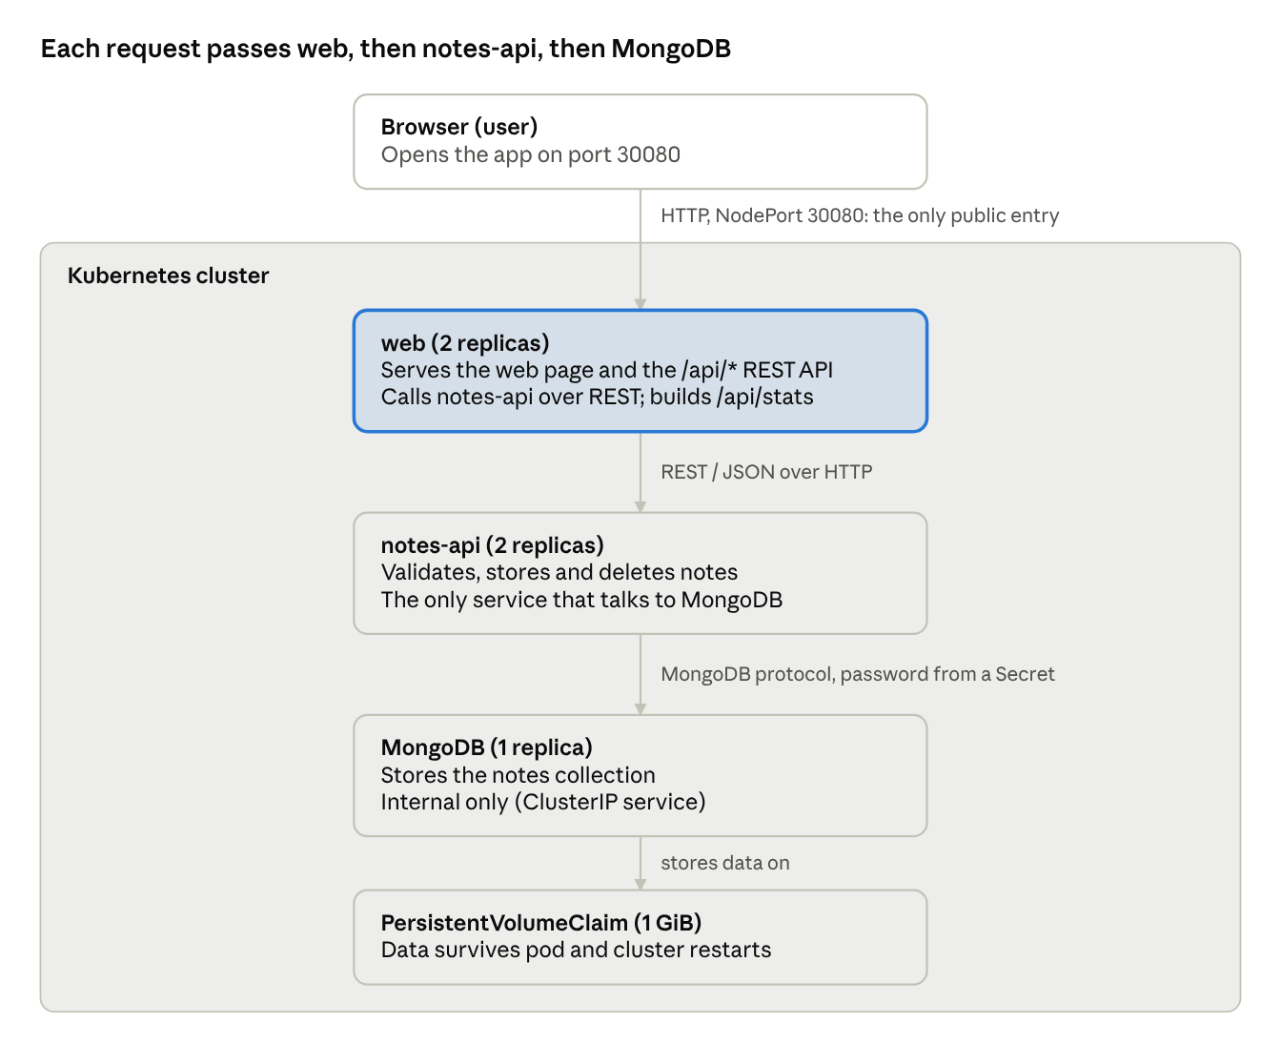
request flow · browser, 2 microservices, database

REST APIs
Both microservices exchange JSON over HTTP.
web (public, used by the browser)
Method | Path | What it does
GET | / | Returns the web page (HTML + JavaScript)
GET | /api/notes | Lists all notes (calls notes-api)
POST | /api/notes | Adds a note; body {"text": "..."} (calls notes-api)
DELETE | /api/notes/{id} | Deletes a note (calls notes-api)
GET | /api/stats | Returns note count, average length and the serving pod names
GET | /health | Health check used by Kubernetes
notes-api (internal, reachable only inside the cluster)
Method | Path | What it does
GET | /notes | Returns all notes from MongoDB
POST | /notes | Validates the text (1–500 characters) and stores the note; returns 201
DELETE | /notes/{id} | Deletes a note; 400 for an invalid id, 404 if not found
GET | /health | Health check used by Kubernetes
If notes-api cannot be reached within 3 seconds, web answers 503 notes-api unavailable instead of hanging.

Running on Kubernetes
The whole application is deployed with one manifest, k8s/app.yaml, using kubectl apply -f k8s/app.yaml.
- Images: notes-api and notes-web are built from their Dockerfiles and pushed to Docker Hub, where Kubernetes pulls them. MongoDB uses the official mongo:7 image.
- Access from outside: only web is exposed, as a NodePort service on port 30080 (e.g. http://localhost:30080 or http://<server-ip>:30080). notes-api and mongo are internal ClusterIP services.
- Independent scaling: web and notes-api are separate Deployments, each starting with 2 replicas. Either can be scaled on its own, e.g. kubectl scale deployment notes-api --replicas=4.
- Persistent database: MongoDB runs as a single replica and stores its data on a 1 GiB PersistentVolumeClaim.
- Credentials: the database username and password come from a Kubernetes Secret, not from the code.
- Health checks: each microservice has a /health endpoint used as a readiness probe, so traffic only goes to pods that are ready.

Scale assumption
The application is deliberately small, and a notes board with a few users does not need to scale.
To see why the design makes sense, imagine it is a company-wide notice board used by thousands of employees. Page and read traffic would then be much higher than writes. You could add more web replicas to handle browser traffic, or more notes-api replicas to handle data requests, without changing the other service.

Technologies used
Part | Technology
Microservices | Node.js 20, Express 5
REST client in web | Node.js built-in fetch
Database | MongoDB 7, official mongodb Node.js driver
User interface | Plain HTML and JavaScript
Containers | Docker (node:20-alpine base image), images on Docker Hub
Orchestration | Kubernetes: Deployments, Services, Secret, PersistentVolumeClaim

