Architecture Design
The Notes application is split into a public gateway (web), an internal data service (notes-api) and a database (mongo), each running as its own Kubernetes Deployment behind its own Service.

Architecture at a glance
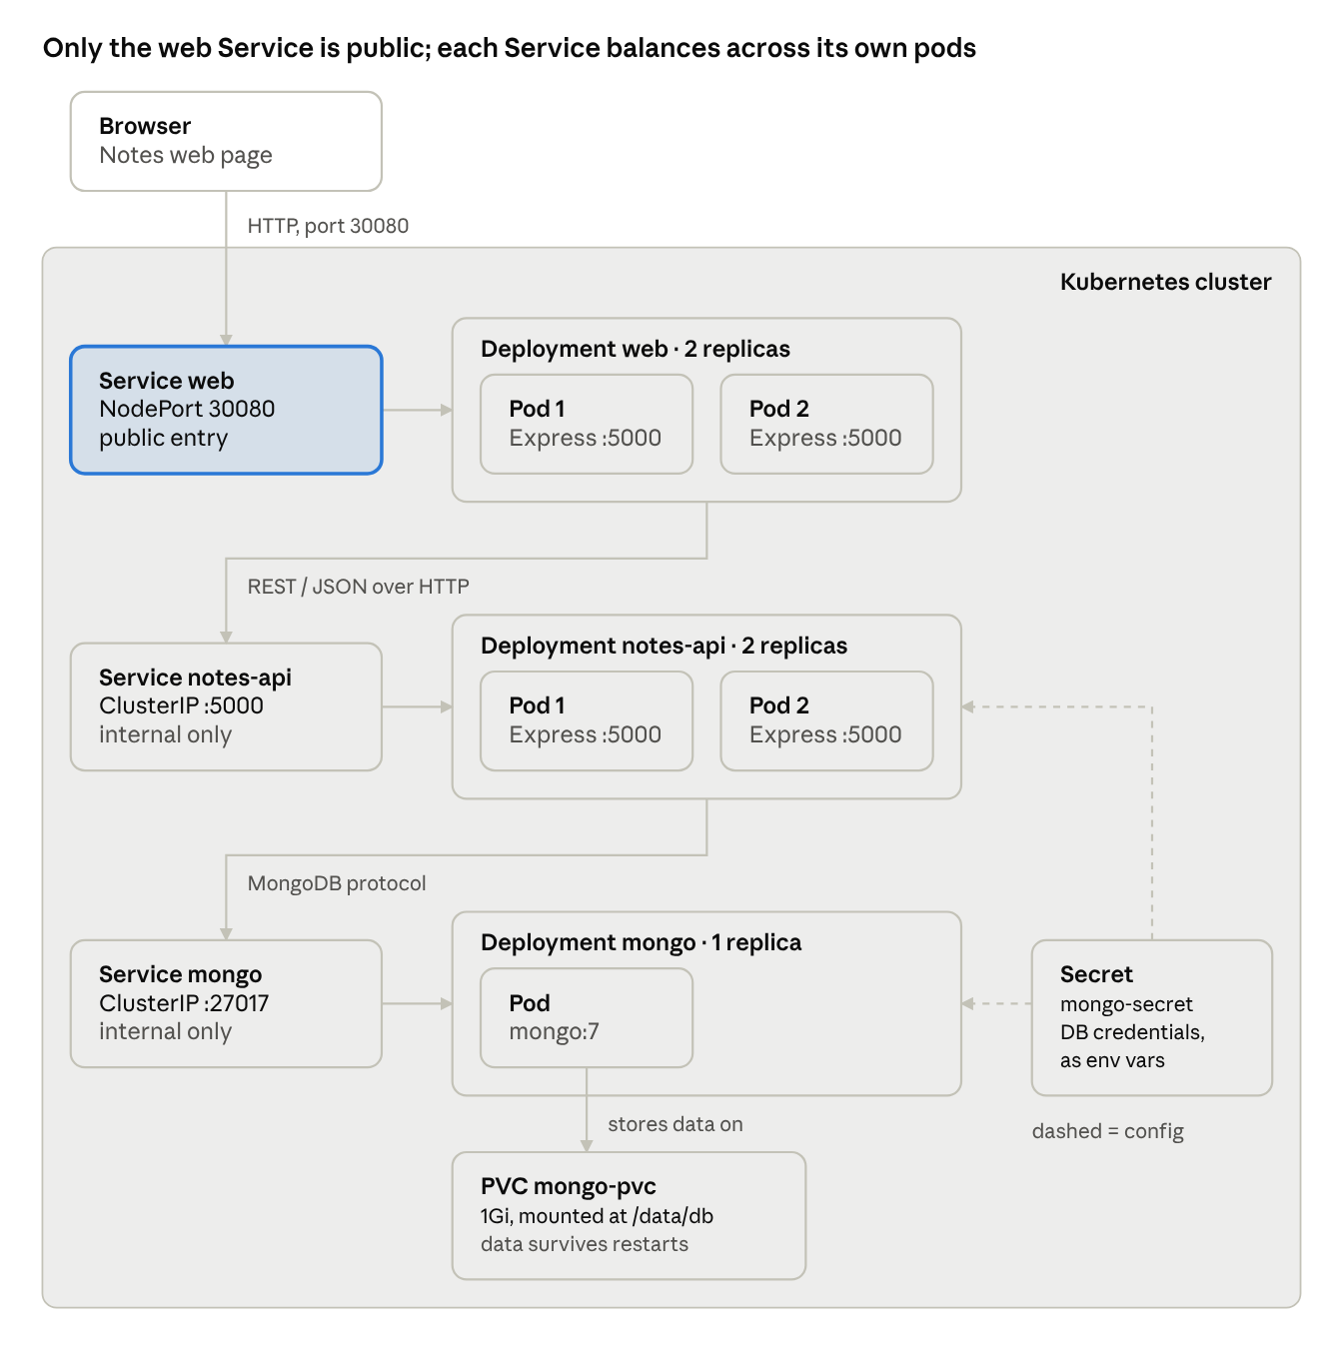
component view · 3 Services, 3 Deployments, Secret, PVC
Each tier is a Service in front of a Deployment. A request goes from the browser through each Service to one of its pods, then to the next tier. The Secret supplies the database credentials to notes-api and mongo.

Components and responsibilities
Component | Role | Responsibilities
User interface | What the user sees | Single HTML page with plain JavaScript. Calls /api/* on web with fetch, shows notes, stats and the serving pod names. Inserts note text with textContent so notes cannot inject HTML.
Gateway / BFF (web) | The only public entry point | Serves the user interface. Exposes the public REST API. Forwards note requests to notes-api over REST with a 3-second timeout and returns 503 if it is unavailable. Computes /api/stats from the data it receives. Holds no data.
Notes service (notes-api) | Owner of the notes data | Exposes the internal REST API for notes. Validates input (1–500 characters, valid ids). Reads and writes MongoDB. Returns proper status codes (201, 400, 404, 500).
Database (mongo) | Durable storage | Stores the notes collection in the notesdb database. Requires a username and password. Writes its data to a persistent volume.
Configuration and secrets | Settings kept outside the code | A Kubernetes Secret holds the database credentials. Environment variables hold service URLs (MONGO_URL, NOTES_API_URL).
Kubernetes platform | Runs and connects everything | Schedules pods, restarts failed ones, gives each Service a DNS name, load-balances requests across replicas and only sends traffic to pods that pass their readiness check.

Mapping: components to microservices
Three microservices implement the six components: two built by me, plus the official MongoDB image.
Software component | Microservice | Container image | Kubernetes objects | Source
User interface | web | <user>/notes-web:1.0 (built by me) | served by the web Deployment | web/static/index.html
Gateway / BFF | web | <user>/notes-web:1.0 (built by me) | Deployment web, Service web (NodePort 30080) | web/server.js
Notes service | notes-api | <user>/notes-api:1.0 (built by me) | Deployment notes-api, Service notes-api (ClusterIP) | notes-api/server.js
Database | mongo | mongo:7 (official) | Deployment mongo, Service mongo (ClusterIP), PersistentVolumeClaim mongo-pvc | k8s/app.yaml
Configuration and secrets | used by notes-api and mongo | none | Secret mongo-secret, environment variables | k8s/app.yaml
Kubernetes platform | none (runs all three) | none | all of the above | k8s/app.yaml
<user> is the Docker Hub account the images are pushed to.

Architecture principles and patterns
Principle or pattern | What it means | How it is applied here
Microservices, single responsibility | Each service does one job and is deployed on its own | web handles presentation and the public API; notes-api handles notes data. Separate code, images and Deployments.
API Gateway / Backend for Frontend | One public entry point that shields internal services | The browser only talks to web. notes-api and mongo are ClusterIP Services, unreachable from outside.
Database per service | Only the owning service touches its data | Only notes-api has the database credentials and connects to MongoDB. web gets data through the REST API.
Synchronous REST communication | Services talk over HTTP with JSON | web calls GET/POST /notes and DELETE /notes/{id} on notes-api with Node.js fetch.
Stateless services, horizontal scaling | Any replica can answer any request | web and notes-api keep no local state, so each Deployment can be scaled on its own with kubectl scale.
Service discovery and load balancing | Services find each other by name; traffic is spread | web calls http://notes-api:5000; notes-api calls mongo:27017. Kubernetes DNS resolves the names and each Service balances across its pods.
Health endpoint monitoring | Each service reports whether it is ready | GET /health on both services, used as readiness probes.
Fail fast (timeout + fallback) | A slow dependency must not hang the caller | web gives up on notes-api after 3 seconds and returns 503 notes-api unavailable.
External configuration | Settings live outside the code | Service URLs come from environment variables; credentials from a Kubernetes Secret.
Persistent storage for stateful parts | Data outlives the containers | MongoDB data lives on a PersistentVolumeClaim. The Recreate strategy stops two database pods writing the same volume.
Declarative infrastructure | The desired state is described in a file | All objects are in k8s/app.yaml and are created with one kubectl apply.

How the components interact
Adding a note passes through every component:
- The user types a note and clicks Add. The page sends POST /api/notes with {"text": "..."} to port 30080.
- The web Service picks one of the web pods.
- That web pod calls POST http://notes-api:5000/notes with the same body.
- The notes-api Service picks one of the notes-api pods.
- notes-api checks the text is 1–500 characters. If not, it returns 400 and nothing is stored.
- notes-api inserts the note into MongoDB through the mongo Service, using the credentials from the Secret. MongoDB writes it to the persistent volume.
- notes-api returns 201 with the new note's id, plus an X-Served-By header naming its pod.
- web relays the response to the browser and adds its own pod name. The page reloads the list and calls GET /api/stats, which web computes from GET /notes.
Listing and deleting notes follow the same path. If notes-api is down or slower than 3 seconds, web stops at step 3 and returns 503.

Deployment details
All values come from k8s/app.yaml.
 | web | notes-api | mongo
Image | <user>/notes-web:1.0 | <user>/notes-api:1.0 | mongo:7
Replicas | 2 (scalable) | 2 (scalable) | 1 (not scaled)
Container port | 5000 | 5000 | 27017
Service type | NodePort, port 80 → 5000, node port 30080 | ClusterIP, port 5000 | ClusterIP, port 27017
Reachable from | Outside the cluster | Inside the cluster only | Inside the cluster only
Readiness probe | GET /health | GET /health | none
CPU request / limit | 50m / 250m | 50m / 250m | not set
Memory request / limit | 64Mi / 128Mi | 64Mi / 128Mi | not set
Configuration | NOTES_API_URL | MONGO_URL built from mongo-secret | root user from mongo-secret
Storage | none | none | mongo-pvc, 1Gi, ReadWriteOnce, at /data/db
Update strategy | Rolling update | Rolling update | Recreate
Both Node.js images use node:20-alpine, install dependencies with npm ci --omit=dev and run as the non-root node user.

