Meridian Motors
Global Manufacturing Data Platform
A Complete Walkthrough of the Plant Network, Core Systems, and Data Estate
Enterprise Data & Analytics
Manufacturing Systems Documentation

Contents
Part I – Business Overview
1. Introduction
2. Global Plant Network
3. Vehicle Platforms and Production Volume
4. Enterprise Asset Register
5. Manufacturing Execution – Summary
6. Statistical Process Control
7. Quality Management
8. Asset Maintenance
9. Warehousing and Logistics
10. Product Lifecycle and Supply Planning
11. Data Volume Summary
Part II – Data Dictionary: Complete File-by-File Walkthrough
How the Data Estate Is Organized
12. Enterprise Resource Planning (ERP)
13. Master Data Management (MD)
14. Manufacturing Execution – Process Routing
15. Manufacturing Execution – Component Plant Lot Execution
16. Manufacturing Execution – Vehicle Assembly
17. Manufacturing Execution – Per-Vehicle Quality Data
18. Manufacturing Execution – Cross-Plant Assembly Genealogy
19. Statistical Process Control (SPC)
20. Quality Management System (QMS)
21. Enterprise Asset Management (EAM)
22. Warehouse Management System (WMS)
23. Product Lifecycle Management (PLM)
24. Advanced Planning & Scheduling / Supply Chain (APS-SCM)
Appendix – Complete Table Inventory

PART I
Business Overview

1. Introduction
Meridian Motors operates a globally distributed automotive manufacturing network spanning 17 plants across seven countries, producing passenger vehicles across three platforms. This document provides a complete walkthrough of the data estate that supports day-to-day operations across the network: enterprise asset management, manufacturing execution, statistical process control, quality management, maintenance, warehousing and logistics, product lifecycle management, and supply and capacity planning.
Part I gives a narrative, metric-led overview of the business - how the plant network fits together, how vehicles move through it, and what the headline operational numbers look like. Part II is a complete data dictionary: every file maintained across the estate, its business purpose, every column it carries, and a real example record, organized exactly as the underlying systems themselves are organized - by source system, and within each system, by whether a file is maintained once for the whole network or separately by each plant.

2. Global Plant Network
The network comprises 5 final-assembly plants and 12 component and feeder plants, organized around a body-in-white chain (raw coil stock through stamped panels, welded body, and painted shell) and a set of direct-ship sub-assembly suppliers - battery packs and electric drive units, engines and transmissions, wiring harnesses, seating and interior trim, and electronics modules - each shipping finished lots directly into one or more final-assembly plants.
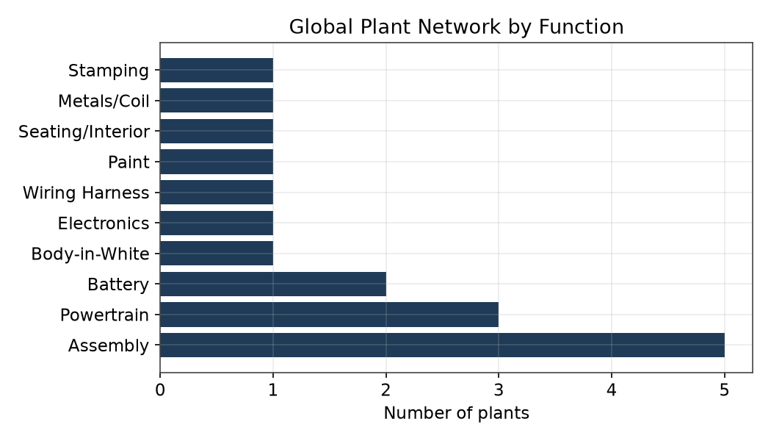
Figure 1. Plant count by functional role across the network.
Table 1 lists each plant, its primary function, and its home country.
Facility | Function | Country | Commissioned
Assembly Plant CN | Assembly | CN | 2015-08-19
Assembly Plant DE (Old) | Assembly | DE | 2014-06-18
Assembly Plant IN | Assembly | IN | 1988-02-28
Assembly Plant MX | Assembly | MX | 1986-10-24
Assembly Plant US (Old) | Assembly | US | 1997-11-05
Battery & eDrive Plant CN | Battery | CN | 1998-09-11
Battery & eDrive Plant PL | Battery | PL | 2012-12-27
BIW/Welding Plant DE | Body-in-White | DE | 1989-09-11
Electronics & Wiring Harness Plant MX | Electronics | MX | 2006-03-21
Engine Plant DE | Powertrain | DE | 1988-10-01
Engine Plant US | Powertrain | US | 2001-06-12
Ferrovia Harness Components Plant | Wiring Harness | VN | 2003-07-06
Paint Shop DE (Old) | Paint | DE | 2010-06-28
Seating & Interior Plant PL | Seating/Interior | PL | 2010-07-19
Solara Metals Coil Plant | Metals/Coil | DE | 1999-07-29
Stamping Plant DE | Stamping | DE | 2005-03-15
Transmission Plant PL | Powertrain | PL | 2008-01-26

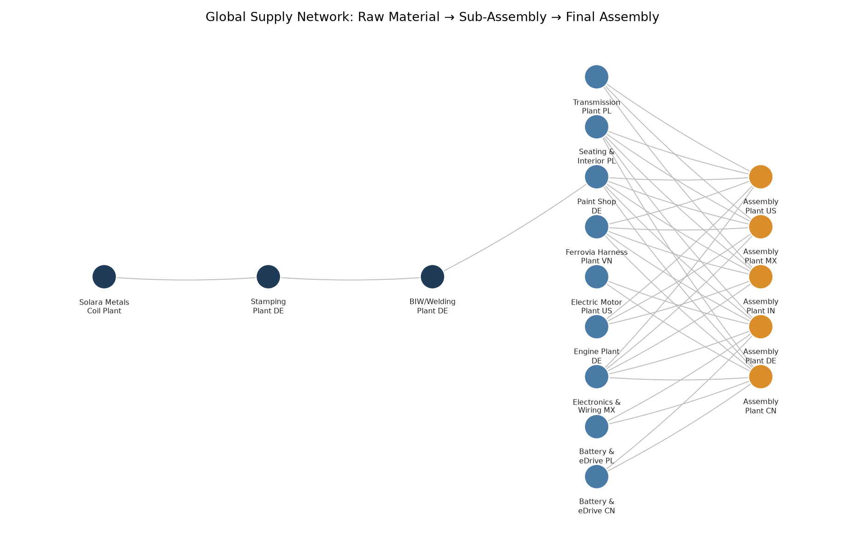
Figure 2. Material and sub-assembly flow from raw stock through final assembly.

3. Vehicle Platforms and Production Volume
Across the current reporting window, the network's five final-assembly plants built 383,500 vehicles across three platforms - a compact passenger platform, a battery-electric platform, and an SUV platform. 382,965 vehicles completed the build process; 535 were scrapped mid-build following an unrecoverable quality hold, a scrap rate of 0.14%, consistent with a mature, well-controlled assembly operation.
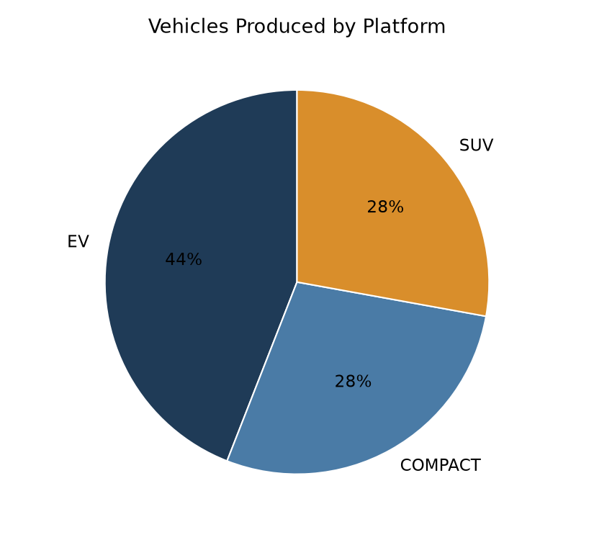
Figure 3. Vehicle mix by platform.
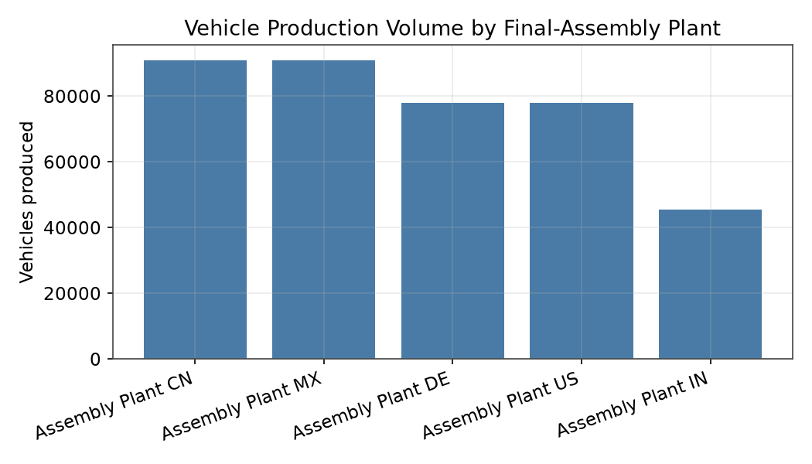
Figure 4. Production volume by final-assembly plant.

4. Enterprise Asset Register
The fixed-asset register tracks 11,284 machines and production equipment across the network, sourced from 101 distinct supplier name entries in the underlying ERP extracts. Gross acquisition value is recorded in each plant's local operating currency; converted to a common basis at period-end exchange rates, the network's installed equipment base represents approximately $1.22 billion in gross acquisition value.
Currency | Machines | Gross Acquisition Value
CNY | 1923 | 317,145,300
EUR | 2370 | 390,975,900
MXN | 1230 | 200,125,100
PLN | 1288 | 205,066,900
USD | 4332 | 691,305,600
VND | 141 | 25,714,800

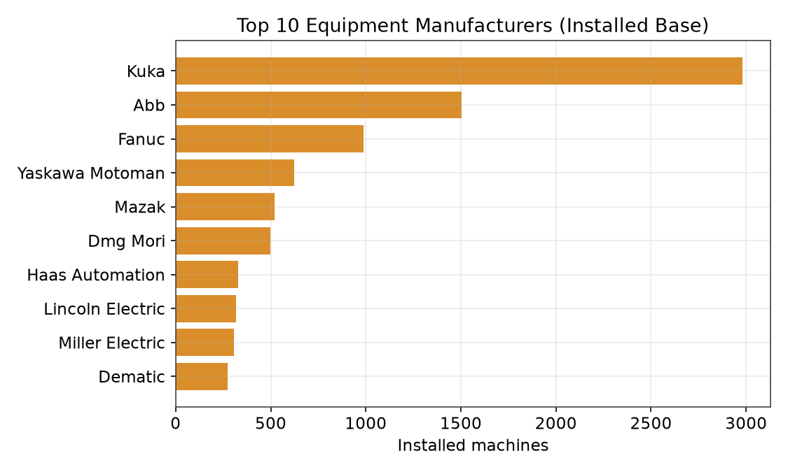
Figure 5. Ten most-represented equipment manufacturers by installed machine count.

5. Manufacturing Execution – Summary
The manufacturing execution layer carries two distinct granularities, consistent with how component plants and final-assembly plants actually operate. Across the twelve component and feeder plants, production is tracked as discrete lots and containers moving through a sequence of process steps, with material issue and in-process quality readings logged against each lot. Across the five final-assembly plants, every vehicle is individually VIN-traceable, moving through a defined sequence of major zone-transition checkpoints from body-in-white receipt through final functional test. A full column-level walkthrough of every file in this layer appears in Part II, Sections 14-18.
Layer | Scope | Records
Routing and process structure | All 17 plants | 5,253
Component-plant lot execution | 12 component/feeder plants | 2,914,432
Vehicle movement and checkpoints | 5 final-assembly plants | 9,965,164
Per-vehicle quality data collection | 5 final-assembly plants | 45,955,800
Cross-plant assembly genealogy | 5 final-assembly plants | 2,280,108

6. Statistical Process Control
The SPC program carries 2,312,960 capability readings across monitored characteristics network-wide, with a mean process capability index (Cpk) of 1.73. 955,814 readings (41.3%) fall below the 1.33 minimum-acceptable threshold used across the network's control plans, flagging the specific characteristics and stations that warrant engineering follow-up.
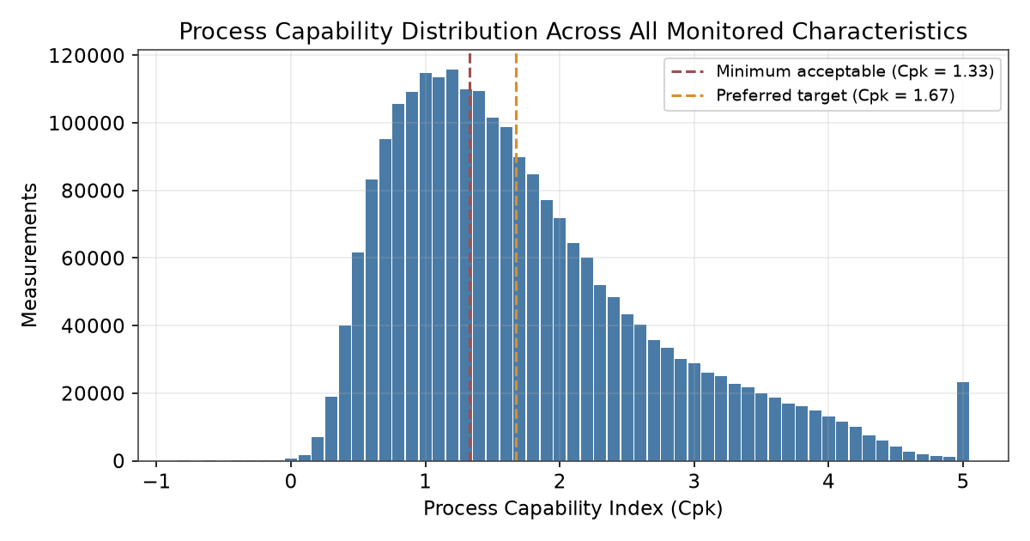
Figure 6. Distribution of process capability (Cpk) across all monitored characteristics.

7. Quality Management
2,404 nonconformance reports were raised across the network, carrying a combined cost of poor quality of approximately $3,132,154. 1,294 progressed to a formal 8D investigation, 281 of which produced a tracked corrective action (CAPA). Separately, 73 Production Part Approval Process submissions were processed against the active part catalog, of which all but one were approved.
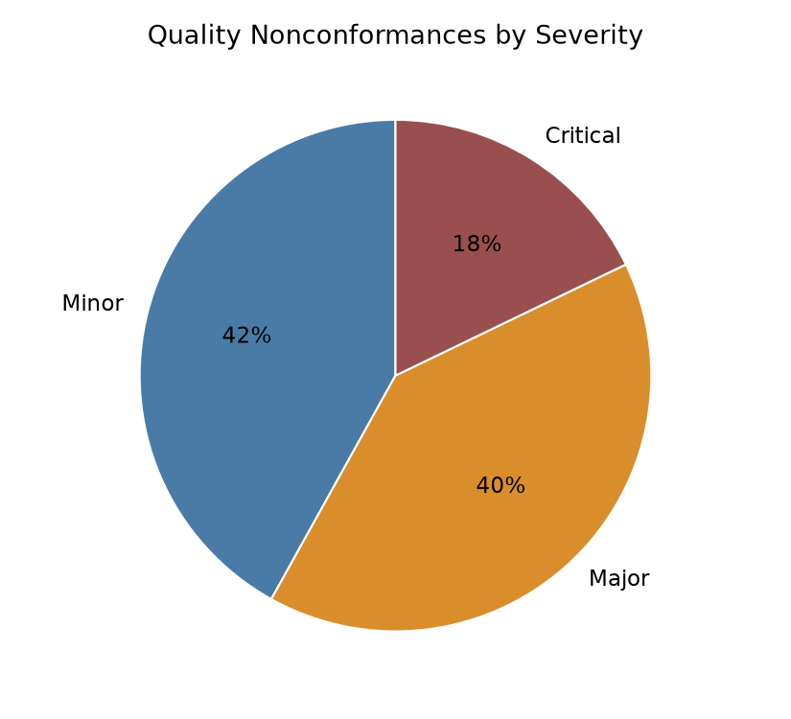
Figure 7. Nonconformance reports by severity.
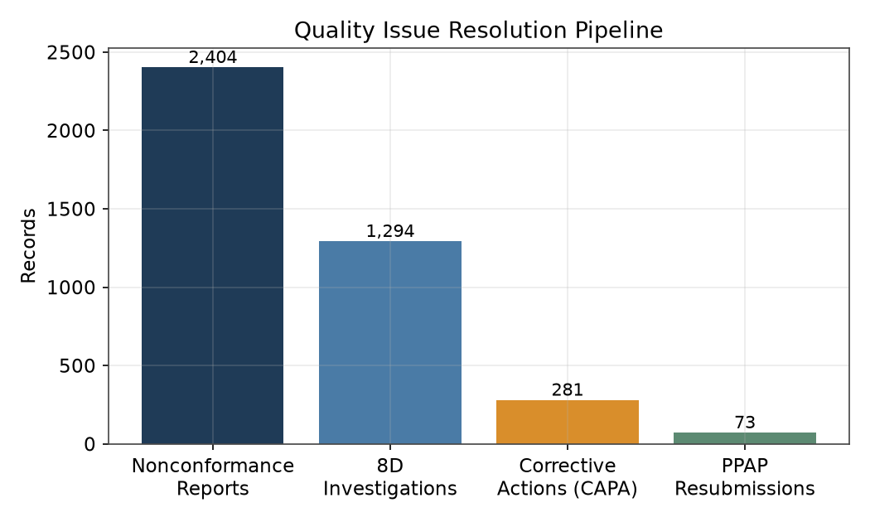
Figure 8. Quality issue resolution pipeline, from initial report through corrective action.

8. Asset Maintenance
The maintenance program carries 52,682 work orders across the network's preventive and corrective maintenance schedules, with 25,582 individual failure reports logged against the governed failure-code hierarchy, each carrying a distinct problem, cause, and remedy entry.

9. Warehousing and Logistics
Inter-plant material movement is tracked through 244,270 shipment records, covering the lanes connecting each component and feeder plant to the final-assembly plants it supplies, alongside on-hand inventory positions split across unrestricted, quality-inspection, and blocked stock at each receiving location.

10. Product Lifecycle and Supply Planning
The product lifecycle management system carries the governed bill of materials for all three vehicle platforms, along with controlled-document management, Design and Process FMEA, APQP phase-gate tracking, and DVP&R test records for each platform's development and change history. Supply and capacity planning carries rolling demand forecasts and weekly capacity plans for every plant in the network.

11. Data Volume Summary
In total, the data estate profiled in this walkthrough spans 63,875,924 records across 399 source files. Figure 9 shows the relative scale of each system domain; note the logarithmic axis, reflecting the several-orders-of-magnitude range between master/reference data and the high-frequency execution and quality-data layers generated on the shop floor.
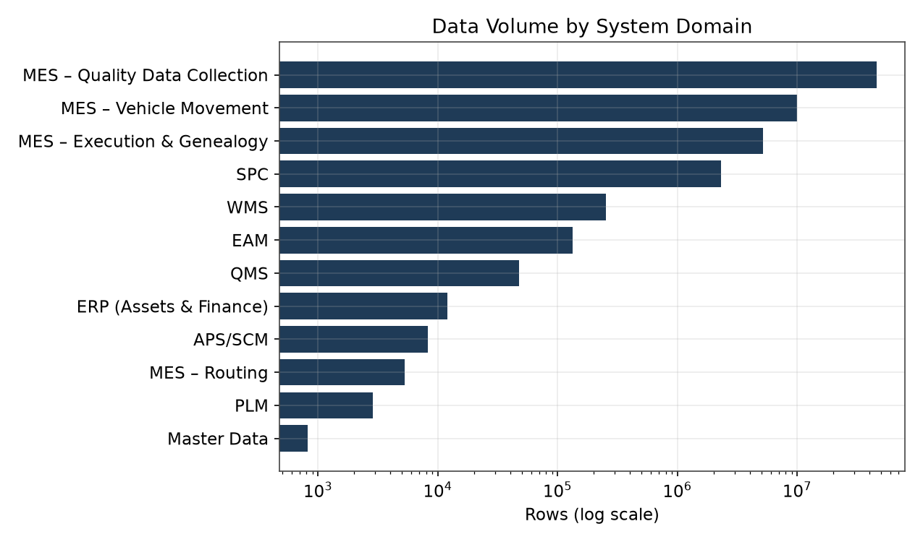
Figure 9. Record volume by system domain (logarithmic scale).

PART II
Data Dictionary: Complete File-by-File Walkthrough

How the Data Estate Is Organized
Every file in the estate falls into one of two organizational scopes, and the distinction matters for how each file is read and joined. Network-wide files - the governed engineering record (bills of material, characteristics, control plans, FMEA), the formal quality-escalation record (8D investigations, corrective actions, layered audits, customer complaints, PPAP, deviations), the failure-code taxonomy, the supplier scorecard, and the planning and forecast tables - are maintained once for the whole business, not duplicated per plant, because the entities they describe (a part revision, an engineering change, an investigation, a supplier relationship) are not themselves plant-specific.
Plant-scoped files - the asset register, master data, process routing, maintenance, SPC, the nonconformance log, warehouse movement and inventory, and the full manufacturing-execution layer - are maintained independently by each of the 17 plants, each publishing its own extract on its own operating cadence. A plant-scoped file's row count in this document is the sum across however many plants carry that file; not every plant carries every plant-scoped file; the manufacturing-execution layer in particular splits further still, since the twelve component plants and five final-assembly plants track production on genuinely different structures, described in Sections 15-18 below.
Each of the following sections documents one source system. Within a system, every file is presented in the same structure: its business purpose, a complete listing of every column it carries, and one real example record drawn directly from the current data.

12. Enterprise Resource Planning (ERP)
The ERP fixed-asset register is the financial system of record for every piece of production equipment and capital asset across the network. Each plant maintains its own extract; a network-level supplier scorecard tracks vendor performance centrally.

erp
Plant-scoped • maintained independently by 17 plants • 11,284 records combined
Fixed asset register - one row per piece of production equipment or capital asset installed at the plant, carrying its full financial and lifecycle history from acquisition through depreciation to eventual disposal.
Column | Description
PlantCode | Internal plant code this asset belongs to.
FixedAssetNo | Unique fixed-asset number; the asset's primary key in the finance ledger.
AssetDesc | Free-text description of the machine or equipment and the process it performs.
AcqValue | Original gross acquisition cost, recorded in the plant's local operating currency.
Manufacturer | Equipment OEM / vendor name.
Currency | ISO currency code for AcqValue and the related financial fields.
AcqDate | Date of purchase / capitalization.
InServiceDate | Date the asset was placed into productive service.
AssetClass | High-level fixed-asset classification.
AssetGroup | Finer-grained equipment category / process family.
SerialNumber | Manufacturer-issued serial number.
UsefulLifeYears | Depreciation useful life, in years.
DepreciationMethod | Accounting depreciation method applied.
AccumulatedDepreciation | Depreciation posted to date.
NetBookValue | Current carrying value (acquisition cost less accumulated depreciation).
SalvageValue | Estimated residual value at end of useful life.
CostCenter | Owning cost center for financial reporting.
GLAccount | General-ledger account the asset posts to.
Location | Physical location / area within the plant.
DisposalDate | Date retired or disposed, null for in-service assets.
DisposalMethod | How the asset was disposed, null for in-service assets.
WarrantyExpirationDate | End of manufacturer warranty coverage.
SupplierRef | Vendor the asset was procured from.
PurchaseOrderRef | Originating purchase order.
ProgramRef | Vehicle program / platform this capital investment supports, where applicable.
InsuredValue | Insured replacement value.
LastPhysicalInventoryDate | Date of the last physical asset-verification count.
ResponsibleDepartment | Department accountable for the asset.
CapitalProjectRef | Capital project the acquisition was funded under.
ParentAssetRef | Parent asset, for a tracked sub-asset (e.g. a spindle tracked separately under its parent machine).

Example record:
Field | Value
PlantCode | P1160
FixedAssetNo | 000170000053
AssetDesc | Riveting Station
AcqValue | 38358.06
Manufacturer | KUKA AG
Currency | CNY
AcqDate | 2025-01-12
InServiceDate | 2025-02-01
AssetClass | Production Machinery
AssetGroup | Assembly Automation
SerialNumber | SN51366120
UsefulLifeYears | 15
DepreciationMethod | Straight-Line
AccumulatedDepreciation | 4143.93
NetBookValue | 34214.13
SalvageValue | 2090.43
CostCenter | CC-4837
GLAccount | 15100
Location | Bay 12
DisposalDate | 2026-07-14
DisposalMethod | Traded-In
WarrantyExpirationDate | 2027-01-12
SupplierRef | KUKA AG
PurchaseOrderRef | PO-2025-00002
ProgramRef | SUV
InsuredValue | 42413.42
LastPhysicalInventoryDate | 2025-02-08
ResponsibleDepartment | Production
CapitalProjectRef | CAPEX-2025-963
ParentAssetRef

erp_supplier_scorecard
Network-wide (maintained once, not duplicated per plant) • 742 records
Periodic supplier performance scorecard - one row per supplier per reporting period, summarizing delivery and quality performance for sourcing and supplier-management review.
Column | Description
SupplierRef | Supplier identifier.
Period | Reporting period the scorecard covers.
OnTimeDeliveryPct | Share of deliveries received on time in the period.
QualityPPM | Defective parts per million received from this supplier in the period.
SCARCount | Number of open Supplier Corrective Action Requests in the period.
OverallRating | Composite supplier rating for the period.

Example record:
Field | Value
SupplierRef | ABB
Period | 2026-03
OnTimeDeliveryPct | 91.3
QualityPPM | 37.8
SCARCount | 0
OverallRating | B

13. Master Data Management (MD)
Master Data maintains the governed, slowly-changing reference records for the plant and line hierarchy - the structural backbone every other system joins against.

md_plant
Plant-scoped • maintained independently by 17 plants • 17 records combined
Plant master record - one row per plant, carrying its identity, location, and organizational ownership.
Column | Description
Facility | Plant name - the join key used throughout the network.
PlantCode | Internal plant code, maintained independently within Master Data (not shared with the planning system's own plant-code scheme).
CompanyCode | Parent company / legal-entity code.
Country | Country of operation.
Address | Street address.
City | City.
Latitude | Site latitude.
Longitude | Site longitude.
TimeZone | Local time zone.
PlantType | Primary function (Assembly, Stamping, Powertrain, Battery, etc.).
CommissionedDate | Date the plant began operation.
PlantManager | Plant leadership contact.
Updated_On | Date this record was last updated.

Example record:
Field | Value
Facility | Assembly Plant CN
PlantCode | MD-P001
CompanyCode | CC-CN
Country | CN
Address | 151 Industrial Park Rd
City | Shanghai
Latitude | 31.2304
Longitude | 121.4737
TimeZone | Asia/Shanghai
PlantType | Assembly
CommissionedDate | 2015-08-19
PlantManager | Wei Kowalski
Updated_On | 2025-12-02

md_line
Plant-scoped • maintained independently by 17 plants • 800 records combined
Line master record - one row per production line within the plant, a finer granularity than the plant record itself.
Column | Description
Facility | The owning plant.
Line_Ref | Line identifier.
Updated_On | Date this record was last updated.
UpdatedBy | Who last updated the record.
LineDescription | Free-text line description.
ShopCode | Shop area the line sits in (Paint Shop, Press Shop, Body Shop, Assembly Shop, Powertrain).
LineStatus | Active / Inactive / UnderConstruction / Decommissioned.
LineType | Flow / Cell / Batch.
ShiftPattern | Operating pattern (1-shift / 2-shift / 3-shift / continuous).
CommissionedDate | Date the line began operation.
DecommissionedDate | Date the line was retired, null for active lines.
ResponsibleManager | Line owner.

Example record:
Field | Value
Facility | Assembly Plant CN
Line_Ref | Assembly Plant CN Line 12
Updated_On | 2019-06-18
UpdatedBy
LineDescription | Assembly Plant CN Line 12
ShopCode | Assembly Shop
LineStatus | Decommissioned
LineType | Flow
ShiftPattern | 1-shift
CommissionedDate | 2019-09-22
DecommissionedDate | 2021-03-07
ResponsibleManager | Fatima Chen

14. Manufacturing Execution - Process Routing
The routing layer defines how each plant actually builds what it builds: the sequence of operations, the equipment and time standards behind each one, and the controlled work instructions and characteristics tied to each station.

mes
Plant-scoped • maintained independently by 17 plants • 5,253 records combined
Process routing - one row per operation/station in a production line's sequence, the structural backbone every execution-layer transaction ultimately references.
Column | Description
PROD_LINE | Production line.
PROC_NUMBER | Process / operation number.
PROC_NAME_LOCAL | Local operation name.
STATION_ID | Station identifier.
EQUIP_REF | Equipment performing the operation.
PRODUCT_REF | Finished product this operation builds, where the line builds a tracked finished product.
MATERIAL_REF | Raw material this operation consumes, where applicable.
WORK_UNIT_ID | Work-unit identifier within the line.
OperationSequence | Position in the line's own operation sequence.
SetupTimeSeconds | Batch setup time, independent of lot size.
RunTimeSecondsPerPiece | Planned run time per piece.
LaborTimeSecondsPerPiece | Planned labor time per piece.
TaktTimeSeconds | Line takt time.
WorkInstructionRef | Linked controlled work instruction for this operation.
CharacteristicRef | Linked quality characteristic measured at this station.
RoutingVersion | Routing revision currently in effect.
RoutingEffectiveDate | Date this routing revision became effective.

Example record:
Field | Value
PROD_LINE | L01
PROC_NUMBER | PR-0002
PROC_NAME_LOCAL | RESISTANCE WELDING
STATION_ID | S01
EQUIP_REF | 000170000001
PRODUCT_REF | MER-VEH-EV-0001
MATERIAL_REF | MER-LIGHTING-SYSTEM-0024
WORK_UNIT_ID | WU1
OperationSequence | 10
SetupTimeSeconds | 213.0
RunTimeSecondsPerPiece | 148.4
LaborTimeSecondsPerPiece | 125.8
TaktTimeSeconds | 173.1
WorkInstructionRef | WI-PR-0002
CharacteristicRef | CHR-00214
RoutingVersion | REV-2
RoutingEffectiveDate | 2023-07-15

15. Manufacturing Execution - Component Plant Lot Execution
The twelve component and feeder plants track production as discrete lots moving through a sequence of process steps, with material consumption and in-process quality readings logged against each lot - the same lot/container discipline used throughout the network's Tier-1 supply base.

mes_container
Plant-scoped • maintained independently by 12 plants • 102,050 records combined
Lot / container master - one row per production lot moving through a component plant, from creation through completion, shipment, or scrap.
Column | Description
ContainerName | Lot / container identifier.
Level | Lot (in-process) or PackLot (packaged for shipment).
Product | Part number this lot contains.
ProductRevision | Part revision.
MfgOrderName | Production order this lot was built against.
StartQty | Quantity at lot creation.
CompletedQty | Quantity on completion.
CurrentQty | Quantity currently on hand against this lot.
Status | Active (WIP stock) / Active (FG stock) / Closed (consumed) / Shipped / Scrapped.
StartDate | Date the lot was created.
CompletedDate | Date the lot completed its routing.
ERPBatch | Linked ERP batch / goods-movement reference.
ShippedDelivery | Outbound delivery reference, where shipped.
ShipDate | Date shipped, where shipped.

Example record:
Field | Value
ContainerName | BAT-CN-260330-00001
Level | Lot
Product | MER-BATTERY-PACK-0026
ProductRevision | A
MfgOrderName | MO-BAT-CN-260330-008969
StartQty | 40
CompletedQty | 40
CurrentQty | 0
Status | Shipped
StartDate | 2026-03-30T19:51:08
CompletedDate | 2026-04-03T19:00:00
ERPBatch | 509132
ShippedDelivery | DLV-BAT-CN-260330-00001
ShipDate | 2026-04-07T08:00:00

mes_container_history
Plant-scoped • maintained independently by 12 plants • 1,397,673 records combined
Lot transaction / movement log - one row per event in a lot's own life, from creation through every process-step move to final completion or shipment.
Column | Description
TxnId | Transaction identifier.
TxnDate | Transaction timestamp.
TxnType | Start / MoveIn / MoveStd / Hold / Scrap / Rework / Complete / Ship.
ContainerName | The lot this event belongs to.
Product | Part number.
MfgOrderName | Production order.
StepName | Process step at which the event occurred.
SpecRevision | Routing / spec revision in effect.
ResourceName | Equipment involved.
Employee | Operator who logged the event.
Qty | Lot quantity at the time of this event.
QtyChange | Quantity change applied by this event.
ReasonCode | Reason code, populated for Hold / Scrap / Rework events.
Comments | Free-text note.
Shift | Shift the event occurred on.

Example record:
Field | Value
TxnId | TXN-BAT-CN-260330-00001-000
TxnDate | 2026-03-30T16:04:02
TxnType | Start
ContainerName | BAT-CN-260330-00001
Product | MER-BATTERY-PACK-0026
MfgOrderName | MO-BAT-CN-260330-008969
StepName | Start
SpecRevision | A
ResourceName | 000040000029
Employee | rsantos
Qty | 40
QtyChange | 40
ReasonCode
Comments | Started from MfgOrder MO-BAT-CN-260330-008969
Shift | B

mes_component_issue
Plant-scoped • maintained independently by 12 plants • 799,285 records combined
Material consumption log - one row per material or upstream component issued into a lot, closing the chain back either to an internally-produced upstream lot or an external supplier shipment.
Column | Description
TxnId | Transaction identifier.
TxnDate | Transaction timestamp.
ContainerName | The lot the material was issued into.
Product | The part this lot is building.
StepName | Process step at which the material was consumed.
ComponentProduct | The material or component actually consumed.
IssueQty | Quantity issued.
FromContainerName | The upstream internal lot the material was drawn from, where sourced from another plant in the network's own supply chain; null when sourced externally.
ComponentLot | External raw-material lot number, where sourced externally.
VendorLotNumber | The vendor's own lot number, where sourced externally.
Vendor | Supplier name, where sourced externally.
Employee | Operator who logged the issue.

Example record:
Field | Value
TxnId | ISS-BAT-CN-260330-00001-001
TxnDate | 2026-03-30T10:09:08
ContainerName | BAT-CN-260330-00001
Product | MER-BATTERY-PACK-0026
StepName | OP10
ComponentProduct | RAW-MER-BATTERY-PACK-0026
IssueQty | 40.6
FromContainerName
ComponentLot | RM-346565
VendorLotNumber | VL-81059
Vendor | Lear Corporation Seating
Employee | dmueller

mes_data_collection
Plant-scoped • maintained independently by 12 plants • 615,424 records combined
In-process quality reading log - one row per measurement taken against a lot, or a standalone equipment check not tied to any specific lot.
Column | Description
TxnId | Transaction identifier.
TxnDate | Transaction timestamp.
ContainerName | The lot the reading was taken against; null for a standalone equipment check.
Product | Part number, where tied to a lot.
StepName | Process step the reading was taken at.
SpecRevision | Spec revision in effect.
ResourceName | Gauge / equipment used.
DataPointName | Characteristic or check performed.
SampleNo | Sample number within the reading.
Value | Measured value.
Unit | Unit of measure.
LowerLimit | Lower spec limit.
UpperLimit | Upper spec limit.
IsOutOfSpec | Whether the reading fell outside spec.
Employee | Operator who took the reading.

Example record:
Field | Value
TxnId | DC-BAT-CN-260330-00001-001
TxnDate | 2026-03-30T11:04:46
ContainerName | BAT-CN-260330-00001
Product | MER-BATTERY-PACK-0026
StepName | OP10
SpecRevision | A
ResourceName | 000040000093
DataPointName | CHR-00218
SampleNo | 2
Value | 39.438
Unit | mm
LowerLimit | 37.11
UpperLimit | 41.01
IsOutOfSpec | N
Employee | lnguyen

16. Manufacturing Execution - Vehicle Assembly
The five final-assembly plants build uniquely-configured, individually VIN-traceable vehicles rather than interchangeable lots. Each vehicle moves through a defined sequence of major zone-transition checkpoints, from body-in-white receipt through final functional test.

mes_vehicle_unit
Plant-scoped • maintained independently by 5 plants • 383,500 records combined
Vehicle master - one row per VIN built, carrying its platform, line, build order, and final outcome.
Column | Description
VIN | Vehicle identification number.
Plant | Assembly plant.
PlatformCode | Vehicle platform (COMPACT, EV, SUV).
ProductRef | The platform's own root part number.
Line | Assembly line.
ModelYear | Model year.
ProductionOrderRef | Production order this vehicle was built against.
SequencePosition | Just-in-sequence build position for the plant.
BuildDate | Date the build started.
CompletionDate | Date the vehicle completed the line; null if scrapped.
Status | Complete or Scrapped.

Example record:
Field | Value
VIN | VINASMCN2603300001
Plant | plant_assembly_cn
PlatformCode | EV
ProductRef | MER-VEH-EV-0001
Line | L04
ModelYear | 2026
ProductionOrderRef | PO-ASM-CN-260330-EV
SequencePosition | 1
BuildDate | 2026-03-30T10:19:13
CompletionDate | 2026-04-01T03:53:13
Status | Complete

mes_vehicle_movement
Plant-scoped • maintained independently by 5 plants • 9,581,664 records combined
Vehicle checkpoint log - one row per major zone-transition event in a vehicle's build, from body-in-white receipt through paint, trim, chassis marriage, and final end-of-line release.
Column | Description
TxnId | Transaction identifier.
VIN | The vehicle.
Plant | Assembly plant.
CheckpointName | Named checkpoint (e.g. Body Weld Complete, Paint Inspection, Chassis Marriage, Final/EOL Release).
Zone | Body / Paint / Trim / Chassis / Final.
Timestamp | When the checkpoint was reached.
Line | Assembly line.
Employee | Operator who logged the checkpoint.
Shift | Shift.
Status | Pass / Hold / Rework / Scrap.
ReasonCode | Reason, populated for a Hold, Rework, or Scrap event.

Example record:
Field | Value
TxnId | MV-VINASMCN2603300011-004
VIN | VINASMCN2603300011
Plant | plant_assembly_cn
CheckpointName | Paint Prep
Zone | PAINT
Timestamp | 2026-03-30T23:43:28
Line | L91
Employee | nabara
Shift | C
Status | Rework
ReasonCode | Rework - wiring harness routing

17. Manufacturing Execution - Per-Vehicle Quality Data
Beyond the coarse checkpoint log, every vehicle carries its own set of individually logged quality-critical measurements - torque-controlled fasteners being the classic automotive example, alongside functional and fit checks across the body, chassis, trim, and final-assembly areas.

mes_assembly_quality
Plant-scoped • maintained independently by 5 plants • 45,955,800 records combined
Per-vehicle quality data collection - one row per individually logged measurement point on a vehicle, linked back to the governed quality characteristic it verifies.
Column | Description
TxnId | Transaction identifier.
VIN | The vehicle.
Plant | Assembly plant.
PlatformCode | Vehicle platform.
Zone | Body / Chassis / Trim / Final area the characteristic belongs to.
PartNumber | The part this characteristic is measured on.
CharacteristicRef | The specific governed quality characteristic (e.g. a torque-controlled fastener or a fit/gap check).
Timestamp | When the measurement was taken.
SampleNo | Sample number.
Value | Measured value.
Unit | Unit of measure.
LowerLimit | Lower spec limit.
UpperLimit | Upper spec limit.
IsOutOfSpec | Whether the reading fell outside spec.
Employee | Operator who took the reading.

Example record:
Field | Value
TxnId | QD-VINASMCN2603300001-001
VIN | VINASMCN2603300001
Plant | plant_assembly_cn
PlatformCode | EV
Zone | BODY
PartNumber | MER-BODY-0002
CharacteristicRef | CHR-00010
Timestamp | 2026-03-30T18:31:38.850688
SampleNo | 1
Value | 71.83
Unit | mm
LowerLimit | 71.393
UpperLimit | 72.327
IsOutOfSpec | N
Employee | hlindgren

18. Manufacturing Execution - Cross-Plant Assembly Genealogy
The genealogy layer closes the golden-thread traceability chain a single material-lot field alone could never represent: for every vehicle, which specific upstream lot of each major tracked sub-assembly - the painted body shell, the battery pack or engine and transmission, the wiring harness, the seating module, and the electronics module - was actually installed, and which plant produced it.

mes_assembly_genealogy
Plant-scoped • maintained independently by 5 plants • 2,280,108 records combined
Installed-component genealogy - one row per major tracked sub-assembly installed on a given vehicle, tying the finished VIN back to the originating component-plant production lot.
Column | Description
VIN | The vehicle.
Plant | The assembly plant that built it.
ComponentPartNumber | The sub-assembly part number installed.
ComponentSerialOrLotRef | The specific upstream lot actually installed.
SourcePlant | The component plant that produced this sub-assembly.
SourceLotRef | The originating production lot at the source plant.
InstallDate | Date installed on the vehicle.
StationRef | Station / checkpoint at which it was installed.

Example record:
Field | Value
VIN | VINASMCN2603310001
Plant | plant_assembly_cn
ComponentPartNumber | MER-BODY-SHELL-0003
ComponentSerialOrLotRef | PNT-DE-260330-00013
SourcePlant | plant_paintshop_de
SourceLotRef | PNT-DE-260330-00013
InstallDate | 2026-03-31T14:07:56
StationRef | Body-In-White Receipt

19. Statistical Process Control (SPC)
The SPC program monitors process capability continuously against every governed characteristic in the network's control plans, using the standard automotive capability indices alongside full gauge-traceability detail for Measurement System Analysis.

spc
Plant-scoped • maintained independently by 17 plants • 2,312,960 records combined
Capability study readings - one row per sample measurement against a monitored characteristic, carrying both the raw reading and its derived capability indices for that subgroup.
Column | Description
Characteristic_No | The characteristic being monitored.
Station_Ref | Station the reading was taken at.
Value | Measured value.
UpperSpecLimit | Upper spec limit.
LowerSpecLimit | Lower spec limit.
Cpk | Within-subgroup process capability index.
Ppk | Overall process performance index, using total sample variation.
Cp | Full-tolerance-width counterpart to Cpk.
Pp | Full-tolerance-width counterpart to Ppk.
Timestamp | When the sample was taken.
SampleIndex | Sample position within its subgroup.
SubgroupID | Subgroup identifier.
SubgroupSize | Number of samples in the subgroup - needed to interpret Cpk/Ppk correctly, since different AIAG constants apply at different subgroup sizes.
ChartType | Control chart type in use (X-bar/R, X-bar/s, Individual/Moving Range, p-chart, etc.).
NominalValue | Target / nominal spec value.
CharacteristicRef | Linked characteristic master record.
MeasurementDeviceID | Gauge / instrument used, for MSA and calibration traceability.

Example record:
Field | Value
Characteristic_No | K1001
Station_Ref | S01
Value | 61.384
UpperSpecLimit | 62.77
LowerSpecLimit | 59.199
Cpk | 2.417
Ppk | 2.106
Cp | 3.418
Pp | 2.978
Timestamp | 2026-03-30T13:50:00
SampleIndex | 1
SubgroupID | SG-000001
SubgroupSize | 2
ChartType | X-bar/R
NominalValue | 60.984
CharacteristicRef
MeasurementDeviceID | GAUGE-S01-B

20. Quality Management System (QMS)
The quality system carries the full lifecycle of a nonconformance - from initial detection, through formal 8D root-cause investigation and corrective action, to the layered audits and supplier-facing processes (PPAP, customer complaints, deviations) that surround it.

qms
Plant-scoped • maintained independently by 17 plants • 2,404 records combined
Nonconformance report (NCR) register - one row per quality nonconformance, the entry point for the network's entire quality-escalation process.
Column | Description
QualityRecordID | NCR identifier.
Part_No | Affected part.
Defect_Type | Nature of the defect.
Station_Ref | Station where detected.
DispositionCode | Disposition applied (use-as-is, rework, scrap, etc.).
PPM | Parts-per-million impact.
EightD_Stage | Current stage of the linked 8D investigation, where one exists.
DateRaised | Date raised.
DateClosed | Date closed, null while open.
RaisedBy | Who reported it.
Severity | Minor / Major / Critical.
QuantityAffected | Units affected.
UnitSerialNumber | Specific traceable unit, where a specific unit is implicated.
SourceType | Internal detection, customer complaint, or supplier-caused.
CustomerComplaintRef | Linked customer complaint, where the NCR originated from one.
SupplierRef | Supplier implicated, where supplier-caused.
ContainmentAction | Immediate containment taken.
RootCauseCode | Root cause classification.
CorrectiveActionOwner | Owner of the fix.
CorrectiveActionDueDate | Due date for the fix.
CostOfPoorQuality | Quantified cost impact.
SCARRef | Linked Supplier Corrective Action Request, where a supplier is implicated.

Example record:
Field | Value
QualityRecordID | NCR-CN-00028
Part_No | MER-REAR-SUSPENSION-0011
Defect_Type | WELD-MISALIGN
Station_Ref | ASY-S01
DispositionCode | Scrap
PPM | 445.0
EightD_Stage | Closed
DateRaised | 2026-04-06
DateClosed | 2026-04-13
RaisedBy | Ahmed Hassan
Severity | Major
QuantityAffected | 6
UnitSerialNumber
SourceType | Supplier-Caused
CustomerComplaintRef
SupplierRef | Yazaki Wiring Solutions
ContainmentAction | Quarantine affected lot
RootCauseCode | Design
CorrectiveActionOwner | Chloe Bernard
CorrectiveActionDueDate | 2026-05-12
CostOfPoorQuality | 2378.44
SCARRef | SCAR-2026-00028

qms_ncr_trace
Plant-scoped • maintained independently by 17 plants • 2,404 records combined
Cross-reference from an NCR to the specific unit, lot, or work order it implicates.
Column | Description
QualityRecordID | The NCR.
RefSystem | The system the implicated record lives in.
RefType | The type of record implicated.
RefValue | The implicated record's own identifier.

Example record:
Field | Value
QualityRecordID | NCR-CN-00001
RefSystem | MES
RefType | EquipRef
RefValue | 000170000382

qms_eight_d
Network-wide (maintained once, not duplicated per plant) • 1,294 records
Formal 8D root-cause investigation - one row per investigation opened against a nonconformance, following the standard eight-discipline structure.
Column | Description
EightDRef | Investigation identifier.
SourceRecordType | The type of record this investigation was opened against (an NCR, in every case today).
SourceRecordRef | The specific NCR.
D1_Team | Investigation team.
D1_Champion | Investigation champion.
D2_ProblemDescription | Problem statement.
D3_ContainmentActions | Immediate containment taken.
D3_Date | Date containment was put in place.
D4_RootCauseOccurrence | Root cause of occurrence.
D4_RootCauseEscape | Root cause of the detection escape.
D4_AnalysisMethod | Root-cause analysis method used.
D5_PermanentCorrectiveActions | Permanent fix.
D6_ImplementationValidation | How the fix was validated.
D6_Date | Date validated.
D7_PreventRecurrence | Systemic action taken to prevent recurrence elsewhere.
D8_Closure | Closure statement.
DateClosed | Closure date.
Status | Current stage.

Example record:
Field | Value
EightDRef | 8D-plant_assembly_cn-NCR-CN-00001
SourceRecordType | NCR
SourceRecordRef | NCR-CN-00001
D1_Team | Quality, Maintenance, Supply Chain
D1_Champion | Omar Haddad
D2_ProblemDescription | PAINT-BLISTER observed at ASY-S01, part MER-BATTERY-HOUSING-0029
D3_ContainmentActions | Quarantine affected lot
D3_Date | 2026-04-08
D4_RootCauseOccurrence | Process root cause confirmed via analysis
D4_RootCauseEscape | Control plan frequency insufficient for this failure mode
D4_AnalysisMethod | 5-Why
D5_PermanentCorrectiveActions | Revised work instruction
D6_ImplementationValidation | Verified via follow-up audit
D6_Date | 2026-05-13
D7_PreventRecurrence | Reduced gauge calibration interval
D8_Closure | Closed - corrective action sustained
DateClosed | 2026-04-27
Status | Closed

qms_capa
Network-wide (maintained once, not duplicated per plant) • 281 records
Corrective and Preventive Action - one row per CAPA raised from a closed 8D, extending its fix into a broader system, process, or equipment change.
Column | Description
CapaRef | CAPA identifier.
CapaType | Corrective or Preventive.
SourceRecordType | The record type this CAPA originates from (an 8D, in every case today).
SourceRecordRef | The specific 8D.
Description | What the CAPA does.
Owner | Accountable owner.
Department | Owning department.
DateOpened | Date opened.
DueDate | Due date.
DateCompleted | Completion date, null while open.
Status | Open or Completed.
EffectivenessResult | Verified effectiveness outcome, once completed.
TargetSystem | The system the CAPA changes (equipment, part, or process).
TargetObjectRef | The specific object changed.

Example record:
Field | Value
CapaRef | CAPA-00001
CapaType | Corrective
SourceRecordType | 8D
SourceRecordRef | 8D-plant_seating_pl-NCR-PL-00047
Description | Added poka-yoke fixture
Owner | Ingrid Larsen
Department | Engineering
DateOpened | 2026-06-12
DueDate | 2026-09-08
DateCompleted | 2026-09-15
Status | Completed
EffectivenessResult | Effective
TargetSystem | MES
TargetObjectRef | PR-0036

qms_deviation
Network-wide (maintained once, not duplicated per plant) • 35 records
Temporary deviation / waiver - one row per approved deviation from a drawing or process requirement, granted for a defined quantity and time window.
Column | Description
DeviationRef | Deviation identifier.
DeviationType | Material Substitution / Dimensional Waiver / Process Deviation.
Part_No | Affected part.
CharacteristicRef | Affected characteristic, where one specific characteristic is implicated.
Requirement | The normal requirement.
DeviatingCondition | What's being allowed instead.
Reason | Business reason (supplier shortage, tooling repair in progress, etc.).
StartDate | Start of the validity window.
EndDate | End of the validity window.
QtyLimit | Maximum quantity covered.
CustomerApprovalRequired | Whether customer sign-off was required.
CustomerApprovalRef | Customer approval reference, where required.
ApprovedBy | Internal approver.
Status | Active or Closed.
RiskAssessment | Risk level assigned.

Example record:
Field | Value
DeviationRef | DEV-0001
DeviationType | Process Deviation
Part_No | MER-BATTERY-CELL-MOD-0027
CharacteristicRef | CHR-00224
Requirement | Per approved process parameters
DeviatingCondition | Alternate process parameters used temporarily
Reason | Supplier shortage
StartDate | 2026-08-17
EndDate | 2026-09-20
QtyLimit | 1722
CustomerApprovalRequired | True
CustomerApprovalRef | CAR-DEV-0001
ApprovedBy | Rachel Kim
Status | Active
RiskAssessment | Medium

qms_deviation_trace
Network-wide (maintained once, not duplicated per plant) • 733 records
Cross-reference from a deviation to each specific unit, lot, or container produced under it.
Column | Description
DeviationRef | The deviation.
RefSystem | The system the implicated record lives in.
RefType | The type of record implicated (work order, lot, container).
RefValue | The implicated record's own identifier.

Example record:
Field | Value
DeviationRef | DEV-0001
RefSystem | WMS
RefType | Container
RefValue | CNT-DEV-0001-001

qms_lpa_result
Network-wide (maintained once, not duplicated per plant) • 39,848 records
Layered Process Audit result - one row per audit question answered, across the three-layer audit cadence (shift supervisor, area manager, plant manager) every production station is subject to.
Column | Description
LpaRef | Audit identifier.
AuditDate | When the audit ran.
Shift | Shift audited, where applicable.
Layer | Audit layer (Supervisor / Area Manager / Plant Manager).
Auditor | Who conducted it.
Station_Ref | Station audited.
QuestionRef | Audit question reference.
Question | The audit question text.
Answer | Yes or No.
Comment | Follow-up note, populated for a No answer.
ImmediateActionTaken | Immediate action taken, populated for a No answer.

Example record:
Field | Value
LpaRef | LPA-000005
AuditDate | 2026-04-01
Shift | 1.0
Layer | Layer 1 - Supervisor
Auditor | Marco Silvestri
Station_Ref | S01
QuestionRef | Q8
Question | Is housekeeping/5S standard met at this station?
Answer | No
Comment | Immediate correction made, logged for trend review
ImmediateActionTaken | Verbal coaching, re-check next shift

qms_customer_complaint
Network-wide (maintained once, not duplicated per plant) • 426 records
Customer-reported field complaint - one row per complaint, whether or not it traces back to an internal NCR.
Column | Description
ComplaintRef | Complaint identifier.
ComplaintType | Nature of the complaint.
CustomerID | Customer.
CustomerReference | The customer's own reference number.
DateReceived | Date received.
ReceivedBy | Who logged it.
Part_No | Internal part number.
CustomerPartNumber | The customer's own part number.
ProblemDescription | What was reported.
Symptom | Observed symptom.
QtyReported | Units reported.
QtyReturned | Units returned.
Severity | Minor / Major.
Containment | Immediate response taken.
Linked8D | Linked internal 8D investigation, where one exists.
Status | Current status.
DateClosed | Closure date.
ChargebackUSD | Cost chargeback.
PPM_Impact | Parts-per-million impact.

Example record:
Field | Value
ComplaintRef | COMP-00001
ComplaintType | Field Return
CustomerID | OEM-01
CustomerReference | CC-2026-00006
DateReceived | 2026-03-31
ReceivedBy | Rachel Kim
Part_No | MER-WHEELS-0014
CustomerPartNumber | CUST-MER-WHEELS-0014
ProblemDescription | ELEC-OPEN-CIRCUIT
Symptom | Field-reported defect
QtyReported | 6
QtyReturned | 6
Severity | Minor
Containment | Add in-process gauge check
Linked8D | 8D-plant_assembly_cn-NCR-CN-00006
Status | Closed
DateClosed | 2026-04-08
ChargebackUSD | 717.1
PPM_Impact | 378.0

qms_ppap
Network-wide (maintained once, not duplicated per plant) • 73 records
Production Part Approval Process submission - one row per PPAP package submitted either to a customer (outbound) or received from a supplier (inbound).
Column | Description
PpapRef | Submission identifier.
Direction | Outbound (to a customer) or Inbound (from a supplier).
Part_No | Part being approved.
Counterparty | OEM customer or Tier-2 supplier.
Reason | New Part Launch / Engineering Change / Annual Revalidation.
SubmissionLevel | PPAP submission level (1 through 5).
SubmitDate | Submission date.
DecisionDate | Decision date, null while still under review.
Status | Approved / Rejected / Under Review.
LinkedChangeRef | Linked engineering change, where the submission reason is an engineering change.

Example record:
Field | Value
PpapRef | PPAP-0001
Direction | Outbound
Part_No | MER-VEH-COMPACT-0001
Counterparty | OEM Customer
Reason | Engineering Change
SubmissionLevel | 1
SubmitDate | 2025-08-18
DecisionDate | 2025-09-18
Status | Approved
LinkedChangeRef | ECN-2024-0721

21. Enterprise Asset Management (EAM)
The maintenance system covers the full asset-reliability discipline: formal work orders, the preventive maintenance schedules that generate most of them, condition-monitoring points and their readings, lighter-weight operator tickets, and the safety-incident reporting that sits alongside equipment reliability.

eam
Plant-scoped • maintained independently by 17 plants • 52,682 records combined
Maintenance work order - one row per work order, whether preventive, corrective, or operator-requested.
Column | Description
OrderRef | Work order identifier.
EquipID | Equipment the order is against.
Type | Preventive / Corrective / other work-order type.
DowntimeMinutes | Downtime incurred.
MTBFHours | Mean time between failures for this equipment at the time of the order.
LinkedAssetRef | Linked fixed-asset record.
MeterReadingAtService | Meter / odometer reading at time of service.
WorkOrderStatus | Current status.
Priority | Priority level.
FailureCode | Failure classification.
ProblemCode | Problem classification.
DateCreated | Date created.
DateScheduled | Date scheduled.
DateCompleted | Date completed, null while open.
AssignedTechnician | Who performed the work.
CraftCode | Craft / trade required.
LaborHours | Labor hours recorded.
MaterialCost | Material cost.
LaborCost | Labor cost.
TotalCost | Total cost.
WorkOrderDescription | What the order covers.
PMNum | Linked preventive-maintenance schedule, where generated from one.
RequestedBy | Requestor.
FunctionalLocation | Location hierarchy.
ParentWorkOrderRef | Parent order, for a sub-task.
CostCenter | Owning cost center.
ApprovedBy | Approver.
CompletionNotes | Closeout notes.
SafetyPermitRequired | Whether a safety permit was needed.
ActualStartDate | Actual start date.
ActualFinishDate | Actual finish date.
VendorRef | External vendor, where contracted out.
WarrantyFlag | Whether covered under warranty.
EstimatedHours | Planned labor hours.

Example record:
Field | Value
OrderRef | WO-000460
EquipID | ASSET-000107
Type | Corrective
DowntimeMinutes | 214
MTBFHours | 3944
LinkedAssetRef | 000170000107
MeterReadingAtService | 21159
WorkOrderStatus | CLOSE
Priority | 2
FailureCode | BELT
ProblemCode | MOTOR
DateCreated | 2026-04-29
DateScheduled | 2026-05-03
DateCompleted | 2026-05-03
AssignedTechnician | kcole
CraftCode | ELEC
LaborHours | 4.43
MaterialCost | 443.27
LaborCost | 287.95
TotalCost | 1252.2
WorkOrderDescription | Corrective maintenance on ASSET-000107
PMNum
RequestedBy | operator
FunctionalLocation | plant_assembly_cn
ParentWorkOrderRef | WO-000459
CostCenter | MAINT-ASM-CN
ApprovedBy | srodriguez
CompletionNotes | Completed per standard procedure
SafetyPermitRequired | False
ActualStartDate | 2026-05-03
ActualFinishDate | 2026-05-03
VendorRef | VND-MOTORTECH
WarrantyFlag | False
EstimatedHours | 3.82

eam_pm_schedule
Plant-scoped • maintained independently by 17 plants • 11,623 records combined
Preventive maintenance plan - one row per recurring PM schedule, distinct from the individual work orders it generates.
Column | Description
PMNum | Schedule identifier, matching the reference carried on the work orders it generates.
LinkedAssetRef | Asset covered.
Description | What the PM covers.
JobPlanRef | Standard job plan / procedure followed.
Frequency | Recurrence value.
FrequencyUnit | Recurrence unit (e.g. weeks).
LeadTimeDays | Lead time before the due date to schedule the work.
EstimatedDurationHours | Planned duration.
Status | Active / Inactive.
LastCompletedDate | Last completion date.
NextDueDate | Next due date.

Example record:
Field | Value
PMNum | PM-000001
LinkedAssetRef | ASSET-000001
Description | Routine PM - ASSET-000001
JobPlanRef | JP-12W
Frequency | 12
FrequencyUnit | Weeks
LeadTimeDays | 10
EstimatedDurationHours | 3.1
Status | Active
LastCompletedDate | 2026-06-23
NextDueDate | 2026-09-15

eam_pm_schedule_audit
Plant-scoped • maintained independently by 17 plants • 902 records combined
Change history for a PM schedule's own frequency - a genuinely different audit dimension from ordinary work-order status history, since quietly extending a PM interval is itself a tracked, reviewable change.
Column | Description
PMNum | The schedule changed.
ChangedBy | Who made the change.
ChangeTimestamp | When the change was made.
PreviousFrequency | Frequency before the change.
NewFrequency | Frequency after the change.
Memo | Reason for the change.

Example record:
Field | Value
PMNum | PM-000009
ChangedBy | tmitchell
ChangeTimestamp | 2026-08-31T09:00:00
PreviousFrequency | 12
NewFrequency | 24
Memo | Reliability engineering review - interval optimized

eam_failure_hierarchy
Network-wide (maintained once, not duplicated per plant) • 27 records
Governed failure-code taxonomy - a master Class -> Problem -> Cause -> Remedy hierarchy that every failure report's free-text alternative is replaced by.
Column | Description
FailureCode | Code.
Description | What it means.
ParentFailureCode | Parent code in the hierarchy, null at the top level.
Type | Problem / Cause / Remedy.

Example record:
Field | Value
FailureCode | SPNDL
Description | Spindle fault
ParentFailureCode | HMC
Type | Problem

eam_failure_report
Plant-scoped • maintained independently by 17 plants • 25,582 records combined
Per-work-order problem / cause / remedy entries - a work order can carry several of each, not one flat field apiece.
Column | Description
OrderRef | The work order.
FailureCode | References the failure hierarchy.
Type | Problem / Cause / Remedy.
LineNum | Entry sequence, since a work order can carry multiple entries of the same type.
RemarkDescription | Free-text note.

Example record:
Field | Value
OrderRef | WO-000003
FailureCode | CTRL
Type | Problem
LineNum | 0
RemarkDescription | Control/PLC fault

eam_measure_point
Plant-scoped • maintained independently by 17 plants • 942 records combined
Condition-monitoring point master - one row per monitored point on an asset, created once.
Column | Description
PointRef | Point identifier (e.g. a specific spindle's own vibration point).
LinkedAssetRef | Asset the point belongs to.
Description | What's being monitored.
MeterName | Meter name.
LowerActionLimit | Lower action threshold, nullable.
LowerWarnLimit | Lower warning threshold, nullable.
UpperWarnLimit | Upper warning threshold, nullable.
UpperActionLimit | Upper action threshold, nullable.

Example record:
Field | Value
PointRef | ASSET-000013-TEMP-IR
LinkedAssetRef | ASSET-000013
Description | ASSET-000013 infrared bearing temperature
MeterName | TEMP-IR
LowerActionLimit
LowerWarnLimit
UpperWarnLimit | 70.0
UpperActionLimit | 85.0

eam_measurement
Plant-scoped • maintained independently by 17 plants • 24,492 records combined
Condition-monitoring reading - one row per reading taken against a monitored point, created repeatedly.
Column | Description
PointRef | References the monitored point.
MeasureDate | Reading date.
Value | Reading value.
Inspector | Who took it.
OrderRef | Linked work order, where the reading was taken under one.

Example record:
Field | Value
PointRef | ASSET-000049-TEMP-IR
MeasureDate | 2026-05-04
Value | 52.28
Inspector | mmitchell
OrderRef | WO-000211

eam_service_request
Plant-scoped • maintained independently by 17 plants • 931 records combined
Operator-raised maintenance ticket - a lighter-weight "something's wrong" mechanism than a formal work order, which it sometimes spawns.
Column | Description
TicketID | Ticket identifier.
Description | What's wrong.
LinkedAssetRef | Asset affected.
ReportedBy | Who reported it.
ReportDate | When it was reported.
Status | Current status.
Priority | Priority level.
RelatedOrderRef | Work order this ticket spawned, where one was created.

Example record:
Field | Value
TicketID | SR-000009
Description | ASSET-000080 - unexpected noise, production stopped
LinkedAssetRef | ASSET-000080
ReportedBy | kcole
ReportDate | 2026-09-02
Status | RESOLVED
Priority | 1
RelatedOrderRef | WO-000337

eam_ehs_incident
Plant-scoped • maintained independently by 17 plants • 4 records combined
Environmental, health, and safety incident - one row per recordable incident.
Column | Description
IncidentRef | Identifier.
IncidentType | Classification.
LinkedAssetRef | Related asset, where applicable.
Location | Where it occurred.
DateOccurred | When it occurred.
ReportedBy | Who reported it.
InjuredPerson | Injured party, where applicable.
BodyPart | Body part affected, where applicable.
Severity | Severity level.
RootCause | Root cause.
CorrectiveActionRef | Linked corrective action.
Status | Current status.
DateClosed | Closure date.

Example record:
Field | Value
IncidentRef | INC-000001
IncidentType | Property Damage
LinkedAssetRef
Location | plant_assembly_in
DateOccurred | 2026-06-05
ReportedBy | supervisor
InjuredPerson
BodyPart
Severity | First Aid
RootCause | Procedure not followed - retraining completed
CorrectiveActionRef
Status | Closed
DateClosed | 2026-06-07

eam_near_miss
Plant-scoped • maintained independently by 17 plants • 57 records combined
Near-miss safety observation - one row per report, for an event that could have caused harm but didn't.
Column | Description
NearMissRef | Identifier.
Description | What was observed.
Location | Where.
DateOccurred | When.
ReportedBy | Who reported it.
PotentialSeverity | Severity had it actually occurred.
ActionTaken | Response taken.
Status | Current status.

Example record:
Field | Value
NearMissRef | NM-000001
Description | Pinch point exposed during changeover
Location | plant_assembly_cn
DateOccurred | 2026-08-21
ReportedBy | team_lead
PotentialSeverity | Low
ActionTaken | Interlock guard inspected and reset
Status | Closed

22. Warehouse Management System (WMS)
The warehouse system tracks material movement between plants and on-hand inventory positions at each receiving location, distinguishing usable stock from stock held for quality disposition and from blocked stock.

wms
Plant-scoped • maintained independently by 17 plants • 244,270 records combined
Inter-plant material shipment - one row per shipment transaction along a lane connecting an issuing plant to a receiving plant.
Column | Description
MaterialNumber | Material shipped.
StorageBin | Source storage location.
QtyShipped | Quantity shipped.
KanbanCardID | Linked kanban card, where the lane is kanban-controlled.
IssuingPlant | The shipping plant.
ReceivingPlant | The receiving plant.
MovementType | Movement classification.
LotNumber | Material lot shipped.
UnitOfMeasure | Unit of measure.
ShipDate | Ship date.
ReceiptDate | Receipt date.

Example record:
Field | Value
MaterialNumber | MAT-991886
StorageBin | A-27-1
QtyShipped | 1631.0
KanbanCardID | KANBAN-00001
IssuingPlant | Battery & eDrive Plant CN
ReceivingPlant | Assembly Plant CN
MovementType | 641
LotNumber | LOT-CN-000001
UnitOfMeasure | EA
ShipDate | 2026-04-01
ReceiptDate | 2026-04-02

wms_inventory
Plant-scoped • maintained independently by 17 plants • 9,395 records combined
On-hand inventory position - one row per material / storage-bin snapshot at the plant, split across the three real stock-status buckets a warehouse always tracks separately.
Column | Description
MaterialNumber | Material.
StorageBin | Storage location.
Plant | Plant holding the stock.
UnrestrictedQty | Usable stock.
QCInspectionQty | Stock held for quality disposition.
BlockedQty | Quarantined / blocked stock.
AsOfDate | Snapshot date.
LotNumber | Lot this position covers.

Example record:
Field | Value
MaterialNumber | MAT-991886
StorageBin | A-27-1
Plant | Assembly Plant CN
UnrestrictedQty | 4281.7
QCInspectionQty | 208.2
BlockedQty | 45.0
AsOfDate | 2026-09-30
LotNumber | LOT-CN-015367

23. Product Lifecycle Management (PLM)
The PLM system carries the governed engineering record for all three vehicle platforms: the bill of materials, the quality characteristics and control plans that flow from it, Design and Process FMEA, the engineering change process end to end, controlled documents, program phase-gate tracking, and test verification.

plm_bom_compact_platform
Network-wide (maintained once, not duplicated per plant) • 42 records
Governed bill of materials for the COMPACT platform - one row per part, carrying its position in the BOM structure and the engineering change that introduced it.
Column | Description
PartNumber | The part.
PartRevision | Current revision.
ParentPartNumber | Parent assembly in the BOM structure, null for the platform's own root vehicle part.
ECN_Number | The engineering change that introduced this part / revision.
EffectivityDate | Date this part/revision took effect.
PlatformCode | The vehicle platform.
Quantity | How many of this part per parent assembly.
UnitOfMeasure | Unit of measure.
BOMType | Engineering or Manufacturing BOM.
Description | Part description.
LifecycleStatus | Current lifecycle state.
Owner | Responsible engineer.
Weight | Part mass.
WeightUnit | Mass unit.
Material | Base material.
ScrapPercentage | Planned scrap allowance.
ReferenceDesignator | Position reference on the parent assembly.
SupersededByPartNumber | The part that replaces this one, where superseded.
ECN_ApprovalDate | Date the engineering change was approved.

Example record:
Field | Value
PartNumber | MER-BODY-SHELL-0003
PartRevision | B
ParentPartNumber | MER-BODY-0002
ECN_Number | ECN-2024-0338
EffectivityDate | 2022-12-26
PlatformCode | COMPACT
Quantity | 1
UnitOfMeasure | EA
BOMType | Manufacturing BOM
Description | Body Shell
LifecycleStatus | Active
Owner | Dr. Elena Vasquez
Weight | 49.51
WeightUnit | kg
Material | Steel
ScrapPercentage | 2.01
ReferenceDesignator | RD-402
SupersededByPartNumber
ECN_ApprovalDate | 2022-11-26

plm_bom_ev_platform
Network-wide (maintained once, not duplicated per plant) • 40 records
Governed bill of materials for the EV platform - one row per part, carrying its position in the BOM structure and the engineering change that introduced it.
Column | Description
PartNumber | The part.
PartRevision | Current revision.
ParentPartNumber | Parent assembly in the BOM structure, null for the platform's own root vehicle part.
ECN_Number | The engineering change that introduced this part / revision.
EffectivityDate | Date this part/revision took effect.
PlatformCode | The vehicle platform.
Quantity | How many of this part per parent assembly.
UnitOfMeasure | Unit of measure.
BOMType | Engineering or Manufacturing BOM.
Description | Part description.
LifecycleStatus | Current lifecycle state.
Owner | Responsible engineer.
Weight | Part mass.
WeightUnit | Mass unit.
Material | Base material.
ScrapPercentage | Planned scrap allowance.
ReferenceDesignator | Position reference on the parent assembly.
SupersededByPartNumber | The part that replaces this one, where superseded.
ECN_ApprovalDate | Date the engineering change was approved.

Example record:
Field | Value
PartNumber | MER-BODY-0002
PartRevision | B
ParentPartNumber | MER-VEH-EV-0001
ECN_Number | ECN-2024-0039
EffectivityDate | 2023-03-06
PlatformCode | EV
Quantity | 1
UnitOfMeasure | EA
BOMType | Engineering BOM
Description | Body
LifecycleStatus | Active
Owner | Pavel Novak
Weight | 158.14
WeightUnit | kg
Material | Aluminum
ScrapPercentage | 6.9
ReferenceDesignator | RD-305
SupersededByPartNumber
ECN_ApprovalDate | 2022-12-10

plm_bom_suv_platform
Network-wide (maintained once, not duplicated per plant) • 42 records
Governed bill of materials for the SUV platform - one row per part, carrying its position in the BOM structure and the engineering change that introduced it.
Column | Description
PartNumber | The part.
PartRevision | Current revision.
ParentPartNumber | Parent assembly in the BOM structure, null for the platform's own root vehicle part.
ECN_Number | The engineering change that introduced this part / revision.
EffectivityDate | Date this part/revision took effect.
PlatformCode | The vehicle platform.
Quantity | How many of this part per parent assembly.
UnitOfMeasure | Unit of measure.
BOMType | Engineering or Manufacturing BOM.
Description | Part description.
LifecycleStatus | Current lifecycle state.
Owner | Responsible engineer.
Weight | Part mass.
WeightUnit | Mass unit.
Material | Base material.
ScrapPercentage | Planned scrap allowance.
ReferenceDesignator | Position reference on the parent assembly.
SupersededByPartNumber | The part that replaces this one, where superseded.
ECN_ApprovalDate | Date the engineering change was approved.

Example record:
Field | Value
PartNumber | MER-BODY-SHELL-0003
PartRevision | C
ParentPartNumber | MER-BODY-0002
ECN_Number | ECN-2025-0087
EffectivityDate | 2023-05-15
PlatformCode | SUV
Quantity | 1
UnitOfMeasure | EA
BOMType | Manufacturing BOM
Description | Body Shell
LifecycleStatus | Obsolete
Owner | Mei Lin
Weight | 49.51
WeightUnit | kg
Material | Steel
ScrapPercentage | 4.7
ReferenceDesignator | RD-512
SupersededByPartNumber
ECN_ApprovalDate | 2023-04-30

plm_characteristic
Network-wide (maintained once, not duplicated per plant) • 308 records
Governed quality-characteristic master - one row per tracked characteristic on a part, the authoritative source every station-level and vehicle-level quality reading ultimately references.
Column | Description
CharacteristicRef | Identifier.
PartNumber | The part this characteristic applies to.
PartRevision | The part revision.
CharacteristicName | What's measured.
Nominal | Target value.
LSL | Lower spec limit.
USL | Upper spec limit.
Classification | Criticality classification (e.g. Critical / Significant).
CustomerSymbol | Customer-specified symbol / flag for this characteristic.
VerificationMethod | How it's verified (Torque Wrench, CMM, Visual, Gauge, Functional Test).
BalloonNo | Drawing balloon number.

Example record:
Field | Value
CharacteristicRef | CHR-00001
PartNumber | MER-VEH-COMPACT-0001
PartRevision | B
CharacteristicName | Weld Penetration Depth
Nominal | 395.84
LSL | 391.512
USL | 400.168
Classification | Critical
CustomerSymbol | ◆
VerificationMethod | Caliper
BalloonNo | 1

plm_control_plan
Network-wide (maintained once, not duplicated per plant) • 411 records
Governed control plan - one row per characteristic controlled at a given process step, tying the quality-characteristic master to the real production process that controls it.
Column | Description
ControlPlanRef | The control plan.
ControlPlanRevision | Its revision.
ProcessStep | The operation this control applies to.
Machine | Equipment performing the step.
CharacteristicRef | The characteristic controlled.
EvaluationTechnique | Measurement technique.
SampleSize | Sample size / frequency basis.
Frequency | How often it's checked.
ControlMethod | How it's controlled (SPC chart, go/no-go gauge, etc.).
ReactionPlan | What happens if it goes out of control.
Status | Current status.

Example record:
Field | Value
ControlPlanRef | CP-00001
ControlPlanRevision | A
ProcessStep | PR-0115
Machine | 000150000454
CharacteristicRef | CHR-00001
EvaluationTechnique | 100% Inspection
SampleSize | 2 pcs
Frequency | Each Shift
ControlMethod | Automated Gauge Feedback
ReactionPlan | Re-inspect last known-good lot
Status | Active

plm_pfmea
Network-wide (maintained once, not duplicated per plant) • 589 records
Process Failure Mode and Effects Analysis - one row per failure mode analyzed against a process step, following the standard AIAG risk-assessment structure.
Column | Description
FmeaRef | Identifier.
FmeaRevision | Revision.
ProcessStep | The operation this failure mode applies to.
Function | The function being analyzed.
FailureMode | The failure mode.
FailureEffect | Its effect.
Severity | AIAG severity rating.
Occurrence | AIAG occurrence rating.
Detection | AIAG detection rating.
FailureCause | The cause.
PreventionControl | Prevention control in place.
DetectionControl | Detection control in place.
ActionPriority | Resulting action priority.
RecommendedAction | Recommended action.
Responsible | Who owns it.
ActionTaken | What was done.
RevisedSeverity | Severity rating after the action.
RevisedOccurrence | Occurrence rating after the action.
RevisedDetection | Detection rating after the action.

Example record:
Field | Value
FmeaRef | PFMEA-PR-0002
FmeaRevision | A
ProcessStep | PR-0002
Function | Fastening operation
FailureMode | Contamination
FailureEffect | Scrap
Severity | 8
Occurrence | 10
Detection | 7
FailureCause | Material variation
PreventionControl | Poka-yoke fixture
DetectionControl | In-process gauge check
ActionPriority | H
RecommendedAction | Improve detection control
Responsible | Priya Desai
ActionTaken | Implemented
RevisedSeverity | 6
RevisedOccurrence | 8
RevisedDetection | 6

plm_dfmea
Network-wide (maintained once, not duplicated per plant) • 198 records
Design Failure Mode and Effects Analysis - one row per failure mode analyzed against a part and characteristic, the design-side counterpart to the process FMEA.
Column | Description
FmeaRef | Identifier.
FmeaRevision | Revision.
PartNumber | The part this failure mode applies to.
CharacteristicRef | The characteristic implicated.
Function | The function being analyzed.
FailureMode | The failure mode.
FailureEffect | Its effect.
Severity | AIAG severity rating.
Occurrence | AIAG occurrence rating.
Detection | AIAG detection rating.
FailureCause | The cause.
PreventionControl | Prevention control in place.
DetectionControl | Detection control in place.
ActionPriority | Resulting action priority.
RecommendedAction | Recommended action.
Responsible | Who owns it.
ActionTaken | What was done.
RevisedSeverity | Severity rating after the action.
RevisedOccurrence | Occurrence rating after the action.
RevisedDetection | Detection rating after the action.

Example record:
Field | Value
FmeaRef | DFMEA-MER-BODY-0002
FmeaRevision | A
PartNumber | MER-BODY-0002
CharacteristicRef | CHR-00006
Function | Weld joint
FailureMode | Incomplete weld
FailureEffect | Functional degradation
Severity | 9
Occurrence | 6
Detection | 2
FailureCause | Operator error
PreventionControl | Poka-yoke fixture
DetectionControl | In-process gauge check
ActionPriority | H
RecommendedAction | Add design margin
Responsible | Lukas Berg
ActionTaken | In Progress
RevisedSeverity | 7
RevisedOccurrence | 4
RevisedDetection | 1

plm_problem_report
Network-wide (maintained once, not duplicated per plant) • 69 records
Engineering problem report - the trigger event that, once accepted, becomes a formal change request.
Column | Description
ProblemRef | Identifier.
PartNumber | Affected part.
ProblemSource | Where it was found.
Customer | Customer involved, where applicable.
Priority | Priority level.
Status | Current status.
Requestor | Who raised it.
CreationDate | When it was raised.

Example record:
Field | Value
ProblemRef | PR-0001
PartNumber | MER-VEH-SUV-0001
ProblemSource | Supplier Issue
Customer | OEM-Internal
Priority | Low
Status | Closed
Requestor | Fatima Zahra
CreationDate | 2023-10-18

plm_change_request
Network-wide (maintained once, not duplicated per plant) • 95 records
Engineering change request - one row per requested change to a part.
Column | Description
ChangeRequestRef | Identifier.
PartNumber | Affected part.
Reason | Why the change is needed.
ChangeType | What kind of change.
Priority | Priority level.
Status | Current status.
Analyst | Engineer assigned.
CostEstimate | Estimated cost impact.
CustomerApprovalRequired | Whether customer sign-off is needed.

Example record:
Field | Value
ChangeRequestRef | ECR-0001
PartNumber | MER-FUEL-SYSTEM-0035
Reason | Process drift
ChangeType | Specification Update
Priority | Low
Status | Implemented
Analyst | Sofia Petrov
CostEstimate | 5362.66
CustomerApprovalRequired | False

plm_change_relation
Network-wide (maintained once, not duplicated per plant) • 164 records
Links between change objects - how a problem report, change request, and engineering change notice relate to one another.
Column | Description
PrimaryObjectRef | The first linked object.
RelationType | How they relate (Implements / Supersedes / Related-To).
SecondaryObjectRef | The second linked object.
SecondaryType | The second object's type.

Example record:
Field | Value
PrimaryObjectRef | ECN-2022-0671
RelationType | Implements
SecondaryObjectRef | ECR-0001
SecondaryType | ChangeRequest

plm_workflow_task
Network-wide (maintained once, not duplicated per plant) • 380 records
Engineering change approval workflow - one row per task in a change's formal review workflow.
Column | Description
TaskRef | Identifier.
ChangeObjectRef | The change object this task belongs to.
WorkflowTemplate | The workflow being followed.
TaskName | The review step (Design Review, Quality Review, Manufacturing Review, Final Approval).
Assignee | Who owns the task.
State | Current state.
StartDate | Start date.
CompletionDate | Completion date, null while open.
Decision | Approved or Rejected.

Example record:
Field | Value
TaskRef | TASK-00001
ChangeObjectRef | ECN-2022-0671
WorkflowTemplate | Standard ECN Approval
TaskName | Design Review
Assignee | Lukas Berg
State | Complete
StartDate | 2023-12-17
CompletionDate | 2023-12-27
Decision | Approved

plm_controlled_document
Network-wide (maintained once, not duplicated per plant) • 220 records
Controlled document register - work instructions, specifications, and other governed documents.
Column | Description
DocumentRef | Identifier.
DocumentType | Document class (e.g. Work Instruction).
Title | Document title.
Revision | Current revision.
EffectiveDate | When this revision took effect.
ApprovedBy | Approver.
Status | Active / Superseded / Obsolete.

Example record:
Field | Value
DocumentRef | WI-PR-0001
DocumentType | Work Instruction
Title | Work Instruction for PR-0001
Revision | B
EffectiveDate | 2021-11-18
ApprovedBy | Fatima Zahra
Status | Active

plm_apqp_phase
Network-wide (maintained once, not duplicated per plant) • 15 records
Advanced Product Quality Planning phase-gate tracking - one row per program phase.
Column | Description
ProgramRef | The vehicle program.
PhaseNumber | The APQP phase number.
PhaseName | The phase name.
PlannedDate | Planned gate date.
ActualDate | Actual gate date.
Status | Current status.
GateReviewApprovedBy | Who approved the gate.

Example record:
Field | Value
ProgramRef | SUV
PhaseNumber | 1
PhaseName | Plan and Define Program
PlannedDate | 2024-02-18
ActualDate | 2024-02-18
Status | Complete
GateReviewApprovedBy | Fatima Zahra

plm_dvpr
Network-wide (maintained once, not duplicated per plant) • 175 records
Design Verification Plan and Report - one row per test, verifying a part against its requirements and, where applicable, a specific DFMEA failure mode.
Column | Description
DvprRef | Identifier.
PartNumber | Part under test.
TestDescription | What's being tested.
AcceptanceCriteria | Pass criteria.
TestMethod | Method used.
PlannedDate | Planned test date.
ActualDate | Actual test date.
Result | Pass/fail outcome.
LinkedDfmeaRef | The DFMEA failure mode this test verifies, where linked.

Example record:
Field | Value
DvprRef | DVPR-00001
PartNumber | MER-VEH-COMPACT-0001
TestDescription | Durability Test for MER-VEH-COMPACT-0001
AcceptanceCriteria | No functional degradation after rated cycle count
TestMethod | Durability Test
PlannedDate | 2025-07-23
ActualDate | 2025-07-24
Result | Pass
LinkedDfmeaRef | DFMEA-MER-VEH-COMPACT-0001

24. Advanced Planning & Scheduling / Supply Chain (APS-SCM)
The planning system carries the forward-looking capacity and demand view for the network, reconciling planned against actual output and rolling demand against platform mix.

aps_scm_capacity_plan
Network-wide (maintained once, not duplicated per plant) • 3,298 records
Weekly capacity plan - one row per plant / line / period, reconciling planned against actual output and available hours.
Column | Description
Period | Planning period.
Plant_Code | The plant (the planning system's own plant-code scheme, maintained independently of Master Data's own plant codes).
Line_Ref | The line.
Volume | Planned output.
ActualVolume | Actual output.
AvailableHours | Planned available capacity.
ActualAvailableHours | Actual available capacity.
LeadTimeDays | Lead time.
PlanningScenario | Which planning scenario this reflects.
ConstraintType | The binding constraint, where applicable.
SafetyStockDays | Safety stock policy.
OrderType | Order classification.

Example record:
Field | Value
Period | 2020-W02
Plant_Code | PL-001
Line_Ref | Line 1
Volume | 2861.0
ActualVolume | 2951
AvailableHours | 1912.0
ActualAvailableHours | 1788.9
LeadTimeDays | 5
PlanningScenario | Baseline
ConstraintType | Machine
SafetyStockDays | 16
OrderType | Make-to-Stock

apscm_demand_forecast
Network-wide (maintained once, not duplicated per plant) • 4,913 records
Rolling demand forecast - one row per plant / line / platform / period.
Column | Description
Period | Forecast period.
Plant_Code | The plant.
Line_Ref | The line.
PlatformCode | The vehicle platform forecast.
ForecastedVolume | Forecast quantity.
ForecastVersion | Which forecast run this is.
ForecastDate | When the forecast was generated.
Source | Forecast source / method.

Example record:
Field | Value
Period | 2020-W02
Plant_Code | PL-001
Line_Ref | Line 1
PlatformCode | SUV
ForecastedVolume | 3253
ForecastVersion | V1
ForecastDate | 2019-10-08
Source | Sales Forecast

Appendix – Complete Table Inventory
The following is the complete inventory of every file in the data estate, grouped by system, with its total row count as of the current reporting period.
System | File | Scope | Records
Enterprise Resource Planning (ERP) | erp | 17 plants | 11,284
Enterprise Resource Planning (ERP) | erp_supplier_scorecard | Network-wide | 742
Master Data Management (MD) | md_plant | 17 plants | 17
Master Data Management (MD) | md_line | 17 plants | 800
Manufacturing Execution - Process Routing | mes | 17 plants | 5,253
Manufacturing Execution - Component Plant Lot Execution | mes_container | 12 plants | 102,050
Manufacturing Execution - Component Plant Lot Execution | mes_container_history | 12 plants | 1,397,673
Manufacturing Execution - Component Plant Lot Execution | mes_component_issue | 12 plants | 799,285
Manufacturing Execution - Component Plant Lot Execution | mes_data_collection | 12 plants | 615,424
Manufacturing Execution - Vehicle Assembly | mes_vehicle_unit | 5 plants | 383,500
Manufacturing Execution - Vehicle Assembly | mes_vehicle_movement | 5 plants | 9,581,664
Manufacturing Execution - Per-Vehicle Quality Data | mes_assembly_quality | 5 plants | 45,955,800
Manufacturing Execution - Cross-Plant Assembly Genealogy | mes_assembly_genealogy | 5 plants | 2,280,108
Statistical Process Control (SPC) | spc | 17 plants | 2,312,960
Quality Management System (QMS) | qms | 17 plants | 2,404
Quality Management System (QMS) | qms_ncr_trace | 17 plants | 2,404
Quality Management System (QMS) | qms_eight_d | Network-wide | 1,294
Quality Management System (QMS) | qms_capa | Network-wide | 281
Quality Management System (QMS) | qms_deviation | Network-wide | 35
Quality Management System (QMS) | qms_deviation_trace | Network-wide | 733
Quality Management System (QMS) | qms_lpa_result | Network-wide | 39,848
Quality Management System (QMS) | qms_customer_complaint | Network-wide | 426
Quality Management System (QMS) | qms_ppap | Network-wide | 73
Enterprise Asset Management (EAM) | eam | 17 plants | 52,682
Enterprise Asset Management (EAM) | eam_pm_schedule | 17 plants | 11,623
Enterprise Asset Management (EAM) | eam_pm_schedule_audit | 17 plants | 902
Enterprise Asset Management (EAM) | eam_failure_hierarchy | Network-wide | 27
Enterprise Asset Management (EAM) | eam_failure_report | 17 plants | 25,582
Enterprise Asset Management (EAM) | eam_measure_point | 17 plants | 942
Enterprise Asset Management (EAM) | eam_measurement | 17 plants | 24,492
Enterprise Asset Management (EAM) | eam_service_request | 17 plants | 931
Enterprise Asset Management (EAM) | eam_ehs_incident | 17 plants | 4
Enterprise Asset Management (EAM) | eam_near_miss | 17 plants | 57
Warehouse Management System (WMS) | wms | 17 plants | 244,270
Warehouse Management System (WMS) | wms_inventory | 17 plants | 9,395
Product Lifecycle Management (PLM) | plm_bom_compact_platform | Network-wide | 42
Product Lifecycle Management (PLM) | plm_bom_ev_platform | Network-wide | 40
Product Lifecycle Management (PLM) | plm_bom_suv_platform | Network-wide | 42
Product Lifecycle Management (PLM) | plm_characteristic | Network-wide | 308
Product Lifecycle Management (PLM) | plm_control_plan | Network-wide | 411
Product Lifecycle Management (PLM) | plm_pfmea | Network-wide | 589
Product Lifecycle Management (PLM) | plm_dfmea | Network-wide | 198
Product Lifecycle Management (PLM) | plm_problem_report | Network-wide | 69
Product Lifecycle Management (PLM) | plm_change_request | Network-wide | 95
Product Lifecycle Management (PLM) | plm_change_relation | Network-wide | 164
Product Lifecycle Management (PLM) | plm_workflow_task | Network-wide | 380
Product Lifecycle Management (PLM) | plm_controlled_document | Network-wide | 220
Product Lifecycle Management (PLM) | plm_apqp_phase | Network-wide | 15
Product Lifecycle Management (PLM) | plm_dvpr | Network-wide | 175
Advanced Planning & Scheduling / Supply Chain (APS-SCM) | aps_scm_capacity_plan | Network-wide | 3,298
Advanced Planning & Scheduling / Supply Chain (APS-SCM) | apscm_demand_forecast | Network-wide | 4,913

Total across all 51 files: 63,875,924 records.

