MICROCONTROLLER (ECE3003)

VEHICLE SAFETY SYSTEM

PROJECT REPORT(2019-20)



IN GUIDANCE OF

Dr.John S Rani Alex

SUBMITTED BY:

Venkata Vineeth Inuganty (18BLC1161)

Abhyuday Singh Mandloi(18BLC1159)

Jashmitha T H(18BLC1045)

Ramya sree D(18BEC1012)

**ABSTRACT**

Automobile sector is actively growing sector, which also play very important role in building India’s economy , its backbone of India’s economy, with largely increase in use of automobiles due to which vehicle accidents are increasing every single day , number of death rate rates are increasing due to weak safety system and unreachability of ambulance and police in time , due to delay in informing nearest ambulance the chances of blood lose is high which result in death. Emerging technologies will help automobiles companies to compete in market as well as developing proper and efficient technical system that will help to prevent loses if accident happens, this will be very useful to save lives of peoples having accident.

System fixed with a GSM module and vibration sensor along with microcontroller. Whenever a user vehicle meets with any accident, the vibration sensor detects and gives its output. This output is then detected by the microcontroller. Now the microcontroller sends this change detection signal to a GSM Module. GSM Module begins sending the accident data by SMS.

INTRODUCTION

Vehicle safety system is very important nowadays, it attracts buyers too. Developing technology is very effective way to enhance safety, by using 8051 microcontroller, gsm & gprs modules we can develop a safety system, which can be inbuilt in cars, SUVs etc which can send signal for help to the nearest ambulance and inform about accident to relatives.

Several sensors, are used to predict the extent of accident, after which suitable aid will be provided by this technical system to get help as fast as possible.

Due to decrease in time delay we can save many lives.

Our project is small representation of safety system, with adding more sensors, by developing software which will connect all vehicle to control room for asap help, this system can be very efficient for providing better safety system to the customers.

COMPONENTS USED:

8051 microcontroller, gsm module, 8051 development board, jumpers & vibration sensor.

SOFTWARE USED:

Keilµvision

BLOCK DIAGARAM:

8051

P3.0(RXD)

P3.1(TXD)

P3.2

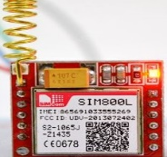

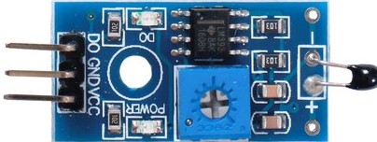

All are connected to 5V voltage source and grounded by jumper wires.

WORKING:

* Vibration sensor connected to P3.2(INT0) , which is an external interrupt source , which interrupts processor if any kind of vibration is detected.
* GSM module connected to P3.1(TxD [Transmit Serial Communications Signals]) , receive the signal transmitted from microcontroller , and then send the information about accident to the given number .

CODE:

#include<reg51.h>

#include"GSM.h"

#define NUMBER1 "9826990507"

sbit vib = P3^2;

code unsigned char SMS1[2] = "AT" ;

code unsigned char SMS2[9] = "AT+CMGF=1" ;

code unsigned char SMS3[8]= "AT+CMGS=" ; // send

code unsigned char SMS4[3]= "ATD" ; // send "

code unsigned char SMS5[3]= "ATH" ;

void sendSMS(unsigned char *num , unsigned char *msg);

void delay1(unsigned int tim);

void sendserial(unsigned char mydata1);

unsigned char i;

void sendSMS(unsigned char *num , unsigned char *msg)

{

for (i=0;i<2;i++)

sendserial(SMS1[i]);

sendserial(0X0D);

delay1(60);

for (i=0;i<9;i++)

sendserial(SMS2[i]);

sendserial(0X0D);

delay1(60);

for (i=0;i<8;i++)

sendserial(SMS3[i]);

sendserial(0x22); // "

for(;*num!=0;num++)

sendserial(*num);

sendserial(0x22); // "

sendserial(0X0D);

delay1(60);

for(;*msg!=0;msg++)

sendserial(*msg);

sendserial(0X1A);

delay1(80);

}

void delay1(unsigned int tim)

{

unsigned int h;

for(h=0;h<=tim;h++) {

TMOD=0X21;

TH0=0x4B;

TL0=0xFD;

TR0=1;

while(TF0==0);

TF0=0;

}

}

void sendserial(unsigned char mydata1)

{

TI=0;

SBUF= mydata1;

while(TI==0);

}

void init_serial()

{

SCON=0x50;

TMOD=0x21;

TH1=0xFD;

TL1=0xFD;

TR1=1;

}

void main(){

init_serial();

while(1){

if(vib==1){

sendSMS(NUMBER1,"accident detected");

}

}

}

HEX CODE:

/*--------------------------------------------------------------------------

REG51.H

Header file for generic 80C51 and 80C31 microcontroller.

Copyright (c) 1988-2002 Keil Elektronik GmbH and Keil Software, Inc.

All rights reserved.

--------------------------------------------------------------------------*/

#ifndef __REG51_H__

#define __REG51_H__

/* BYTE Register */

sfr P0 = 0x80;

sfr P1 = 0x90;

sfr P2 = 0xA0;

sfr P3 = 0xB0;

sfr PSW = 0xD0;

sfr ACC = 0xE0;

sfr B = 0xF0;

sfr SP = 0x81;

sfr DPL = 0x82;

sfr DPH = 0x83;

sfr PCON = 0x87;

sfr TCON = 0x88;

sfr TMOD = 0x89;

sfr TL0 = 0x8A;

sfr TL1 = 0x8B;

sfr TH0 = 0x8C;

sfr TH1 = 0x8D;

sfr IE = 0xA8;

sfr IP = 0xB8;

sfr SCON = 0x98;

sfr SBUF = 0x99;

/* BIT Register */

/* PSW */

sbit CY = 0xD7;

sbit AC = 0xD6;

sbit F0 = 0xD5;

sbit RS1 = 0xD4;

sbit RS0 = 0xD3;

sbit OV = 0xD2;

sbit P = 0xD0;

/* TCON */

sbit TF1 = 0x8F;

sbit TR1 = 0x8E;

sbit TF0 = 0x8D;

sbit TR0 = 0x8C;

sbit IE1 = 0x8B;

sbit IT1 = 0x8A;

sbit IE0 = 0x89;

sbit IT0 = 0x88;

/* IE */

sbit EA = 0xAF;

sbit ES = 0xAC;

sbit ET1 = 0xAB;

sbit EX1 = 0xAA;

sbit ET0 = 0xA9;

sbit EX0 = 0xA8;

/* IP */

sbit PS = 0xBC;

sbit PT1 = 0xBB;

sbit PX1 = 0xBA;

sbit PT0 = 0xB9;

sbit PX0 = 0xB8;

/* P3 */

sbit RD = 0xB7;

sbit WR = 0xB6;

sbit T1 = 0xB5;

sbit T0 = 0xB4;

sbit INT1 = 0xB3;

sbit INT0 = 0xB2;

sbit TXD = 0xB1;

sbit RXD = 0xB0;

/* SCON */

sbit SM0 = 0x9F;

sbit SM1 = 0x9E;

sbit SM2 = 0x9D;

sbit REN = 0x9C;

sbit TB8 = 0x9B;

sbit RB8 = 0x9A;

sbit TI = 0x99;

sbit RI = 0x98;

#endif

SIMULATION:

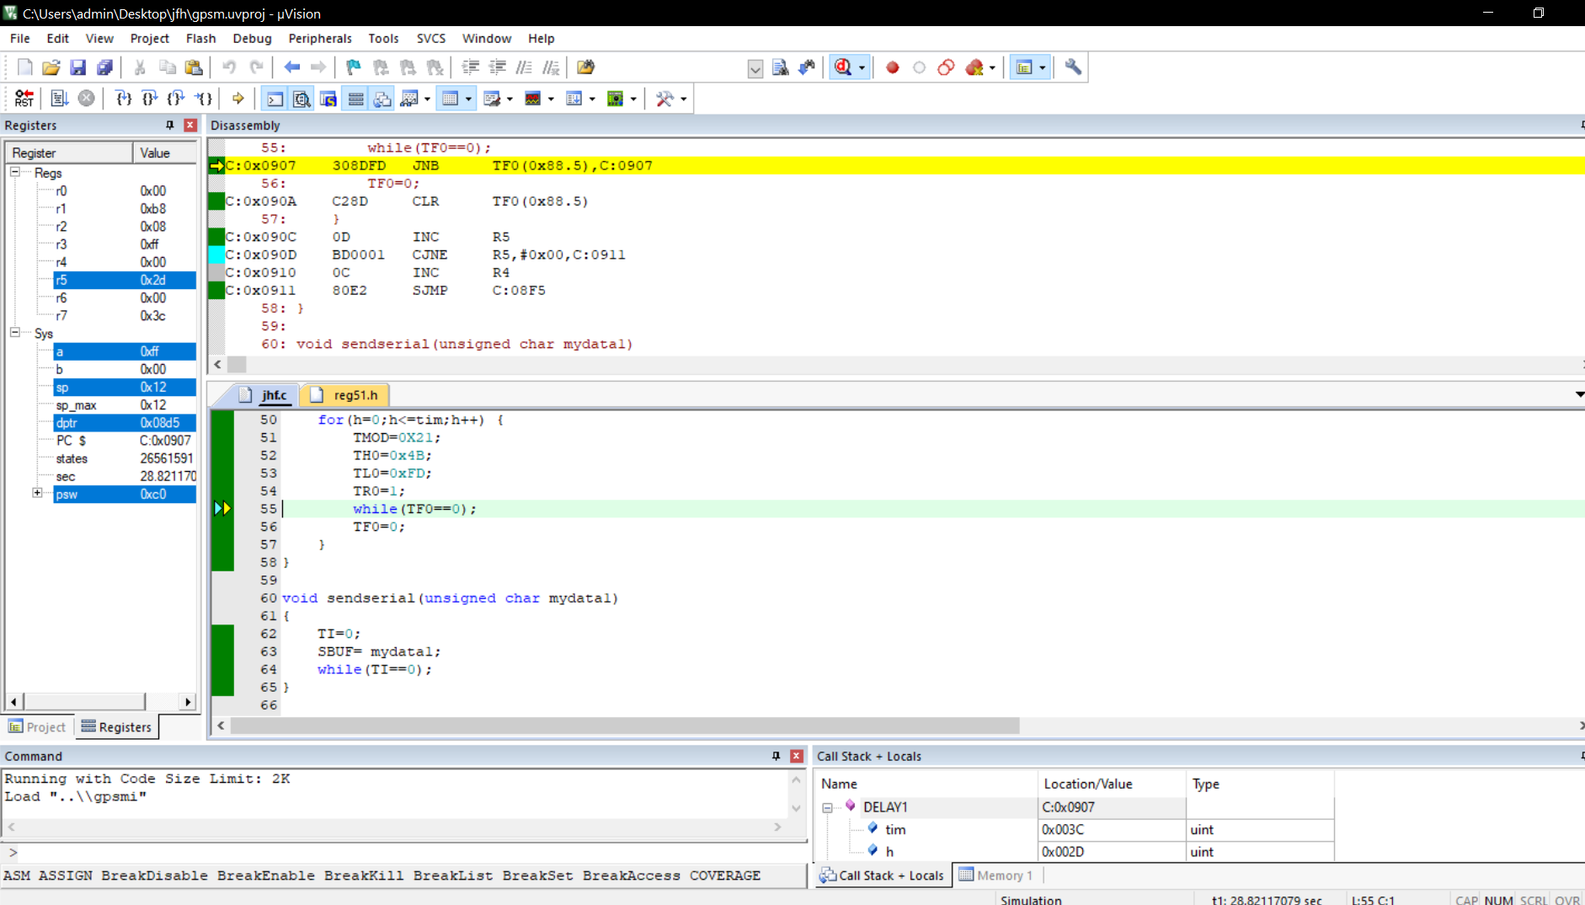

FUTURE WORK:

This project is small representation of how we can develop a technical system to enhance security of vehicle, further is this project we can create a cloud in which via developed software we can connect every vehicle to nearest ambulance and control room, so in emergency in very less time help will reach to the victims.

By developing apps, software we can make it more efficient and reliable so we can be more than before.

Reference:

[https://www.researchgate.net/publication/273511031_Road_accidents_in_India](https://www.researchgate.net/publication/273511031_Road_accidents_in_India%20%20%20%20%20%20%20%20%20%20%20%20%20%20%20%20%20%20%20%20%20%20%20%20%20%20%20%20%20%20%20%20%20%20%20%20%20%20%20%20%20%20%20%20%20%20%20%20%20)

<http://iamtechnical.com/input-output-programming-in-8051>

<https://www.includehelp.com/embedded-system/8051-microcontroller-programming-using-keil-uvision-ide.aspx>