Vancouver

Ishaan Advani

3 December 2017

This R MarkDown will help in plotting break-ins for all the requested years on Vancouvers map.

I will first call the configuration file.

source("VancouverConfig.R")

##   
## Attaching package: 'dplyr'

## The following objects are masked from 'package:stats':  
##   
## filter, lag

## The following objects are masked from 'package:base':  
##   
## intersect, setdiff, setequal, union

## Loading required package: ggplot2

## Google Maps API Terms of Service: http://developers.google.com/maps/terms.

## Please cite ggmap if you use it: see citation("ggmap") for details.

## [1] "loading dataset filtered for breakins and year 2003"  
## min_long max_long min_lat max_lat crime_type  
## 1 -123.1414 -123.1021 49.27797 49.28760 high  
## 2 -123.2199 -123.1806 49.20091 49.21054 low

## Source : https://maps.googleapis.com/maps/api/staticmap?center=vancouver+ca&zoom=12&size=640x640&scale=2&maptype=terrain

## Source : https://maps.googleapis.com/maps/api/geocode/json?address=vancouver%20ca

## Warning: Removed 1 rows containing missing values (geom_rect).

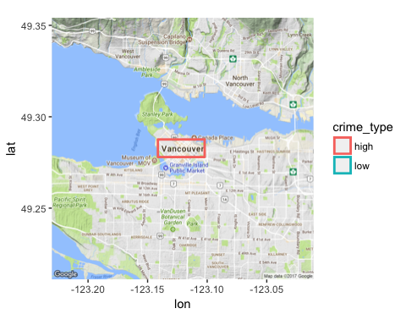

I will use the plot_crime function in order to come up with plots for every year 