

**-: Project Report :-**

***Members:***

Ishaan Almeida

Hrishikesh Balaji

*Under the guidance of*

*Prof. Kamal Mistry*

*In partial fulfilment for the award of the degree of*

*Bachelor of Technology*

*In the Computer Engineering branch of study*

*At*

**

**-: Declaration :-**

*I, (Hrishikesh Balaji and Ishaan Almeida) Roll No. B010, B007 respectively, BTech (Computer Engineering), Semester IV understand that plagiarism is defined as any 1 or any combination of the following:*

* **Un-credited verbatim copying of individual sentences, paragraphs or illustration (such as graphs, diagrams, etc.) from any source, published or unpublished, including the internet.**
* **Un-credited improper paraphrasing of pages paragraphs (changing a few words phrases, or rearranging the original sentence order)**
* **Credited verbatim copying of a major portion of a paper (or thesis chapter) without clear delineation of who did wrote what. (Source: IEEE, The institute, Dec. 2004)**
* **I have made sure that all the ideas, expressions, graphs, diagrams, etc., that are not a result of my work, are properly credited. Long phrases or sentences that had to be used verbatim from published literature have been clearly identified using quotation marks.**
* **I affirm that no portion of my work can be considered as plagiarism and I take full responsibility if such a complaint occurs. I understand fully well that the guide of the seminar/ project report may not be in a position to check for the possibility of such incidences of plagiarism in this body of work.**

Names: Hrishikesh Balaji, Ishaan Almeida

Signature: ______________ X ______________

Roll No. : B010, B007

Place: Mumbai, Maharashtra

Date: 30/03/2020

## -: Certificate :-

This is to certify that the project entitled “**The Canteen Management System**” is the creation of **Ishaan Almeida**, **Hrishikesh Balaji** of BTech, MPSTME (NMIMS), Mumbai, during the IV semester of the academic year 2019- 20 , in fulfilment of certain requirements for the course: *Programming Language*.

___________________

**Prof. Kamal Mistry**

**Internal Mentor**

____________________ ________________________

**Examiner 1** **Examiner 2**

**-: Table Of Contents :-**

|  |  |
| --- | --- |
| -: Sr No. :- | -: Title :- |
| I) | *Introduction* |
| II) | *Software used along with description* |
| III) | *API used along with description* |
| IV) | *Functions Used* |
| V) | *Screenshots of the Output* |
| VI) | *Conclusion* |
| VII) | *Future Scope of the Project* |
| VIII) | *Real Time Applications of the Project* |

**-: Introduction :-**

*“****The Canteen Management System****” is a simulation of a real management system which numerous workspaces use in order to cater to the need of people who wish to avail the food/beverages that is provided by said Canteen.*

*This particular System is designed for college going students. It accepts the Student ID, Student Name (Username), Stream of the Student studying in the respective College, the Year (grade) of study of the Student as required details.*

*After procuring these details, the User Interface then has an option below that allows the current user (Student) to place their order.*

*The options are in the form of a “****Dropdown list****” out of which the user can select one at a time. After selecting the desired item, the user can click on the “****Add new****” button which then transfers all the entered details into a list which is stored in a database.*

*Numerous orders for different Users (Students) can be placed in this format. All the specified/mentioned data will be stored in a database in the same manner.*

*Getting a new entry from various users would become tedious if they had to clear every field on their own whilst entering their details, which would differ without saying. To ease this, they can make use of the “****Clear****” button which empties all the previously filled text fields and makes them blank and ready to accept new entries.*

*In case a Manager wants to verify/check all the placed orders, they can do the same by pressing the “****Display****” button. This proceeds to show all the orders that have been placed until then under the “****Order Logs****” column.*

*If an existing User wants to place another order, they don’t have to enter their details all over again, they can simply click on their previous order which will automatically enter their details again, and they can proceed to order a new food item or a beverage by simply selecting it from the dropdown menu and clicking the “****Add New****” button.*

*When a particular User wants to check/verify all the orders that they may have placed, they can enter their Student ID in the “****SAPID****” field and then hit the “****Search****” button which will then display all the orders that have been placed by the user with the corresponding Student ID.*

*Suppose a particular Student who doesn’t want his data to be stored in the database, they can do so by, first displaying all the orders, clicking on their order and then pressing the “****Delete****” which then removes the specified record from the database permanently until entered once again whilst ordering. This feature is advised to be used once the User’s current ordered has been delivered to them to avoid any discrepancies later on.*

*Once the Canteen has been closed or in case the staffs go for a lunch break, the Manager can press the “****Exit****” button which then closes the Interface until opened again once the Canteen resumes their services.*

**-: Software :-**

*Python IDLE 3.8: This has been used as the Editor in which we have coded and compiled in Python language.*

*DB Browser: Used for viewing SQLite Databases.*

**-: API used :-**

*Sqlite3:* Used as a database to store records for the Canteen.

*TKinter: Used to construct the Graphical User Interface (GUI).*

**-: Functions Used :-**

1. **AddInfo-Student can enter his details and place his order, these details are stored in the database with the hlep of this function****.**
2. **Display- This funtion displays the details of all the orders placed and have been stored in the database.**
3. **Search- This function lets the user load the order history of a specific Student.**
4. **Delete- This function lets the user delete an order record from the database.**
5. **FindRec- This function finds the most ordered food item from the order logs and displays it on the user’s screen.**

**-: Screenshots of the Output :-**

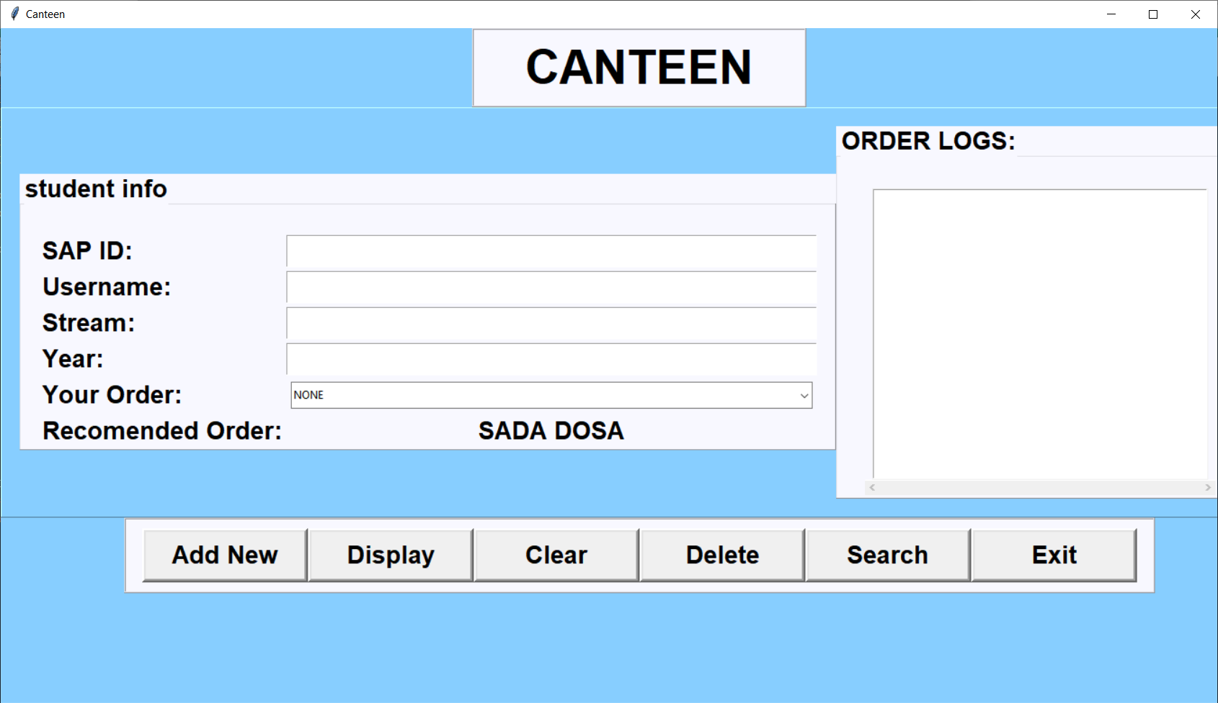

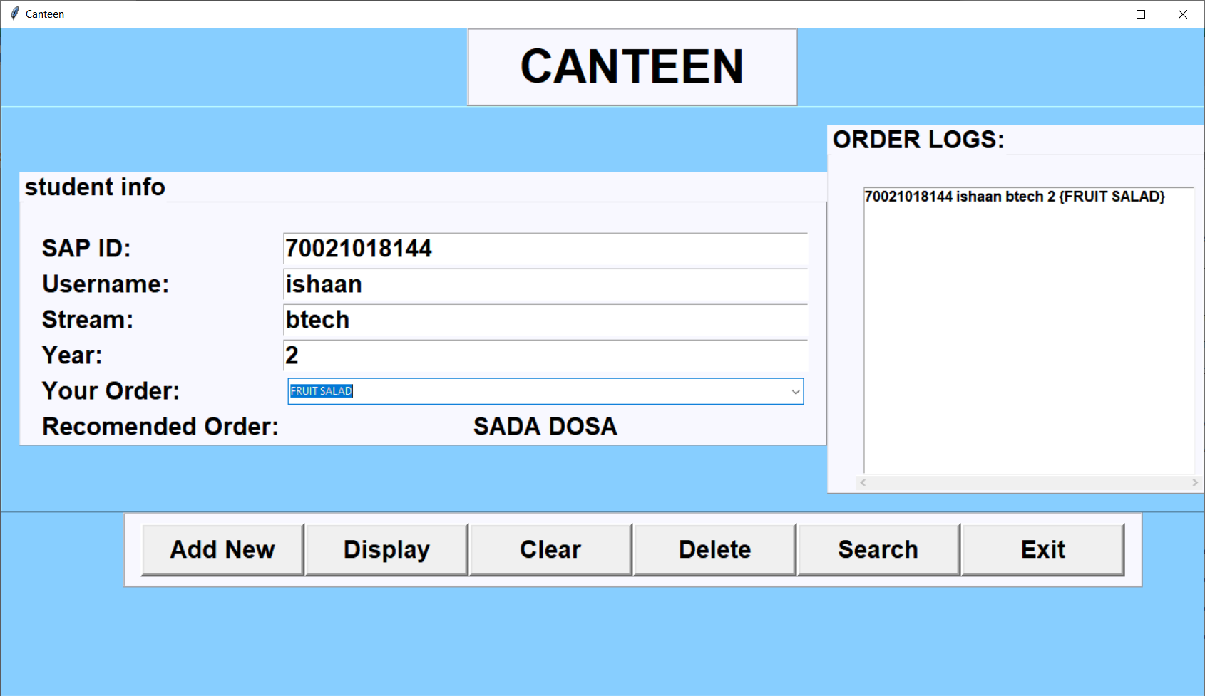

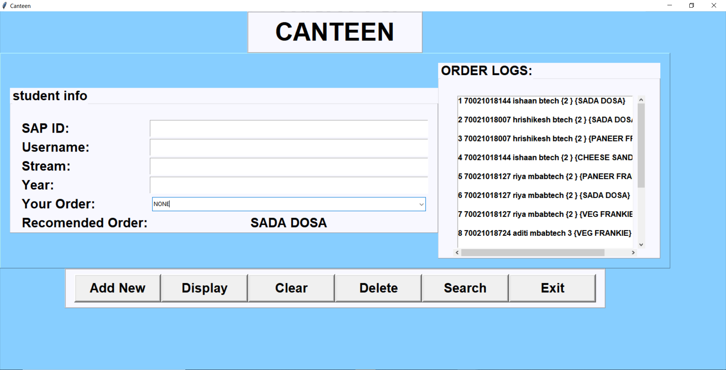

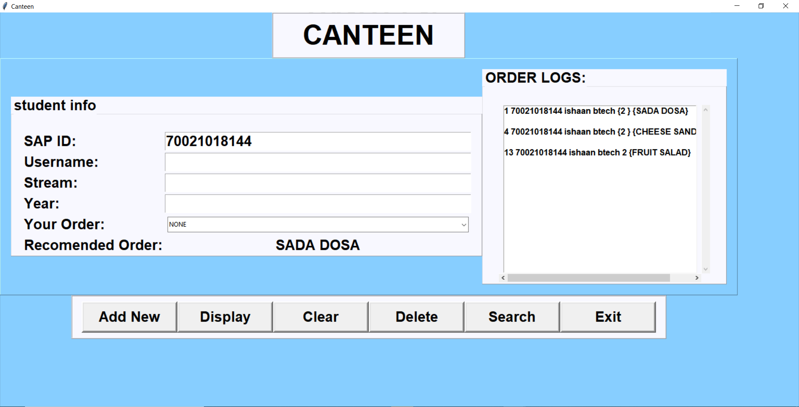

**-: Conclusion :-**

*This project was assigned to us by Prof. Kamal Mistry as a part of our curriculum. This in turn paved way for us to develop a keen interest in developing and working with user interfaces, databases, database management and so on. During the course of the making of our managerial system, the two of us learnt how various concepts of Python (Programming Language) and SQLite could be used to combine stand alone programs and databases to create a combined large application.*

**-: Future Scope :-**

*This is just a simulation of the real systems that have been implemented in workspaces by various Companies. Our Management system although complete, has a scope for improvement without a doubt. Many more features can be added to make this a more feasible system (than it already is) that may allow us to implement it in another project that someone else might be working on and requires the use of such a Managerial System.*

**-: Real Time Applications :-**

*This can be used in mini/small parties organised by new-found start-ups or parties held by a small housing colony to keep track of orders and to cater sufficiently well.*