**Name: Ishaan Barde**

**Roll No: 116**

**RESULT**

**Data Visualization Using Python:**

1. Condition Of The House

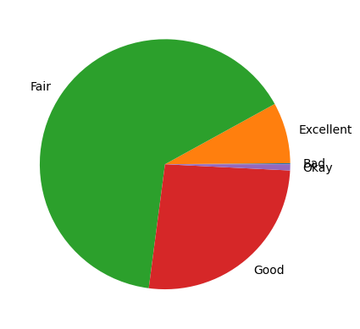

1. Number Of House By House Condition

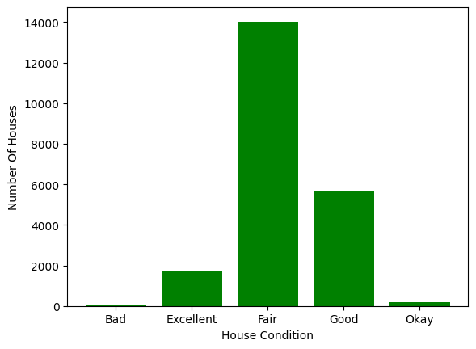

1. Selling Price Vs Area (Scatter Plot)

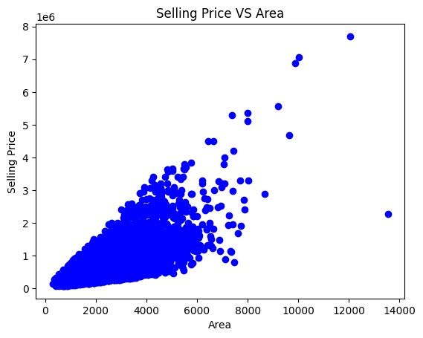

1. Number Of Houses By Age

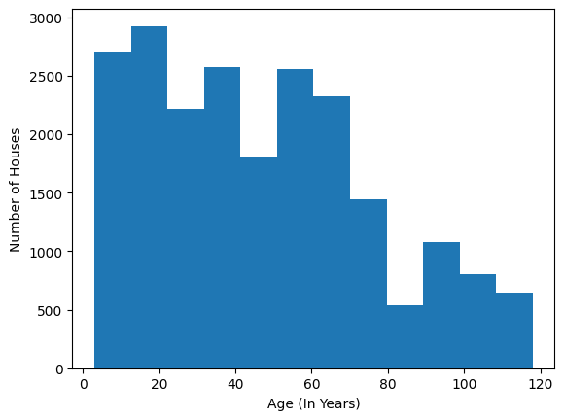

1. Sale Price Box Plot

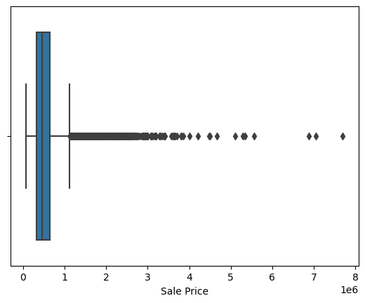

1. Line Graph Of Sale Price

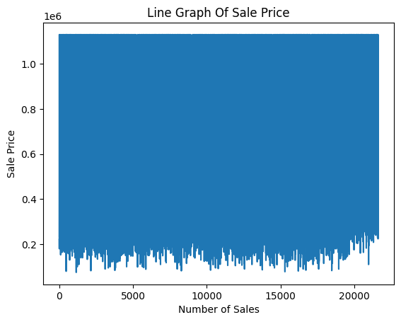

**POWER BI REPORT:**

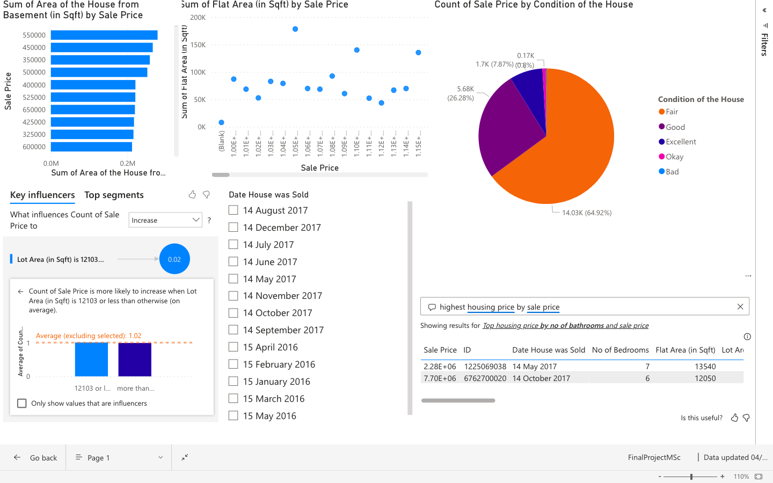

**Accuracy & Evaluation Metrics:**

Three models were built. The first one is built on linear regression algorithm using sklearn library.

The accuracy is

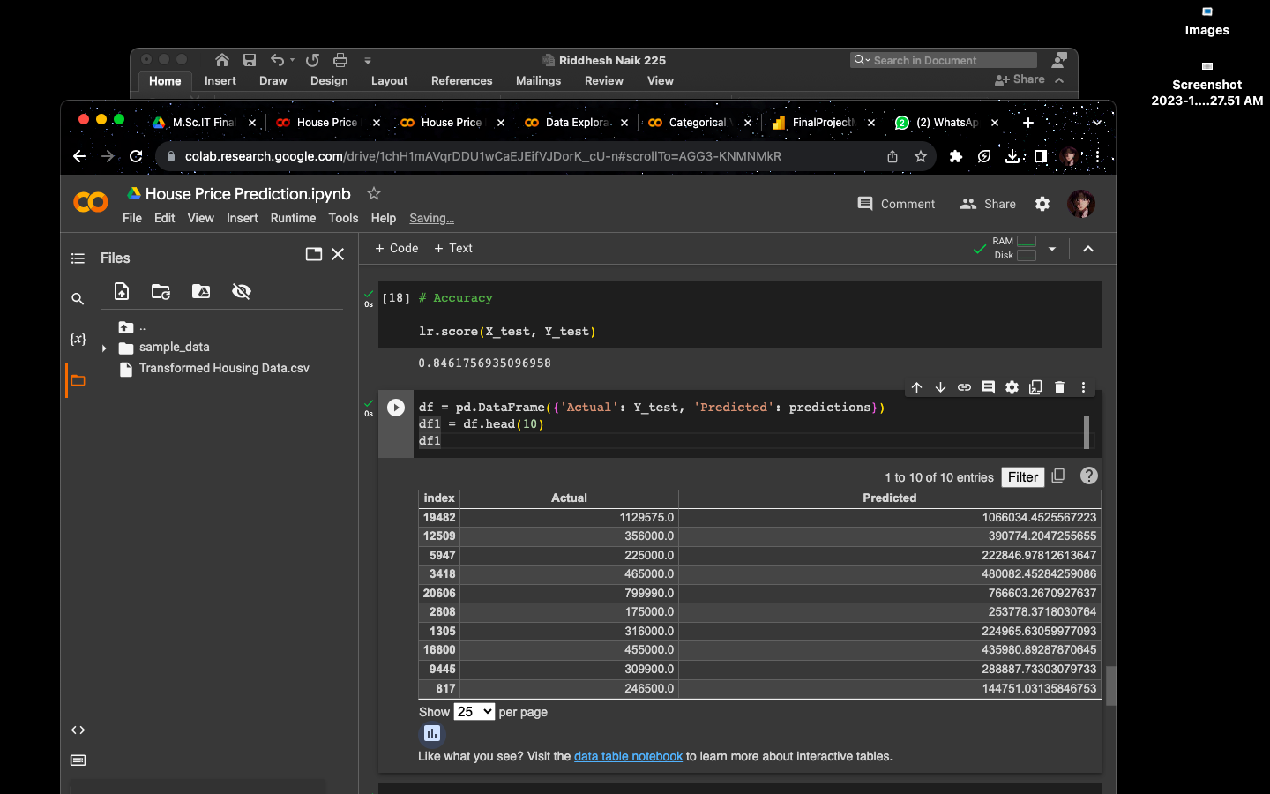

Evaluations performances are

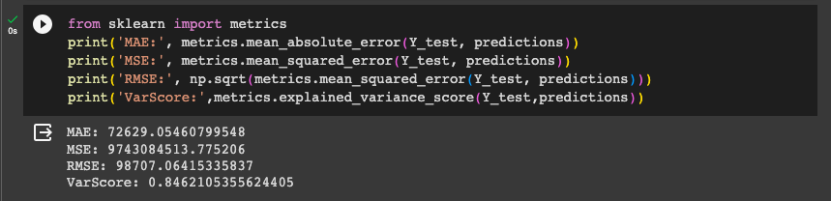

The second model was built on the same algorithm based on a deep learning model using the Keras library.

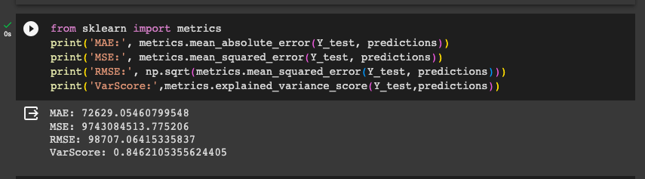

The third model was also a deep learning model but the algorithm used was LSTM or Long-Short Term Memory.

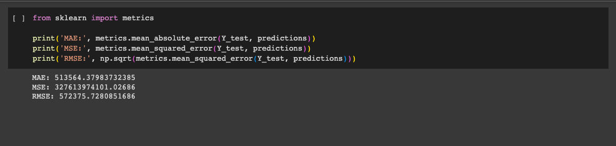

**Residual Plot:**

A residual plot is a graphical representation of the residuals, which are the differences between the observed (actual) values and the predicted values in a regression analysis. These plots are often used to assess the goodness of fit of a regression model and to check whether the assumptions of linear regression are met.

Sklearn Model

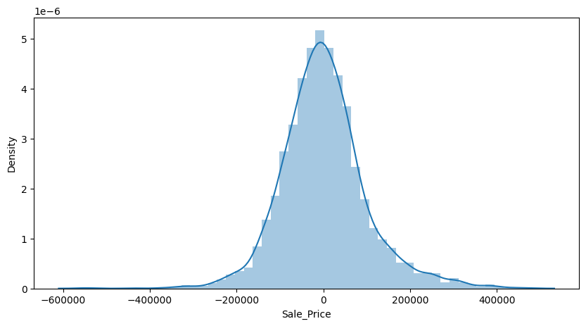

Scatter Plot:

A scatter plot is a graphical representation of individual data points in a two-dimensional space, with each point representing a single observation. Scatter plots are used to visualize the relationship between two variables and can reveal patterns, trends, correlations, and outliers in the data. They are particularly useful for exploring and understanding the distribution and association between variables.

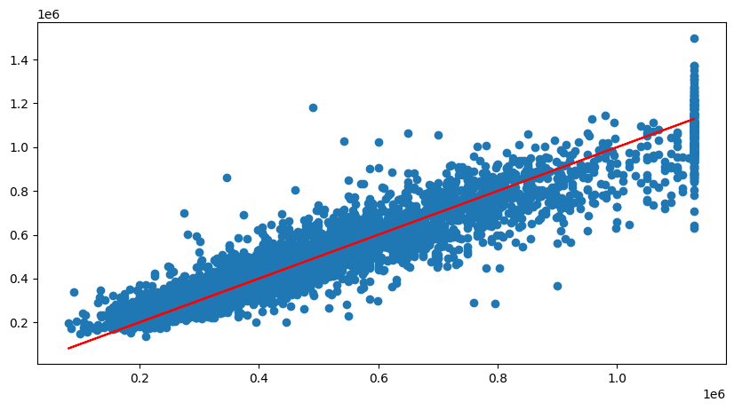

**CONCLUSION**

In conclusion, our house price prediction model is a valuable tool for both homebuyers and real estate professionals. It provides accurate and data-driven estimates of property values, enhancing decision-making in the real estate market.

To conclude the technical part both the algorithms work great with the problem statement but the deep learning algorithms are better in terms of accuracy. This does not mean that the standard machine learning model doesn’t have good accuracy. For example: A data scientist has conducted a study for comparison of two libraries and the machine learning model’s accuracy is significantly low compared to the deep learning model

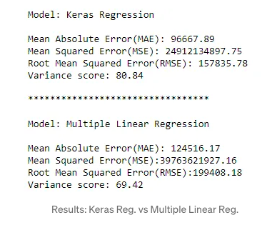

As give above, according to this the Keras deep learning model outperforms the sklearn model. This is because the data is not pre-processed properly. Henceforth, the dataset in this project is handled and is processed for better working model.

The Power BI dashboard and reports are also a powerful tool for data analysis and visualization. The have an edge on python analysis and visualisation because of its simplicity and interactive system. You can basically just place the data and play around with different features to gain maximum and valuable insights.

For future improvements, we can add a user interface, a feature where the model can predict the sale price by user input and more. By that, we have successfully achieved our project objectives, and we look forward to further developments and enhancements in the future. This project exemplifies the power of data-driven insights and predictive modelling in solving real-world problems. We hope that it will serve as a valuable resource for anyone looking to navigate the complex world of real estate transactions.

**References**

**House Price Prediction Using LSTM" by Keyu Zhang and Zhiqiang Wei (2018)**

This paper investigates the application of Long Short-Term Memory (LSTM) networks in predicting housing prices, focusing on the ability of LSTM to capture temporal dependencies in time series data.

**LINK:** [**https://arxiv.org/abs/1709.08432**](https://arxiv.org/abs/1709.08432)

**House Price Prediction with Machine Learning Techniques: A Review and Comparative Study by Wei Sun et al. (2020)**

This study provides a comprehensive review of various machine learning techniques applied to house price prediction. It includes a comparative analysis of different algorithms and their performance.

**LINK:** [**https://www.researchgate.net/publication/325435801_House_Prices_Prediction_with_Machine_Learning_Algorithms**](https://www.researchgate.net/publication/325435801_House_Prices_Prediction_with_Machine_Learning_Algorithms)

**Deep Learning Model for House Price Prediction Using Heterogeneous Data Analysis Along With Joint Self-Attention Mechanism**

This paper studies and discusses the house price predictions, uses different data analysis techniques and implements deep learning algorithms

**LINK:** [**https://ieeexplore.ieee.org/document/9395585**](https://ieeexplore.ieee.org/document/9395585)

**House Prices Prediction Using Deep Learning**

The goal of this statistical analysis is to help us understand the relationship between house features and how these variables are used to predict house price.

**LINK: <https://towardsdatascience.com/house-prices-prediction-using-deep-learning-dea265cc3154>**