Final Project: The Relationship Between Food Insecurity, Poor Sleep, and Hypertension in the US
Ishaan Bhaduri
UCSF BIOSTAT 212
31 Aug 2025 10:22:16

Introduction
The purpose of this study is to examine the association between a combination of food insecurity and poor sleep and the prevalence of hypertension in US adult population. Hypertension is a significant public health burden, and while various risk factors have been identified, the combined impact of socioeconomic and behavioral factors is not fully understood. This analysis will investigate how two factors together contribute to a heightened risk of hypertension, using data from the 2017-2018 National Health and Nutrition Examination Survey (NHANES).

Figure 1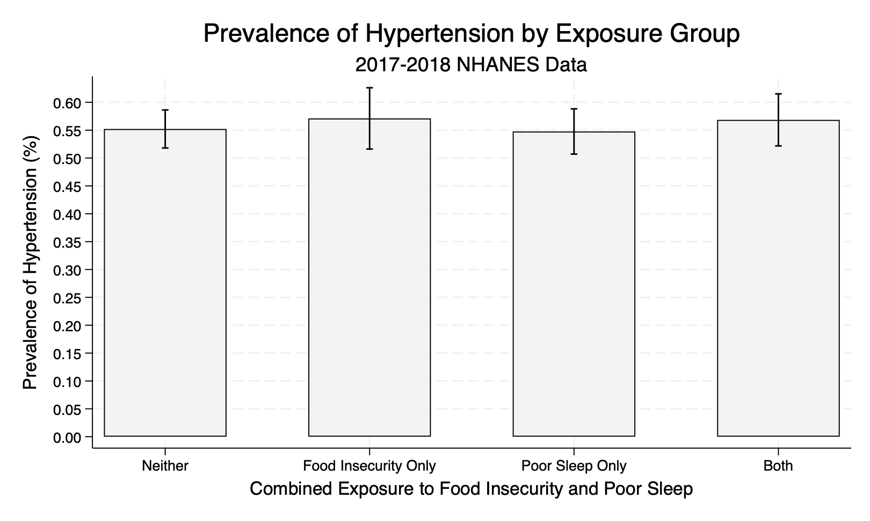
Figure 1. Prevalence of Hypertension by Combined Exposure to Food Insecurity and Poor Sleep. The prevalence and 95% confidence intervals were calculated using survey weights from the 2017-2018 NHANES data. The four exposure groups are defined as: Neither, Food Insecurity Only, Poor Sleep Only, and Both.

Table 1
Table 1. Logistic Regression Model of the Odds of Hypertension
 | OR | 95% CI | p-value | Z-stat | Std. Err.
Food Insecurity Only | 0.84 | 0.59, 1.19 | 0.294 | -1.09 | 0.1370
Poor Sleep Only | 1.16 | 0.90, 1.50 | 0.239 | 1.23 | 0.1391
Both | 1.10 | 0.81, 1.49 | 0.521 | 0.66 | 0.1561
Gender | 0.61 | 0.50, 0.73 | 0.000 | -5.69 | 0.0533
Other Hispanic | 1.10 | 0.81, 1.50 | 0.508 | 0.68 | 0.1590
Race | 0.93 | 0.67, 1.30 | 0.669 | -0.44 | 0.1454
Non-Hispanic Black | 1.56 | 1.16, 2.10 | 0.007 | 3.16 | 0.2194
Non-Hispanic Asian | 1.46 | 1.02, 2.09 | 0.042 | 2.23 | 0.2476
Other Race | 0.63 | 0.42, 0.93 | 0.023 | -2.52 | 0.1160
9-11th grade | 1.12 | 0.82, 1.54 | 0.437 | 0.80 | 0.1645
High school graduate | 0.93 | 0.69, 1.25 | 0.620 | -0.51 | 0.1298
Education | 1.05 | 0.77, 1.44 | 0.724 | 0.36 | 0.1551
College graduate or above | 0.68 | 0.48, 0.96 | 0.031 | -2.38 | 0.1112
Annual household income | 0.97 | 0.94, 1.00 | 0.088 | -1.82 | 0.0149
Age in years at screening | 1.04 | 1.03, 1.04 | 0.000 | 13.82 | 0.0026
Intercept | 0.26 | 0.14, 0.48 | 0.000 | -4.73 | 0.0739
OR: Odds Ratio; 95% CI: 95% Confidence Interval. Reference groups are: full food security, no poor sleep, male, Non-Hispanic White, and college graduate or above.

Table 1. Logistic Regression Model of the Odds of Hypertension. The model uses a combined exposure variable for food insecurity and poor sleep, adjusted for demographic factors. OR: Odds Ratio; 95% CI: 95% Confidence Interval. Reference groups are: full food security, no poor sleep, male, Non-Hispanic White, and college graduate or above.
The intercept represents the odds of hypertension when all other variables in the model are at their reference level. It corresponds to a male, Non-Hispanic White, college graduate or above with full food security and no poor sleep.

