Georgia Institute of Technology
CS 4365/6365: Introduction to Enterprise Computing
Summer 2026
Project Checkpoint 3 Report

Group: 4
Name(s): Ishaan Bhardwaj and Gowtam Kommi
Project Name: NORP Food Assistance Need-Capacity Gap Explorer
Context and Related Work:
Prior NORP work focused on NL2SQL/RAG chatbots so non-technical researchers could query nonprofit data, and repeatedly drifted into SQL-generation benchmarking instead of surfacing sociological correlations. This semester's course direction is an agentic data-exploration layer that cleans data, verifies its own work, and computes correlations to surface trends.
Our project applies this to a concrete question: where does food-related community need outpace nonprofit capacity to address it? Checkpoint 1 verified the data plan against the live NORP Metabase. Checkpoint 2 built the deterministic pipeline: six raw tables loaded, profiled, and gated automatically, aggregated to the county level, and joined into a scored 3,027-county panel. Checkpoint 3, reported here, completes the agentic loop: an LLM correlation-candidate agent, an LLM advisory review of the quality gate, publication-ready figures, and a generated findings summary. Python remains the source of truth for every statistic; the LLM proposes and frames, but never computes.
Project Plan (Plan)
Research question: Can an agentic workflow identify U.S. counties where food-related need is high but nonprofit food/human-service capacity is relatively low?
Secondary question: Which indicators correlate most strongly with nonprofit capacity across counties? (Unit of analysis: county, joined on 5-digit FIPS.)
Where the Agent Acts
All three autonomous decision points from the Checkpoint 1 plan are now implemented.
- Data-quality triage (built, CP2): the profiler classifies each table and join as usable, usable_with_warning, or drop, and the pipeline acts on that classification without manual intervention (auto-excluding rows from a join when a state's match rate is too low, then logging why).
- Correlation candidate generation (built, CP3): the LLM receives only the panel schema (column names, descriptions, and five summary statistics per column, never raw rows) and proposes 5-8 need-vs-capacity variable pairs, each with a hypothesis and an expected correlation sign. Python then computes Pearson and Spearman correlations for the exhaustive 7x4 need-by-capacity grid (28 pairs), so the agent prioritizes and hypothesizes but cannot invent, skip, or skew a statistic. Its output is hard-validated: any candidate naming a column outside the schema is dropped.
- Self-verification gate (built: rule-based CP2, LLM review CP3): the rule-based proceed / proceed_with_warning / stop gate remains authoritative. The CP3 agent adds an advisory second opinion: it reads the profiler's gate verdict and reasons and issues its own verdict with a rationale. On the committed run both agree on proceed_with_warning; disagreement would be logged, never acted on.
Reproducibility Design
Every LLM response is cached to data/output/llm_candidates.json and committed. The default run mode is offline: it replays the committed artifact byte-for-byte, so a grader reruns the entire Checkpoint 3 analysis (correlations, figures, findings summary) with no API key. A --live flag regenerates the artifact through the Anthropic API. The committed artifact was authored by Claude from the panel schema in an offline development session (the environment had no API key); its metadata records this, and either mode leaves every statistic Python-computed.
Non-Goals
- No chatbot interface; no NL2SQL benchmarking.
- No causal claims about nonprofit effectiveness; correlations are descriptive county-level associations and the gap score is a triage signal.
- No forcing of unreliable joins; Florida and Connecticut remain logged and auto-dropped.
- The LLM never computes statistics; Python outputs are the source of truth.
Project Deliverables
Deliverable | Description | Technical Stack
Profiler & Quality Gate | Loads nonprofit and need-side data, classifies each table/join, and decides proceed / proceed_with_warning / stop before downstream steps run. | Python, pandas
County Capacity & Need Tables | Aggregates NGOs_with_categories + F9 990 filings and tract-level need data to county level. | Python, pandas
Joined Gap-Score Panel | County FIPS join of capacity and need tables; computes need_score, capacity_score, gap_score. | Python, scipy
Correlation Agent & Reporting | LLM proposes candidate need-vs-capacity pairs from the schema and reviews the gate; Python tests and ranks the exhaustive grid, renders top-gap plots, and generates the findings summary. | Python, matplotlib, Anthropic API
Project Milestones
Checkpoint | Milestone | Technical Scope & Deliverables | Work Splitup | Status
Checkpoint 1 | Scope project, verify Metabase data sources, test county join feasibility, repo skeleton | Repo structure, Metabase verification, GitHub setup | Both | Complete
Checkpoint 2 | Build profiler, capacity/need tables, resolve FL/CT crosswalk, produce joined and scored county panel | Ishaan: profiler, join logic, pipeline orchestration. Gowtam: capacity/need table builders, crosswalk. | Both | Complete
Checkpoint 3 | LLM correlation-discovery agent, top-gap plots, findings summary | Ishaan: analysis orchestration, plotting, output organization. Gowtam: correlation agent, LLM caching design, findings summary. | Both | Complete
Current Progress Report (Match)
- Built the correlation agent (src/correlation_agent.py). It assembles a schema-only context (11 analyzable columns split into 7 need-side and 4 per-capita capacity-side variables, each with descriptions and summary statistics), sends one structured request to the LLM, and hard-validates the JSON reply. Python then computes the exhaustive 28-pair Pearson + Spearman grid (2,928-3,027 counties per pair) and checks each LLM hypothesis against the measured sign.
- Made the LLM layer reproducible. The agent's response is cached to data/output/llm_candidates.json and committed; offline replay is the default and --live refreshes the cache through the API. This directly implements the Checkpoint 2 feedback to keep the LLM on candidate generation and summarization so the statistics stay reproducible.
- Key finding: nonprofit capacity tracks wealth, not need. Median household income correlates positively with filer revenue per capita (Spearman rho = +0.33), while poverty and unemployment correlate negatively with capacity (poverty vs revenue per capita rho = -0.29; unemployment vs NGOs per 10k rho = -0.31). All 7 LLM-hypothesized signs were confirmed by the Python-computed statistics.
- A second, sobering finding: food-desert intensity is nearly uncorrelated with food-nonprofit presence per capita (rho = -0.09), and the disadvantaged-tract share barely registers (rho = -0.02). Food-focused capacity is not systematically located where food access is worst, which is exactly the kind of pattern the NORP track wants surfaced.
- Rendered four committed figures (top-gap bar chart, need-vs-capacity scatter with the top-10 gap counties highlighted, gap-score distribution, and the 7x4 correlation heatmap) and generated data/output/findings_summary.md, where every number is Python-computed and the LLM contributes hypotheses and framing only.
- Added the LLM advisory gate review. On the committed run it agrees with the rule-based proceed_with_warning verdict and independently flags that the panel is not nationally exhaustive (FL/CT absent), which the summary now discloses next to every national claim.
Compared to the planned milestone
Checkpoint 3 is complete: the correlation agent, plots, and findings summary were all delivered, and the gap score itself had already landed a checkpoint early in CP2. Two of the three CP2 actionable suggestions are fully implemented (LLM strictly on candidates/summaries; plots + findings summary for non-technical readers).
Changes to the original plan
- Full-table rerun deferred. The CP2 feedback suggested rerunning on the full 3,420,024-row NGO table before the final report. That table is not exportable from our Metabase access in one pull, so the committed run remains on the documented 1,048,575-row sample and every output carries the sample disclaimer. The pipeline itself is row-count agnostic: pointing the loader at the full export is a drop-in change if access is arranged.
- Offline-first LLM design. We originally planned a live-only LLM step; we changed to a committed response cache with an optional --live refresh so the analysis is reproducible by anyone (including graders) without an API key, and so the exact artifact behind the committed findings is version controlled.
Supporting Evidence (Factual)
Team GitHub Repository: https://github.com/ishaanbhardwaj2003/NORP-Food-Assistance-Need-Capacity-Gap-Explorer
New this checkpoint (all committed to main):
- src/correlation_agent.py: schema context builder, LLM proposal + validation, exhaustive Pearson/Spearman grid, hypothesis sign-checking, advisory gate review.
- src/make_plots.py: the four figures, rendered headlessly from the committed panel.
- scripts/run_analysis.py: Checkpoint 3 orchestration with --live, --model, --skip-plots; offline cached replay is the default.
- data/output/llm_candidates.json: the committed LLM artifact (schema context, 7 candidates with hypotheses and expected signs, advisory gate review, framing notes).
- data/output/correlation_results.csv: the authoritative 28-pair grid, annotated with LLM-proposed pairs and sign checks.
- data/output/figures/ and data/output/findings_summary.md: the four figures and the generated findings summary.
Execution results: python scripts/run_analysis.py
[1/6] Loading committed panel + county names ...
panel: (3027, 22) gate verdict: proceed_with_warning
[2/6] Computing exhaustive need x capacity correlation grid (Python) ...
28 pairs tested
[3/6] LLM candidate proposal (cached replay) ...
7 candidates | advisory gate: proceed_with_warning
[4/6] Evaluating LLM candidates against measured statistics ...
-> ./data/output/correlation_results.csv
[5/6] Rendering figures ...
-> ./data/output/figures/top_gap_counties.png
-> ./data/output/figures/need_vs_capacity.png
-> ./data/output/figures/gap_distribution.png
-> ./data/output/figures/correlation_heatmap.png
[6/6] Writing findings summary ...
-> ./data/output/findings_summary.md
Real output of the offline run (paths shortened for width). The cached LLM artifact is replayed, Python tests all 28 pairs, and the figures and findings summary are regenerated deterministically.
Strongest correlations (Python-computed, ranked by |Spearman rho|)
Need variable | Capacity variable | Spearman rho | Pearson r | n | LLM proposed
med_household_income | revenue_per_capita | +0.33 | +0.10 | 3,025 | yes (sign confirmed)
med_household_income | assets_per_capita | +0.32 | +0.08 | 3,025 | no
unemployment | ngo_per_10k | -0.31 | -0.22 | 3,025 | yes (sign confirmed)
avg_dac_score | ngo_per_10k | -0.30 | -0.23 | 3,027 | no
poverty_rate | revenue_per_capita | -0.29 | -0.10 | 2,928 | yes (sign confirmed)
avg_food_desert_pct | food_ngo_per_10k | -0.09 | -0.01 | 3,027 | yes (weak; sign confirmed)
Pearson and Spearman diverge on the financial metrics because the per-capita revenue/asset distributions are heavily skewed; Spearman (rank-based) is the more robust readout, and both are reported in the committed CSV.
Figures (committed to data/output/figures/)
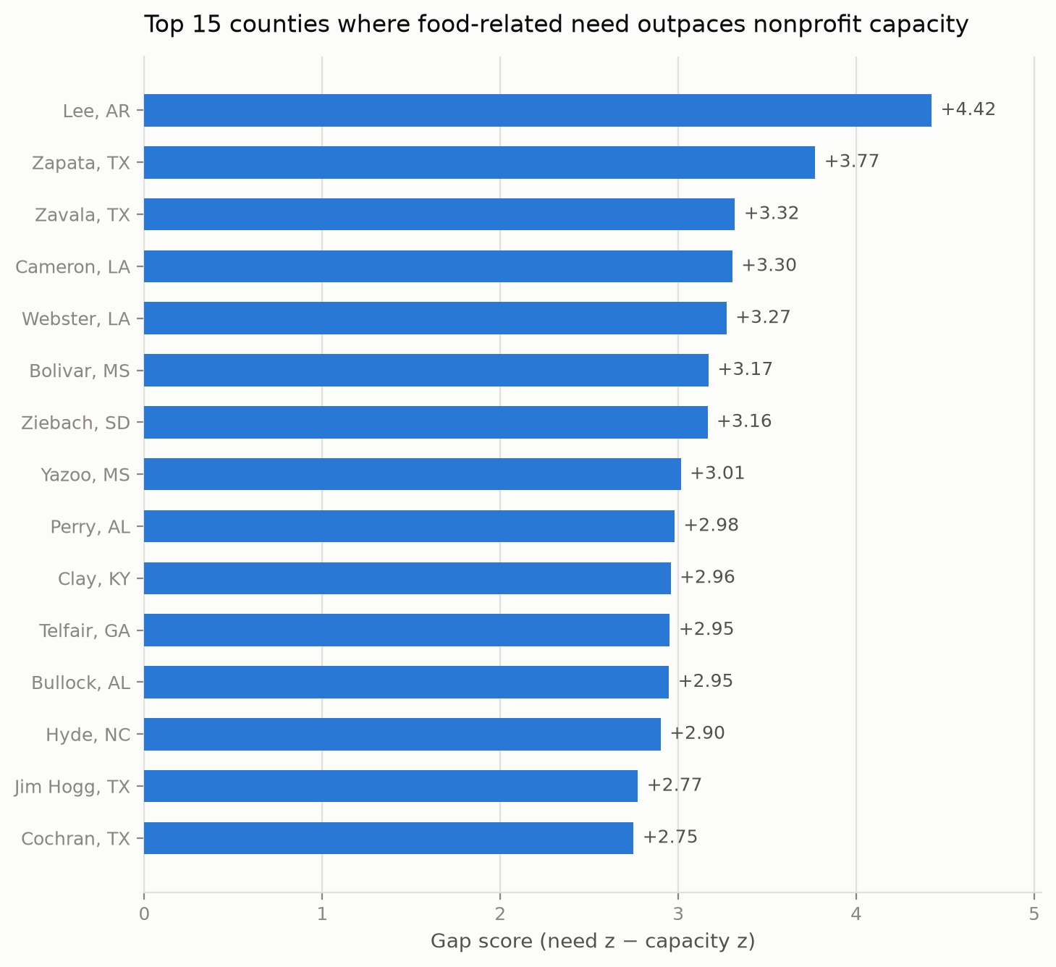
Figure 1. The 15 highest-gap counties: the Arkansas/Mississippi Delta, the Texas border, the Alabama Black Belt, Appalachian Kentucky, and Ziebach County, SD (Cheyenne River reservation).
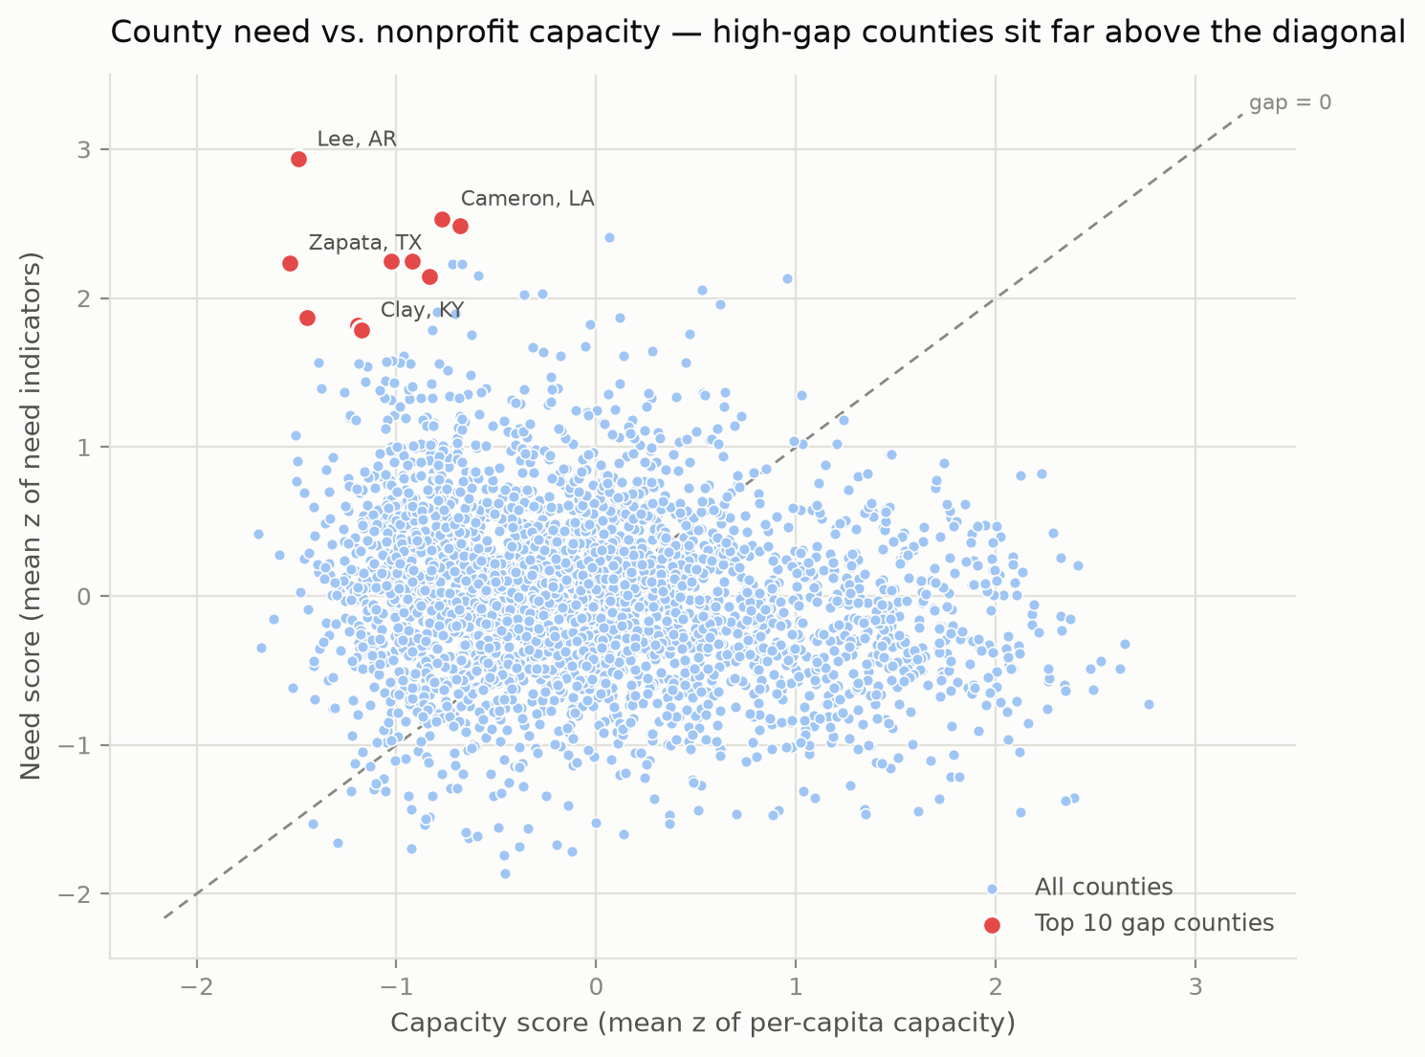
Figure 2. Need vs capacity scores for all 3,027 counties; the top-10 gap counties (red) sit far above the gap = 0 diagonal.
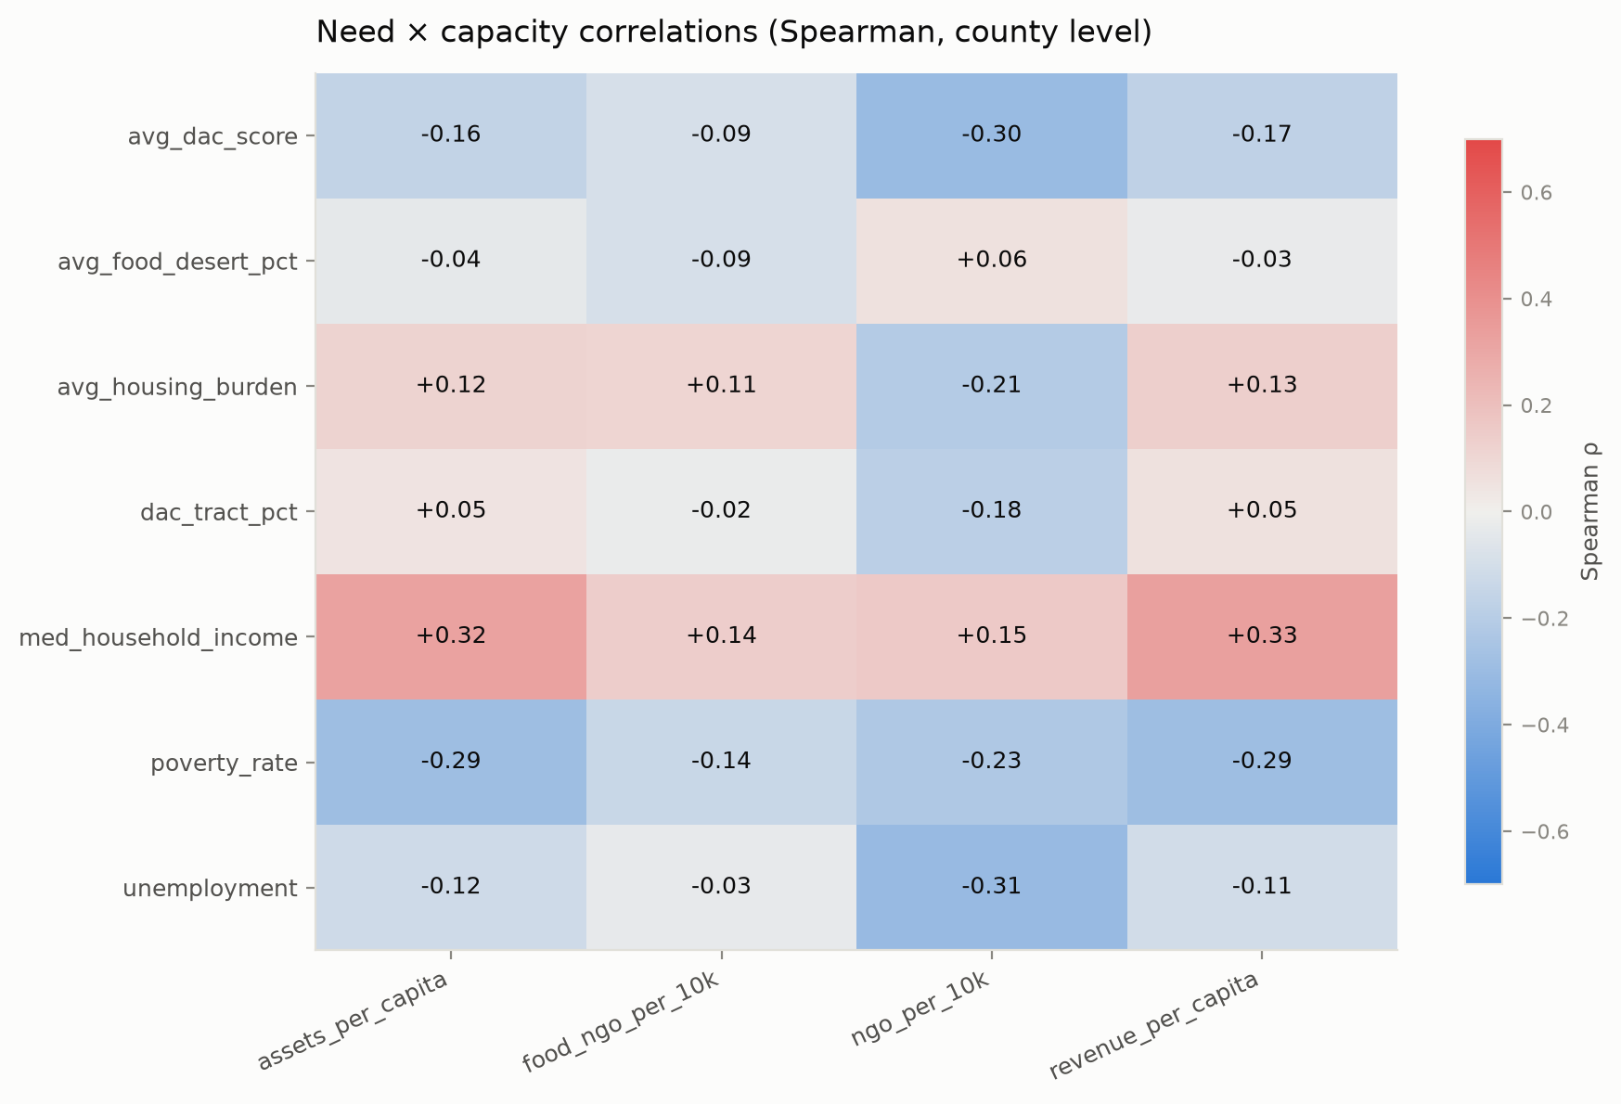
Figure 3. The exhaustive need x capacity Spearman grid. Income-linked cells are positive (red), deprivation-linked cells negative (blue): capacity follows wealth rather than need. (The fourth committed figure, the gap-score distribution, is in the repository.)
Reproduce
python scripts/run_pipeline.py --verbose # rebuild the panel (~15 s)
python scripts/run_analysis.py # offline: replays committed LLM cache
python scripts/run_analysis.py --live # optional: refresh LLM artifact (ANTHROPIC_API_KEY)
Skill Learning Report
- LLM integration with guardrails (new this checkpoint): we learned to design the LLM boundary explicitly: schema-only prompting (no raw rows leave the machine), JSON output that is hard-validated against the known schema, and a committed response cache so the agentic step does not break reproducibility. The agent can only prioritize what Python will compute anyway.
- Robust correlation analysis: computing the exhaustive grid instead of only the proposed pairs removes cherry-picking, and comparing Pearson to Spearman on skewed per-capita financials (rho = +0.33 vs r = +0.10 for income x revenue) taught us to lead with rank-based statistics for this data.
- Data visualization for non-technical readers: single-hue magnitude encoding, a diverging colormap centered at zero for signed correlations, selective labeling to avoid collisions, and committing figures as evidence, closing the loop on the NORP goal of legible results.
- Agentic workflow design (continued): separating advisory LLM judgments from the authoritative rule-based gate let us add intelligence without giving up determinism; the two verdicts are logged side by side in the findings summary.
Self-Evaluation
Plan: 100%
Match: 95%
Factual: 95%
LLM Feedback:
- Project Plan (Plan): The three-point agentic architecture stated in Checkpoint 1 is now fully implemented, and the plan's honesty about what is advisory vs authoritative carries through to the code (the rule-based gate still decides).
- Progress Report (Match): The team delivered the full Checkpoint 3 scope (agent, plots, summary) and converted both applicable CP2 suggestions into design decisions. The one deferred item, rerunning on the full 3.42M-row table, is disclosed with a concrete reason and a drop-in path; the sample caveat is carried on every affected number.
- Supporting Evidence (Factual): Self-contained: the committed LLM artifact, correlation CSV, figures, and findings summary are all regenerable offline with two commands, and the execution log in this report matches the committed outputs.
Actionable Suggestions:
- Arrange a full 3,420,024-row NGO export and rerun the pipeline once before the final submission so headline aggregates are no longer sample-based.
- Add a county choropleth of the gap score as a final-report figure; the bar chart names the extremes but a map shows the regional clustering directly.
- Consider partial correlations controlling for population or rurality to check that the wealth-capacity relationship is not purely an urban-rural artifact.

