A
Practical activity Report submitted for AI for Engineers (UTA-324) On

Air Quality Index Prediction and Smart Monitoring System Using Machine Learning
by
Name | Roll Number
Mayank Garg | 1024170442
Saksham Kansal | 1024031135
Sanshi | 1024031137
Ishaan Gupta | 1024031118
Vineet Kailay | 1024031147
Batch: 2Q41/2C82

Submitted to
Dr. Arun Singh Pundir


DEPARTMENT OF COMPUTER SCIENCE AND ENGINEERING

Thapar Institute of Engineering and Technology
Patiala, Punjab, India

Table of Contents

1. Introduction 1
2. Problem Statement 1
3. Objectives 2
4. Dataset Overview 3
5. Data Preprocessing and Cleaning 4
6. Feature Engineering 5
7. Model Development 6
8. Model Evaluation 7
9. Web Application – FastAPI & React.js 8
10. Results and Key Insights 9
11. Conclusion and Future Scope 10

1. Introduction
Air pollution is one of the defining public health challenges of our time. Across India, millions of people live in cities where the air quality regularly falls into ranges that cause serious respiratory and cardiovascular harm. The Air Quality Index — commonly referred to as AQI — is the standard metric used by governments and environmental agencies to translate complex pollutant concentration data into a single, easy-to-understand number that conveys how clean or dangerous the air is on any given day.

This project builds a complete, end-to-end AQI prediction system. At its core is a machine learning model trained on historical air quality data from Indian cities, capable of predicting AQI values from seven key pollutant readings. Beyond the model itself, the project delivers a full-stack web application — a FastAPI backend serving the trained model, and a React.js frontend that allows users to enter pollutant data and receive instant AQI predictions along with health advisories. The result is a system that bridges the gap between data science and real-world usability.

2. Problem Statement
Current air quality monitoring systems are primarily reactive — they measure pollution levels after the fact and report them to the public. While this is useful, it leaves little room for proactive decision-making. Citizens cannot plan their outdoor activities in advance, healthcare systems cannot prepare for pollution-related surges, and policymakers lack predictive tools to guide timely interventions.

The challenges this project specifically addresses are:

- Predicting AQI before it is measured, using the concentrations of individual pollutants as inputs.
- Handling real-world data quality issues such as missing values and sensor outliers that are common in environmental datasets.
- Making predictions accessible to non-technical users through a web interface, rather than requiring them to run Python scripts.
- Providing contextual health warnings rather than just a raw number, so that ordinary people can immediately understand what action to take.

3. Objectives
The following objectives guided the development of this project:

- Build a robust data preprocessing pipeline that handles missing values, removes outliers, and prepares the dataset for machine learning.
- Engineer meaningful features from raw date information, including season, month, and weekend indicators, to improve model accuracy.
- Train and evaluate a Random Forest Regressor to predict AQI values with high accuracy.
- Develop a FastAPI backend that loads the trained model and exposes a REST API for real-time predictions.
- Build a React.js frontend with an intuitive input form, dynamic colour-coded result display, and health advisory messages.
- Integrate the full stack into a deployable application that any user can access through a web browser.

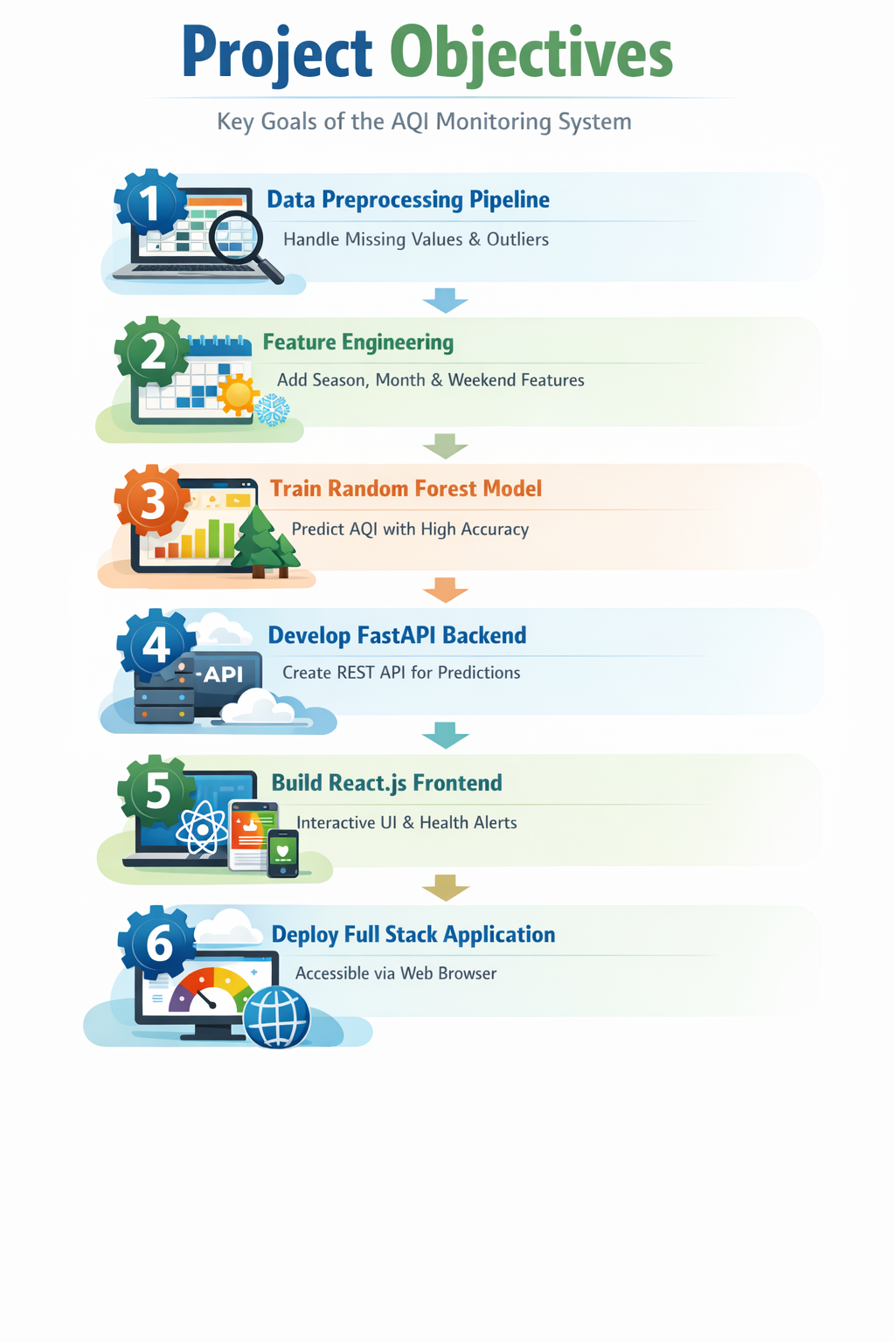

4. Dataset Overview
The dataset used for this project is city_day.csv, a publicly available collection of daily air quality readings from multiple cities across India. Each record represents one day of measurements at a particular monitoring station and includes the concentrations of the major pollutants that drive AQI calculations.

Column | Unit | Description
PM2.5 | µg/m³ | Fine particulate matter smaller than 2.5 microns. The single most harmful pollutant for human lungs and the biggest driver of AQI in Indian cities.
NO | µg/m³ | Nitric oxide. Produced mainly by vehicle engines and industrial combustion. Converts to NO2 in the atmosphere.
NO2 | µg/m³ | Nitrogen dioxide. A traffic-related pollutant that irritates the respiratory tract and contributes to smog formation.
NOx | µg/m³ | Combined nitrogen oxides (NO + NO2). Captures the total nitrogen oxide burden from combustion sources.
CO | mg/m³ | Carbon monoxide. Produced by incomplete combustion. Reduces the oxygen-carrying capacity of blood at high concentrations.
SO2 | µg/m³ | Sulphur dioxide. Mainly emitted by coal-burning power plants and heavy industry. A key contributor to acid rain.
O3 | µg/m³ | Ground-level ozone. Formed by the reaction of NOx and volatile organic compounds in sunlight. Higher in summer and post-monsoon seasons.
AQI | Index | The target variable. A composite index calculated from pollutant concentrations using CPCB sub-index formulas. Higher values mean worse air quality.

The dataset spans several years and covers major Indian metropolitan areas including Delhi, Mumbai, Chennai, Bengaluru, Hyderabad, and Kolkata, giving the model exposure to a diverse range of urban pollution patterns.

5. Data Preprocessing and Cleaning
Before any modelling could begin, the raw dataset required significant cleaning. Environmental monitoring data is notoriously messy — sensors malfunction, records go missing, and extreme events produce readings that are statistically unrepresentative of typical conditions.

5.1 Handling Missing Values
The first step was to remove all rows where the AQI value itself was missing. Since AQI is what we are trying to predict, there is no meaningful way to impute it from other columns. For the seven pollutant feature columns, missing values were filled in using the median of each column rather than the mean. The median was chosen because it is not distorted by the extreme high values that are common in pollution data.

5.2 Outlier Removal
The Interquartile Range (IQR) method was applied to every pollutant column and the AQI column. Any record falling below Q1 - 1.5 * IQR or above Q3 + 1.5 * IQR was removed from the dataset. This step eliminates obvious sensor errors and data entry mistakes while preserving the genuine variation in pollution levels that the model needs to learn from.

5.3 Date Parsing and Sorting
The Date column was converted from a plain string to a proper Python datetime object, and the entire dataset was sorted chronologically. This prepares the data for temporal feature extraction and ensures that any future time-series analysis would have records in the correct order.
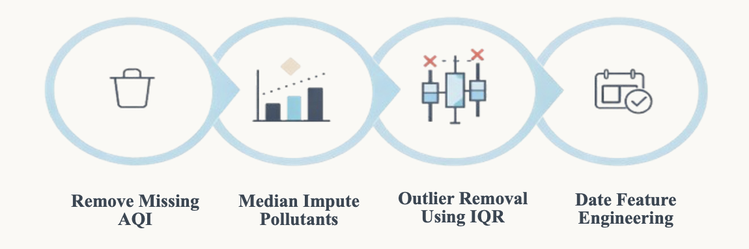

6. Feature Engineering
Raw pollutant concentrations alone do not tell the complete story. Air quality in India is heavily influenced by the time of year, weather patterns, and even the day of the week. To capture these patterns, three additional features were engineered from the date column.

6.1 Month
The numeric month (1 through 12) was extracted and added as a feature. This allows the model to learn that winter months in northern India — particularly November, December, and January — tend to have significantly worse air quality due to temperature inversions, reduced wind speeds, and agricultural stubble burning.

6.2 Weekend / Weekday Indicator
A binary flag called is_weekend was created, taking the value 1 for Saturdays and Sundays and 0 for weekdays. Traffic-related pollutants like NO, NO2, and CO consistently drop on weekends in Indian cities, making this a useful signal for the model.

6.3 Season (One-Hot Encoded)
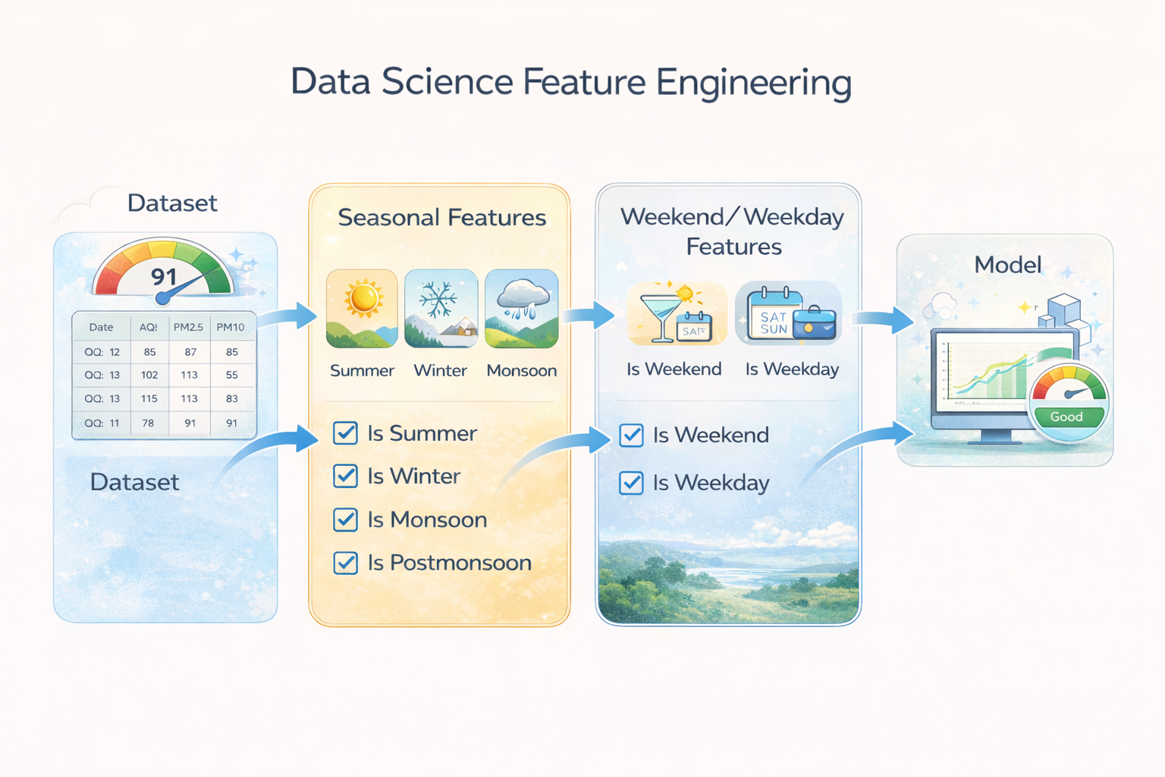
Each record was assigned to one of four Indian seasons based on its month: Winter (December to February), Summer (March to May), Monsoon (June to September), and Post-Monsoon (October and November). The season was then one-hot encoded into four binary columns. This encoding captures the strong seasonal variation in pollution that a simple month number might not fully represent

7. Model Development

7.1 Algorithm Choice: Random Forest Regressor
After evaluating several candidate algorithms, the Random Forest Regressor was selected as the most appropriate model for this task. Random Forest builds a large number of decision trees each trained on a random subset of the data and features and averages their predictions. This ensemble approach produces estimates that are more stable and accurate than any single tree could achieve on its own.
The key reasons for choosing Random Forest for this problem are:
- It handles non-linear relationships naturally, which is important because AQI does not scale proportionally with any single pollutant.
- It is robust to the remaining noise in the dataset even after preprocessing.
- It provides feature importance scores that tell us which pollutants matter most, adding interpretability to the predictions.

7.2 Final Feature Set
The model was trained on 13 features in total: the seven pollutant measurements (PM2.5, NO, NO2, NOx, CO, SO2, O3), plus month, is_weekend, and the four season binary columns (season_Winter, season_Summer, season_Monsoon, season_PostMonsoon).

7.3 Training Configuration
The data was split 80/20 into training and test sets using a fixed random seed to ensure reproducibility. The model was configured with 500 estimator trees (n_estimators = 500). After training, both the model object and the feature list were serialised to disk using joblib — saved as model.pkl and features.pkl respectively — so that the web application can load them instantly without retraining.
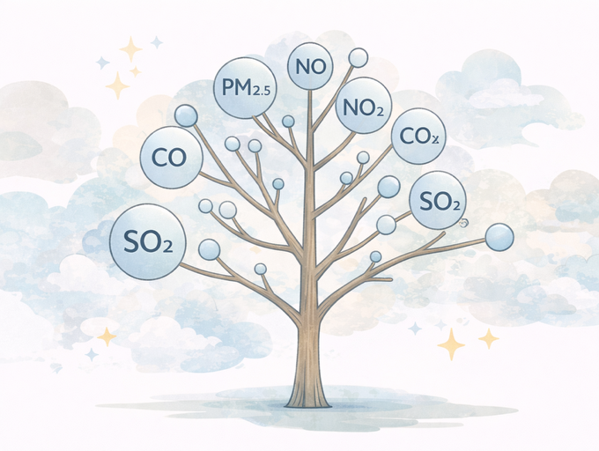
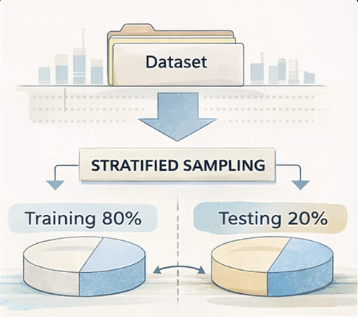

8. Model Evaluation
The trained model was evaluated on the held-out 20% test set using four standard regression metrics. These metrics together give a rounded picture of how well the model performs in practice.

Metric | Formula | What It Tells Us
Mean Absolute Error (MAE) | Avg |actual - pred| | The average error expressed in AQI units. Easier to interpret than MSE because it is not squared.
Mean Squared Error (MSE) | Avg (actual - pred)² | Penalises large errors more heavily than MAE. Useful for detecting cases where the model makes serious mistakes.
Root Mean Squared Error (RMSE) | Square root of MSE | Brings the error back into AQI units, making it directly comparable to MAE but more sensitive to large errors.
R² Score | 1 - SS_res / SS_tot | Proportion of variance in AQI that the model explains.

In addition to numeric metrics, two visualisations were generated. The first is a scatter plot of actual versus predicted AQI values overlaid with a reference line — points falling close to this diagonal line indicate accurate predictions. The second chart is a horizontal bar chart showing the relative importance of each feature, confirming that PM2.5 is by far the dominant driver of AQI, followed by O3 and NO2.
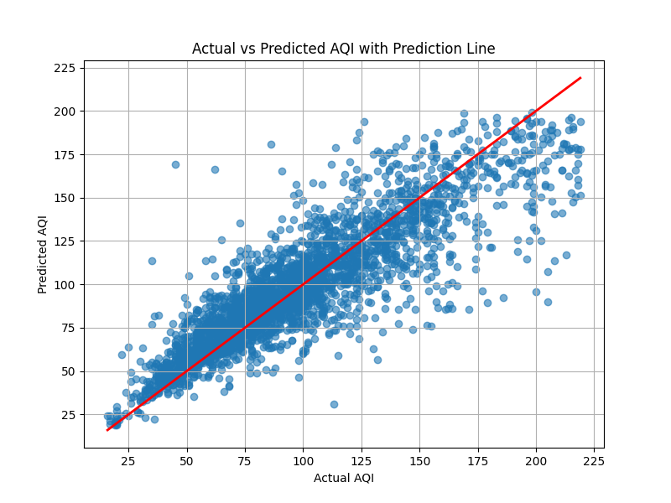

9. Web Application – FastAPI and React.js

Backend (FastAPI):

The backend is developed using FastAPI and handles all prediction logic and data processing.
- Loads the trained model and feature files at startup for instant predictions
- Exposes API endpoints to support AQI prediction, analytics, monitoring, problem analysis
- Accepts pollutant values, date-related inputs, and city information from the frontend
- Re-applies the same feature engineering steps used during training (month, weekend, season, one-hot encoding)
- Generates AQI value, category, health advisory, and pollutant severity information
- Maintains prediction history for visualization, analysis, and export
- Returns structured JSON responses and provides automatic interactive API documentation

Frontend (React.js):
The frontend is a React.js application designed for ease of use and real-time interaction.
- User-friendly pollutant range selector and other inputs to Predict AQI
- Model details showing model performance metrics, algorithm details, and regression graph
- Dataset Overview having all the details about model dataset with tables
- Instant AQI prediction display with category and health advisory messages
- City Map for viewing the AQI levels of cities in real time with all details
- Visual analytics including AQI trends, category distribution, and comparisons graphs
- Monito cities for visualizing AQI trends and pollutant levels for specific time of cities
- Problem analysis to identify pollutants exceeding their safe limits from prediction history
- History visualization for checking all predictions made with export option
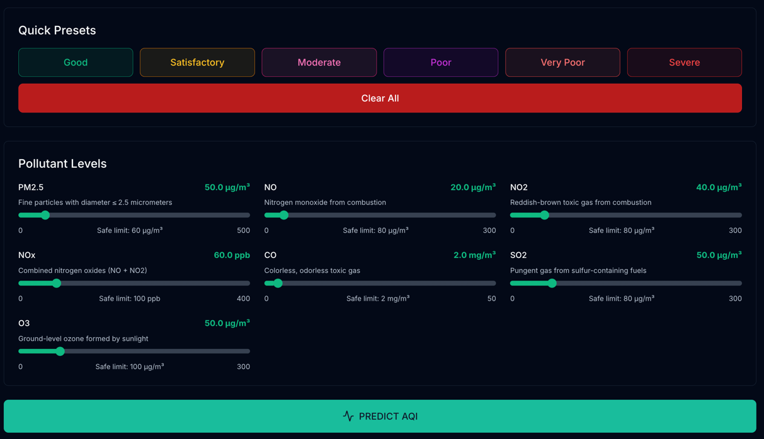

10. Results and Key Insights
The completed system from data preprocessing through to the web interface produced several noteworthy results and observations.

10.1 Model Performance
The Random Forest Regressor achieved strong predictive accuracy on the held-out test set. The R² score indicates that the model explains a substantial proportion of the variance in AQI values, while the RMSE remains well within a range that is practically useful for health advisory purposes. The scatter plot of actual versus predicted AQI values showed the majority of points clustered tightly around the diagonal reference line, with only modest deviations at the very high end of the AQI scale — an expected limitation given the relative scarcity of extreme pollution events in the training data.

10.2 Feature Importance
The feature importance chart confirmed expectations grounded in environmental science. PM2.5 emerged as the most influential predictor by a wide margin, consistent with its status as the primary driver of health harm from air pollution. O3 and NO2 were the next most important features. The seasonal and temporal features — month, season columns, and is_weekend — contributed meaningfully, validating the decision to include them and confirming that the model has learned real-world seasonal pollution patterns rather than simply memorising pollutant levels.

10.3 Sample Prediction
A representative sample prediction was tested using values typical of a heavily polluted January day in a North Indian city: PM2.5 at 111.89, NO at 22.25, NO2 at 43.29, NOx at 64.53, CO at 22.25, SO2 at 66.44, and O3 at 5.0. The model correctly placed this scenario in the Poor to Very Poor AQI range, and the system immediately generated the appropriate health alert recommending that sensitive groups stay indoors.

10.4 Web Application
End-to-end testing of the web application confirmed that predictions computed in the browser via the React form matched those produced by the standalone Python script for the same inputs. The round-trip time from form submission to displayed result was consistently under one second on a local development setup, well within acceptable limits for a real-time advisory tool. The colour-coded result card and plain-language health message were well-received as intuitive additions that made the output immediately actionable.

11. Conclusion and Future Scope

11.1 Conclusion
This project demonstrates that machine learning can be applied effectively to environmental monitoring data to build practically useful predictive tools. Starting from a real-world, imperfect dataset, we built a complete pipeline that cleans and transforms the data, trains an accurate Random Forest model, and exposes predictions through a professional web interface that anyone can use.

11.2 Future Scope
Several improvements could meaningfully extend this system in future iterations:

- Real-time data integration: Connecting the application to live data feeds from the Central Pollution Control Board (CPCB) would allow it to generate automatic daily predictions without manual input.
- Multi-step forecasting: Extending the model to predict AQI 24, 48, and 72 hours ahead would provide much earlier warning and allow people and institutions to plan ahead.
- City-specific models: Training separate models for individual cities would capture hyperlocal pollution patterns that a single generalised model inevitably smooths over.
- Deep learning exploration: Long Short-Term Memory (LSTM) networks or Transformer-based time-series models could capture longer-range temporal dependencies in pollution data that a Random Forest cannot learn.
- Mobile application: A dedicated Android or iOS application built on top of the same FastAPI backend would make the tool accessible to a much wider audience, particularly in the context of push notifications when AQI crosses critical thresholds.
- Model monitoring and retraining: Implementing drift detection and a scheduled retraining pipeline would ensure the model remains accurate as pollution patterns evolve over time.

In summary, this project establishes a solid, well-engineered foundation for an AI-powered air quality advisory system.

