CO2020 – Assignment 1
Initial Value Problems
Ishaan Jain(CO21BTECH11006)

Ques1.

Case (a): The value calculated by euler method is -3.0454844895509754 and the exact value is -3.0474258731775667 and the error is -0.0019413836265913
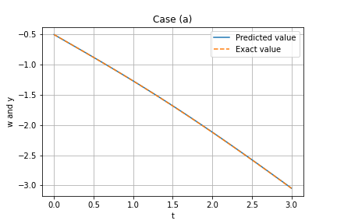

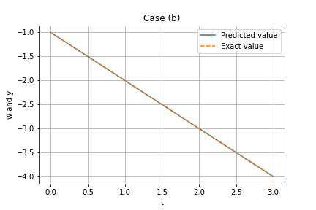
Case (b): The value calculated by euler method is -3.9999999999999583 and the exact value is -4 and the error is -4.1744385725905886e-14

The Euler method is

hereis
By taking the initial value as give in both cases, we find the values on different points.

Ques2.

The Euler method is

hereis

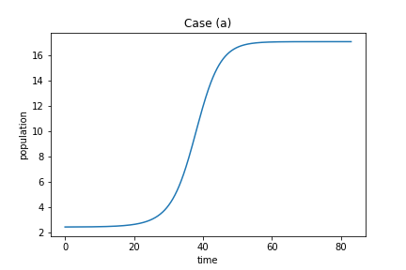
To determine the eventual population, we take the initial value and use the Euler method until we find that the value of x isn’t changing much by comparision with a certain tolerance.

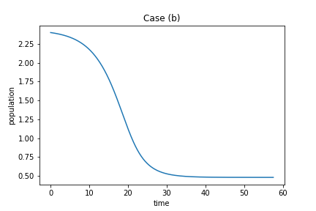
At time 83.10000000000001, the population level became constant with the value 17.083096606060824 when initial population was 2.44

At time 57.6, the population level became constant with the value 0.48057527881415757 when initial population was 2.4

Ques3.

The scheme asked is RK4. Here we take the initial value and apply the following operations till we reach a point where the slope of graph tends towards zero to a certain tolerance value.

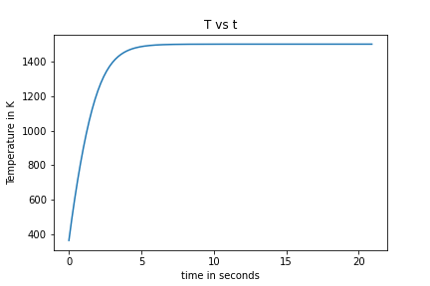

In time 21.0 seconds, the plate reaches equilibrium with the error of in the slope of the T wrt time whem it reaches zero. The final Temparature is 1499.9999990461863 K.

Ques4.
In RK2 method, we do the following steps:

This method is second order accurate.
In RK4 method, we do the following steps:

This method is fourht order accurate so the accuracy is higher here.
Theoretical Value = 216.00077160493828
By RK2,
Estimated value at t = 6 is 216.02056533871982 and error %age is 0.009163732904502198%

By RK4,
Estimated value at t = 6 is 216.00077275622138 and error %age is 5.329995315751851e-07%
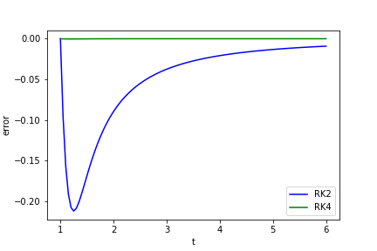

Ques5.

RK2 is a single step method and requires only a single point.

AB2 is a multi-step method and requires 2 points to evaluate the next point.
The first step is a predictor step which goes like
The next step is the corrector step which corrects the predicted value. This step goes like

Both methods are 2nd order accurate.
Error comparision in this ques goes as follows:
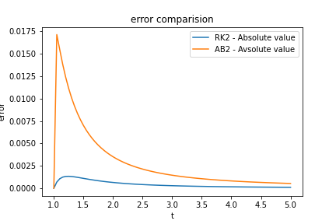

Ques6.

RK4 is a single step method and requires only a single point.
In RK4 method, we do the following steps:

AB4 is a multi-step method and requires 4 points to evaluate the next point.
The first step is a predictor step which goes like
The next step is the corrector step which corrects the predicted value. This step goes like

Both methods are 4nd order accurate.
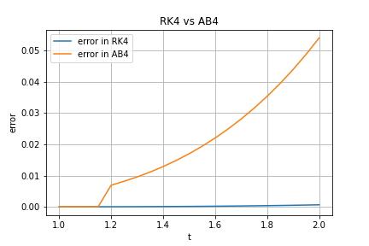
Error comparision in this ques goes as follows:

We can see that the error in RK4 is very small as compared to AB4.

Ques7.
We solved this problem using RK2.

whereand

also
initial condition given is

We do the exact same operations as we do in 1- D RK2. Just that k1, k2 and w are vectors of dimension (2*1).

The approximate value of period of this function is 6.662768 (By interpolation of values close to the x axis).
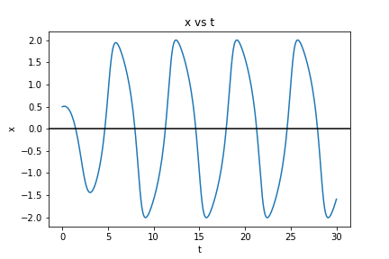
The plot above is the required priodic function for the first 4 cycles.

